7-Lecture. MASTERING THE USE OF THE GALFIT PROGRAM
GALFIT 3 is a widely used stand-alone-two-dimensional (2D) fitting code designed to model the surface brightness (SB) distribution of astronomical sources. GALFIT 3 applies 2D-parametric models to account for galaxies’ substructures and individual stars; this means more information is used than the 1D approach. Each subcomponent has its independent orientation; hence, the separation of components is more reliable. A common misconception suggests that 1D approaches work better in low signal-to-noise (S/N) regions or the presence of low-SB features; indeed, there isn’t any advantage from 1D over the 2D approaches due to the Poisson behavior of the signal². The user provides the point spread function (PSF), and GALFIT 3 has built-in functions to model the PSF. GALFIT 3 convolves the PSF with the chosen profile to fit a given galaxy. This differs from most previous approaches that deconvolved the galaxy’s image, generated the isophotes, and then fit a 1D profile.
With GALFIT 3, the user can apply multiple profiles to fit the following components: bulges, disks, bars, spiral arms, and asymmetries to one or several galaxies simultaneously. This gives a substantial advantage in crowded galaxy fields, such as compact groups or clusters of galaxies. Galaxies being extended objects are modeled better when the galaxy of interest is fitted together with its closely neighboring galaxies instead of masking. This has been shown through simulations (Häussler et al., 2007; Añorve, 2012).
GALFIT 3 applies a χν2 optimization scheme for parameter selection, including the background, generating parameter uncertainties, and produces a FITS (Flexible Image Transport System) image cube containing the image of the input object, the model image resulting after the fit, and the residual image. However, GALFIT 3 does not include a graphical tool to compare the input image with its resulting model image. Users commonly applied IRAF’s ellipse; nevertheless, this suite of programs became difficult to access after IRAF’s discontinuation in 2013; fortunately, IRAF’s ellipse is implemented in the Astropy library and new releases through. In any case, the main difficulty is that one needs to adequate GALFIT 3 ’s output format to the format admitted by external codes. However, this process could be time-consuming and prone to mistakes in handling.
Additionally, in crowded fields, neighboring galaxies near the target galaxy can be fitted simultaneously using GALFIT 3, resulting in more accurate outcomes. Häussler et al. (2007) demonstrated through simulations that masking galaxies in such fields leads to inaccurate fits for both the target galaxy and its neighbors. Improved fits were achieved when galaxies nearby were fitted simultaneously. However, this method is not feasible with IRAF’s ellipse task, which processes only one galaxy at a time.
EllipSect was designed to be user-friendly for most users. It omits any direct interaction with the code or translation of GALFIT 3 ’s data format. The program is efficiently executed via the command line. It only requires the latest GALFIT 3 ’s model output files.
GALFIT 3’s output files consist of a data cube in FITS format, which includes the original image but chopped into the fit region, the model image, and residual image (i.e., galaxy image − model image), a file named galfit.nn (where nn indicates the number of attempts run by GALFIT 3). This last file contains the parameters that fit each component of the model. Additionally, GALFIT 3 creates a log file including the model parameter values and their errors. EllipSect uses the GALFIT output file (galfit.nn) to parse the input magnitude zero point, plate scale, mask file name, output file, and model parameters.
The output GALFIT 3 file may contain information about the simultaneous fit of neighboring galaxies to the target galaxy. Using the distances among model components, EllipSect can discern which components belong to each galaxy.
EllipSect uses the same mask employed by GALFIT to remove the undesired pixels from the image. Once this is done, EllipSect reads the sky component from the GALFIT output file and subtracts it from the output galaxy and model images. The program divides the galaxy and its model into sectors equally spaced in angle around their centers. This is accomplished using the sectors_photometry routine from the mgefit⁵ Python library by Cappellari (2002). The routine also calculates the counts within each sector, extending outward testing the galaxy’s center until a specified minimum count level is reached. This is set by the MINLEVEL parameter of the routine. The default value is zero for this parameter. The ellipse is divided into sectors from the major axis to the minor axis, with the number of sectors set to a default value of 19, resulting in sectors spanning an angle of 5∘. Sectors around the galaxy are built using the position angle and ellipticity found in the model component of the output GALFIT file. If multiple components are fitted to the galaxy, the geometric information is taken from the last component in the model, as it is identified as the galaxy’s outermost component. This component is typically an exponential model, although this may vary depending on the specific galaxy model used. The user can change all these default parameters.
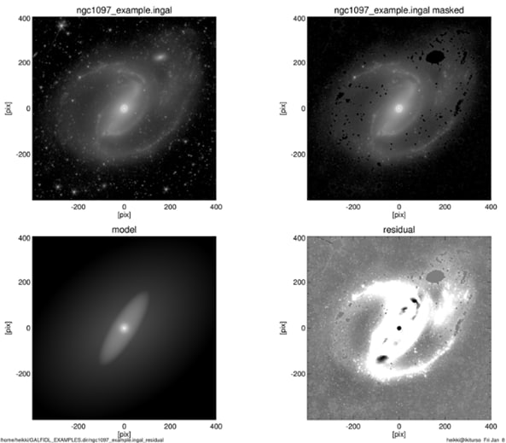

Parametric Modeling in Astronomy
Parametric modeling assumes that the light distribution of an object can be represented by mathematical functions. In galaxy studies, commonly used profiles include:
- Sérsic profile
- Exponential disk profile
- Gaussian profile
- de Vaucouleurs profile
GALFIT implements these models and optimizes their parameters using nonlinear least-squares fitting algorithms.
GALFIT was developed to perform fast and accurate two-dimensional fitting of galaxy images. It supports multiple components, convolution with point spread functions (PSFs), masking of unwanted regions, and simultaneous fitting of multiple objects.
Key capabilities include:
- Multi-component galaxy fitting
- PSF convolution
- Sky background estimation
- Flexible constraint handling
- Support for various image formats (e.g., FITS).

Astronomical Image Requirements
High-quality input data are essential for reliable GALFIT results. Images should be well calibrated, background-subtracted, and free from major artifacts. Common preprocessing steps include bias subtraction, flat-field correction, cosmic ray removal, and image alignment.

Point Spread Function (PSF)
The PSF describes how a point source is spread by the telescope and atmosphere. Accurate PSF modeling is critical, especially for fitting compact galaxy cores or active galactic nuclei (AGN). GALFIT convolves model components with the PSF to match observational conditions.

Sigma and Mask Images
The sigma image represents pixel-wise uncertainties and plays a crucial role in weighting the fit. Mask images are used to exclude foreground stars, neighboring galaxies, or image defects from the fitting process.
GALFIT produces several outputs:
- Best-fit model image
- Residual image (data − model)
- Parameter file with uncertainties
Residual images are critical for assessing fit quality and identifying unmodeled structures.

Physical Interpretation of Parameters
Interpreting GALFIT results requires astrophysical context. For example:
- High Sérsic index (n ≈ 4) suggests bulge-dominated systems
- Low Sérsic index (n ≈ 1) indicates disk-dominated galaxies
Parameter correlations and degeneracies must be carefully evaluated.

GALFIT is widely used in studies of:
- Galaxy morphology and evolution
- Active galactic nuclei host galaxies
- Scaling relations (e.g., size–mass relations)
- High-redshift galaxy structure

