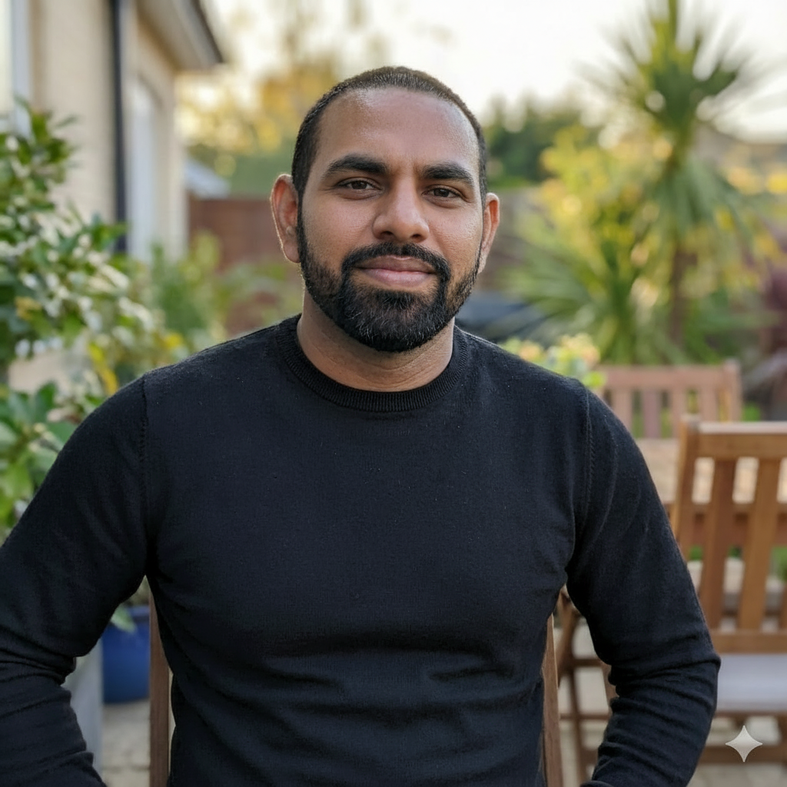
Sobodh Jagaran

Full-Stack Engineer & System Architect
Contact: +27 81 7372 497 | sobodh10@gmail.com | Pietermaritzburg, South Africa

Profile Summary

Highly experienced Senior Software Developer with 10+ years of continuous experience specializing in full-stack development, mobile application delivery, and robust backend systems built using C#/.NET Core, PHP/Laravel, JavaScript and Java. Expert in designing, developing, and integrating software for web, desktop, and mobile platforms, including hardware integration. Proven ability in Software and Mobile App Testing and Bug Fixing, along with successfully building and deploying complex systems. This continuous focus on code quality and technical depth makes me an ideal candidate for high-rate AI Code Evaluation and Technical QA roles.

Experience

Software Developer | Nortech International | Electronics and Software Solutions | Permanent |
Pietermaritzburg | January 2019 – Current
- Full-stack software design, development, and integration for various platforms, including web, desktop, and mobile applications.
- Specialized in hardware integration into software systems to enhance product functionality and data processing.
- Responsible for the maintenance and modernization of legacy/old code bases, ensuring system stability, security, and performance.
- Contributed to the development lifecycle across all stages (design, coding, integration, and deployment).
- Continued application of expertise in Java, and JavaScript across all projects.

Software Developer | Lemonaide Ltd | Software Development & Financial Crime | Contract | Randburg |
29 January 2018 – December 2018
- Full-stack development, maintenance, and system analysis using C#, .Net Framework, and .Net Core.
- Built the SmartKos e-commerce and delivery application solo in 3 months (ASP.NET Core 2, Azure SQL DB), including a web scrapping tool to gather product data from major retailers.
- Provided crucial QA and integration support on the Honeycomb Application (FIC compliance system) and the UWE/Uwe Assist project (Raspberry Pi/scale integration).
- Completed and built the Boskruin Butchery e-commerce store and successfully resolved all outstanding requirements and bugs for the Fleetwach web/mobile app.
- Provided high-level support and mentorship to a junior developer, tackling complex implementation challenges.

IT Programmer | Hellomarketing | Marketing | Permanent | Pietermaritzburg
February 2016 to November 2017

- Managed full-stack development, maintenance, and hosting infrastructure for multiple web properties and mobile applications.
- Designed and built the B4B Door Knocker Mobile App (Android/iOS) using Ionic framework and a Slim PHP API to capture and manage leads via the Salesforce CRM.
- Developed a CRM-like website feature and a web-based search engine using the Laravel PHP Framework and MySQL.
- Engineered a data processing solution using an algorithm to sort, check, and validate over 3 million lead records from spreadsheets before database entry.

Developer | Tanjent Ltd | Web Development & Social Media Marketing | Permanent | Randburg

March 2015 to December 2015

- Built from scratch a Mobile App for a Small Poker League Tournament using the Ionic framework and Firebase.
- Developed and worked on various websites using Opencart and WordPress.
- Contributed to the first phase development of the Versofy website before relocating.

Tester and Automation Tester | STS | IT | Internship | Johannesburg

July 2014 to October 2014

- Performed software testing (manual and automation) using Selenium and Java.

Education

- BSc Computer Science and Information Technology | UKZN Pietermaritzburg |
- High School Matric (Bachelor’s Degree) | Heather Secondary School |

Skills and Knowledge

Languages: C#, JavaScript & TypeScript, PHP, SQL, Java, C++.

Frameworks: Angular, Ionic, Vue, React, Bootstrap, Material Design, Tailwind, Laravel, Slim, Selenium (Used for Automation Testing), Salesforce, .Net Framework, .Net Core.

Tools: Git, Microsoft Visual Studio, Visual Studio Code, MySQL Workbench, NetBeans, Eclipse, Android Studio, Xcode.

References

Keshena Rampath | 072 332 7514
Divar Ramnath | 074 580 6416
Keabetwswe Phokela | Web and App Developer @ Tanjent | 071 913 2585
Shannon Harley | Marketing & Team Manager @ Hellomarketing. | 082 445 3591
Tebogo Langa | Developer @ Lemonaide Ltd. | 072 721 5514
Lance Gamsu | Support & Quality Assurance @ Lemonaide Ltd. | 071 883 9069
Ridwan Umardutt | R&D Manager @ Nortech International Ltd. | 083 502 5357

