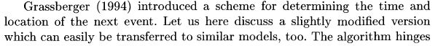
źródło:
Hergarten, Self-Organized Criticality In Earth Systems, Springer 2002

