Micro food web

knitr::opts_knit$set(root.dir = "D:/Knowledge-based/BISE/meta-bio-net/Bionet_V2/")  
knitr::opts_knit$set(warning = FALSE, include=FALSE)

#### Setting global parameters

#### Load KB

taxo=read.csv2(file_taxo)  
tg=read.csv2(file_tg)  
tg_fw=read.csv2(file_tg_fw)  
  
taxo_tg=merge(tg,taxo,by.x="scientificName",by.y="verbatimScientificName")[taxa_attributes]  
rm(taxo)  
rm(tg)  
  
taxo_tg$surf=rep(1,dim(taxo_tg)[1])  
taxo_tg$subsurf=rep(1,dim(taxo_tg)[1])  
taxo_tg$soil=rep(1,dim(taxo_tg)[1])

#### Generate taxa-level KB

consumers=merge(tg_fw,taxo_tg[c("scientificName","key","trophicGroup")],by.x="consumer_TG",by.y="trophicGroup")  
taxa_fw=merge(consumers,taxo_tg[c("scientificName","key","trophicGroup")],by.x="resource_TG",by.y="trophicGroup",suffixes = c("_consumer","_resource"))  
  
taxa_fw$cooccur<-rep(1,dim(taxa_fw)[1])  
write.csv2(taxa_fw,"metafoodweb.csv")  
rm(consumers)  
  
taxa_metadata<-unique(taxo_tg[,-2])

#### Creating metanetwork

taxa_nodes=apply(taxa_metadata,1, function(x){  
 microhab=list(surf=x["surf"],subsurf=x["subsurf"],soil=x["soil"])  
 node=Taxon$new(gbif_id=as.character(x['key']),  
 label = as.character(x['scientificName']),  
 broad=as.character(x['kingdom']),  
 rank=as.character(x['rank']),  
 microhab=microhab)  
 })  
  
metaweb=MetaWeb$new(  
 mwebname="microfoodweb", taxa=taxa_nodes, edge_list=taxa_fw[,edge_ends_taxa],   
 edge_metadata=taxa_fw[,edge_attributes],res_name="key_resource",cons_name="key_consumer",type="interaction_type",cooccur="cooccur")  
  
metaweb$print()

## Metaweb:   
## Name: microfoodweb  
## Network statistics:   
## Number of taxa: 117  
## Number of interactions: 797  
## Connectivity: 0.05872384

g=metaweb$graph  
plot(g,  
 vertex.label=V(g)$scName,  
 vertex.color=rainbow(10)[as.factor(V(g)$broad)],  
 vertex.size=10,  
 plot.layout=layout_as_tree)

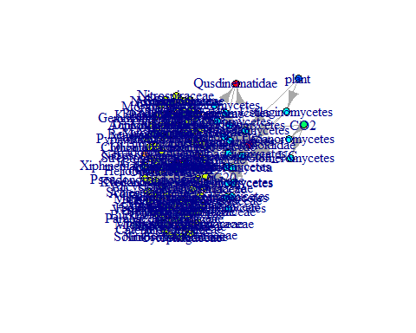

#### Load data

occur=merge(subset(read.csv2(file_occur),(ScientificName %in% taxa_metadata$scientificName)),taxa_metadata[c("key","scientificName")],by.x="ScientificName",by.y="scientificName")  
design=read.csv2(file_design)  
pt_names=as.character(design[,lev])

### Creating local networks

subnets=lapply(as.vector(pt_names), function(x){  
 community_compos=as.character(occur[which(occur[,x]>=min_occur),"key"])  
 subnetwork=metaweb$project_metanetwork(sublist_taxa_keys = community_compos,net_name = x,verbose=verb)   
 return(subnetwork)  
 })

## Projected trophic web:   
## Name: P1  
## Network statistics:   
## Number of taxa: 100  
## Number of interactions: 669  
## Connectivity: 0.06757576   
## Projected trophic web:   
## Name: P2  
## Network statistics:   
## Number of taxa: 99  
## Number of interactions: 675  
## Connectivity: 0.06957328   
## Projected trophic web:   
## Name: P3  
## Network statistics:   
## Number of taxa: 94  
## Number of interactions: 625  
## Connectivity: 0.07149394   
## Projected trophic web:   
## Name: P4  
## Network statistics:   
## Number of taxa: 90  
## Number of interactions: 472  
## Connectivity: 0.05892634   
## Projected trophic web:   
## Name: P5  
## Network statistics:   
## Number of taxa: 92  
## Number of interactions: 550  
## Connectivity: 0.06569517   
## Projected trophic web:   
## Name: P6  
## Network statistics:   
## Number of taxa: 89  
## Number of interactions: 470  
## Connectivity: 0.06001021   
## Projected trophic web:   
## Name: P7  
## Network statistics:   
## Number of taxa: 97  
## Number of interactions: 653  
## Connectivity: 0.07012457   
## Projected trophic web:   
## Name: P8  
## Network statistics:   
## Number of taxa: 100  
## Number of interactions: 674  
## Connectivity: 0.06808081   
## Projected trophic web:   
## Name: P9  
## Network statistics:   
## Number of taxa: 95  
## Number of interactions: 616  
## Connectivity: 0.06898096   
## Projected trophic web:   
## Name: P10  
## Network statistics:   
## Number of taxa: 106  
## Number of interactions: 635  
## Connectivity: 0.05705301   
## Projected trophic web:   
## Name: P11  
## Network statistics:   
## Number of taxa: 104  
## Number of interactions: 707  
## Connectivity: 0.06600075   
## Projected trophic web:   
## Name: P12  
## Network statistics:   
## Number of taxa: 105  
## Number of interactions: 714  
## Connectivity: 0.06538462   
## Projected trophic web:   
## Name: P13  
## Network statistics:   
## Number of taxa: 89  
## Number of interactions: 585  
## Connectivity: 0.07469356   
## Projected trophic web:   
## Name: P14  
## Network statistics:   
## Number of taxa: 94  
## Number of interactions: 625  
## Connectivity: 0.07149394   
## Projected trophic web:   
## Name: P15  
## Network statistics:   
## Number of taxa: 98  
## Number of interactions: 657  
## Connectivity: 0.06911424   
## Projected trophic web:   
## Name: P16  
## Network statistics:   
## Number of taxa: 103  
## Number of interactions: 693  
## Connectivity: 0.06596231   
## Projected trophic web:   
## Name: P17  
## Network statistics:   
## Number of taxa: 100  
## Number of interactions: 665  
## Connectivity: 0.06717172   
## Projected trophic web:   
## Name: P18  
## Network statistics:   
## Number of taxa: 101  
## Number of interactions: 690  
## Connectivity: 0.06831683   
## Projected trophic web:   
## Name: P19  
## Network statistics:   
## Number of taxa: 102  
## Number of interactions: 699  
## Connectivity: 0.0678509   
## Projected trophic web:   
## Name: P20  
## Network statistics:   
## Number of taxa: 103  
## Number of interactions: 685  
## Connectivity: 0.06520084   
## Projected trophic web:   
## Name: P21  
## Network statistics:   
## Number of taxa: 101  
## Number of interactions: 667  
## Connectivity: 0.0660396   
## Projected trophic web:   
## Name: P22  
## Network statistics:   
## Number of taxa: 104  
## Number of interactions: 706  
## Connectivity: 0.06590739   
## Projected trophic web:   
## Name: P23  
## Network statistics:   
## Number of taxa: 107  
## Number of interactions: 733  
## Connectivity: 0.06462705   
## Projected trophic web:   
## Name: P24  
## Network statistics:   
## Number of taxa: 105  
## Number of interactions: 705  
## Connectivity: 0.06456044   
## Projected trophic web:   
## Name: P25  
## Network statistics:   
## Number of taxa: 103  
## Number of interactions: 698  
## Connectivity: 0.06643823   
## Projected trophic web:   
## Name: P26  
## Network statistics:   
## Number of taxa: 97  
## Number of interactions: 649  
## Connectivity: 0.06969502   
## Projected trophic web:   
## Name: P27  
## Network statistics:   
## Number of taxa: 105  
## Number of interactions: 714  
## Connectivity: 0.06538462   
## Projected trophic web:   
## Name: P28  
## Network statistics:   
## Number of taxa: 99  
## Number of interactions: 669  
## Connectivity: 0.06895485   
## Projected trophic web:   
## Name: P29  
## Network statistics:   
## Number of taxa: 104  
## Number of interactions: 687  
## Connectivity: 0.06413368   
## Projected trophic web:   
## Name: P30  
## Network statistics:   
## Number of taxa: 105  
## Number of interactions: 699  
## Connectivity: 0.06401099

#### Compute alpha metrics on the metaweb and local networks

broad_light=c("plant")  
broad_som=c("SOM")  
  
broad_fungi=c("Fungi")  
broad_bacteria=c("Bacteria","Archaea")  
  
att="broad"  
scNames_opp=c()  
scNames_min=c()  
  
topoenerg_metrics=lapply(subnets,topoenergetic_metrics)  
topoenerg_metrics[[length(topoenerg_metrics)+1]]=topoenergetic_metrics(metaweb$graph)  
  
topometrics_df=do.call(rbind,lapply(topoenerg_metrics, as.data.frame))  
topometrics_df$observation_id=c(as.character(design$Pot),"metaweb")  
write.csv2(topometrics_df,outfile_metrics)

#### Compute betadiversity between plots

eta=c(0,1,2)  
div=c('P','L')  
labdiv=c('Taxonomic','Link')  
names(labdiv)=div  
groups=as.character(design$Trt)  
  
params=vector(mode="list",length=length(eta)*length(div))  
cpt=1  
for(d in div) for (e in eta){  
 params[[cpt]]=list(e=e,d=d)  
 cpt=cpt+1  
}   
  
beta_list=lapply(1:length(params),function(x){  
 betadivdf=betanet(gList=subnets,groups=NULL,  
 file_beta =   
 paste(outfile_beta,params[[x]]$e,"_",params[[x]]$d,".csv",sep=""),  
 pt_names = pt_names,div=params[[x]]$d,eta=params[[x]]$e)  
   
 return(betadivdf)  
})

## PCOA of betadiversity between plots

pcoa_list=lapply(1:length(params), function(x) {  
 pcoa=pcoa_plot(D=as.dist(beta_list[[x]]),Y=NULL,  
 corr="none",groups=groups,  
 title=paste(  
 "Betadiversity :",labdiv[params[[x]]$d],  
 "turnover, Hill number= ",params[[x]]$e))  
   
 print(pcoa$plot)  
   
})

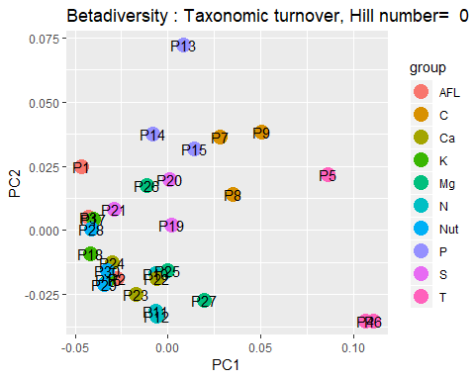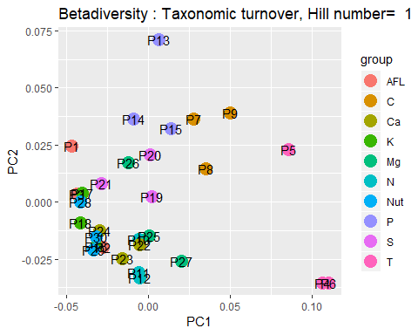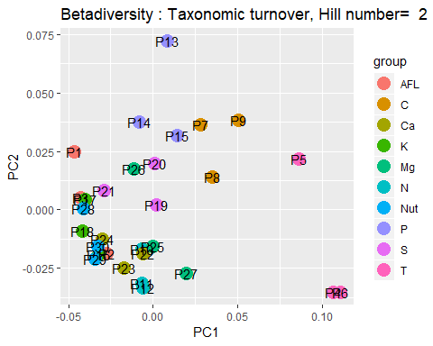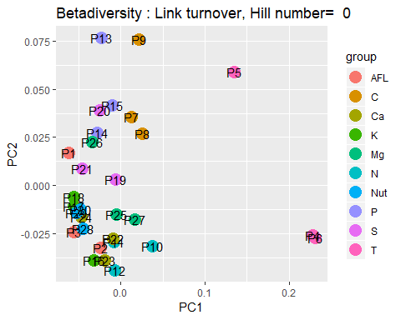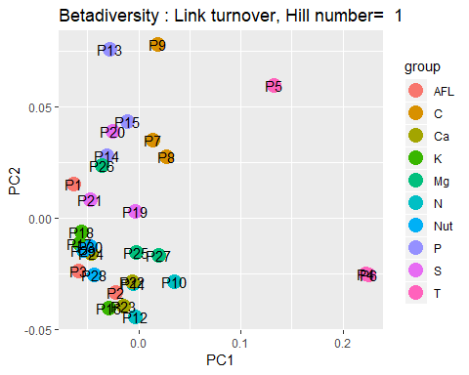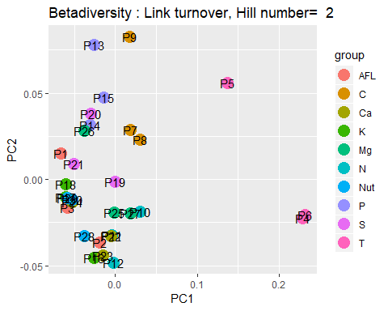

#### Functional redundancy within plots

###Occurrence of groups  
occur_tg=merge(taxo_tg,occur,by="key")  
func_redund=aggregate(x=occur_tg[,as.character(design$Pot)],  
 FUN = sum,by = list(TG=occur_tg$trophicGroup))  
  
write.csv2(func_redund,outfile_fredund)  
  
fct_div=redund_fct(func_redund,as.character(design$Pot))  
write.csv2(fct_div,outfile_fdiv)