**Simulation model**

We used a process-based stochastic model adapted from Virtualcomm (Gallien and Münkemüller 2015) to simulate the assembly of individuals from a regional species pool into communities, on different locations sampled along an environmental gradient. The assembly process is controlled by three filtering mechanisms: the response to the abiotic environment, the outcome of biotic interactions and reproduction. For simplicity, the spatial structure of communities and thus dispersal processes are ignored. In other words, there is no exchange of individuals between neighboring communities. The simulation starts with a given or random initial composition for each community independently. Individuals are replaced through time until an equilibrium state is reached or a user-defined number of iterations is completed. The final communities’ composition is returned at the end. The detailed simulation steps are described in Box.

### ***Box: how does the simulation work?***

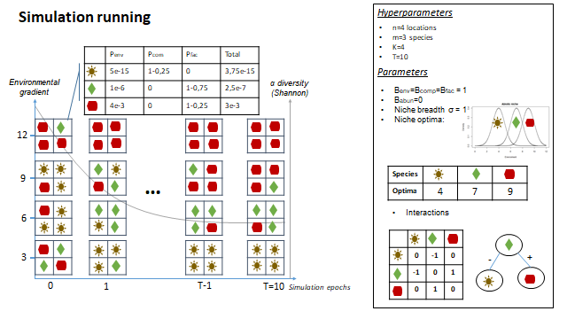

**Notation**

* We start by sampling **n** locations uniformly on a single environmental gradient **E**.
* All locations have the same carrying capacity of **K** individuals from a common pool of **m** species **S**={Sj / j∈[1,m]}.
* Each species has its own optimal environmental value $μ_{j }ϵ E$ as well as a niche breadth $σ_{j }ϵ E.$
* Biotic interactions are described by a full interaction matrix $I=(I_{jk}) / j,k ϵ \left[1,m\right]² ; -1≤ I_{jk}≤1$ where $I_{jk}$ represents the effect of the interaction between the pair (Sj, Sk) on species Sk. We also write: $I = I{}^{+} - I^{-}$ such that:
* $I{}^{+} =({I{}^{+}}_{jk}) / j,k ϵ \left[1,m\right]² ; 0≤ {I{}^{+}}_{jk}≤1$ represents the matrix of positive effects (facilitation matrix)
* $I{}^{-} =({I{}^{-}}_{jk}) / j,k ϵ \left[1,m\right]² ; -1≤ {I{}^{+}}_{jk}≤0$ represents the matrix of negative effects (competition matrix)

**Assembly rules**

At each timestep (epoch), given an actual composition **c**, the probability that an individual from a given species **i** to replace any other individual of **c** is given by the following equation:



s.t

* $B_{env}$: weights of the abiotic filter.
* $B_{comp}$: weight of the competition.
* $B_{fac}$: weight of the facilitation.
* $B_{abun}$: weight of the reproduction filter, can be interpreted in terms of growth rate.
* $P_{env,i,c}$: the probability of species i to occur under the environmental value Ec is given by the normalized density on Ec of a Gaussian distribution parameterized by its optimum and niche breadth. The closer to its optima, the higher the probability of the species’ occurrence.



* $P_{comp,i,c}$: the probability for an individual of species i to join the community given the aggregated effect of its competitors in c.



* $P_{fac,i,c}$: the probability for an individual of species i to join the community given the aggregated effect of its facilitators in c.

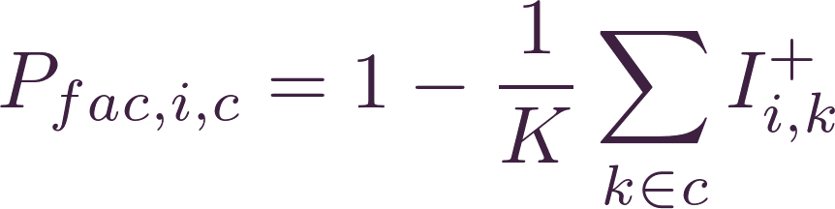

* $P_{abund,i,c}$: probability of an individual of species i to join the community as a result of the reproduction of some of the $N_{i,c}$ conspecifics in c.



The unnormalized weights $\hat{W}$ i,c for each species are then normalized by dividing each one of them by their sum. The result is a vector of probabilities W that sums to 1.

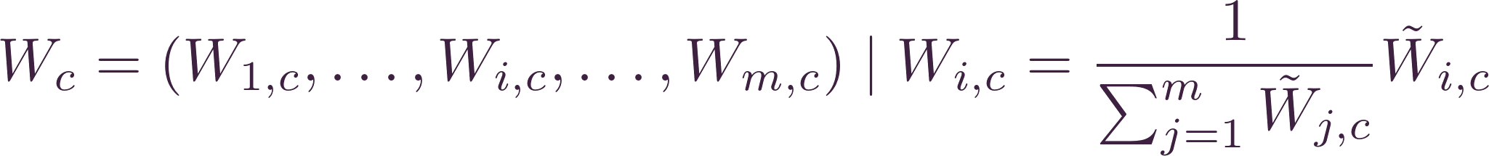

Finally, we sample from a multinomial distribution; parameterized with W; K individuals to compose the new community.