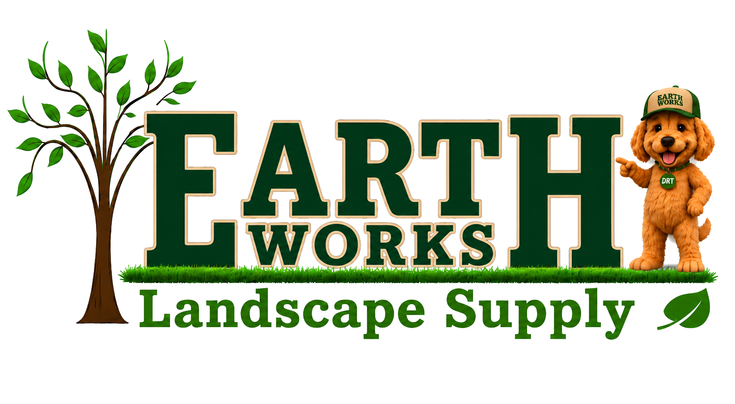
EARTH WORKS
Website Brand & UI Guide
Typography, color, spacing, navigation, components and responsive implementation standards
Implementation rule
Use this system across every page and every new component. Do not introduce new display fonts, red/blue interface accents, or one-off spacing values unless the brand guide is intentionally revised.

1. Brand foundation
The website should feel local, practical, premium and easy to scan. The visual language is built around strong black-and-white contrast, Earth Works green, restrained cream backgrounds, clear product photography, and a small amount of handwritten personality.
Color | Hex | Swatch | Use
Primary Green | #4F7A07 |  | Primary buttons, links, active navigation, accents
Bright Green | #6F9D12 |  | Hover states, small highlights, service accents
Deep Green | #234D06 |  | Announcement bar, service banners, dark green panels
Black | #050604 |  | Primary dark header, footer, high-contrast sections
Paper | #FFFDF8 |  | Main light backgrounds
Cream | #F2EADB |  | Warm supporting section backgrounds
Muted | #62685E |  | Secondary copy, captions, supporting text
Color guardrail: interface accents stay within the green / black / white / cream system. Do not use red or blue for menu states, service callouts, hover states or cards.

2. Typography system
The website uses three typographic roles. Keeping those roles fixed is the fastest way to prevent the uneven “different website on every page” feeling.
Role | Font | Use | Rules
Display | Oswald | H1-H4, product names, navigation, major buttons | Uppercase only where the design already uses uppercase. Tight but readable tracking.
Body | DM Sans | Paragraphs, forms, labels, product details, supporting UI | Neutral, readable, 1.55-1.65 line height for paragraphs.
Accent | Kalam | Service promise, selected eyebrows, occasional CTA personality | Use sparingly. Never use for long paragraphs or dense UI.
Responsive type scale
Element | Font | Desktop | Tablet | Mobile | Line height
H1 / page hero | Oswald | 64-72 px | 52-56 px | 40-44 px | 0.96-1.00
H2 / major section | Oswald | 48-54 px | 40-44 px | 34 px | 1.00
H3 / cards & subsections | Oswald | 26-28 px | 24 px | 22 px | 1.08-1.14
Body | DM Sans | 15-16 px | 15 px | 15 px | 1.55-1.65
Card / supporting copy | DM Sans | 13 px | 13 px | 13 px | 1.45-1.55
Navigation | Oswald | 14 px | 13 px | 13 px | 1.00
Promise headline | Kalam | 18 px | 17 px | 16 px | 1.08
Pickup / Delivery / Install | Kalam | 14.5 px | 13.5 px | 13 px | 1.10

3. Spacing system
Use an 8-point spacing rhythm. Components may combine adjacent steps, but avoid arbitrary 17 px / 27 px / 43 px values that make the layout drift.
8 / 12 / 16 / 24 / 32 / 48 / 64 / 80 px
- Header desktop column gap: 22 px at full width; reduce to 13 px around laptop widths before switching to the mobile layout.
- Section vertical rhythm: typically 64-96 px depending on section density.
- Card internal padding: 16-24 px. Dense menu cards may use 10-14 px.
- Body copy should not be crowded against headings: use 12-20 px between heading and paragraph.
4. Header & navigation standards
The header has three layers. The announcement bar scrolls away. The black utility bar and white primary navigation remain sticky as one unit.
Layer | Desktop height | Background | Content
Announcement bar | 30 px | Deep green | Centered: “Installation slots are booked 2-3 days out – Call Today!”
Black utility bar | 76 px | Black | Promise + service links, search, two phone numbers, My Account, language, cart
White primary nav | 66 px | White | Logo, Landscape Supplies, Reviews, About Us, Contact Us, FAQ, Get a Quote
Utility bar behavior
- “We Have Your Grounds Covered!” uses Kalam at 18 px desktop. It should not visually compete with the logo or phone numbers.
- Pick Up / Delivery / Install use Kalam at 14.5 px desktop with a restrained green underline.
- Search, promise, phone blocks and utilities use even horizontal gaps. Avoid one-off padding that makes one block look detached.
- My Account: bottom-right desktop toast “My Account is coming soon.”
- Cart: bottom-right desktop toast “E-commerce is coming soon.”
- Language selector: show US flag + EN by default. Dropdown shows English and Spanish with flags. Only choosing Spanish shows “Spanish language support is coming soon.”
- On mobile, toast messages appear centered near the bottom, above the mobile action bar.
Mega menu behavior
- Hovering Landscape Supplies initially shows only the category list.
- Products and the service/help panel appear only after a category is hovered or keyboard-focused.
- Selected category state uses Earth Works green on a soft green background. Do not use red.
- Service panel uses deep green / green / paper tones. Do not use blue.
- Product names use DM Sans for compact readability; the selected category title uses Oswald.

5. Component rules
Buttons
- Primary: green fill, white label, Oswald, 12-14 px, uppercase where existing UI uses uppercase.
- Secondary: white or paper fill with subtle neutral border; dark label.
- Do not introduce blue/red buttons for service or catalogue actions.
Cards and product UI
- Use white/paper cards with subtle neutral borders and low-contrast shadows.
- Product imagery should remain visually dominant. Use consistent aspect ratios within a grid.
- Product title: Oswald 22-24 px. Supporting copy: DM Sans 13 px. Utility metadata: 9-11 px.
Sections
- Large section headings should stay within the responsive H2 scale. Avoid one section jumping to 64+ px while neighboring sections use 36 px.
- Eyebrows may use Kalam, but only as a short label. Do not use Kalam for body copy or forms.
- Maintain consistent max-widths so body text remains comfortable to scan.
Responsive checkpoints
Viewport | Layout mode | Header behavior | Typography / spacing
≥ 1320 px | Full desktop | Single-row utility bar with even 22 px gaps; full white nav | Full type scale, generous 64-96 px section spacing
981-1319 px | Laptop | Reduced gaps and compact utility controls; same two-bar structure | Slightly reduced heading sizes; preserve readability
621-980 px | Tablet | Promise/search/phones reorganize; utility buttons hidden; mobile nav toggle | H1 42-56 px; H2 34-44 px
≤ 620 px | Mobile | Single-column utility layout; phone blocks hidden; service panels modal-style | H1 40 px; H2 34 px; 15 px body
Developer QA checklist
- Black and white header stay sticky; announcement bar scrolls away.
- No red/blue interface states in navigation, service panels or mega menus.
- Landscape Supplies initially shows categories only.
- Category hover reveals product + service content; keyboard focus does the same on desktop.
- My Account / Cart toast copy is correct; language menu itself does not show a toast.
- Spanish selection alone triggers the Spanish-coming-soon toast.

