Consent Form (inserted on first page)

----

Video/Audio Testing

To be eligible for compensation in this study, you must (1) be able to record your facial movements via your webcam, and (2) have your sound on.

On the next page, we will help you check that your webcam and sound are working.

Note: it is OK to see a delay in your video feed -- so long as your face is visible and approximately in the center of the frame.

< participants encounter audio and video check via Gorilla platform>

----

Video/Audio Confirmation

Thank you for testing your video recording and sound devices.

It is normal to see a slight delay in the video preview.

If you did not detect any other issues, please click the next button to begin the study.

----

Cover story (condition 1: No Threat Condition)

Today’s study examines how multi-tasking influences mathematical speed and accuracy.

You are eligible to receive $6 for completing this task

When you are ready to begin, click the Next button.

----

Cover story (condition 2: Threat Condition)
Today’s study examines how multi-tasking influences mathematical speed and accuracy.

You are eligible to receive $6 for completing this task. However, we will deduct $2 if we find that you did not follow instructions satisfactorily during the recorded segments of the study. Please check the box below to confirm that you agree with these conditions:

- I agree to have my payment deducted if I do not follow the instructions.

When you are ready to begin, click the Next button.

Filler Task 1 (sequential condition):

On the next screen, you will receive instructions for your first physical task (of four).
When you are ready to review the instructions, click Next
----

For your first task, the computer has assigned you the following instructions:

Place your left hand behind your head and blink your eyes once per second for 5 seconds.

The next screen will provide you with a timer to help you with this task.

Please take a moment to practice this task now. When you are ready to begin the task, proceed to the next screen.

----

Filler task 4
On the next screen, you will receive instructions for your last physical task.
When you are ready to review the instructions, click Next
----

The computer has assigned you the following task:

Tap your left leg with your right-hand index finger once per second for 5 seconds.

The next screen will provide you with a timer to help you with this task.

Please take a moment to practice this task now. When you are ready to begin the task, proceed to the next screen.

----

Facial movement instructions (condition 1: smile + Repetition (1 vs. 10))
On the next screen, you will receive instructions for your next physical task.
When you are ready to review the instructions, click Next
---

The computer has assigned you the following task:

We are going to show you a set [10 sets] of images.

When you encounter the [each] image set, please adopt and maintain the expression pictured below. Your camera will automatically start and stop recording while you complete the task.

When you are ready to start, click the Next button.

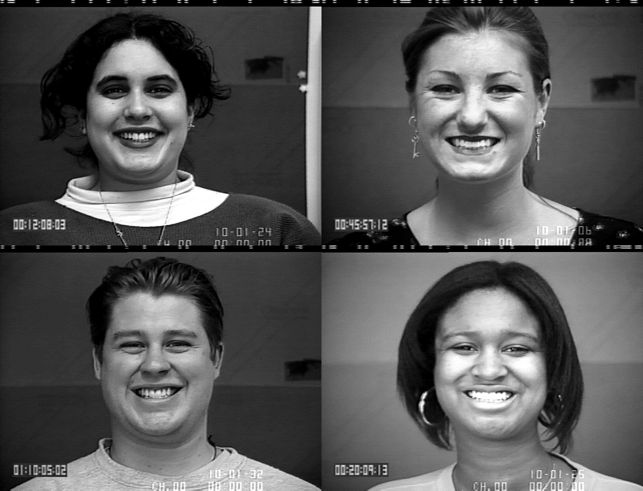

----

Facial movement instructions (condition 2: express naturally + Repetition (1 vs. 10))
The computer has assigned you the following task:

We are going to show you a set [10 sets] of images.

When you encounter the [each] image set, please do not attempt to control your natural facial posture and movements -- even if the people pictured below look differently. Your camera will automatically start and stop recording while you complete the task.

When you are ready to start, click the Next button.



----

Images (condition 1: positive )

[Use Maciej’s methodology to generate up to 10 sets of similar images as what we originally used. Let Nicholas know if you cant find it.]

----

Images (condition 2: negative)
[Use Maciej’s methodology to generate up to 10 sets of similar images as what we originally used. Let Nicholas know if you cant find it.]

Filler Math 1

Please solve the following equation:

2 + 5 =

----

Discrete Emotions Questionnaire
While performing the physical movement task, to what extent did you experience these emotions?

7-point Likert scale, from 1 (not at all) to 7 (an extreme amount)

- happiness
- satisfaction
- enjoyment
- alarmed
- scared
- fear
- irritation
- aggravation
- annoyance

----

Satisfaction with Life
Please indicate the response that best fits you, using the 7-point scale below.

7-point Likert scale, from 1 (strongly disagree) to 7 (strongly agree)

- In most ways my life is close to my ideal
- The conditions of my life are excellent
- I am satisfied with my life
- If I could live my life over, I would change almost nothing

----

Burnout measure
To what extent do you feel the following?

7-point Likert scale, from 1 (not at all) to 7 (an extreme amount)

- tired
- hopeless
- worthless
- disappointed
- depressed

----

Filler Math 2
Please solve the following equation (three examples below)

9 - 5 =
7 - 2 =
7 + 1 =
3 + 4 =

----

Break (in between facial movement trials)

You have successfully completed all questions related to the first two movement tasks. There are 4 in total.

Thank you for your responses so far! When you are ready to start the next movement task, click the Next button.

Demographics
What is your age, in years?

What is your gender?
- Female
- Male
- Transgender female
- Transgender male
- Gender variant / non-conforming
- Prefer not to answer
- Other - please specify:

Quality control
Please describe any issues that may compromise the quality of the data you provided for this study.

<text entry>
-----
What do you believe was the purpose of this study?

<text entry>
-----

There are details about the purpose of this study that we have not yet told you about. What do you think those details might be?

<text entry>

Debriefing

Thank you for completing our study. If you would like to learn more about this study, additional information is below. When you are finished, please click the next button to submit your survey response.

Debriefing

As you may know, scientific methods sometimes require that researchers withhold some information about the study until after people have completed their participation. We don't always tell people everything at the beginning of a study because we do not want to influence their responses. If we tell people the true purpose of the study and how we expect them to react, then their reactions would not be a good indication of how they would react in everyday situations.

In this study, we told you that we are interested in whether multi-tasking affected your mathematical accuracy and speed. In actuality, we were primarily interested in whether your posed facial expressions influenced your emotional experience.

Some researchers believe that posing your face in a manner that resembles an emotion influences the degree to which you experience that emotion. For example, some researchers hypothesize that smiling can make one feel happier. However, some researchers also believe that being forced to pose smiles in certain contexts – e.g., over long durations of time or in response to threats – is bad for mood. The study you just completed was designed to shed further light on this issue.

If other people knew the true purpose of the study, it might affect how they behave/answer questions, so we are asking you not to share the information we just discussed.

If you have questions, concerns, or complaints or think the research has hurt you, please contact Dr. Nicholas Coles at ncoles@ufl.edu.

Now that the study has been explained, are you willing to allow us to use the data we collected from you? If you decide not to allow the use of your data in the research, you will still receive full payment for your participation in the research.
- Yes
- No

Research at the University of Florida involving human participants is carried out under the oversight of the Institutional Review Board in the office of Research Development and Compliance. This research has been reviewed and approved by the IRB. For information about the rights of people who take part in research, please contact the Institutional Review Board at 352‐273‐9600. Thank you again for your participation.

