**Schedule of this week (Week 1)**

**14th. Thursday.**

**Brainstorm:** Come up with hypotheses based on the literature search

**15th. Friday.**

Revise and improve the hypotheses and finally choose one for the project

Meet the mentor

**Paper lists**

**social cognition:**

Castelli, F., Happé, F., Frith, U., & Frith, C. (2000). Movement and mind: a functional imaging study of perception and interpretation of complex intentional movement patterns. In *Social neuroscience* (pp. 155-169). Psychology Press.

(PDF in the discord already)

**HCP description:**

Barch, D. M., Burgess, G. C., Harms, M. P., Petersen, S. E., Schlaggar, B. L., Corbetta, M., ... & Van Essen, D. C. (2013). Function in the human connectome: task-fMRI and individual differences in behavior. *Neuroimage*, *80*, 169-189.

(PDF file name as nihms569034)

**Other papers recommended:**

*Everybody, please put the paper titles here, and send the PDF file to the discord channel, thanks!*

*we can put any paper that would be helpful to our projects here.*

* *(*Fatma) Understanding Animate Agents Distinct Roles for the Social Network and Mirror System -*Thalia Wheatley, Shawn C. Milleville, and Alex Martin*

For today,

Deng will read the social cognition paper mainly,

Yannik will read the HCP paper mainly

Other people can choose either paper to read according to preferences (you can read both if you have time and interests, of course).

Besides, we can search for papers more broadly and put them here and on discord. You can put your name after it if you have already read it.

**W1D3 record**

**Ideas**

social cognition - gambling - emotional regulation

comparison between tasks (compare the similarity matrices of brain regions between two potential conditions), using the average BOLD signal of the specific condition.

**Rudimentary ideas:**

DMN?

Previous papers?

Other models in the analysis?

language data of HCP?

causal correlation?

(math and language (semantic processing) are similar to social cognition because all higher cognition)

story conditions are more social (while math conditions are pure logical)

WHAT TO DO NEXT:

specify the question (the rudimentary ideas)

* The network of social cognition: matrices of brain regions (examine the hcp data in detail) **Ayan looking at all the data related (play with them, explore), Fatma**
* ToM condition vs. resting state & random vs. resting state (Resting-state activity vs. ToM activity) **Deng found more papers about social vs. resting state (DMN)**
* Math data (language) vs. resting-state data (as control), (story data) **Alex found more papers about social vs. language, and Jialin summarize them**
* General review **Fatma**

**W1D4 record**

**specific questions:**

Comparing

Two control groups: Math & language (difference between the

**Hypothsis:**

The similarity between social cognition brain networks and resting state is higher than the similarity between other tasks used in HCP dataset and resting state.

**similarity (social, rest) > similarity (other tasks, rest)**

**more overlap**

Comparing the network of social cognition via matrices of brain regions

1. ToM condition vs. resting state
2. Random Condition vs. resting state (Resting-state activity vs. ToM activity)
3. data (language) vs. resting-state data (as control), (story data)

Alex: ToM condition subtract by random conditions (as baseline) = pure ToM

**Formula:**

1. Dimensionality reduction (social cognition)
2. **Pick ROI**: e.g. TPJ (according to HCP parcellation)

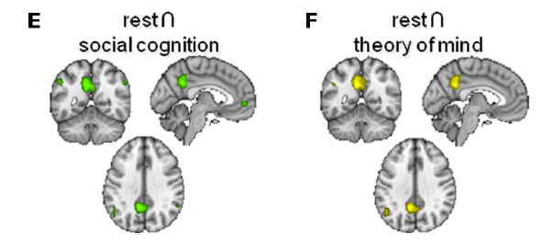

1. Calculate the dissimilarity matrix (social cognition ToM)
2. Resting subtraction (What model) finding the overlap (contrast to other conditions math, language, and random condition)

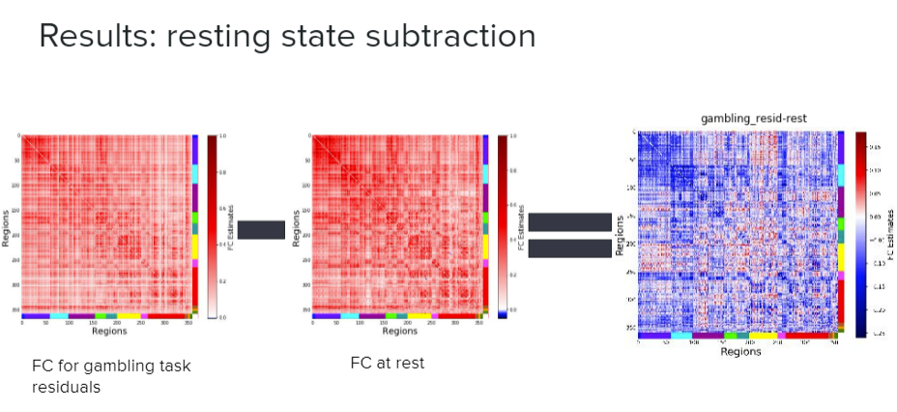

*Other directions:*

CCA to improve the correlation.

the similarity between resting state and social cognition -> *performance* in social cognition task (no access?)

Why models?

Temporal correlation?

**data in ToM social cognition 360 brain regions 274 timepoints (put them into one)**

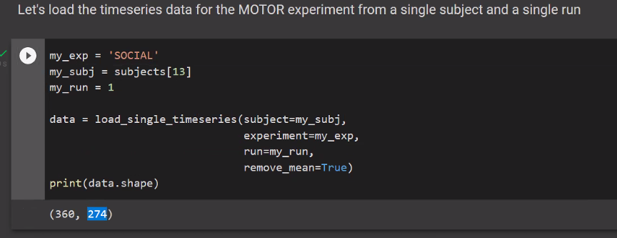

resting state data of HCP (NMA)? how to find it. (Emeka will let us know soon)

What’s next:

1. **Familiar with the data:** social cognition, resting state, other tasks we mentioned (no fine-grained analysis, averaged level)
2. **Dive into hypothesis:** How do we define SImilarity? Which measurement do we use? Will there be another pre-processing step?

each cell in the matrix represents the similarity of activation level between two brain regions.

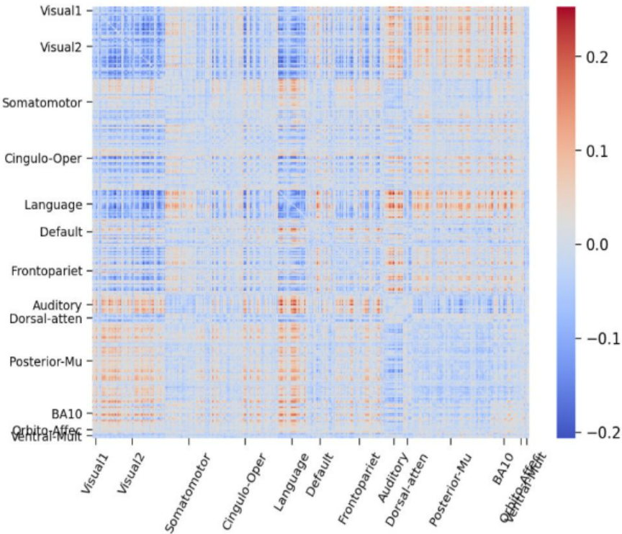

literature research: the methods used

**W1D5 record**

**Group Name: social dragon**

**Logo:**

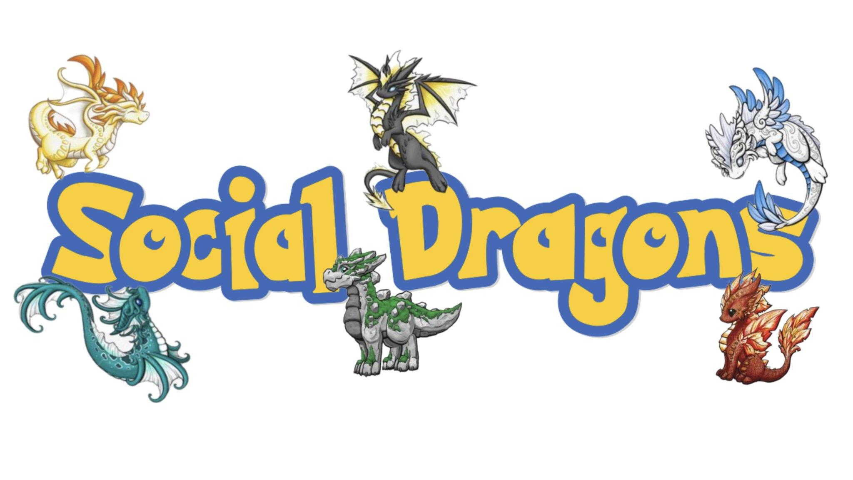

**Aim:**

**presentation: Yannki, Deng**

**literature research: Fatam, Jialin**

**data: Alex Ayan**

**Dataset: HCP 2021**

**Research Proposal for HCP Social Group**

**Group name: social dragons**

**Alex Xinyi Ye; Ayan Mahapatra; Deng Pan; Fatma Çelebi; Jialin Li; Yannik Schneider**

**Introduction:** Previous studies have demonstrated that the activation patterns of the brain during mentalizing are similar to that of the default mode network (Spunt & Lieberman, 2012; Mars et al. 2012). While mentalizing is a kind of social cognition, other researchers have found that the neural basis of social cognition and the default mode network correlate. Specifically, the overlapped areas are the precuneus, which is found to engage in social interaction (Schilbach et al., 2006); the temporoparietal junction area (TPJ), which involves in the differentiation between self and others (Vogeley and Fink, 2003); the anterior cingulate, which relates to monitoring the action from self and others (Amodio and Frith, 2006). Together, this evidence implies that the human brain might have a natural tendency to process social information when a resting state. Hereby, we asked whether there are similar brain networks between social cognition and the default mode network.

**Hypothesis:** Our hypothesis is that the similarity between social cognition brain networks and resting state (default mode network) is higher than the similarity between other conditions in the HCP dataset and resting state.

**Methods:** We plan to compare the data of the theory of mind (ToM) condition and the data of the resting state condition in the HCP dataset first. To control the baseline, we will compare the data of the control condition, which is the random condition in the social cognition task, and the resting state data. Additionally, we will also investigate the relationship between data from other cognition tasks, such as language tasks and math tasks, and the resting state data. We will pick some ROIs to compare or do the whole brain analysis, then calculate the dissimilarity matrices for each comparison.

**Expected Results:** We expected to see the largest similarity in connectivity of brain regions between the ToM condition and the resting state, other comparisons will be less similar. The figure below clarifies our expected results.

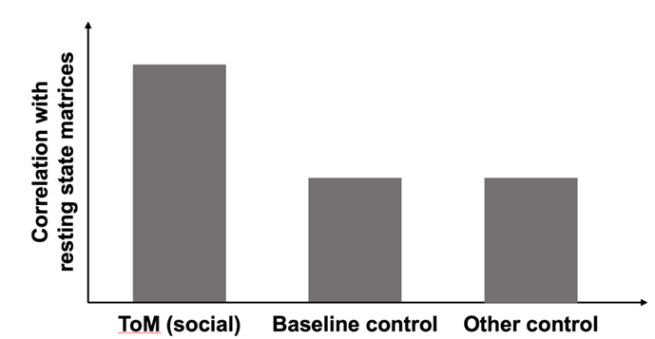

**W2D2 How to implement:**

0. **Decide brain regions**:

* Try first with whole brain data (360 regions)
* Pick ROIs (ROIs social brain or ROIs default mode network, or the overlap) but probably have a bias in these steps in getting positive results.
* 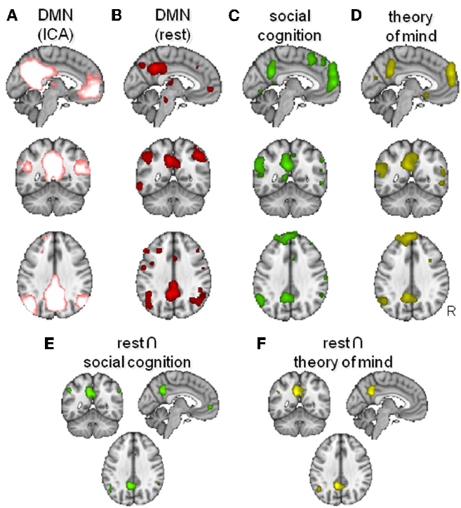

1. **Connectivity similarity matrices (360 × 360）**: functional connectivity (activation is not the best)

* plan A: average the same trials of 2 runs, plan B: don’t average
* Each cell: functional connectivity between all brain regions pairs in timepoints (280+ data points × 5 videos), method: how to compute the functional connectivity between two regions (e.g., PPI), read papers in the discord (especially Finn2015)
* Each matrix: for each individual (339 people)
* Calculate for each task: (social ToM, random, math, language, resting state)

now there are 339 matrices (360×360) for each task (5 tasks)

2. **Comparison between matrices**: (Pearson)

* compare five matrices: 339 datapoints

**W2D3:**

Preprocess the resting state data

100k voxels resting state

-> 100k voxel map with 360 registered regions (100k space nifty file with 360 region labels)

**W3D1**

weird results: mental_vs_rest is not more correlated with random_vs_rest

instead story_vs_rest (highest)

plan A: before we calculate the matrix, mental time series - random time series

plan B: after calculating the matrix, mental matrix - random matrix

**Abstract**

**Group name: social dragons**

**Alex Xinyi Ye; Ayan Mahapatra; Deng Pan; Fatma Çelebi; Jialin Li; Yannik Schneider**

Previous studies have demonstrated that the activation patterns of the brain during mentalizing are similar to that of the Default Mode Network (DMN). While mentalizing is a kind of social cognition, the neural basis of social cognition and the default mode network has been proven correlated. It might imply that the human brain might have a natural tendency to process social information when in a resting state. Hereby, we asked whether there are similar brain networks between social cognition and DMN. Our main hypothesis is that the similarity between social cognition brain networks and resting state is higher than the similarity between other conditions and resting state in the Human Connectome Project (HCP) dataset. We expected to see the largest similarity in connectivity of brain regions between the theory of mind condition and the resting state, other comparisons will be less similar. The figure below clarifies our expected results. We used Pearson correlation to compute the similarity. After the primary analysis, we found that the story condition from the language task had the highest correlation with the resting state, which contrasted with our hypothesis. Potential reasons are following: Firstly, we suspect that baseline control might be a factor influencing our result – as social tasks require watching the stimuli, while language tasks only require listening to the stimuli, it could be possible that by subtracting data of the random condition (control condition) from that of the ToM condition, noise from lower-level processing can be eliminated. In this way, the correlation results might be improved. The other potential reason is that the story condition does have a correlation to the DMN since it might contain more social information than the ToM condition. We plan to find some literature support for this result. Additionally, since there are overlapped brain areas involved in both social and language tasks (e.g. PFC), we plan to choose specific ROIs to further analyze the data.

**W3D2**

**Try in the code (colab):**

<https://colab.research.google.com/drive/1Zp5pl-Z3Wom9PnEHKM48QfT40RxE_6Ux#scrollTo=GppvS7KaR_uY>

**1. functional connectivity computation:** (try to change the previous method, Pearson correlation)

Granger Causality (Jialin) or Inverse Covariance (nilearn package, Ayan)

**2. plot out the t_map on the brain** (help to find some ROIs): Deng Pan

**3. literature research**:

Alex Fatma: how they parcelled the regions (NMA)

**Literature Review**

**LIF & RIF: semantic processing**

**Semantic, factual and social language comprehension in adolescents with Autism: an fMRI study**

left and right inferior frontal (LIF and RIF) regions are implicated with integration of speaker information, world knowledge, and semantic knowledge (auditory sentence comprehension)

**STS (complex social info)**

**Naturalistic fMRI mapping reveals superior temporal sulcus as the hub for the distributed brain network for social perception**

the **posterior temporal area**s responded more strongly to social than non-social signals. Significantly higher activity to social than non-social features was also observed in the **lateral fusiform gyrus (FG)** (visual movies)

**Beyond Superior Temporal Cortex: Intersubject Correlations in Narrative Speech Comprehension**

understanding language in ecologically valid contexts is less clearly understood. In a fMRI study, they presented 24 subjects with auditory or audiovisual narratives, and used model-free intersubjective correlational analyses. Conventional comparisons to a resting state were also performed. Two finding:

1. many areas in the ‘**‘default mode’’ network** (typically deactivated relative to rest) were systematically modulated by the time-varying properties of the **auditory or audiovisual input.**
2. extensive **bilateral inferior frontal and premotor regions** were implicated in **auditory** as well as **audiovisual language comprehension**. This extended network of regions may be important for higher-level linguistic processes, and interfaces with extra linguistic cognitive, affective, and interpersonal systems.

**Neural correlates of social cognition in naturalistic settings: A model-free analysis approach**

ToM network is divisible in more circumscribed, smaller functionally connected networks, possibly mediating face processing, language processing, and self-referential processes.

**Sociotopy in the temporoparietal cortex: common versus distinct processes**

whether activity in the **posterior superior temporal** **sulcus** and **adjacent temporoparietal junction (pSTS/TPJ-region)** evoked by various tasks represents a common processor distinct processes.

Biological Motion (BM), Theory-of-Mind (ToM) and Moral Judgment (MJ) tasks--------increasingly more complex processing of the communicative significance of other people’s behavior, represented by hierarchically increasing **activity in left pSTS** and bilateral **TPJ** elicited by ToM and MJ.

**Patterns of Brain Activity Supporting Autobiographical Memory, Prospection, and Theory of Mind, and Their Relationship to the Default Mode Network**

fMRI to examine brain activity during autobiographical remembering, prospection, and theory of- mind reasoning. multivariate analyses, A functional connectivity analysis revealed that activity of a critical node in the DMN, medial prefrontal cortex, was correlated with activity in other regions in the DMN during all three tasks.

**DMN**

**Definition and characterization of an extended social-affective default network**

meta-analytic connectivity modeling and resting-state analyses in the meta-analytically defined DMN regions that showed statistical overlap with regions associated with social and affective processing. The cluster formed by the temporo-parietal junction and anterior middle temporal sulcus/gyrus was associated with language and social cognition.

**The Default Mode of Human Brain Function Primes the Intentional Stance**

the default mode of human brain function present when the mind is at rest

brain regions activated by actively adopting an intentional rather than non-intentional stance to another person were anatomically similar to those demonstrating default responses to a fixation baseline condition

These results identify a biological basis for the human tendency to adopt the intentional stance. More broadly, they suggest that the brain’s default response may have evolved, in part, as a response to life in a social world

**Notes with Mentor:**

1. how to map functional connectivity
   1. pearson correlation (might not be best)
   2. covariance
   3. no need to visualize data →apply a threshold (e.g. .2) to nothing and only visualize major focus, gives you meaningful network across subjects
2. how to go from individual to group level
   1. access your research questions at individual level (correlation between matrices) → paired t-test, to see if the similarity is significantly different
3. whether we can predict the activation of brain from resting state (it’s beyond a simple assessment)
   1. connectome-based predictive model / other ML models
      1. CPM uses connectivity measures to predict outcomes: check if the model can be applied to other populations
   2. cross-validation to test performance of the models

resting state connectivity → target task connectivity

how well can resting state connectivity predict the performance of an individual within a task

whether the degree of similarity between resting state connect and task state connect: if your resting state brain is more social, does it mean that you perform better at social tasks?

paired t-test

nonparametric paired sample test (e.g.wilcoxon's test)

if you want to measure activity then subtraction is useful

if you want to measure connectivity it’s not necessary

task-based FC should limit to data from specific time series

ROI: also a good measure

schedule:

by the end of 27th July: list ROIs & related functions; get parcellation info

by the project time on 28th July: allocation of workload; get data & results ready

28th July project time: revise presentation together

| **i** | **Related Brain Function** | **Paradigm** | **Stimuli Modality** |
| --- | --- | --- | --- |
| left and right inferior frontal cortice (LIF & RIF) | speaker information, world knowledge, and semantic knowledge | sentence comprehension | auditory |
| premotor cortex | language comprehension | cartoon narrations | auditory and audiovisual stimuli |
| bilateral inferior frontal | language comprehension | cartoon narrations | auditory and audiovisual stimuli |
| posterior superior temporal sulcus (pSTS)(within DMN) | ToM | picture comprehension | visual |
| adjacent temporoparietal junction (TPJ) | ToM | picture comprehension | visual |
| temporo-parietal junction (TPJ) | language and social cognition | Meta-analytic connectivity modeling | / |
| anterior middle temporal sulcus/gyrus (within DMN) | language and social cognition | Meta-analytic connectivity modeling | / |
| medial prefrontal cortex (within DMN) | ToM, autobiographical memory, prospection | photograph comprehension | visual |

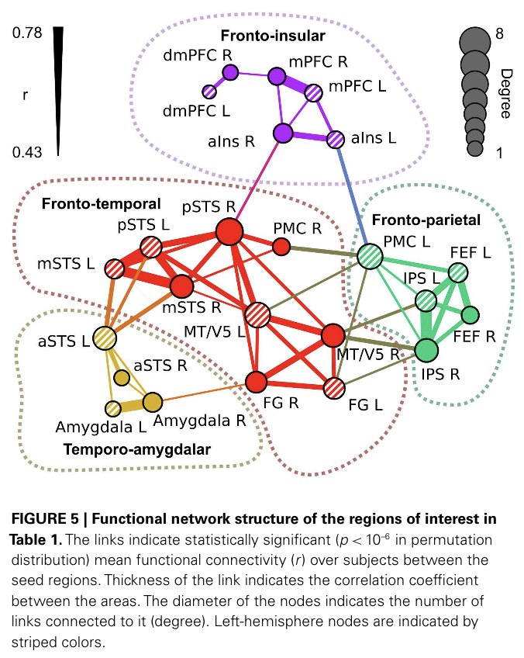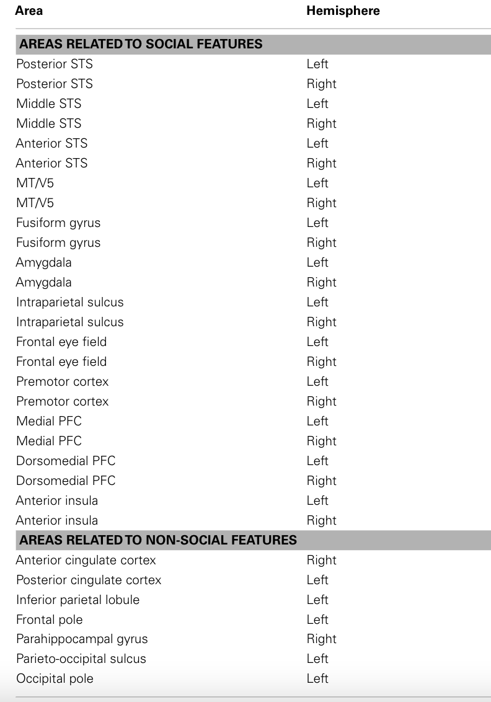

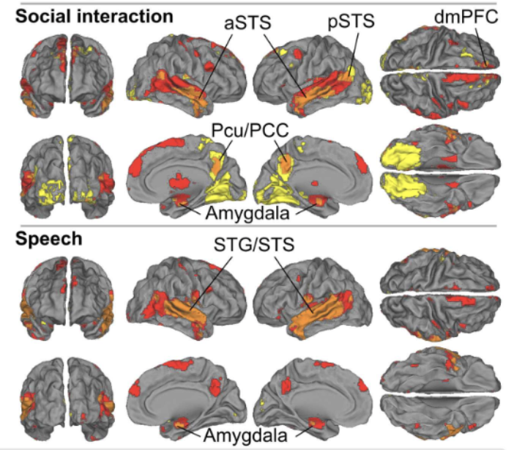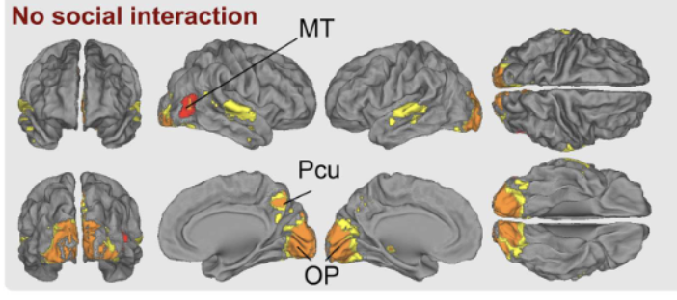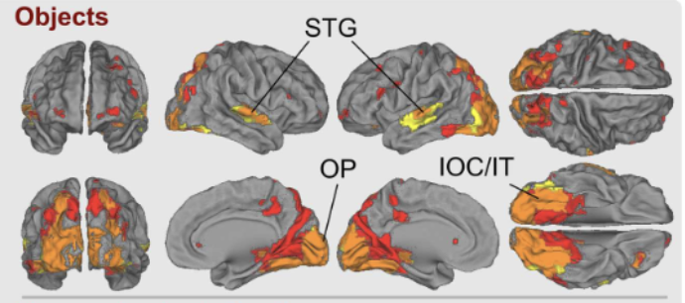

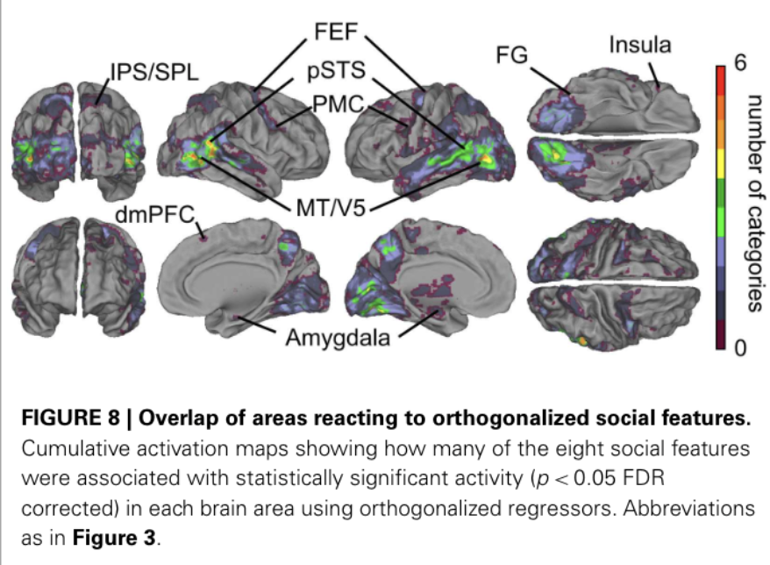

**Last day!!**

**presentation:**

**Intro1 (Alex):** logo, cover, general question (title page), general background (social vs DMN) (2pages: title+first intro, 1min)

**Intro2 (Fatma)**: literature review, why we select the ROIs, Hypothesis (1page, 1min)

**Result1 (Ayan)**: calculate the matrix (figure of brain connectome, matrix) (1page, 1min)

**Results2 (Deng):** compare the matrix across task, t-test results (1page, 1min)

**Discussion (Jialin)**: conclusion, discussions (future direction, limitation, application), (2 pages: discussion+Thanks, 1min)