Refugee Outcomes Transition Fund

Data Specification

Version f13a7b2

Generated on 09 August 2021

# About this document

This document outlines the Refugee Outcomes Transition Fund (RTOF) Data Specification.

The document outlines the data fields, types, and descriptions for all required data collection during the lifetime of the Refugee Transition Outcome Fund. The description for each field outlines the context, collection frequency and milestone at which it should be collected.

The validation rules that apply for each field are noted in the grey tables for each record. These will be applied on submission of data, if any validation rules are not met, a report will be produced with details of the fields and specified errors for the given fields. The images below outline the key milestones and data collection points during the program.

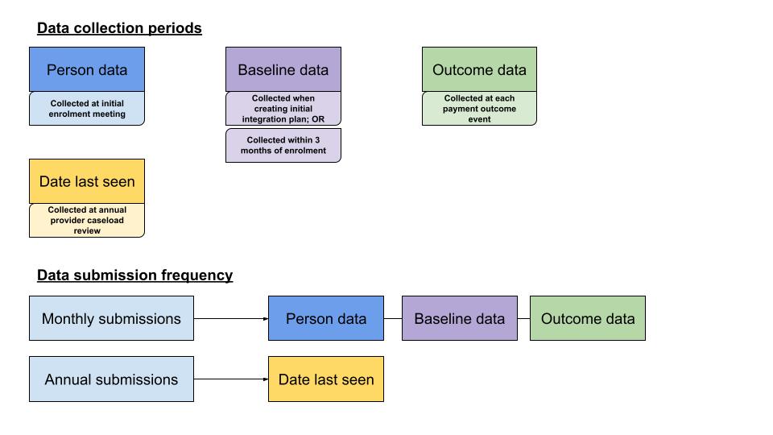

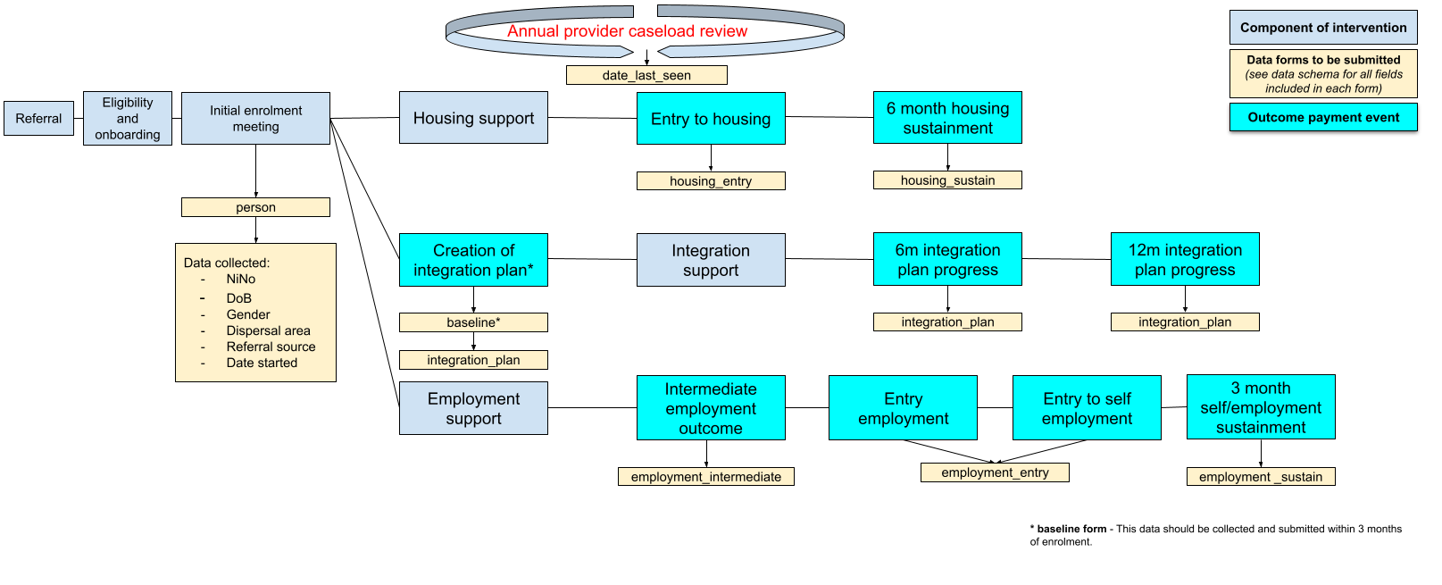

# Changelog

Summary of git tags?

# Table of Contents

Don’t know if we can generate this, but worth a try

About this document 2

Changelog 3

Table of Contents 4

Records 5

Validation Rules 9

# Records

Records are the top-level entities of the RTOF data specification and correspond to tables in relational databases.

Records capture information about a specific step in the programme flow and contains essential information for the outcomes validation and payment metrics.

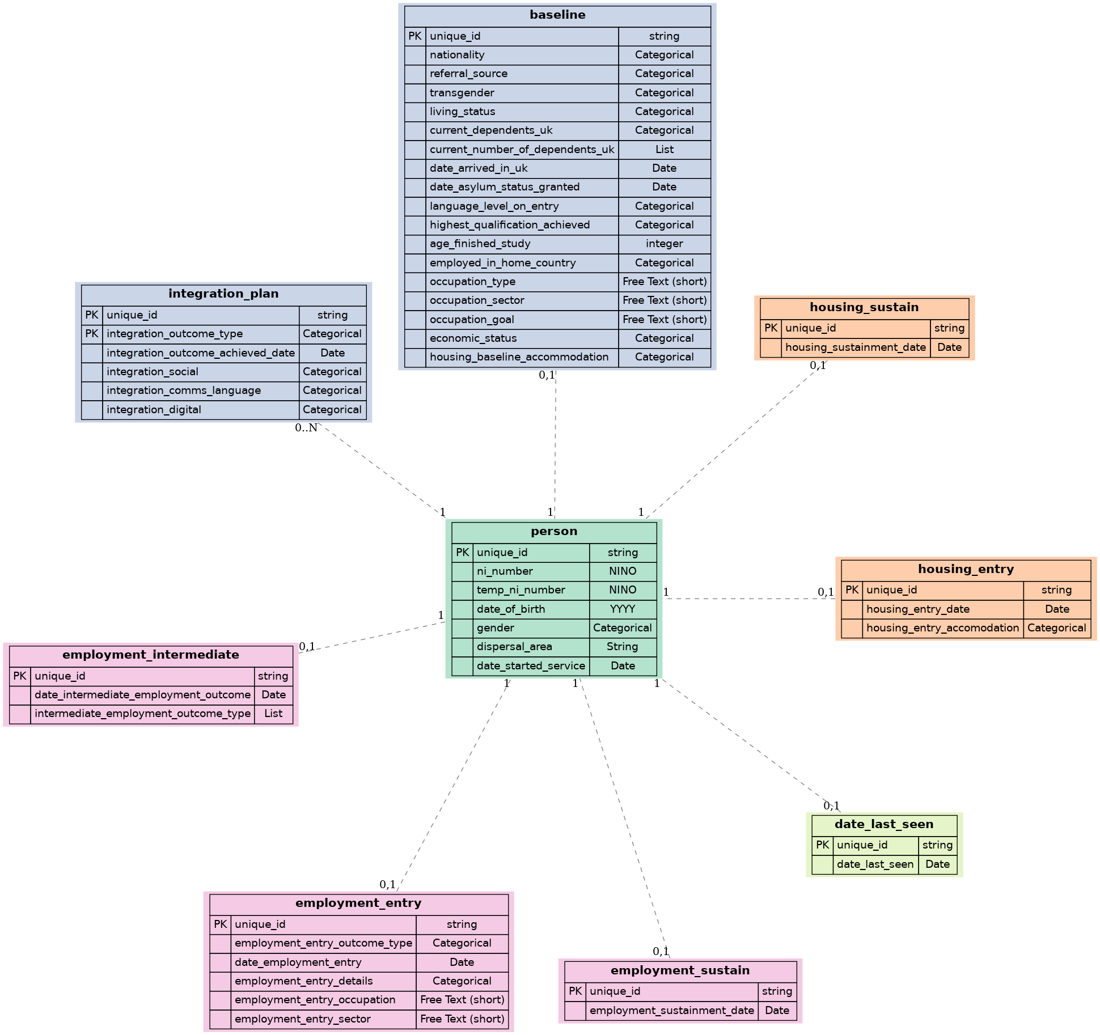

## PERSON Record

This form outlines the required information for all service users, the data is to be collected once at enrolment.

Workflow: Enrolment

### Fields

|  |  |  |
| --- | --- | --- |
| ID | Name | Type |
| unique_id [PK] | Unique person identifier | string |
| ni_number | NI Number | NINO |
| temp_ni_number | Temp NI number | NINO |
| date_of_birth | Date of birth | YYYY |
| gender | Gender | Categorical |
| dispersal_area | Dispersal area | String |
| date_started_service | Date started with service | Date |

#### unique_id: Unique person identifier

Person identifier provided in the person form. This can be a NINO or a unique provider ID. This must be unique for each individual supported on RTOF.

|  |  |
| --- | --- |
| Type | string |
| Primary Key | True |
| Required | True |
| Validators | required |

**Status:** *Decided*

#### ni_number: NI Number

UK National Insurance number. Must be unique. To be collected at enrolment into the program. All upper case and no spaces [regular expressions for NiNos]

|  |  |
| --- | --- |
| Type | NINO |
| Required | True |
| Validators | required, unique |

**Status:** *Decided*

Comments

*None*

#### temp_ni_number: Temp NI number

This field is only relevant if a participant has a temporary NINO. In these cases, you should submit the temporary NINO, in this persons form, leaving the ni_number field blank, until the participant receives a permanent NINO. Once a permanent NINO has been received this form should be updated. All upper case and no spaces [regular expressions for NiNos]

|  |  |
| --- | --- |
| Type | NINO |
| Required |  |
| Validators | unique |

**Status:** *Decided*

#### date_of_birth: Date of birth

Date of birth of participant. To be collected once at enrolment

|  |  |
| --- | --- |
| Type | YYYY |
| Required | True |
| Validators | required |

**Status:** *Pending consideration*

Comments

*Deleted 'MM' collection, just to collect age (year of birth) - to confirm if this satisfies HO requirements*

#### gender: Gender

Gender of participant. Must be one of the five categories provided. To be collected once at enrolment. Note there is a follow-up gender question as part of the baseline data collection.

|  |  |
| --- | --- |
| Type | Categorical |
| Required | True |
| One of | Man, Woman, Non-binary, Other, Prefer not to say |
| Validators | required, dimension |

**Status:** *Decided*

#### dispersal_area: Dispersal area

Local authority where participant was located once asylum status was granted. To be collected once at enrolment into the program.

|  |  |
| --- | --- |
| Type | String |
| Required | True |
| Validators | required |

**Status:** *Decided*

Comments

*None*

#### date_started_service: Date started with service

Date of participant enrolment onto the program. Month and Year of enrolment required. To be collected once at enrolment.

|  |  |
| --- | --- |
| Type | Date |
| Required | True |
| Validators | required, date_after |

**Status:** *Decided*

## HOUSING_ENTRY Record

This form outlines the required data for participants who achieve the housing entry outcome. Data should be collected when achieving the housing entry outcome.

Workflow: Housing

### Fields

|  |  |  |
| --- | --- | --- |
| ID | Name | Type |
| unique_id [PK] | Unique person identifier | string |
| housing_entry_date | Date of housing entry | Date |
| housing_entry_accomodation | Accomodation type | Categorical |

#### unique_id: Unique person identifier

Person identifier provided in the person form. This can be a NINO or a unique provider ID. This must be unique for each individual supported on RTOF.

|  |  |
| --- | --- |
| Type | string |
| Primary Key | True |
| Required | True |
| Validators | required, unique |

**Status:** *Decided*

#### housing_entry_date: Date of housing entry

Date of housing entry outcome achieved. To be collected once at entry to housing outcome submission.

|  |  |
| --- | --- |
| Type | Date |
| Required | True |
| Validators | required, date_after |

**Status:** *Decided*

#### housing_entry_accomodation: Accomodation type

tbc

|  |  |
| --- | --- |
| Type | Categorical |
| Required | True |
| One of | tbc |
| Validators | required, dimension |

**Status:** *Work in progress*

Comments

*tbc - same comments as 'housing_baseline_accommodation', categories to align*

## HOUSING_SUSTAIN Record

This form outlines the required data for participants who achieve the housing sustainment outcome. Data should be collected when achieving the housing sustainment outcome.

Workflow: Housing

### Fields

|  |  |  |
| --- | --- | --- |
| ID | Name | Type |
| unique_id [PK] | Unique person identifier | string |
| housing_sustainment_date | Date housing sustainment achieved | Date |

#### unique_id: Unique person identifier

Person identifier provided in the person form. This can be a NINO or a unique provider ID. This must be unique for each individual supported on RTOF.

|  |  |
| --- | --- |
| Type | string |
| Primary Key | True |
| Required | True |
| Validators | required, unique |

**Status:** *Decided*

#### housing_sustainment_date: Date housing sustainment achieved

Date of housing sustainment outcome achieved. To be collected once at housing sustainment outcome submission.

|  |  |
| --- | --- |
| Type | Date |
| Required | True |
| Validators | required, date_after |

**Status:** *Decided*

## BASELINE Record

This form outlines the required baseline data for all service users, the data is to be collected across interactions with participants and submitted either when submitting form: integration_plan or within 3 months after enrolment.

Workflow: Integration

### Fields

|  |  |  |
| --- | --- | --- |
| ID | Name | Type |
| unique_id [PK] | Unique person identifier | string |
| nationality | Nationality | Categorical |
| referral_source | Referral source | Categorical |
| transgender | Transgender | Categorical |
| living_status | Living status | Categorical |
| current_dependents_uk | Current dependents in UK | Categorical |
| current_number_of_dependents_uk | Current dependents in UK | List |
| date_arrived_in_uk | Date arrived in UK | Date |
| date_asylum_status_granted | Date asylum status granted | Date |
| language_level_on_entry | Language level on entry | Categorical |
| highest_qualification_achieved | Highest qualification level achieved | Categorical |
| age_finished_study | Age when finished study | integer |
| employed_in_home_country | Employed in home country | Categorical |
| occupation_type | Occupation type | Free Text (short) |
| occupation_sector | Sector | Free Text (short) |
| occupation_goal | Occupation goal at baseline | Free Text (short) |
| economic_status | Main economic status at baseline | Categorical |
| housing_baseline_accommodation | Accommodation type | Categorical |

#### unique_id: Unique person identifier

Person identifier provided in the person form. This can be a NINO or a unique provider ID. This must be unique for each individual supported on RTOF.

|  |  |
| --- | --- |
| Type | string |
| Primary Key | True |
| Required | True |
| Validators | required |

**Status:** *Decided*

Comments

*None*

#### nationality: Nationality

Nationality of participant. A list of nationalities are provided. Must select one of the given categories, please see nationality descriptions to link with the relevant code. To be collected once and submitted within 3 months of enrolment.

|  |  |
| --- | --- |
| Type | Categorical |
| Required | True |
| One of | AD, AE, AF, AG, AI, AL, AM, AO, AQ, AR, AS, AT, AU, AW, AX, AZ, BA, BB, BD, BE, BF, BG, BH, BI, BJ, BL, BM, BN, BO, BQ, BR, BS, BT, BV, BW, BY, BZ, CA, CC, CD, CF, CG, CH, CI, CK, CL, CM, CN, CO, CR, CU, CV, CW, CX, CY, CZ, DE, DJ, DK, DM, DO, DZ, EC, EE, EG, EH, ER, ES, ET, FI, FJ, FK, FM, FO, FR, GA, GB, GD, GE, GF, GG, GH, GI, GL, GM, GN, GP, GQ, GR, GS, GT, GU, GW, GY, HK, HM, HN, HR, HT, HU, ID, IE, IL, IM, IN, IO, IQ, IR, IS, IT, JE, JM, JO, JP, KE, KG, KH, KI, KM, KN, KP, KR, KW, KY, KZ, LA, LB, LC, LI, LK, LR, LS, LT, LU, LV, LY, MA, MC, MD, ME, MF, MG, MH, MK, ML, MM, MN, MO, MP, MQ, MR, MS, MT, MU, MV, MW, MX, MY, MZ, NA, NC, NE, NF, NG, NI, NL, NO, NP, NR, NU, NZ, OM, PA, PE, PF, PG, PH, PK, PL, PM, PN, PR, PS, PT, PW, PY, QA, RE, RO, RS, RU, RW, SA, SB, SC, SD, SE, SG, SH, SI, SJ, SK, SL, SM, SN, SO, SR, SS, ST, SV, SX, SY, SZ, TC, TD, TF, TG, TH, TJ, TK, TL, TM, TN, TO, TR, TT, TV, TW, TZ, UA, UG, UM, US, UY, UZ, VA, VC, VE, VG, VI, VN, VU, WF, WS, YE, YT, ZA, ZM, ZW |
| Validators | required, dimension |

**Status:** *Decided*

Comments

*None*

#### referral_source: Referral source

The referral source that led the participant to RTOF.

|  |  |
| --- | --- |
| Type | Categorical |
| Required | True |
| One of |  |
| Validators | required, dimension |

**Status:** *Blocked*

Comments

*Categories tbc after provider engagement*

#### transgender: Transgender

Do you identify as transgender? A question which follows on from the question in the person data form, with 'identify as transgender', 'do not identify as transgender' or 'prefer not to say'. To be collected once and submitted within 3 months of enrolment.

|  |  |
| --- | --- |
| Type | Categorical |
| Required | True |
| One of | Identify as transgender, Do not identify as Transgender, Prefer not to say |
| Validators | required, dimension |

**Status:** *Pending consideration*

#### living_status: Living status

Selection of either single or couple. Couple includes living with more than one individual. To be collected once and submitted within 3 months of enrolment.

|  |  |
| --- | --- |
| Type | Categorical |
| Required | True |
| One of | Single, Couple |
| Validators | required, dimension |

**Status:** *Pending consideration*

#### current_dependents_uk: Current dependents in UK

Do you currently have any dependents in the UK? Yes / No to understand whether the participant has any depedents curently in the UK. To be collected once and submitted within 3 months of enrolment.

|  |  |
| --- | --- |
| Type | Categorical |
| Required | True |
| One of | Yes, No |
| Validators | required, dimension |

**Status:** *pending consideration*

#### current_number_of_dependents_uk: Current dependents in UK

Selection of each option that applies to the participant. To be collected once and submitted within 3 months of enrolment.

|  |  |
| --- | --- |
| Type | List |
| Required | True |
| Any of | 0-4, 5-11, 11-17, Caring responsibilities for an adult |
| Validators | required, dimension |

**Status:** *Pending consideration*

#### date_arrived_in_uk: Date arrived in UK

Date participant entered the UK, relating to their latest and current arrival. To be collected once and submitted within 3 months of enrolment.

|  |  |
| --- | --- |
| Type | Date |
| Required | True |
| Validators | required, date_after |

**Status:** *Decided*

Comments

*None*

#### date_asylum_status_granted: Date asylum status granted

Date participant was granted asylum status, relating to their latest and current asylum status. To be collected once and submitted within 3 months of enrolment.

|  |  |
| --- | --- |
| Type | Date |
| Required | True |
| Validators | required, date_after |

**Status:** *Decided*

Comments

*None*

#### language_level_on_entry: Language level on entry

The language level of participant when entering RTOF. Selection of one of the specified category, further information on these levels can be found here [https://esol.britishcouncil.org/sites/default/files/attachments/informational-page/ESOL%20level%20descriptors.pdf]. To be collected once and submitted within 3 months of enrolment.

|  |  |
| --- | --- |
| Type | Categorical |
| Required | True |
| One of | Below formal levels, Pre-entry, Entry level 1, Entry level 2, Entry level 3, Level 1, Level 2, Beyond Level 2 |
| Validators | required, dimension |

**Status:** *Decided*

Comments

*None*

#### highest_qualification_achieved: Highest qualification level achieved

The highest level of qualification of participant when entering RTOF. Selection of one of the specified category, these refer to [https://www.gov.uk/what-different-qualification-levels-mean/list-of-qualification-levels#:~:text=Level%205%20qualifications%20are%3A,higher%20national%20diploma%20(%20HND%20)]. To be collected once and submitted within 3 months of enrolment.

|  |  |
| --- | --- |
| Type | Categorical |
| Required | True |
| One of | Below formal levels, Entry level, Level 1-2, Level 3-4, Level 5+, Unknown |
| Validators | required, dimension |

**Status:** *Decided*

Comments

*None*

#### age_finished_study: Age when finished study

This should only be submitted if the response to the field "highest qualification level achieved" was "unknown"

|  |  |
| --- | --- |
| Type | integer |
| Required |  |
| Validators |  |

**Status:** *Pending consideration*

#### employed_in_home_country: Employed in home country

When participant left home country were they in any form of employment - yes / no response. To be collected once and submitted within 3 months of enrolment.

|  |  |
| --- | --- |
| Type | Categorical |
| Required | True |
| One of | Yes, No |
| Validators | required, dimension |

**Status:** *Decided*

Comments

*None*

#### occupation_type: Occupation type

If answered 'Yes' to employed in home country field, state job role [e.g. teacher] of their last employment. Max word count 10 words. To be collected once and submitted within 3 months of enrolment.

|  |  |
| --- | --- |
| Type | Free Text (short) |
| Required |  |
| Validators | character_limit |

**Status:** *Decided*

Comments

*None*

#### occupation_sector: Sector

If answered 'Yes' to employed in home country field, state the sector [eg. education] of their last employment. Max word count 10 words. To be collected once and submitted within 3 months of enrolment.

|  |  |
| --- | --- |
| Type | Free Text (short) |
| Required |  |
| Validators | character_limit |

**Status:** *Decided*

Comments

*None*

#### occupation_goal: Occupation goal at baseline

All participants to be asked what their employment goals. This can be sector, job role or employment-type. To be collected once and submitted within 3 months of enrolment.

|  |  |
| --- | --- |
| Type | Free Text (short) |
| Required |  |
| Validators | character_limit |

**Status:** *Pending consideration*

#### economic_status: Main economic status at baseline

Selection of a single category describing the employment status of the participant prior to entering RTOF. To be collected once and submitted within 3 months of enrolment.

|  |  |
| --- | --- |
| Type | Categorical |
| Required | True |
| One of | PT 0-15 hours per week, PT 16-30 hours per week, FT 31 hours +, Self employed, Government employment training programme, Unpaid work for relatives business, Unemployed (but looking/available for work), Looking after family/home, Temporarily sick/injured, Long term sick or disabled, Retired |
| Validators | required, dimension |

**Status:** *Work in progress*

Comments

*tbc with James W (Ecorys) to confirm requirements of the VfM assessment*

#### housing_baseline_accommodation: Accommodation type

tbc

|  |  |
| --- | --- |
| Type | Categorical |
| Required | True |
| One of | tbc |
| Validators | required, dimension |

**Status:** *Work in progress*

Comments

*tbc by Ecorys re. Value for Money assessment*

## INTEGRATION_PLAN Record

This form outlines the required data for participants who achieve each integration plan outcome - one submission for each creation, 6-month progress and 12-month progress. Data should be collected when achieving each integration plan outcome.

Workflow: Integration

### Fields

|  |  |  |
| --- | --- | --- |
| ID | Name | Type |
| unique_id [PK] | Unique person identifier | string |
| integration_outcome_type [PK] | Integration outcome type | Categorical |
| integration_outcome_achieved_date | Date integration plan outcome acheived | Date |
| integration_social | Social bonds / bridges / links | Categorical |
| integration_comms_language | Language and communication | Categorical |
| integration_digital | Digital skills | Categorical |

#### unique_id: Unique person identifier

Person identifier provided in the person form. This can be a NINO or a unique provider ID. This must be unique for each individual supported on RTOF.

|  |  |
| --- | --- |
| Type | string |
| Primary Key | True |
| Required | True |
| Validators | required, unique |

**Status:** *Decided*

#### integration_outcome_type: Integration outcome type

Selection of which integration outcome has been achieved. To be collected at each outcome submission.

|  |  |
| --- | --- |
| Type | Categorical |
| Primary Key | True |
| Required | True |
| One of | Creation, 6 month, 12 month |
| Validators | required, dimension |

**Status:** *Decided*

#### integration_outcome_achieved_date: Date integration plan outcome acheived

Date of integration plan outcome achievement. To be collected at each outcome submission.

|  |  |
| --- | --- |
| Type | Date |
| Required | True |
| Validators | required, date_after |

**Status:** *Decided*

#### integration_social: Social bonds / bridges / links

tbc. To be collected at each outcome submission.

|  |  |
| --- | --- |
| Type | Categorical |
| Required | True |
| One of | tbc |
| Validators | required, dimension |

**Status:** *Blocked*

Comments

*tbc - Ecorys to confirm categories after provider engagement*

#### integration_comms_language: Language and communication

tbc. To be collected at each outcome submission.

|  |  |
| --- | --- |
| Type | Categorical |
| Required | True |
| One of | tbc |
| Validators | required, dimension |

**Status:** *Blocked*

Comments

*tbc - Ecorys to confirm categories after provider engagement*

#### integration_digital: Digital skills

tbc. To be collected at each outcome submission.

|  |  |
| --- | --- |
| Type | Categorical |
| Required | True |
| One of | tbc |
| Validators | required, dimension |

**Status:** *Blocked*

Comments

*tbc - Ecorys to confirm categories after provider engagement*

## EMPLOYMENT_INTERMEDIATE Record

This form outlines the required data for participants who achieve the intermediate employment outcome. Data should be collected when achieving the intermediate outcome.

Workflow: Employment

### Fields

|  |  |  |
| --- | --- | --- |
| ID | Name | Type |
| unique_id [PK] | Unique person identifier | string |
| date_intermediate_employment_outcome | Date achieved intermediate outcome | Date |
| intermediate_employment_outcome_type | Type of intermediate outcome | List |

#### unique_id: Unique person identifier

Person identifier provided in the person form. This can be a NINO or a unique provider ID. This must be unique for each individual supported on RTOF.

|  |  |
| --- | --- |
| Type | string |
| Primary Key | True |
| Required | True |
| Validators | required, unique |

**Status:** *Decided*

#### date_intermediate_employment_outcome: Date achieved intermediate outcome

Date of intermediate employment outcome achievement. To be collected once at intermediate employment outcome submission.

|  |  |
| --- | --- |
| Type | Date |
| Required | True |
| Validators | required, date_after |

**Status:** *Decided*

Comments

*None*

#### intermediate_employment_outcome_type: Type of intermediate outcome

Selection of at least 3 intermediate outcomes achieved from the provided list [link to list]. To be collected once at intermediate employment outcome submission.

|  |  |
| --- | --- |
| Type | List |
| Required | True |
| Any of | qualifications or skills, training course, mentoring and/or coaching, employability, Volunteering, work experience, Internship, sector-specific language training, business plan for self-employment, Registered business for self-employment, another specified activity |
| Validators | required, dimension |

**Status:** *Decided*

Comments

*None*

## EMPLOYMENT_ENTRY Record

This form outlines the required data for participants who achieve the employment OR self-employment entry outcome. A participant can only achieve either the employment or self-employment outcome. Data should be collected when achieving the employment entry outcome.

Workflow: Employment

### Fields

|  |  |  |
| --- | --- | --- |
| ID | Name | Type |
| unique_id [PK] | Unique person identifier | string |
| employment_entry_outcome_type | Type of employment entry outcome | Categorical |
| date_employment_entry | Date entered employment | Date |
| employment_entry_details | Details of paid employment | Categorical |
| employment_entry_occupation | Occupation type | Free Text (short) |
| employment_entry_sector | Sector | Free Text (short) |

#### unique_id: Unique person identifier

Person identifier provided in the person form. This can be a NINO or a unique provider ID. This must be unique for each individual supported on RTOF.

|  |  |
| --- | --- |
| Type | string |
| Primary Key | True |
| Required | True |
| Validators | required |

**Status:** *Decided*

#### employment_entry_outcome_type: Type of employment entry outcome

Employment entry can either be an employment outcome or self-employment outcome. To be collected once at entry to employment outcome submission.

|  |  |
| --- | --- |
| Type | Categorical |
| Required | True |
| One of | Employment, Self-employment |
| Validators | required, dimension |

**Status:** *Decided*

#### date_employment_entry: Date entered employment

Date of employment entry submission. To be collected once at entry to employment outcome submission.

|  |  |
| --- | --- |
| Type | Date |
| Required | True |
| Validators | required, date_after |

**Status:** *Decided*

#### employment_entry_details: Details of paid employment

Selection of a single category describing the type of employment participant is entering for the employment outcome achievement. To be collected once at entry to employment outcome submission.

|  |  |
| --- | --- |
| Type | Categorical |
| Required | True |
| One of | PT 0-15 hours per week, PT 16-30 hours per week, FT 31 hours +, Government employment training programme |
| Validators | required, dimension |

**Status:** *Pending consideration*

#### employment_entry_occupation: Occupation type

State participants employment type for the achievement of entry to employment outcome. To be collected once at entry to employment outcome submission.

|  |  |
| --- | --- |
| Type | Free Text (short) |
| Required | True |
| Validators | required, character_limit |

**Status:** *Decided*

#### employment_entry_sector: Sector

State the participants employment sector for the achievement of entry to employment outcome. To be collected once at entry to employment outcome submission.

|  |  |
| --- | --- |
| Type | Free Text (short) |
| Required | True |
| Validators | required, character_limit |

**Status:** *Decided*

## EMPLOYMENT_SUSTAIN Record

This form outlines the required data for participants who achieve the employment sustainment outcome. Data should be collected when achieving the employment sustainment outcome.

Workflow: Employment

### Fields

|  |  |  |
| --- | --- | --- |
| ID | Name | Type |
| unique_id [PK] | Unique person identifier | string |
| employment_sustainment_date | Date employment sustainment outcome achieved | Date |

#### unique_id: Unique person identifier

Person identifier provided in the person form. This can be a NINO or a unique provider ID. This must be unique for each individual supported on RTOF.

|  |  |
| --- | --- |
| Type | string |
| Primary Key | True |
| Required | True |
| Validators | required, unique |

**Status:** *Decided*

#### employment_sustainment_date: Date employment sustainment outcome achieved

Date of employment sustainment outcome achieved. This can be either be for the self-employment or employment route. To be collected once at employment sustained outcome submission.

|  |  |
| --- | --- |
| Type | Date |
| Required | True |
| Validators | required, date_after |

**Status:** *Decided*

## DATE_LAST_SEEN Record

This form outlines the required data for participants who are no longer engaged with the service. Data should be collected during the annual caseload review.

Workflow: Annual review

### Fields

|  |  |  |
| --- | --- | --- |
| ID | Name | Type |
| unique_id [PK] | Unique person identifier | string |
| date_last_seen | Date last seen | Date |

#### unique_id: Unique person identifier

Person identifier provided in the person form. This can be a NINO or a unique provider ID. This must be unique for each individual supported on RTOF.

|  |  |
| --- | --- |
| Type | string |
| Primary Key | True |
| Required | True |
| Validators | required, unique |

**Status:** *Decided*

#### date_last_seen: Date last seen

Date of last interaction with participant. Month and Year required. To be collected annually during annual caseload review.

|  |  |
| --- | --- |
| Type | Date |
| Required | True |
| Validators | required, date_after |

**Status:** *Decided*

Comments

*None*

# Dimensions

The following categorical lists are referenced throughout the specification.

* employed_in_home_country
* housing_baseline_accommodation
* referral_source
* housing_entry_accomodation
* transgender
* employment_entry_details
* integration_outcome_type
* highest_qualification_achieved
* language_level_on_entry
* employment_entry_outcome_type
* living_status
* nationality
* integration_comms_language
* current_number_of_dependents_uk
* integration_digital
* employment_outcome_type
* current_dependents_uk
* economic_status
* gender
* integration_social

#### employed_in_home_country

|  |  |
| --- | --- |
| Value | Description |
| Yes | None |
| No | None |

#### housing_baseline_accommodation

|  |  |
| --- | --- |
| Value | Description |
| tbc | None |

#### referral_source

|  |  |
| --- | --- |
| Value | Description |

#### housing_entry_accomodation

|  |  |
| --- | --- |
| Value | Description |
| tbc | None |

#### transgender

|  |  |
| --- | --- |
| Value | Description |
| Identify as transgender | None |
| Do not identify as Transgender | None |
| Prefer not to say | None |

#### employment_entry_details

|  |  |
| --- | --- |
| Value | Description |
| PT 0-15 hours per week | None |
| PT 16-30 hours per week | None |
| FT 31 hours + | None |
| Government employment training programme | None |

#### integration_outcome_type

|  |  |
| --- | --- |
| Value | Description |
| Creation | None |
| 6 month | None |
| 12 month | None |

#### highest_qualification_achieved

|  |  |
| --- | --- |
| Value | Description |
| Below formal levels | None |
| Entry level | None |
| Level 1-2 | None |
| Level 3-4 | None |
| Level 5+ | None |
| Unknown | None |

#### language_level_on_entry

|  |  |
| --- | --- |
| Value | Description |
| Below formal levels | None |
| Pre-entry | None |
| Entry level 1 | None |
| Entry level 2 | None |
| Entry level 3 | None |
| Level 1 | None |
| Level 2 | None |
| Beyond Level 2 | None |

#### employment_entry_outcome_type

|  |  |
| --- | --- |
| Value | Description |
| Employment | None |
| Self-employment | None |

#### living_status

|  |  |
| --- | --- |
| Value | Description |
| Single | None |
| Couple | None |

#### nationality

|  |  |
| --- | --- |
| Value | Description |
| AD | Andorra |
| AE | United Arab Emirates |
| AF | Afghanistan |
| AG | Antigua and Barbuda |
| AI | Anguilla |
| AL | Albania |
| AM | Armenia |
| AO | Angola |
| AQ | Antarctica |
| AR | Argentina |
| AS | American Samoa |
| AT | Austria |
| AU | Australia |
| AW | Aruba |
| AX | Åland Islands |
| AZ | Azerbaijan |
| BA | Bosnia and Herzegovina |
| BB | Barbados |
| BD | Bangladesh |
| BE | Belgium |
| BF | Burkina Faso |
| BG | Bulgaria |
| BH | Bahrain |
| BI | Burundi |
| BJ | Benin |
| BL | Saint Barthélemy |
| BM | Bermuda |
| BN | Brunei |
| BO | Bolivia |
| BQ | Caribbean Netherlands |
| BR | Brazil |
| BS | Bahamas |
| BT | Bhutan |
| BV | Bouvet Island |
| BW | Botswana |
| BY | Belarus |
| BZ | Belize |
| CA | Canada |
| CC | Cocos (Keeling) Islands |
| CD | Democratic Republic of the Congo |
| CF | Central African Republic |
| CG | Congo (Republic of) |
| CH | Switzerland |
| CI | Côte d'Ivoire (Ivory Coast) |
| CK | Cook Islands |
| CL | Chile |
| CM | Cameroon |
| CN | China |
| CO | Colombia |
| CR | Costa Rica |
| CU | Cuba |
| CV | Cape Verde |
| CW | Curaçao |
| CX | Christmas Island |
| CY | Cyprus |
| CZ | Czech Republic |
| DE | Germany |
| DJ | Djibouti |
| DK | Denmark |
| DM | Dominica |
| DO | Dominican Republic |
| DZ | Algeria |
| EC | Ecuador |
| EE | Estonia |
| EG | Egypt |
| EH | Western Saharan |
| ER | Eritrea |
| ES | Spain |
| ET | Ethiopia |
| FI | Finland |
| FJ | Fiji |
| FK | Falkland Islands |
| FM | Micronesia |
| FO | Faroe Islands |
| FR | France |
| GA | Gabon |
| GB | United Kingdom |
| GD | Grenada |
| GE | Georgia |
| GF | French Guiana |
| GG | Guernsey |
| GH | Ghana |
| GI | Gibraltar |
| GL | Greenland |
| GM | Gambia |
| GN | Guinea |
| GP | Guadeloupe |
| GQ | Equatorial Guinea |
| GR | Greece |
| GS | South Georgia and the South Sandwich Islands |
| GT | Guatemala |
| GU | Guam |
| GW | Guinea-Bissau |
| GY | Guyana |
| HK | Hong Kong |
| HM | Heard and McDonald Islands |
| HN | Honduras |
| HR | Croatia |
| HT | Haiti |
| HU | Hungary |
| ID | Indonesia |
| IE | Ireland |
| IL | Israel |
| IM | Isle of Man |
| IN | India |
| IO | British Indian Ocean Territory |
| IQ | Iraq |
| IR | Iran |
| IS | Iceland |
| IT | Italy |
| JE | Jersey |
| JM | Jamaica |
| JO | Jordan |
| JP | Japan |
| KE | Kenya |
| KG | Kyrgyzstan |
| KH | Cambodia |
| KI | Kiribati |
| KM | Comoros |
| KN | Saint Kitts and Nevis |
| KP | North Korea |
| KR | South Korea |
| KW | Kuwait |
| KY | Cayman Islands |
| KZ | Kazakhstan |
| LA | Laos |
| LB | Lebanon |
| LC | Saint Lucia |
| LI | Liechtenstein |
| LK | Sri Lanka |
| LR | Liberia |
| LS | Lesotho |
| LT | Lithuania |
| LU | Luxembourg |
| LV | Latvia |
| LY | Libya |
| MA | Morocco |
| MC | Monaco |
| MD | Moldova |
| ME | Montenegro |
| MF | Saint Martin (France) |
| MG | Madagascar |
| MH | Marshall Islands |
| MK | Macedonia |
| ML | Mali |
| MM | Burma (Republic of the Union of Myanmar) |
| MN | Mongolia |
| MO | Macau |
| MP | Northern Mariana Islands |
| MQ | Martinique |
| MR | Mauritania |
| MS | Montserrat |
| MT | Malta |
| MU | Mauritius |
| MV | Maldives |
| MW | Malawi |
| MX | Mexico |
| MY | Malaysia |
| MZ | Mozambique |
| NA | Namibia |
| NC | New Caledonia |
| NE | Niger |
| NF | Norfolk Island |
| NG | Nigeria |
| NI | Nicaragua |
| NL | Netherlands |
| NO | Norway |
| NP | Nepal |
| NR | Nauru |
| NU | Niue |
| NZ | New Zealand |
| OM | Oman |
| PA | Panama |
| PE | Peru |
| PF | French Polynesia |
| PG | Papua New Guinea |
| PH | Philippines |
| PK | Pakistan |
| PL | Poland |
| PM | St. Pierre and Miquelon |
| PN | Pitcairn |
| PR | Puerto Rico |
| PS | Palestine |
| PT | Portugal |
| PW | Palau |
| PY | Paraguay |
| QA | Qatar |
| RE | Réunion |
| RO | Romania |
| RS | Serbia |
| RU | Russian Federation |
| RW | Rwanda |
| SA | Saudi Arabia |
| SB | Solomon Islands |
| SC | Seychelles |
| SD | Sudan |
| SE | Sweden |
| SG | Singapore |
| SH | Saint Helena |
| SI | Slovenia |
| SJ | Svalbard and Jan Mayen Islands |
| SK | Slovakia |
| SL | Sierra Leone |
| SM | San Marino |
| SN | Senegal |
| SO | Somalia |
| SR | Suriname |
| SS | South Sudan |
| ST | São Tome and Príncipe |
| SV | El Salvador |
| SX | Saint Martin (Netherlands) |
| SY | Syria |
| SZ | Swaziland |
| TC | Turks and Caicos Islands |
| TD | Chad |
| TF | French Southern Territories |
| TG | Togo |
| TH | Thailand |
| TJ | Tajikistan |
| TK | Tokelau |
| TL | Timor-Leste |
| TM | Turkmenistan |
| TN | Tunisia |
| TO | Tonga |
| TR | Turkey |
| TT | Trinidad and Tobago |
| TV | Tuvalu |
| TW | Taiwan |
| TZ | Tanzania |
| UA | Ukraine |
| UG | Uganda |
| UM | United States Minor Outlying Islands |
| US | United States of America |
| UY | Uruguay |
| UZ | Uzbekistan |
| VA | Vatican |
| VC | Saint Vincent and Grenadines |
| VE | Venezuela |
| VG | British Virgin Islands |
| VI | United States Virgin Islands |
| VN | Vietnam |
| VU | Vanuatu |
| WF | Wallis and Futuna Islands |
| WS | Samoa |
| YE | Yemen |
| YT | Mayotte |
| ZA | South Africa |
| ZM | Zambia |
| ZW | Zimbabwe |

#### integration_comms_language

|  |  |
| --- | --- |
| Value | Description |
| tbc | None |

#### current_number_of_dependents_uk

|  |  |
| --- | --- |
| Value | Description |
| 0-4 | None |
| 5-11 | None |
| 11-17 | None |
| Caring responsibilities for an adult | None |

#### integration_digital

|  |  |
| --- | --- |
| Value | Description |
| tbc | None |

#### employment_outcome_type

|  |  |
| --- | --- |
| Value | Description |
| qualifications or skills | Successful formal recognition and/or comparison of qualifications or skills |
| training course | Completion of relevant training course |
| mentoring and/or coaching | Completion of 10 hours+ mentoring and/or coaching |
| employability | Completion of 10 hours+ employability training |
| Volunteering | Volunteering - at least 10 days |
| work experience | Work experience - at least 5 days |
| Internship | Internship- maximum 10 days, unless paid for at the National Minimum Wage (or above) for people aged 18-22 or the National Living Wage (or above) for people aged 23+* |
| sector-specific language training | Completion of sector-specific language training which is additional to the mainstream. |
| business plan for self-employment | Developed business plan for self-employment |
| Registered business for self-employment | Registered business for self-employment |
| another specified activity | another specified activity directly relevant to achieving the individual’s employment goals |

#### current_dependents_uk

|  |  |
| --- | --- |
| Value | Description |
| Yes | None |
| No | None |

#### economic_status

|  |  |
| --- | --- |
| Value | Description |
| PT 0-15 hours per week | None |
| PT 16-30 hours per week | None |
| FT 31 hours + | None |
| Self employed | None |
| Government employment training programme | None |
| Unpaid work for relatives business | None |
| Unemployed (but looking/available for work) | None |
| Looking after family/home | None |
| Temporarily sick/injured | None |
| Long term sick or disabled | None |
| Retired | None |

#### gender

|  |  |
| --- | --- |
| Value | Description |
| Man | None |
| Woman | None |
| Non-binary | None |
| Other | None |
| Prefer not to say | None |

#### integration_social

|  |  |
| --- | --- |
| Value | Description |
| tbc | None |

# Validation Rules

To ensure high-quality and accurate data, the specification includes a number of validation rules. These rules will be checked upon processing of received data, and an error-report may be generated including references to the record and field that contained the error and which rule was found in violation. These rules will help trace issues.

## required

A field with 'required: true' must be present in the data record, and must have a non-blank value. It is short-hand  
for 'notnull: true' and 'notblank: true'.

## notnull

A field with 'notnull: true' must be present in the data record.

## notblank

A field with 'notblank: true' must have a value that's not blank (i.e. an empty string or a string  
consisting entirely of whitespace).

## dimension

Only used for fields of type categorical, this validator ensures that the provided value is part of category  
list identified.

## date_after

Only used for fields of type date, this validator ensures that the provided value is after the date indicated. When  
multiple

## national_insurance_number

UK National Insurance Number - uppercase with all whitespace removed. Validated according to format given in  
https://github.com/dwp/nino-format-validation