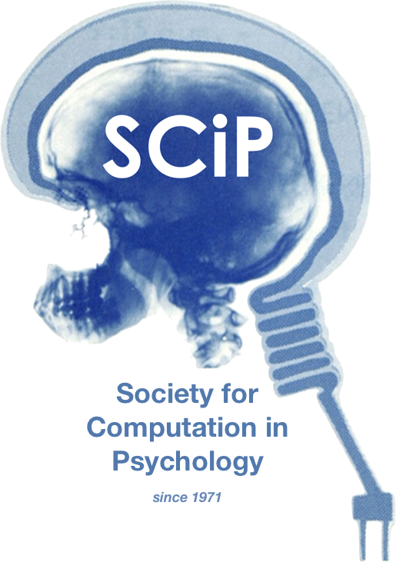

**The 52st Annual Meeting of the Society for Computation in Psychology**

**Psychology in the Age of Technology: Implications for Philosophy, Methods, and Practice**

**November 17th, 2022**

**https://computation in psych.com/**