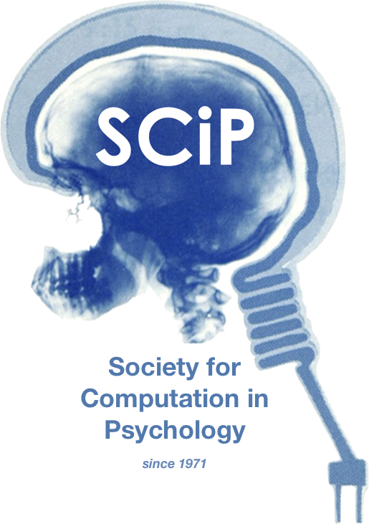

**The 53rd Annual Meeting of the Society for Computation in Psychology**

**Advancing Theory by Opening the Black Box: Uses of AI in Psychology**

**November 16th, 2023**

**https://computation in psych.com/**