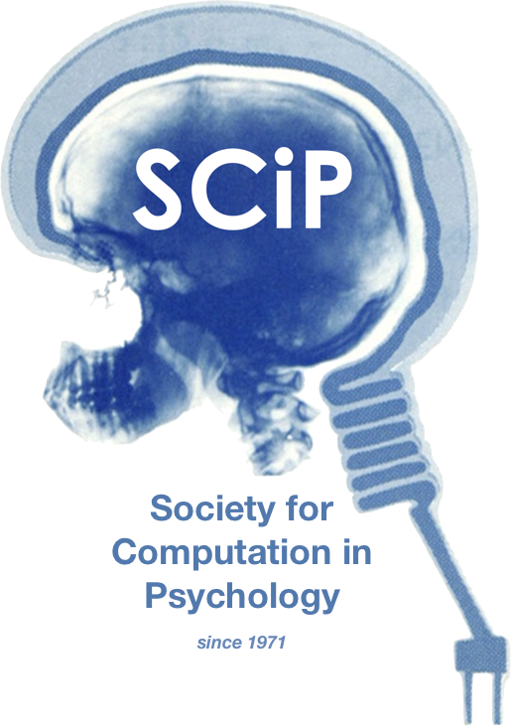

**The 54th Annual Meeting of the Society for Computation in Psychology**

**Digital Cognitive Science: Software-driven Insights into the Mind**

**November 21st, 2024**

**https://computation in psych.com/**