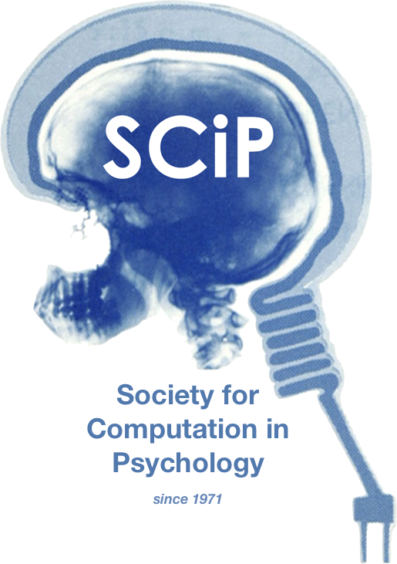

The 56th Annual Meeting of the Society for Computation in Psychology

Scaling Up Cognition: Team Approaches to Cognitive Science

November 19th, 2026

https://computation in psych.com/

