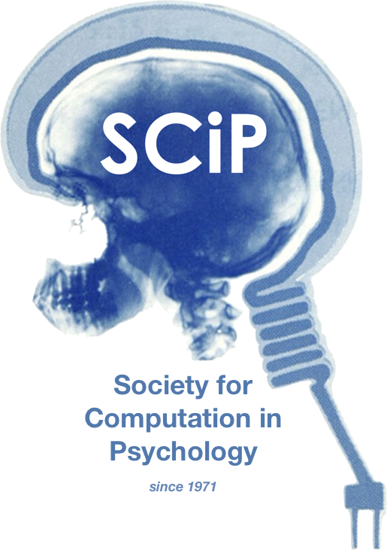

**The 55th Annual Meeting of the Society for Computation in Psychology**

***Computation Everywhere: Studying Cognition in Environments of Technological Ubiquity***

**November 20th, 2025**

**https://computation in psych.com/**