**Section 8 Motion/Vibration Analysis**

8.1 Recurring Abbreviations

8.2 First Order Motion

8.2.1 Elements of First Order Motion

8.2.2 First Order Motion Descriptive Parameters

8.2.3 Determining Descriptive Parameter *t*

8.3 Second Order Motion

8.3.1 Elements of Second Order Motion

8.3.2 Second Order Motion Descriptive Parameters

8.3.3 Determining Descriptive Parameters

8.4 Complex Plane

8.5 Parameter Conversions

8.6 Vibration Nomograph

8.7 References

**8.1 Recurring Abbreviations**

###### *C 1/x* number of cycles to achieve 1/*x* amplitude

###### *D* damping

*D1,D2* peak-to-peak displacement (subsequent)

*FV* final value

*F(t) forcing function*

*f* frequency, cycles/sec = w/(2p)

*HCAR* half cycle amplitude ratio (i.e., *x2/x1*, *x3/x2*, etc.)

*Im* imaginary axis

*M* mass

*MP* peak overshoot

*Re* real axis

*rms* root mean square

*s*1, *s*2 equation roots of second order

*T* period = 1/*f* = 2p/wd (seconds)

*Td* delay time (i.e., time to 50% of FV)

*Tr* rise time (i.e., time from 10% to 90% of FV)

*Tp* time to peak amplitude

*TPR* transient peak ratio

*Ts* settling time (time to settle within *x*% of FV)

*T 1/2* time to achieve 1/*x* amplitude

*x* displacement

*x1,x2* peak displacements (subsequent)

*v* velocity

*vo* peak velocity

*e =zwn /wd* = z/[1-z2].5

*f* phase lag (radians)

*z* damping coefficient (non-dimensional)

*s* damping rate *=zwn* = 1/*t*

*t* time constant =1/*zwn*

w frequency, radians/sec

*wd* damped natural frequency (rad/sec)

*wn* natural frequency (rad/sec)

**8.2 First Order Motion**

Found in classical aircraft roll and spiral modes. Named first-order because the motions are described by mathematics using the first derivative of a parameter.

**8.2.1 Elements of First Order Motion**

Mechanical analogy contains elements of mass, damping and

sometimes a forcing function.

Example: Determine the vertical velocity of a diver as she hits the water at 10 ft/s (assume constant body position & neutral buoyancy)

Summing vertical forces gives



Since *D* & *M* are constant



Apply initial condition

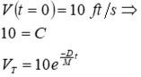

Plot response over time

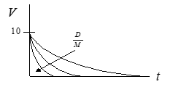

· Exponential rate of decay described by *D/M* ratio

· Example 2: Diver with 20 lb submerged weight releases from zero velocity at top of pool (quiescent condition).

Solve using Laplace analysis methods:

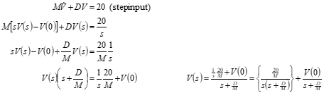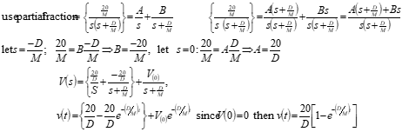

This “force/damping” ratio is merely a scaling factor for the steady state.

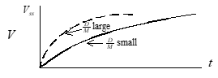

· Several methods can be used to describe the quickness of convergence toward steady state (i.e., time to 99.999 % of *Vss*, time to 1/2 *Vss*).

· By convention, we use a % that directly reflects the exponent.

· Establish a time constant *t* based on *D/M*.

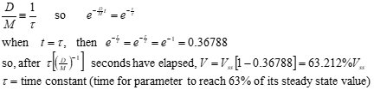

**8.2.2 First Order Motion Descriptive Parameters**

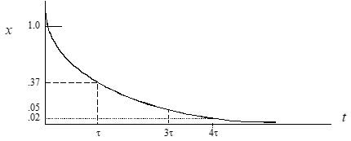

when *t* = 0.6931t: *x = e*-.6931 = 0.5 (time to half amplitude)

when *t* = t: *x = e*-1 = 0.37

when *t* = 3t *x = e*-3 = 0.05

when *t* = 4t: *x = e*-4 = 0.02

If exponent > 0, then motion is divergent.

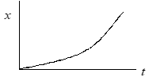

· *t* again describes the exponential rate of divergence.

· By convention, the “time to double amplitude” (*t2*) is usually applied as the evaluation metric.

· *x*(t2) = 2*x*(0)  where *x*(0)  = *cem*0

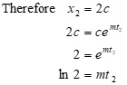

**8.2.3 Determining *t* from Step Input Time History**

**Method #1**

t = time to reach 0.632 *xss*

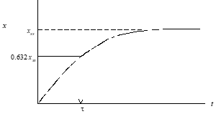

**Method #2**

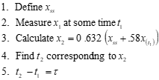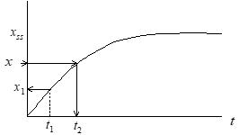

**Method #3**

1. Pick any time *t1*.

2. Draw tangent at *t1*.

3. Note *t2* where tangent intercepts xss.

4. *t* = *t2*-*t1*

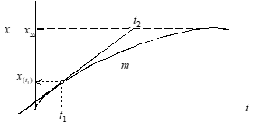

**Method #4** When *XSS* is unknown use

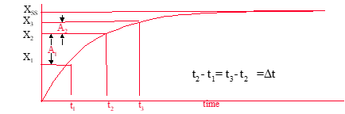

**Method #5** When *Xss* is known, use

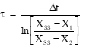

**Linearity check:**

Note parameter change between even time increments.

Plot parameter changes vs elapsed time on semi-log scale

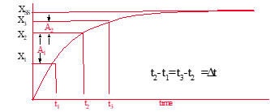

Slope of line equals *t*

Dp

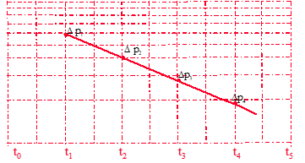

**8.3 Second Order Motion**

Found in classical aircraft phugoid, Dutch roll and short period modes as well as noise filter and vibration testing. Named second-order because the motions are described by mathematics using the second derivative of a parameter.

**8.3.1 Elements of Second Order Motion**

Mechanical systems have elements of spring, mass, and usually damping. Forcing functions can be included (see illustration).

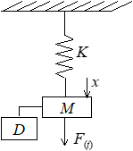

*K* = spring stiffness (*F*/*x*)

*x* = displacement from equilibrium

*M* = mass

*F*(*t*) = forcing function

*D* = damping

#### Natural character is observed when system is allowed to move with no external input [*F*(*t*) = 0]



#### Apply operator technique:



Divide out *est*, since it never equals zero, the characteristic equation remains:



The values of *s* that satisfy this equation are called the roots



Solve for the roots using the quadratic equation



**8.3.2 Second Order Motion Descriptive Parameters**

Solution (*x*) calculated as



Apply Euler’s identity for complex conjugate roots



· f defines the **phase shift**.

•  *A* defines the **initial amplitude**.

•  The real part of the root [*D*/2*M*] defines the **envelope** of the motion.

•  The imaginary part of the root identifies the **damped frequency**

of the oscillations, w*d* (rad/sec).



· If damping is reduced to *D* = 0 then only [*K/M*]1/2 remains.

This is the undamped or **“natural” frequency** (wh).



•  If



then *D* is conisidered to be critical [just enough to prevent oscillations]



· For oscillatory motion, actual system damping is typically expressed as a fraction critical damping. Define **damping ratio** as

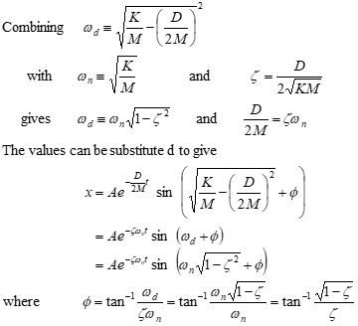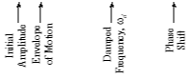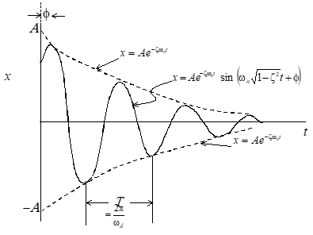

Possible Solutions:

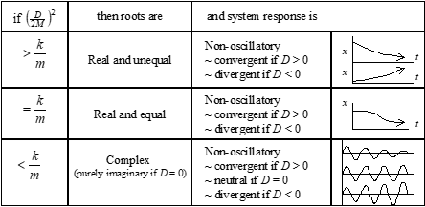

· The various combination of *K*, *M*, and *D* and their effects on system response can be related to damping ratio *z* as follows:

z > 1 Real & unequal roots exponential, convergent

z = ± 1 Real & equal roots exponential, conv or div

0 < z < 1 Complex pair roots sinusoidal, convergent

z = 0 Imaginary pair roots sinusoidal, neutral

-1 < z < 0 Complex pair roots sinusoidal, divergent

z < - 1 Real & unequal roots exponential, divergent

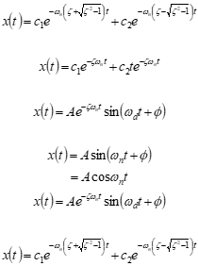

**Damping ratio effect on second order system**

Response of various second order systems to an impulse input.

Second-order systems are oscillatory if

-1 > *z* > 1.

Motion typically

described by

*wn* and *z*

*T*, *wd*, *wn* and *z* are linked such that knowledge of any two will yield

the other two.

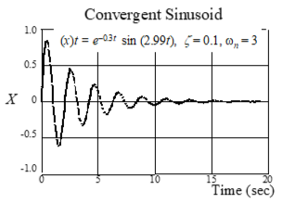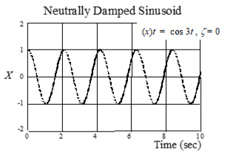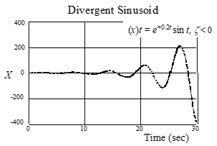

2nd order system response to **unit step input** for **underdamped systems**

(0 > *z* > 1)

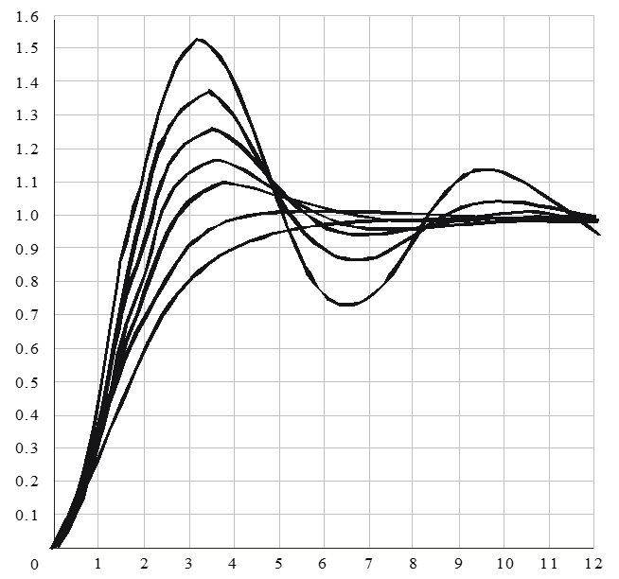

**Decay rates (for 0 < z <1)andUseful Insights**

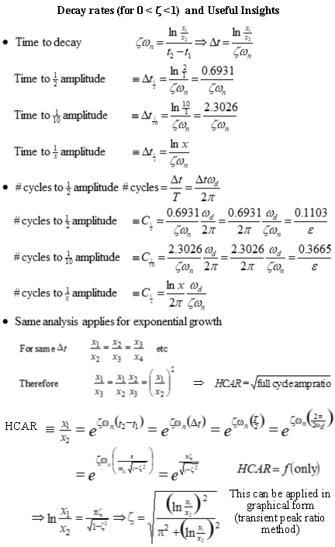

**8.3.3 Determining Descriptive Parameters**

Time domain metrics

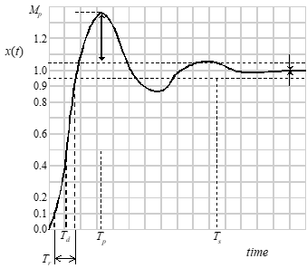

Peak Value, *MP*: largest value

Final Value, *FV*: steady state value

Delay Time, *Td*: 50% of final value

Rise Time, *Tr*: 10% - 90% of FV

Peak Time, *Tp*: time to MP

Settling Time, *Ts*: time to reach some defined % of final value

% Overshoot, *PO*:



*target value = unity*

**Method #1** Basic Analysis

Note

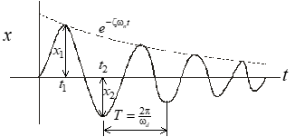

Easily measured values: can use any points on envelope

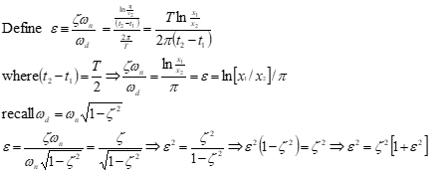

**Method #2** Transient Peak Ratio Analysis

1) Measure either *D* or *x* distances as shown.

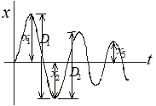

Example Calculation

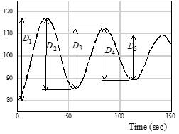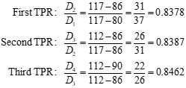

 Average TPR = 0.8409

2) Note ratio of adjacent peak values (transient peak ratios).

3) Average several TPRs.

4) Use equation to find *z*:

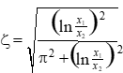

4a) Can use

*D1/D2* or *x1/x2*

ratios in above equation.

4b) In lieu of equation, use

adjacent look-up curve to find *z*.

4c) Time ratio method works better with heavy damping.

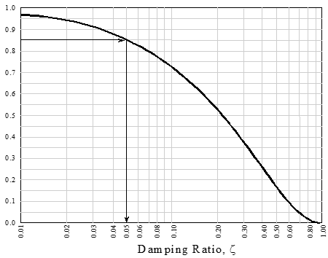

**Method #3** Multiple*TPR* Analysis

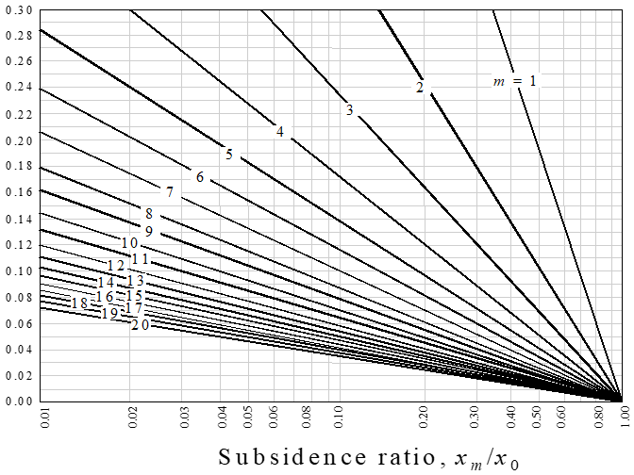

To determine damping ratio

~  Use the *m* = 1 line when comparing the next ratio.

 ~  Use the *m* = 2 line for comparing every other

peak ratio.

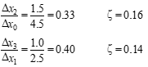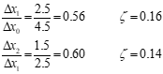

**Method #4** Time Ratio Analysis

· If the damping ratio is between 0.5 and 1.0 (two or less overshoots), then the time ratio method can be used to determine frequency and damping ratio. Select a peak where the response if free.

· Note times for amplitude to reduce to 73.6%, 40.9%, and 19.9% of the peak value.

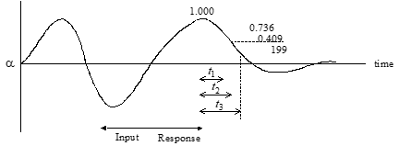

·  Form the time ratios *t2/t1*, *t3/t1*, and [*t3-t2*]/[*t2-t1*]

·  Enter the next figure at the time ratio side to find z for each time ratio.

·  This technique is valid if the system transfer function has no zeros.

· If recorded measurements are not available and if the number of overshoots is between 2 and 6, then



**Frequency Time Products (wnDt3), (wnDt2), (wnDt1)**

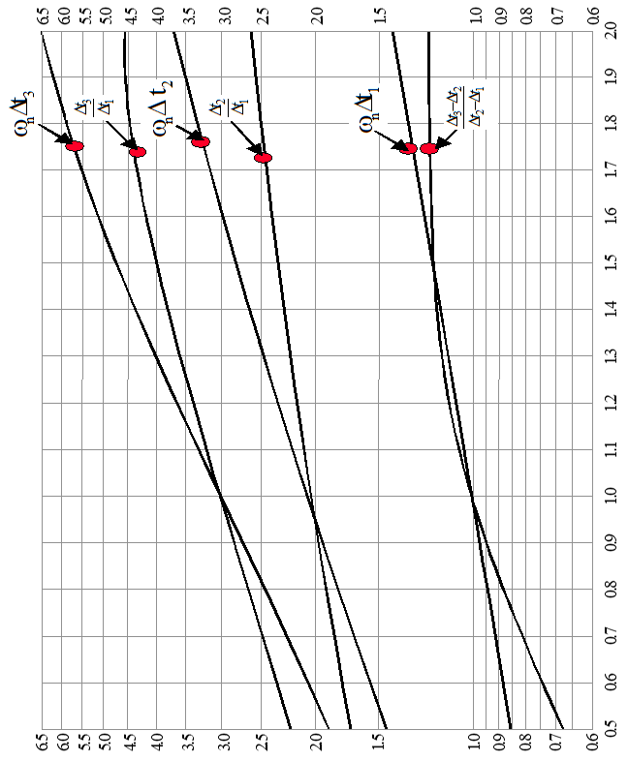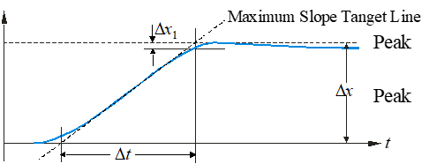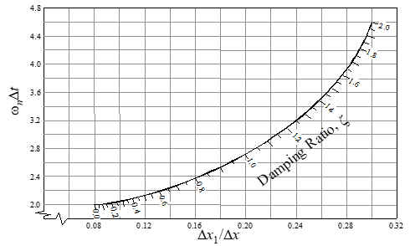

· Calculation of *z* somewhat sensitive to D*x*1 measurement

·  w*n* = not too sensitive to D*x*1



· Best if 0.5 £ z £ 1.4

· Initial overshoot approximation: let (step inputs only)

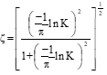

**Method #6** Separated Real Root Analysis (when z>1)

1) Determine several steady state D*X*(*t*) values from time history

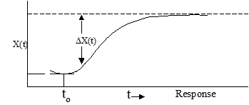

2) Plot D*X* vs *t* on semi-log scale

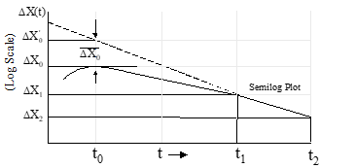

3) After the faster root has decayed, the semi-log plot will be a straight line whose slope determines the slower root (1/t1)

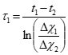

4) Determine by extrapolating the straight line portion of the response to establish the values

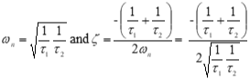

**Method #7** Modified Separated Real Root Analysis

•  Method #6 is sensitive to errors in determining steady state values

•  Alternate method is to avoid need for steady state value

·  Define D*X*(*t*) º [ *x*(*t*+ D*T*) -*x*(*t*)] where D*T* is a time increment

1) From time history, measure D*X* values according to definition

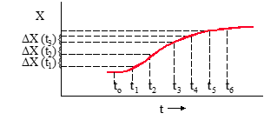

DT = (t1-to) = (t2-t1), etc.

2) Plot D*X* (*t*) vs time on semi-log scale

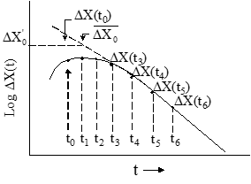

3) Use previous method to determine roots and characteristics

· Gross error will result if z is actually <1

· If z is near 1, check results using time ratio or slope method

**Method # 8** Frequency Sweep Analysis

Determine *wn* and *z* using sinusoidal inputs.

· This “forced response” method most useful when damping is heavy.

· For a second order system, output/input amplitude ratio and phase shift are a function of input frequency.

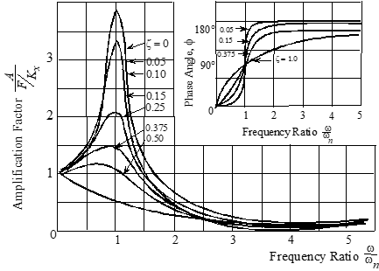

· Amplitude ratio peaks at “resonant” frequency, w*r.*

· Resonant peaks increase as *z* decreases below 0.707.

· Peak amplitude ratio “rolls off” as *z* increases above 0.707.

· Resonant frequency approaches natural fre

quency as damping decreases:

w*r* = w*n*[1 - 2*z*2].5

· Phase shift = 90° if excited at w*n*, regardless of damping ratio.

 z = 0.5(w2 – w1)/wn

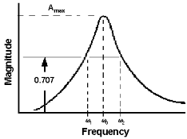

Frequency Sweep Analysis (continued)

1. Using sinusoidal inputs excite system @ w near w*n*

2. Measure phase lag (*f*) of

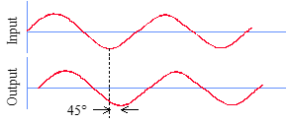

3. Excite system @ another w near w*n*

4. Again Measure phase lag *f*

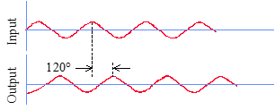

5. Plot f vs input frequency

6. w*n* occurs at f = 90°

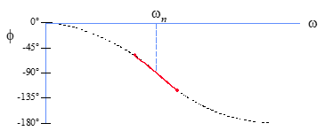

**Linearity Check /Accuracy Improvement**

1) On semi-log scale, plot ratio of initial amplitude to subsequent peak

amplitudes at each half cycle (points *a-e*).

2) Fair straight line (*f*) through these points.

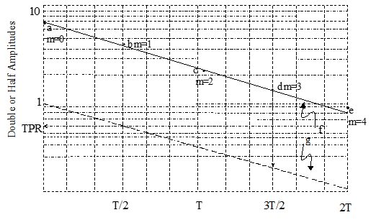

3) Draw line (*g*) parallel (*f*) intercepting the ordinate at *TPR*=1

4) Average *TPR* occurs at *T*/2 on line *g*

**8.4 Complex Plane**

Begin with sum of forces in spring-mass-damper example

 Apply quadratic equation to solve for roots

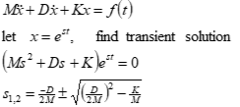

 Recall previous analogy

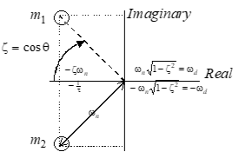

Location of Roots on Complex Plane

1. Line of constant damping ratio z - varying *C*1/*n* and w*n*

2. Line of constant w*n* - varying z

3. Line of constant w*d* and period (*T*)

4. Line of constant real part (zw*n*) and time to damp (*T*1/*n*)



*s* = zw*n* = 1/*t* = damping rate

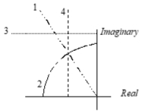

**Sample second order root plots and corresponding time histories**

(time histories represent trends only)

Examples of “two real roots”

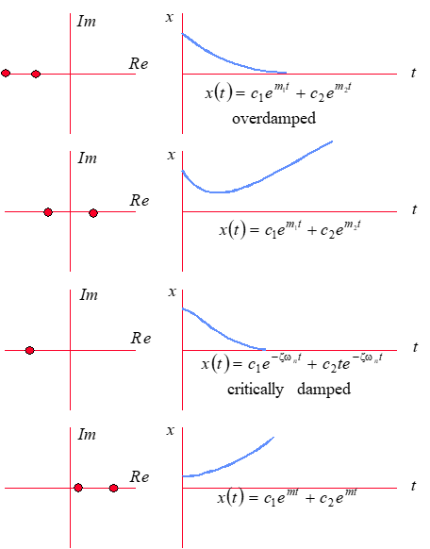

**More sample second order root plots and corresponding time histories**

Examples of “imaginary roots”

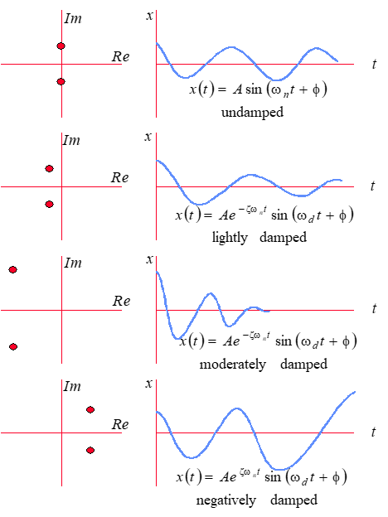

**8.5 Parameter Conversions**

For conversion of accelerometer measurements.

· For magnitude conversion substitute 2*pf* for *jw*.

· Assumes linear spectra.

· Conversion factor should be squared for power spectra.

*Acceleration to velocity*

to convert from to multiply by

*ft/s2 rms ft/s rms* 1*/jw*

*ft/s2 rms in/s rms* 12*/jw*

*ft/s2 rms in/s peak* 16.97/*jw*

*g rms in/s rms* 386*/jw*

*g rms in/s peak* 545.8/*jw*

*m/s2 rms mm/s rms* 1000/*jw*

*m/s2 rms mm/s peak* 1414*/jw*

*g rms mm/s rms* 9806*/jw*

*g rms mm/s peak* 13865.7/*jw*

*Acceleration to Displacement*

to convert from to multiply by

*ft/s2 rms in rms* 12/(jw)2

*ft/s2 rms in p-p* 33.9/(jw)2

*ft/s2 rms mil p-p* 33.9 *E* 03/(jw)2

*g rms in rms* 386/(jw)2

*g rms in p-p* 1091.6 *E* 03/(jw)2

*g rms mil p-p* 1091.6 *E* 03/(jw)2

*m/s2 rms mm rms* 1000/(jw)2

*m/s2 rms mm p-p* 2828/(jw)2

*m/s2 rms* micron *p-p* 2828 *E* 03/(jw)2

*E*= engineering exponent (x10 __)

*g* = 32.174 ft/sec2

*in*= inches

*mil* = thousandths of an inch

*mm* = milimeters

*p-p* = peak-to-peak

*rms* = root mean square

**8.6 Vibration Nomographs**

**Vibration Nomograph equations**

**For British** [V in inches/sec], [d in inches]

*V =* 386*g /* 2π*f*

*d* = 386*g* / (2π*f*)2

where 386 = earth's gravitational pull [in/sec2]

**For metric** [V in mm/sec] , [d in mm]

*V =* 9800*g /* 2π*f*

*d* = 9800*g* / (2π*f*)2

where 9800 = earth's gravitational pull [mm/sec2]

**Nomograph - British Units**

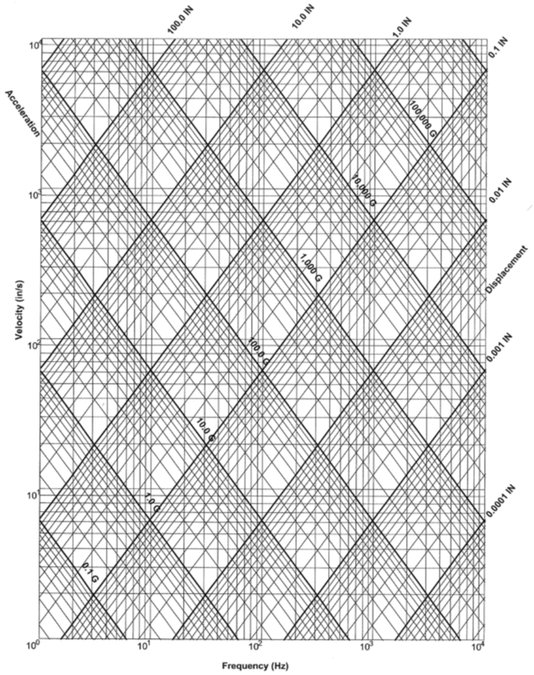

**Nomograph - Metric Units**

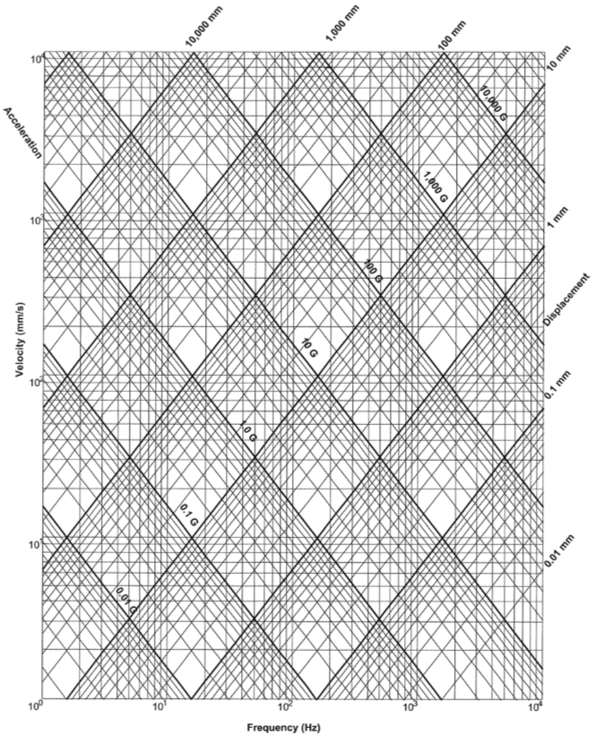

**8.7 References**

8.7.1 Lawless, Alan R., *Math and Physics for Flight Testers*, “Chapter 9, Motion Analysis,” National Test Pilot School, Mojave CA, 1999.

8.7.2 Ward, Don, *Introduction to Flight Testing*, Texas A&M, Elsevier, 1993.

8.7.3 Lang, George F., *Understanding Vibration Measurements*,

Application Note 9, Rockland Scientific Corporation, Rockleigh, New Jersey, December 1978.

8.7.4 *The Fundamentals of Modal Testing*, Application Note 243-3,

Hewlett-Packard Company,

Additional Reading

Hartog, J.P. Den, *Mechanical Vibrations*, Dover Publications, New York, New York, 1984.

Jacobsen, Ludik S. and Ayre, Robert S., *Engineering Vibrations*, McGraw-Hill Book Company, New York, New York, 1958.

Meirovitch, Leonard, *Elements of Vibration Analysis*, McGraw-Hill Book Company, New York, New York, 1986.

Meirovitch, Leonard, *Analytical Methods in Vibrations*, Macmillan Publishing Company, New York, New York, 1967.

Myklestad, N.O., *Vibration Analysis*, McGraw-Hill Book

Company, New York, New York, 1944.