**15 Handling Qualities**

**15.1 Cooper-Harper Rating Related Figures**

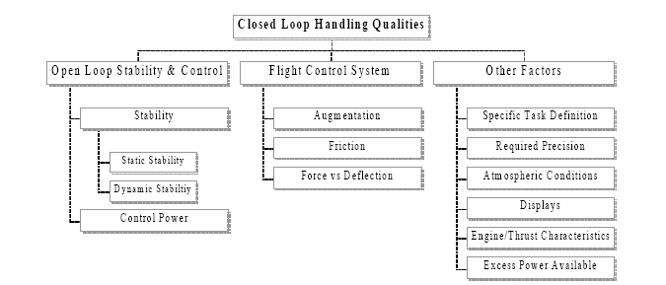

**Figure 15.1-1 Elements of Closed-Loop Handling Qualities**

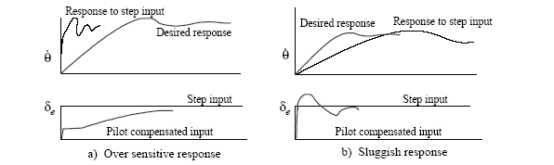

**Figure 15.1-2 Undesirable step input responses and pilot compensation to achieve**

**desired response**

**a) Lag compensation, b) lead-lag compensation.**

**a) Lag compensation, b) lead-lag compensation.**

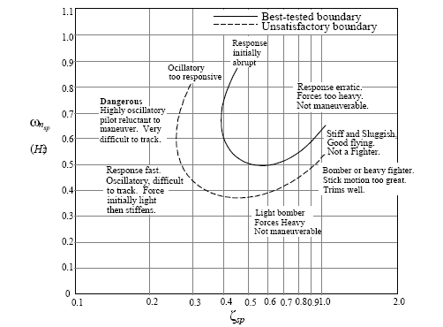

**Figure 15.1-3 Optimum Short Period Frequency and Damping Based on Pilot Opinion**

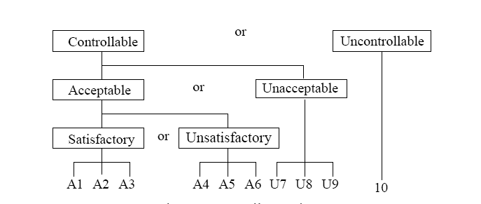

**Figure 15.1-4 General Pilot Ratings for Handling Qualities**

**Closed Loop Handling Qualities Test Requirements**

1) Explicit **mission definition:** what the pilot must accomplish. Identify the circumstances and operating conditions.

2) Define mission **tasks**. Tasks should be repeatable, require sufficient control input frequency to stress the system, and they should be of adequate duration to differentiate transient from steady state responses.

3) Establish **desirable** and **acceptable** criteria for task performance. Criteria established should be quantifiable, recordable, and realistic. Desirable criteria specify a satisfactory level of performance. Acceptable criteria specify the level of performance that is marginally adequate.

4) Test should include realistic typical **distractions and disturbances**.

5) Record task **performance** relative to the criteria established (comments, video, audio, pipper movement, etc.)

6). Measuring & record pilot **workload** and compensation.

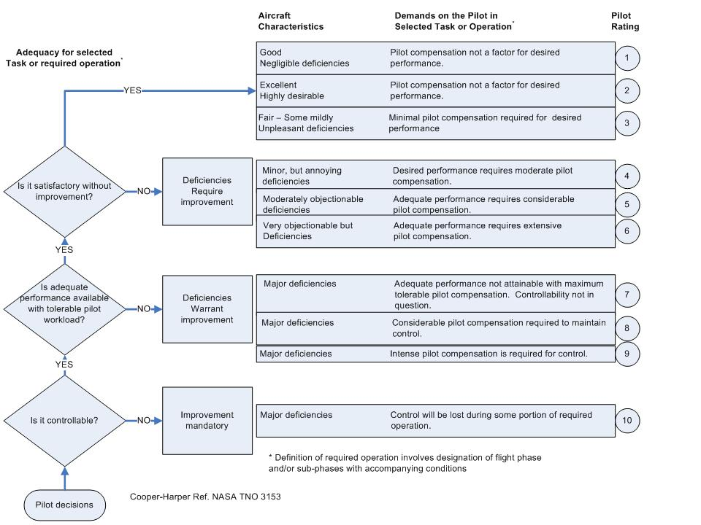

**Figure 15.1-5 Cooper Harper Workload and Handling Qualities Rating Scale**

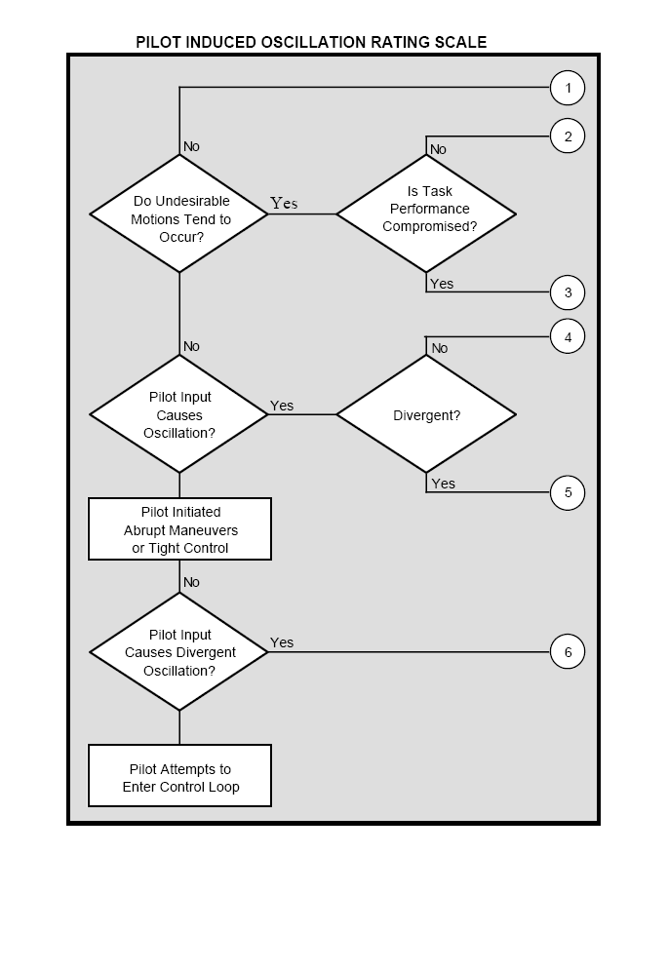

**Figure 15.1-6 Pilot Induced Oscillations Rating Scale**