FLIGHT 00XX CUBESATS

www.perlanproject.cloud

RAM FEED INSTALLED

**+X**

**+Z**

**+Y**

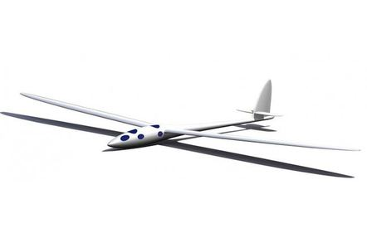

+Y

+X

+Z