true
next page →

Additive Photography

by Ives Maes

Sunville (Introduction)
I grew up in a village named Sunville. Its name brings to mind a utopian place, far too perfect for its reality: a few houses surrounded with forests, swamps and moorland. The coat of arms contains a radiating yellow sun shining brightly over a blue sky. Older versions of the shield contained a black sun with an upside-down smile. Growing up, I started to understand that this melancholic sun symbolised a state of exception. The sun never sees a shadow, a philosopher once said, although it casts many.¹ After the recent suicide of my brother, I returned to our childhood homestead. In the forlorn months after his death, I wandered the countryside with a camera and stacks of accidentally expired film, photographing the locations of long-repressed memories. The colour variations in these exposed and expired negatives suggested images much older than they were, reminiscent of photographs taken in the 1970s. My photographs were brought together with snapshots from the family album and footage found in the village’s historical archive. The blue-hued Super 8 films my father had taken with his Kodak Instamatic became, upon watching, tangible memories. Over the course of six seasons, these sequences of look-back time² symbolically concluded with a partial solar eclipse over the village. [fig. 2] [fig. 3] [fig. 4] [fig. 5] [fig. 6] [fig. 7] [fig. 8] [fig. 9] [fig. 10]
All photographs in this new series were taken between November 2013 and March 2015 but remained unprinted for a while. These images were so disturbing to me that I once believed they would never see the light of day. Exhibiting this new archive to an audience was intimidating, but instead of hiding the vulnerabilities embedded in the series, I used display strategies to mediate them. A number of experiments first led me to create sculptures out of these photographs, which eventually led me to photographic installations. These transmutations of the print were supported by my ongoing research into the materiality of photography.
This became the subject of my Ph.D. in the arts at KASK, School of Arts of University College Ghent. During the course of this Ph.D. in the arts, I have been researching the physical, sculptural, and architectural aspects of photography. Since the invention of photography, there have been numerous hybrid experiments between photography, sculpture, and architecture that demonstrate a continuous influence of sculpture and architecture on photography and vice versa. In my Ph.D. I gave a historical overview, beginning with the sixteenth-century camera obscura pavilion and ending with twenty-first-century digital processes. I also described a number of experiments, including Daguerre’s diorama, Charlotte Perriand’s 1937 Agriculture Pavilion, Richard Hamilton’s photo-installations, the 1970s MoMA exhibition ‘Photography into Sculpture’, Dennis Adams’s bus shelters, and Olafur Eliasson’s camera obscura installations. I analysed and applied these ideas to my artistic practice with the words of Robert Heinecken in mind: ‘To accept only the most obvious or utilitarian function of an image-making device is to deny the real potential of artistic involvement at its deepest level.’³
From 2014 onwards, I started exploring my photographs as spatial objects and installations, as prints and 3D-prints. In this exposition, I would specifically like to show how the photosculpture process of François Willème initially inspired me to create new visual work. He aimed, in the late 1850s, to reproduce sculpture with the help of photography, creating a union of the two media. After a historical description of his work, I will show my attempt to reconstruct his experiments. After further reflecting on other proto-photographic installations, such as the panorama pavilion and the Cinéorama, I will demonstrate how these ideas and techniques were then adapted within my own work. At the same time, this is an exemplary case study on how my theoretical research is steering the creation of my visual research within a Ph.D. in the arts.

¹ ‘Il sole non vide mai nessuna ombra’, Leonardo da Vinci wrote in his Codex Atlanticus (1479 – 1519).
² ‘Look-back time’: a term to describe, for example, the temporality of starlight that reaches us long after the star itself has disappeared.
³ Heinecken, Robert, ‘Manipulative Photography’, Robert Heinecken: Object Matter, ed. by Eva Respini (New York: The Museum of Modern Art, 2014) p. 157.
next page →
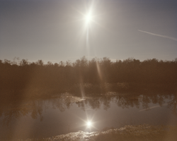
fig. 2 | Double Sun
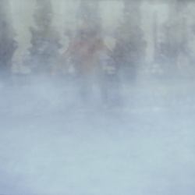
fig. 4 | Sequence #5 (Snow)
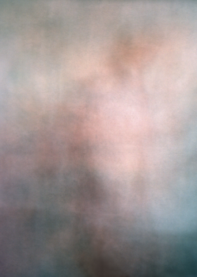
fig. 6 | Sequence #3 (Wedding Party)
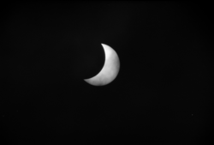
fig. 9 | Eclipse (detail)
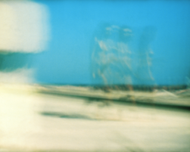
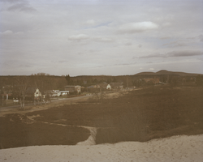
fig. 3 | Black Mountain
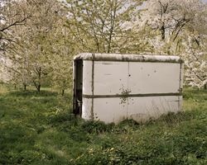
fig. 5 | Blossoms

fig. 7 | Nude Beach Bound
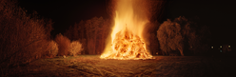
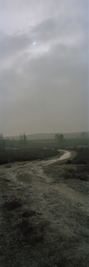
fig. 8 | Hololool
fig. 10 | Eclipse
← previous page | next page →

Spaceland^(1)
My first experiment was an attempt to translate photography into sculpture, in which the two-dimensional photographic print would become a three-dimensional photographic object with physical properties. François Willème’s photosculpture process proved to be an interesting method of visual abstraction that had the potential to do exactly this, while simultaneously negotiating the emotionally loaded content of my photographs.
One of the great paradoxes of photography lies in its ability to turn a real three-dimensional world into a photographic two-dimensional world. This two-dimensional illusion seems to evoke a three-dimensional world, despite the fact that the image is little more than a photosensitive chemical substance on the surface of a three-dimensional support. But it is this paradox that enables the precise spatial dimensions of a sculpture to be rendered on a two-dimensional surface. It is possible for perceived depths within the image to be translated in real, correct dimensions, simply by measuring the distances on the photograph. This act of translation from two to three dimensions later evolved into a technique called photosculpture, which enabled spatial forms to protrude out of a flat image.
Photosculpture — which, when it began, meant simply the practice of photographing sculptures — suggested a distinctive union between photography and sculpture. This concept was advanced by the French sculptor and photographer François Willème (1830–1905). In the late 1850s, he aimed to accurately reproduce sculpture with the help of photography. Willème developed a shadowing apparatus for mapping the surface of an inanimate object. A sculpture would be placed onto a revolving turntable marked by 24 different points; at each of these points, during the objects revolution, a camera ‘successively recorded the shadows cast by the apparatus.’² The resulting 24 photographic profiles would then be individually projected onto a screen, and each profile could then be transferred onto a three-dimensional model using a pantograph measuring device.³ The model, or prototype, was a ‘sum of profiles’ to be ‘modelled out in plaster.’⁴ This was done without any artistic pretence and as accurately as possible.
By the 1860s, photosculpture had radically changed, as Willème patented and commercialised his practice under the same term. Around this time, he moved on to a greater challenge: turning portrait photography into sculptures. Portrait photography had been made possible by improved lenses, cameras, accelerating substances to reduce exposure times, and glasshouse studios. For this experiment, Willème’s device had to go beyond a turntable and camera. In order to register the sitter’s profile correctly and without their becoming impatient and moving, he needed to take 24 photographs completely surrounding the model at exactly the same moment. For this reason, he constructed a glass-domed circular pavilion in which he embedded 24 synchronised cameras. [fig. 11] The entire figure of the posing sitter could be captured in a few seconds, after which the same profiling procedure as described above was used to convert the images into an accurate likeness. With the aid of Achille Collas’s réduction méchanique — a machine similar to a pantograph that could copy objects at various scales — Willème had successfully invented a photography-based, mechanical method of producing portrait sculptures. [fig. 12]
With the subject centred in the middle, encircled by cameras to register volume information, this elaborate device resembled the modern-day 3D scanner. This method was capable of collecting unprecedentedly accurate and precise information on volume. However, the process of reconstruction into sculpture was corrupted by manual intervention: details were lost as photographs were converted into profiles, followed by profiles converted into clay, then finally, clay into plaster.⁵ The differences between the two-dimensional photographic image and the three-dimensional cast were finely attuned but cannot be compared to the computerised accuracy of the modern-day 3D printer. Ahead of its time, this prototype 3D scanner had to wait for the precision of the 3D printer.
Another challenge lay in photographing moving subjects and visualising the physiology of a living organism in motion. A body cast of a figure in motion was — and still is —impossible, but the next generation of scientist-photographers looked to Willème’s photographic scanner for the next best thing. By the 1880s, the shutter speed of a photographic recording had surpassed both the speed of zoological movement and the speed of human vision. These years saw developments in both micro- and macro-photography, and a growing interest in what lay beyond the visible spectrum. Here Willème’s photosculpture practice became valuable again, as researchers looked to find ways to visualise motion in three-dimensions. Since photography was a physical imprint of reality, and the physiology of movement was captured on such an imprint, it would be possible to extract, using Willème’s technique, a physical and tangible object in motion.
When scientist and cardiologist Étienne-Jules Marey started using photography to record his physiological experiments, he turned to Willème’s photosculpture process to simulate and, more importantly, solidify motion as a three-dimensional, sculptural animation. Fascinated by bird flight and the movement of wings, he set out in 1886–87 to record the flight of a seagull. [fig. 13] Influenced by Eadweard Muybridge, who had made synchronised photographs of the same subject from three different angles of view, Marey came up with the idea of taking synchronised photographs from the lateral, frontal, and vertical view. In order to retrieve accurate information about movement from a series of photographs, Marey built two darkened pavilions flanked by two chronophotographic cameras, with a third camera fixed to the roof facing downwards onto an area of black cloth rolled out on the ground.⁶ These three synchronised cameras could simultaneously capture three different angles of the same subject. Much like the contemporary 3D scanner, and reminiscent of Willème’s technique, the chronophotographs made along the X, Y, Z axis collected all the information needed to subtract a three-dimensional object from a real bird in flight. [fig. 14] ‘We have been able, using these three images, to build a series of figures in relief showing the successive positions of the bird’, Marey wrote. He created ten three-dimensional sculptures showing the various positions of a seagull during flight, separated from each other according to the real distances between each recorded position. [fig. 15] Finally, he merged the bodies of 24 birds into a single sculpture, hereby creating an exact three-dimensional figure that would correspond exactly to the physical distances between positions spaced at one fiftieth of a second intervals.⁷ [fig. 16] [fig. 17] In this, Marey had expanded on Willème’s photosculpture process to create a solidified volume of motion. On the one hand, he translated a photograph’s frozen moment of time and space into sculpture, and on the other, he developed new techniques that laid the foundations for cinema.
In 1900, only a few years later, the Exposition Universelle de Paris focused entirely on film and the moving image, during which Marey’s photosculptural experiments received modest attention in a small window display. The influence of Willème and Marey’s work was more strongly felt in Cubist and Futurist circles, especially in the work of Boccioni and Duchamp. Their sculptural techniques were copied and adapted in the twentieth century by Pötschke, Reissig, Selke, Givaudan, and others.
It was only in the twenty-first century that a true reconstruction of tangible spatial information from a flat photograph could be fully realised. Willème and Marey’s early attempts to reproduce objects from light can trace a lineage to the present, in cinema and 3D scanning and printing. We are now at a point in history where 3D printers can make this imprecise sculpture perfect, and I have attempted to reconstruct and adapt their experiments for my own visual work using these contemporary technologies.

¹ Abbott, Edwin A., Flatland: A Romance of Many Dimensions, (London: Seely & Co., 1884). In Flatland, a novel published in 1884, a Square was lured into the three-dimensional world by a luscious Sphere. The Square, living in a two-dimensional world occupied by geometric figures, could not comprehend a third dimension until he saw Spaceland for himself. Overexcited, he tried to convince the Sphere of a fourth and fifth dimension and gets himself expelled from Spaceland for reasons of blasphemy. Once returned to Flatland he wrote his memoirs for the keep of future generations that would be able to see and handle multiple dimensions.
² Sobieszek, Robert A., ‘Sculpture as the Sum of Its Profiles: François Willème and Photosculpture in France, 1859-1868’, The Art Bulletin (1980) 617–630.
³ A pantograph is a mechanical drawing device invented to copy two-dimensional forms in a reduced or enlarged version. The device has two reference points: one that traces the original size and a second which gives a smaller or larger size but with the exact same proportions. The pantograph was adapted with a third point to duplicate three-dimensional forms and became very popular with sculptors.
⁴ Sobieszek, Robert A., ‘Sculpture as the Sum of Its Profiles: François Willème and Photosculpture in France, 1859-1868’, The Art Bulletin (1980) 617–630.
⁵ Molderings Herbert, Lens-based Sculptures. The Transformation of Sculpture through Photography, (Cologne: Verlag der Buchhandlung Walter König, 2014) p. 11.
⁶ Frizot, Michael, A New History of Photography, ed. by Michael Frizot, (Cologne: Könemann Verlagsgesellschaft mbH, 1998) p. 249.
⁷ Frizot, Michael, ‘Sculpture, between Visual Perception and Photography’, in Lens-based Sculptures, the Transformation of Sculpture through Photography, (Cologne: Verlag der Buchhandlung Walter König, 2014) p. 61.
← previous page | next page →
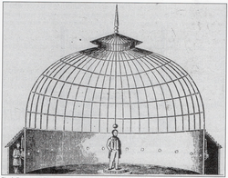
fig. 11 | Willème’s photography studio with 24 synchronized camera’s in a round, glass-domed pavilion.
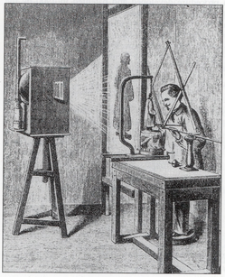
fig. 12 | Willème’s conversion method to translate photographs into sculptures through projection.
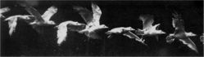
fig. 13 | Marey’s chronophotograph of a seagull in flight in successive sequences.
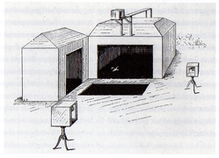
fig. 14 | Marey’s test-site with three chronophotographic camera’s to simultaneously photograph a seagull in flight from three different angels.
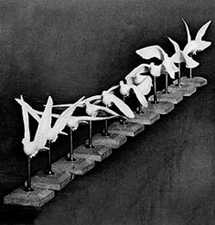
fig. 15 | Marey’s photo-sculpture of a seagull in flight in successive sequences.
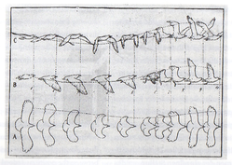
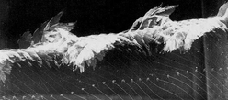
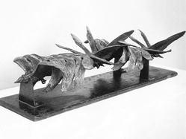
fig. 16 | Marey’s chronophotograph of a seagull in flight in one merged sequence.
fig. 17 | Marey’s photo-sculpture of a seagull in flight in one merged sequence.
← previous page | next page →

Additive Photography
My original aim in copying and perfecting the experiments of Willème and Marey was to distance myself from the emotional content in my photographs, turning them instead into abstract objects. The content of the photographs was to remain exclusive information. This procedure was deliberately intended to avoid sentimentalism, instead drawing the work into the realm of theoretical and historical discourse and the technical aspects of its creation.
My personal reflection on the relationship between photography and sculpture sets out from Nicéphore Niépce’s Le Point de vue du Gras (1826), considered the world’s first example of photography. What fascinates me about this proto-photograph is its material thickness: besides the physicality of its support, a pewter plate coated with bitumen of Judea, the exposure process consisted of slowly inscribing the image into the bitumen tar, which gave it a physical depth, however infinitesimal. It is the most eloquent manifestation of the fact that analogue photography was first a three-dimensional imprint: light carving traces into a physical substance.¹ The first photograph in history appeared as a black, sculptural object, exactly the sort of abstraction I was looking for.
With the invention of contemporary 3D scanners and printers, it has become possible to realise Willème’s ambitions. You can now scan a sculpture or a person and print it at any size desired, with a minimal margin of inaccuracy between scanning and printing. Today, through 3D software programs, it is also possible to translate an existing photograph into a sculpture, omitting the scanning part altogether.
In 2014, I started working in Cinema 4D, a 3D-software program that allows the user to import a digital photograph and translate the image’s contrasts into spatial depth. The lighter areas of the photograph are read by the program as having a different level in depth as the darker areas, much like in Niépce’s tar coating. This assigned depth lends the image an abstract quality, which I found very interesting. The program accurately translated contrast into depth in a way that differed from Willème and Marey’s experiments. The software did not consider the actual proportions of the figure — as it would have when scanned — but only considered the difference between light tonalities. In other words, it produced an inaccurate figure. Its algorithm turned parts of the photograph outward or inward according to light contrasts, transforming perceived reality into a physical impossibility.
For example, my work Photographer originates from an image with strong light contrasts. [fig. 18] In its conversion from two to three dimensions, the protagonist photographer’s dark hair is pressed into the surface, while his jacket surfaces in the foreground. His black camera becomes unrecognisable due to the strong reflections of light on its surface. The leaves in the background, meanwhile, do not follow their natural shape, but peak where the light bounces back. [fig. 19] [fig. 20] The unusual results of the final, three-dimensional shape occur because the image’s translation into depth is made by its light contrast instead of its volume. Here, the software interprets entirely differently to the artist’s eye, leading to an inaccurate interpretation of reality. As an artistic experiment, the software delivered an interesting free-form map that could then be turned into an object. Progressing from this design, I had the file printed in plastic on a size of 28 x 37 x 6 cm. [fig. 21] I had the 3D print moulded and cast into bronze in order to emphasise its sculptural nature, after which it was framed in a specially designed oak frame. [fig. 22]
The image used for Photographer comes from a Super 8 film my father once recorded. It shows a family member taking photographs, which has symbolic resonance for the work. What interested me most about this image was the profile of the person and his camera. When considering images to convert with my photography-into-sculpture process, this image seemed, to me, like the relief of a frieze. My interest in this sculptural application of photography led me to record new, malleable images that could be appropriated to create objects: images of landscape and memory that could be semantically altered by changing their physical framework and context. This would also shift their emotional meaning into a grid of historical concepts and abstraction. I started applying this procedure to different photographs in order to see different effects. At first, I chose the most emotional images from my series, so as to bury their emotional content in abstraction. In addition, I selected images based on their possibility of becoming an interesting frieze. For example, figure 23, the picture of an apartment, is a deeply emotional image, and converting it into abstraction served its purpose. [fig. 23] But beyond this, the wallpaper in that room proved to be a very interesting object to convert into three dimensions. [fig. 24]
I also tried a different process of abstraction: I projected the Super 8 films made by my father on a screen and simultaneously recorded analogue photographs of these projections. The discrepancy between the still of the photograph and the motion of the film made colourful abstractions of our family album. Nude Beach Bound shows a half-naked woman walking on a French nudist beach, caught on film and angered by my father’s intrusion. I recorded her progression in nine steps, experimenting with the different speed of the projection and the recording time of the photograph. These captured images of motion, relating to Marey’s chronophotographs, turned into abstract hues and their 3D printed counterparts into abstract, rocky formations. [fig. 25] Still, I found them not abstract enough — they were still revealing too much. [fig. 26] I wanted to go beyond rendering flat surfaces into bas-reliefs.

¹ Menegoi, Simone, ‘The Camera’s Blind Spot: On the Materiality of Photography’ (2016).
← previous page | next page →
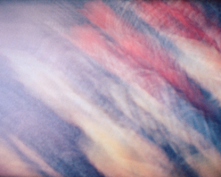
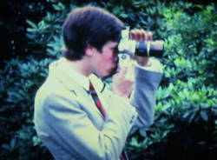
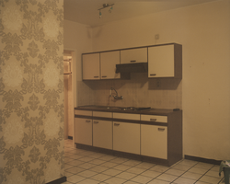
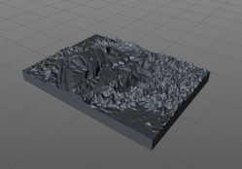
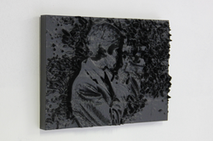
fig. 21 | 3D-print, side views
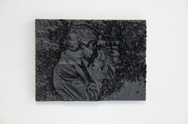
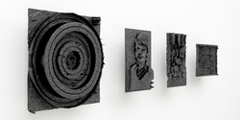
fig. 18 | Digital photograph of a photographing family member
fig. 19 | 3D translation of light into depth in Cinema 4D
fig. 23 | Digital photograph of an apartment
fig. 25 | A photograph recorded from a projected Super 8 film showing tulips in motion and its 3D rendering
fig. 26 | 3D renders of different photographs
fig. 21b | 3D-print, front view
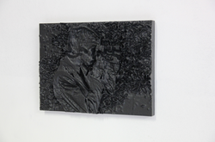
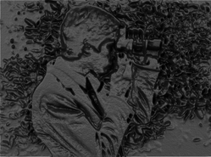
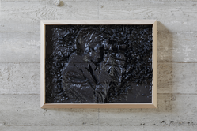
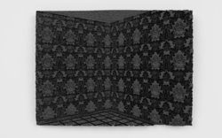
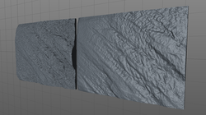
fig. 20 | Digital 3D render of photographer
fig. 22 | Bronze cast framed in oak
fig. 24 | Digital 3D render of a corner in the apartment
← previous page | next page →

A Reversed Panoramic Perspective
As I began to research Willème’s photosculpture process, I also started thinking about his circular photography room: his glass-domed circular pavilion that allowed an object to be photographed in the round. Willème’s pavilion offered an inverse view to that of its predecessors, the camera obscura pavilion and the panorama pavilion, both of which presented an outward rather than inward view. Willème’s pavilion, meanwhile, encircled a central object, in exactly the same way as a contemporary 3D scanner. This presented a major departure from what had existed beforehand: photographs taken from a single, pivoting point of view. I started to research possible photographic vantage points and their effects on 3D printing.
During my historical research, I have come across many experiments connected to photography that apply very different vantage points. The camera obscura pavilion brought the outside world inside: its design channelled a ray of light through a small aperture into a dark space, projecting an upside-down image of the outside onto the opposing wall, functioning as a cinema in real-time. As such, it reversed the perspective position of the viewer, facing away from the actual landscape to instead look at an opposing mirror image.
While the camera obscura pavilion projected the exterior landscape of its immediate surroundings, the panorama pavilion imported its images from distant places of wonder. Devised by Irish painter Robert Barker in 1785 and patented in 1787, this large, circular landscape painting gave the hyper-realistic illusion of a real, three-dimensional, 360-degree view, radically changing the viewer’s point of perspective as they entered the space. [fig. 27] The physical environment of his panorama evoked a real place somewhere else, giving the viewer a sense of being within the represented location. The latest inventions were used in order to create a panorama painting. The painter would, once in their chosen location, use a special revolving camera obscura mounted on a tripod to make topographic tracings and atmospheric studies of the surrounding view. This comprehensive survey was used in the construction of the painting. The drawings were transferred onto a glass cylinder or onto glass plates that were projected through convex lenses by a strong light source, such as a magic lantern.¹ This projection was then traced and transferred onto a large canvas with a system of quadrants. Then, the artist painted a distorted, cylindrical perspective at life-size, creating an uncanny reproduction of reality. So that this circular panoramic painting appeared to be without beginning or end, the building was adapted to house a staircase leading up to a raised viewing platform at the centre of the cylinder.² This viewing platform ensured that viewers remained approximately 10 meters away from the painting, giving multiple vantage points, but always from a distance. Upon arriving in the viewing circle, disorientated and slightly blinded by the sudden daylight, the spectators experienced a moment of feeling as though they were somewhere else entirely. Although the panorama pavilion was more or less imitating the effects of the camera obscura pavilion, it went beyond its predecessor, improving the experience with its 360-degree view and myriad vantage points.
A few other marvels of the time also helped to broaden the horizon of vantage points. Etienne-Louis Boullée’s Cenotaph for Isaac Newton, engraved and made public in 1784 but never realised, proposed a sphere of 150 meters in diameter that was pierced by countless holes in the vaulting that, when illuminated by the sun, gave the illusion of stars in the night sky. [fig. 28] Although the structure was never built, it suggested the idea of an even wider expanded view, of peering from the horizon into the darkness of space, as in the modern planetarium. In 1826, Charles François Paul Delanglard built a structure in Paris that went further still: a full 360 x 180-degree spherical panorama painting. [fig. 29] In this géorama, visitors would look from a platform onto an inverted image of the earth, from a viewpoint situated in the volcanic core of the planet. Similarly, in James Wyld’s Great Globe, which had opened together with the Great Exhibition of 1851 in London, visitors could gaze at an inverted map of the world. [fig. 30] The Great Globe was a purpose-built hall with four elevated platforms, from which the viewer could see a full panoramic sphere of 26 meters in diameter. On its interior surface was an inverted surface of the earth, complete with three-dimensional mountain ranges and rivers in plaster.³ The spectator was no longer looking upon a comprehensible globe but found himself inside a panoramic orb.
At the Exposition Universelle et Internationale de Paris of 1900, the experience of the panorama painting was taken to new extremes by the new medium of cinema. Underneath the Eiffel Tower stood Raoul Grimion-Sanson’s Cinéorama, an early type of panoramic projection. [fig. 31] It brought the ideas behind the camera obscura and panorama pavilions together with the new cinema technology. Upon entering the pavilion, visitors experienced an effect similar to that of the panorama pavilion, rising from a darkened tunnel over a spiral staircase onto a circular platform. The platform resembled a large balloon basket that could hold up to 150 spectators and was roped to the lower part of a hot-air balloon, giving the impression that the visitors were stepping inside a real hot-air balloon, moments away from ascension. Instead of looking onto a painted panorama, they were surrounded by ten blank canvasses of nine square meters. Underneath the platform was a projection booth that held 10 synchronized 70mm movie projectors arranged in a circle, so that, when projected, the films appeared to be joined together, creating a 360-degree panoramic cinema. As the projection began, the platform seemed to ascend, giving visitors the impression that the balloon was lifting them hundreds of meters above the neighbouring Tuileries Gardens.⁴ The experience centred on the physical sensation of rising and viewing the perspective. The Cinéorama had lifted earthly perspective.
Félix Nadar had taken the first aerial photographs in 1858 from his own hot-air balloon. Nadar wrote that viewing the Earth’s surface from above ‘reduces all things to their relative proportions — to the truth’. Truth is a big word, but photography and film had radically changed conventional vantage points. In 1874, for instance, James Nasmyth and James Carpenter prefigured a lunar point of view in a marvellous hybrid illustration.⁵ [fig. 32] They made plaster models of the moon’s surface that were carefully lit to simulate lunar conditions, which were then photographed for reproduction. These images of plaster lunar photo-sets constructed an artificial viewpoint from the moon’s surface. One of their chromolithographs even shows a solar eclipse ‘as it would appear as seen from the moon’.⁶ These fantasised images of a lunar perspective were, like the balloon flight, in line with the aspirations of the time: to keep flying onwards. A bird’s eye view was unattainable before the invention of the hot-air balloon but had long been imagined. Soon after, reality followed fantasy, in the form of aerial photographs and films with multiple, newly acquired points of view.
It is precisely this point vantage point, from the moon to the earth, which interested me in my own experiments. It reduced the planet to a comprehensible size, and this relative proportion could then be transferred to the photosphere as an object to be looked at from afar.

¹ Gernsheim, Helmut and Allison, J. L. M. Daguerre: The History of the Diorama and the Daguerrreotype, Dover Publications Inc., New York, 1968
² Pinson, Stephen C., Speculating Daguerre: Art & Enterprise in the Work of L.J.M. Daguerre, The University of Chicago Press, Chicago, 2012.
³ Tallis’s Illustrated London; In Commemoration of the Great Exhibition of all Nations in 1851, Tallis and Co., London, 1851.
⁴ Van Wesemael, Pieter, Architecture of Instruction and Delight, OIO Publishers, Rotterdam, 2001.
⁵ Nead Lynda, The Haunted Gallery: Painting, Photography, Film c. 1900, Yale University Press, New Haven, 2007.
⁶ Nasmyth, James & Carpenter, James, The Moon: Considered as a planet, a World and a Satellite, 1874.
← previous page | next page →
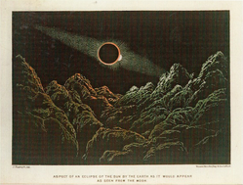
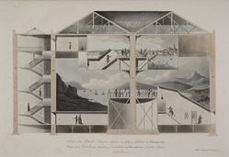
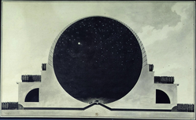
fig. 28 | Etienne-Louis Boullée’s Cenotaph for Isaac Newton
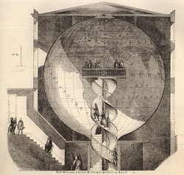
fig. 29 | Charles Delanglard’s Georama
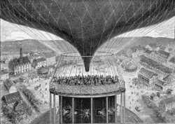
fig. 31 | Raoul Grimion-Sanson’s Cinéorama
fig. 27 | Robert Barker’s Panorama
fig. 32 | James Nasmyth’s Sun eclipsed by the Earth
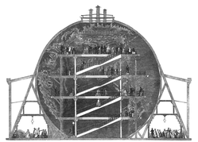
fig. 30 | James Wyld’s Great Globe
← previous page | next page →

Spheres
In my own research, I wanted a greater degree of abstraction than the rectangular frame of a photograph could offer. The different perspectives from the camera obscura, the panorama pavilion, the Géorama, the Cinéorama, and the sketches of James Nasmyth offered more interesting possibilities. I started photographing panoramic landscapes in the round. These digital panoramic photographs were taken with an 8mm wide-angle camera and a special tripod equipped with a Nodal Ninja, which allows 360-degree pivoting without horizontal discrepancies. With six photographs recorded — four in the round, one from the sky, and one from the ground — a full photosphere of 360 x 180 degrees can be stitched together in one equirectangular panorama, using a software program such as PTGui.
With a full panoramic photosphere, different perspectives can then be explored. For instance, the photosphere can be rolled out as a flat image and viewed as a rectangular photograph. From there, the panorama can be folded back into a sphere, which you can view from within, much like the photographer’s point of view, or from outside, as from a lunar perspective. It could also be viewed as a disc, commonly referred to as a ‘little planet’ and prefigured as a format in the 1850s by the photographer Eugène Viollet-Le-Duc. Of most interest to me was a lunar perspective, in which the folded sphere is viewed from the outside. This is something entirely different to little planet discs. The lunar perspective turns the photosphere into an object, into a panoramic orb.
Proceeding from this point onwards, I applied to the photosphere the same logarithm in Cinema 4D, translating the light contrasts into depth. This gave an entirely different form when rendered: the skeleton of a tarpaper shack, with its clear lines intersecting rocky foregrounds. [fig. 33] An abandoned train tunnel as an elliptical form. [fig. 34] A roundabout with a public sculpture featuring five rusty palm trees becomes entirely abstract, except for the palm trees. [fig. 35] All these places photographed held special meaning and memories connected to my family history, but they were also intended to influence the eventual shape of the sphere’s relief. The beams of the tarpaper shack drew strong lines in the eventual object. The train tunnel became a dark, covered space with bright light at both ends. The roundabout’s palm trees translated beautifully, carved deeply and clearly into the object, while the circular form of the roundabout corresponded perfectly with the circles of the sphere.
The next step was printing these image files into objects. I printed an example in plastic, 20 cm in diameter, with a high-end 3D printer. It was based on a photograph of a forest, with a vantage point located between the trees. [fig. 36] The panoramic photograph of the dense forest became an object shaped like a star, the treetops turned into a wild landscape of spikes. [fig. 37] It was, however, so detailed and fragile, that a cast in bronze proved impossible. And plastic as an end result was not desirable, for the same reason as Photographer was cast in bronze — to emphasise its sculptural nature and to give the object both a physical and psychological weight in its perception.
Therefore, I experimented with printing these spheres in titanium. Titanium printers are the most precise printers available and are able to build up complex self-supporting forms. The natural appearance of the printable alloy provided the necessary strength and weight. The original panorama photograph contained a landscape with a road and a flat field with overhanging trees on one side; on the other side was a clearly identifiable tree on the distant horizon. It was an interesting panorama, since it offered such a heterogeneous composition of different landscapes in one image. [fig. 38] When it became an object, it rendered the photographed landscape nearly unrecognizable. Fluffy clouds became mountain ridges on a sea of sky, the horizon an abyss, the nearby forest an almost unprintable frenzy of deep lines. A rare identifiable feature in this experiment was a naked poplar tree from the foreground. The result, 51°00’15.4“N x 5°24’01.3”E, was a photograph that has been converted from two to three dimensions. It is a 360 x 180-degree panoramic photograph of a landscape that has been translated into depth. The landscape is seemingly carved into the surface, varying in depth according to their brightness in the original image. This image-as-sculptural-form, which gleans its title from the photograph’s geographic coordinates, carries the idea of photo-sculptures to an extreme conclusion. Once translated and materialised, these titanium orbs looked like little stars. Like a sun shaped by its own light. The outcome is a solidified photograph of landscape and memory. [fig. 39]
← previous page | next page →
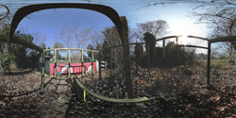

fig. 33 | 360° x 180° photosphere of a tarpaper shack in my father’s garden and its 3D conversion in Cinema 4D
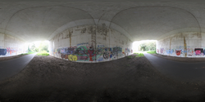
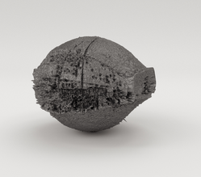
fig. 34 | 360° x 180° photosphere of a train tunnel in the village and digital render of its 3D conversion
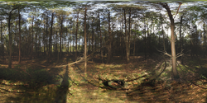
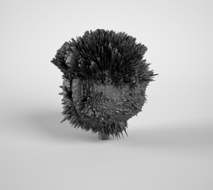
fig. 36 | 360° x 180° photosphere of a forest and digital render of its 3D conversion
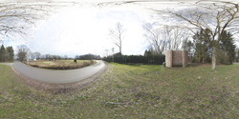
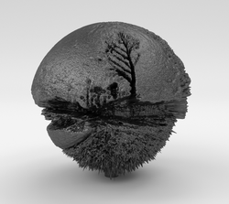
fig. 38 | 360° x 180° photosphere of a road with tree and digital render of its 3D conversion
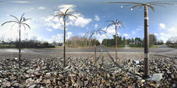
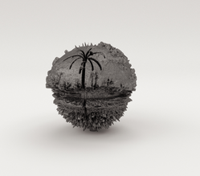
fig. 35 | 360° x 180° photosphere of a roundabout sculpture in the village and digital render of its 3D conversion
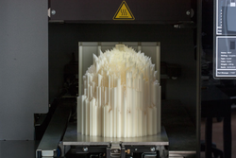
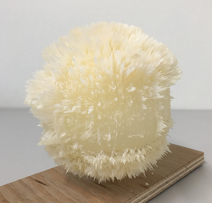
fig. 37 | 3D print in plastic of the photosphere, from 3D printer to finished model
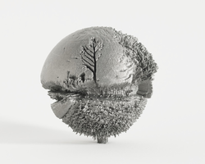
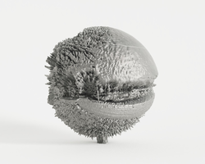
fig. 39 | 3D print in titanium of the photosphere, seen from two sides
← previous page | back to start →

Lodestar (Conclusion)
With the widespread use of digital media, the photograph has mutated once again. No longer simply a combination of image and its physical support, the photograph has become a multiplicity of objects, ranging from ephemeral images to photographic installations or the fluid materiality of binary code. The principle of photography has expanded beyond any preconceived limits and has permeated every aspect of life. A 360-degree photographic environment surrounds us at all times. Art and architecture are now completely premeditated by computer-generated images — even photography itself is.
Today, this digital image complex is leading many artists to experiment with old photographic techniques in search of new photographic materialities. A whole generation of artists are creating hybrid photographic installations: Wolfgang Tillmans’s experimental prints and exhibition strategies, Tacita Dean’s nostalgic Super 8 film, Dirk Braeckman’s painted photographs, Runa Islam’s recycled silver-salt sculptures, Sarah Vanderbeek’s photo-installations, or Johan Österholm’s collodion glass plate pavilions. All of these visual artists have been in search of a new pictorial objecthood — not only in old techniques, but also the newest digital inventions, which allow even more precise experimentation with the materiality of photography. Take, for instance, Simon Starling’s 3D blowups of photosensitive silver-salt particles or David Claerbout’s experiments with 360-degree digital panoramas. These artists’ works all share an unexpected emphasis on photography’s material qualities and objecthood, and many of these projects originate from very personal stories.
Through artistic research, I hope to construct an operation manual that develops new forms of photography out of the little-known history and work of artists such as Willème. This is my sincere interest and the true purpose of artistic research: to instigate new and unexpected experiments in the visual art practice. Through additive manufacturing (or 3D print), a photograph can now become a whole lot of matter. A photograph can materialise in an entirely different and unprecedented form, becoming a sculpture. Likewise, a sculpture can become a photograph. And like the passage of a photograph into an object, a fact can shift into an artifact. This sculpture can turn an emotional image into an abstract object, hiding and bolstering its subject matter. [fig. 40] [fig. 41] [fig. 42] [fig. 43]
My historical research has steered my visual practice and ultimately returned me to the photograph’s emotional content. I began this series in an attempt to sublimate sorrow, but over time I felt the need to emphasise, rather than mask, the vulnerability embedded in some of the original images. In combination with my metallic spheres, I started to design photographic installations: large prints, self-designed frames, fragile papers. Some frames are curved and reference panorama paintings. In Eclipse, the crooked path is pulled towards the viewer. [fig. 44] The curved frame of Double Sun strengthens the mirror effect of the image. [fig. 45] In Hololool, the curved frame draws more attention to the large bonfire and activates the dark corners, while pulling the spectator inside the work. [fig. 46] [fig. 47] I also re-photographed the tarpaper shack to make a second version of it: a life-size, deconstructed version of the original. This photographic environment offers yet another view: that of being inside a panoramic sphere rather than looked upon. [fig. 48] [fig. 49] Together with the 3D titanium prints, different meanings and perspectives of this story are presented. They coexist within exhibitions and support one another by providing different points of view and interpretation — of photographic perspectives as well as on my stages of grief. [fig. 50]
Sunville became an aperture, through which these images of look-back time were projected in a ray of light through the eye into the darkest chamber — of both the camera obscura and the mind itself. ‘Photography authenticates the existence of a certain being,’ Roland Barthes wrote. ‘The photograph is literally an emanation of the referent. From a real body, which was there, proceed radiations which ultimately touch me, who am here; the duration of the transmission is insignificant; the photograph of the missing being will touch me like the delayed rays of a star.’¹
For me, the coincidental event of the partial solar eclipse in Sunville mediated this regression into my past, acting as something between a eulogy and a metaphor about photography — with the sun as its protagonist. The crescent-shaped image of the sun is intrinsically part of the photographic phenomenon of the camera obscura, since it was discovered when the image of the sun in partial eclipse projected its shadow version through the leaves of a tree. And so, this new series intuitively became research into the peripheries of lens-based media and the objecthood of the photographic surface.

¹ Barthes, Roland, Camera Lucida: Reflections on Photography, (London: Vintage Books, 2000).
← previous page | back to start →
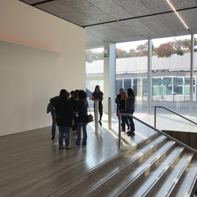
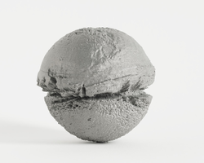
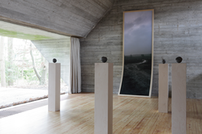
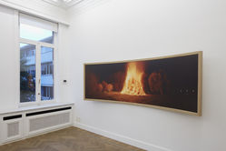
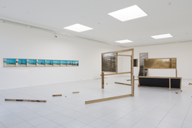
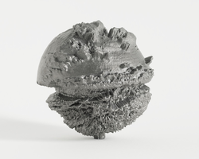
fig. 40 | 50°57’11“N × 5°27’05”E
fig. 41 | 50°58’18.9“N × 5°26’57.1”E
fig. 44 | Eclipse and 3D prints at Woning van Wassenhove, Deurle, Belgium, 2015. Installation view by Rik Vannevel
fig. 46 | Hololool and Sequence #3 (Wedding Party) at Sofie Van De Velde Gallery, Antwerp, Belgium, 2017. Installation view by Jan Kempenaers
fig. 48 | Nude Beach Bound, Tar Paper Shack and Eclipse at Museum Dhondt-Dhaenens, Deurle, Belgium, 2018. Installation view by Rik Vannevel
fig. 50 | Four 3D-prints at Prada Foundation Milan, 2018.
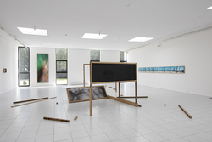
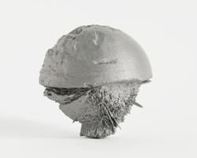
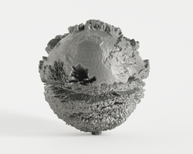
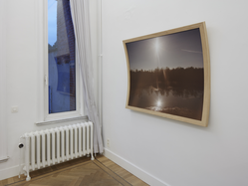
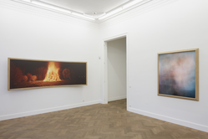
[TABLE]
[TABLE]
fig. 45 | Double Sun at Sofie Van De Velde Gallery, Antwerp, Belgium, 2017. Installation view by Jan Kempenaers
fig. 49 | Camellia, Tar Paper Shack and Nude Beach Bound at Museum Dhondt-Dhaenens, Deurle, Belgium, 2018. Installation view by Jan Kempenaers
fig. 47 | Hololool at Sofie Van De Velde Gallery, Antwerp, Belgium, 2017. Installation view by Jan Kempenaers

