TELANGANA

* ANKUSH WELFARE SOCIETY

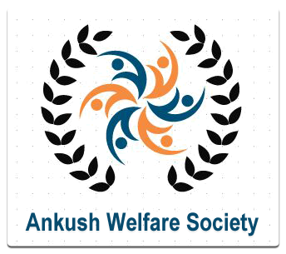

 Ankush Welfare Society has a very strong goal of improving the Educational awareness among the rural people, child labour elimination & mainstreaming, non formal education for the above school ages. Identification of drop outs-establishing the bridge course center for their mainstreaming. Women welfare & child development activities. Old age persons welfare activities. Widows & orphans women care & support. Handicapped welfare. Income generating training for the youth through providing education, giving care, love and support, Strive to provide opportunities and made them self reliant. Additionally, it promotes empowerment of rural community people in various areas affecting humanity.

**PHONE: +91.9494362639**

**EMAIL:**[info@ankushwelfaresociety.org](mailto:info@ankushwelfaresociety.org)

**Website:** <http://www.ankushwelfaresociety.org>

**Address:** H.No. 4-109, Ramnagar Quarters  
 Near Shivalayam Dasnapur  
 Adilabad (Dist.), Telangana. INDIA

* ARANYA AGRICULTURE ALTERNATIVES



“ARANYA” aims to provide alternative solutions to the present conventional and chemical agricultural practices.  Since forest is the mother of agriculture, ARANYA is committed to follow the philosophy of natural agricultural practices with focus on forest farming so as to take up production without causing destruction to planet earth, enabling all life forms to coexist. To achieve sustainable development on our Earth, mankind must act only in accordance with nature.  ARANYA strongly  believes that there is only one law i.e., Nature’s Law and  human beings should not extract anything beyond their needs  from the nature and also should  return whatever that remains unused   back to nature, a law which can be stated as LAW OF RETURNS to increase the ability of sustainable production.

**PHONE: 9440826722**

**EMAIL:**permanent.agriculture@gmail.com

**Website:** <http://permacultureindia.org>

**Address:** Flat No. 203, Sony Sai Kuteer,, Thyagaraya Nagar, Kothapet, Hyderabad, Telangana 500035

* Shantiniketan empowering differently abled



**MISSION:**  
To sensitize the general community, Govt. and non-Govt. organizations, and parents of Special need children and provide evidence based primary and higher education to those differently abled children through expanding the services, manpower, as well as the research and development programs in the field of Disability & rehabilitation.

**PHONE:** **01191 (9440234118), 8341249333.**

**EMAIL:** shantiniketanadb@gmail.com

**Website:** http://shantiniketanadb.org

**Address:** Kondapur, Mdl: Nirmal, Dist: Adilabad, Telangana, India

* SERVICE WITH A SMILE

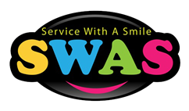

**Main mottos include:**

**--> To cause real happiness in the minds of ailing**

**patients.. And to extend at most compassion to the**

**BLINDNESS by giving the eyes of ailing patients who are about to die..thus, the life of blind person would Stand in day-to-day life and they would feel natural happiness and the person who is about to die (donated person) being human virtues he will gain the perfect contentment in his next birth...**

**--> To feed the people who have been left uncared of the society.. Spread Love wherever you go.**

**PHONE:** +91 9652707125

**EMAIL:** karingulapranay@gmail.com

**Website:** https://swas.webs.com

**Address:** Dist: Adilabad, Telangana, India

* Adarana- Home for underprivileged and needy children

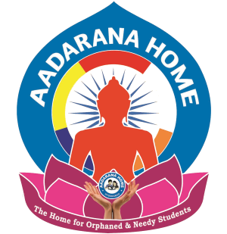

Today millions of children are deprived of their childhood rights- right to live, right to education. Their childhood dreams are shattered because of their poverty.

These hapless children are forced to child labour. The environment in which they work prompts them to nurse a grudge against the cruelty of their masters and the unkind society at large. Slowly they take to vices and finally are driven to the world of crime. This is the unfortunate scourge of our society.

These children of circumstances should be lifted from the gutters and hugged with much love and care. Thus AADARANA founded by Sri.Jadi Madhava Rao who had been nursing a sincere desire to help these poor souls to become respectable citizens in future.

AADARANA picks these unlucky kids up, free them from child labor, and also the children rotting in gutters and undesirable environments. They are given love and protection, food and shelter, education and careers and ushered into respectable lives.

**PHONE:** (+91) 800800 5535, (+91) 9346 005469

**EMAIL:**  contact@aadarana.org  
 madhavarao@aadarana.org

**Website:** https://www.aadarana.org

**Address:** Plot No.74, Krishna Nagar Colony,  Saroor Nagar, Hyderabad- 500074.

* Aashayein Foundation



Aashayein Foundation recognizes the vitality of quality education in the growth and development of every individual, community, country, and even the world. Education is a key element in constituting the society, which keeps it healthy and well nourished. The various activities of the foundation are directly aimed at achieving this – access to quality education.

**PHONE:** (+91) 800800 5535, (+91) 9346 005469

**EMAIL:**[info.hyd@aashayeinfoundation.org](mailto:info.hyd@aashayeinfoundation.org)  or

[suyash.chopra@aashayeinfoundation.org](mailto:suyash.chopra@aashayeinfoundation.org)

**Website:** [aashayeinfoundation.org](http://aashayeinfoundation.org/)

**Address:** [Bangalore](https://en.wikipedia.org/wiki/Bangalore), [Hyderabad](https://en.wikipedia.org/wiki/Hyderabad,_India) [India](https://en.wikipedia.org/wiki/India)

* Abhaya association for empowerment of women

Abhaya NGO

Registered under The society act 1956, Abhaya, was formed as a non-profit organization with the aim to do their best for the needy in the society. Abhaya innovates and evolves, trying out novel concepts that are continuously refined and scaled up to cover larger groups of disadvantaged populations.  
Abhaya provides help to people without prejudice to caste, creed, sex, race or religion or economic status with major emphasis on educating to empower women for earning a decent income through vocational skills.

**PHONE:** 040- 27133813[abhayaforwomen@gmail.com](mailto:abhayaforwomen@gmail.com)

**EMAIL:abhayaforwomen@gmail.com**

**Website:** <http://abhayango.org>

**Address:** Plot No 80, 1-8-2, North X Road, 27, Ayyappa Swamy Temple Rd, South Kamala Nagar, ECIL, Kushaiguda Industrial Area, Moula Ali, Hyderabad, Telangana 500062

* Abhilasha research center for special needs children society

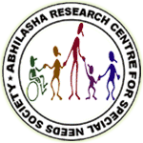

 mission is to provide the highest quality education and therapeutic programming available to the children with multiple disabilities. We want to help children with special needs maximize their potential by providing effective therapy programs that increase independence, develop and enhance functional skills, and accelerate progress.

**PHONE:** +91 9701948444

**EMAIL:** [abhilashaspecialkids@gmail.com](mailto:abhilashaspecialkids@gmail.com)

abhilashakids@gmail.com

**Website:** [www.abhilashakids.com](http://www.abhilashakids.com)

**Address:** H.No:27, Asbestos Staff Colony, Opp: Kharkhana KFC, Behind HDFC Bank, Vikrampuri, Secunderabad-09

* ACT seven international

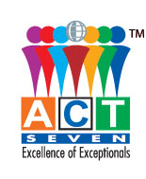

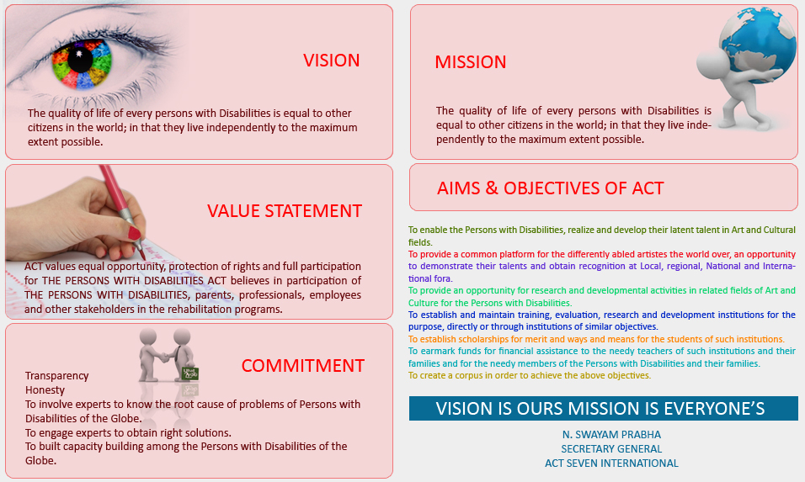

**PHONE:** +91-40-2333 6666

**EMAIL:** actseven.org@gmail.com

**Website:** www.actseveninternational.org

**Address:** C-12, second floor, Maheshwari towers, Road no.-1, Banjara hills, Hydrabad- 500 034

* Action for food production



The Aim of the Society is development of weaker sections of rural community and to move towards sustainable development through overall increase in their knowledge and skills, in the areas which directly affect their standard and quality of life

**PHONE:** 91-40-27150413/2717042

**EMAIL:** aro.hyd@afpro.org

**Website:** http://www.afpro.org

**Address:** 1-3-29/5,Nandanvan Colony Street No.4, Habsiguda, Hyderabad-500 007 Andhra Pradesh

* **Aim education and research society**



To eradicate the evilness of donation and capitations from Primary Educational Level to Higher Educational Level and merit is followed to spread education among masses, particularly the poorest of the poor in the Welfare State through knowledge creation.

**PHONE:** 09140 – 64526515, 9160295725

**EMAIL:** [aim_ea@yahoo.co.in](http://www.aimers.in/contactus.html)

[Info@aimacademy.co.in](http://www.aimers.in/contactus.html)

**Website:** http://www.aimers.in

**Address:** 208, SAKINA COMPLEX, MEHDIPATNAM – HYDERABAD – 28 (AP)

* Amma social welfare association (ASWA)



**“Taking up activities to imbibe ‘Giving back to society” is**

**everyone’s responsibility, Promoting ‘Love All- Serve All”**

**through activities which helps people who are uncared,**

**need of economical and  emotional support, Organizing**

**activities to counter illiteracy among people all stages,**

**involving society in making green environment, making**

**determined citizens by applying 360o dream plan of ASWA”**

**PHONE:** 9948885111

**EMAIL:** [amma.aswa@gmail.com](mailto:amma.aswa@gmail.com)

**Website:** www.aswa.co.in

**Address:**

* Andhra Pradesh mahila abhivruthi society



The first step in our 17 years of journey was supporting women SHG movement in the erstwhile Andhra Pradesh in 2001 and across several states in the country. The credibility gained in terms of building social capital through strengthening of rural and urban SHGs provided an impetus to empower the poor and marginalized communities through promotion of livelihoods, natural resources management, integrated farming systems, farmer producer organizations, and model villages besides reaching out to a few developing countries (Bangladesh, Ethiopia, Thailand, Myanmar and Vietnam).

Currently we have direct field presence in the states of Telangana, Andhra Pradesh and Bihar and through SHPIs (self-help promoting institutions) in Rajasthan, Uttar Pradesh and Maharashtra. Whereas, the focus of our capacity building initiatives and Research & Advocacy is in several states across and outside the country. The programmes that are currently being implemented could be categorized into three major streams

**PHONE:** +91 - 8413 - 403118 /120

**EMAIL:** [info@apmas.org](mailto:info@apmas.org)

**Website:** http://www.apmas.org

**Address:** APMAS Plot 11 & 12, HIG, HUDA Colony, Tanesha Nagar, Near Dream Valley, Manikonda, Hyderabad 500089.

* People for animals



From 1990 to present, PFA Hyderabad’s founding members have been incessantly involved in animal welfare, animal rights and cruelty prevention. They have taken massive strides towards a more humane Hyderabad.

**PHONE:**[7337450641](tel:+917337450641)

**EMAIL:**:

**Website** : https://pfahyd.org

**Address:**  5-4-72, Opp. Sundaram Motors, M.G. Road, Ranigunj, Secunderabad – 500003

* **Ankuram- women and child development society**



1. Prevents child and woman trafficking; \rehabilitate and reintegrate those children & women who are subjected to various forms of abuse, exploitation and violence and trafficking.

2. Assisting organisations to Establish transit \shelter home \ resource centres for girls and women, ensuring care and support.

3. Create awareness among communities especially girls,women and vulnerable sections ; build their capacities and provided skills trainings to assert their rights, and to become self-reliant individuals.

**PHONE:** +91 9494 94 86 96

**EMAIL:**: ankuram@yahoo.com

**Website** : http://www.ankuram.in

**Address:** Government area hospital  
 Kondapur,Sreeram Nagar,  
 Hyderabad-500084,  
 Telangana, India.

* Shaheen women’s resource and welfare association



The Mission of Shaheen is to create greater consciousness of the gender and socio-religious oppression in the society. In particular, looking at how these issues have developed in our history and how they are affecting our politics today.

**PHONE:** + 91-40-2438 6994

**EMAIL:**: [jameelanishat@gmail.com](mailto:contact@electrohomeopathy.co.in)

**Website** : http://shaheencollective.org

**Address:** H. No. 23-3-540, Baqshi Bazar,  
                      Sultan Shahi, Old City  
                     Hyderabad – 500 265

* Anuraag Human services



In The History of social service activities saw the beginning of a small effort by a group of professionals who together floated an organization to serve needy Destitute Disabled, Women, Children and Aged persons. This small effort which began with rehabilitation service for 3 Disabled persons in small shed has grown in leaps and bound, with a great deal of support from many well-wishers to the present status. The unending guidance and support of all the welfare oriented persons who are associated with us, has been the back bone which neither bent nor broke, over these years of hurdles and pit falls faced by the management and executed team. We are extremely thankful to God and the dedicated persons associated in helping the organization grow and shine in all its radiant colours as a well-established non-profit service organization. The ensuing paragraphs give a gist of all service programs of the organization.

**PHONE:** +91 40-23569799 / 23560993  
 +91 9392040300 / 9391008292

**EMAIL:**: [anuraaghumanservices@yahoo.com](mailto:anuraaghumanservices@yahoo.com)

[thoota_madhav@yahoo.com](mailto:thoota_madhav@yahoo.com)

**Website** : http://www.anuraaghumanservice.org

**Address:**  No. 9-4-136/B, Qutub Shahi Tombs Road, Anuraag Colony, Toli Chowki,  
 Hyderabad-500 008,India.

* Anveshi research centre for women’s studies



Anveshi was set up in 1985 in Hyderabad by a small group of activist-scholars to provide resources to research and develop a feminist theory relevant to women’s lives in contemporary India. Today we are one of the foremost non-university research centers in India. Our work focuses on six research initiatives: education; health and health care systems; law and critical legal theory; dalits and minorities; development; and public domain. Projects in these initiatives examine the shifts in development theory; the crisis of medicine in the Indian context; hegemonic perspectives in school textbooks; the question of secularism and minority in Indian politics; the problematic nature of law and rights in domestic violence; and thinking about what it entails to be a ‘Dalit woman’ in modern India.

**PHONE:**  91 40 27423690/3168

**EMAIL:**: [anveshirc@gmail.com](mailto:anveshirc@gmail.com)

**Website** : http://www.anveshi.org.in

**Address** : 2-2-18/2/A, Durgabai Deshmukh Colony,

Bagh Amberpet, Hyderabad, Telangana,

India, PIN:500013

* + Aware- Action for welfare and awakening in rural environment



One unique nature of AWARE’s program is that it does not work in a particular area for more than 8-10 years. It initially motivates the people in process of development by

* Helping them to organize themselves by promoting and protecting human rights and gender justice
* Educating people to understand their rights and responsibilities
* Providing training in leadership, skills development, agriculture, animal husbandry
* Assisting in growing more food
* Generating employment and better income realization
* Offering Health support,  Legal support and Environment education

**PHONE:**  9177771521

**EMAIL:**: [ed@aware-group.com](mailto:ed@aware-group.com), [info@aware-group.com](mailto:info@aware-group.com)

**Website** : http://aware-group.com

**Address** : HNO:5-9-24/78  
 LAKE HILL ROAD,  
 ADHARSH NAGAR,  
 HYDERABAD-500063.

* Ashray Akruti



Ashray Akruti’s project ‘Cochlear Implant Surgery’ is mainstreaming many hearing impaired children by the gift of hearing through free Cochlear Implant surgery. Ashray Akruti has executed this project with the help of Max foundation, Hans foundation, Vijaya Diagnostics-Hyderabad, AYJNIHH- Mumbai and Ministry Of Social Justice and Empowerment.

The younger the kid receives an implant the easier for him or her to listen and speak. Till Now, Ashray Akruti supported 20 cochlear Implants. The cochlear implant enables the sound to be transferred to hearing nerves and enables to hear. It helps the children to gain hearing and develop speech and language.

**PHONE:**  040-4004 2250

**EMAIL:**: [ashrayakruti@yahoo.com](mailto:ashrayakruti@yahoo.com)

**Website** : http://ashrayakruti.org

**Address** : 8-3-1027/A2, Lane Opp,To Indian Bank,Srinagar Colony,

Hyderabad-500 073.

* Ashrita Bio foundation



Ashrita Bio Foundation was established in the year 2010 initially as a help desk supporting Academic students & scholars in various activities like projects, training programs, awareness programs & extended services to Corporate and Government sector through Industry facilitating the skills & knowledge with a concept of Advocacy, Consultancy, Training, Awareness & Project Management in the domain of Life Sciences, Environment, Science & Technology to meet the existing challenges and latest technological trends to fill in the skill gaps & knowledge gaps.

**PHONE:** +91 7675050534

**EMAIL:**: [info@ashritabiofoundation.org](mailto:ceo@ashritabiofoundation.org) or [sushanth@ashritabiofoundation.org](mailto:sushanth@ashritabiofoundation.org)

**Website** : http://ashritabiofoundation.org

**Address** : Ashrita Villa # 45, Nakshatra Enclave, Sidhanthi, Shamshabad, Telangana- 501218, India.

* Association for social health in india



Shelter

There are hundreds of women of all ages who are either thrown out of their families or are forced to leave their homes. ASHI takes them in its fold through its various centres and helps them regain self esteem and self confidence. Different homes are being run by ASHI:

Short Stay Homes

Shelter Home

Old Age Home

Half-Way Home

Children’s Home

Juvenile Guidance centre

Creche Centres

Nursery and Primary Schools

**PHONE:** 91-11-23233428, 23232209

**EMAIL:**: [ashidelhi@hotmail.com](mailto:ashidelhi@hotmail.com)

**Website** : http://www.ashiindia.org

**Address:**19,Rouse Avenue Institutional Area,  
 New Delhi 110002 (INDIA)

* Society for integrated development urban and rural areas (SIDUR)

Sidur India Organises health awareness among the rural, 
        We organized Medical camps, AIDS and TB awareness camps in various places of A.P and Telangana

SIDUR came into existence in the year 1990 to address the problems plaguing Street Children, Urban and Rural Poor and Dalits.

**Major projects include:**

HIV/AIDS Prevention and control

Childline Programme

Street Children Rehabilitation

Slum Development Programme

Water and Sanitation

Dalit Empowerment Programme

Community Based Rehabilitation

Braille Book Production

Housing for weaker sections in 5 coastal districts

NGO Facilitation

**PHONE:** +91 -040-66368110

**EMAIL:**: info@sidurindia.org

**Website** : www.sidurindia.org

**Address:** 144/2RT, Vijayanagar Colony, Hyderabad-500 057

* Blood Cross society



"Blood Cross Society" Services play a critical role all over the World's Blood, Education, Orphans, Old age and Health care systems.

The "BLOOD CROSS SOCIETY" empowers ordinary people to perform extraordinary acts of service. They share one thing – a generous spirit, a desire to give back to their community and help others. They play an integral role in the delivery of modern healthcare; we call them "Gods”.

The "BLOOD CROSS SOCIETY" relies on its proud blood donors and those, whose lives were changed by receiving donated blood, to help inspire those around them to join this cause by making blood donation a regular part of their lives. The "BLOOD CROSS SOCIETY" provides blood donors.

**PHONE:** [(+91)-9491913752.](http://bloodcrosssociety.com/contact.php)

**EMAIL:**: [Info@bloodcrosssociety.com](mailto:)

**Website** : http://bloodcrosssociety.com

**Address:** H.No.5-2-340, Plot No.19, Blood Cross Society Building, Gayatri Nagar, Bank Colony, Vanasthalipuram, Hyderabad - 500 070, Telangana, India.

* Byrraju Foundation



To realize our responsibility towards the rural underprivileged and constantly strive to enable them to achieve self reliance.

|  |
| --- |
| The Foundation has adopted Six Sigma as its core management framework as it: |
| http://byrrajufoundation.org/images/spacer.gif |
| |  |  | | --- | --- | | **»** | Is the best of the frameworks for designing new processes and making breakthrough improvements to existing processes. | | **»** | Ensures robustness of processes and reduces variation, cycle time and defects. | | **»** | Helps in innovating, predicting and consistently delivering what the customer (beneficiary) expects | |

**PHONE:** +91-40-23191725

**EMAIL:**:  **[mail@byrrajufoundation.org](mailto:mail@byrrajufoundation.org)**

**Website** : https://www.byrrajufoundation.org

**Address:** Satyam Enclave   
 2-74, Jeedimetla Village, NH-7   
 Hyderabad-500 055    
 Andhra Pradesh, India

* CADRE- centre for action on disabled rights and empowerment



**Mission:**

To play a catalyst role in creating development opportunities for the most marginalized and deprived communities by building their capacities to assert their Constitutional rights and entitlements.

**Aim:**

The aim of the organization is to empower the poor and the most deprived communities through the initiatives on access to quality education, promoting child rights, health, nutrition, skills & livelihood development, women empowerment and creating awareness and facilitating linkages to the rights and entitlements. 

**Our Approach:**

* Ascertaining Community Ownership
* Ensuring Equal opportunities
* Participatory approach in decision making
* Ensure Accountable and Transparent Practices

**PHONE:** +91.8885512035

**EMAIL:**:  cadreindiafoundation@gmail.com

**Website** : www.cadreindia.org

**Address:** #3-35, 2nd Floor  
 Besides Tata Motors Uppal, Hyderabad - 500039  
 Telangana, India

* Peace welfare society



**The Peace welfare Society has its specific approach in undertaking development programmes for the poor and rural People. It may be recalled that the rural and remote area people were culturally strong and they repose highest confidence on their cultural practices.In the contemporary situation of Information Technology and Faster Growth perspectives, one has to understand the value system prevailing in rural areas and then understand the current situation through that perspective.Then, it provides an opportunity to chalk safe path for development to the rural people.**

**PHONE:** 9912276429.

**EMAIL:**:

**Website** : http://www.peacewelfaresociety.org

**Address:** Peace Welfare Society,  
 C-788,N.G.O's Colony,  
 Vanasthalipuram,  
 Hyderabad-500 070

* Cause an effect foundation



|  |  |
| --- | --- |
| |  | | --- | | Cause an Effect Foundation is an award winning Not-for-Profit organization with international repute focusing on Health & Nutrition, Childcare & Education, Sustainable Livelihood, Agriculture, Disability and Animal Care. The Foundation operates by harnessing the potential of ICT (Information & Communication Technology) for sustainable & equitable development, to enable the poor and the marginalized communities to transform their lives. The Charter of the Foundation is a 360 degree addressal of their socio-economic needs. Cause an Effect works with its strong partner base to have a wider reach and access at the grass root level. | |

**PHONE:** + 91 9703222225

**EMAIL:**:  i[nfo@causeaneffect.org](mailto:info@causeaneffect.org)

**Website** : http://causeaneffect.org

**Address:** 8-3-1084/1&1A   
 Srinagar Colony  
 Hyderabad - 500073  
 India

* Centre for development and research



Centre for Development and Research (CDR) is a registered, not for profit organisation working for the development of tribal communities in the State of Andhra Pradesh, since 1983.  
  
CDR started its work in 1983 by assisting the tribal communities in 41 villages of Jainoor and Sirpur (U) mandals in Adilabad District in identifying and executing drought relief works. CDR also was instrumental in preparation of people centered village development documents that were presented to the government. The government, perhaps for the first time, had the opportunity to participate in a programme designed and implemented by the people. The programme was drawn up in all the 41 villages as per the priorities decided by the community. This decentralized people owned village development experience was influential later in formulation of the community centered Janma Bhoomi programme implemented by the then Government of Andhra Pradesh, during the years 1994 - 2003.

**PHONE:** 040 - 2715 0965

**EMAIL:**:   [director@ceedeer.org](mailto:director@ceedeer.org)

**Website** : http://www.ceedeer.org

**Address:** # 12, Madhuvan Enclave   
 Street No.4,  Habsiguda   
 Hyderabad - 500 007,AP, INDIA