Question 1

Part A

1. SQuirrel SQL Client
2. It is a graphical SQL client written in Java
3. It has 415,115 lines of java and 433,855 total lines.

We calculated this using the SLOCCount package. The command was $sloccount .

Part B

1. See attached paper
2. It checks file names for the names of design patterns.
3. It is probably close to correct because this particular program appears to use proper file naming convention and has the design patterns being used in the file name.

Question 2

1. I used the file upload feature on github.com
   1. 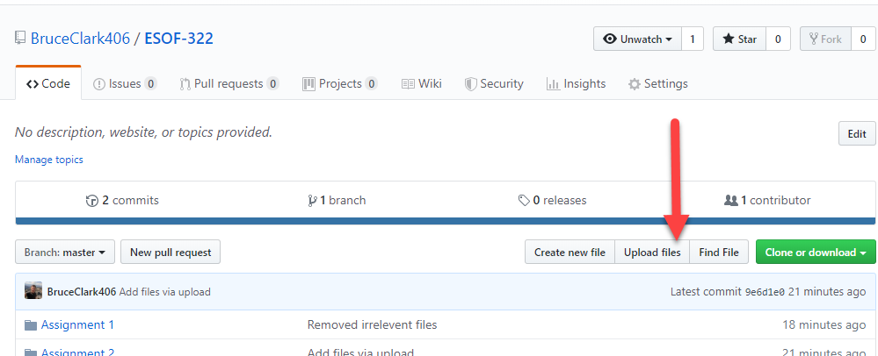
   2. 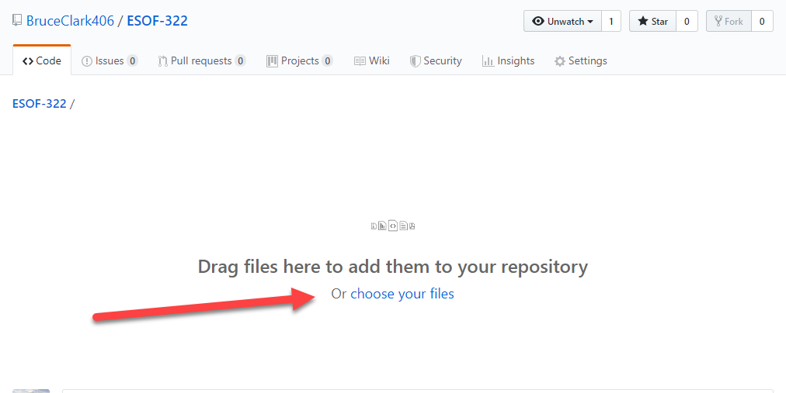
2. Added a file (MyAnswers.docx) to my local machine
   1. 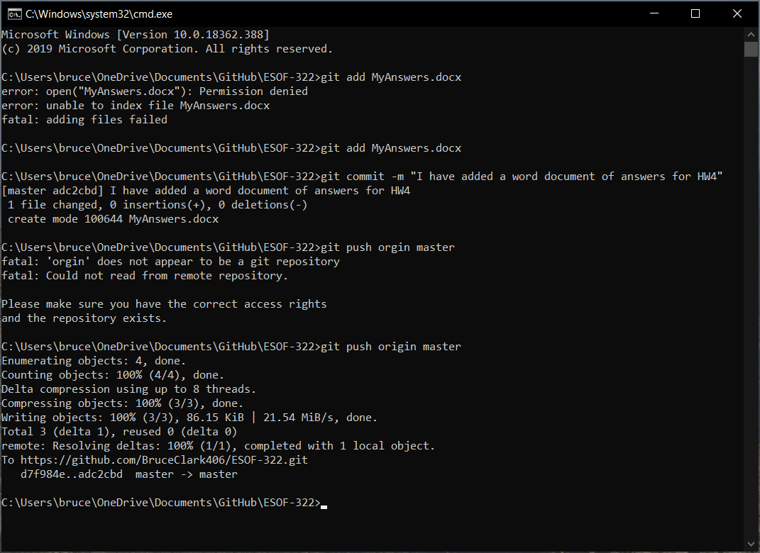
   2. add MyAnswers.docs
   3. git commit -m “I have added a word document do answers for HW4”
   4. git push origin master
   5. 