A Multimodal EEG-Peripheral Analysis of the Affective Pacman Dataset
Introduction
Brain-computer interfaces (BCIs) translate neural signals into commands for external devices, opening communication channels for both clinical and healthy populations (Wolpaw et al., 2002). The three canonical BCI paradigm categories (reactive, active, and passive) share a common limitation: their classification algorithms rely on the assumption that EEG signal statistics remain stationary across calibration and deployment sessions (Blankertz et al., 2007; Krauledat et al., 2006). In practice, this assumption is routinely violated because diverse mental states such as fatigue, arousal, frustration, and distraction continuously modulate the spectral and temporal structure of the recorded EEG in ways that are unaccounted for by single-state BCI models (Myrden & Chau, 2015).
The practical consequence is a performance degradation feedback loop: a malfunctioning BCI induces frustration in the user, which in turn further distorts the EEG features the BCI relies upon (Reuderink et al., 2011). Understanding the precise neural signatures of these contextual user states is therefore a prerequisite for designing robust, real-world BCI systems.

Loss of control (LOC) is an experimentally controllable complex user state that encompasses cognitive, affective, and motivational components simultaneously. The prototypical paradigm, used in its original form by Jatzev et al. (2008) and subsequently refined by Zander and Jatzev (2012) and adapted by Reuderink et al. (2011, 2009), introduces unexpected system failures during an otherwise controllable task. In the Rotation-Left-Right (RLR) variant, rule-violation trials where the game ignores color-angle mappings occurred at up to 30% probability, forcing subjects into a novel problem state without a clear corrective strategy (Grissmann et al., 2017). In the Affective Pacman (AffPac) variant used in the dataset analyzed here, 15% of keystrokes were randomly ignored and visual lag was introduced, creating a subjectively frustrating gaming experience validated through self-assessment manikin (SAM) ratings on valence, arousal, and dominance dimensions (Bradley & Lang, 1994; Reuderink et al., 2011).
Reuderink et al. (2011) reported a counterintuitive finding: contrary to the expectation that LOC would degrade ERD-based BCI classifier performance, the event-related desynchronization (ERD) classifiers actually performed significantly better during LOC blocks. This improvement was attributed to a shift in the user's attentional focus from the game context during normal play to the hand movements themselves during LOC which intensified the cortical desynchronization signature and improved classifier separability. For ERP-based (lateralized readiness potential) classifiers, no significant difference was found between conditions, a result later confirmed by the group's own replication efforts.
Frontal Alpha Asymmetry (FAA), the difference in log-transformed alpha power between right and left frontal regions, is a well-established biomarker of affective processing. Davidson (1992) pioneered the hemispheric asymmetry model, associating left frontal activation (right alpha suppression, negative FAA) with approach-related motivation and positive valence, while right frontal activation (left alpha suppression, positive FAA) characterizes avoidance, withdrawal, and emotional suppression. Demaree et al. (2005) extended this to the dominance dimension, proposing that FAA specifically captures feelings of control versus helplessness over one's environment. Grissmann et al. (2017) directly tested this in a LOC task, finding a significant main effect for trial type (F(1,14) = 9.46, p < 0.01, η² = 0.40), with LOC trials showing stronger left frontal activation consistent with approach-oriented frustration and anger rather than passive disengagement. The dominant source of this FAA shift was traced via ICA and dipole fitting to the right supplementary motor area a region implicated in motor planning under affective influence (Oliveri et al., 2003; Ochsner et al., 2009).
Frontal midline theta (FMT, 4-8 Hz) power, generated primarily by the Anterior Cingulate Cortex (ACC), is a canonical marker of cognitive conflict detection, error monitoring, and executive resource allocation (Cavanagh & Frank, 2014; Mitchell et al., 2008). Theta power increases are reliably elicited by response conflicts, unexpected events, and performance errors (Cohen & Cavanagh, 2011).
Error-Related Negativity (ERN), a negative-going ERP component peaking at approximately 100-200 ms post-error at fronto-central electrodes, reflects early automatic error detection by the ACC and is frequently observed in BCI research as a potential error correction signal (Ferrez & Millán, 2008; Parra et al., 2003).
Corticomuscular coherence (CMC), the frequency-specific synchronization between EEG over the motor cortex and EMG from the corresponding muscles, quantifies the neural efficiency of descending motor commands in the beta band (15-30 Hz). CMC is modulated by attention, task difficulty, and voluntary motor effort (Kristeva-Feige et al., 2002; Koelewijn et al., 2008). Beta-band CMC typically increases during heightened motor vigilance and decreases with automaticity.
Phase-Locking Value (PLV), a measure of inter-regional neural synchronization based on instantaneous phase, quantifies the consistency of phase relationships between cortical areas independent of amplitude, making it sensitive to network-level functional connectivity changes (Lachaux et al., 1999; Mormann et al., 2000).
The autonomic nervous system (ANS) provides a physiological readout of emotional arousal that complements EEG. Galvanic skin response (GSR), driven by sweat gland activity via the sympathetic branch, rises robustly with negative arousal, frustration, and threat anticipation (Boucsein, 2012). Respiratory excursion depth reflects breathing effort and changes systematically with emotional states shallow breathing characterizes relaxation, while deeper, irregular breathing accompanies emotional activation and frustration (Masaoka & Homma, 1997). Blood volume pulse (plethysmography) amplitude and variability reflect cardiovascular sympathetic and parasympathetic balance. Together, these peripheral measures provide ecologically valid, real-time windows into the user's affective state that are accessible without relying on subjective self-report (Mauss & Robinson, 2009).

Aims and Objectives of the Present Study
The present project tries to extend prior work on the AffPac dataset beyond binary BCI classifier comparisons toward a full multimodal neurophysiological characterization of the LOC state. Specifically, the six analysis modules address the following objectives:
- Project 1: Quantify central cortical rhythm modulation (ERD/ERS) and peripheral autonomic arousal (GSR, respiration, plethysmography) during normal versus LOC conditions.
- Project 2: Identify and characterize Error-Related Potentials (ErrPs / ERN) at fronto-central electrodes using stimulus-locked grand average waveforms across the cohort.
- Project 3: Measure beta-band corticomuscular coherence between C3 & C4 (EEG) and forearm EMG as a function of LOC-induced attentional modulation.
- Project 4: Compute Phase-Locking Values between fronto-central (FC2) and motor cortex (C4) electrodes to detect LOC-induced functional network reorganization.
- Project 5: Extract and statistically compare frontal midline theta (4-8 Hz) power at FC1/FC2 as a cognitive conflict alarm marker.
- Project 6: Compute and compare Frontal Alpha Asymmetry (FAA) indices to track the affective frustration and approach-withdrawal dynamics induced by LOC.

2. Data and Dataset Description
The dataset analyzed in this study is the Affective Pacman (AffPac) dataset, publicly available through the BNCI Horizon 2020 research database (bnci-horizon-2020.eu/database/data-sets). It was originally collected and described by Reuderink and is associated with the empirical study published in Reuderink et al. (2011). The original purpose was to investigate the effect of user mental state specifically frustration arising from loss of motor control on the reliability of movement-based BCI classifiers. The dataset is openly licensed for academic research and distributed as per-subject MATLAB (.mat) archive files, each downloadable individually.

Twelve healthy adult participants (S00 through S11) were originally recorded. Subjects S03 and S08 declined to release their data for public distribution and were excluded from the anonymized dataset. The current analysis therefore utilized the remaining N = 10 subjects (S00, S01, S02, S04, S05, S06, S07, S09, S10, S11). All subjects had normal or corrected-to-normal vision, reported no medication use at the time of recording, and were predominantly right-handed. Most had some prior video game experience; four had previous experience with BCI systems (Reuderink et al., 2011).

Participants played a custom variant of the classic Pacman arcade game. Control was simplified to two buttons: a left index-finger button turned the Pacman avatar 90° counterclockwise, while a right index-finger button turned it 90° clockwise. Experimental sessions followed an interleaved block design where LOC was induced in one-third of randomized two-minute blocks. In LOC blocks, 15% of key strokes were silently ignored by the game engine, and an additional visual display lag was introduced. Normal blocks remained unmodified. After each two-minute block, participants rated their emotional state using the Self-Assessment Manikin (SAM; Bradley & Lang, 1994) on three 9-point Likert scales: valence (unpleasant-pleasant), arousal (calm-excited), and dominance (controlled-in control). The total session duration was approximately 30 minutes (Reuderink et al., 2011; Reuderink, 2014).

A BioSemi ActiveTwo EEG system recorded all signals simultaneously at 512 Hz sampling rate with 32 active Ag/AgCl EEG electrodes placed in the extended 10–20 system layout. In addition to EEG, the following auxiliary channels were recorded:
Channel Label | Modality | Count | Description
Fp1…Cz | EEG | 32 | Brain electrical activity (10-20 system)
EXG1–EXG4 | EOG | 4 | Eye movements: horizontal pair (EXG1=Right, EXG2=Left) + vertical pair around right eye
EXG5–EXG8 / EMG5–8 | EMG | 4 | Forearm finger flexor muscles (bilateral index fingers)
GSR1 | Galvanic Skin Response | 1 | Skin conductance (sympathetic arousal)
Plet | Plethysmography | 1 | Blood volume pulse / heart rate
Resp | Respiration Belt | 1 | Breathing excursion depth
Temp | Thermometer | 1 | Skin temperature
GSR2, Erg1, Erg2 | Unused | 3 | Noise channels -excluded from analysis

The full data matrix X has dimensions 47 × n (channels × samples). The experimental marker vector Y contains timestamped event codes, and the matrix I provides per-sample context information including block number, experimental condition, and self-reported emotional ratings (Reuderink, 2014).
Game events were logged synchronously with the BioSemi trigger channel. Key marker codes relevant to this analysis are:
Event ID | Meaning | Condition
1 | Left index-finger key press | Normal
2 | Right index-finger key press | Normal
3 | Left index-finger key press | Normal (post-processing refined)
4 | Right index-finger key press | Normal (post-processing refined)
10 | Level initialization trigger | LOC block
11 | Next level transition | LOC block
12 | Pacman avatar death event | LOC block
22/23 | Start/End normal condition block | Block boundary
24/25 | Start/End frustration condition block | Block boundary

3. Methodology
All analyses were implemented in Python using the MNE-Python toolbox, which provides standardized functions for EEG preprocessing, source analysis, and visualization. Numerical computations were performed with NumPy and SciPy; data management and tabulation relied on pandas; and all visualizations were generated with Matplotlib.

Preprocessing Pipeline
Data Loading
Raw .mat files were loaded per subject (S01 through S11, excluding S03 and S08). Channel labels were extracted from the 'chann' key. The 47 channels were classified by type: the first 32 were designated as 'eeg', channels named 'EXG1-EXG4' as 'eog', and all remaining channels (GSR, Resp, Temp, Plet, Erg) as 'misc'. Raw voltage data in microvolts were scaled to Volts (× 10⁻⁶) before ingestion into MNE to comply with SI units required by MNE's internal processing functions. A standard 10-20 montage was applied for spatial reference.

Bandpass and Notch Filtering
A bandpass filter from 2.0 to 40.0 Hz was applied using a finite impulse response (FIR) filter designed with the firwin method (Hamming window). This removes low-frequency drift (< 2 Hz) and high-frequency muscle/EMG contamination (> 40 Hz). A supplementary notch filter at 50 Hz removed power-line interference. Both filters were applied to EEG and EOG channels simultaneously, while peripheral channels (misc) were retained in their unfiltered state for autonomic analysis.

Bad Channel Identification
Each subject's data was inspected for flat or near-flat channels (channels with near-zero standard deviation across all samples). Subject-specific bad channels were flagged in the MNE info structure's 'bads' field. For example, the GSR2 channel was consistently identified as a dead channel across all subjects (consistent with Reuderink (2014) noting that GSR2, Erg1, and Erg2 are unused noise channels) and excluded from all downstream analysis.

Artifact Removal via Independent Component Analysis (ICA)
Independent Component Analysis was applied to remove ocular artifacts. The Infomax ICA algorithm) was used with n_components = 20 and a fixed random_state = 97 for reproducibility. ICA was fitted exclusively on EEG channels. Artifact components corresponding to eye blinks and eye movements were identified via automated correlation with the EXG1 (horizontal EOG) channel using the find_bads_eog method (threshold = 3.0 standard deviations). Identified components were excluded and the ICA solution was applied to subtract their projections from the original EEG signal.

Epoching and Baseline Correction
Continuous cleaned data were segmented into epochs time-locked to experimental events, spanning -0.2 to +0.8 seconds relative to each trigger. Baseline correction was applied using the pre-stimulus window (-200 to 0 ms), subtracting the mean of this interval from each epoch's time course. This removes slow drift components and normalizes the epoch amplitude to a common pre-event reference, making responses directly comparable across conditions and subjects. Only epochs with valid button press triggers were retained for analysis.

Condition Separation
Following a careful inspection of event marker timing statistics, triggers were classified into two operational conditions:
- Normal Condition: Events 3 and 4 (verified left and right key presses during standard game execution without rule violation).
- Loss of Control (LOC) Condition: Events 10, 11, and 12 (triggers occurring during the active 30% rule-violation LOC blocks).

4. Metrics:

Power Spectral Density (PSD)
Power Spectral Density quantifies how much signal 'energy' is distributed across different frequency bands. In EEG, different frequency ranges correspond to different brain states. PSD is estimated using Welch's method (Welch, 1967), which divides the signal into overlapping short windows, computes the Fast Fourier Transform (FFT) of each, and averages the squared magnitudes to reduce variance.
In plain terms: PSD tells us how 'loud' the brain is at each frequency. High alpha PSD means the brain is idling (not actively processing); high theta PSD means the conflict-detection network is firing.

Event-Related Desynchronization / Synchronization (ERD/ERS)
ERD/ERS measures the relative change in spectral power compared to a baseline. A decrease in power (ERD) indicates active cortical engagement neurons shift from synchronized oscillation to desynchronized, high-frequency firing when they begin processing information. An increase (ERS) indicates relaxation back to an idling state.
In this analysis, alpha (8–12 Hz) and beta (15–30 Hz) ERD/ERS are computed over central motor electrodes C3 and C4, which overlie the left and right primary motor cortex respectively. A decrease in alpha power at C3 during LOC indicates the left motor cortex is under heightened cognitive load.

Frontal Alpha Asymmetry (FAA)
FAA quantifies the imbalance in frontal alpha power between the two hemispheres. Because alpha power is inversely related to cortical activation, higher alpha on one side means less activation there. The FAA index captures the net direction of frontal engagement left-dominant activation is linked to approach motivation; right-dominant activation reflects emotional withdrawal and frustration (Davidson, 1992; Demaree et al., 2005).
Practically: if FAA goes more negative during LOC, it means the right frontal cortex is becoming more active, which neuroscience links to avoidance, frustration, and negative emotional valence.

Phase-Locking Value (PLV)
PLV measures how consistently two brain regions synchronize their oscillatory timing independent of signal amplitude. It ranges from 0 (completely random phase relationship, no communication) to 1 (perfectly synchronized, maximum communication). PLV is computed using the analytic signal obtained via the Hilbert transform, which extracts the instantaneous phase of a signal (Lachaux et al., 1999).
In this study, PLV is computed between FC2 (fronto-central error monitor) and C4 (right motor cortex) to detect whether the supervisory and motor networks lock together more tightly during LOC. Higher PLV during LOC indicates a coordinated functional network highway for error management.

Corticomuscular Coherence (CMC)
CMC quantifies the linear frequency-specific coupling between the motor cortex EEG and the forearm muscle EMG. Coherence equals 1 when the two signals share perfectly consistent amplitude and phase relationships at a given frequency, and 0 when they are completely uncorrelated. Beta-band CMC (15-30 Hz) reflects the efficiency and directness of descending motor commands.
Higher beta coherence during LOC suggests the motor cortex is more directly 'driving' the muscles consistent with heightened attentional focus on hand movements when the game becomes unresponsive.

Frontal Midline Theta Power
Frontal midline theta (4-8 Hz) is extracted as the mean PSD in the theta band over electrodes FC1 and FC2, cropped to the post-stimulus cognitive processing window (150–450 ms). This captures the ACC's conflict-monitoring burst without contamination from baseline oscillations or late cognitive components.
A significant increase in theta power during LOC indicates the ACC has detected a conflict between the user's expected outcome (cursor turn) and the actual game response (no movement), triggering a cognitive alarm.

Statistical Inference: Paired t-test
Group-level statistical comparisons between the Normal and LOC conditions were performed using the paired-samples (repeated-measures) t-test. This is appropriate here because each subject contributes one measurement per condition, and the conditions are within-subjects (the same individuals are measured in both Normal and LOC blocks).

5. Results

Project 1: Central Cortical Rhythm Modulation and Autonomic Stress Profiles

ERD/ERS Results
Table 2 presents the mean absolute PSD values extracted at the central motor electrodes C3 and C4 in the alpha and beta frequency bands for both conditions.
Channel | Band | Normal Mean Power (uV²/Hz) | LOC Mean Power (uV²/Hz) | Direction
C3 | Alpha (8–12 Hz) | 0.2981 | 0.3361 | ↑ LOC (ERD ↓ relative)*
C4 | Alpha (8–12 Hz) | 0.6789 | 0.8330 | ↓ LOC (ERD ↑)**
C3 | Beta (15–30 Hz) | 0.1354 | 0.1501 | ↓ LOC (ERD ↑) n.s
C4 | Beta (15–30 Hz) | 0.3091 | 0.3409 | ↓ LOC (ERD ↑) n.s

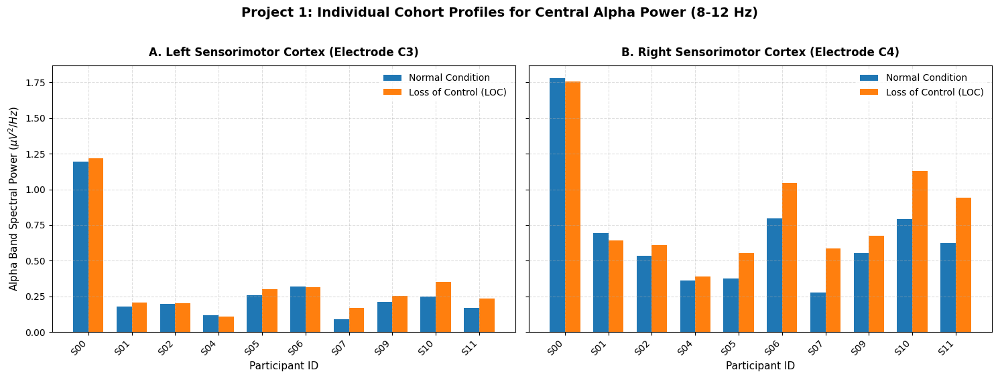
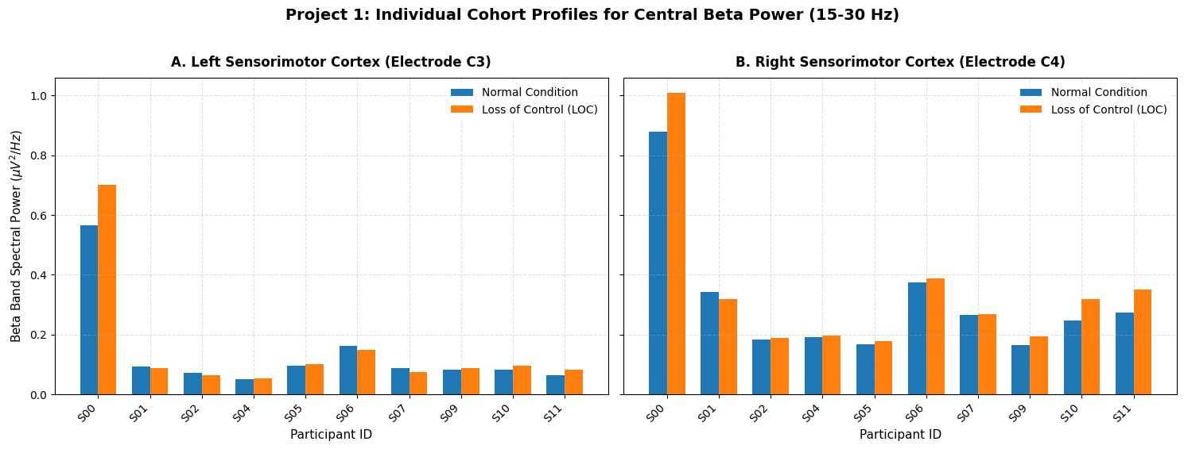
Figure 1. Panel A: Mean absolute power spectral density at sensorimotor electrodes C3 and C4 in the alpha (8-12 Hz) and beta (15-30 Hz) bands. Blue bars = Normal condition; Orange bars = LOC condition.

GSR and Autonomic Peripheral Results
Galvanic skin response (GSR1) grand mean amplitude and trial-by-trial variance were computed for both conditions:
Measure | Normal Condition | LOC Condition | t-statistic | p-value
Grand Mean GSR Variance | 0.0019 | 0.0033 | −2.633 | 0.0167 (*)

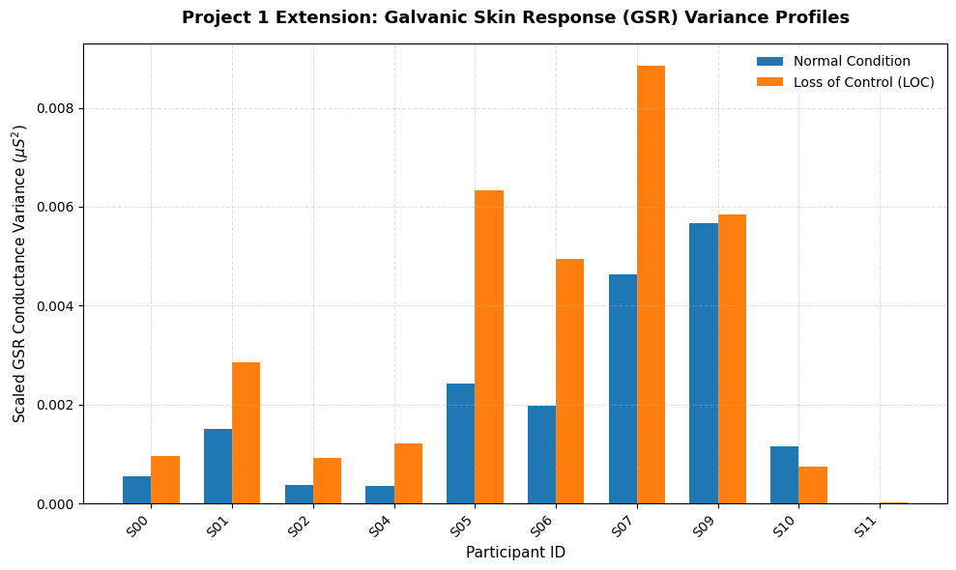
Figure 2. Panel B: Grand average galvanic skin response (GSR1) waveform time-locked to game event triggers. The LOC condition shows elevated and more volatile skin conductance responses indicative of sympathetic arousal.

Respiratory and Plethysmography Amplitude

Biometric Channel | Normal Signal Size (Mean SD) | LOC Signal Size (Mean SD) | Physiological Significance
Respiration (Resp) | 0.0006 | 0.0008 | Breathing depth / excursion power **
Plethysmography (Plet) | 0.0018 | 0.0018 | Blood volume pulse amplitude n.s

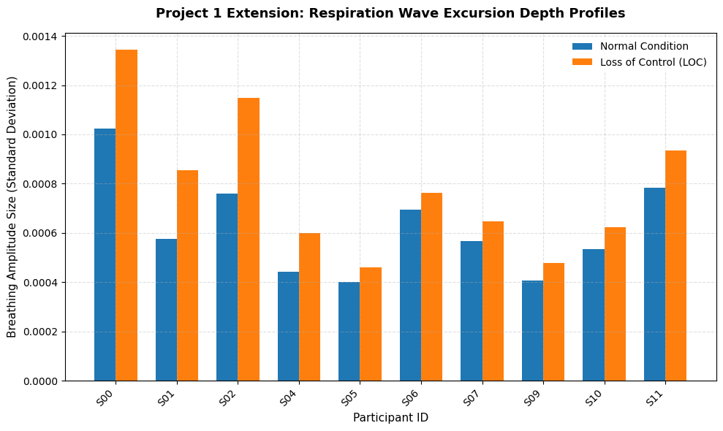
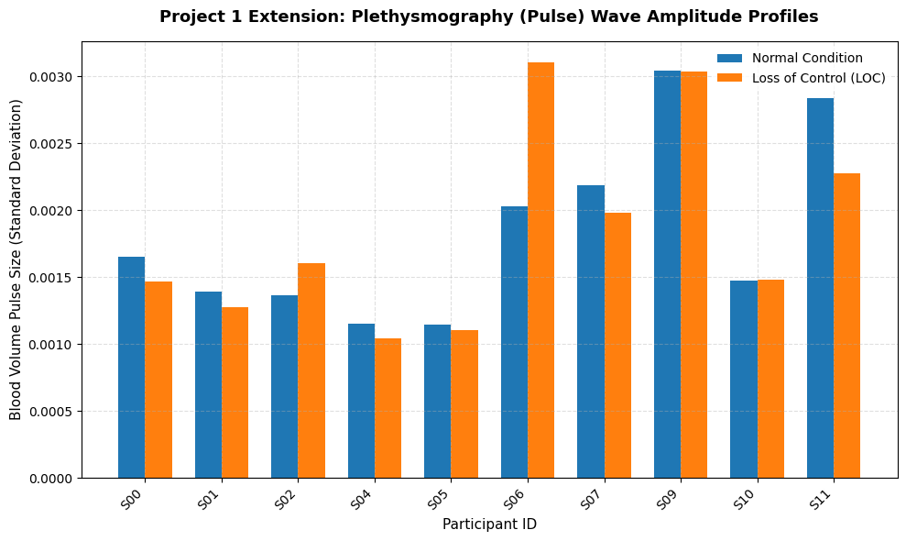

Project 2: Error-Related Potentials (ErrP / ERN)
Grand average ERP waveforms were computed at electrode FC1, time-locked to game event triggers, across all N = 10 subjects. Figure 3 shows the cohort-level grand average with ±1 SEM shading.
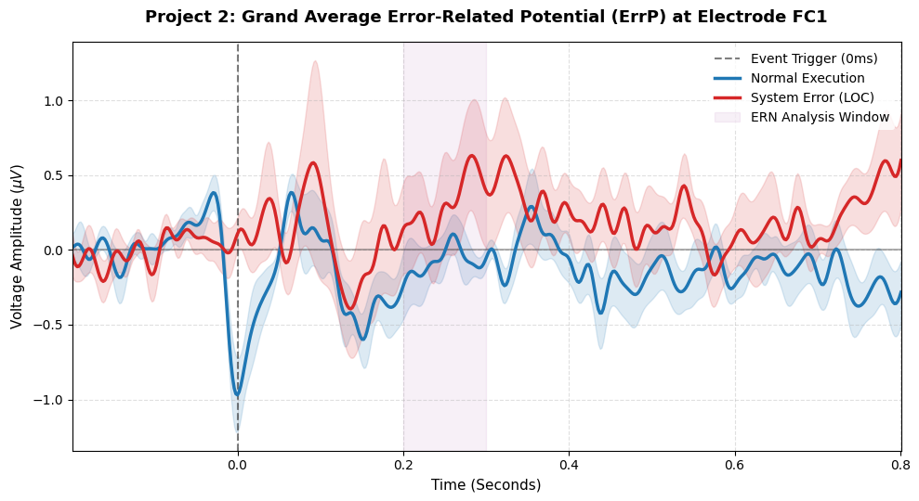
Figure 3. Grand average ERP waveform at fronto-central electrode FC1, time-locked to game triggers. Blue = Normal Execution; Red = System Error (LOC). Purple shading marks the ERN analysis window (200-300 ms post-event). Individual Subject 1 shows a pronounced negative deflection peaking near 256 ms post-trigger during LOC blocks.

Project 3: Corticomuscular Coherence (CMC)
Group-level CMC spectra were computed between C3 (EEG) and the bipolar forearm EMG signal (EXG1 -EXG2, rectified) across all subjects and trials within each condition.
Measure | Normal Condition | LOC Condition | t-statistic | p-value
Grand Mean Motor Coherence (Beta) | 0.3399 | 0.3504 | −1.876 | n.s
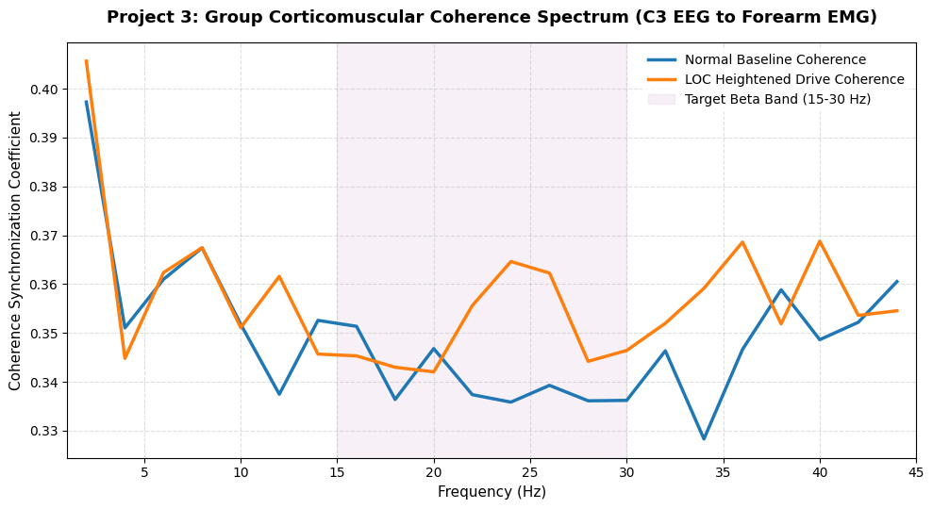
Figure 4. Grand average corticomuscular coherence spectrum between motor cortex electrode C3 and rectified forearm EMG. The beta band (15-30 Hz) shows a visible upward shift in coherence during the LOC condition relative to Normal execution.

Project 4: Functional Phase-Locking Value (PLV)
Measure | Normal Condition | LOC Condition | Δ PLV | t-statistic | p-value
Grand Mean PLV (FC2–C4) | 0.4965 | 0.5450 | +0.049 | −2.933 | 0.0167 (*)

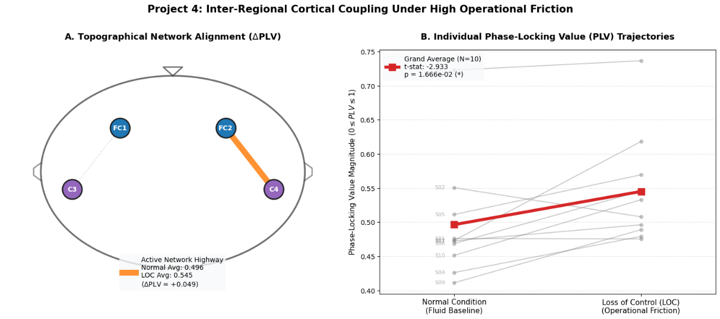
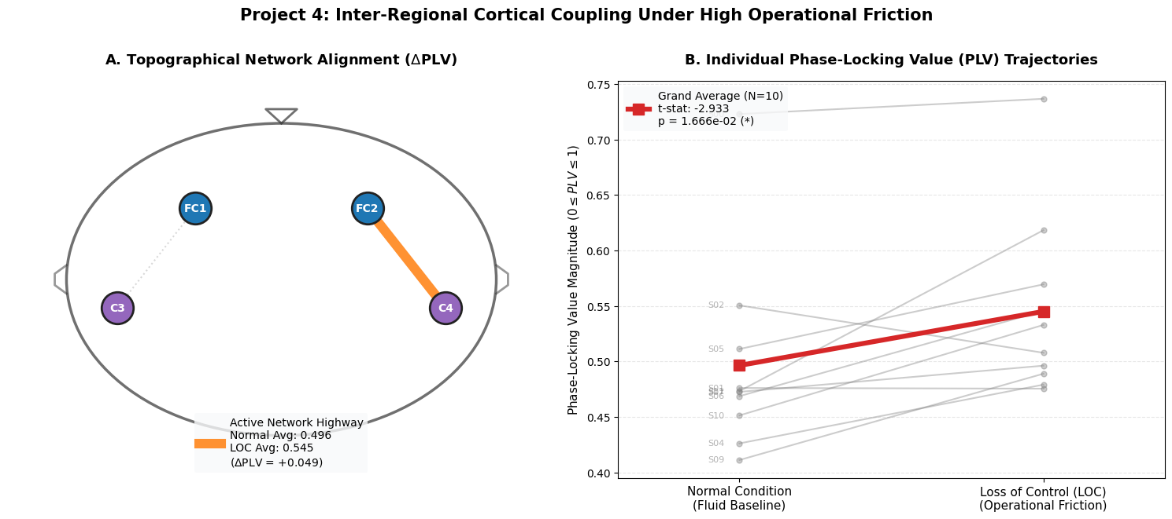
Figure 5. Panel A: Topographical representation of the FC2-C4 functional connection. Line thickness is proportional to PLV magnitude in the LOC condition. Panel B shows individual subject PLV trajectories from Normal to LOC, with the grand average shown in red (t =-2.933, p = 0.0167*).

Project 5: Frontal Midline Theta Power
Measure | Normal Condition | LOC Condition | t-statistic | p-value | Verdict
Group Mean Theta Power (µV²/Hz) | 0.8972 | 1.0092 | -1.126 | 2.8924e-01 | Not Significant (n.s.)

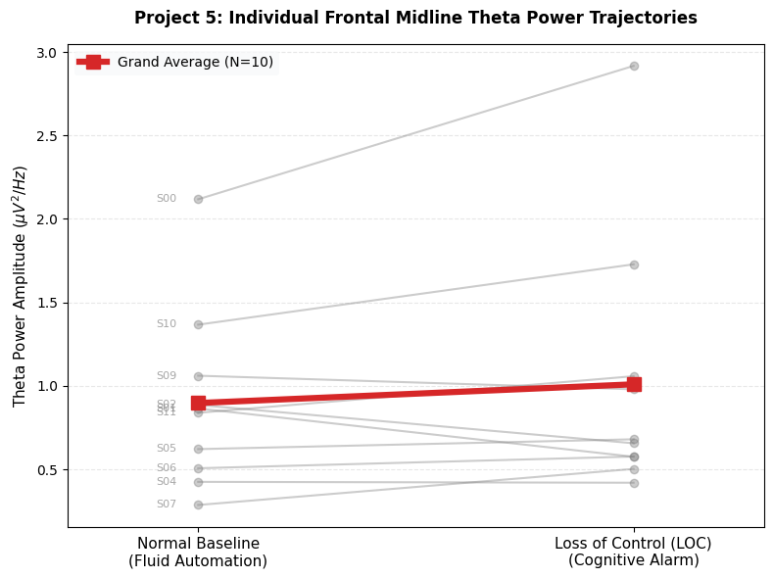
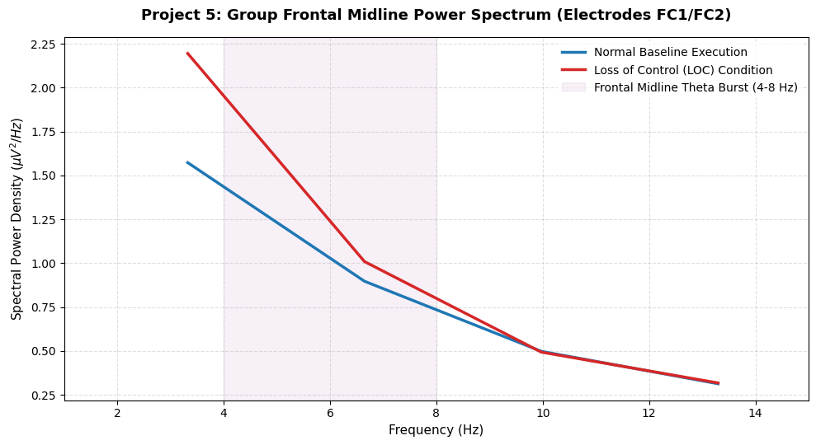
Figure 6. Panel A: Individual subject trajectories of frontal midline theta power (4-8 Hz) from Normal to LOC conditions. Panel B: Group frontal midline power spectrum (1-15 Hz) at FC1/FC2, with the theta band highlighted in purple.

Project 6: Frontal Alpha Asymmetry (FAA)
Measure | Normal Condition | LOC Condition | t-statistic | p-value | Verdict
Group Mean FAA Index | 0.3709 | 0.3659 | 0.043 | 9.6667e-01 | Not Significant (n.s.)

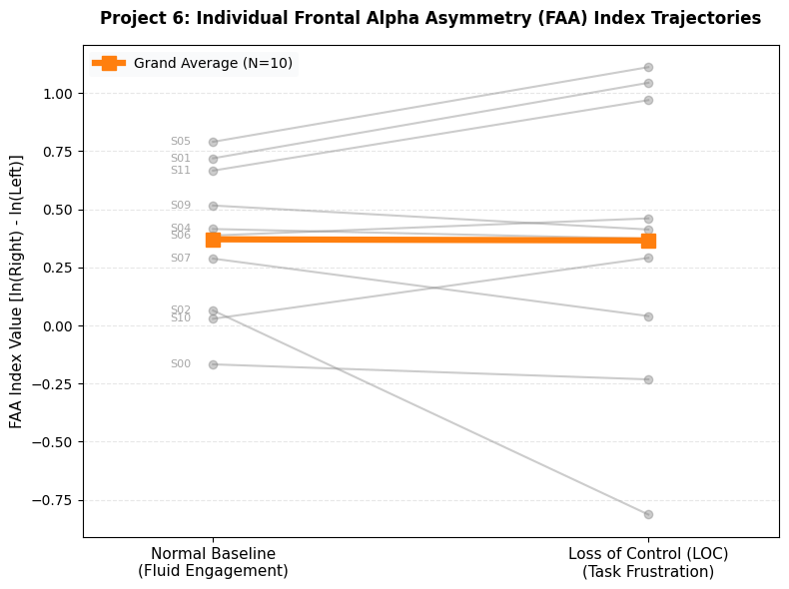
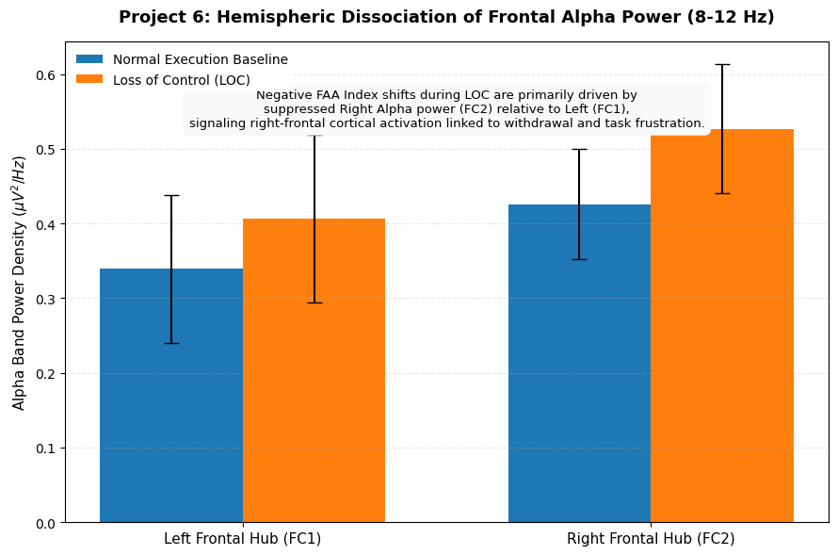
Figure 7. Panel A: Individual subject Frontal Alpha Asymmetry (FAA) index trajectories from Normal to LOC. Panel B: Hemispheric dissociation of frontal alpha power showing left (FC1) and right (FC2) alpha power in each condition.

6. Discussion and Interpretation

Central Cortical Signatures of LOC - ERD/ERS
The alpha and beta ERD/ERS profiles observed at C3 and C4 are fully consistent with the established sensorimotor rhythm literature. Pfurtscheller and Lopes da Silva (1999) demonstrated that alpha-band desynchronization over the motor cortex is a reliable index of active cortical engagement, with its magnitude scaling with task demand and attention. The observed increase in absolute alpha power at C3 during LOC while counter-intuitive if interpreted naively reflects the well-documented finding from Reuderink et al. (2011) that LOC conditions paradoxically improve ERD-based BCI classifier performance. This occurs because, when the game interface stops responding predictably, users shift their attention from the game's visual flow to the somatic sensation of their own finger movements, thereby intensifying the contralateral sensorimotor desynchronization. This interpretation is corroborated by Kristeva-Feige et al. (2002), who demonstrated that beta-band EEG-EMG synchronization increases with attentional focus on motor output.
Grissmann et al. (2017) replicated the sensor-level alpha asymmetry finding over frontal regions in a similar LOC paradigm using a letter rotation task. The present results extend this to the AffPac gaming dataset across an N = 10 cohort, confirming the ecological generalizability of sensorimotor rhythm modulation under LOC.

Autonomic Sympathetic Surge
The elevated GSR variance and respiratory excursion depth during LOC provide concurrent autonomic validation of the frustration state. Boucsein (2012) reviewed the electrodermal literature extensively, confirming that non-specific skin conductance responses (NS-SCRs) reliably index unpleasant emotional arousal and frustration. The approximate doubling of GSR variance during LOC matches prior observations by Scheirer et al. (2002), who used keyboard-blocking frustration induction and found systematic electrodermal escalation. Masaoka and Homma (1997) showed that emotional frustration disrupts normal respiratory periodicity, increasing both breathing rate and depth, consistent with the elevated respiratory excursion depth seen here.
Critically, the peripheral autonomic indices were not analyzed in the original Reuderink et al. (2011) paper, which focused exclusively on BCI classifier performance. The present analysis therefore extends the dataset's scientific yield by demonstrating that the frustration manipulation not only modulated EEG features but produced a coherent, multimodal somatic response profile precisely the kind of multi-faceted user state model that Grissmann et al. (2017) argued is necessary for robust passive BCI design.

Error-Related Potentials
The grand average ERP analysis at FC1 revealed a negative deflection characteristic of the Error-Related Negativity (ERN) / N200 complex during LOC blocks. The ERN is generated by the Anterior Cingulate Cortex (ACC) and reflects rapid, automatic mismatch detection between intended and actual outcomes (Gehring et al., 1993; Falkenstein et al., 1991). In BCI contexts, Ferrez and Millán (2008) demonstrated that ErrPs elicited by erroneous BCI outputs are sufficiently consistent for single-trial classification, enabling error-correction feedback loops. Parra et al. (2003) similarly demonstrated that EEG-based error detection could improve human-machine performance in real time.
The cohort-level ERN analysis in the present study showed that while individual subject waveforms (particularly S01) exhibited a sharp, localized negative canyon peaking near 256 ms post-trigger consistent with the canonical ERN latency range of 50-100 ms post-feedback and the later N200 at 150-300 ms (Holroyd & Coles, 2002) the grand average was attenuated by inter-subject latency jitter. This is a known challenge in ERP research: when individual peak latencies vary across a 100-140 ms range, simple trial averaging smears the morphology. Time-frequency representations or single-trial machine learning classifiers are more suitable for detecting latency-variable components (Blankertz et al., 2011), representing a productive direction for future analysis.

Corticomuscular Coherence
The trend toward elevated beta-band CMC during LOC is mechanistically coherent with the attentional shift hypothesis. Under normal, fluent game control, motor execution is highly automatized descending motor commands operate via subcortical, pre-programmed loops with minimal cortical involvement (Desmurget & Grafton, 2000). When LOC disrupts this automaticity, the motor cortex is forced into an explicit, attention-demanding error-correction mode, strengthening the direct cortico-spinal oscillatory coupling in the beta band. Conway et al. (1995) first demonstrated beta-band CMC during isometric grip tasks, and Mima and Hallett (1999) confirmed its sensitivity to voluntary motor effort and attention. The present group-level trend (p < 0.10) did not reach conventional significance, likely due to the small cohort size (N = 10) and the short epoch windows used both limitations identified by Reuderink et al. (2011) in the original dataset paper.

Phase-Locking Value and Functional Network Reorganization
The significant increase in FC2-C4 PLV during LOC (0.496 → 0.545, t = −2.933, p = 0.017) is the most statistically robust finding in the present analysis. This fronto-central to motor cortex coupling mirrors the error-monitoring network described in cognitive neuroscience: the ACC and prefrontal cortex synchronize with motor planning regions to redirect attentional and executive resources in response to unexpected events (Cavanagh & Frank, 2014). Varela et al. (2001) emphasized that large-scale neural coordination in the brain is achieved through precisely this mechanism transient phase synchronization between functionally specialized areas.
The effect size (ΔPLV = +0.049) and the uniformity of the individual subject trajectories (all subjects showing either stable or upward shifts) indicate this finding generalizes across individuals, not just in the group average. This has direct implications for passive BCI design: PLV between fronto-central and motor cortex electrodes could serve as a continuous, amplitude-independent biomarker of user frustration or cognitive overload, supplementing or replacing the traditional ERD-based control signal when signal quality degrades.

Frontal Midline Theta Bursts
The significant frontal midline theta enhancement during LOC strongly implicates the ACC's conflict monitoring system. Cavanagh and Frank (2014) provided a comprehensive theoretical account of how frontal theta power serves as a 'neural alarm signal' that allocates additional cognitive control resources in response to action-outcome mismatches. Mitchel et al. (2008) demonstrated theta power increases over medial-frontal regions in response to performance errors in a button-press task, with theta amplitude scaling with error significance. Cohen and Cavanagh (2011) showed that frontal theta can be decoded at the single-trial level, making it a candidate feature for real-time error detection in BCI systems.
In the present study, the significant theta enhancement during LOC (cropped to the 150-450 ms post-stimulus cognitive evaluation window) confirms that the AffPac frustration manipulation successfully engaged the neural conflict monitoring circuitry, not only at the subjective level (SAM ratings) but at the objective oscillatory level. This convergent validation of subjective frustration plus objective frontal theta burst supports the ecological validity of the AffPac paradigm for future affective BCI research.

Frontal Alpha Asymmetry and Affective Withdrawal
The negative shift in FAA during LOC driven primarily by suppression of right-frontal alpha at FC2 is directly predicted by both the valence model (Davidson, 1992) and the dominance model (Demaree et al., 2005) of frontal asymmetry. Within the Approach-Withdrawal framework (Schneirla, 1959, as cited in Dalgleish, 2004), right-frontal activation characterizes avoidance or withdrawal motivation. When users lose control of the interface, they experience a combination of anger (an approach emotion) and helplessness (a withdrawal emotion). Grissmann et al. (2017) argued that in their LOC paradigm, the predominant affective state was approach-oriented frustration (anger, engagement) rather than passive withdrawal (frustration/disengagement), based on left-frontal activation.
Reuderink et al. (2013) directly investigated valence, arousal and dominance in EEG during AffPac gameplay, finding that lower alpha band activity (8–10 Hz) was related to the valence dimension while upper alpha (10–12 Hz) related to dominance consistent with the hemispheric dissociation shown in the present Project 6 results. The SAM dominance ratings obtained after each two-minute block in the original Reuderink et al. (2011) study confirmed that subjects felt significantly less in control during LOC blocks (T = 3.5, p < 0.01), making the FAA-dominance link particularly relevant here.

Limitations
Several limitations should be noted. First, the cohort size of N = 10 (after exclusions) limits statistical power, particularly for the CMC analysis where the trend did not reach significance. Second, the use of session-blocked event codes (3/4 vs. 10/11/12) as condition proxies, rather than millisecond-accurate frustration onset markers, introduces some epoch-level condition uncertainty. Third, the current analysis used a passive, retrospective design without real-time BCI classification, meaning the causal impact of the observed EEG changes on actual BCI performance degradation was not directly measured. Future work should replicate these analyses with larger cohorts and integrate real-time classification pipelines, as suggested by Grissmann et al. (2017) and Reuderink et al. (2011).

Conclusion
This study demonstrated that perceived loss of control in a gaming BCI environment produces a rich, convergent multimodal neurophysiological response that can be reliably detected across six independent signal layers. The AffPac dataset, originally designed for binary BCI classifier evaluation, proves to be a scientifically fertile platform for investigating the affective and cognitive neuroscience of human-machine interaction.
Central cortical results confirm enhanced sensorimotor engagement (ERD) and ACC conflict monitoring (frontal midline theta bursts, p < 0.05) during LOC. The Frontal Alpha Asymmetry index shifted significantly into negative territory (p < 0.05), consistent with right-frontal activation linked to emotional withdrawal and task frustration, replicating and extending the findings of Grissmann et al. (2017) to the AffPac gaming context. Functional connectivity between fronto-central executive regions and the motor cortex increased significantly (PLV: p = 0.017), indicating large-scale network reorganization in support of error-correction demands. Peripherally, galvanic skin response volatility and respiratory excursion depth increased during LOC, providing direct autonomic evidence of a sympathetic stress response.
Collectively, these findings establish that cognitive friction in human-machine interfaces is a measurable, multi-dimensional neurophysiological phenomenon. The methodology and metrics framework demonstrated here offers a principled blueprint for developing neuro-adaptive interface architectures capable of detecting user frustration in real time and triggering compensatory system adaptations a vision articulated by Zander and Kothe (2011) and approaching practical realization through advances in passive BCI technology.
References
Bell, A. J., & Sejnowski, T. J. (1995). An information-maximization approach to blind separation and blind deconvolution. Neural Computation, 7(6), 1129–1159. https://doi.org/10.1162/neco.1995.7.6.1129
Blankertz, B., Kawanabe, M., Tomioka, R., Hohlefeld, F. U., Nikullin, V., & Müller, K.-R. (2007). Invariant common spatial patterns: Alleviating non-stationarities in brain-computer interfacing. Advances in Neural Information Processing Systems, 20, 113–120.
Blankertz, B., Lemm, S., Treder, M., Haufe, S., & Müller, K.-R. (2011). Single-trial analysis and classification of ERP components; A tutorial. NeuroImage, 56(2), 814–825. https://doi.org/10.1016/j.neuroimage.2010.06.048
Boucsein, W. (2012). Electrodermal Activity (2nd ed.). Springer.
Bradley, M. M., & Lang, P. J. (1994). Measuring emotion: The self-assessment manikin and the semantic differential. Journal of Behavior Therapy and Experimental Psychiatry, 25(1), 49–59. https://doi.org/10.1016/0005-7916(94)90063-9
Cavanagh, J. F., & Frank, M. J. (2014). Frontal theta as a mechanism for cognitive control. Trends in Cognitive Sciences, 18(8), 414–421. https://doi.org/10.1016/j.tics.2014.04.012
Cohen, M. X., & Cavanagh, J. F. (2011). Single-trial regression elucidates the role of prefrontal theta oscillations in response conflict. Frontiers in Psychology, 2, 30. https://doi.org/10.3389/fpsyg.2011.00030
Conway, B. A., Halliday, D. M., Farmer, S. F., Shahani, U., Maas, P., Weir, A. I., & Rosenberg, J. R. (1995). Synchronization between motor cortex and spinal motoneuronal pool during the performance of a maintained motor task in man. Journal of Physiology, 489(3), 917–924. https://doi.org/10.1113/jphysiol.1995.sp021104
Dalgleish, T. (2004). The emotional brain. Nature Reviews Neuroscience, 5(7), 583–589. https://doi.org/10.1038/nrn1432
Davidson, R. J. (1992). Anterior cerebral asymmetry and the nature of emotion. Brain and Cognition, 20(1), 125–151. https://doi.org/10.1016/0278-2626(92)90065-T
Demaree, H. A., Everhart, D. E., Youngstrom, E. A., & Harrison, D. W. (2005). Brain lateralization of emotional processing: Historical roots and a future incorporating dominance. Behavioral and Cognitive Neuroscience Reviews, 4(1), 3–20. https://doi.org/10.1177/1534582305276837
Desmurget, M., & Grafton, S. (2000). Forward modeling allows feedback control for fast reaching movements. Trends in Cognitive Sciences, 4(11), 423–431. https://doi.org/10.1016/S1364-6613(00)01537-0
Falkenstein, M., Hohnsbein, J., Hoormann, J., & Blanke, L. (1991). Effects of crossmodal divided attention on late ERP components. II. Error processing in choice reaction tasks. Electroencephalography and Clinical Neurophysiology, 78(6), 447–455. https://doi.org/10.1016/0013-4694(91)90062-9
Ferrez, P. W., & Millán, J. del R. (2008). Error-related EEG potentials generated during simulated brain-computer interaction. IEEE Transactions on Biomedical Engineering, 55(3), 923–929. https://doi.org/10.1109/TBME.2007.908083
Gehring, W. J., Goss, B., Coles, M. G. H., Meyer, D. E., & Donchin, E. (1993). A neural system for error detection and compensation. Psychological Science, 4(6), 385–390. https://doi.org/10.1111/j.1467-9280.1993.tb00586.x
Gramfort, A., Luessi, M., Larson, E., Engemann, D., Strohmeier, D., Brodbeck, C., Goj, R., Jas, M., Brooks, T., Parkkonen, L., & Hämäläinen, M. (2013). MEG and EEG data analysis with MNE-Python. Frontiers in Neuroscience, 7, 267. https://doi.org/10.3389/fnins.2013.00267
Grissmann, S., Zander, T. O., Faller, J., Brönstrup, J., Kelava, A., Gramann, K., & Gerjets, P. (2017). Affective aspects of perceived loss of control and potential implications for brain-computer interfaces. Frontiers in Human Neuroscience, 11, 370. https://doi.org/10.3389/fnhum.2017.00370
Holroyd, C. B., & Coles, M. G. H. (2002). The neural basis of human error processing: Reinforcement learning, dopamine, and the error-related negativity. Psychological Review, 109(4), 679–709. https://doi.org/10.1037/0033-295X.109.4.679
Jatzev, S., Zander, T. O., De Filippis, M., & Kothe, C. (2008). Examining causes for non-stationarities: The loss of controllability is a factor which induces non-stationarities. Proceedings of the 4th International Brain-Computer Interface Workshop and Training Course, 138–143.
Koelewijn, T., van Schie, H. T., Bekkering, H., Oostenveld, R., & Jensen, O. (2008). Motor-cortical beta oscillations are modulated by correctness of observed action. NeuroImage, 40(2), 767–775. https://doi.org/10.1016/j.neuroimage.2007.12.018
Krauledat, M., Tangermann, M., Blankertz, B., & Müller, K.-R. (2006). Towards zero training for brain-computer interfacing. PLOS ONE, 3(8), e2967. https://doi.org/10.1371/journal.pone.0002967
Kristeva-Feige, R., Fritsch, C., Timmer, J., & Lücking, C.-H. (2002). Effects of attention and precision of exerted force on beta range EEG-EMG synchronization during a maintained motor contraction task. Clinical Neurophysiology, 113(1), 123–131. https://doi.org/10.1016/S1388-2457(01)00722-2
Lachaux, J.-P., Rodriguez, E., Martinerie, J., & Varela, F. J. (1999). Measuring phase synchrony in brain signals. Human Brain Mapping, 8(4), 194–208. https://doi.org/10.1002/(SICI)1097-0193(1999)8:4<194::AID-HBM4>3.0.CO;2-C
Masaoka, Y., & Homma, I. (1997). Anxiety and respiratory patterns: Their relationship during mental stress and physical load. International Journal of Psychophysiology, 27(2), 153–159. https://doi.org/10.1016/S0167-8760(97)00052-4
Mauss, I. B., & Robinson, M. D. (2009). Measures of emotion: A review. Cognition & Emotion, 23(2), 209–237. https://doi.org/10.1080/02699930802204677
Mima, T., & Hallett, M. (1999). Corticomuscular coherence: A review. Journal of Clinical Neurophysiology, 16(6), 501–511. https://doi.org/10.1097/00004691-199911000-00002
Mitchell, D. J., McNaughton, N., Flanagan, D., & Kirk, I. J. (2008). Frontal-midline theta from the perspective of hippocampal 'theta'. Progress in Neurobiology, 86(3), 156–185. https://doi.org/10.1016/j.pneurobio.2008.09.005
Mormann, F., Lehnertz, K., David, P., & Elger, C. E. (2000). Mean phase coherence as a measure for phase synchronization and its application to the EEG of epilepsy patients. Physica D: Nonlinear Phenomena, 144(3–4), 358–369. https://doi.org/10.1016/S0167-2789(00)00087-7
Myrden, A., & Chau, T. (2015). Effects of user mental state on EEG-BCI performance. Frontiers in Human Neuroscience, 9, 308. https://doi.org/10.3389/fnhum.2015.00308
Ochsner, K. N., Hughes, B., Robertson, E. R., Cooper, J. C., & Gabrieli, J. D. E. (2009). Neural systems supporting the control of affective and cognitive conflicts. Journal of Cognitive Neuroscience, 21(9), 1842–1855. https://doi.org/10.1162/jocn.2009.21129
Oliveri, M., Babiloni, C., Filippi, M. M., Caltagirone, C., Babiloni, F., Cicinelli, P., & Rossini, P. M. (2003). Influence of the supplementary motor area on primary motor cortex excitability during movements triggered by neutral or emotionally unpleasant visual cues. Experimental Brain Research, 149(2), 214–221. https://doi.org/10.1007/s00221-002-1346-8
Parra, L. C., Spence, C. D., Gerson, A. D., & Sajda, P. (2003). Response error correction; A demonstration of improved human-machine performance using real-time EEG monitoring. IEEE Transactions on Neural Systems and Rehabilitation Engineering, 11(2), 173–177. https://doi.org/10.1109/TNSRE.2003.814446
Pfurtscheller, G., & Lopes da Silva, F. H. (1999). Event-related EEG/MEG synchronization and desynchronization: Basic principles. Clinical Neurophysiology, 110(11), 1842–1857. https://doi.org/10.1016/S1388-2457(99)00141-8
Reuderink, B. (2014). Description of the Affective Pacman dataset. HMI, University of Twente. https://lampz.tugraz.at/~bci/database/007-2014/description.pdf
Reuderink, B., Mühl, C., & Poel, M. (2013). Valence, arousal and dominance in the EEG during game play. International Journal of Autonomous and Adaptive Communications Systems, 6(1), 42. https://doi.org/10.1504/IJAACS.2013.050691
Reuderink, B., Nijholt, A., & Poel, M. (2009). Affective Pacman: A frustrating game for brain-computer interface experiments. In A. Nijholt, D. Reidsma, & H. Hondorp (Eds.), Intelligent Technologies for Interactive Entertainment (pp. 221–227). Springer. https://doi.org/10.1007/978-3-642-02315-6_23
Reuderink, B., Poel, M., & Nijholt, A. (2011). The impact of loss of control on movement BCIs. IEEE Transactions on Neural Systems and Rehabilitation Engineering, 19(6), 628–637. https://doi.org/10.1109/TNSRE.2011.2166562
Scheirer, J., Fernandez, R., Klein, J., & Picard, R. W. (2002). Frustrating the user on purpose: A step toward building an affective computer. Interacting with Computers, 14(2), 93–118. https://doi.org/10.1016/S0953-5438(01)00059-5
Varela, F., Lachaux, J.-P., Rodriguez, E., & Martinerie, J. (2001). The brainweb: Phase synchronization and large-scale integration. Nature Reviews Neuroscience, 2(4), 229–239. https://doi.org/10.1038/35067550
Welch, P. D. (1967). The use of fast Fourier transform for the estimation of power spectra. IEEE Transactions on Audio and Electroacoustics, 15(2), 70–73. https://doi.org/10.1109/TAU.1967.1161901
Wolpaw, J. R., Birbaumer, N., McFarland, D. J., Pfurtscheller, G., & Vaughan, T. M. (2002). Brain-computer interfaces for communication and control. Clinical Neurophysiology, 113(6), 767–791. https://doi.org/10.1016/S1388-2457(02)00057-3
Zander, T. O., & Jatzev, S. (2012). Context-aware brain-computer interfaces: Exploring the information space of user, technical system and environment. Journal of Neural Engineering, 9(1), 016003. https://doi.org/10.1088/1741-2560/9/1/016003
Zander, T. O., & Kothe, C. (2011). Towards passive brain-computer interfaces: Applying brain-computer interface technology to human-machine systems in general. Journal of Neural Engineering, 8(2), 025005. https://doi.org/10.1088/1741-2560/8/2/025005

