//////////////////////////////////////////////////////////////////////////////////////////////////
// 19/05/2017. Jgarrigos.
// This example tries to demonstrate the workflow from hls-to-vivado-to-sdk-to-board in a
// very straightforward way (too “straightforward” perhaps, as it does not deal with lots of
// parameters, options and design techniques that should be covered in more advanced
// tutorials).
// It uses a very simple component (defined in mycnt_hls.cpp) with two inputs and two
// outputs that have a different latency (delay): dout1 is immediate (it performs the sum
// of the two inputs), while dout2 will take several clk cycles (it counts from the value in
// the first input to the value of the second). This delay is thus a function of the input
// values, so that it is not possible to check the output without a proper handshaking
// protocol.
// The coding style in mycnt_hls is “sub-optimal” on purpose, just to be able to test some
// tricks and special behaviors, like the effect of static or const, the use of different
// handshaking protocols, the effect of these on the software, using interrupts or not, etc.
// SO, PLEASE, DO NOT TAKE mycnt_hls AS AN EXAMPLE OF GOOD CODING PRACTICES for
// Vivado HLS. There are way more efficient approaches to get the behavior of mycnt_hls
// if that were our intention, although it would not have much sense to write such a
// behavior to an hw peripheral in any case.
// The purpose of this project is just to serve as an example of the workflow for similar and
// more complex designs, and as a playground to test several difficult concepts (handshaking,
// axi interfaces, using driver functions, interrupts,…) but beginning with and example that
// already works, so that if you mess with something, you know where to find the errors. ;-)
// May the force be with you, little padawan.
/////////////////////////////////////////////////////////////////////////////////////////////////
==============================================
Part One: Define the peripheral’s behavior in Vivado HLS
==============================================
# Create a new Vivado HLS project.
# Add mycnt_hls.cpp as the design file and mycnt_hls_tb.cpp as the testbench. mycnt_hls.h does not need to be added to the project, but it should be in the same directory as the other two files.
# Specify mycny_hls as the top function and ZedBoard as the target board.
# Run build and csim (compile and execute the c code) and check there are no errors and results are as expected.
# Add s_axilite interface directives for the 4 I/O parameters of the hw top function and for the function itself (return), if they are not already included as pragmas in the code (the should be included, if you are using the last code version used in class).
# Run synthesis
# Run C/RTL co-simulation and check that results are identical as in the c simulation.
# Export design as an IP catalog component.
============================================================================
Part Two: Integrate created peripheral with microprocessor and the rest of the SoC in Vivado
============================================================================
# Create a new Vivado Project.
- Select Do not specify sources at this time
- Select VHDL instead of Verilog as the preferred design language
- Select Zedboard as the target board
# Add a new block diagram
# Add a zynq block to the diagram
Run designer assistance /connection automation to setup default configuration.
# Select Manage IP Catalog and add the hls_project/solution1/imp/ip directory to the list of IP repositories where Vivado looks for IP cores.
# Now the hls peripheral should be shown in the IP catalog. Search for it and add the block the to the block diagram.
Run designer assistance /connection automation to automatically connect the peripheral to the zynq block though an axi interface.
# Manually connect the hls peripheral’s interrupt output to the zynq interrupt input:
- First, enable interrupts from the PL to the PS in the zynq configuration: open block config > Interrupts > Enable Fabric Interrupts > Enable IRQ_F2P[15:0].
- Second, manually draw a line from the hls peripheral to the zynq block.
# Validate design. Check that there are no errors in the block diagram. The BD should be as this one:
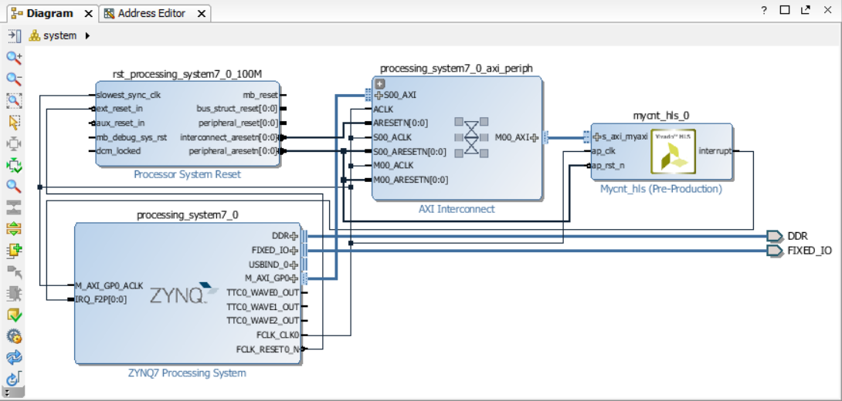

# Select .bd file and click on Generate output products in the floating menu.
# Select .bd file and click on Generate HDL wrapper in the floating menu.
# Select Generate bitstream. Synthesis and implementation (translate, map, place&route) will be run if they don’t exist or are not up-to-date.
# Export hardware design to SDK (Menu > File > Export > Export hardware). Do not forget to select “Include Bitstream” option.
# Launch SDK.

============================================================================
Part Three: Design the application software to execute on the microprocessor in SDK
============================================================================
# Select Menu > File > New application project
- Enter the desired name for the app
- Check that the hw platform selected is the correct one if there is more than one
- Check that the OS is configured as standalone (no OS in fact)
- Check that a new BSP will be created for the hw platform
- Select a “helloworld” template for your app
# Modify the helloworld template with the provided code in mycnt_hls_tb_ARM.c
# Save your app file. This will also run compile. Check that no errors are shown in the log console window and that an executable (.elf) file is produced correctly.
# Go to Menu > Xilinx Tools and select Program FPGA.
- Of course, before you should have connected and turned on the board.
- Do not forget to connect both cables: usb-jtag to program the fpga and usb-uart for the console with the microprocessor
- Check that a blue led on the board lights on, this means programming has been successful.
# Open the Teraterm utility and config a connection to the serial COM6 port with 115200bps. Let the rest of parameters with their default values.
- The COM6 port will not be present if the ZedBoard is not powered.
# Select your app project and in the floating menu select Run As> launch on hardware (GDB)
# Check the teraterm console and see your app executing on the board.
# CONGRATULATIONS!! Now you have your custom defined SoC created and running on your desk. Not many people can say that. ;-)

