Project Report for Web Design & Development
Contents
1 Introduction 1
2 Link to Github Pages 1
3 Installation/Usage 1
4 Design Decisions Made 1
4.1 Colours, Text and Fonts 1
4.2 Breakpoints 2
4.3 Navigation 2
5 Performance 2
6 SEO 2
7 Accessibility 2
8 Wireframes 2
9 Reflection on your work 2

Introduction
For my Web Design and Development E-commerce Website Project. I decided to do a design that focused on capturing the essence of Warhammer a Popular TTWG (Tabletop Wargame). I choose this due to the fact of it having a website that I wanted to see if I could improve upon as well as take inspiration from to make something that is uniquely my own while still being something that pays great tribute to the history of Warhammer.

Link to GitHub
SodaFunkCitizen/TheWebdesignProject: This is my Year 2 , Semester 1 project for Web Design Fundamentals.

Installation/Usage
Every extra item that would be required for use is standard. Node is a live server. I also used bootstraps, although they don't require installation.
Below is the Test User. Email and Password
email: FullMarks@please.com password: comeOnThisGottaBeWorthAlot

Use of GenAI
I used generative AI throughout this project as a general Debugging tool to aid when I didn’t understand nor could figure out where an error code was coming from. Some examples of this would include my cart. As seen in GitHub uploads the cart was a major struggle this was due to me not understanding I need to put the cart code under the public directory.
Aswell Quill Bot I will state has been used in the making of the fancier wording in majority of this Project document.
Image Attribution
All images used outside of the project page are of my own personal miniatures that I made and painted myself. The photos where then taken on a Canon DSLR camera that is also mine. All the product images are from Official Warhammer Products. There is no rule against using any of these images as Games Workshop does have Policies that allow the use of the official images for the selling of Products on third party vendor websites with this project would fall under the banner of.
Design Decisions Made
Look and Feel
The whole look and feel of my website were heavily based off the black colour scheme the official 40k Website used to use.
Breakpoints
Bootstrap’s responsive grid system was used to manage breakpoints efficiently. The main breakpoints implemented were as follows:
- Mobile (<576px)
Products stack vertically in a single column, navigation collapses into a hamburger menu, and form elements span full width for easier touch interaction.
- Tablet (≥576px and ≥768px)
Product cards display in two columns, and spacing between elements increases to improve readability.
- Desktop (≥992px)
Product cards display in three columns, and the checkout page uses a two-column layout separating customer/payment information from the order summary.
Minor responsive adjustments were handled automatically by Bootstrap classes such as col-12, col-sm-6, and col-lg-4.
Performance
Several steps were taken to improve site performance:
- Bootstrap CDN was used to load CSS efficiently with browser caching.
- JavaScript logic for the cart was written in plain JavaScript, avoiding unnecessary libraries.
- Cart data is stored in Local Storage, eliminating server requests for cart updates. Aswell as Products being stored in Local Storage in the App.js
- Minifying CSS files through SASS.
SEO
Basic SEO best practices were applied across the site:
- Each page includes a unique <title> tag defined in Handlebars (e.g., Home, Shop, Cart, Checkout).
- Product names are wrapped in heading tags (<h5>), improving content hierarchy.
- Meta viewport tags were included to support mobile viewing.
- Clean and readable URLs (/shop, /cart, /checkout) were implemented using Express route.
Accessibility
Accessibility was considered throughout the design:
- Semantic HTML elements improve screen reader navigation.
- All images include alt attributes, ensuring content is accessible to visually impaired users.
- Bootstrap’s default form controls provide accessible labels and focus states.
- Buttons and links use clear, descriptive text (e.g., “Add to Cart”, “Place Order”).
- Colour contrast was adjusted using custom CSS variables to ensure readable text against dark backgrounds.

WireFrames

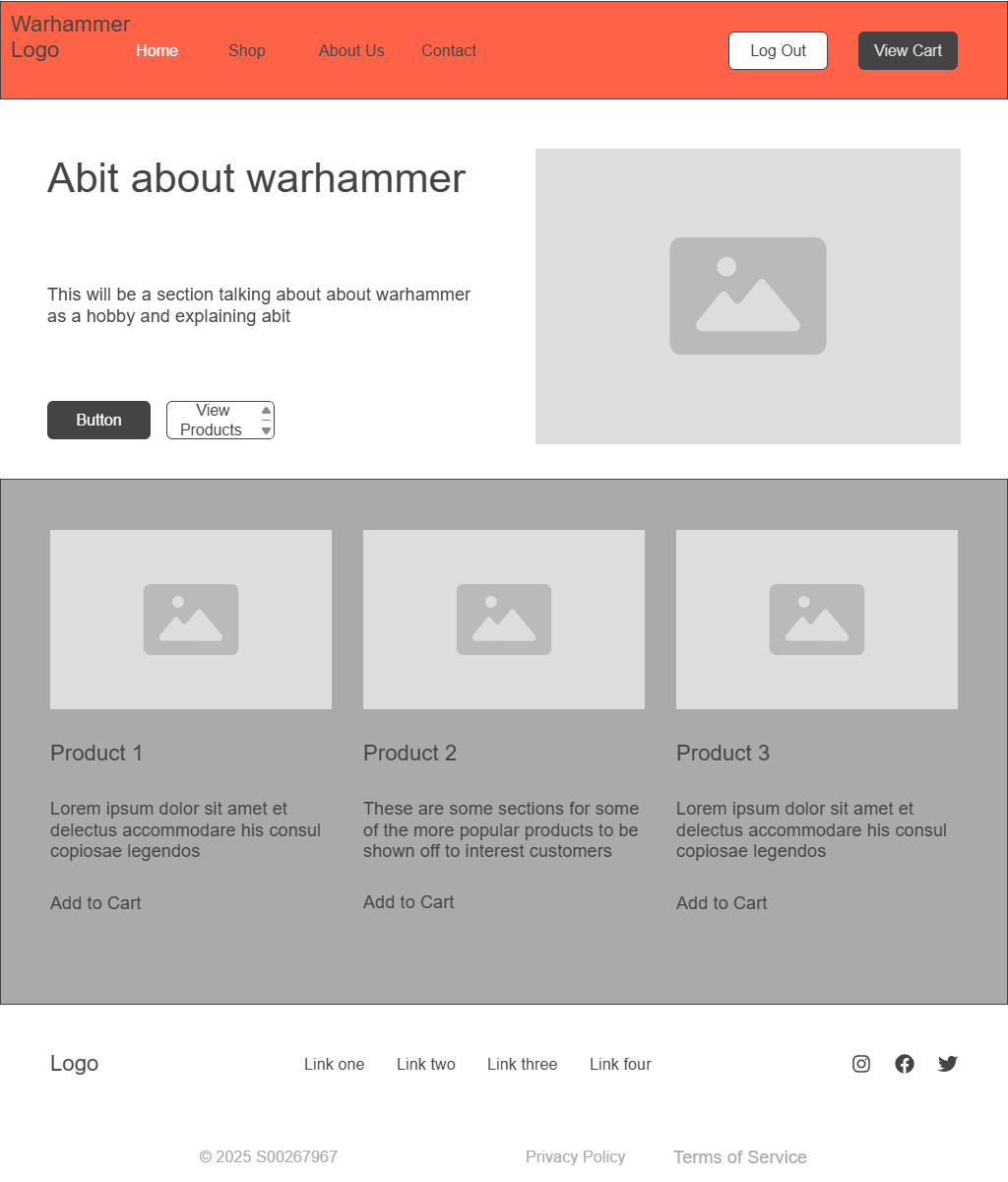
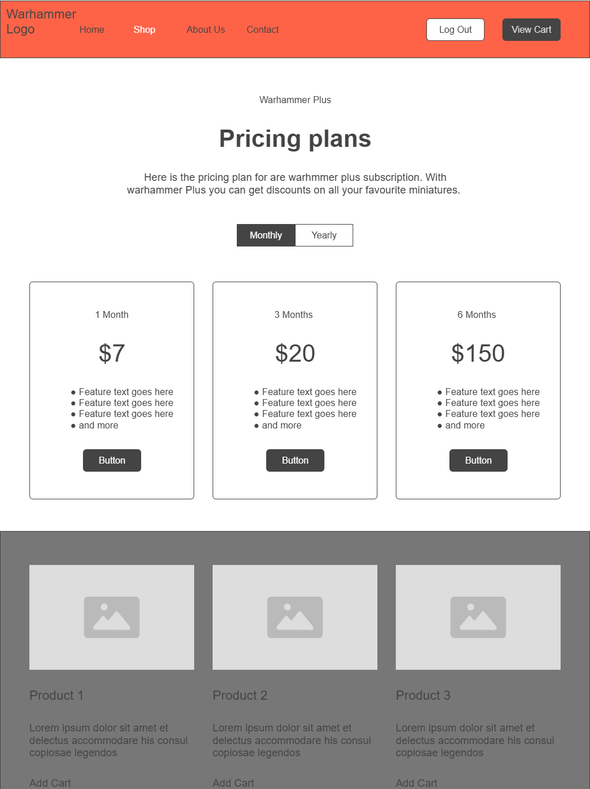
The only change I made is putting the products into the card format I had put on this webpage for a subscription instead. Apart from that it is identical.

Reflection on My Work

What went well?
Generally, the use of Bootstrap was successful because it made it possible to quickly create an interface that was both visually consistent and responsive. With little to no original CSS, the grid system, form components, and utility classes made it simpler to develop layouts that functioned across various screen sizes. Additionally, by keeping layout, partials, and page content separate, Express with Handlebars kept the code tidy.
As well I feel my general use of reusing old code and online resources through out the project aided in me getting the vision I wanted across throughout the project. This allowed me to spend more time on issues and working through those rather then having to burn all my time on CSS.

What did not go well and what would I do differently?
Managing JavaScript state across several sites was the most difficult element of the project, specially making sure the cart updated correctly on the checkout and cart screens. It took longer than anticipated to debug problems with LocalStorage.
If I were to recreate the project, I would start with the JavaScript code. For better state management. I would also give testing edge scenarios, such empty carts and incorrect user input. I.e There is no way to back out of purchase after putting in card details.

Did you do anything not covered in this module?
Yes, some aspects of this project moved beyond the module's main content. Independent research was needed for LocalStorage for client-side state management. The heavy focus on using the LocalStorage to hold product info , Test Account info and also the ability to create new accounts.

