PROJECT PROPOSAL (SHORT FORM)
AI Request Router
Nile University of Nigeria, Department of Software Engineering. Draft of 16 October 2026. Team and supervisor: to be confirmed.
In one sentence: a gateway that scores each request for difficulty, weighs predicted quality, cost and the live load on every backend, and sends it to the best model, hosted or self-hosted, with failover.
Working assumption: the router is a layer that sends each incoming LLM request to the best model by cost, quality and latency. Adjust if the project is something else.

1. The problem
Teams often hard-code a single model. Sending every request to one large model wastes money, and sending everything to a small one hurts quality. Hard-coding also brings latency spikes and no failover.
Existing routers mostly optimise cost and quality offline. Few handle live load, latency budgets and self-hosted model serving together. Our target users are developers and organisations running more than one LLM.

2. Existing solutions and their drawbacks
Each tool solves one slice. In the documentation we reviewed, none picks the model per prompt, watches live load, and also runs on your own GPUs.
Solution | What it does well | Drawback for our users
OpenRouter | One API to many hosted providers, with fallbacks and uptime-aware balancing. | Chooses between providers of the model you name, not between models. By default it avoids providers with recent outages, then favours lower price. Latency and throughput come from rolling 5-minute statistics, so a sudden queue build-up shows up late, and setting a sort order turns load balancing off. Its routing docs cover listed providers and your own provider keys, not self-hosted GPUs.
LiteLLM Router and Auto Router | Balances across your own deployments with latency-based, least-busy and cost-based strategies, plus fallbacks. Its Auto Router (beta, 2026) sorts each request into a complexity tier and maps tiers to models. | The core Router spreads traffic across copies of the model the caller names, so an easy and a hard question go to the same model. Its usage-based strategy adds latency from Redis tracking and is not recommended for production. The Auto Router docs we reviewed do not mention live load, queue depth, GPU use or per-request latency budgets.
RouteLLM | Learns to pick between one strong and one weak model from preference data. | A research framework: two models only, with no live load, latency budget or failover.
FrugalGPT-style cascades | Try the cheap model first and escalate if the answer looks weak. | A hard question pays the latency of every failed attempt before the right model answers.
Commercial routers (for example Martian) | Managed routing without running your own. | Closed. As far as we know, the routing rules cannot be inspected and the router cannot run on your own infrastructure.

3. How we plan to solve it
Each feature below answers one gap.
What is missing | What we build | Built with
Same model for easy and hard prompts | Scores each prompt for difficulty and task type before choosing a model. | sentence-transformers (turns text into numbers) with scikit-learn logistic regression (a small, fast classifier)
Load seen late or not at all | Reads live queue length, GPU use and tokens per second from each self-hosted server and avoids busy ones. | vLLM (server that runs open models efficiently) and Prometheus (collects metrics)
No self-hosted backends | Puts hosted APIs and your own GPU servers behind one OpenAI-compatible endpoint. | vLLM, Ollama (runs models locally) and FastAPI (Python framework for the async gateway)
Price-only or quality-only decisions | Combines predicted quality, cost and latency into one score, and honours a per-request latency budget. | Custom scoring function in Python
Failures and slow providers | Retries on the next-best backend and temporarily stops sending traffic to one that keeps failing. | Redis (fast in-memory store for shared health state) and a circuit-breaker pattern
Cascade latency | Decides before calling, in one hop, instead of trying models in sequence. | The same classifier, run before the request is sent
Unproven savings | Plots cost against quality and p95 latency (the time 95% of requests beat) versus always-strong and always-weak baselines. | RouterBench and MT-Bench (public benchmarks), Grafana (dashboards)
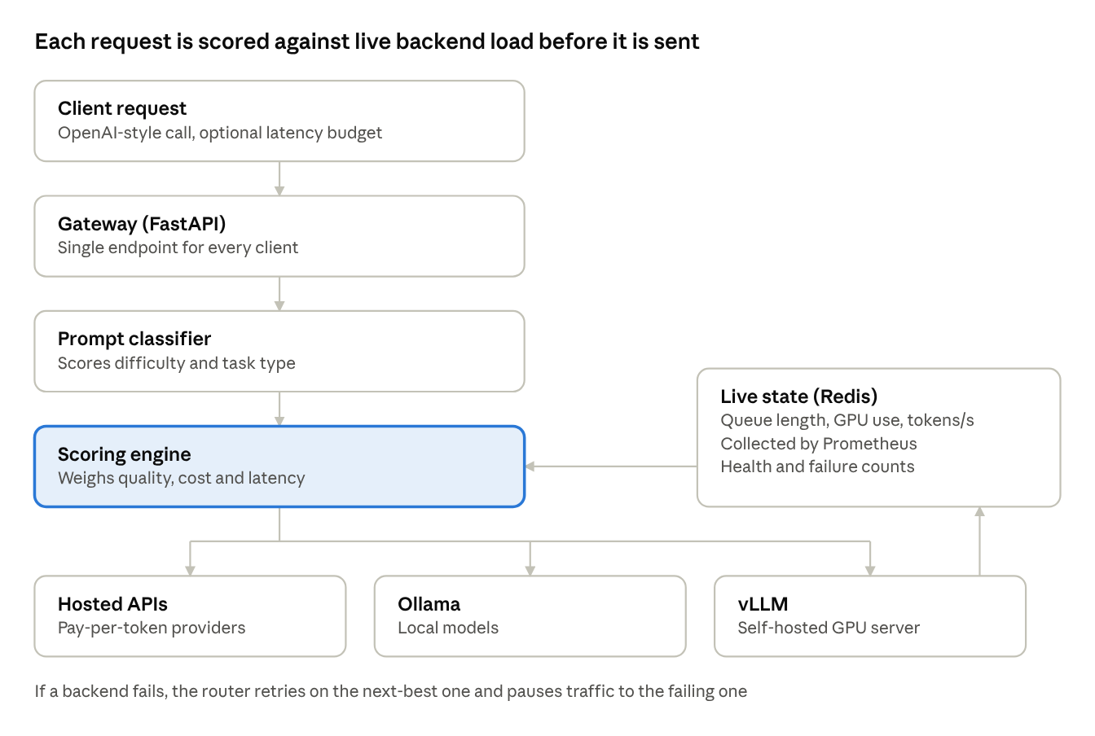
Figure 1. How a request flows. Every request passes the classifier and scoring engine once. Live load from the self-hosted servers feeds the score before a backend is chosen.

4. Scope and phasing
Proposed order, built from the project objectives. To be confirmed with the team.
- Phase 1, gateway and classifier: one OpenAI-compatible endpoint over hosted and self-hosted backends, the prompt classifier, and the cost, quality and latency score.
- Phase 2, resilience and load awareness: fallback with a circuit breaker, and live queue, GPU and throughput signals from vLLM through Prometheus.
- Phase 3, benchmarking: compare against always-strong and always-weak baselines on RouterBench and MT-Bench.
- Out of scope: building or training the language models. The router only chooses between existing ones.

5. How we will know it works
Numeric targets are not set yet. We will agree them with the supervisor before testing.
- Cost versus quality, against single-model baselines.
- Latency, including p95.
- Routing accuracy: how often the classifier picks the right model.

6. Main risks and how we handle them
Risk | Mitigation
Poor generalisation | Routers trained on one model pair generalise poorly. Test the classifier on more than one model pair using RouterBench before trusting it.
Noisy quality labels | Quality labels from preference data are noisy. Use public benchmarks and preference data, and report uncertainty rather than a single number.
Little prior work on live-load routing | Runtime-aware routing is thin in the literature. Treat it as the project's gap and measure it directly against load-blind routing.
Competitors are moving | LiteLLM's Auto Router now routes by complexity, so our difference is the combination of live load, latency budgets and self-hosted serving. Re-check the LiteLLM and OpenRouter docs before submission.
Sources
OpenRouter, provider routing
LiteLLM, routing and load balancing
LiteLLM, Auto Router v2 (13 July 2026)
LiteLLM, Auto Routing (beta)
Literature base, names only. Exact authors, years and links still need to be checked before citing.
Methods: FrugalGPT, RouteLLM, Hybrid LLM. Systems: OpenRouter, LiteLLM, Martian. Benchmarks: RouterBench, MT-Bench, Chatbot Arena.
Review: Adaptive LMS and AI Request Router (project document, October 2026).

