Review: AI-Assisted Collaborative Study Platform
Applying the research steps from Research Methodology slides 4 to 8 (topic, problem statement, aim and objectives, literature review) to the study platform.
Assumption: the platform is taken as the refined version in AI_Study_Platform_System_Design, plus a shared library whose visibility widens from private, to course, to university. A public level is roadmap only. Adjust if the scope changes.

AI-Assisted Collaborative Study Platform (with a shared library)

Step 1: Topic
- Problem: students rarely have time to turn their notes into revision questions, and the material peers share has no record of where it came from, who checked it or whether it is right.
- Target users: undergraduate students, starting with one Nile Software Engineering course, and lecturers or tutors who review material.
- Proposed solution: a web platform where any user generates flashcards and multiple-choice questions from their own notes with AI, checks each item against the passage it came from, and shares the reviewed set through a library.
- Evaluation: whether AI assistance cuts preparation time compared with manual creation while meeting content-quality and usability targets.

Step 2: Problem statement
Students keep lecture notes but seldom turn them into practice questions, so revision material is made late or not at all. What does get made is passed around in chat groups and drives. The consequences are unchecked answers circulating, wasted study time, and students who prompt AI tools well ending up with better material than those who do not. The gap is that existing tools generate questions or share notes, but few link each item back to its source, require a review before sharing, and organise sharing around a course. This is our working hypothesis. We will confirm it through interviews with 5 to 8 students and one lecturer before treating it as established.

Step 3: Aim and objectives
- Aim: to design, implement and evaluate a platform for creating, verifying, practising and sharing course-based revision resources.
- Objectives: elicit requirements, design the architecture and permissions, implement the bounded workflow, verify functional and quality requirements, and evaluate efficiency, content quality and usability.

Step 4: Literature review
- Methods: AI-generated questions with retrieval-augmented generation (Maity et al., 2025), question-quality evaluation (Yao et al., 2025, MCQG-SRefine), spaced repetition (Maye et al., 2026), and the System Usability Scale (Brooke, 1996).
- Systems: NotebookLM, Quizlet, Studocu AI and Anki.
- Evidence: a meta-analysis of 29 experiments on generative AI and higher-order thinking, a 2026 study of AI-generated content in medical training, and a randomised trial of spaced-repetition flashcards with dental students.
- Limitations: generated items can be wrong, and a source reference shows traceability, not correctness. Much of the evidence comes from medical and dental education and small samples, so it may not transfer to one software engineering course.
- Gap: most work stops at generating questions or at individual practice. Combining source-linked generation, a review step and course-scoped sharing is thinly covered. This still has to be confirmed in the guide's ten-source literature matrix.

Where existing solutions fall short
No single option combines AI generation from a student's own notes, a link from each item to its source passage, a review step, and a library built around a course.
Solution | Example of the shortfall
NotebookLM (Google) | Generates flashcards and quizzes from uploaded documents, with explanations that cite the source. But it is built around a personal notebook. Sharing is by link, so there is no searchable course library, no review trail across students and no local-curriculum focus.
Quizlet | AI tools turn notes, slides and readings into flashcards and practice tests, and sets can be shared. The feature descriptions we reviewed do not mention a link from each card back to its source passage, so checking a card is left to the user.
Studocu AI | AI summaries, quizzes and Ask AI, built on a large pool of peer-shared notes. Its launch announcement does not explain how shared content is verified or whether answers cite sources, and coverage of our courses and Nigerian past questions is unknown.
Anki and shared decks | Strong spaced repetition and a large pool of shared decks. But cards are made by hand, so effort is the barrier, and shared decks generally carry no link back to the original note.
WhatsApp, Drive, Telegram | Where students share notes today, instantly and for free. But there is no structure by course or topic, no review or attribution, and no connection between a note and the questions made from it.

What our system offers
Gap | Our function | Technology (what it does)
Cannot tell where an AI answer came from | Source-linked generation. Every AI-drafted flashcard or multiple-choice question links to the supporting passage and page in the student's own text or PDF. | A hosted language model (low-cost tier, behind a narrow interface so it can be swapped) with strict JSON-schema validation (checks the reply has the right fields and passage IDs)
No quality check before sharing | A review gate. The owner edits items and marks the set reviewed before it can be shared. Any later edit clears the review, and published sets are fixed versions. | PostgreSQL (relational database) with Prisma (database access library); transactions protect publishing
No one place to find and share material | A library with visibility levels: Private, Course, University (verified student email) and Public (roadmap). Only generated items are shared, never the original files. Others can copy and remix a set, and the original contributor stays credited. | Next.js (web interface framework) and Node.js/Express (backend API)
No AI help for students who do not know how to prompt | AI generation for every user, with per-user daily limits and a project spend cap. Manual authoring always stays available. | Redis (fast in-memory store for sessions, rate limits and the daily generation cap)
Material not tied to their own course | A course focus. Each set belongs to a course and topic. We start with one Nile Software Engineering course and add local past questions. | Course and topic fields in PostgreSQL
A download, not a study loop | Quiz answers scored on the server, with attempt history and a weak-topic view. | Node.js/Express server-side grading, so answer keys never reach the browser early
Copyright and unauthorised uploads | Originals are never public. Shared sets carry a citation (title and page), a licence choice and a declaration, plus a report and takedown path. We will confirm Nigerian copyright rules with the supervisor. | Private file storage (disk in development, an S3-compatible bucket such as Supabase Storage or Cloudflare R2 in the pilot; never public by default)
Student data and consent | Consent, pseudonymous research IDs, a fixed deletion period, and logs that never hold document text, handled under the Nigeria Data Protection Act 2023. | Server-side permission checks on every file and API call; logs hold identifiers and timings only
Unproven benefit | Compares AI-assisted and manual preparation time with 15 to 20 students, rates 100 to 150 sampled items, and reports usability. Proposed targets, not results: median time at least 25% lower, at least 90% of published items passing checks, SUS of at least 70. | SUS (10-question usability questionnaire) and rubric-based ratings by an independent reviewer

How a study set is made and shared
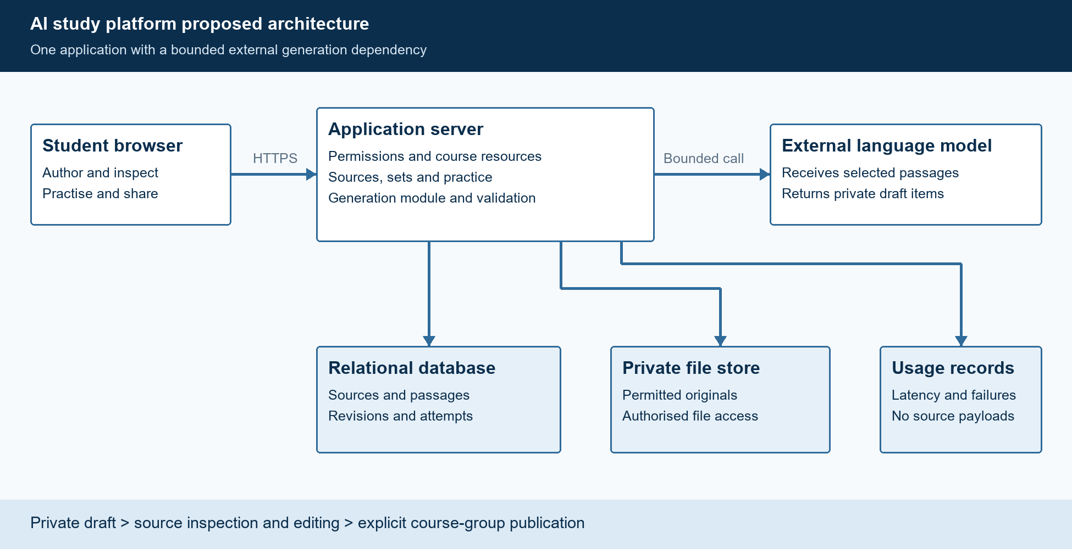
Study platform architecture · one application, one bounded model call
Every draft starts private. The server sends only selected passages to the model, the owner checks and edits each item against its source, and a set is shared only after the owner marks it reviewed and chooses a visibility level.
Note: the sources above were gathered through database searches during this review, so check exact authors and years before using them in a proposal. The Quizlet row rests on an earlier read of its feature page, which could not be re-fetched at the last check.

