BDA400 / Data Science Tools and Techniques
Assignment 5
Technical Analysis using R, Development Phase
Name: Sodiq Yunusa

Repository for this assignment
https://github.com/SodiqYunusa/TechnicalAnalysis/tree/main/Assignment5

1. Overview
This report accompanies the nine R scripts that make up Stage 2 (Development Phase) of the Technical Analysis project. Stage 1 (Assignment 2) built the TechnicalAnalysis repository and loaded stock data for the portfolio symbols; this stage adds the indicator functions that Stage 3 will use for filters and trading rules. Every function is written in base R only. No packages are loaded by any script; the built-in functions lm(), sd() and stats::filter() appear only in run_tests.R, as an independent yardstick for checking my results.
Function names and argument names follow the supplied templates exactly, so the instructor's test file can call them directly.
Script | Function | Depends on
sma.R | sma(data, period) | none
ema.R | ema(data, period) | none
macd.R | macd(data, short_period, long_period, signal_period) | ema.R
stdev.R | stdev(data) | none
linreg.R | linreg(regressionSource, regressionLength, regressionOffset) | none
rsi.R | rsi(data, period) | none
stoch_rsi.R | stoch_rsi(data, period, k_period, d_period) | rsi.R, sma.R
crossover.R | crossover(arr1, arr2) | none
crossunder.R | crossunder(arr1, arr2) | none

macd.R and stoch_rsi.R load the scripts they depend on automatically if those functions are not already in memory, so each file also works on its own.

2. How to run the code
- Install R (4.x) and RStudio. No packages need to be installed.
- Clone or download the repository and open the Assignment5 folder.
- In RStudio choose Session > Set Working Directory > Choose Directory and select the Assignment5 folder (or open any .R file from it and choose To Source File Location).
- To run everything at once, type the following in the Console. It loads all nine scripts and runs 46 automated checks:
source("run_tests.R")

- To use a single function, source its script and call it:
source("sma.R")
sma(c(10, 12, 15, 20, 18, 22, 25, 24, 21), period = 3)

- A successful test run ends with the line ALL 46 CHECKS PASSED. The full output is reproduced in Appendix A and RStudio screenshots are in Appendix B.

3. Explanation of each implementation

3.1 Simple Moving Average (sma.R)
SMA is the plain mean of the most recent 'period' values, which smooths short-term noise. The function stops with the required error message if the data is shorter than the period, creates an empty result vector, and loops over each window data[i:(i + period - 1)], storing sum(window) / period. The result has length(data) - period + 1 values, as in the pseudocode, so the first value corresponds to observation number 'period'.
Example: sma(c(10,12,15,20,18,22,25,24,21), 3) returns 12.33, 15.67, 17.67, 20.00, 21.67, 23.67, 23.33.

3.2 Exponential Moving Average (ema.R)
EMA gives more weight to recent prices. The multiplier is 2 / (period + 1). The first value is seeded with data[1]; every later value is EMA[i] = (data[i] - EMA[i-1]) * multiplier + EMA[i-1]. The output is the same length as the input.
Example: ema(c(10,12,15,20,18,22,25,24,21), 3) starts 10, 11, 13, 16.5, 17.25, ... (checked by hand: 10 + (12 - 10) * 0.5 = 11).

3.3 MACD (macd.R)
MACD measures momentum as the gap between a short-term and a long-term EMA. The function computes ema(data, short_period) and ema(data, long_period), takes macd_line = short - long, smooths the MACD line with ema(macd_line, signal_period) to get the signal line, and returns histogram = macd_line - signal_line. The three vectors are returned in a named list (macd_line, signal_line, histogram).
Example: for the series 100, 105, ..., 130 with periods 3, 5, 2 the MACD line rises from 0 to about 4.20, positive throughout, which signals bullish momentum on a steady uptrend.

3.4 Standard Deviation (stdev.R)
The function follows the six steps in the brief: mean, differences from the mean, squares, their average (the variance), then the square root. It divides by n, so it is the population standard deviation and is slightly smaller than R's sd(), which divides by n - 1. This is deliberate and matches the formula supplied. The test file confirms stdev(c(2,4,4,4,5,5,7,9)) = 2 exactly.

3.5 Linear Regression (linreg.R)
linreg fits the least-squares line y = intercept + slope * x to a window of the series, using x = 1, 2, ..., L. The window is the most recent regressionLength points, optionally shifted back by regressionOffset points. The function validates its inputs (length must not exceed the data, offset must be smaller than length), extracts the window, and computes slope = sum((x - mean_x)(y - mean_y)) / sum((x - mean_x)^2) and intercept = mean_y - slope * mean_x. It returns a list with slope, intercept and predicted_values (one fitted value per point in the window).
Verification: the results match R's lm() on random data to eight decimal places for both offset 0 and offset 3, and a perfect line (1, 3, 5, 7, 9, 11) returns slope 2 and intercept -1.

3.6 Relative Strength Index (rsi.R)
RSI compares the size of recent gains with recent losses on a 0 to 100 scale (above 70 is traditionally overbought, below 30 oversold). The function takes the price differences, splits them into gains and losses (absolute value), and averages the first 'period' of each as the starting averages. It then applies Wilder's smoothing, avg = (previous_avg * (period - 1) + latest) / period, and converts each result with RSI = 100 - 100 / (1 + RS), where RS = average gain / average loss. The vector is the same length as the data and starts with 'period' NA values because that much history is needed.
Edge cases: a loss average of zero gives RSI 100; a perfectly flat series gives 50; if there are not more than 'period' observations the function warns and returns NA values instead of failing.
Example: rsi(c(45,50,48,55,52,49,58,60,65,62), 5) gives NA x5, then 60.00, 74.40, 76.73, 81.88, 70.22. The first value was verified by hand.

3.7 Stochastic RSI (stoch_rsi.R)
StochRSI rescales RSI to 0 to 1 using its own highest and lowest values: (RSI - min RSI) / (max RSI - min RSI), so readings near 0 suggest oversold and near 1 overbought. The function calls rsi(), normalises the valid RSI values, smooths them with sma() over k_period to give %K, and smooths %K with sma() over d_period to give %D. Both lines are returned in a list (k_line, d_line).
Because the RSI warm-up values are NA, the smoothing is applied only to the valid part and the results are placed back in position, so both lines are the same length as the data. For period 14, k_period 3 and d_period 3, %K starts at observation 17 and %D at observation 19. If the data is too short (as in the brief's 10-point example with period 14) the function warns and returns NA lines rather than stopping.

3.8 Crossover (crossover.R)
crossover marks the points where arr1 moves from at-or-below arr2 to above it (a bullish signal). It checks that the arrays have equal length, starts with a vector of FALSE, and for i = 2..n sets element i to TRUE when arr1[i] > arr2[i] and arr1[i-1] <= arr2[i-1]. For the brief's sample arrays the only crossover is at index 4 (20 > 18, after 15 <= 22).

3.9 Crossunder (crossunder.R)
crossunder is the mirror image: TRUE at index i when arr1[i] < arr2[i] and arr1[i-1] >= arr2[i-1], meaning arr1 has dropped below arr2 (a bearish signal). Passing the arrays in the opposite order turns the crossover at index 4 into a crossunder at index 4, which the test file confirms.

4. Where the pseudocode was adjusted, and why
I followed the templates and pseudocode closely. In four places the pseudocode would give an incorrect or inconsistent result, or contradicts the written description, so I made a small, documented change:
Function | Pseudocode as written | What I implemented and why
rsi | The Wilder loop starts at i = period + 1 and smooths in gains[period], which was already counted in the starting average, so that change is counted twice. | The first RSI value (observation period + 1) uses the starting averages; smoothing begins at period + 2. This is the standard Wilder calculation.
linreg | start_index = max(1, n - L + offset) and end_index = min(n, n - offset) select L + 1 points when offset = 0 and fewer than L when offset > 0. | end_index = n - offset and start_index = end_index - L + 1, so the window always has exactly L points, ending 'offset' points before the last one.
crossover / crossunder | Pseudocode stores the strings "Up", "Down", "None" (crossover) and "True"/"False" (crossunder), but the written description says the output is an array of Boolean values. | Both functions return a logical (TRUE/FALSE) vector, as described. This also lets later trading rules use the result directly, for example which(crossover(a, b)).
stoch_rsi | min and max are taken over the whole RSI vector, which contains NA values at the start, and sma() is then applied to a vector that starts with NAs. | min and max ignore the NA warm-up values, and smoothing is applied to the valid section only, then aligned back to the original positions.

Following the pseudocode literally in these places would be a one-line change if a different convention is preferred; the checks in run_tests.R document the behaviour I chose.

5. Testing
run_tests.R contains 46 checks covering all nine functions: known hand-calculated values, comparisons against R's built-in sd(), lm() and stats::filter(), error handling (data shorter than period, bad arguments, unequal array lengths), and edge cases (constant series, strictly rising or falling prices, NA inputs, too little data). All 46 pass. The complete output is shown in Appendix A, and screenshots of the same run in RStudio are in Appendix B.

Appendix A: Output of run_tests.R

=== SMA ===
[1] 12.33333 15.66667 17.66667 20.00000 21.66667 23.66667 23.33333
[PASS] SMA length = n - period + 1
[PASS] SMA matches stats::filter
[PASS] SMA errors when data shorter than period
[PASS] SMA period = length(data) gives the mean

=== EMA ===
[1] 10.00000 11.00000 13.00000 16.50000 17.25000 19.62500 22.31250 23.15625
[9] 22.07812
[PASS] EMA length = n
[PASS] EMA first value seeded with data[1]
[PASS] EMA second value = 10 + (12-10)*0.5 = 11
[PASS] EMA of a constant series is constant
[PASS] EMA period 1 reproduces the data

=== MACD ===
$macd_line
[1] 0.0000000 0.8333333 1.8055556 2.6620370 3.3371914 3.8393776 4.2002100

$signal_line
[1] 0.0000000 0.5555556 1.3888889 2.2376543 2.9706790 3.5498114 3.9834105

$histogram
[1] 0.0000000 0.2777778 0.4166667 0.4243827 0.3665123 0.2895662 0.2167996

[PASS] MACD returns macd_line, signal_line, histogram
[PASS] MACD lengths equal input length
[PASS] MACD histogram = macd_line - signal_line
[PASS] MACD line = EMA(short) - EMA(long)
[PASS] MACD positive on a steady uptrend

=== Standard deviation ===
[1] 4.946629
[PASS] stdev matches sqrt(mean((x-mean(x))^2))
[PASS] stdev matches sd() * sqrt((n-1)/n)
[PASS] stdev of a constant vector is 0
[PASS] stdev(c(2,4,4,4,5,5,7,9)) = 2

=== Linear regression ===
$slope
[1] 2

$intercept
[1] -1

$predicted_values
[1] 1 3 5 7 9 11

[PASS] linreg slope of y = 2x - 1 is 2
[PASS] linreg intercept of y = 2x - 1 is -1
[PASS] linreg predicted values reproduce a perfect line
[PASS] linreg (L=10, offset 0) matches lm() on the last 10 points
[PASS] linreg (L=10, offset 3) matches lm() on points 18-27
[PASS] linreg errors when length > n
[PASS] linreg errors when offset >= length

=== RSI ===
[1] NA NA NA NA NA 60.0000 74.4000 76.7273 81.8761
[10] 70.2239
[PASS] RSI length = n
[PASS] RSI first 'period' values are NA
[PASS] RSI values lie within 0-100
[PASS] RSI of a strictly rising series is 100
[PASS] RSI of a strictly falling series is 0
[PASS] RSI[6] matches hand calculation
[PASS] RSI with too little data returns all NA

=== Stochastic RSI ===
[1] 0.4497 0.5481 0.6744 0.7977 0.7247 0.6384 0.5425 0.5006
[1] 0.4395 0.4821 0.5574 0.6734 0.7323 0.7203 0.6352 0.5605
[PASS] StochRSI returns k_line and d_line
[PASS] StochRSI vectors are the same length as the data
[PASS] %K stays between 0 and 1
[PASS] %K first available at observation 14 + 1 + 3 - 1 = 17
[PASS] %D first available two points later (obs 19)
[PASS] %D is the 3-point SMA of %K
[PASS] StochRSI on the short sample (period 14, 10 points) returns NA, no crash

=== Crossover / Crossunder ===
[1] FALSE FALSE FALSE TRUE FALSE FALSE FALSE FALSE FALSE
[1] FALSE FALSE FALSE FALSE FALSE FALSE FALSE FALSE FALSE
[PASS] crossover is TRUE only at index 4 (20 > 18, previously 15 <= 22)
[PASS] crossunder is FALSE everywhere for the sample data
[PASS] swapping the arrays turns the crossover into a crossunder
[PASS] signals are logical, same length as input
[PASS] equal-then-above counts as crossover (<= on previous bar)
[PASS] crossover/crossunder error on unequal lengths
[PASS] NA inputs give FALSE rather than crashing

ALL 46 CHECKS PASSED

Appendix B: RStudio screenshots of the test run
The screenshots below show run_tests.R executed in RStudio on my computer. Every check reports PASS and the run finishes with ALL 46 CHECKS PASSED.
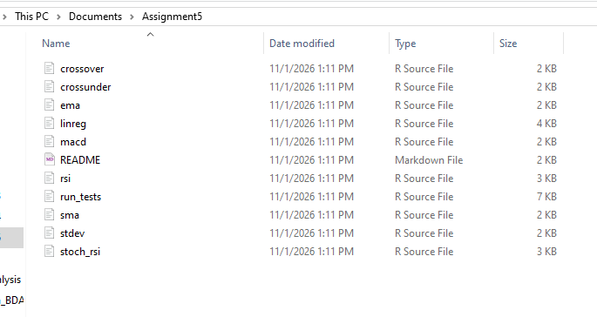
Figure 1: The Assignment5 folder containing the nine indicator scripts, run_tests.R and README.md.
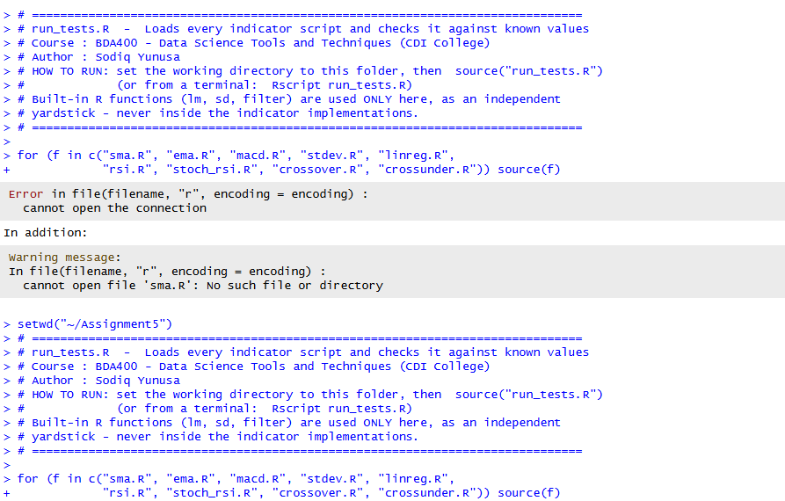
Figure 2: RStudio Console - loading run_tests.R and the nine scripts (working directory set to the Assignment5 folder).
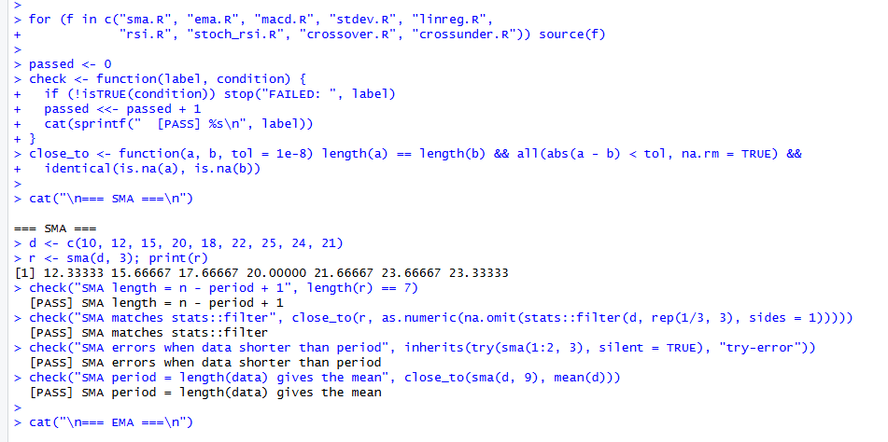
Figure 3: SMA tests - all four checks pass; sma() returns 12.33, 15.67, 17.67, 20.00, 21.67, 23.67, 23.33.
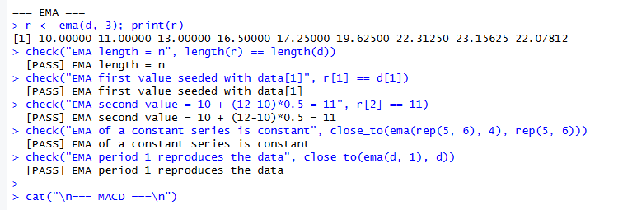
Figure 4: EMA tests - all five checks pass.
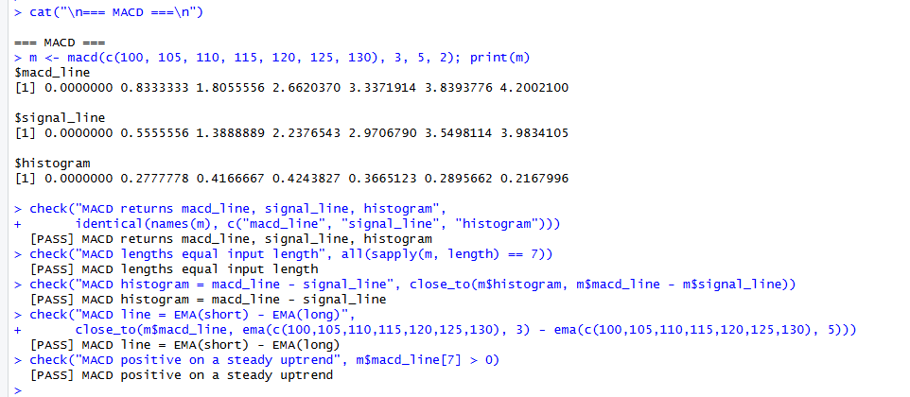
Figure 5: MACD tests - macd_line, signal_line and histogram returned and verified.
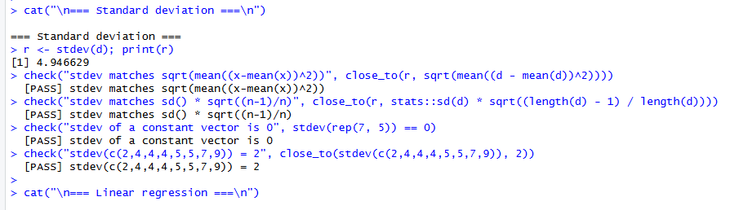
Figure 6: Standard deviation tests - all four checks pass (population standard deviation).
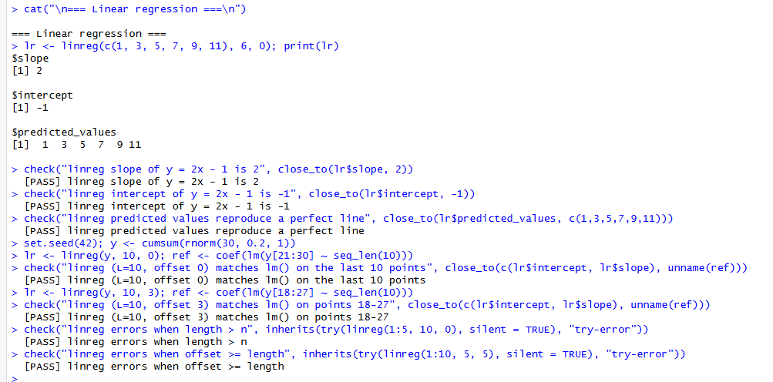
Figure 7: Linear regression tests - slope 2 and intercept -1 on a perfect line; results match lm() for offsets 0 and 3.
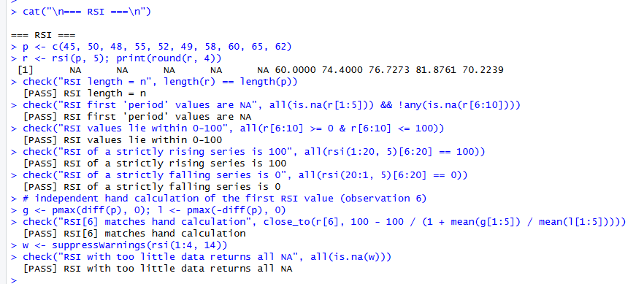
Figure 8: RSI tests - NA warm-up values, then 60.00, 74.40, 76.73, 81.88, 70.22; all seven checks pass.
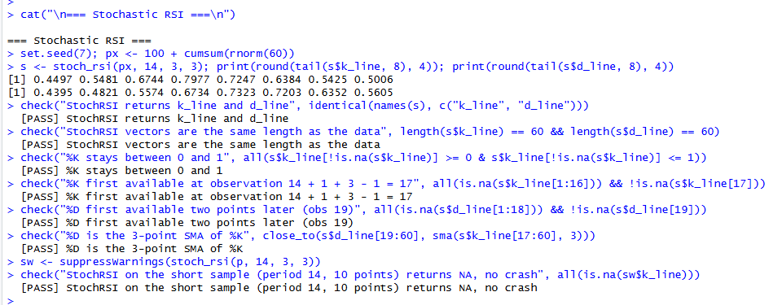
Figure 9: Stochastic RSI tests - %K and %D lines verified; all seven checks pass.
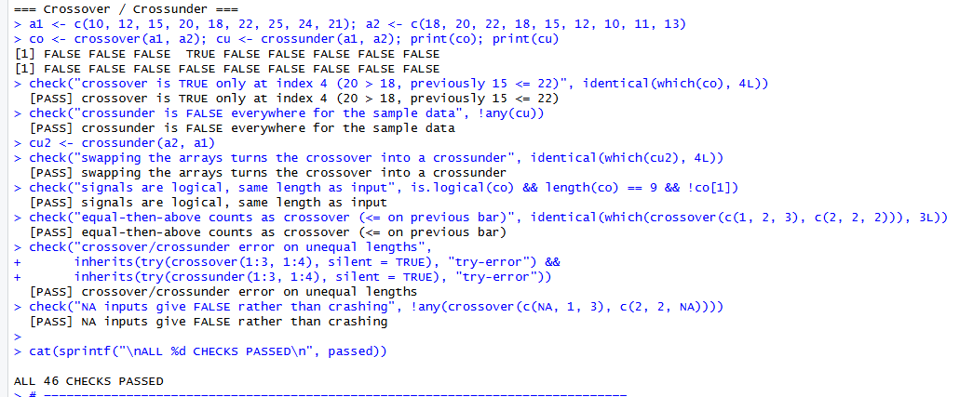
Figure 10: Crossover and crossunder tests, ending with ALL 46 CHECKS PASSED.

