University of Tasmania

Event Organising System

KIT502 Assignment

Project : Campus Connect

Submission By: Submitted To:
Jasleen Kaur - 107492 Dr Corinna Ng
Naman Sanjay Bhalani - 100839 (Lecturer ECA Melbourne)
Harsh Vadadoriya - 101003
Jash Rajnikant Hirani - 121930

Project Overview:
Our team is developing Campus Connect as part of the KIT502 Web Development Course's web-based event organizing system. It is an easy-to-use platform that allows users to efficiently create, manage, and explore all of the events taking place on campus.
The system is designed to support a variety of users, including event planners, administrators, and attendees. Attendees can browse and register for events, organizers can create and manage events, and administrators can keep an eye on the platform and manage system operations. Thanks to the website's dynamic layout, users can easily access event details like names, descriptions, dates, locations, and ticket prices.
The project's top priorities are front-end design and database planning for the application. Many websites have been developed to replicate the features of an actual event management system, including landing pages, registration pages, login pages, create event pages, and event management pages. JavaScript validation is used to check user input before forms are submitted.
The project includes a database schema design and Entity-Relationship (ER) diagram in addition to the front-end interface, which will aid in the backend implementation in the subsequent stage. Future interaction with backend technologies like MySQL and Laravel is made possible by the system's architecture, which enables full functionality like ticket purchasing, event management, and user authentication.
All things considered, CampusConnect demonstrates the principles of web interface design, form validation, database modeling, and collaborative development through GitHub while laying the foundation for a full-stack event management application.

Website Features & Team contribution:

Landing Page - Naman Bhalani
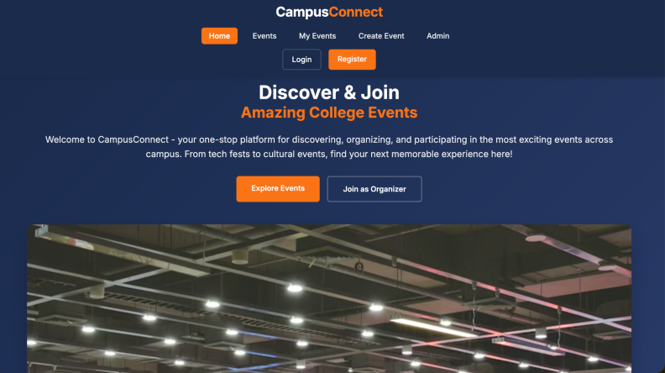 Figure: Landing Page
- The landing page is the first thing users see when they visit my website.
- It shows what the platform is about with a top navigation menu and a welcoming main section.
- This page helps users understand how to navigate through the platform.
- It has a navigation bar so users can easily find what they need.
- The hero section welcomes users and creates a good first impression.
- Users can explore events or go to sign up/log in directly from here.
- This makes the landing page simple and user-friendly.
- I designed the landing page to be intuitive.
- It makes it easy for users to explore the platform.
- Overall, my landing page is designed to be user-friendly and accessible.

My Events Page - Harsh
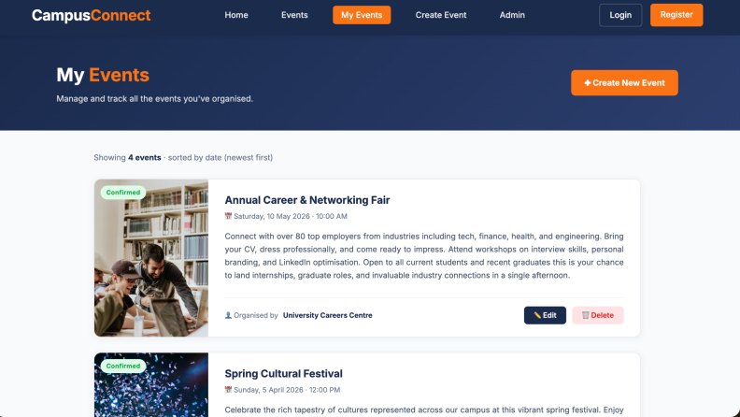
Figure: My Events Page
- This page allows users to manage the events they have created.
- It shows event cards with details like date, description, and event status.
- Users can edit or delete events easily.
- This makes managing events simple and efficient.

Events Listing Section - Harsh
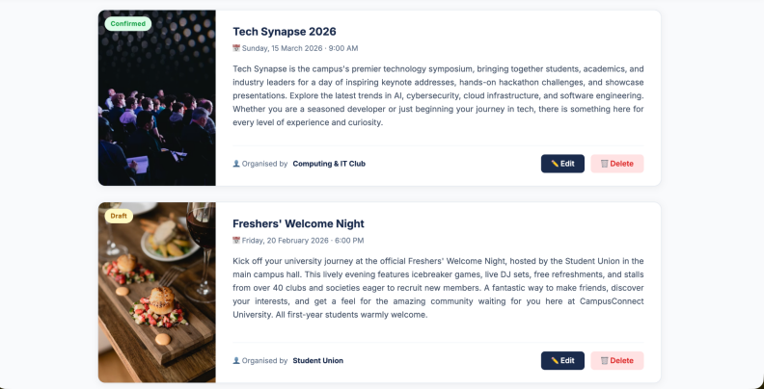 Figure: Events Listing Section
- This section displays all events available on my platform.
- Each event includes details and images.
- This helps users quickly understand what each event is about and decide if they want to participate.
- I have presented the events in a way that makes them easy to understand and visually clear.

Create Event Page - Harsh
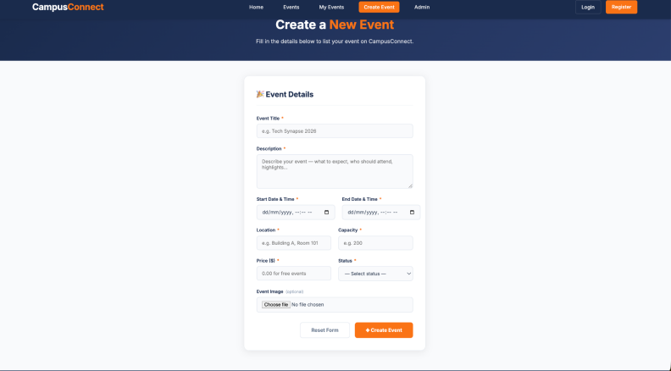Figure: Create Event Page
- The create event page allows users to enter all the details about an event. Users can input information such as the event title, date, time, location, and description. I designed this page to be simple and easy to use, so users can create events without confusion.

Login Page - Jash Hirani

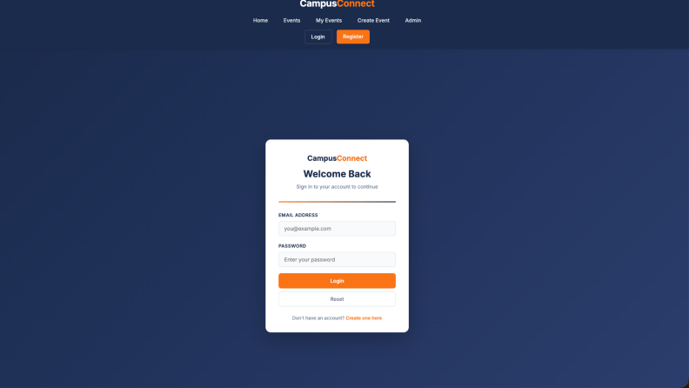Figure: Login Page
- The login page allows users who already have an account to log in securely.
- It includes fields for email address and password.
- The design is simple and easy to use.
- This page helps users access their accounts safely.
- It focuses on providing a clean and minimal interface.
- Overall, it ensures a smooth login experience.
.

Registration Page - Jash Hirani
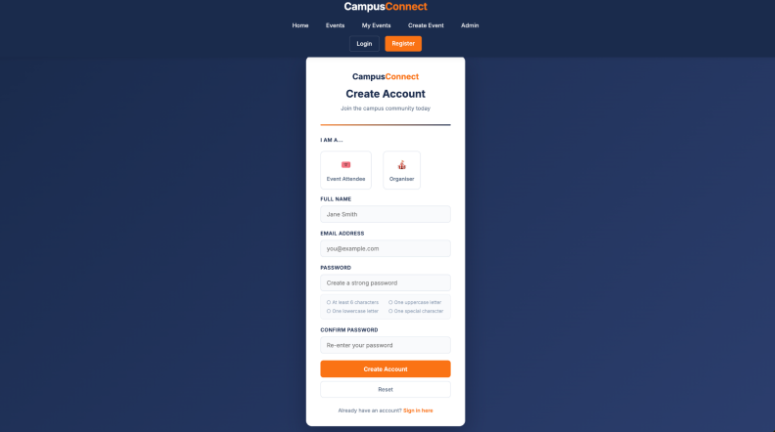Figure: Registration Page
- This page allows new users to create an account. It includes options such as selecting the user role and entering personal details. I designed this page to guide users step-by-step, making the registration process simple and easy.

Admin Dashboard
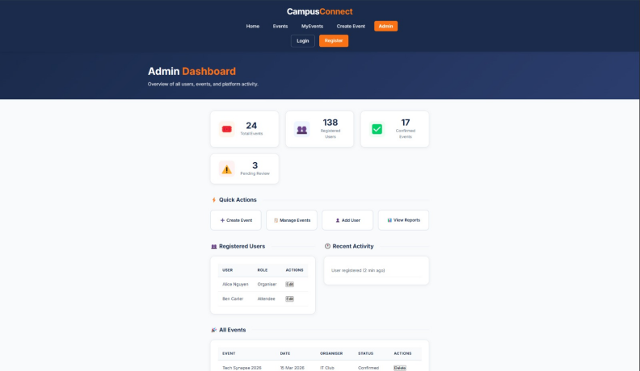
Figure: Admin Dashboard
- The admin dashboard gives an overview of what is happening on the platform. It shows information such as the number of events, total users, and pending reviews. From this dashboard, I can manage users, manage events, and monitor the overall system performance. It helps ensure that everything on the platform is working properly.

ER Diagram: Jasleen Kaur
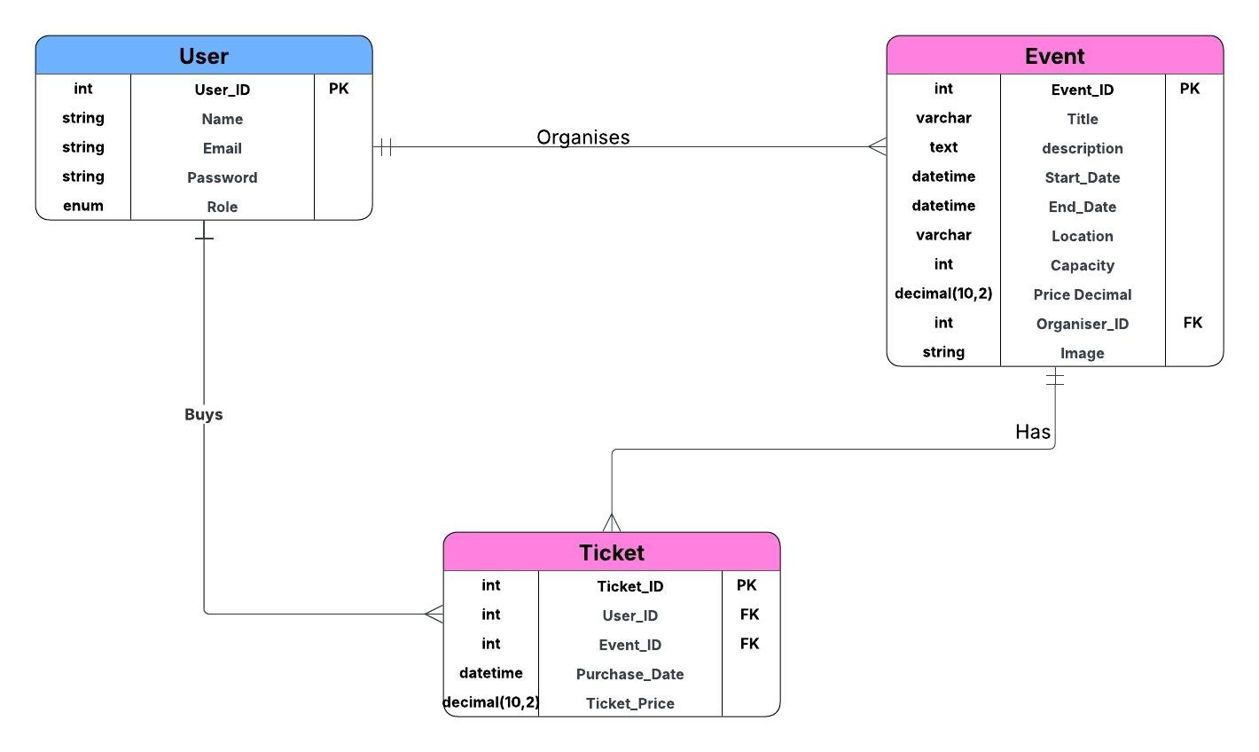
Fig. ER Diagram
ER diagram will help to clearly justify the relationships between the entities used in the web application.
- It will also help in data planning, will show how the data will be managed.
- Will avoid the redundancy of the data flow.

Relational Database Schema: Jasleen Kaur
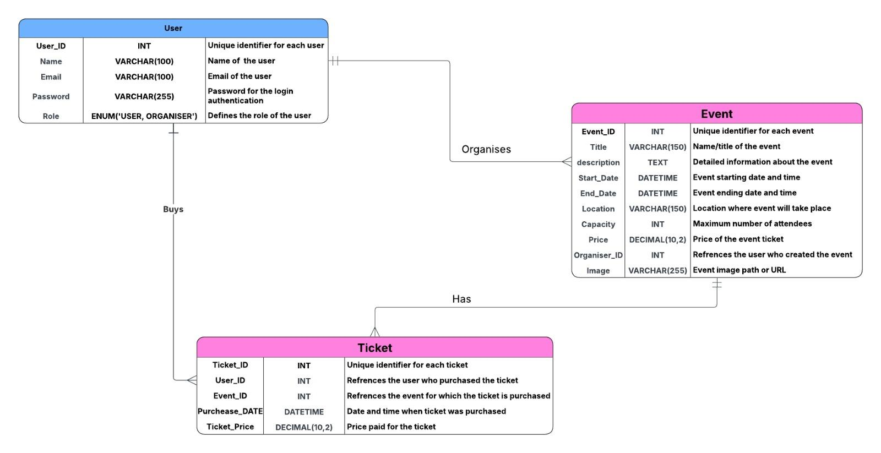
Fig. Relational database Schema
This relational database schema is a logical structure of database. It is defining the attributes with its data types and description.

Resources/Tools Used

-W3 Schools
- MDN Web Docs
- Lucidchart
- draw.io
- Github
- Vs Code

Task Distribution:

The components required for the web application was divided among the team members fairly like:
- Front-end interface design
- Form validation implementation
- Event management interface
- Database modelling
- Documentation

Project Timeline Management:

- Week 2( 2 - 8 March) - In this week assignment was released and discussed between team members and task distribution was done.
- Week 3( 9 - 15 March) - In this week , initial design of the assignment was odne like landing page, site navigation, registration and login with valid javascript was implemented.
- Week 4(16 - 22 March) - In this week, create an event page, event management, ER diagram, database schema and README documentation.
- Week 5 ( 23 - 25 march) - Final amendments was done before final submission which is on 25 march.

Future Development:

In assignment 2, full- stack web application will be implemented:
- Use of Laravel
- MySQL
- Backend authentication system
- Event ticket booking system
- Admin management features

Repository:
The link for the github repository used for this project is:
https://github.com/Sodium-Man/CampusConnect

Conclusion:

CampusConnect is a web-based event planning tool that makes it easy for users to find, create, and manage events. This project shows important ideas in web development, like how to plan a database, design a user interface, and check forms. It also shows how to work well with others and use GitHub while laying the groundwork for a full-stack implementation in the next stage of the project.

