

# Graduate Diploma in Systems Analysis SA47

# Internship Attachment Report

Project Title: Meeting Minutes Application

Incoming Quality Test

E-Part Tracking

SSMC APP

Students: Lynn Lynn Oo @ S.Mor.Sangeetha

(A0186875H)

Organization: Systems on Silicon Manufacturing Co.

Pte. Ltd (SSMC)

**IN PARTIAL FULFILLMENT OF THE REQUIREMENTS**

**FOR THE**

**GRADUATE DIPLOMA IN SYSTEMS ANALYSIS**

**July 2019**

**THE INSTITUTE OF SYSTEMS SCIENCE**

**NATIONAL UNIVERSITY OF SINGAPORE**

Contents

**Chapter 1: Introduction** 5

**1.1: Objective of Industrial Attachment** 5

**1.2 Project Background** 6

**1.3 Project Details** 6

**1.3.1 Nature of Assignment Domain** 6

**1.3.2 Nature of Job Responsibilities** 6

**1.3.3 Software Used** 6

**1.3.4 Project Statistics** 7

**Chapter 2: Overview of Activities** 9

**2.1 Project Plan and Schedules** 9

**2.2 Phases / Activities / Deliverables** 10

**Chapter 3: Recommendations** 16

**3.1 Short Term Recommendation** 16

**3.2 Long Term Recommendation** 16

**Chapter 4: Things Learned** 17

**4.1 Accomplishments** 17

**4.2 Learning Outcome** 19

**Chapter 5: Problems and Solutions** 19

**Chapter 6: Looking Back** 20

**Chapter 7: Acknowledgement** 21

Appendix A 22

A.1: Flow Charts of Meeting Minutes Application 22

A.2: UI Design 24

Appendix B 37

B.1: Progress Reports 37

B.1.1: Week 1 Report 37

B.1.2: Week 2 Report 37

B.1.3: Week 3 Report 38

B.1.4: Week 4 Report 39

B.1.5: Week 5 Report 39

B.1.6: Week 6 Report 40

B.1.7: Week 7 Report 40

B.1.8: Week 8 Report 41

B.1.9: Week 9 Report 41

B.1.10: Week 10 Report 42

B.1.11: Week 11 Report 42

B.1.12: Week 12 Report 42

B.1.13: Week 13 Report 43

B.1.14: Week 14 Report 44

B.1.15: Week 15 Report 44

B.1.16: Week 16 Report 45

B.1.17: Week 17 Report 45

B.1.18: Week 18 Report 46

B.1.19: Week 19 Report 46

B.1.20: Week 20 Report 47

# **Chapter 1: Introduction**

Systems on Silicon Manufacturing Company Pte. Ltd is founded locally on Dec 1998, (SSMC).It is a Joint Venture between NXP B.V. (NXP) and [Taiwan Semiconductor Manufacturing Company Limited](http://www.google.com.sg/url?sa=t&rct=j&q=&esrc=s&source=web&cd=1&cad=rja&uact=8&ved=0ahUKEwiAtreHodnYAhUEFZQKHQrIAKUQFggmMAA&url=http%3A%2F%2Fwww.tsmc.com%2F&usg=AOvVaw1hFUejjI9XHaQvHrnb0vtW) (TSMC). It has grown into a sought after provider of wafer fabrication and foundry services. SSMC is offering flexible and cost effective semiconductor fabrication solutions ranging from 0.25-micron to 0.11-micron technology. It is reputed to offer flexible and cost effective semiconductor fabrication solutions by maintaining fully equipped SMIF cleanroom environment, 100% equipment automation and proven wafer-manufacturing processes. It focus in producing specialty wafers for Connected Car, Secured Connectivity, Portable & Wearable and the Internet of Things applications. The Information Technology and Automation department act as a key in Business values, developing and maintaining applications which are essential components required for smooth running of wafer manufacturing.

Mission and vision for SSMC is going the extra mile to deliver best-in-class foundry services and to be a preferred source of Automobile & High Performance Mixed Signal Semiconductor Wafers.

# **1.1: Objective of Industrial Attachment**

* To expose us to actual working environment, enhance our knowledge and skill from what we have learned in the ISS
* To instill the good qualities of integrity, responsibility and self-confidence
* To help us about the safety practices and regulations inside the industry
* To instill the spirit of teamwork and good relationship with team in a professional perspective

# **1.2 Project Background**

**Meeting Minutes Application**

People used papers and typewriter to recognize the meeting details on the earlier time. This method seem to be wasted on too much time, human effort and cost of the paper. So converting as an application will be saved these all resources and can perform all actions in one places. Minutes is tangible record of the meeting for its participants and a source of information for members and also for members who were unable to attend. In some cases, meeting minutes can act as a reference point like when a meeting’s outcomes impact other collaborative activities or projects within the organization and minutes can track individuals of tasks assigned to them and/or timelines.

The advantages of using Meeting Minutes App are –

* Set up meetings effortlessly. Choose a time and date for meeting and invite attendees.
* Create and collaborate on agendas. Then turn them into meetings.
* Save time by importing meetings from calendar with one click.
* Everyone gets the same meeting documents and spend less time in the meeting room.
* Review previous meetings and track unresolved tasks.

# **1.3 Project Details**

# **1.3.1 Nature of Assignment Domain**

The initial aim of the project was to provide a record of what was discussed, decided in a meeting and agreed at a meeting. Meeting minutes also serve as a record of what actions must be taken, who must take them and when. And although the system is since from 6 month, the organization wanted to redesign and implement again according to its Crashes and Bugs.

# **1.3.2 Nature of Job Responsibilities**

* Requirement Specification & Functional Specs
* Technical Analysis (Design Prototype)
* Database Design
* Development (Coding)
* Create stored procedure in Microsoft SQL Server
* Unit test

# **1.3.3 Software Used**

* ASP.Net Web - used for ePart-Tracking application
* ASP.Net MVC - used for IQC (Incoming Quality Check)
* ADO.net - used in ePart-Tracking, Meeting Minutes App and IQC
* Entity Framework - used in SSMC App
* Stored Procedures - used in ePart-Tracking, Meeting Minutes App and IQC
* Lambda Query - used in SSMC App
* Scanner API - used in IQC
* HTML5 - used for all assigned projects
* Bootstrap - used for all assigned projects
* CSS - used for all assigned projects
* JAVASCRIPT - used for all assigned projects
* JQUERY - used for all assigned projects
* JSON - used for serializing object into strings
* AJAX - used for sending data between client and server side

**Tools**

* Visual Studio 2017 - used for develop Backend and Frontend
* Microsoft SQL Server Management Studio- Used for creating Stored Procedures, functions and test Queries
* VNC Tight Viewer - to change the new version of Tableau report by remoting other desktops via IP Address.
* Excel - used to populate the data to database table by CONCATENATE function
* Photoshop – to create Division App table images.

# **1.3.4 Project Statistics**

**Meeting Minute Application**

* Total 21.5 man-days take for this project (week 12 – 16)
* 7.5 man-days take to fix the bugs and changed respective stored procedures in the old meeting minute application
* Discuss the Business flow with organization’s deputy director who is user for this meeting minute app and browsed the facts in google that are not familiar for 1 man-day.
* Re-Design the Database tables and draw Flowchart for 5 man-hours
* Re-Design UI (7 screens)
* Implement the new system by modifying the existing codes, adding new logics, features and validations.

**IQC (Incoming Quality Check)**

* 10 man-days for design UI for “Job Creation Form”, “Received Part Summary” and “Received Part Form”. Change the design again and again if it does not meet user’s expectation.
* 5 man-days for learn the scanner API.
* 15 man-days for implement the backend for three Forms and Stored Procedures.

**E-Part Tracking**

* 2 man-days for understanding the existing flows for ePart-Tracking.
* 5 man-days for adding one new “All Part Master” page and add this module in the navigation bar.

**SSMC Application**

* 6 man-days to design Dashboard version1, version2 and version 3 and modify back-end code according to flows.
* Adjust the Frontend of Operational app page by CSS.
* Modify the update and Delete function from Admin Page.
* Add Division Apps table into three SSMC Home Pages.

**Others**

* 2 man-days for coding front end for Online Survey Assessment.
* 1 man-day to change the version of report by remoting via IP Address by using Tight VNC Viewer application.

# **Chapter 2: Overview of Activities**

# **2.1 Project Plan and Schedules**

* Analysis
  + Understanding SSMC & IT Standard Operating Procedures
  + Understanding User Requirement Documents
  + Identifying required resources
  + Produce the project plan
* Design
  + Planning and work style discussion
  + Re-Design database
  + Design Flowcharts
* Implementation
  + E-Part Tracking (Newly added 1 module + Enhancements)
  + IQC (3 Screens)
  + Meeting Minutes Application (redesign, fix bugs and changed both Front-ends and Back-ends)(7 screens)
  + SSMC APP (Enhancements)(3 screens)
* Testing
  + Perform testing on every phase of incremental.
* UAT

# **2.2 Phases / Activities / Deliverables**

The first two weeks of internship is to learn the organization culture and securities by attending internship briefing course by SSMC, enrolling about company’s introduction module, Security module and Health & Environment at Integrated learning System (ILS) and raised the request for permission to install the required applications on my pc.

The methodology used in the assigned projects are Agile and Incremental Model.

We broke up the development plan into smaller, working pieces. Those pieces are then developed, implemented, and tested piece by piece until the application is finished. In some of the increment, the tasks from different assigned projects are processing parallelism.

Each phase of incremental described below –

|  |  |  |
| --- | --- | --- |
| **Incremental 1** | Project | Tasks |
| **e-Part Tracking Application**  and  **Online Survey Assessment** | * Understanding the existing documentation and business flow for e-Part Tracking * Design the UI for new page e-Part Tracking * Design the UI for Online Survey Assessment * Add new module into Navigation Bar * Retrieve all the part number with their serial number and form ID to Grid view. * Add update and delete function inside Grid * Add search function with two criteria * Add Import function for save all data from grid as Excel file * Add Export function to populate all the data from excel to grid view * Testing all the functions |

|  |  |  |
| --- | --- | --- |
| **Incremental 2** | Project | Tasks |
| **e-Part Tracking Application**  and  **IQC** | * Gathered the requirements and discuss business flow. * Design the UI for new page e-Part Tracking * Design the UI for Online Survey Assessment * Add additional features and enhancement for Installed Part. (e-Part Tracking) * Add additional features and enhancement in Replace Part. (e-Part Tracking) * Implemented “Create Job Request” Module for both frontend and backend for IQC. * Testing for all the functions |
|  |  | **Deliverables**  **- 1 screens and other Enhancements for e-Part Tracking**  **- Frontend for online survey assessment** |

|  |  |  |
| --- | --- | --- |
| **Incremental 3** | Project | Tasks |
| **IQC**  and  Change Report Version | * Created Store Procedures. * Add method for Generate Unique Reference number. * Add Barcode Scanner API and library * Add method for Generate Batch ID. * Implemented “Create Job Request” Module for both frontend and backend for IQC. * Change the version of the report by remoting desktop via IP address by using VNC Tight viewer. * Testing for all the functions |

|  |  |  |
| --- | --- | --- |
| **Incremental 4** | Project | Tasks |
| **IQC** | * Changed the UI design for “Create Job Request”. (After Testing) * Add new module “Received Part Summary”. * Create Stored Procedures for break down the (n) number of Serial numbers and insert with the same attributes in table. * Add new module for “Received Parts Form” * Testing for these all function |

|  |  |  |
| --- | --- | --- |
| **Incremental 5** | Project | Tasks |
| **IQC** | * Changed the UI design and some logics from backend for “Received Part Form” and “Received Part Summary”. (After Testing) * Add validation for 3 screens * Testing for these all function |

|  |  |  |
| --- | --- | --- |
| **Incremental 6** | Project | Tasks |
| **IQC**  and  **Meeting Minutes App** | * Changed date time format in the stored procedures for IQC. (After Testing) * Bugs fix for Meeting Minutes Application. * Add calendar instead of manual date inputs. * Integration Testing for IQC |
|  |  | **Deliverables**  **- 3 screens for IQC** |

|  |  |  |
| --- | --- | --- |
| **Incremental 7** | Project | Tasks |
| **Meeting Minutes App** | * Understand the existing business flow, discuss and gathered requirement of user that what he wants to add new features. * Redesign the Database * Draw flowchart * Changed UI for 7 screens * Testing |
|  |  |  |

|  |  |  |
| --- | --- | --- |
| **Incremental 8** | Project | Tasks |
| **Meeting Minutes App** | * Modify existing codes, add new logics and features. * Change the UI for Meeting Detail Page (After Testing). * Testing |
|  |  | **Deliverables**  **– 7 screens for Meeting Minutes Application** |

|  |  |  |
| --- | --- | --- |
| **Incremental 9** | Project | Tasks |
| **SSMC App** | * Add internet explorer icon in front of applications which must open with IE browser * Add one condition for adding icon * Changed the Dashboard design of SSMC App * Testing |
|  |  |  |

|  |  |  |
| --- | --- | --- |
| **Incremental 10** | Project | Tasks |
| **SSMC App** | * Changed the Dashboard design of SSMC APP (After testing) V2 & V3 * Add V3 into 3 SSMC home Pages * Adjust the screen design of operational app page with CSS * Testing |
|  |  |  |

|  |  |  |
| --- | --- | --- |
| **Incremental 11** | Project | Tasks |
| **SSMC App**  and  **Meeting Minutes App** | * Adjust the screen design of operational app page with CSS (After Testing) * Modify Update and Delete function Admin Index page. * User wants to change the last page of UI from Meeting Minutes after one week from delivered items. * Change the UI and their respective code for last page of Meeting Minutes App. * Testing |
|  |  | **Deliverables**  **– SSMC App (3 screens) and final updated Meeting Minutes App.** |

# **Chapter 3: Recommendations**

# **3.1 Short Term Recommendation**

* One recommendation I can offer is in the current build, only Web application development platforms are supported. While these may be perhaps the most popular platforms out on the market, there are still many users who don’t have access to either.

# **3.2 Long Term Recommendation**

* Validation is currently develop into application, however, there are scope for improvements for further validation capabilities.
* The current application was developed with user requirement methodology in mind. As we noting down how users interacts with the built application and being open feedback is major in improving the current design of the application that is user friendly and desirable.

# **Chapter 4: Things Learned**

# **4.1** **Accomplishments**

**Meeting Minutes App**

* Create Meeting Module
* Create Meeting
* Search Employee & Assign Action
* Meeting Detail Module
* Update Meeting Detail
* Update Participant
* Update assigned action items and tasks
* My Meeting Module
* Show List of Meetings
* Meeting List Module
* Show summary of Meetings
* Choose status according by action
* Action Detail Module
* Upload File
* Assign SubActionItem
* Choose Status according by action
* Sub Action Detail
* Upload SubActionItem file

**E-Part Tracking** (Web Application)

* Maintain All Part Master Module
* Export
* Import
* Search
* List
* Update
* Install Part module (Enhancement)
* Replace Part (Enhancement)

**IQC**

* Summary Module
  + Received Part Form
  + Create Job Request
* Received Part Form Module
  + Scanned the items
  + Received
* Job Creation Form Module
  + Retrieve data
  + Scanned items
  + Save
  + Submit

**SSMC APP**

* + Home Page (Enhancement)
  + Division Apps Pages (Enhancement)

# **4.2 Learning Outcome**

1. During my internship, I realized each culture and employer have their own standards and how to be respectful.
2. Adapt to new country, new city and new office which requires a high level of adaptability and flexibility.
3. Understand how to effectively communicate in an international office will open as opportunities as the world becomes increasingly globalized.
4. Get plenty of opportunities to solve problems and tackle new challenges.
5. Help to develop teamwork and leadership skills.
6. Time management and project management helped me keep on track to finish the project. Milestones also helped me keep pace, and gave me a sense of accomplishment that the project was moving forward.

# **Chapter 5: Problems and Solutions**

1. Coding part is longer than expectation.
2. Unfamiliar with the usage of API so that I had needed to give time to learn about API.
3. Difficult to understand the inventory culture and organization’s business flows without having documentations.
4. Requirements change lately in development cycle lead to changing design and implementation of system.
5. Users may not be satisfied with the product if it does not meet requirements or expectations so that perform quality control and requirements conformance checks, to ensure project is heading in the right direction.
6. Codes for certain pages are complex so that manpower and effort needed to be reallocated accordingly to become efficient and meet the delivery date.
7. Database design is very important. I had to adjust database schema slightly during the project, due to miscommunication on when designing the database. As a result, some time was lost re-propagating the database.

# **Chapter 6: Looking Back**

1. If assigned a similar project, I would gathered all the requirements of user by asking details and ask for documentation for the facts that I gathered to respective person.
2. I would spend enough time on drawing use cases.
3. I would sketch the all UI and show the user first. Then I would code after User approved the sketchers of UI.
4. I would choose to spend more time finalizing, discussing the database and would draw the sequence diagrams for each use case to make sure interactions between UI, Controller and not to be confused which databases should be used during the coding.
5. I would request user to test well before I hand over the project so that I can manage my time to change whatever (like design, add feature) user wants to change.
6. Through this project, I have learnt to appreciate the rigor and thought necessary to carry through a software development project. I have picked up valuable new skills and perspective from this experience, which I know will serve well for any further similar projects.

# **Chapter 7: Acknowledgement**

The internship opportunity I had with Systems on Silicon Manufacturing Co. Pte. Ltd. [SSMC] was a great chance for learning and professional development. Therefore, I consider myself as a very lucky individual as I was provided with an opportunity to be a part of it. I’m also grateful for having a chance to meet so many wonderful people and professionals who led me though this internship period.

Bearing in mind previous I’m using this opportunity to express my deepest gratitude and special thanks to **Mr. Ho Eng Keong (Head of Department)** who in spite of being extraordinarily busy with his duties, took time out to hear, guide and keep me on the correct path and allowing me to carry out my project at their esteemed organization and extending during the training.

I express my deepest thanks to **Mr. Khek Meng Tay (Deputy Director)** for taking part in useful decision & giving necessary advices and guidance and arranged all facilities to make life easier. I choose this moment to acknowledge his contribution gratefully.

It is my radiant sentiment to place on record my best regards, deepest sense of gratitude to **Ms. Michelle Bondoc (Senior Technical Manager**), **Mr. Sui Yan (Principle Engineer (IT & A))**, **Ms. Elvie Fernandez Yuzi (Senior Software Engineer)** and **Mr. Ravi Gupta (Senior Software Engineer)** for their careful and precious guidance which were extremely valuable for my study both theoretically and practically.

I perceive as this opportunity as a big milestone in my career development. I will strive to use gained skills and knowledge in the best possible way, and I will continue to work on their improvement, in order to attain desired career objectives. Hope to continue cooperation with all of you in the future.

Lastly, my special thanks from the bottom of my heart to my internship advisor **Ms. Megan Wang (Senior Manager from ISS)** who is kind-hearted, smart, perfect and dedicated person. She gave me a chance to discuss my difficulties when the time she met with me. And she ordered me to care my health, not to be put too much stress and do great on work as best as I can. She always told the words of wisdom that words made me really motivated. She always gave me advices for my doubt and pointed me out to the right path which facts made me to feel like I am very lucky to have a supervisor like her.

# Appendix A

# A.1: Flow Charts of Meeting Minutes Application

Create Meeting

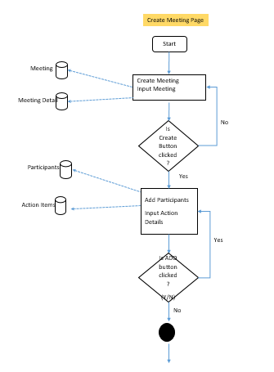

My Meeting Page

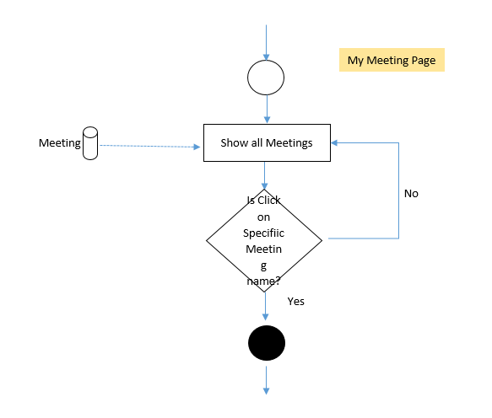

Meeting List

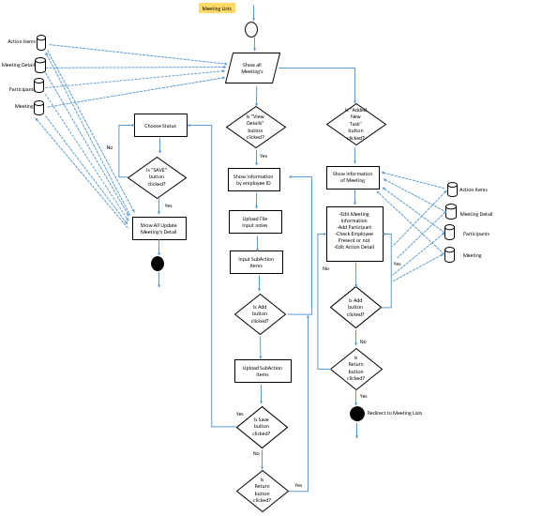

# A.2: UI Design

**Meeting Minutes Application**

Create Meeting

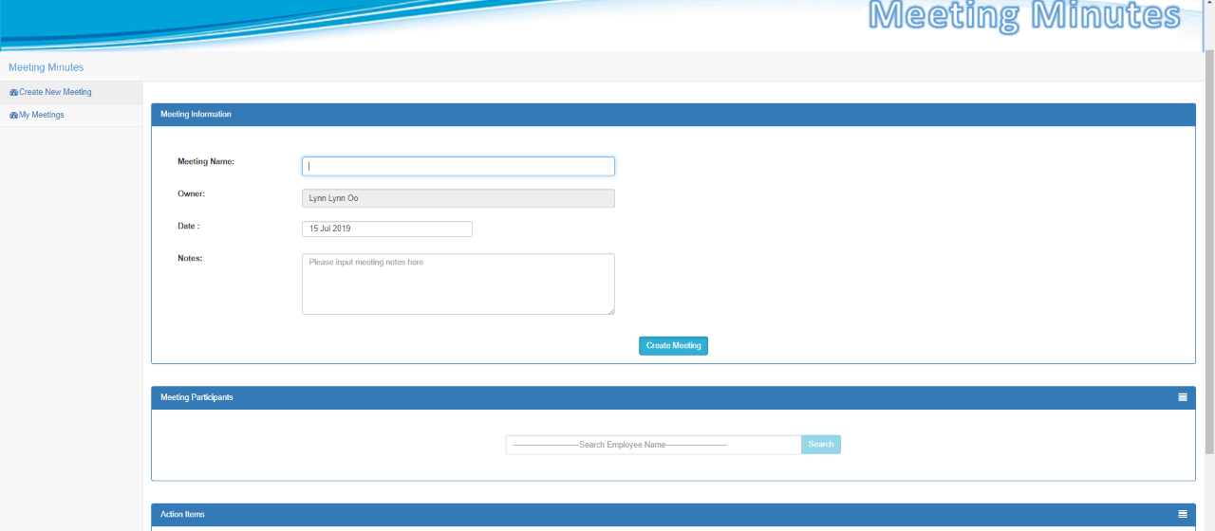

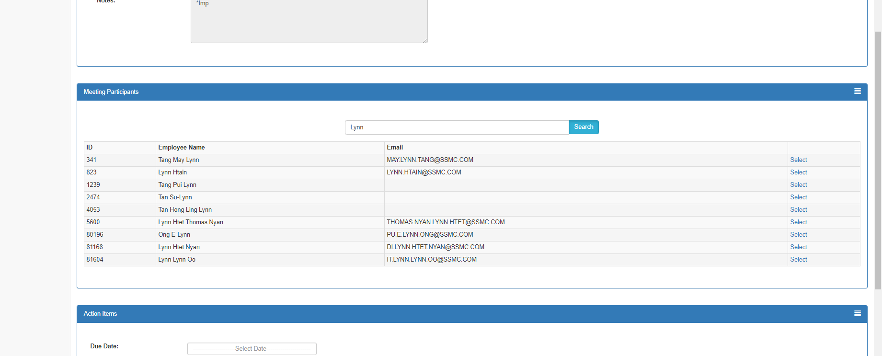Search Employee to assign as meeting participants

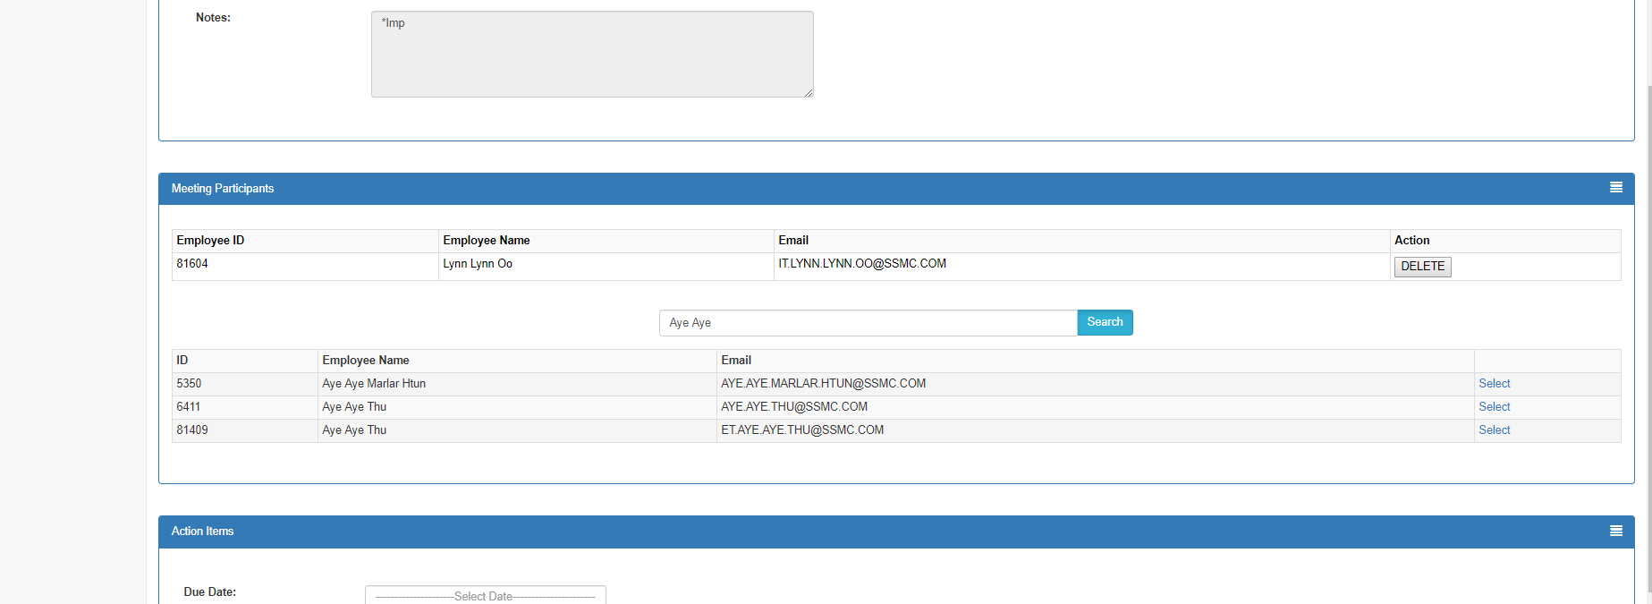Select Employee

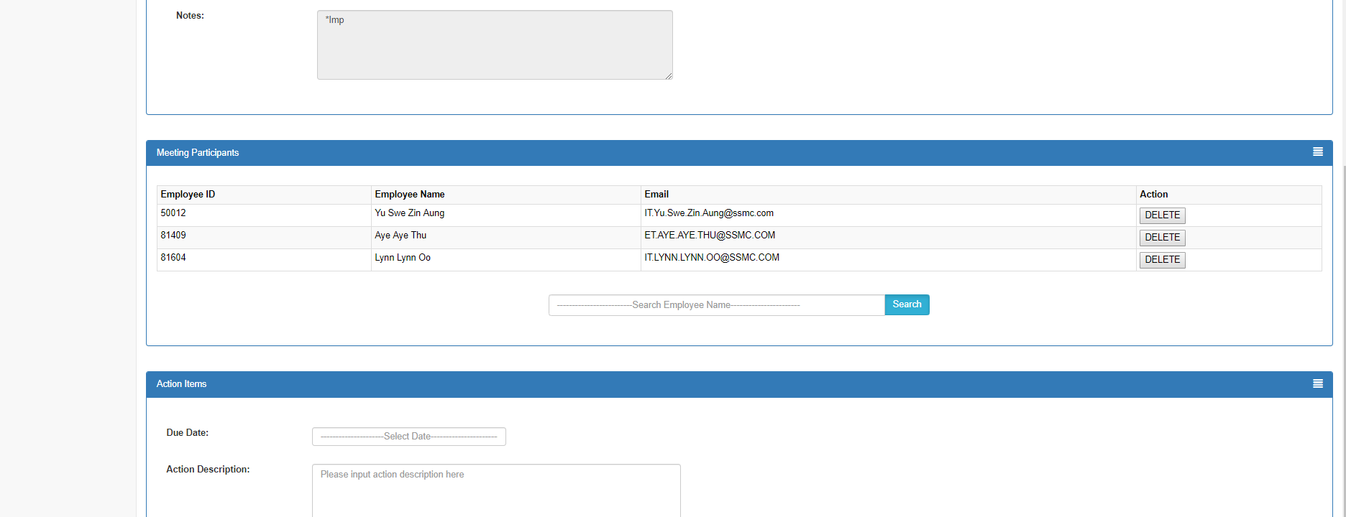Select 3 Employee

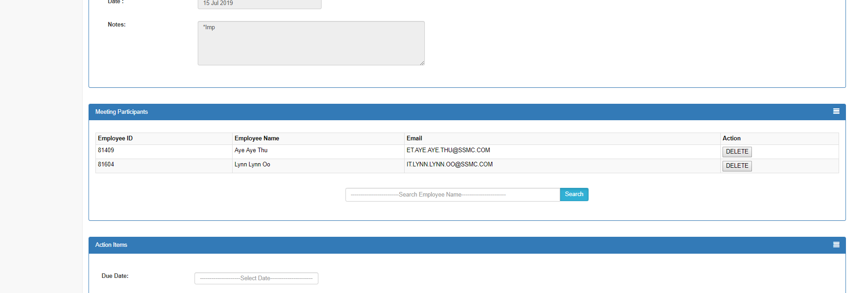After deleted one Employee

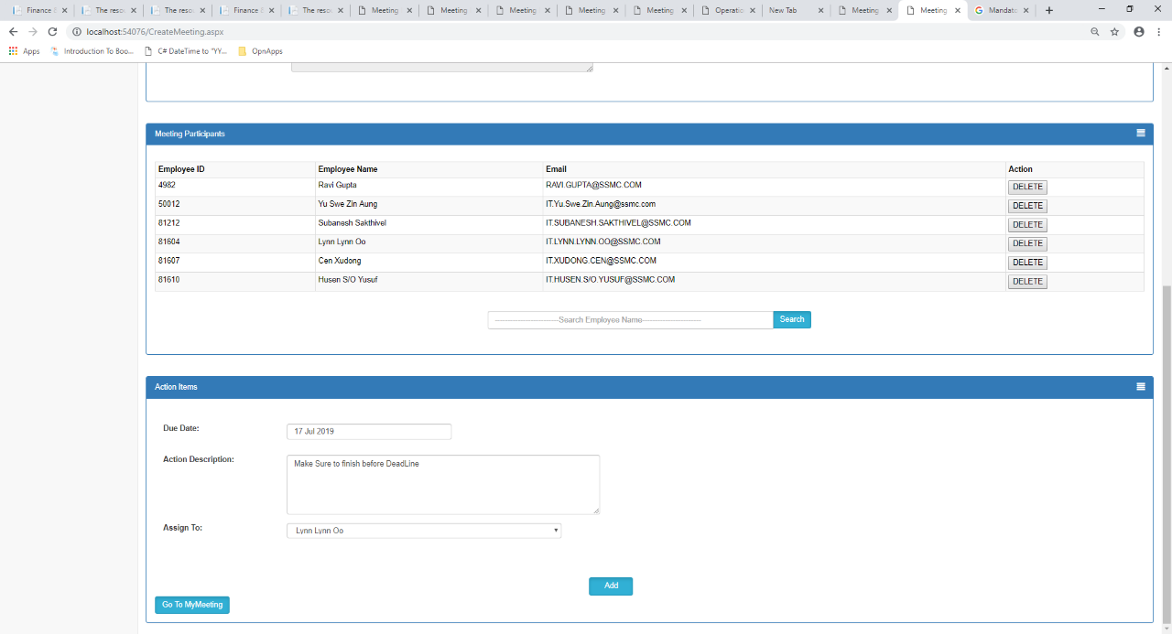Before assign action item

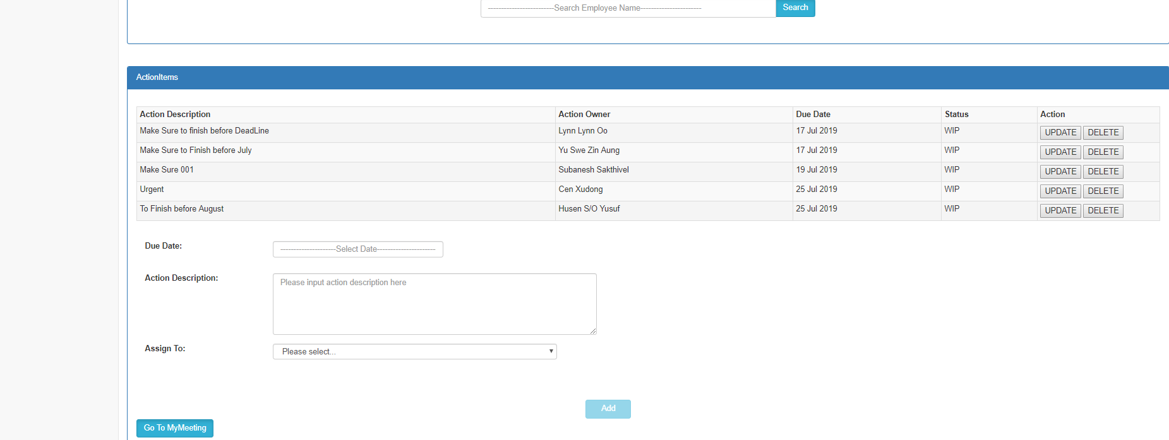After assigned Action Item

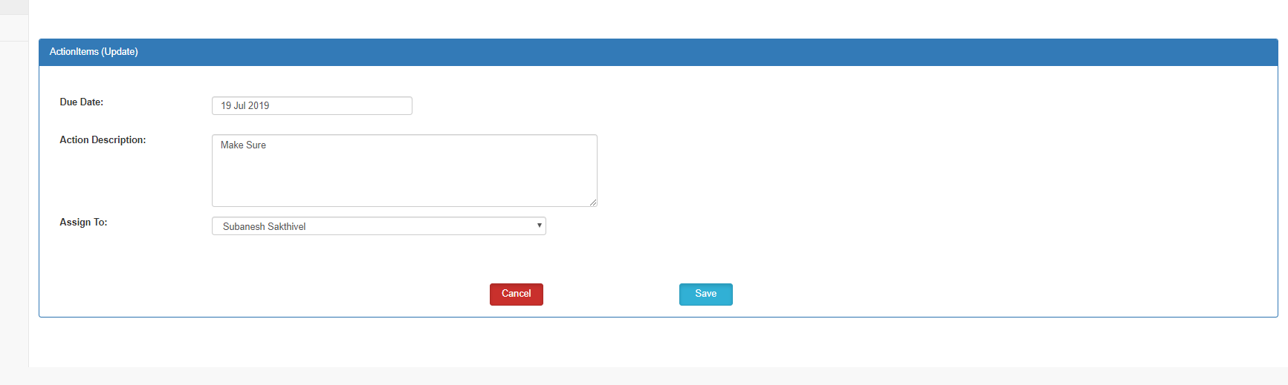Update

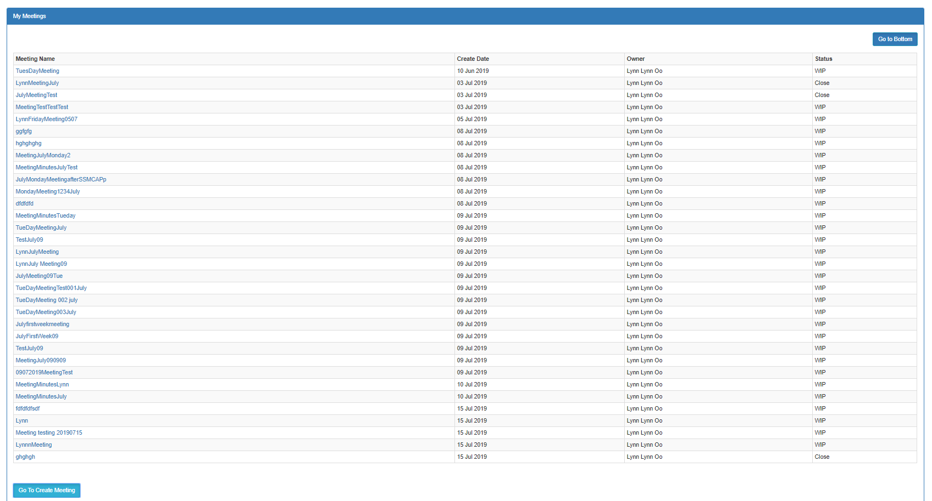My Meeting List

Meeting List

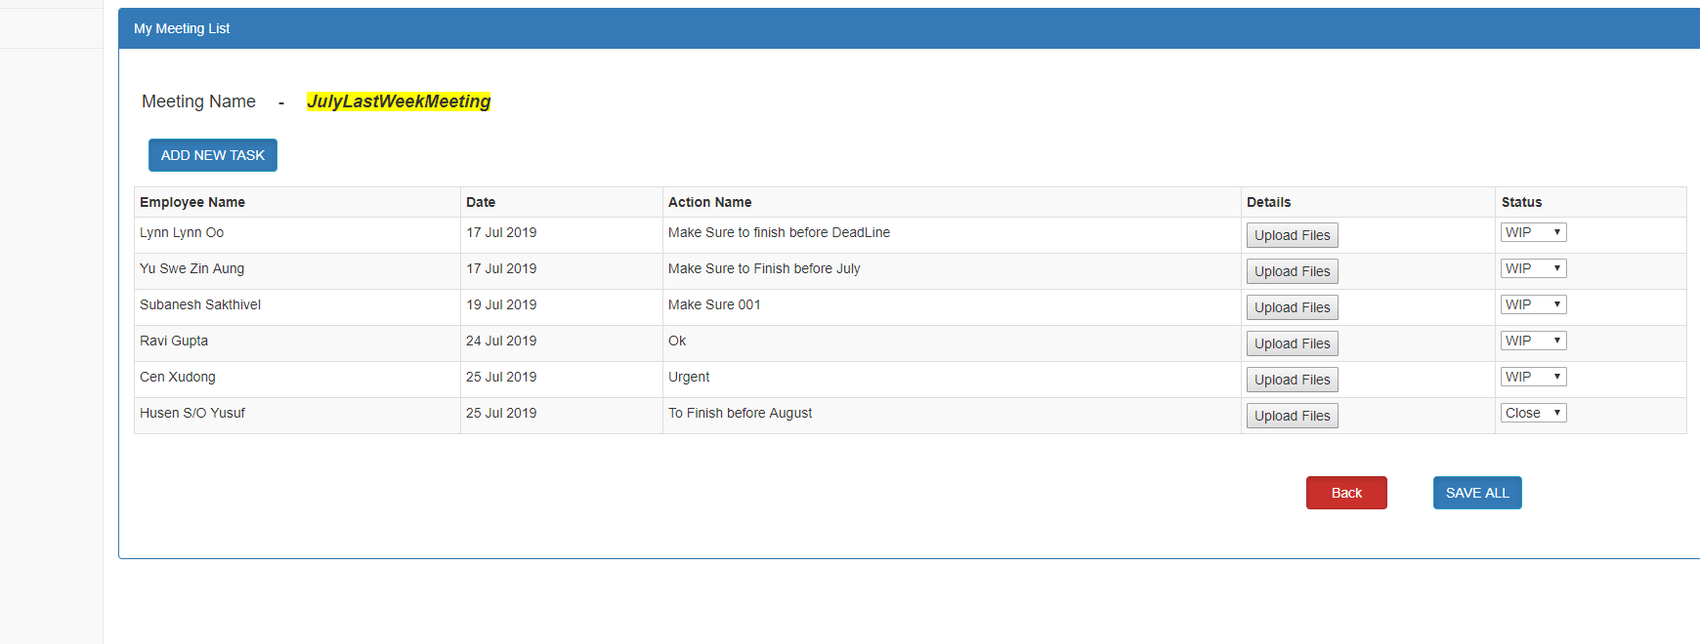

Add new task – is for when user want to add participants, to change the meeting information and to update the task.

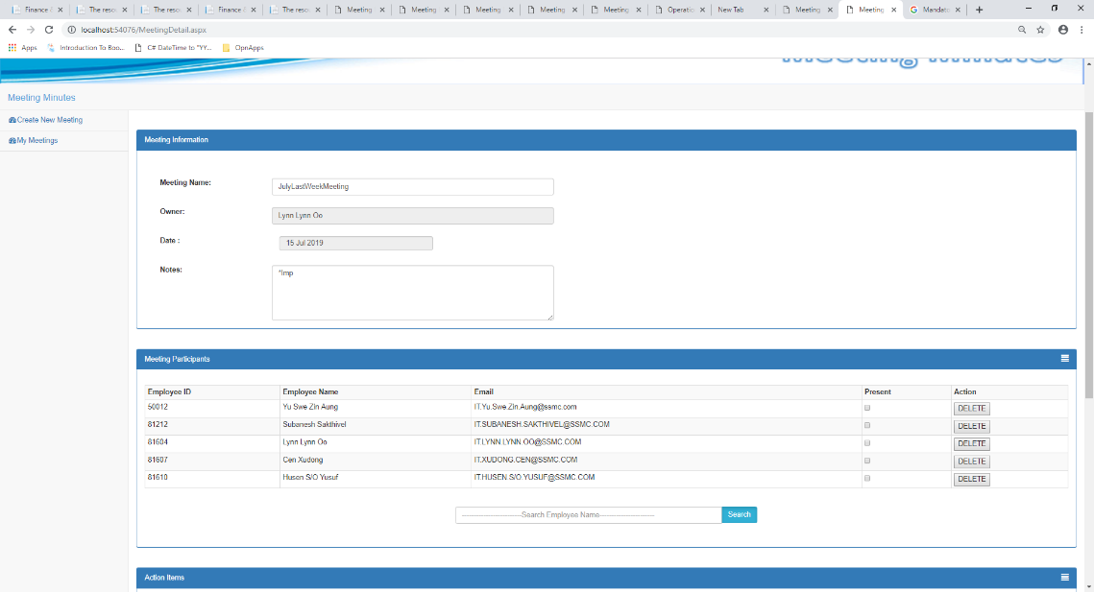

Search Function from Meeting Detail

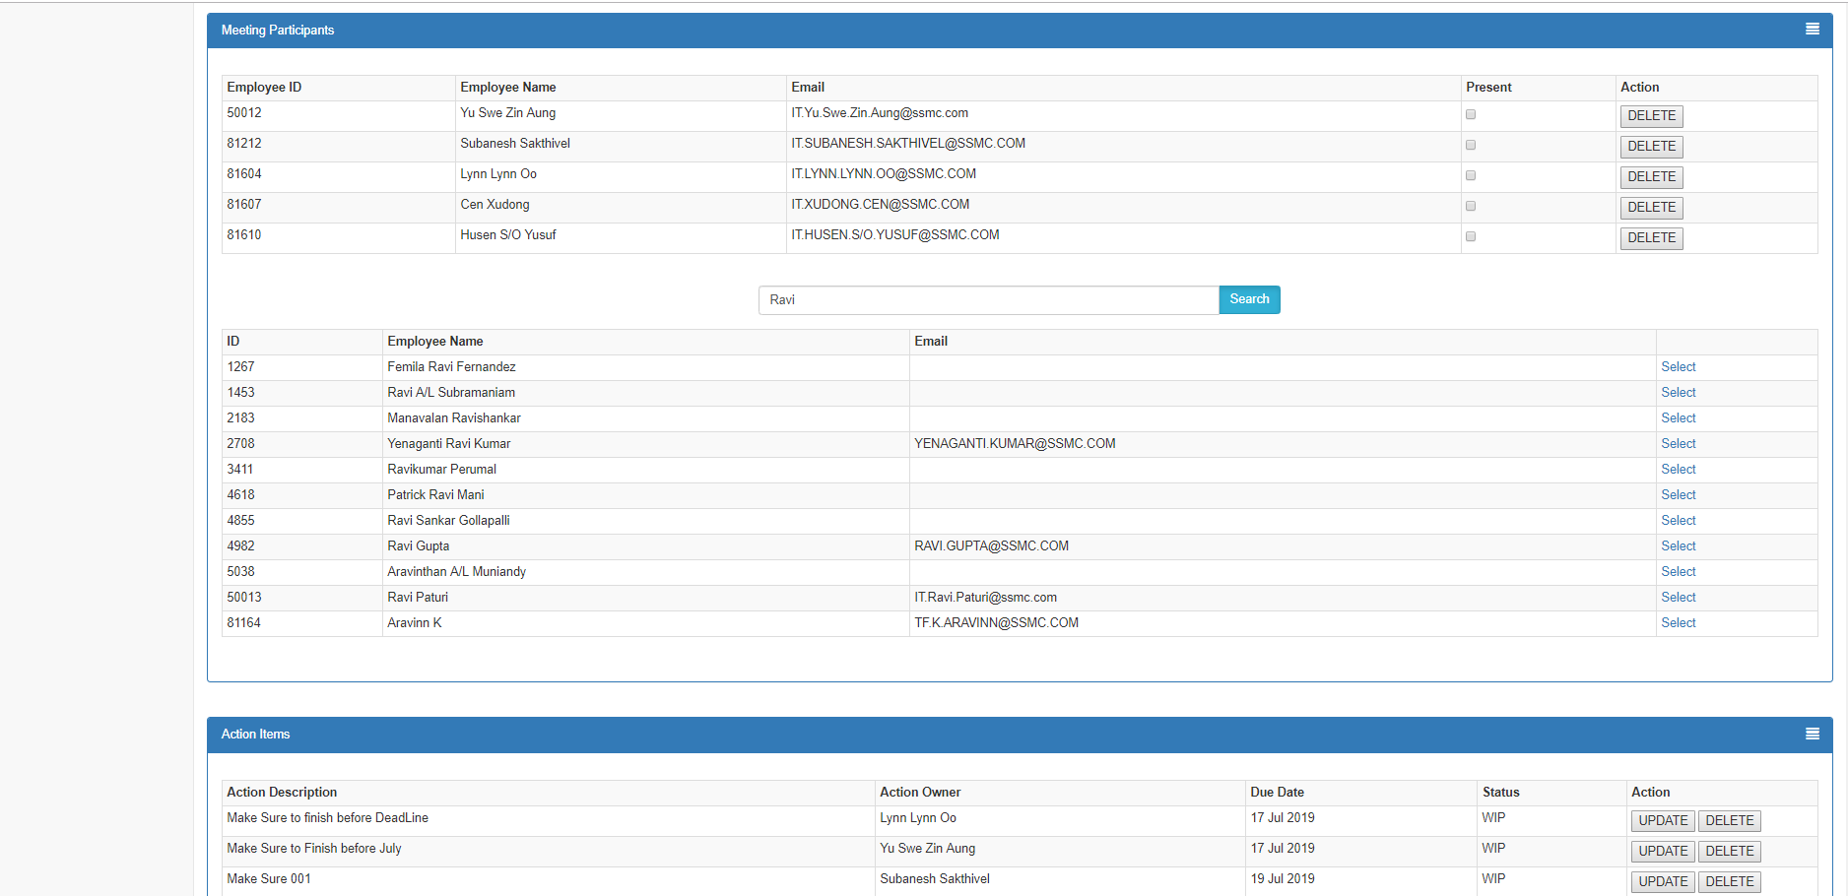

Update Action Item from Meeting Detail

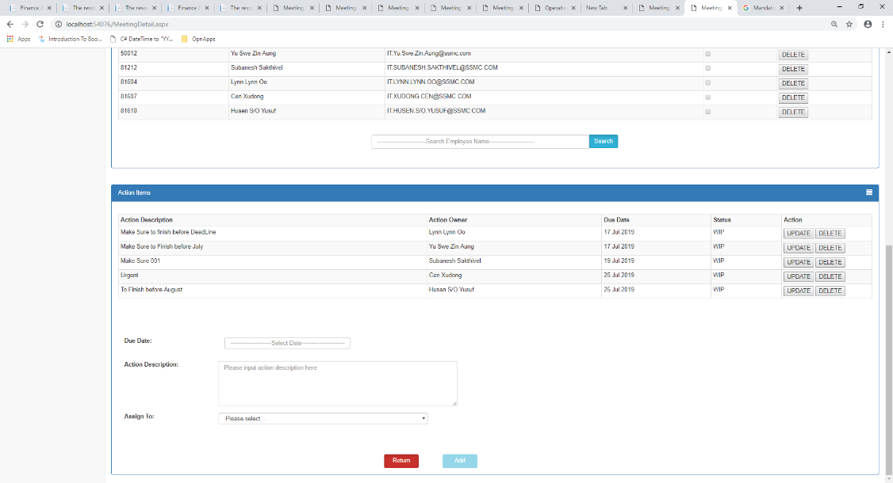

Meeting List

Upload Action Item Page

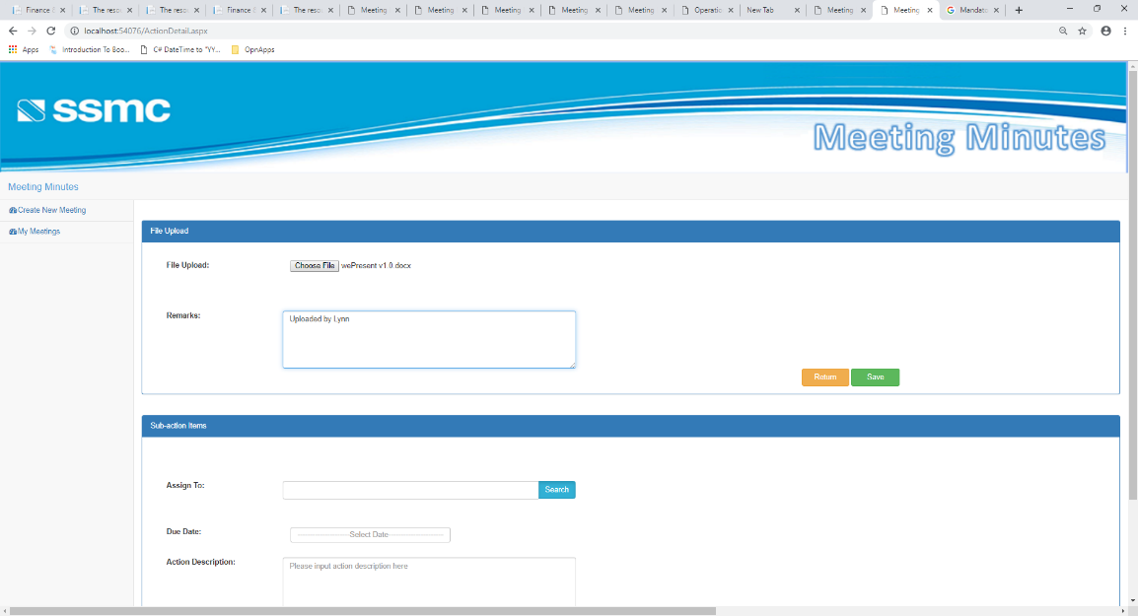

# After Uploaded File and Added Sub Item

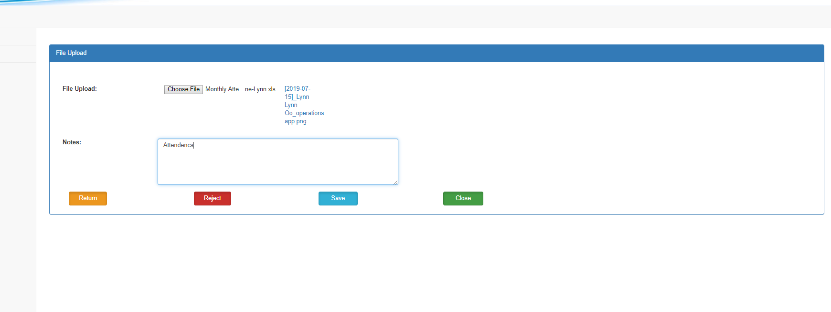Upload Sub Action Item Page

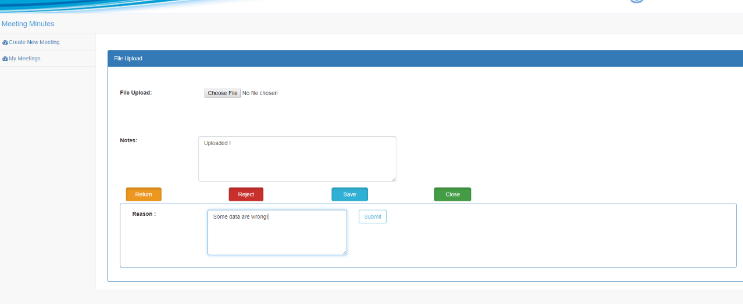Upload Sub Item after clicked reject

**IQC Application**

Received Part Summary

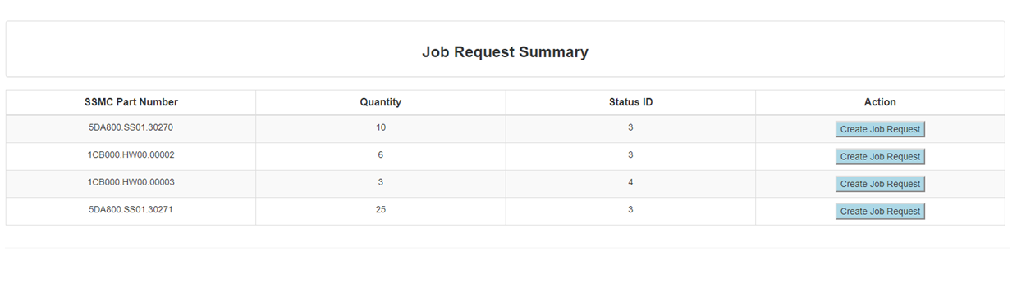1st version

2nd version

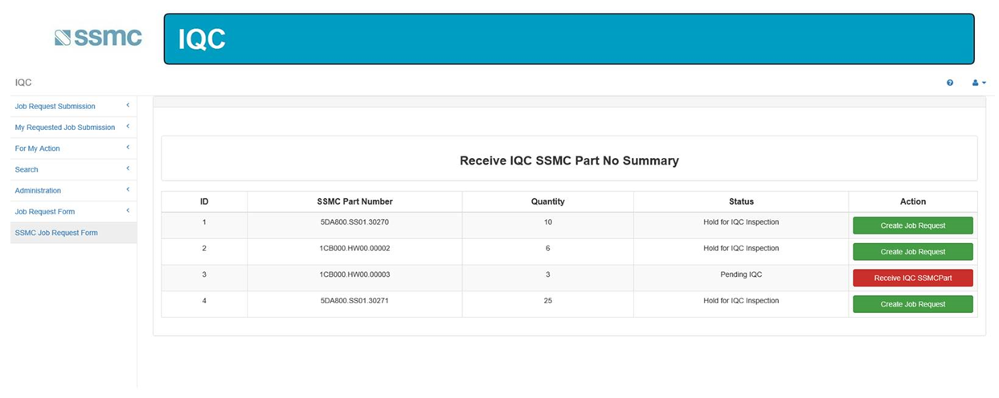

Final Version

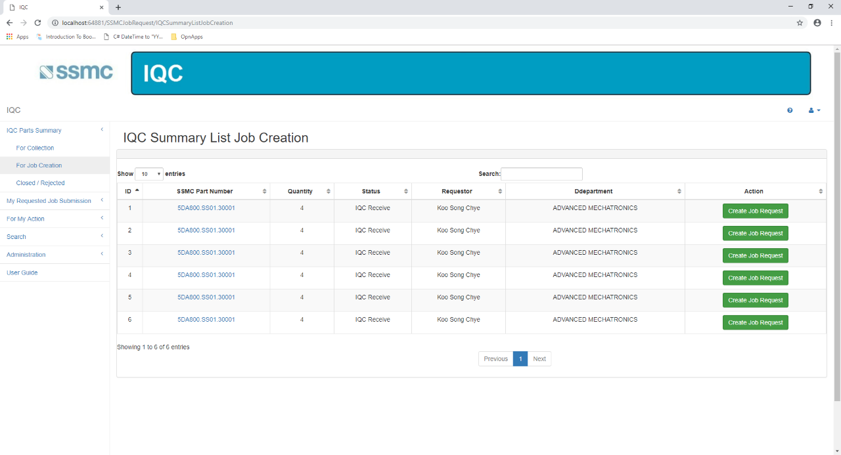

Job Creation Form (1st version)

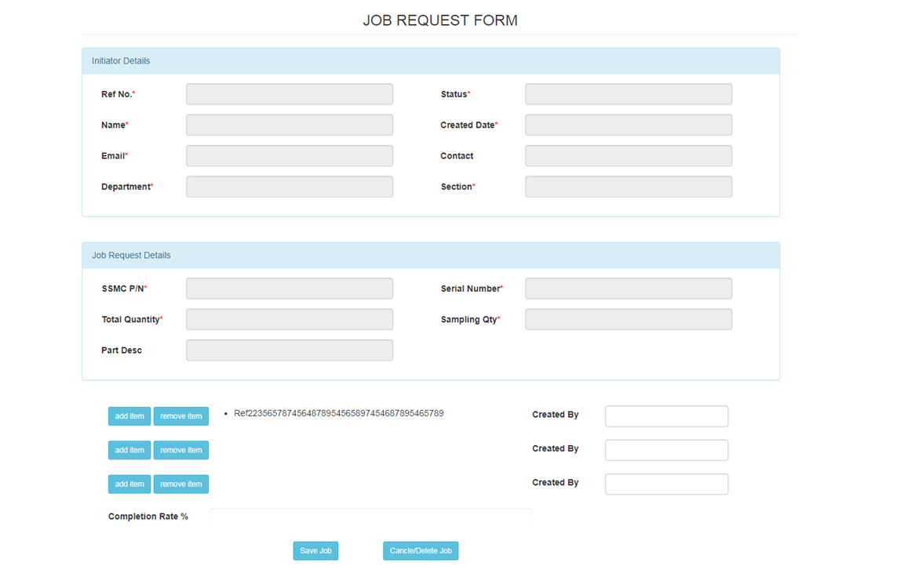

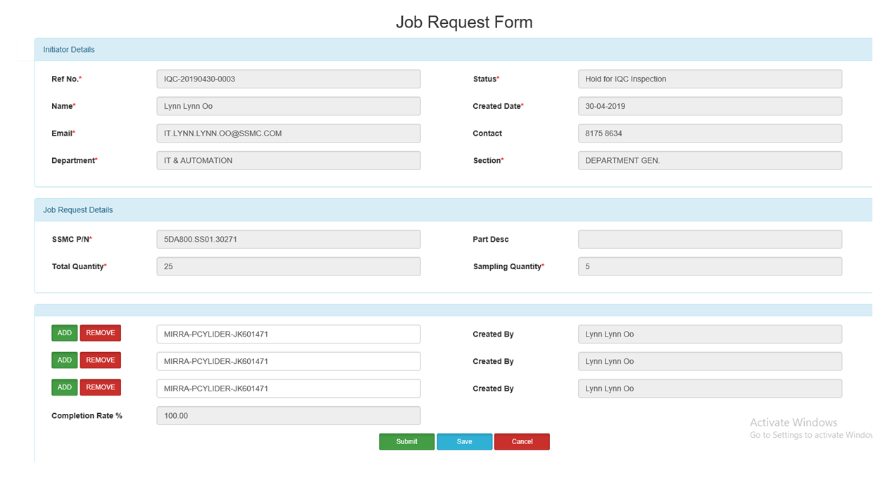Job Creation Form (2nd version)

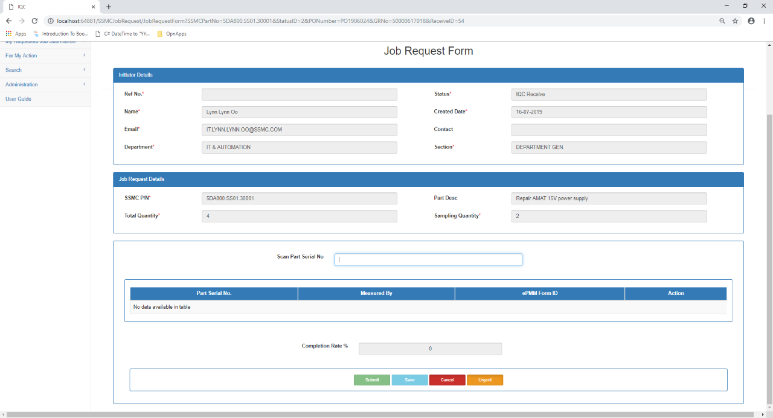Final Version

# Received Part Form

1st version

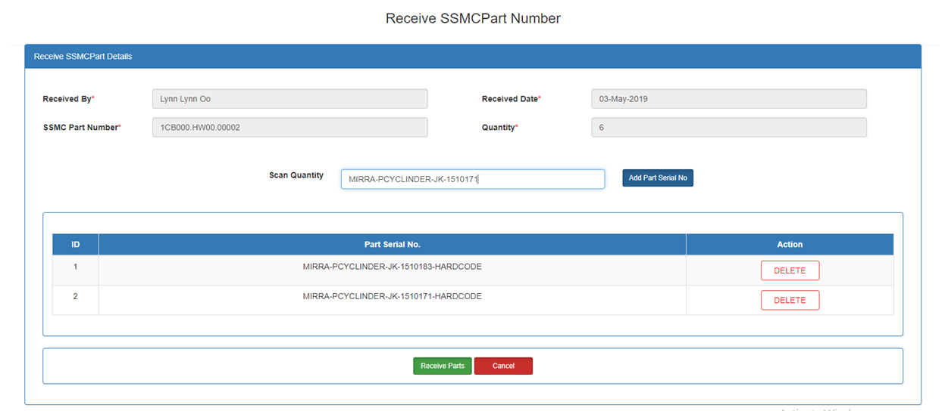

# 2nd Version

# Final Version

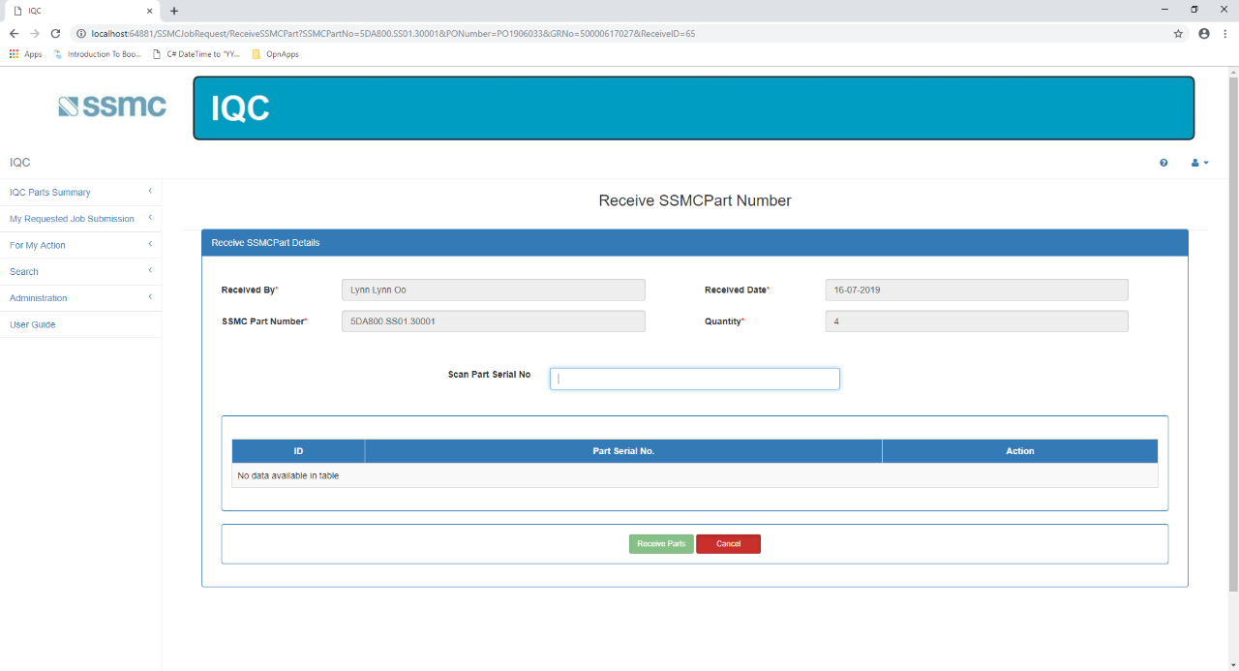

EPart-Tracking Application

Maintain All Part Master Page

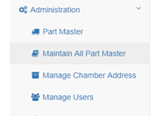

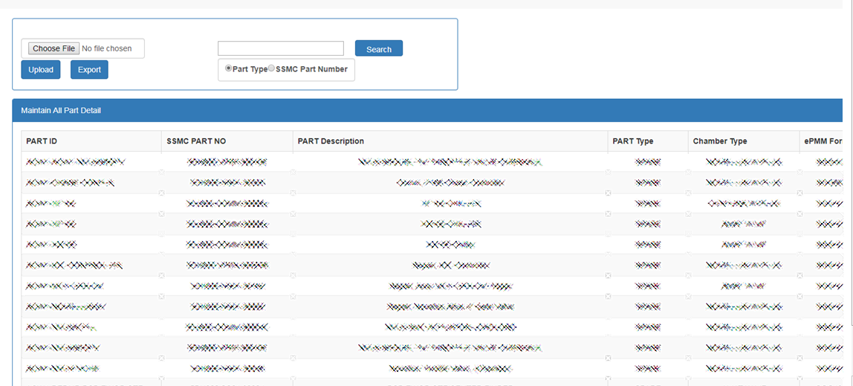

SSMC Application

Version1

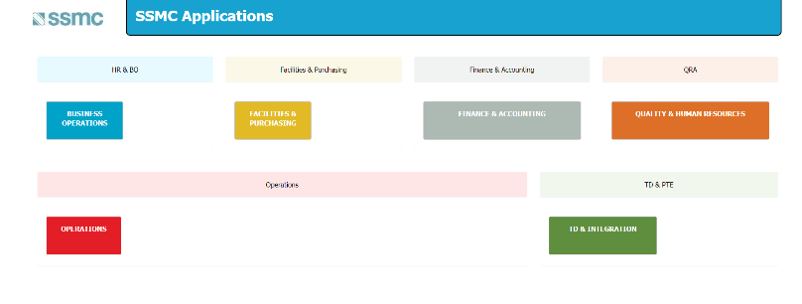

Version2

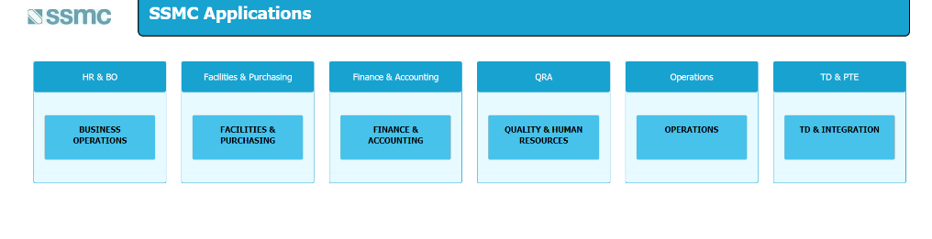

Version 3

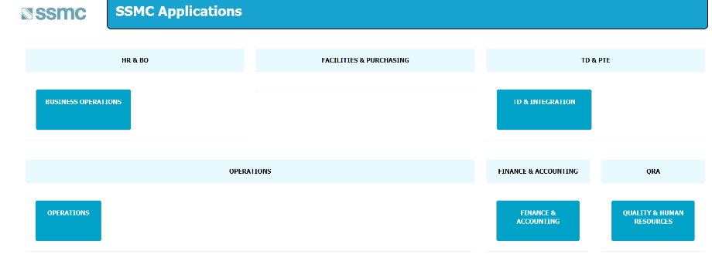

Final Version

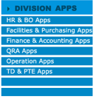

This row are images (inside link) created by Photoshop.

Added this Division App table in three SSMC Home Pages

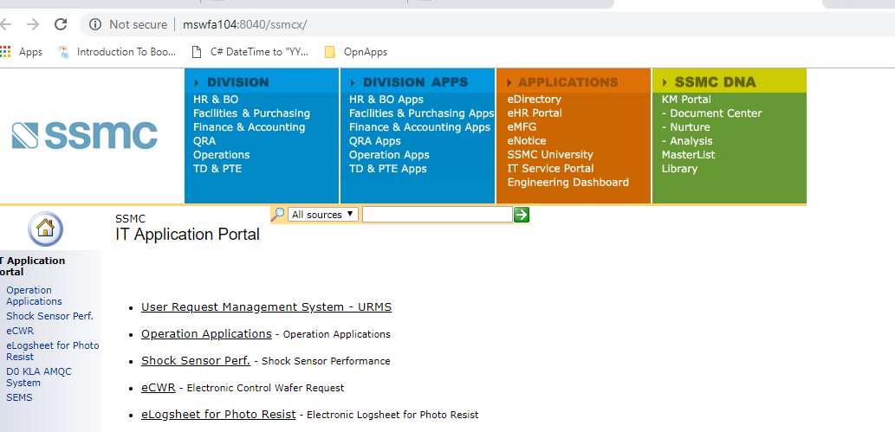

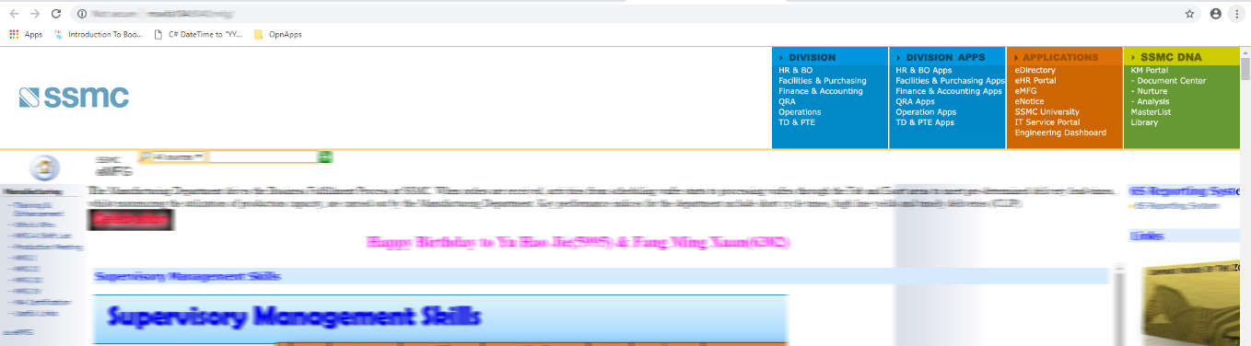

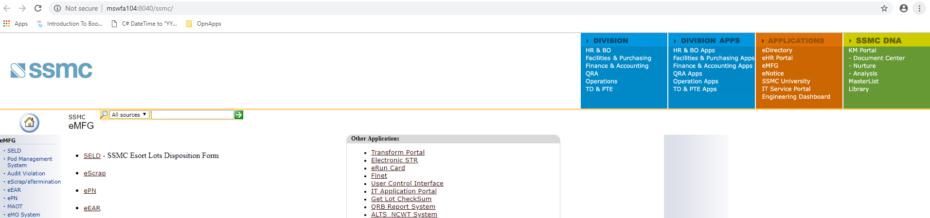

Added explorer icon in front of the application which need to be opened with IE

and adjust the table design with CSS

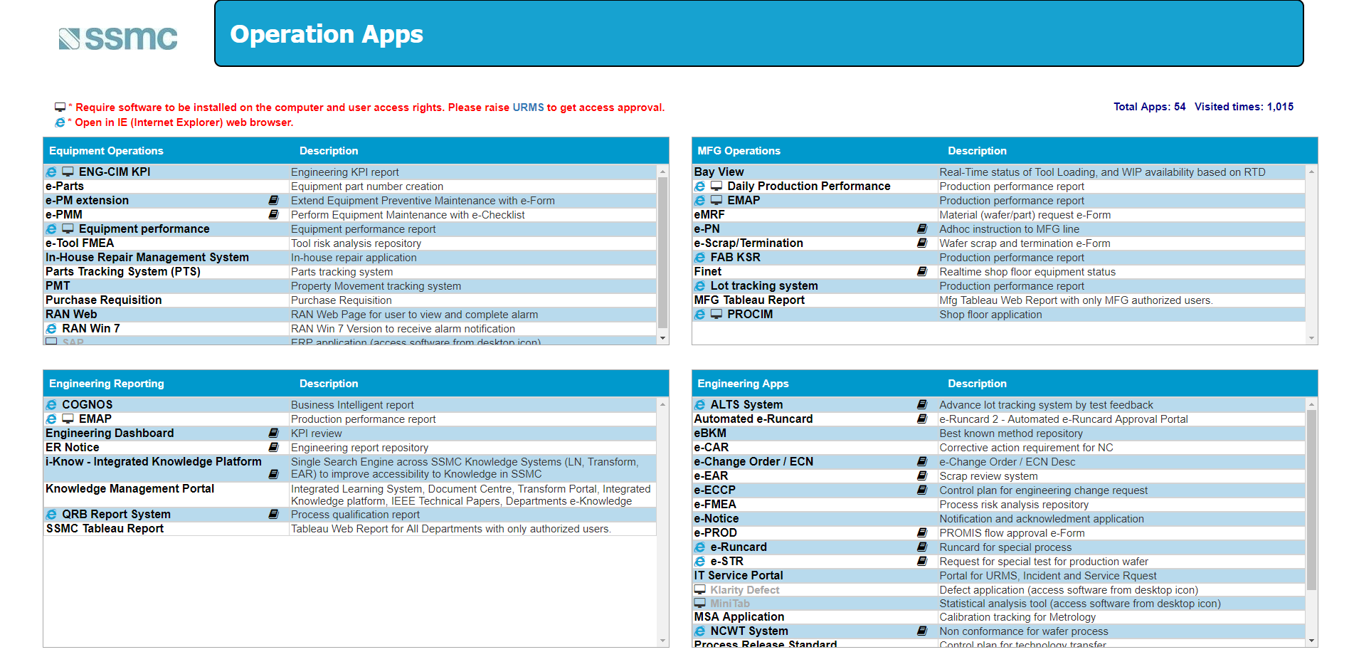

Delete and Update function Admin Page

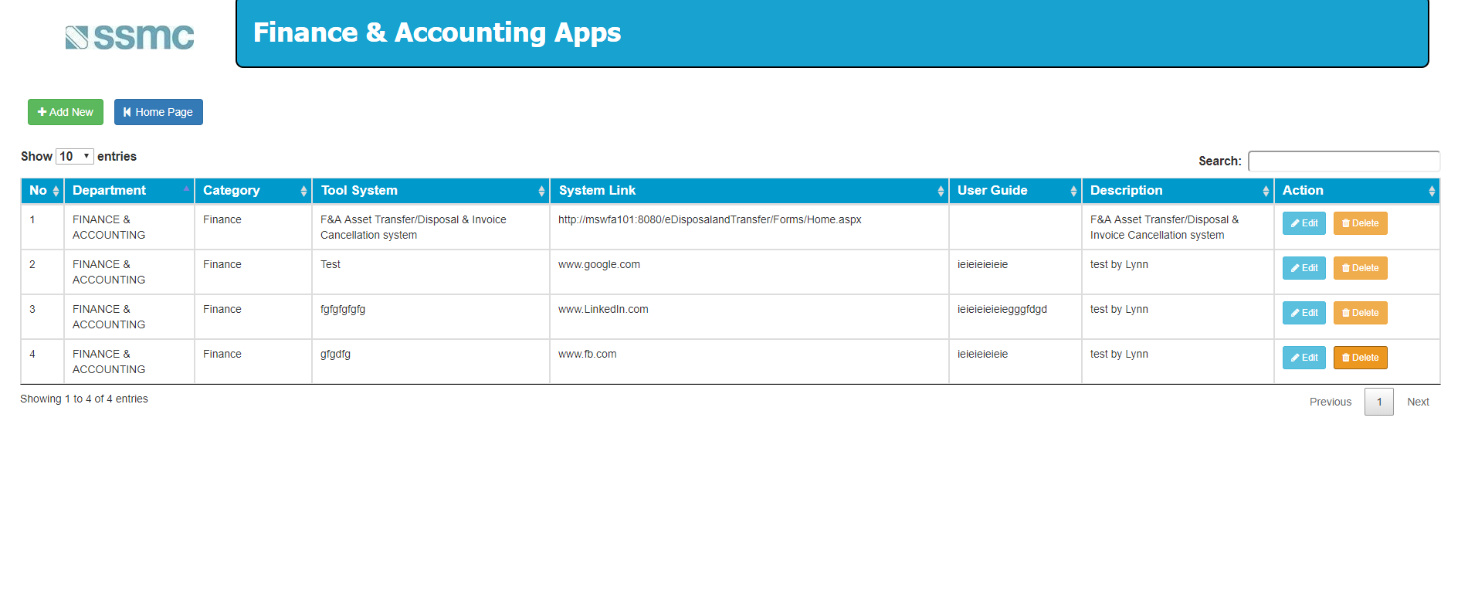

# Appendix B

# B.1: Progress Reports

# B.1.1: Week 1 Report

**Task Completed for this Week (25 March 2019-29 March 2019)**

* Meeting with Supervisors
* Enrolling some important Company’s modules about Company’s Introduction, Security and Health & Environment at Integrated Learning System (iLS) and sitting exam for this modules.
* Looking through their existing application (SSMC Inventory Management System), Codings, Database and Documents for familiarize with the project.
* Adding addition feature that is “Maintain All Part Master”
* Adding Addition feature that is “Maintain All Part Master” and Linking with Navigation bar.
* Looking through back to their existing Bizlogic and DAO.
* Adding Edit and Update Part for “Maintain All Part Master ”

**Tasks in Progress**

None

**Tasks to be completed (1 April 2019 – 5 April 2019)**

* Exporting the existing list to excel file, adding Search function and disabling some textboxes.
* Adding Upload/Import function and checking the items from the list and excel files are match or not and updating the lists if not.

**Issues**

* Desktops with required tools are not ready
* Unable to access ILS due to login issue
* Waiting on approval for internet access

**Resolution**

* Will urge the IT Team to complete
* Will urge the IT Team to solve
* Will send a chaser email to the responsible person

# B.1.2: Week 2 Report

**Task Completed**

* Finished the understanding about the basic information of SSMC.
* Finished the understanding about SSMC’s Inventory Management System (IMS) which is based on ASP.net (web), HTML5.
* Finished to add functionalities in “Maintain All Part Master’’ that is Export data from Excel to Grid, Import data from Grid to Excel, Search Function, List, Edit and Update.
* Finished the design of Front-end for Online Survey Assessment of SSMC.
* Finished in setting up the project folder and added items in navigation bar.

**Tasks in Progress**

* Still understating the existing features and coding.
* Adding addition features in Replace Parts function from IMS app.
* Familiar with the new project’s documentation.

**Tasks to be completed (18 March 2019 – 22 March 2019)**

* Adding addition features in Perform PM from IMS app.
* Understanding the documentations for the new application.

# B.1.3: Week 3 Report

**Task Completed in Last Week**

* Finished the understanding about the basic information of SSMC.
* Finished the understanding about SSMC’s Inventory Management System (IMS) which is based on ASP.net (web), HTML5.
* Finished to add functionalities in “Maintain All Part Master’’ that is Export data from Excel to Grid, Import data from Grid to Excel, Search Function, List, Edit and Update.
* Finished the design of Front-end for Online Survey Assessment of SSMC.
* Finished in setting up the project folder and added items in navigation bar.

**Task Completed for this Week (18 March 2019-22 March 2019)**

* Finished the understating about the existing features and coding.
* Adding addition features in Replace Parts function from IMS app.
* Familiar with the new project’s documentation.
* Finished to add ‘SSMC JOB REQUEST’ in IQC project (both frontend and backend)
* Understanding about UiPath documentations for the RPA project

**Tasks in Progress**

* Learning UiPath from YouTube videos to make RPA project
* Understanding about the UiPath.

**Tasks to be completed (25 March 2019 – 29 March 2019)**

* Adding three more features under ‘SSMC JOB REQUEST’ and Scanner features for IQC Project.
* Understanding the documentations about RPA for SAP Project.

# B.1.4: Week 4 Report

**Task Completed in Last Week**

* Adding addition features in Replace Parts function from IMS app.
* Finished to add ‘SSMC JOB REQUEST’ in IQC project (both frontend and backend)
* Understanding about UiPath documentations for the RPA project

**Task Completed for this Week (25 March 2019-29 March 2019)**

* Adding Barcode Scanner features and email notification function for IQC project
* Learning about UiPath for transferring data from Invoice to Excel.
* Adding Store Procedure in Databases

**Tasks in Progress**

* Learning about UiPath for transferring data from Invoice to Excel

**Tasks to be completed (1 April 2019 – 5 April 2019)**

* Creating Reports and adding Reports to IQC Project
* Adding ePMM Form to IQC Project

# B.1.5: Week 5 Report

**Milestones Met**

**IMS (ePartTracking System) Application**

Completed changing of the current UI design into standardized one for Maintain All Parts, Perform PM and Replace Part

**IQC Project**

Completed both frontend and backend of Initiator Details, Job Request Details and method for generate Unique Refno.

**UiPath RPA Project**

Familiarization with the different functions for tool and trying to transfer data from Invoice to Excel for the sample target files provided (Still on-going)

**Milestones missed**

Adding Barcode Scanner features.

Creating Reports. (Waiting for Documentations from Supervisor)

**Foreseeable risk and resolution**

**Risks**

* Unfamiliar with the library and method for scanner
* Coding will take longer than expected
* Complex functions needed will be difficult to execute

**Resolution**

* Use google and YouTube videos to use barcode scanner
* Seek assistance from seniors and online resources

# B.1.6: Week 6 Report

**Milestones Met**

**IQC Project**

Completed for adding Barcode Scanner Features, method for calculating Completion Rate and method for Status that changing according by the user’s control.

**UiPath RPA Project**

Familiarization with the different functions for tool and trying to transfer data from Invoice to Excel for the sample target files provided (Still on-going)

**Milestones missed**

Creating Reports. (Waiting for Documentations from Supervisor)

Learn different functionalities to transfer data.

**Foreseeable risk and resolution**

**Risks & Resolution**

* None for this week

**Milestones** **to** **be** **met (15 April to 18 April 2019)**

* Creating Reports.
* (UiPATH) Learn different functionalities to transfer data

# B.1.7: Week 7 Report

**Milestones Met**

**IQC Project**

Completed for methods of generating BatchID, adding Stored Procedures and adding extra features for Job Request Form.

Completed for changing the Report versions of ErackID from IP address 192.1.43.89 to 192.1.43.147 by remoting desktop using TightVNC viewer.

**Milestones missed**

Creating Reports. (Waiting for Documentations from Supervisor)

**Foreseeable risk and resolution**

**Risks & Resolution**

* None for this week

**Milestones** **to** **be** **met (22 April to 26 April 2019)**

* Creating Reports.

# B.1.8: Week 8 Report

**Milestones Met**

**IQC Project**

Completed in adding feature that is explore QR code.

Completed for creating “Receive SSMC Part No Summary” Page.

**Milestones missed**

Creating Reports. (Waiting for Documentations from Supervisor)

**Foreseeable risk and resolution**

**Risks & Resolution**

* None for this week

**Milestones** **to** **be** **met**

* Creating Reports.

# B.1.9: Week 9 Report

**Milestones Met**

**IQC Project**

Completed for Creating Search Employee and Receive Parts Form (features are like Job Request Form using Scanner but the scanned result are goes into the DataTable).

**Milestones missed**

* Backend for Receive Parts Form

**Foreseeable risk and resolution**

**Risks**

* Difficulties in creating Stored Procedure for inserting the same statement with different serial numbers (eg. If the quantity is 10 so adding the 10 serial numbers in the DataTable and all 10 serial numbers with the same attributes are store into the Database).
* Cannot pass the data from Ajax to public string method in controller and doubt in retrieving values from DataTable.

**Resolution**

* Ask the Seniors and Search in Google
* Learning in the w3school and Stack Overflow websites for JavaScript and Ajax

**Milestones** **to** **be** **met**

* Receive Parts Form

# B.1.10: Week 10 Report

**Milestones Met**

**IQC Project**

Receive Parts Form (features are like Job Request Form using Scanner but the scanned result are goes into the DataTable).

**Milestones missed**

* To pass the Data from DataTable to Controller and then to Stored Procedure

**Foreseeable risk and resolution**

**Risks & Resolution**

**Milestones** **to** **be** **met**

* Receive Parts Form

# B.1.11: Week 11 Report

**Milestones Met**

**IQC Project**

* Finished Received Part Form.
* Finished to pass the DataTable object to controller then Stored Procedure.
* Finished validations for Summary Page, Job Request Form and Received Part From.
* Finished in writing function in SQL for auto changing Status and StatusID and Stored Procedure for break down the string then insert into the database.

**Milestones missed**

None

**Foreseeable risk and resolution**

**Risks & Resolution**

None

**Milestones** **to** **be** **met**

None

# B.1.12: Week 12 Report

**Milestones Met**

**IQC Project**

* Modifying coding from “Job Request Form” controller by adding Flag and Action for Button functions.
* Modifying Stored Procedure according by Action and Flag.
* Changed datetime format in Database.

**Milestones missed**

* Validation for input Serial Number cannot be duplicate in data Table.
* Modify logic from Completion Rate Method and Measure By (retrieving data check by transaction table )

**Foreseeable risk and resolution**

**Risks & Resolution**

None

**Milestones** **to** **be** **met**

* Validation for input Serial Number cannot be duplicate in Data Table.
* Modify Completion Rate Method and Measure By from data table (retrieving data check by transaction table )

# B.1.13: Week 13 Report

**Milestones Met**

**IQC Project**

* Finished integration.
* I have found 3 more to fix in my code after integration. Two errors have been solved. Another one is ‘Measured By’ that I already retrieved but it doesn’t appear in the data table.

**Meeting Minutes Application**

* This is existing application. Now is to enhance, add new features and fix the errors.
* I have fixed errors. Most of them are associated with ‘cannot convert nvarchar to datetime’ errors.

**Milestones missed**

* To fix for showing Measured By in data table (IQC Project)

**Foreseeable risk and resolution**

**Risks & Resolution**

None

**Milestones** **to** **be** **met**

For Meeting Minutes,

* To add calendar instead of manual date input.
* To add Delete function in Select Employee.
* To enhance for preventing page from jump up.
* To add validations in Calendar.
* To fix to error under “New Task Add” Page.

# B.1.14: Week 14 Report

**Milestones Met**

**Meeting Minutes Application**

* Finished to add calendars instead of manual date inputs.
* Finished to add Delete function in Select Employee.
* Finished to enhance for preventing page from jump up.
* Finished to add validations in Calendars.
* Finished to fix the errors under “New Task Add” Page.
* Finished to change the UI for the whole application
* Finished to change the SP according to new logic.
* Finished to submit Database Relationship Diagram for Meeting Minutes to HOD.

**Milestones missed**

None

**Foreseeable risk and resolution**

**Risks & Resolution**

None

**Milestones** **to** **be** **met**

None

# B.1.15: Week 15 Report

**Milestones Met**

**Meeting Minutes Application**

Although Meeting Minutes Application is an existing app, according of its inconsistent logic HOD wants me to do from the start, to add new pages and remove existing pages if needed.

Finished to draw and submit Flowchart Diagram for the Meeting Minutes.

Finished to change “Create Meeting Page” and I added update function inside Grid view to allow user can change their Action Description, Date and Assign Employees after creation.

I modified the part of retrieving existing information of meeting in “NEW TASK ADD” Page. This page is for when owner want to add another employees in an existing meeting, he can just add by clicking “NEW TASK ADD’’ button.

Instead of employees go and upload their files from Meeting List to Meeting Detail , I deleted Meeting Detail page and just added all the action inside grid view in Meeting List. Then to add Sub-Action and Sub-ActionItem upload page.

**Milestones missed**

To add Sub-Action and Sub-ActionItem upload page.

**Foreseeable risk and resolution**

**Risks & Resolution**

None

**Milestones** **to** **be** **met**

To add Sub-Action and Sub-ActionItem upload page.

# B.1.16: Week 16 Report

**Milestones Met**

**Meeting Minutes Application**

Finished to add “Add Sub-Action” page and “Sub-Action Item Upload” page.

**Milestones missed**

None

**Foreseeable risk and resolution**

**Risks & Resolution**

None

**Milestones** **to** **be** **met**

Testing for Meeting Minutes App

# B.1.17: Week 17 Report

**Milestones Met**

**Meeting Minutes Application**

* Changed the Dashboard design of SSMC APP.
* Finished Backend code to add explorer icon in front of Link Categories in tables.

**Milestones missed**

None

**Foreseeable risk and resolution**

**Risks & Resolution**

None

# B.1.18: Week 18 Report

**Milestones Met**

**SSMC_APP**

* Updated all the application names and Orders, Index by Category in database.
* For dashboard, created image icons using Visual Studio image editor for Division App tables and backend for this tables.
* Finished enhancement with both frontend and backend for division app’s pages.

**Milestones missed**

None

**Foreseeable risk and resolution**

**Risks & Resolution**

None

# B.1.19: Week 19 Report

**Milestones Met**

**SSMC_APP**

* Created image icons with Photoshop for Division App table (The text from the images created by Visual Studio image editor for Division App is fuzzy when resized as small)
* Added this images and codes in four different SSMC Home Pages.
* Fixed for the existing update function that doesn’t work.

**Milestones missed**

None

**Foreseeable risk and resolution**

**Risks & Resolution**

None

**Milestones** **to** **be** **met**

**-**To fix for the delete function

# B.1.20: Week 20 Report

**Milestones Met**

**Meeting Minutes App**

* **As user want to change the UI from the last page, I needed to change the last page of UI .**
* **Changed the button into link button.**
* **Fixed respective codes for this changes.**
* **Finished Delete function for Admin Page from SSMC App**

**Milestones missed**

None

**Foreseeable risk and resolution**

**Risks & Resolution**

None

**Milestones** **to** **be** **met**

**None**