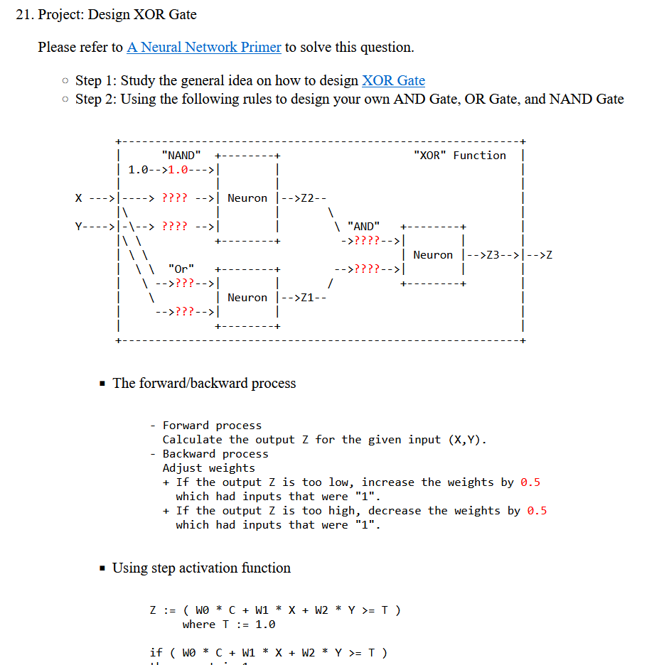
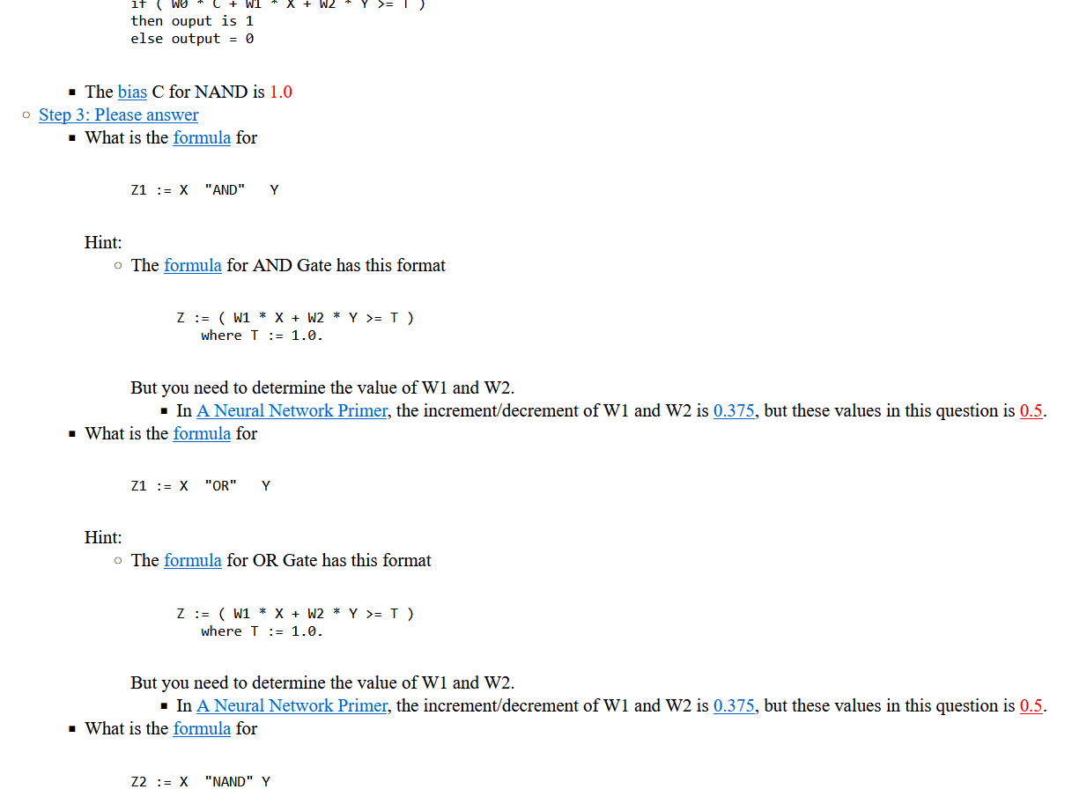
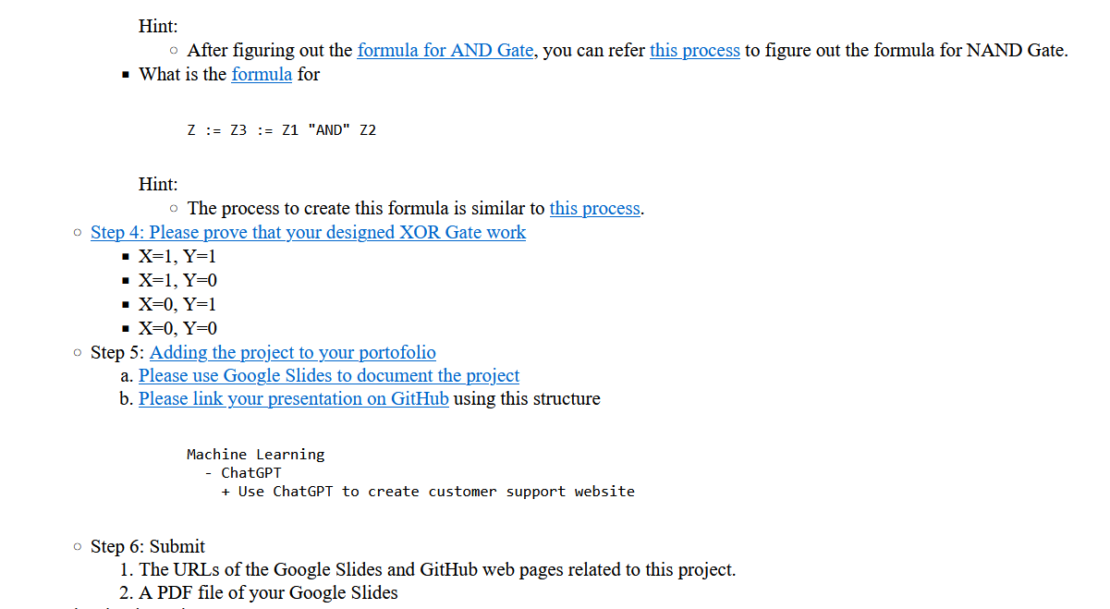

Answer:
The forward/backward process

- Forward process
Calculate the output Z for the given input (X,Y).
- Backward process
Adjust weights
+ If the output Z is too low, increase the weights by 0.5
which had inputs that were "1".
+ If the output Z is too high, decrease the weights by 0.5
which had inputs that were "1".

Using step activation function

Z := ( W0 * C + W1 * X + W2 * Y >= T )
where T := 1.0

if ( W0 * C + W1 * X + W2 * Y >= T )
then ouput is 1
else output = 0

Desired Function for “XOR”:
OR NAND XOR

X Y | Z1 X Y | Z2 X Y | Z3
---------- ---------- ----------
0 0 | 0 0 0 | 1 0 0 | 0
0 1 | 1 AND 0 1 | 1 = 0 1 | 1
1 0 | 1 1 0 | 1 1 0 | 1
1 1 | 1 1 1 | 0 1 1 | 0

Step 3:
“OR” Gate Formula:
Z := ( W1 * X + W2 * Y >= T )
where T := 1.0

Desired Function for “OR”:
X Y | Z
-----------
0 0 | 0
0 1 | 1
1 0 | 0
1 1 | 1

Loop 1:
W1 = W2 = 1.0
X Y | Z1
-------------------
0 0 | 0 Z ok
0 1 | 1 Z ok
1 0 | 1 Z ok
1 1 | 1 Z ok

W1 = 1.0, W2 = 1.0 for “OR” Gate

“Nand” Gate Formula:
Z := ( W0 * C + W1 * X + W2 * Y >= T )
where T := 1.0

Desired Function for “NAND”:
C X Y | Z2
---------------
1 0 0 | 1
1 0 1 | 1
1 1 0 | 1
1 1 1 | 0

Loop 1:
W0 = 0.0
W1 = W2 = 1.0
C X Y | Z2
---------------
1 0 0 | 0 Z too low, increase W0 by 0.5, W0=0.5
1 0 1 | 1 Z ok
1 1 0 | 1 Z ok
1 1 1 | 1 Z too high, decrease all by 0.5, W0=0.0, W1=0.5, W2=0.5

Loop 2:
W0 = 0.0
W1 = W2 = 0.5
C X Y | Z2
---------------
1 0 0 | 0 Z too low, increase W0 by 0.5, W0=0.5
1 0 1 | 0 Z too low, increase W0, W2 by 0.5, W0=1.0, W2=1.0
1 1 0 | 0 Z too low, increase W0, W1 by 0.5, W0=1.5, W1=1.0
1 1 1 | 1 Z too high, decrease all by 0.5, W0=1.0, W1=0.5, W2=0.5

Loop 3:
W0 = 1.0
W1 = W2 = 0.5
C X Y | Z2
---------------
1 0 0 | 1 Z ok
1 0 1 | 1 Z ok
1 1 0 | 1 Z ok
1 1 1 | 1 Z too high, decrease all by 0.5, W0=0.5, W1=0.0, W2=0.0

Loop 4:
W0 = 0.5
W1 = W2 = 0.0
C X Y | Z2
---------------
1 0 0 | 0 Z too low, increase W0 by 0.5, W0=1.0
1 0 1 | 0 Z too low, increase W0, W2 by 0.5, W0=1.5, W2=0.5
1 1 0 | 0 Z too low, increase W0, W1 by 0.5, W0=2.0, W1=0.5
1 1 1 | 0 Z ok

Loop 5:
W0 = 0.5
W1 = W2 = 0.0
C X Y | Z2
---------------
1 0 0 | 1 Z ok
1 0 1 | 1 Z ok
1 1 0 | 1 Z ok
1 1 1 | 1 Z too high, decrease all by 0.5, W0=1.5, W1=0.0, W2=0.0

Loop 6:
W0 = 1.5
W1 = W2 = 0.0
C X Y | Z2
---------------
1 0 0 | 1 Z ok
1 0 1 | 1 Z ok
1 1 0 | 1 Z ok
1 1 1 | 1 Z too high, decrease all by 0.5, W1=1.0, W2=-0.5, W3=-0.5

Loop 7:
W0 = 1.0
W1 = W2 = -0.5
C X Y | Z2
---------------
1 0 0 | 1 Z ok
1 0 1 | 1 Z too low, increase W0, W2 by 0.5, W0=1.5, W2=0.0
1 1 0 | 1 Z too low, increase W0, W2 by 0.5, W0=1.5, W2=0.0
1 1 1 | 1 Z ok

Loop 8:
W0 = 2.0
W1 = W2 = 0.0
C X Y | Z2
---------------
1 0 0 | 1 Z ok
1 0 1 | 1 Z ok
1 1 0 | 1 Z ok
1 1 1 | 1 Z too high, decrease all by 0.5, W1=1.5, W2=-0.5, W3=-0.5

Loop 9:
W0 = 1.5
W1 = W2 = -0.5
C X Y | Z2
---------------
1 0 0 | 1 Z ok
1 0 1 | 1 z ok
1 1 0 | 1 Z ok
1 1 1 | 0 Z ok

W0 = 1.5, W1 = -0.5, W2 = -0.5 for “NAND” Gate

“AND” Gate Formula:
Z := ( W1 * X + W2 * Y >= T )
where T := 1.0

Desired Function for “AND”:

X Y | Z3
-----------
0 0 | 0
0 1 | 0
1 0 | 0
1 1 | 1

Loop 1:
W1 = W2 = 1.0
X Y | Z3
-------------------
0 0 | 0 Z ok
0 1 | 1 Z too high, decrease W2 by 0.5, W2=0.5
1 0 | 1 Z too high, decrease W1 by 0.5, W1=0.5
1 1 | 1 Z ok

Loop 2:
W1 = W2 = 0.5
X Y | Z3
-------------------
0 0 | 0 Z ok
0 1 | 1 Z ok
1 0 | 1 Z ok
1 1 | 1 Z ok

W1 = 0.5, W2 = 0.5 for “AND” Gate

“XOR” Gate formula (plugging W0, W1, and W2s from previous gates):
Z1 := X "Or" Y
Z2 := X "NAND" Y
Z := Z3 := Z1 "AND" Z2
Z := ( X "Or" Y ) "AND" ( X "NAND" Y )
Z := ( 1.0 * X + 1.0 * Y >= 1.0 ) "AND" ( 1.5 * 1.0 + -0.5 * X + -0.5 * Y >= 1.0 )
Z := ( 0.5 * ( 1.0 * X + 1.0 * Y >= 1.0 ) + 0.5 * ( 1.5 + -0.5 * X + -0.5 * Y >= 1.0 ) >= 1.0 )

Desired Function for “XOR”:

X Y | Z3
-----------
0 0 | 0
0 1 | 1
1 0 | 1
1 1 | 0

Step 4:

When X=0, Y=0:

Z3 = (0.5 * ( 1.0 * 0 + 1.0 * 0 >= 1.0 ) + 0.5 * ( 1.5 + -0.5 * 0 + -0.5 * 0 >= 1.0 ) >= 1.0 )
= (0.5 * ( 0.0 >= 1.0 ) + 0.5 * ( 1.5 >= 1.0 ) >= 1.0 )
= (0.5 * ( false ) + 0.5 * ( true ) >= 1.0 )
= 0.5 * 0 + 0.5 * 1 >= 1.0
= 0.5 >= 1.0
= false
= 0 ➔ same as desired

When X=0, Y=1:

Z3 = (0.5 * ( 1.0 * 0 + 1.0 * 1 >= 1.0 ) + 0.5 * ( 1.5 + -0.5 * 0 + -0.5 * 1 >= 1.0 ) >= 1.0 )
= (0.5 * ( 1.0 >= 1.0 ) + 0.5 * ( 1.0 >= 1.0 ) >= 1.0 )
= (0.5 * ( true ) + 0.5 * ( true ) >= 1.0 )
= 0.5 * 1 + 0.5 * 1 >= 1.0 = 1.0 >= 1.0
= true
= 1 ➔ same as desired

When X=1, Y=0:

Z3 = (0.5 * ( 1.0 * 1 + 1.0 * 0 >= 1.0 ) + 0.5 * ( 1.5 + -0.5 * 1 + -0.5 * 0 >= 1.0 ) >= 1.0 )
= (0.5 * ( 1.0 >= 1.0 ) + 0.5 * ( 1.0 >= 1.0 ) >= 1.0 )
= (0.5 * ( true ) + 0.5 * ( true ) >= 1.0 )
= 0.5 * 1 + 0.5 * 1 >= 1.0 = 1.0 >= 1.0
= true
= 1 ➔ same as desired

When X=1, Y=1:

Z3 = (0.5 * ( 1.0 * 1 + 1.0 * 1 >= 1.0 ) + 0.5 * ( 1.5 + -0.5 * 1 + -0.5 * 1 >= 1.0 ) >= 1.0 )
= (0.5 * ( 2.0 >= 1.0 ) + 0.5 * ( 0.5 >= 1.0 ) >= 1.0 )
= (0.5 * ( true ) + 0.5 * ( false ) >= 1.0 )
= 0.5 * 1 + 0.5 * 0 >= 1.0 = 0.5 >= 1.0
= false
= 0 ➔ same as desired

All Z3 same as desired in “XOR” Gate!

