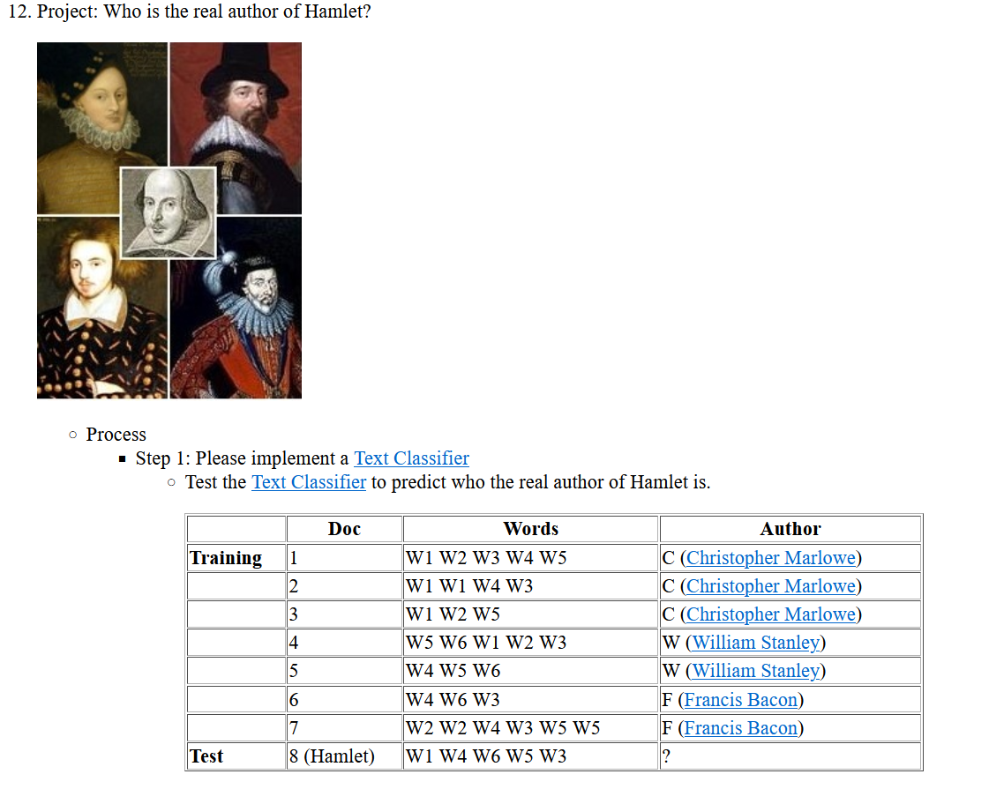

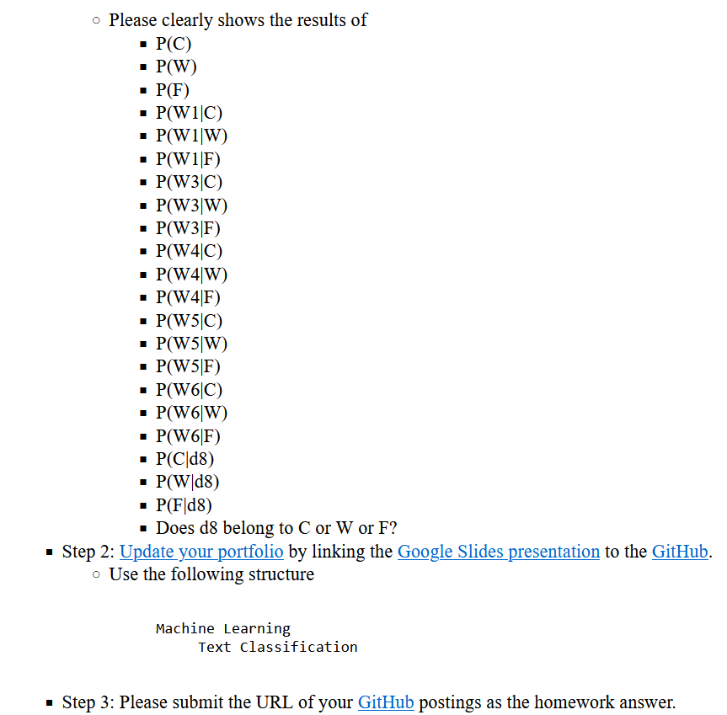

**Solution:**

We have the training data and need to calculate the probabilities of each before testing the Text Classifier to identify the true author of Hamlet.

***P(C): The probability of class C = 3/7***

***P(W): The probability of class W = 2/7***

***P(F): The probability of class F = 2/7***

***P(W1|C): The probability that the word "W1" appears on the 3 class C documents***

= (count (W1, C) + [1](https://class.coursera.org/nlp/lecture/26)) / (count(C)+|V|) = (4+1) / (12+6) = 5/18

4: how many times the word "W1" appear on the 3 class C documents.

12: how many words in the 3 class C documents.

6: number of vocabularies: (W1 W2 W3 W4 W5 W6)

**P(W1|W) : The probability that the word "W1" appears on the 3 class W documents**

= (count (W1, W) + [1](https://class.coursera.org/nlp/lecture/26)) / (count(W)+|V|)= (1+1) / (8+6) = 2/14 = 1/7

1: how many times the word "W1" appear on the 2 class W documents.

8: how many words in the 3 class W documents.

6: number of vocabularies: (W1 W2 W3 W4 W5 W6)

**P(W1|F): The probability that the word "W1" appears on the 2 class F documents**

= (count(W1, F) + [1](https://class.coursera.org/nlp/lecture/26)) / (count(F)+|V|) = (0+1) / (9+6) = 1/15

0: how many times the word "W1" appear on the 2 class F documents.

9: how many words in the 3 class W documents.

6: number of vocabularies: (W1 W2 W3 W4 W5 W6)

**P(W3|C) : The probability that the word "W3" appears on the 3 class C documents**

= (count(W3, C) + [1](https://class.coursera.org/nlp/lecture/26)) / (count(C)+|V|) = (2+1) / (12+6) = 3/18 = 1/6

2: how many times the word "W3" appear on the 3 class C documents.

12: how many words in the 3 class C documents.

6: number of vocabularies: (W1 W2 W3 W4 W5 W6)

**P(W3|W) : The probability that the word "W3" appears on the 3 class W documents**

= (count(W3, W) + [1](https://class.coursera.org/nlp/lecture/26)) / (count(W)+|V|) = (1+1) / (8+6) = 2/14 = 1/7

1: how many times the word "W3" appear on the 2 class W documents.

8: how many words in the 3 class W documents.

6: number of vocabularies: (W1 W2 W3 W4 W5 W6)

**P(W3|F) : The probability that the word "W3" appears on the 2 class F documents**

= (count(W3, F) + [1](https://class.coursera.org/nlp/lecture/26)) / (count(F)+|V|) = (2+1) / (9+6) = 3/15 = 1/5

2: how many times the word "W3" appear on the 2 class F documents.

9: how many words in the 3 class F documents.

6: number of vocabularies: (W1 W2 W3 W4 W5 W6)

**P(W4|C) : The probability that the word "W4" appears on the 3 class C documents**

= (count(W4, C) + [1](https://class.coursera.org/nlp/lecture/26)) / (count(C)+|V|) = (2+1) / (12+6) = 3/18 = 1/6

2: how many times the word "W4" appear on the 3 class C documents.

12: how many words in the 3 class C documents.

6: number of vocabularies: (W1 W2 W3 W4 W5 W6)

**P(W4|W) : The probability that the word "W4" appears on the 3 class W documents**

= (count(W4, W) + [1](https://class.coursera.org/nlp/lecture/26)) / (count(W)+|V|) = (1+1) / (8+6) = 2/14 = 1/7

1: how many times the word "W4" appear on the 2 class W documents.

8: how many words in the 3 class W documents.

6: number of vocabularies: (W1 W2 W3 W4 W5 W6)

**P(W4|F) : The probability that the word "W4" appears on the 2 class F documents**

= (count(W4, F) + [1](https://class.coursera.org/nlp/lecture/26)) / (count(F)+|V|) = (2+1) / (9+6) = 3/15

2: how many times the word "W4" appear on the 2 class F documents.

9: how many words in the 3 class F documents.

6: number of vocabularies: (W1 W2 W3 W4 W5 W6)

**P(W5|C): The probability that the word "W5" appears on the 3 class C documents**

= (count(W5, C) + [1](https://class.coursera.org/nlp/lecture/26)) / (count(C)+|V|) = (2+1) / (12+6) = 3/18 = 1/6

2: how many times the word "W5" appear on the 3 class C documents.

12: how many words in the 3 class C documents.

6: number of vocabularies: (W1 W2 W3 W4 W5 W6)

**P(W5|W): The probability that the word "W5" appears on the 3 class W documents**

= (count(W5, W) + [1](https://class.coursera.org/nlp/lecture/26)) / (count(W)+|V|) = (2+1) / (8+6) = 3/14

2: how many times the word "W5" appear on the 2 class W documents.

8: how many words in the 3 class W documents.

6: number of vocabularies: (W1 W2 W3 W4 W5 W6)

**P(W5|F): The probability that the word "W5" appears on the 2 class F documents**

= (count(W5, F) + [1](https://class.coursera.org/nlp/lecture/26)) / (count(F)+|V|) = (2+1) / (9+6) = 3/15

2: how many times the word "W5" appear on the 2 class F documents.

9: how many words in the 3 class F documents.

6: number of vocabularies: (W1 W2 W3 W4 W5 W6)

**P(W6|C): The probability that the word "W6" appears on the 3 class C documents**

= (count(W6, C) + [1](https://class.coursera.org/nlp/lecture/26)) / (count(C)+|V|) = (0+1) / (12+6) = 1/18

0: how many times the word "W6" appear on the 3 class C documents.

12: how many words in the 3 class C documents.

6: number of vocabularies: (W1 W2 W3 W4 W5 W6)

**P(W6|W): The probability that the word "W6" appears on the 2 class W documents**

= (count(W6, W) + [1](https://class.coursera.org/nlp/lecture/26)) / (count(W)+|V|) = (2+1) / (8+6) = 3/14

2: how many times the word "W6" appear on the 2 class W documents.

8: how many words in the 3 class W documents.

6: number of vocabularies: (W1 W2 W3 W4 W5 W6)

**P(W6|F) : The probability that the word "W6" appears on the 2 class F documents**

= (count(W6, F) + [1](https://class.coursera.org/nlp/lecture/26)) / (count(F)+|V|) = (1+1) / (9+6) = 2/15

1: how many times the word "W6" appear on the 2 class F documents.

9: how many words in the 3 class F documents.

6: number of vocabularies: (W1 W2 W3 W4 W5 W6)

**P(C|d8) : P(C) * P(W1|C) * P(W4|C)* P(W6|C) * P(W5|C) * P(W3|C)**

= ((3/7) * (5/18) * (1/6) * (1/18) * (1/6) * (1/6)

= 0.00003061924 , approx. 0.00004

= 3/7: prior: P(C)

= There are 5 words in d8: W1 W4 W6 W5 W3

Each word "W1" has P(W1|C) = 5/18

The word "W4" has P(W4|C) =3/18 = 1/6

The word "W6" has P(W6|C) = 1/18

The word "W5" has P(W5|C) = 3/18 = 1/6

The word "W3" has P(W3|C) = 3/18 = 1/6

**P(W|d8) = P(W) * P(W1|W) * P(W4|W)* P(W6|W) * P(W5|W) * P(W3|W)**

= (2/7* 2/14 * 2/14 * 3/14 * 3/14 * 2/14)

= 0.00003824936, approx. 0.00003

= 2/7: prior: P(W)

= There are 5 words in d8: W1 W4 W6 W5 W3

Each word "W1" has P(W1|W) = 2/14

The word "W4" has P(W4|W) = 2/14

The word "W6" has P(W6|W) = 3/14

The word "W5" has P(W5|W) = 3/14

The word "W3" has P(W3|W) = 2/14

**P(F|d8)** = P(F) * P(W1|F) * P(W4|F)* P(W6|F) * P(W5|F) * P(W3|F)

= ((2/7) * (1/15) * (3/15) * (2/15) * (3/15) * (3/15))

= 0.00002031746, approx. 0.00002

= 2/7: prior: P(F)

= There are 5 words in d8: W1 W4 W6 W5 W3

Each word "W1" has P(W1|F) = 1/15

The word "W4" has P(W4|F) = 3/15

The word "W6" has P(W6|F) = 2/15

The word "W5" has P(W5|F) = 3/15

The word "W3" has P(W3|F) = 3/15

**Does d8 belong to C or W or F?**

***The probability calculations show that Document 8 should be in Class C because it has the highest probability calculation.***

