**New Technology Trends Based on Embedded System Design**

Soe Wunna, *Student ID: 19651*

**ABSTRACT**

This paper presents the program learning outcome of fundamentals of embedded engineering in the field of computer science. The paper starts with a brief embedded system engineering. In this section, the role of embedded systems in the field of computer science such as artificial intelligence and machine learning, characteristics along with the use of these systems in various industries and the advantages are discussed. In the second section, the paper continues with the brief history of embedded systems and their continuous development and improvements, increase in popularity from the past to current days. In the third section it elaborates on future trends of embedded systems in multiple aspects of computer science fields and the use of them in daily life appliances and machines. Finally, it concludes by highlighting key points from the sections one to three.

**I. INTRODUCTION**

Embedded System is the electronic system which incorporates integrated circuits with software for carrying out the calculations for various projects solutions. The main advantage of using an embedded system is the capability to reduce the complexity of the circuits which becomes convenient It is of the main ingredients for different products, devices and computerized operations, such as artificial intelligence and machine learning applications. As the use of these systems applications have been increasingly popular in almost every industry nowadays, embedded tools and software play a mandatory role in the functioning of modern cars, home gadgets, medical instruments and other appliances we use in our daily lives. The main use of embedded system is to minimize human intervention. The prominent characteristics of embedded systems are task specificness, time specificness, minimum user interface, high efficiency, high reliability, being highly stable, less power consumption and low-cost. Other characteristics such as compact design makes it very useful in industries like aerospace, automotive, biotech and even in the most modern smart city projects. There are four types of Embedded Device such as real-time, stand-alone, networked and mobile.

**II. BRIEF HISTORY OF EMBEDDED SYSTEM DESIGN**

***A. Apollo Guidance System***

Embedded system was first used for developing Apollo Guidance System by Charles Spark Draper at MIT. NASA planned the Apollo project in the early 1960s. One of the greatest technical challenges was the problem of navigating a spaceship from Earth to the moon. To overcome this challenge, NASA assigned the MIT Instrumentation Lab to design and develop the onboard guidance, navigation and control systems for both the Apollo command and lunar modules.

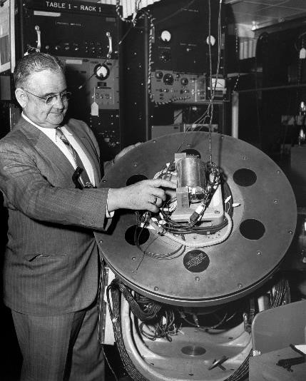

*Fig 1. Apollo Guidance System*

***B. Autonetics D-17 Guidance Computer***

An early mass-produced embedded system was the Autonetics D-17 Guidance Computer in 1962. This computer was used as a guidance system for Minuteman missile. The Minuteman I Intercontinental Ballistic Missile was the first long-range deterrents and was deployed in 1962. The D-17 was a stored program computer whose main memory consisted of a fixed head disk drive with a single one-sided platter with approximately 50 tracks. The CPU had a very few actual hardware registers. All the processing was performed with distinct logic where each part had its own serial number, resistors and capacitors, with everything coated by polyurethane. There were no integrated circuits or core, and solid-state memory was unheard of even for the Military when the it was designed.

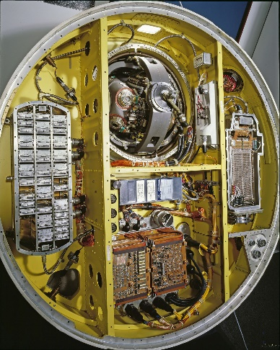 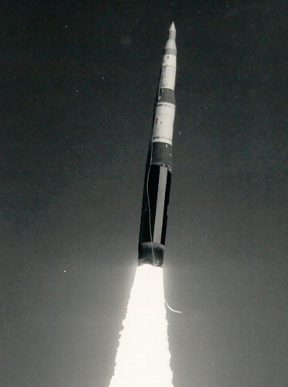

*Figure 2. A. Autonetics D-17 Guidance Computer B.* Minuteman I Intercontinental Ballistic Missile

***C. Intel 4004***

Busicom approached Intel to produce a new design for an electronic calculator in April, 1969. Intel 4004, 4-bit central processing unit, was released by Intel Corporation in 1971 and designed mainly for the use in calculators and other small systems. They based their design on the architecture of the 1965 Olivetti Programma 101, one of the world's first tabletop programmable calculators. However, external and support chips were still required. It was one of the earliest microprocessors. That CPU was sold for $60.

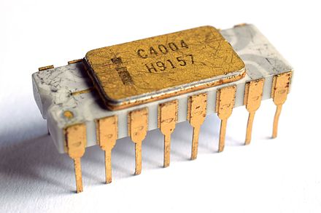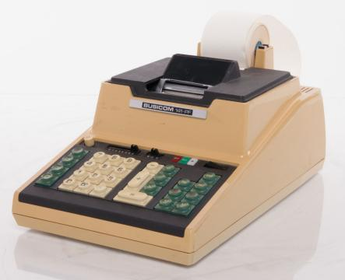

*Figure 3. A. Intel 4004*  *B. Calculator with Intel 4004*

***D. From the Past to Current Days***

Consumer electronics such as Mobile phones, videogame consoles, digital camera are a good example of where embedded systems thrive. Starting from 90s, household appliances which include washing machines, microwave ovens, refrigerators were produced with embedded processors to minimize the human interaction. When it comes to medical fields, the invention of CT scanners, heartbeat monitors and electrocardiogram would not have been possible without the integrated circuits which is controlled by software. Antilock braking systems, air-conditioner controls, electronic fuel injection systems, navigation systems, guidance systems, GPS are still in use and being developed to improve their capabilities for the future.

**III. NEW TECHNOLOGY TRENDS IN EMBEDDED SYSTEM DESIGN**

***A. Progression of Embedded System Designs over the Decade***

As inventions have become a routine in the world of computer science, the embedded systems have also gone through some most noticeable modifications. Currently, the embedded technologies are responsible for the intellectual capabilities of most modern devices, for both consumers as well as industrial fields. The embedded systems not just control everyday use devices such as microwaves, smartphones, tablets, and other electronic devices but also directs the telecommunication systems, submarines, planes, cars, ATMs, and many more. Multi-core processors, virtualization such as augmented reality and virtual reality, mobile devices with improved security requirements and 64-bit processors are some of the achievements of innovation. Being in a favor of such innovative technologies conveys the manufacturing scale of the companies like semiconductor suppliers, system software development, and mechanical components suppliers, system software development companies, and mechanical components suppliers.

***B. Multifunctional Features***

With the emergence of multi-functional engineering, the new generation of wireless communication systems is influencing a new level of technology integration. Integrating effective measures like progressive data rates, connectivity for systems through internet such as the Internet of Things (IoT), less power consumption, and other striving goals can be achieved by joining advanced digital and antenna technologies. An embedded system design which carries out multiple applications is known called multi-mode embedded system design. Apart from that, an embedded system which additionally assists multiple tasks to be executed in a mode is known as a multi-mode multi-task embedded system. The multi-material additive manufacturing processes result in the potential for multi-functional parts to be manufactured in a single procedure.

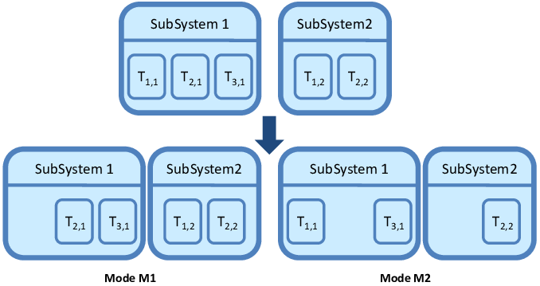

Figure 4. Multi-mode System

***C. Future Trends to Watch***

Developers are keeping an eye on the trends and making appropriate use of the latest advances in techniques and technologies. Some of the trends are Internet of Things (IoT), processor technology, storage, artificial intelligence and, virtual and augmented reality. Also, there are several trends like embedded security, real-time visualization; cloud connectivity and Bluetooth mesh networking, low power consumption and optimization that will help developers working with microcontroller-based solutions.

***D. IoT (Internet of Things)***

An IoT embedded system is an embedded system that requires to be connected to the internet. Another term for IoT embedded system is a "smart" device. An embedded system for IoT has some type of software installed on it to allow it to carry out the required function. It can be simply firmware or an embedded operating system that empowers the IoT embedded system to communicate with other IoT embedded system devices. Self-checkout systems are utilizing IoT embedded system. In the future, it can be look forward to using augmented reality and IoT together to go virtual shopping. For AR shopping, it will become more convenient by eliminating the time to commute and human assistance.

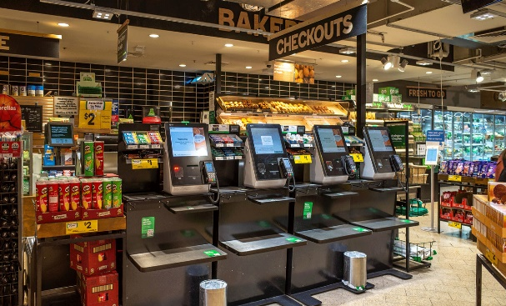

*Figure 5. A. Self-checkout Systems B. Augmented Reality Shopping*

***E. AI (Artificial Intelligence)***

Embedded artificial intelligence is the implementation of machine learning and deep learning in software at the device level. Software can be programmed to support both predictive and reactive intelligence, based on the data that is collected and analyzed. By using embedded artificial intelligence, devices are capable to utilize AI models at the device level and then directly use the results to perform an appropriate task or function. The cloud is also helpful for data storage because data can be stored temporarily at the device level and then sent to a cloud server to keep them safe. Industries where embedded AI technology is automating processes, providing analytics and business insights, and improving customer service, among various other benefits includes aviation, finance, healthcare, manufacturing, retail, shipping, supply chain.

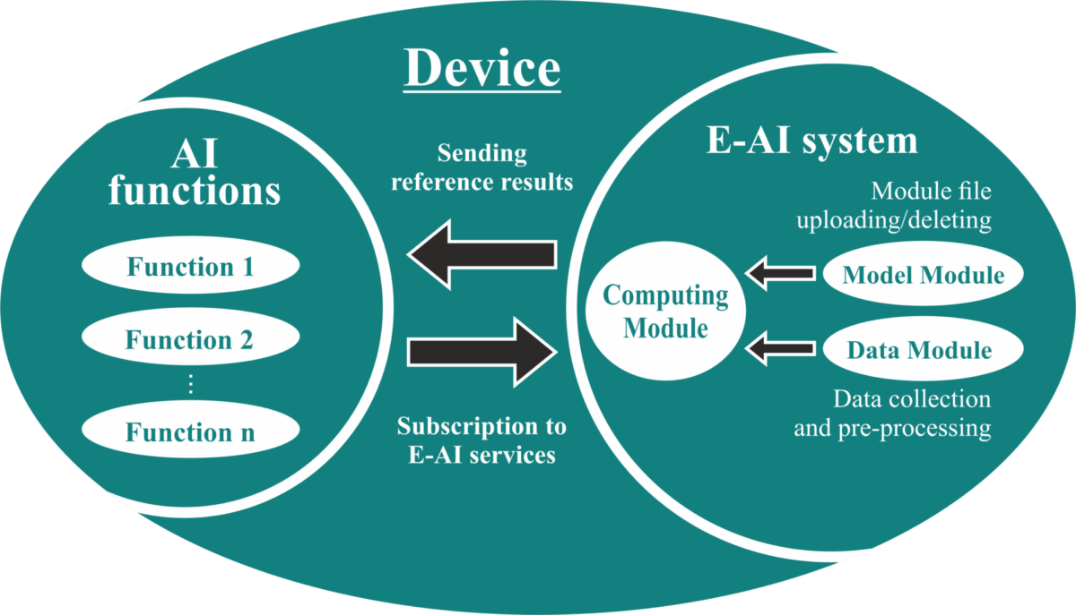

*Figure 6. Embedded Artificial Intelligence System*

**CONCLUSION**

Embedded systems have traversed a long journey and contributed to every aspect of the computer science fields. All the devices or appliances used in our daily lives are designed in such a way that can be used without creating difficulties using the embedded systems. Taking this into consideration, every future object will include of an either a small processor or sensor embedded within itself. Even though it is hard to see and handle, it still implements connection between multiple other devices to make human lives more allied, convenient and accessible than ever before. Using embedded systems, astonishing machines like self-driving cars, fully automated plants, adaptive home appliances and many more devices have successfully been created. In the future, the embedded systems keep looking forward to evolve and advance with technologies that will assist large data storage dimensions, faster communication and highly linked connections among the devices.

**ACKNOWLEDGEMENT**

I would like to express my deepest gratitude to Professor Alex Yang for generously providing knowledge and expertise during the CE450 Fundamentals of Embedded Engineering course at San Francisco Bay University. Furthermore, this endeavor would not have been accomplished without the influence of him because Professor Alex’s energy level of teaching during the lectures was the unparalleled driving force to me.

**REFERENCES**

[1] MIT News, Behind the scenes of Apollo mission at MIT by David L. Chandler, MIT News Office, July 18, 2019.

<https://news.mit.edu/2019/behind-scenes-apollo-mission-0718>

[2] DIGI International, 10 Real Life Examples of Embedded Systems by Bob Blumenscheid (Senior Product Marketing Manager), June 04, 2021.

<https://www.digi.com/blog/post/examples-of-embedded-systems>

[3] Neutrino Technical Library, Embedded System Glossary by Michael Barr, April 21, 2007.

<https://barrgroup.com/embedded-systems/glossary>

[4] Institute of Electrical and Electronics Engineers, The Surprising Story of the First Microprocessor by Shirriff Ken, 30 August 30, 2016.

<https://spectrum.ieee.org/the-surprising-story-of-the-first-microprocessors>

[5] Dell Technologies, Embedded Systems Dell OEM Solutions, January 04, 2011.

<http://content.dell.com/us/en/enterprise/oem-industry-solutions-build-your-product-with-dell>

[6] Designing Embedded Hardware, 2nd Edition by John Catsoulis, May, 2005.

<https://www.oreilly.com/library/view/designing-embedded-hardware/0596007558/>

**Soe Wunna** was graduated with Bachelor of Engineering in Civil Engineering from Technological University (Hmawbi), Yangon, Myanmar in 2018. He is currently pursuing Master of Science in Computer Science at San Francisco Bay University. Soe worked as a civil engineer and contractor for various construction projects prior to joining SFBU.

