Solar EV Charging Station
Viva preparation and internal reference
CL207 Thermodynamics project, final iteration (NASA POWER 2021–2023, measured EV timing, 200-draw Monte Carlo). Internal use: not for submission.
How to use this document. Sections 1–2 give the story in plain language. Sections 3–9 walk through every step of the model from the solar cell to the economics. For each step you get the formula, every term, where the term comes from, and how to defend it. Section 10 is the assumption register. Sections 11–13 are the numbers to memorise, the likely examiner questions with model answers, and the weak points to raise before anyone else does. Section 14 records statements made during preparation that turned out to be wrong, so you do not repeat them.

Contents
1. The project in one page
2. How the station works, in plain language
3. Fixed design: every number and why
4. Weather data and sunlight on the panel
5. PV model step by step
6. Second Law: exergy of sunlight and of the PV cell
7. Battery, converters, EMS and the hourly closures
8. Economics and CO₂
9. Sensitivity and uncertainty
10. Assumption register
11. Where each formula comes from
12. Numbers to know cold
13. Likely viva questions, with answers
14. Weak points to raise first, and corrections log
15. Glossary

1. The project in one page
Question. How much of a fixed EV charging demand can one solar-plus-battery station cover? Where is the work potential (exergy) of the sunlight destroyed? Does the answer change with climate? The station design is identical in Jodhpur, Bengaluru and Guwahati. Only the weather, the state tariff and the grid emission factor differ, so climate is the only physical variable.
Station. 80 × Trina NE19R 620 W modules (49.6 kWp, 216 m², 20° tilt, due south). 104 REPT 280 Ah LFP cells in series (93.2 kWh, 333 V). PV inverter 0.97, battery converter (PCS) 0.97 each way, wiring loss 2 %. EV load 222 kWh/day at the AC bus, with the hourly shape taken from 24,285 measured public-charging sessions.
Method. An hourly simulation covering 3 years × 8,760 h × 3 cities. Every hour it solves a cell-temperature energy balance, computes PV power with temperature and low-light effects, computes solar exergy separately for beam, sky and ground light, runs the dispatch rule, steps the battery, and checks that both the energy balance and the exergy balance close. The economics and CO₂ are a reporting layer built on those results.
Headline (3-year mean) | Jodhpur | Bengaluru | Guwahati
Sunlight on panel [kWh/m²/yr] | 2,076 | 1,745 | 1,662
Diffuse share | 37 % | 52 % | 48 %
Exergy content of sunlight | 0.839 | 0.808 | 0.814
Solar coverage of EV demand | 79.7 % | 74.3 % | 70.4 %
PV energy efficiency η_PV | 20.83 % | 20.94 % | 20.82 %
PV exergy efficiency ψ_PV | 24.83 % | 25.92 % | 25.57 %
PV share of exergy destroyed | 97.8 % | 97.7 % | 97.7 %
LCOE PV only / PV + battery [INR/kWh] | 3.48 / 7.14 | 4.12 / 8.45 | 4.34 / 8.92
Tariff [INR/kWh] | 6.00 | 4.50 | 8.72
NPV PV only / PV + battery [lakh] | +8.0 / −17.0 | −2.5 / −31.8 | +11.6 / −8.8

Five findings to lead with:
- Coverage ranks Jodhpur > Bengaluru > Guwahati (80 / 74 / 70 %) in every year and in every Monte Carlo draw. On ERA5 reanalysis data Bengaluru comes first. The choice of weather dataset matters more than any model parameter.
- Sunlight is worth less than the textbook 93 %. The beam carries 0.93 of its energy as exergy, but diffuse light carries only 0.67–0.80. Annual averages are 0.81–0.84.
- In cloudy weather, η_PV falls but ψ_PV rises. The sunniest city, Jodhpur, has the lowest ψ_PV. This is the result an energy-only analysis cannot produce.
- The PV cell destroys about 98 % of all exergy, and about 80 % of that happens inside the cell. Among the small terms the ranking is inverter > wiring > PCS > battery I²R.
- The battery adds 25–30 points of coverage for under 0.1 % of exergy destruction, but it doubles the LCOE. PV + battery NPV is negative in every city and every draw. The tariff, not the climate, decides the economics.

2. How the station works, in plain language
Follow the electricity from sunlight to car.
- Sunlight hits a solar cell. Light knocks electrons loose in a thin silicon slice, and they flow out as current. About 21 % of the light becomes electricity; the rest becomes heat. A hot cell works worse.
- Cells form panels; panels form the array. Each panel gives up to 620 W in full sun. 80 panels on a canopy over the parking bays give up to 49.6 kW.
- The inverter converts DC to AC. Panels make one-direction current. Chargers and the grid use alternating current. The inverter converts one to the other and loses about 3 % as heat; the cables lose another 2 %.
- Everything meets at one shared connection point (the AC bus). Think of a building's main water pipe: the panels, the battery, the grid and the chargers all connect to it, and at every instant power in equals power out.
- Cars draw from the chargers. 222 kWh per day in total, which is roughly 6–8 cars filled from empty or many partial top-ups.
- Extra sunshine fills the battery. The battery stores DC, so it has its own two-way converter (the PCS), which loses about 3 % each way. Store 1 kWh from the bus and you get about 0.93 kWh back.
- The grid fills the gaps. When the battery is full the station sells (exports) the surplus. When there is no sun and the battery is empty, the station buys (imports). A meter counts both directions.
- A small controller (the EMS) decides every hour. With sunshine: cars first, then the battery, then export. With a shortfall: battery first, then grid. The battery never charges from the grid.
Typical hour | PV (AC) | Cars take | What the EMS does
Sunny noon, Jodhpur | ~36 kW | ~11 kW | 11 kW to the cars, ~25 kW into the battery (limit 46.6 kW); once the battery reaches 90 % SOC the rest is exported
8 pm | 0 | ~12.5 kW | The battery discharges to the cars until it reaches 10 % SOC, then the grid supplies the rest

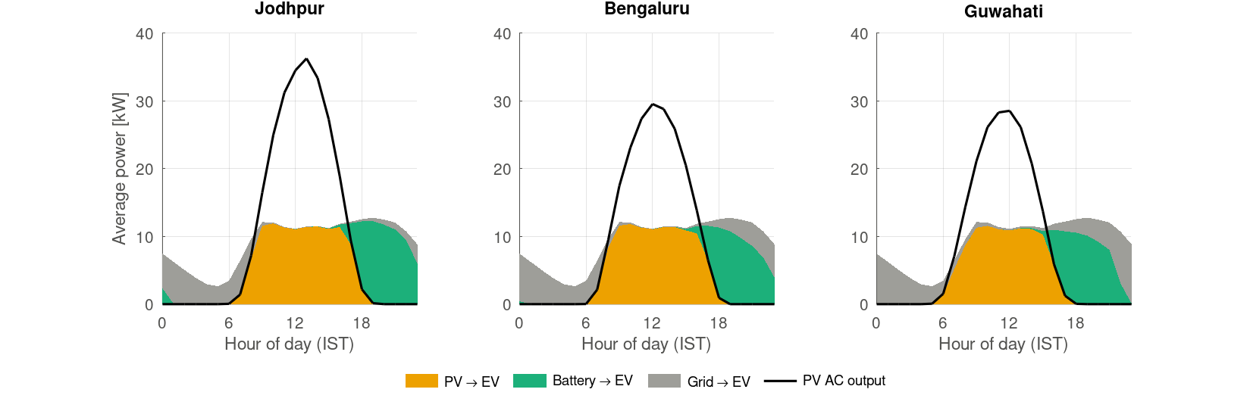
Average day: PV serves the day, the battery the evening, the grid the night and the morning ramp.

3. Fixed design: every number and why

3.1 PV module and array
Value | How it is obtained
620 W = 0.620 kW per module | Datasheet Pmax at STC (1000 W/m², 25 °C cell temperature)
Module area 2.701 m² | 2.382 m × 1.134 m (datasheet dimensions)
η_ref = 22.95 % | 620 / (2.701 × 1000)
49.6 kWp | 80 × 0.620
216.1 m² | 80 × 2.701
β = −0.29 %/K, NOCT 43 ± 2 °C | Datasheet

Why Trina NE19R.
- Its datasheet gives every parameter the model needs: size, efficiency, β, NOCT, Pmax tolerance and the degradation warranty.
- It is a representative tier-1 N-type TOPCon module, the mainstream technology today.
- Any 600 W+ TOPCon module has β ≈ −0.29 to −0.30 %/K and NOCT 42–45 °C, so the thermodynamic results would barely change.
- If asked "why an import?": an ALMM-listed Indian TOPCon module has near-identical β and NOCT. Only cost would change.
Why 80 modules. The array was sized on energy, not economics: annual yield ≈ annual demand.
Annual EV demand = 222 kWh/day × 365 = 81,030 kWh
Typical Indian specific yield ≈ 1,630 kWh/kWp
Required array = 81,030 / 1,630 ≈ 49.7 kWp → 49.7 / 0.620 ≈ 80 modules
Weak point. The array is not an economic optimum. PV-only LCOE is below the tariff in every city, so a larger array may raise NPV. A per-city PV sizing sweep is listed as future work. Say this first.
Why due south. India is in the northern hemisphere, so the sun's daily path lies mostly in the southern sky. Bengaluru (13°N) has the noon sun slightly to the north from about late April to August, but south still wins over the full year.
Why 20° tilt. It came from the PVGIS download settings and was kept so that one geometry applies everywhere. It was not optimised. It has now been checked by re-transposing the NASA POWER data at 0–40°:
City (latitude) | Optimum tilt | POA at optimum | POA at 20° | Loss at 20°
Jodhpur (26.3°N) | 28° | 2,090 | 2,076 | 0.67 %
Bengaluru (13.0°N) | 14° | 1,752 | 1,745 | 0.40 %
Guwahati (26.2°N) | 28° | 1,677 | 1,662 | 0.86 %
The POA at 20° exactly reproduces the model's inputs (2,076 / 1,745 / 1,662), which also validates the transposition script. Defence: the compromise costs under 1 %. A canopy also favours low tilt, for wind load and drainage.

3.2 Battery
Value | How it is obtained
3.2 V per cell | Nominal LFP voltage: the flat discharge plateau (operating range 2.5–3.65 V). It comes from the chemistry, not from a design choice
104 cells | Two standard REPT Y52 modules of 52 cells each
93.2 kWh | 104 × 3.2 V × 280 Ah = 93,184 Wh
332.8 V | 104 × 3.2
31.2 mΩ | 104 × 0.30 mΩ (cell resistance from a supporting listing)
46.6 kW | 0.5C × 93.2 kWh; 140 A is the cell's rated 0.5C standard current
74.6 kWh usable | SOC window 10–90 %

Why LFP.
- No oxygen-releasing cathode, so thermal runaway starts later and is milder. This matters for an outdoor public site at 45 °C.
- 8,000 cycles to 70 % state of health (SOH), which suits a battery cycling daily.
- No cobalt or nickel, so it is cheaper.
- Its lower energy density is irrelevant for a stationary battery.
- It is the same chemistry as the Gorakhpur precedent station.
Why series (1P104S) and not 2P52S. The I²R loss inside the cells is the same for any layout with the same number of cells:
Layout | Voltage | Current at 46.6 kW | R_pack | Cell I²R loss
1P104S (used) | 333 V | 140 A | 31.2 mΩ | 611 W
2P52S | 166 V | 280 A | 7.8 mΩ | 611 W
I²R = (P/V)² × (N_s R_c / N_p) = P² R_c / (N_s N_p V_c²) → depends only on total cell count
The real reasons for series: 333 V sits inside common PCS voltage windows; the external cable current is halved, so cable I²R falls to a quarter; there are no parallel strings to match; and 140 A is exactly the cell's 0.5C rating.
Weak point. 93.2 kWh is "two standard modules", not an optimum. The sensitivity knee is at about 140 kWh, and NPV is negative at every battery size.

3.3 Inverter, battery converter (PCS), round trip
- Inverter: converts the array's DC to grid-synchronised AC (415 V three-phase) and contains the MPPT. Its losses are switching and conduction in the semiconductors, filter components and standby consumption. Modern 50 kW-class string inverters list weighted efficiencies of about 98 %. 0.97 is one point conservative and falls inside the 96–98 % range given in the brief.
- PCS: the battery's two-way converter. It rectifies when charging and inverts when discharging. It is the same class of power electronics as the inverter, so the same 0.97 is used per direction.
- Round trip: PCS 0.97 × 0.97 = 0.9409. The cell I²R adds about 1.3 % per direction at 0.5C, but it is far smaller at the typical current. The simulated AC-to-AC round trip is ≈ 0.93.
- Path comparison: one kWh straight from PV to an EV keeps 0.98 × 0.97 = 0.951. One kWh routed through the battery keeps ≈ 0.87. The battery path costs about 8 % more energy.
Gap. No specific inverter datasheet is cited. Cite one 50 kW string inverter's European or CEC weighted efficiency before the viva. A constant 0.97 also overstates efficiency at very low load, but little energy flows in those hours.

3.4 Wiring and mismatch loss: 2 %
The 2 % term lumps two effects: ohmic (I²R) loss in the DC cables, and mismatch between modules in a string.
- Ohmic: design practice keeps DC voltage drop below 1 % ideally and never above 2 %. PVsyst specifies wiring loss as a percentage at STC, and the annual loss is lower: in one PVsyst report a 1.5 % STC loss gave 0.78 % per year.
- Mismatch: the PVWatts mismatch derate is 0.98, and Aurora's default mismatch is 2 %.
- Combined: about 0.8 % ohmic plus 1–2 % mismatch gives 1.8–2.8 %, so 2 % is mid-range.
- Cite: PVsyst help on ohmic loss, and PVWatts (Dobos 2014, NREL/TP-6A20-62641).
- Do not cite MNRE's 2017 "<2 % cable loss" rule. It applies to DC systems limited to 60 V.
- Model weakness: a constant 2 %, whereas real ohmic loss scales with I², i.e. with irradiance.

3.5 EV demand
- 222 kWh/day is a design value. In the code it is demand at the AC bus (P_EV is drawn directly from the bus). Charger conversion losses (≈ 5 % for DC fast chargers) are outside the station boundary. If 222 kWh means energy into the cars' batteries, the bus demand would be ≈ 233 kWh/day and coverage would be slightly lower.
- The hourly shape comes from 72,856 sessions at 2,119 Korean chargers in 2022 (Scientific Data 2024, CC BY 4.0). The main case uses the public-area, public-institution and public-parking groups: 24,285 sessions.
- The method: each session's energy is spread evenly over its duration and binned by clock hour; the 24 shares are normalised and scaled to 222 kWh/day.
- The measured profile puts 56 % of the energy between 06:00 and 18:00, against 81 % for the synthetic 2/15/5 kW profile. It peaks at 12.8 kW at 19:00.

4. Weather data and sunlight on the panel
Is the panel irradiance given or calculated? For the main case it is calculated. For the ERA5 cross-check it is given.
- NASA POWER gives horizontal values every hour: GHI (total), DNI (direct beam, measured normal to the sun) and DHI (diffuse), plus 2 m temperature and 10 m wind.
- tools/make_power_csv.py converts them to the 20° south-facing plane with the Hay–Davies model and albedo 0.2.
- PVGIS-ERA5 files were downloaded with tilt 20° and azimuth 180° already set, so PVGIS did that conversion itself.
Beam: G_b = DNI · max(cos θ, 0)
Sky: G_d = DHI · [ A_i · R_b + (1 − A_i) · (1 + cos β)/2 ] A_i = DNI / I₀, R_b = cos θ / cos θ_z
Ground: G_r = ρ · GHI · (1 − cos β)/2, ρ = 0.2
I₀ = 1367 · [1 + 0.033 cos(360 n/365)] (extraterrestrial irradiance)
- A_i (anisotropy index): the share of the sky diffuse that behaves like extra beam, because the sky is brighter near the sun (circumsolar). The rest is treated as an even glow from the whole sky.
- (1 + cos β)/2: the fraction of the sky dome the tilted panel sees. (1 − cos β)/2: the fraction of ground it sees.
- Sun position (Duffie & Beckman) is evaluated at mid-hour: declination δ = 23.45° sin[360(284+n)/365], hour angle ω = 15°(t_solar − 12), and cos θ = sin δ sin(φ−β) + cos δ cos(φ−β) cos ω for a south-facing plane.
- Hour stamps: POWER values are hour means. The centre of the daily irradiance curve sits 0.42–0.51 h before solar noon, which confirms this, so rows are stamped at hh:30 UTC and shifted +6 rows to IST.
Why NASA POWER is the main case.
- It is satellite-based, not a weather model.
- It has near-zero GHI bias against BSRN ground stations.
- It agrees with long-term Indian solar maps.
- ERA5 is a reanalysis and under-reads clear-sky winter irradiance in north India: Jodhpur shows ≈ 400 W/m² at clear January noons, where ≈ 900–1,000 W/m² is expected. ERA5 reads 21 % low for Jodhpur and 24 % low for Guwahati, but only 3 % off for Bengaluru.
Biggest weak point of the whole project. On ERA5 the coverage ranking becomes Bengaluru > Jodhpur > Guwahati. The Monte Carlo only covers ±7 % irradiance, so the "100 % of draws" claims hold within NASA POWER only. Raise this yourself, with the evidence for why POWER is more credible.

5. PV model step by step

5.1 Light that actually gets into the cell (G_eff)
G_eff = G_b · IAM_b(θ) + 0.95 · G_d + 0.65 · G_r
IAM_b = 1 − b₀ (1/cos θ − 1), b₀ = 0.05
- IAM (incidence-angle modifier): extra reflection off the glass when light arrives at a slant, relative to head-on.
- ASHRAE form, b₀ = 0.05: Souka & Safwat (1966). This is the PVsyst default for glass-faced modules.
- 0.95 for sky light: effective sky-diffuse modifier at 20° tilt (Martin & Ruiz 2001).
- 0.65 for ground light: an estimate with no direct source. Ground light arrives at steep angles. Defence: it is under 1 % of the plane irradiance at 20°, so even a large error has no effect on the results.

5.2 Cell temperature T_c: the energy balance (no closed-form formula)
There is no single formula T_c = …. The code solves a heat balance on the panel every hour. T_c appears in it four times, including as T_c⁴, so it cannot be rearranged algebraically and is solved numerically.
α·G_eff − η(T_c)·G_eff = 2·h·(T_c − T_a) + ε_f·σ·(T_c⁴ − T_sky⁴) + ε_b·σ·(T_c⁴ − T_a⁴)
Term | Meaning | Value | Source
α·G_eff | Light absorbed per m² | α = 0.90 | Duffie & Beckman use τα ≈ 0.9 (literature range 0.9–0.97)
η(T_c)·G_eff | Electricity sent out (not heat) | From §5.3 | Coupled
2h(T_c − T_a) | Convection to air, both faces | h = h_free + 3.0·v | Watmuff et al. 1977 slope; h_free calibrated
ε_f σ (T_c⁴ − T_sky⁴) | Front glass radiating to the sky | ε_f = 0.84 | Glass 0.84–0.91 in the literature
ε_b σ (T_c⁴ − T_a⁴) | Back sheet radiating to the ground (taken at T_a) | ε_b = 0.89 | Backsheet 0.85–0.91
σ | Stefan–Boltzmann constant | 5.67×10⁻⁸ W/m²K⁴ | Constant
T_sky | Effective clear-sky temperature | 0.0552 · T_a^1.5 | Swinbank 1963
v | Wind at panel height | v₁₀ × (3/10)^(1/7) = 0.84 v₁₀ | 1/7 power law, 3 m canopy

h_free is calibrated, not assumed (calibrate_hfree.m). It is the value that makes the balance return the datasheet NOCT exactly at the NOCT test conditions: 800 W/m², 20 °C air, 1 m/s wind, panel open circuit so η = 0.
T_N = 316.15 K, T_a = 293.15 K, T_sky = 0.0552 × 293.15^1.5 = 277.1 K
absorbed α G = 0.9 × 800 = 720.0 W/m²
front radiation 0.84 σ (316.15⁴ − 277.1⁴) = 195.2 W/m²
back radiation 0.89 σ (316.15⁴ − 293.15⁴) = 131.5 W/m²
h = (720 − 326.7) / (2 × 23) = 8.55 W/m²K → h_free = 8.55 − 3.0 × 1 = 5.55 W/m²K
Solving it (Newton's method):
- Start from the NOCT guess T = T_a + (43 − 20)/800 · G_eff.
- Compute the imbalance f(T) between the two sides of the balance.
- Correct the guess: T_new = T − f/(df/dT).
- Repeat until the change is below 10⁻⁸ K, which takes a few iterations.
- At night, set T_c = T_a.
Case | T_c | η
Jodhpur noon: 900 W/m², 35 °C, 3 m/s | 49.7 °C | 21.3 %
Same, nearly calm (0.5 m/s) | 56.7 °C | 20.8 %
NOCT conditions, panel producing power | 36.9 °C | 22.2 %

Why not the simple NOCT formula T_c = T_a + (NOCT − 20)/800 · G? It is this balance linearised at one test point. It ignores wind, the cold sky and the cooling caused by producing electricity: a producing panel at NOCT conditions runs ≈ 37 °C, not 43 °C. Over a year it runs cells 6–9 K hot and under-predicts yield by 1.8–2.8 %. It is kept as a sensitivity case.
Weak points. (1) Watmuff's full correlation is h = 2.8 + 3.0·v, and the 2.8 already includes free convection and radiation. The model reuses only the 3.0 slope, replaces the 2.8 with the calibrated 5.55, models radiation explicitly and applies h to both faces. At the NOCT point nothing is double-counted, but 5.55 W/m²K per face is high for still air (typically 2–4), because the calibration absorbs errors in α and ε. Call it a "calibrated lumped coefficient". (2) α = 0.90, ε_f = 0.84 and ε_b = 0.89 appear as bare numbers in params.m; add citations there.

5.3 PV efficiency
η = η_ref · f_low(G') · [1 − β (T_c − 25)], G' = G_eff / 1000
f_low = 1 + k₁ ln G' + k₂ (ln G')², k₁ = −0.017237, k₂ = −0.040465
Term | Meaning | Value | Fixed or varies
η | Efficiency this hour (light in → electricity) | ~19–23 % | Hourly
η_ref | Datasheet efficiency at STC | 22.95 % | Fixed
f_low | Weak-light correction | 1.00 at 1000, 0.993 at 500, 0.98 at 400, 0.92 at 200 W/m² | Hourly
β | Efficiency lost per °C above 25 °C | 0.0029 /K | Fixed (datasheet)
T_c | Cell temperature (§5.2) | — | Hourly
25 | STC cell temperature where η_ref and β were measured | 25 °C | Fixed reference

- Why 25 is fixed and T_a does not appear: 25 °C is the factory test temperature, the reference point the datasheet numbers are measured from. The bracket equals 1 at 25 °C, is below 1 for hotter cells and above 1 for colder ones (a cold winter morning at T_c = 20 °C gives +1.5 %). Air temperature enters only through T_c: T_a, sunlight and wind → T_c → η → P.
- Origin: the temperature bracket is the standard linear derating (Evans 1981; Duffie & Beckman). f_low is the irradiance part of the Huld et al. 2011 model, with the PVGIS-5 crystalline-silicon coefficients (pvlib lists them exactly).
- Hybrid: Huld's temperature terms (k₃–k₆) are dropped and the datasheet β is used instead, because Huld's terms were fitted to older modules (~ −0.47 %/K). Describe it as "Huld low-light terms + datasheet temperature coefficient", not "the Huld model".
- Coupling: η depends on T_c, and T_c depends on η, because electricity sent out does not heat the cell. Newton's method solves both together.
Weak point. PVGIS-6 refitted these coefficients for modern modules: k₁ = −0.0068, k₂ = −0.0164, about 40 % of the values used. The model therefore overstates weak-light loss for TOPCon, so η_PV in the monsoon and coverage are slightly low. Defensible: PVGIS-5 was the standard fit when the model was built. Mention the update.

5.4 Power: P_DC and P_AC
P_DC = η · A · G_eff (definition of efficiency, rearranged)
P_AC = P_DC × 0.98 (cables) × 0.97 (inverter)
- Origin: η = electrical power out / light power in, and light power in = G_eff · A. Nothing is derived here; all the physics sits inside η.
- Losses multiply, they do not add: each loss acts on what remains. 0.98 × 0.97 = 0.9506, against 0.95 if added. Here the difference is negligible, but adding is wrong in principle.
- Worked hour (Jodhpur noon): G_eff = 900, T_c = 49.7 °C → η = 0.2295 × [1 − 0.0029 × 24.7] = 0.2131 → P_DC = 0.2131 × 216.1 × 900 = 41.4 kW → P_AC = 39.4 kW (0.8 kW lost in the cables, 1.2 kW in the inverter).
- Where P_DC is used: in ψ_PV = P/Ex_in; in PV exergy destruction (Ex_in − P); and in the cell heat balance.
- Where P_AC is used: as the EMS input; for coverage; for LCOE, NPV and CO₂ avoided.
- P_DC − P_AC: the exergy destroyed in the wiring and the inverter. Electricity is 100 % exergy, so the energy lost equals the exergy destroyed.
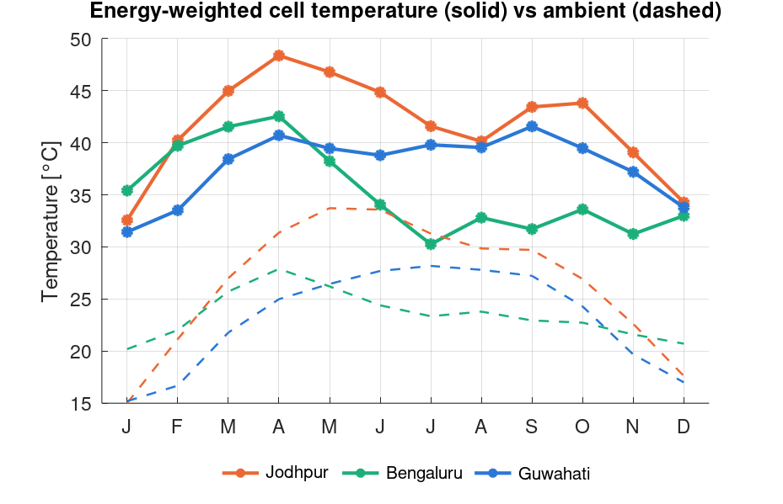
Monthly energy-weighted cell temperature vs ambient.

6. Second Law: exergy of sunlight and of the PV cell

6.1 Petela: exergy of direct sunlight
For blackbody radiation from a source at temperature T, per unit area, the energy flux is E = σT⁴ and the entropy flux is S = (4/3)σT³. The environment at T₀ radiates back E₀ = σT₀⁴ and S₀ = (4/3)σT₀³.
Ex = (E − E₀) − T₀ (S − S₀) = σT⁴ − (4/3)σT₀T³ + (1/3)σT₀⁴
Ex/E = 1 − (4/3)(T₀/T_sun) + (1/3)(T₀/T_sun)⁴ = 1 − 0.06923 + 0.0000024 = 0.931 (T₀ = 300 K, T_sun = 5778 K)

6.2 Diluted radiation: exergy of diffuse and ground light
Diffuse light has roughly the solar spectrum but is spread over the whole sky, so its radiance is a tiny fraction ε of the sun's surface radiance. Spreading the same energy over more directions raises its entropy and lowers its exergy (Landsberg & Tonge 1979).
ψ(ε) = 1 − (4/3)(T₀/T_sun) · X(ε)
X(ε) = 45/(4π⁴ε) ∫₀^∞ x² [(1+n)ln(1+n) − n ln n] dx, n = ε/(eˣ − 1)
ε_d = G_d / [σ T_sun⁴ (1+cos β)/2], ε_r = G_r / [σ T_sun⁴ (1−cos β)/2]
Ex_in = A · [ G_b ψ_P + G_d ψ(ε_d) + G_r ψ(ε_r) ]
- X(1) = 1, so undiluted light gives back Petela. Typical ε_d of 10⁻⁶–10⁻⁵ gives ψ ≈ 0.67–0.71; even bright overcast light stays below 0.80.
- X is integrated numerically once and tabulated (radiation_exergy_factor.m). It matches a direct integration to 4 decimals.
- The Petela environment term (≈ 10⁻⁵) is dropped for diluted light, where it is not well defined.
- The dead state T₀ is the hourly ambient temperature.
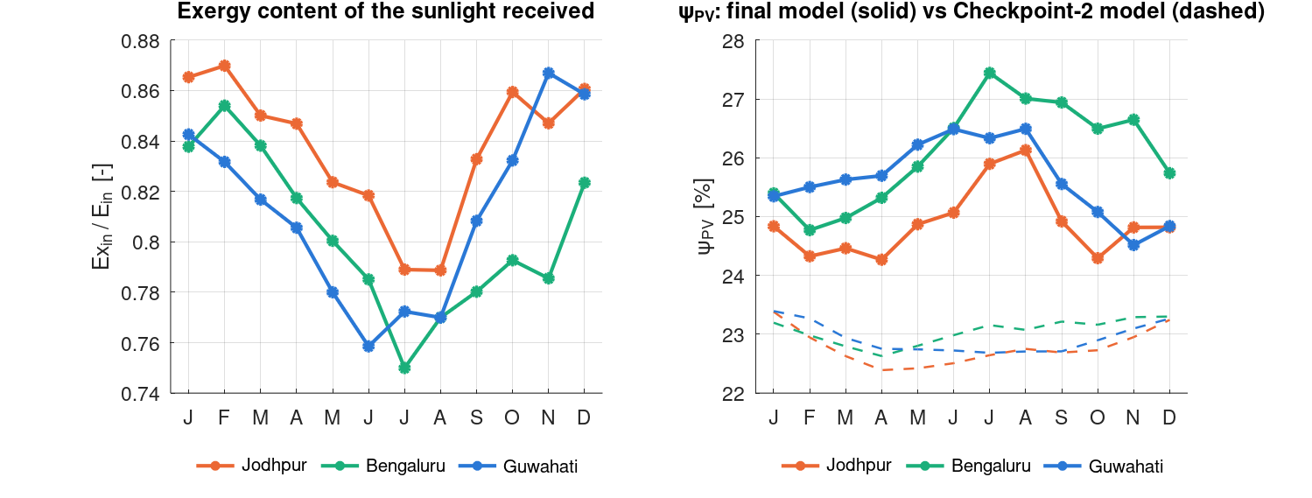
Left: exergy content of the light received. Right: ψ_PV, final model (solid) vs Checkpoint-2 all-Petela model (dashed).

6.3 PV exergy balance and the key identity
Ex_out = P (electricity is pure exergy)
Ex_opt = A Σ G_k (1 − α IAM_k) ψ_k reflected / unabsorbed light
Ex_Q = Q_heat (1 − T₀/T_c) work potential of rejected heat (lost)
Ex_int = Ex_in − P − Ex_opt − Ex_Q = T₀ S_gen,int ≥ 0 (asserted each hour)
η_PV = P/(A G), ψ_PV = P/Ex_in ⇒ ψ_PV = η_PV / (Ex_in/E_in)
- Check: Jodhpur 20.83/0.839 = 24.83 %; Bengaluru 20.94/0.808 = 25.92 %; Guwahati 20.82/0.814 = 25.57 %.
- Ex_in < A·G always, so ψ_PV > η_PV always. The Checkpoint-2 slides said ψ < η; that was wrong and has been corrected.
- Why ψ_PV rises in the monsoon: the exergy per kWh of light falls 7–8 %, while the electricity per kWh of light falls only 2–4 %. The cell wastes a smaller share of a smaller, lower-grade input. This is not better performance, and saying so explicitly prevents the examiner from reading it as a bug.
- Inside the PV loss: about 80 % is internal destruction (hot-carrier thermalisation, recombination, resistance), 17 % optical and 3 % the exergy of the rejected heat. The heat leaves only 7–19 K above T₀, so its Carnot factor is a few per cent. Cooling a panel helps through β, not through recovering heat.
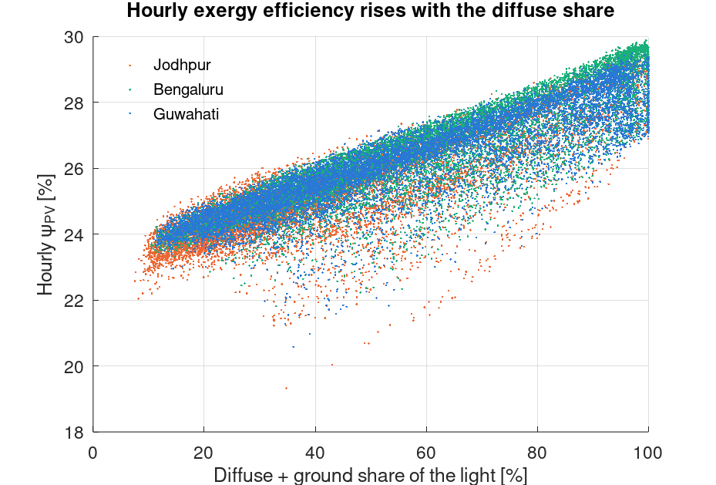
Hourly ψ_PV rises with the diffuse share.

7. Battery, converters, EMS and the hourly closures

7.1 Battery
I = P/V_nom, P_loss = I²R, E(t+1) = E(t) + (P_c − P_d − I²R)Δt
m c_p dT_b/dt = I²R − UA (T_b − T_a) (exact solution over each 1 h step)
S_gen = Q/T_b (inside pack) + Q(1/T₀ − 1/T_b) (heat flowing out) = Q/T₀ ⇒ Ex_dest = T₀ S_gen = I²R
- Gouy–Stodola: electrical exergy degraded to near-ambient heat is fully destroyed. The heat at T_b carried only Q(1 − T₀/T_b) ≈ 2 % of Q (T_b is at most ≈ 7 K above ambient), and that is lost anyway.
- Power limits: the charge limit solves P − kP² = headroom/Δt and the discharge limit solves P + kP² = available/Δt, with k = 1000R/V². The SOC window therefore holds including the loss term. Both are capped at 0.5C.
- Ageing: fade is 0.30/8000 = 3.75×10⁻⁵ per equivalent full cycle at 25 °C, scaled by an Arrhenius factor with E_a = 31.7 kJ/mol (Wang et al. 2011). Results: 0.9–1.3 %/yr; Jodhpur 268 cycles/yr.
- Thermal mass 104 × 5.5 kg × 1,100 J/kgK and UA = 40 W/K are assumptions. They only affect T_b (max rise 6.3–6.9 K) and, marginally, fade.
- Consequence: for the battery, inverter and wiring ψ = η. Only the PV cell has ψ ≠ η, because its input is not pure work. "PV dominates destruction" is therefore structural; present it as such, not as a surprise.
Cell resistance. 0.30 mΩ is the usual AC value at 1 kHz; DC resistance under load is typically 2–3× higher. That is why the Monte Carlo spans 0.30–0.90 mΩ. At 3× R, battery destruction triples to 488–631 kWh/yr and coverage drops by only 0.2 points.

7.2 Dispatch and closures
Each hour: PV_to_EV = min(P_AC, P_EV)
surplus → battery (through PCS, up to limits) → export
deficit ← battery (through PCS, down to SOC 10 %) ← import
First Law: A·G + import = EV + export + ΔE_b + optical + heat + wiring + inverter + PCS + I²R
Exergy: Ex_in + import = EV + export + ΔE_b + Σ Ex_dest
Max residual: 5.7×10⁻¹⁴ kWh (asserted; the run stops if either fails)
Coverage (SCR) = (E_PV→EV + E_batt→EV) / E_EV grid dependency = E_import / E_EV
ψ_solar = (E_EV − E_imp + E_exp + ΔE_b) / Ex_in ψ_sys = (E_EV + E_exp + ΔE_b) / (Ex_in + E_imp)

8. Economics and CO₂ (reporting layer)
LCOE = [C₀ + Σ (O&M_y + Repl_y)(1+d)^−y] / Σ E_solar D_y (1+d)^−y
NPV = −C₀ + Σ [D_y (E_served·tariff + E_export·3.0) − O&M_y − Repl_y] / (1+d)^y
d = 8 % real, L = 25 yr, D_y = (1 − 0.01)(1 − 0.004)^(y−1) (Trina warranty curve)
Capex item | Rate | INR lakh
PV modules + structure | 40,000 /kWp × 49.6 | 19.8
Battery + BMS | 18,000 /kWh × 93.2 | 16.8
Inverter + PCS | 6,000 /kW × 49.6 + 8,000 /kW × 46.6 | 6.7
Balance of system | 15 % of equipment | 6.5
Total (PV only: 26.2) |  | 49.8

- O&M 1.5 %/yr. Battery replaced at year 15 at 60 % of today's price; converters at year 12. Export credit 3 INR/kWh (APPC-level). Energy charge only: fixed and demand charges are the same with or without PV, because the evening EV peak sets contract demand.
- Two numbers people confuse: LCOE (cost per solar kWh used, exports included) and NPV (cash vs grid-only). PV-only LCOE is below the tariff in all three cities, yet the PV-only NPV in Bengaluru is −2.5 lakh. About 48 % of PV output is exported at only 3 INR/kWh, and Karnataka's 4.50 tariff leaves little margin on the rest.
- The Monte Carlo median NPV is below the baseline because the sourced battery-price range (16–25k) is centred above the 18k baseline.
- CO₂: CEA v21 national factor, 0.710 t/MWh. India has one integrated grid and no state factors are published. Avoided CO₂ (61.8 t/yr in Jodhpur) can exceed the grid-only total (57.5 t/yr) because exports also displace grid power.
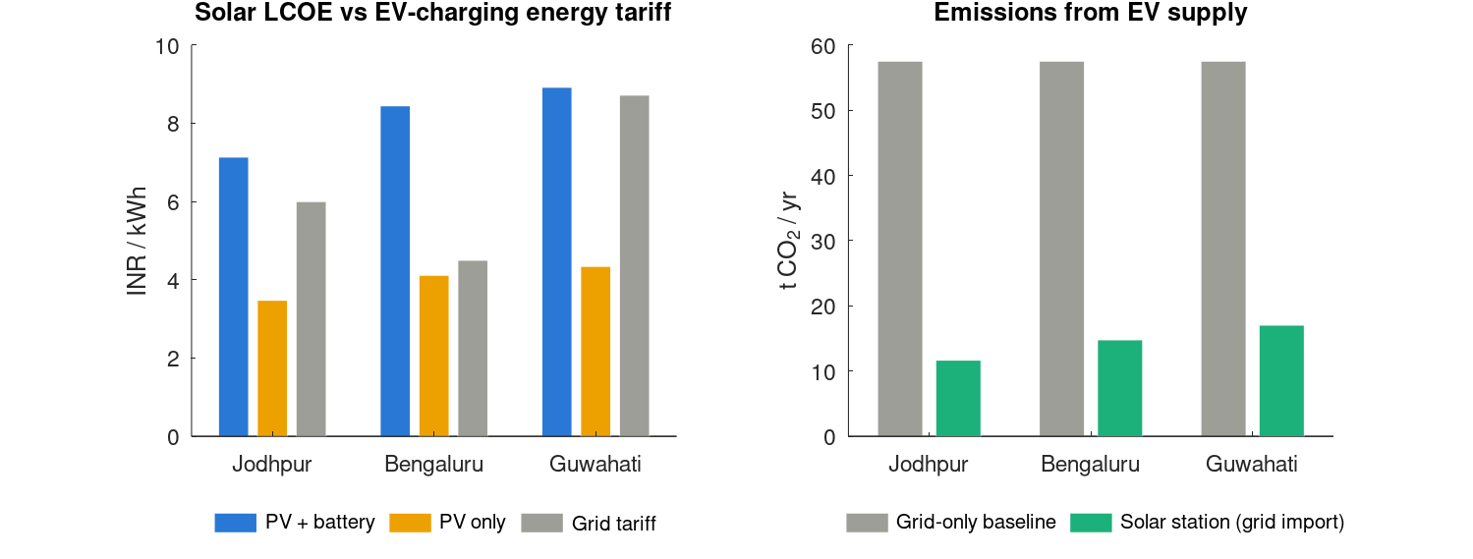
LCOE vs tariff, and CO₂ vs the grid-only baseline.

9. Sensitivity and uncertainty
Change (one at a time) | Effect
Weather source ERA5 2023 | Coverage 71.8 / 76.6 / 61.7 % (J/B/G): Bengaluru first. ψ_PV spread smaller; monsoon ψ still above winter ψ
EV timing: workplace / residential / synthetic | Residential −15 to −18 points; synthetic +7 to +10. City order unchanged
Irradiance 80 → 130 % | Coverage moves only 12–14 points over the whole range; ψ_PV ≤ 0.2 points
PV 24.8 → 74.4 kWp | Coverage 54→84 (J), 46→82 (B), 43→77 (G); above 49.6 kWp most of the extra output is exported
Battery 0 → 186 kWh | +25–30 points up to 93 kWh, +8–12 more at 140 kWh, then +1–3; knee ≈ 140 kWh
NOCT formula instead of balance | Cells 6–9 K hotter, yield 1.8–2.8 % lower
Battery R × 3 | Battery destruction × 3; coverage −0.2 points
PV model Checkpoint 2 vs final | ψ_PV changes by 2.1–2.9 points and its ranking flips; yield ±2 %

Monte Carlo design. 200 draws. Each draw picks a weather year and samples six inputs uniformly within ranges that can be defended. The same draw is applied to all three cities (paired), so shared errors cancel when cities are compared.
Input | Range | Basis
Irradiance scale | 0.93–1.07 | POWER GHI ≈ 0 bias vs BSRN; ±7 % for the 1° grid cell + transposition
Module η_ref | ±3 % | Datasheet Pmax tolerance
NOCT | 41–45 °C | Datasheet 43 ± 2 (h_free recalibrated each draw)
Inverter, PCS | 0.96–0.98 each | Project brief
Cell R | 0.30–0.90 mΩ | AC value; DC is 2–3×
Battery price | 16–25k INR/kWh | 2026 C&I quotes
Weather year | 2021/22/23 | Equal probability

Deliberately not sampled: the EV profile (a scenario, not a measurement error), the tariffs (published), the exergy model (a modelling choice, compared directly), and the weather dataset (shown separately). The ranges are uniform and independent: they bound plausible outcomes; they are not calibrated probabilities.
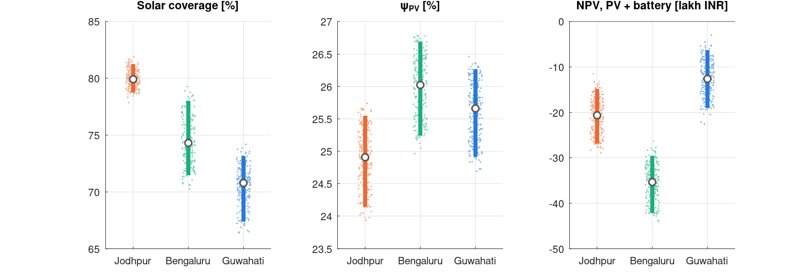
Monte Carlo 5–95 % bars, median and draws.

10. Assumption register
Status codes: D datasheet or measured · L literature · C calibrated · A assumption · S study-design choice.
Assumption | Value | St. | Defence | Weakness
Fixed design, all cities | — | S | Climate is the only physical variable | Not cost-optimal per city
Module | Trina NE19R 620 W | D | Full datasheet; representative TOPCon | Import; ALMM module would match thermally
Array size | 49.6 kWp | S | Yield ≈ demand at 1,630 kWh/kWp | Not an economic optimum
Tilt / azimuth | 20° / south | S | < 1 % loss vs optimum (checked) | Inherited from the PVGIS download
Battery | 93.2 kWh LFP, 1P104S | D/S | Two standard modules; 0.5C ≈ PV peak | Knee at 140 kWh
SOC window | 10–90 % | A | Common LFP practice | —
EMS | Priority, PV-only charging | S | Transparent; optimisation out of scope | Not optimal
EV demand | 222 kWh/day at AC bus | S | Like-for-like comparison | Charger losses outside boundary
EV timing | Korean public sessions | D | Only open session-level data | Not Indian; identical every day
Weather | NASA POWER 2021–23 | D | Satellite, ~0 bias vs BSRN | 1° grid; ERA5 flips ranking
Transposition | Hay–Davies, ρ = 0.2 | L | Standard; reproduces POA | Few % model uncertainty
Beam IAM | ASHRAE b₀ = 0.05 | L | PVsyst default | —
Diffuse / ground IAM | 0.95 / 0.65 | L / A | Martin & Ruiz / ground < 1 % of POA | 0.65 unsourced
α | 0.90 | L | Duffie & Beckman τα ≈ 0.9 | Range 0.9–0.97; absorbed by calibration
ε_f / ε_b | 0.84 / 0.89 | L | Published ranges 0.84–0.91 | Uncited in params.m
T_sky | Swinbank | L | Standard clear-sky | Overstates cooling when overcast
Wind slope | 3.0 | L | Watmuff 1977 | Only the slope reused
h_free | 5.55 | C | Reproduces NOCT exactly | High for pure free convection
Steady T_c per hour | — | A | Time constant 5–10 min ≪ 1 h | —
β | −0.29 %/K | D | Datasheet | —
k₁, k₂ | PVGIS-5 c-Si | L | Published fit | PVGIS-6 values ~40 % smaller
Wiring + mismatch | 2 % | L | PVsyst ~0.8 % + PVWatts 2 % | Constant, not ∝ I²
Inverter / PCS | 0.97 | L | Brief 96–98 %; ~1 pt below datasheets | No specific datasheet cited
Dead state | T₀ = T_a hourly | L | Convention | —
Diffuse exergy | Grey-diluted, isotropic | L | Landsberg & Tonge | Real sky is bluer; circumsolar part is near-beam
Cell R | 0.30 mΩ (MC 0.30–0.90) | D | Propagated | AC value
Ageing | Cycle + Arrhenius | D/L | Brochure + Wang 2011 | No calendar ageing
Battery thermal | 572 kg, UA 40 W/K | A | Only affects T_b | —
Prices, finance | See §8 | A | Indicative; battery price propagated | Drives NPV
Export credit | 3 INR/kWh | A | APPC-level, conservative | Sets Bengaluru PV-only NPV sign
Tariffs | 6.00 / 4.50 / 8.72 | D | State EV-charging orders | Energy charge only
Emission factor | 0.710 t/MWh | D | CEA v21, national | No state factors

11. Where each formula comes from
Formula | Source | Used in literature?
Panel energy balance (absorbed − electricity = convection + radiation) | Jones & Underwood 2001, Solar Energy 70(4) 349–359 | Yes; theirs is transient, ours is steady per hour
T_sky = 0.0552 T_a^1.5 | Swinbank 1963, Q. J. R. Meteorol. Soc. 89 | Yes, standard
Wind slope 3.0 v | Watmuff, Charters & Proctor 1977 (valid 1–7 m/s) | Yes (only the slope reused)
Wind height (z/10)^(1/7) | Hellmann 1/7 power law | Yes
η = η_ref[1 − β(T_c − 25)] | Evans 1981; Duffie & Beckman | Yes, standard
f_low (k₁, k₂) | Huld et al. 2011, Sol. Energy Mater. Sol. Cells 95, 3359–3369; PVGIS-5 | Yes; hybrid use
ASHRAE IAM | Souka & Safwat 1966; PVsyst | Yes
Diffuse IAM | Martin & Ruiz 2001, Sol. Energy Mater. Sol. Cells 70, 25–38 | Yes
Hay–Davies transposition | Hay & Davies 1980; Duffie & Beckman ch. 2 | Yes, standard
Petela factor | Petela 1964, J. Heat Transfer 86, 187–192 | Yes, standard
Diluted-radiation exergy | Landsberg & Tonge 1979, J. Phys. A 12, 551–562 | Yes, rarer in PV papers
Ex_dest = T₀ S_gen | Gouy–Stodola theorem (Bejan) | Textbook
LFP ageing E_a = 31.7 kJ/mol | Wang et al. 2011, J. Power Sources 196, 3942–3948 | Yes
Citation fix. The earlier report cites Huld as "Solar Energy 85". The correct journal is Solar Energy Materials & Solar Cells 95 (2011) 3359–3369. Landsberg & Tonge (1979) is J. Phys. A 12, 551–562. The LaTeX report uses the corrected references.

12. Numbers to know cold
Quantity | Jodhpur | Bengaluru | Guwahati
POA [kWh/m²/yr]; ERA5 | 2,076; 1,598 | 1,745; 1,774 | 1,662; 1,300
Mean T_a; energy-weighted T_c; max T_c [°C] | 26.7; 42.1; 67.1 | 23.5; 36.1; 57.8 | 23.1; 37.9; 62.5
Specific yield [kWh/kWp]; PR | 1,883; 0.863 | 1,591; 0.867 | 1,508; 0.862
Temperature / low-light loss | 5.0 / 1.5 % | 3.2 / 2.2 % | 3.8 / 2.4 %
Ex_in/E_in; diffuse share | 0.839; 37 % | 0.808; 52 % | 0.814; 48 %
η_PV; ψ_PV | 20.83; 24.83 % | 20.94; 25.92 % | 20.82; 25.57 %
ψ_PV winter → monsoon | 24.64 → 25.45 | 25.26 → 26.94 | 25.21 → 26.17
Coverage (direct + battery) | 79.7 (49.8 + 29.9) | 74.3 (48.5 + 25.7) | 70.4 (45.0 + 25.4)
Grid dependency; export [MWh] | 20.3 %; 22.5 | 25.7 %; 13.4 | 29.6 %; 12.7
Ex_in; total destroyed [MWh/yr] | 376; 289 | 305; 231 | 293; 223
PV internal / optical / heat [MWh] | 226 / 47 / 9.3 | 180 / 40 / 6.2 | 173 / 38 / 7.7
Inverter / wiring / PCS / batt [kWh] | 2,746 / 1,868 / 1,527 / 209 | 2,321 / 1,579 / 1,314 / 164 | 2,199 / 1,496 / 1,296 / 162
Battery EFC/yr; SOH yr 1; max ΔT_b | 268; 0.987; 6.5 K | 231; 0.991; 6.3 K | 227; 0.991; 6.9 K
Weak month (coverage) | Dec 74.0 % | Nov 62.2 % | Jun 58.6 %
MC coverage 5/50/95 | 78.7/79.9/81.2 | 71.5/74.3/78.0 | 67.4/70.8/73.2
MC NPV 5/50/95 [lakh] | −26.9/−20.6/−14.8 | −42.2/−35.3/−29.6 | −19.0/−12.6/−6.3
Payback PV only / PV + batt [yr] | 7.7 / 18.5 | 12.4 / never | 7.0 / 12.8
CO₂ avoided [t/yr] | 61.8 | 52.2 | 49.5

Constants: h_free 5.55 W/m²K · Petela 0.931 · capex 49.8 lakh (PV-only 26.2) · grid factor 0.710 t/MWh · annual demand 81,030 kWh · 26,280 hours per city · residual 5.7×10⁻¹⁴ kWh.

13. Likely viva questions, with answers

Framing and scope
Q. Why is this a thermodynamics project and not just a PV yield study?
Because the deliverable is the Second Law picture: where work potential is destroyed, per subsystem, each hour. The headline finding (ψ_PV rises when η_PV falls) only exists in an exergy analysis. Yield and coverage come from the First Law half.
Q. Why hold the design fixed? Isn't that unrealistic?
It is a controlled experiment: climate becomes the only physical variable. Per-city sizing is a different question; the PV and battery sweeps show its direction.
Q. Why hourly and not daily or monthly?
η(G, T_c) and the exergy factors are nonlinear. Averaging the weather first biases the results (Jensen's inequality): the brightest hours are also the hottest, so averaged weather overstates yield. Dispatch also depends on the hour-to-hour timing.

PV model
Q. Is there a formula for T_c?
No closed form. It is a steady energy balance with T⁴ radiation terms, coupled to η, solved by Newton iteration each hour. The NOCT formula is its linearisation at one test point.
Q. What is the 25 in the efficiency formula, and why isn't it T_a?
25 °C is the STC cell temperature at which η_ref and β are measured. Ambient temperature enters only through T_c.
Q. Where does h_free come from?
It is calibrated so that the balance returns exactly 43 °C at NOCT conditions with the panel open circuit: 5.55 W/m²K. It is recalibrated in every Monte Carlo draw. It is a lumped coefficient that also absorbs errors in α and ε.
Q. Aren't you double-counting radiation by using Watmuff?
Watmuff's constant 2.8 contains free convection and radiation; only his 3.0 wind slope is reused. The constant is replaced by the calibrated h_free, and radiation is modelled explicitly. At the NOCT point the balance matches the datasheet, so nothing is double-counted there.
Q. Your ψ_PV (25 %) is above the 10–20 % in the literature. Why?
Two reasons. The module is a 23 % TOPCon; most of that literature uses 12–16 % modules. And most papers use Petela for all light, which overstates Ex_in by 11–15 %. With that convention our station gives 22.8–23.0 %.
Q. Why does ψ_PV go up in the monsoon? Isn't that a bug?
No. ψ = η / (Ex_in/E_in). Diffuse light has an exergy content of 0.67–0.80 against 0.93 for the beam, so Ex_in per kWh falls 7–8 % while η falls only 2–4 %. The cell wastes a smaller fraction of a lower-grade input. The station produces less, but converts the work potential it receives better.
Q. Why does Jodhpur have the lowest ψ_PV even though it is sunniest?
Its light is beam-rich (37 % diffuse), so it carries the most exergy per kWh, and its cells are the hottest (5.0 % temperature loss). η is about the same in all three cities, so the larger denominator lowers ψ.
Q. Is the diluted-radiation treatment established?
The theory (Landsberg & Tonge; Petela) is established, but its use in PV exergy papers is rarer, and the environment term for diluted light is debated. Simplifications used here: a grey spectrum and an isotropic sky. The direction of the effect is robust; its exact size is not. Both models are reported side by side.

Exergy destruction
Q. Isn't "PV dominates destruction" trivially true?
Largely, yes: the electrical subsystems have ψ = η ≈ 0.97, while the PV cell turns a non-work input into work at about 25 %. The informative part is inside the PV term: 80 % internal, 17 % optical, 3 % heat. Heat recovery could therefore never be worth much.
Q. Why is the battery's exergy destruction equal to I²R?
Gouy–Stodola. The Joule heat generated at T_b ends at T₀. Entropy generated inside (Q/T_b) plus across the gradient (Q(1/T₀ − 1/T_b)) totals Q/T₀, and T₀ × Q/T₀ = Q.
Q. The battery destroys only 0.07 % of exergy. Why is it the expensive part, then?
Thermodynamically it is nearly reversible. The cost is economic (34 % of capex), and each shifted kWh also loses ≈ 7 % in two PCS passes. The two laws and the economics give different verdicts on the battery.

Data
Q. Why NASA POWER and not ERA5?
POWER is satellite-derived with ≈ 0 GHI bias against BSRN ground stations. ERA5 is a reanalysis that shows ≈ 400 W/m² at clear January noons in Jodhpur, where clear-sky physics gives 900–1,000. ERA5 is kept as a cross-check, and the ranking flip it causes is reported.
Q. The coverage ranking flips on ERA5. So is your ranking robust?
Within the NASA POWER data, yes: all 3 years and 100 % of draws. Across datasets, no. The dataset choice is a larger uncertainty than any model parameter. A third independent check (NSRDB or Meteosat-IODC) is the next step.
Q. Why Korean EV data for an Indian station?
It is the only open session-level dataset found. Only the timing is used; the energy is fixed at 222 kWh/day. The workplace, residential and synthetic profiles bracket the effect: −15 to +10 points.

Economics
Q. PV-only LCOE is below the tariff in Bengaluru but the NPV is negative. Contradiction?
No. LCOE counts every solar kWh, but about 48 % is exported at 3 INR/kWh. NPV values self-consumed kWh at 4.50 and exports at 3.0, which does not recover the capex at 8 %.
Q. Why does Guwahati have the best economics with the least sun?
Assam's tariff is 8.72 INR/kWh, against 6.00 and 4.50. The economic ranking follows the tariff.
Q. Why is the MC median NPV worse than your baseline?
The sourced battery-price range (16–25k) is centred at 20.5k, above the 18k baseline.

Design choices
Q. Why 20° when the latitudes are 13° and 26°?
One tilt in every city. Re-transposition shows the loss against each city's optimum is 0.4–0.9 % of POA.
Q. Why put the cells in series?
Cell I²R loss is layout-independent for a fixed cell count. Series puts 333 V inside common PCS windows, halves cable current and avoids parallel-string matching.
Q. Why does the battery charge only from PV?
Grid charging would import grid CO₂ and blur the solar-coverage metric. It is excluded on purpose.

14. Weak points to raise first, and corrections log

14.1 Raise these before the examiner does
- ERA5 flips the coverage ranking. Dataset choice dominates all model uncertainty; give the evidence for POWER.
- PV dominance is structural. Present it as a structural result, then move to the internal / optical / heat split.
- The ψ reversal against the Checkpoint-2 hypothesis. Explain it with ψ = η/(Ex/E) before anyone asks.
- EV timing is Korean. It moves coverage as much as climate does.
- Low-light coefficients are older-module fits (PVGIS-6 has smaller values).
- Unsourced numbers: α, ε_f and ε_b have literature ranges but are uncited in params.m; the ground IAM of 0.65 has no source (immaterial); there is no specific inverter datasheet.
- Not modelled: soiling (2–5 %/yr in Rajasthan dust) and inverter part-load efficiency. PR 0.86 is optimistic, and Jodhpur would be hit hardest by soiling.
- Figure 5's axis says "(Petela)" but the bars use the split model. Fix the label in make_plots.m or mention it.

14.2 Corrections log: statements from preparation that were wrong
Earlier statement | Correct version
T_c = T_a + (NOCT − 20)/800 · G is the model's cell temperature | The main model is the convection + radiation balance calibrated to NOCT; the NOCT formula is only a sensitivity case
Exergy input uses plain Petela (0.93) | Component-wise: beam with Petela, diffuse and ground light with diluted-radiation factors (0.67–0.80)
η = η_ref [1 − β(T_c − 25)] only | It also has the Huld low-light factor f_low, and uses G_eff after reflection losses
Jodhpur cells ~60–64 °C at noon (10 % loss) | ≈ 50–57 °C depending on wind (7–9 % bracket loss); annual peak 67 °C
PV alone has positive NPV in every city | PV-only LCOE is below the tariff everywhere, but the PV-only NPV is −2.5 lakh in Bengaluru
Checkpoint 2: ψ < η | ψ > η always, because Ex_in < A·G
Huld 2011 in "Solar Energy 85" | Sol. Energy Mater. Sol. Cells 95, 3359–3369
Open question: is 222 kWh at the AC bus? | Yes: P_EV is drawn from the bus; charger losses are outside the boundary
20° tilt costs about 1–2 % | Checked: 0.4–0.9 % of POA

14.3 To-do before the viva
- Put citations next to α, ε_f, ε_b and the 0.65 ground IAM in params.m; name an inverter datasheet.
- Fix the Figure 5 axis label ("Petela" → "split model").
- Confirm the author name, course name and department on the report title block (filled in as Rehan Mallik, CL207 Thermodynamics, Dept. of Chemical Engineering, IIT Bombay).
- Optional: run PVGIS PVcalc for each site (49.6 kWp, 20°, 180°) and compare yields; run a PVGIS-6 k₁/k₂ sensitivity.

15. Glossary
Term | Meaning
POA | Plane of array: irradiance on the tilted panel
GHI / DNI / DHI | Global horizontal / direct normal / diffuse horizontal irradiance
STC | Standard test conditions: 1000 W/m², 25 °C cell, AM1.5
NOCT | Nominal operating cell temperature: 800 W/m², 20 °C air, 1 m/s, open circuit
IAM | Incidence-angle modifier (extra reflection at slant angles)
PCS | Power conversion system: the battery's two-way converter
EMS | Energy management system: the dispatch rule
SOC / SOH | State of charge / state of health (remaining capacity)
EFC | Equivalent full cycle
SCR / coverage | Share of EV energy supplied by solar (direct + via battery)
PR | Performance ratio: AC output / (kWp × POA in kWh/m²)
Dead state | Reference environment (T₀ = hourly ambient) against which exergy is measured
Gouy–Stodola | Ex_destroyed = T₀ × S_generated
Diluted radiation | Radiation with the solar spectrum but much lower radiance (spread over a larger solid angle)
LCOE / NPV | Levelised cost per solar kWh used / net present value vs grid-only
ALMM | Approved List of Models and Manufacturers (MNRE) for solar modules

