## 

**Incident report**

**Report #:**  1    
**Date of incident:**  05/05-2022 10:30

**Incident type:** Crash  
**Craft involved:**  Yellow EiT drone  
**Operations area:**  HCA Airport, OptiTrack  
**Pilot:**  Søren Madsen  
**Operator/observer**: None  
**Project** Master thesis

**Incident description, short.**

During a flight test using the off board mode on the flight controller a mistake was made in the code. The mistake caused the drone to hit the roof of the Optitrack followed by a kill switch causing the drone to crash into the ground.

**1 Incident location**

SDU drone center OptiTrack

**2. Pilot and observer reports**

**Pilots report:**

The flight was a planned flight test as part of a Master thesis project.

The UAS was the yellow EiT drone.

The pilot has a multirotor A1/A3 certificate with several hours of flight time. Has also flown this model of drone multiples times.

[First the drone was tested with flying the drone in position mode, to test everything was working properly. Afterwards a test operation was started in off board mode. The code for the off board mode had a flag, which changes the code from simulation to OptiTrack parameters. The pilot had forgotten to change the flag. This caused the drone to takeoff to 6 meters, which is higher than the roof of the OptiTrack system. The drone therefore hit the roof. This was followed by the pilot trying to take manual control by changing it to attitude mode. No reaction was seen, and when the drone started tilting, the pilot decided to hit the kill switch, which caused the drone to hit the ground from approximately 5 meters.](https://vimeo.com/358277462)

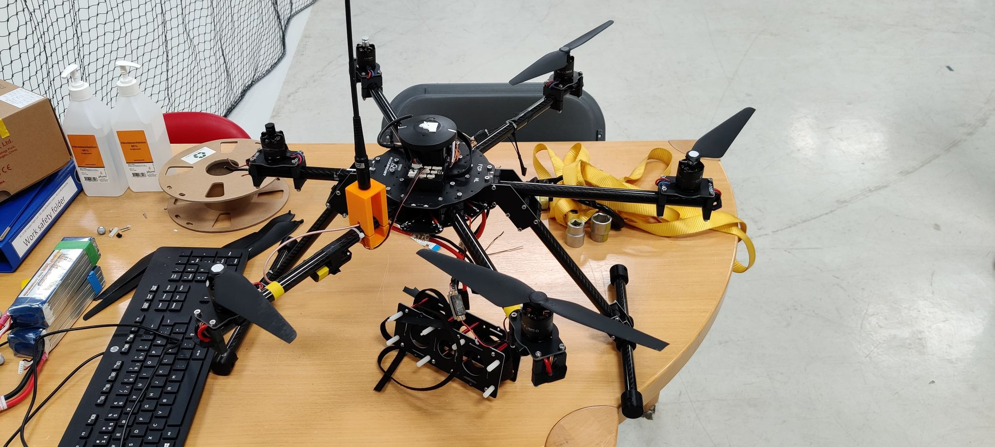

*Picture taken after the crash.*

**3. Response**

Since the crash happened inside, only SDU drone center was notified.

**4. Analysis and recommendations**

**Pilot's analysis and recommendation:**

The code should not have a flag, which changes the code from simulation to real world flight. This needs to be done in a more secure way like having it as an argument when running the off board node, so it needs to be manually set every time.