Incident report
Report #: 1
Date of incident: 18/05-2022 11:30
Incident type: Crash
Craft involved: Yellow EiT drone
Operations area: HCA Airport, OptiTrack
Pilot: Søren Madsen
Operator/observer: None
Project Master thesis

Incident description, short.
During a flight test using the off board mode on the flight controller the drone started to receive wrong estimations for its own altitude, which caused it to continue flying up, and hit the roof.

1 Incident location
SDU drone center OptiTrack

2. Pilot and observer reports
Pilots report:
The flight was a planned flight test as part of a Master thesis project.
The UAS was the yellow EiT drone.
The pilot has a multirotor A1/A3 certificate with several hours of flight time. Has also flown this model of drone multiples times.
The flight was the fourth test flight of the day, using nearly identical programs. The operation started with the drone flying in offboard mode, which set a waypoint at 3.5 meters altitude, which is similar to previous flights same day. When flying the drone didn’t stop at 3.5 meters but continued flying upwards. When the pilot discovered that it didn’t stop he tried to save it by changing to position mode. During the change the kill switch was accidental activated. The pilot quickly deactivated it again, but when the kill switch was deactivated and the drone in position mode. It started flying full speed upwards, even though the throttle stick was less than half way up. The drone hit the metal in the roof of the OptiTrack system, which broke some propellers on the drone and caused it to crash.
The log files of the flight was later examined and it was discovered that the drones own altitude estimation, which comes from the OptiTrack system, stopped changing after the drone reached 2.5 meters. This caused the drone to think it stayed at 2.5 meters even though it was moving and tried to continue flying upwards. Below is inserted a picture of the graf of the altitude estimation and the manual control input from the RC. The exact reason of why the drone estimated its own altitude to 2.5 meters is unknown but assumed to come from the position received from the OptiTrack system.

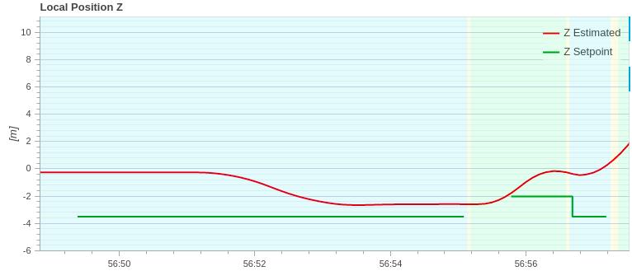Estimated altitude

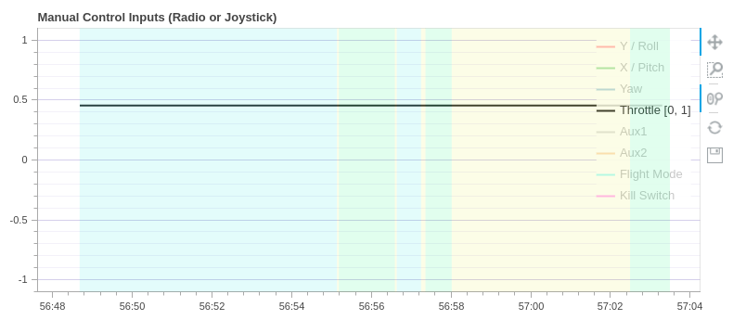Control input shown less than 50% throttle during the entire flight

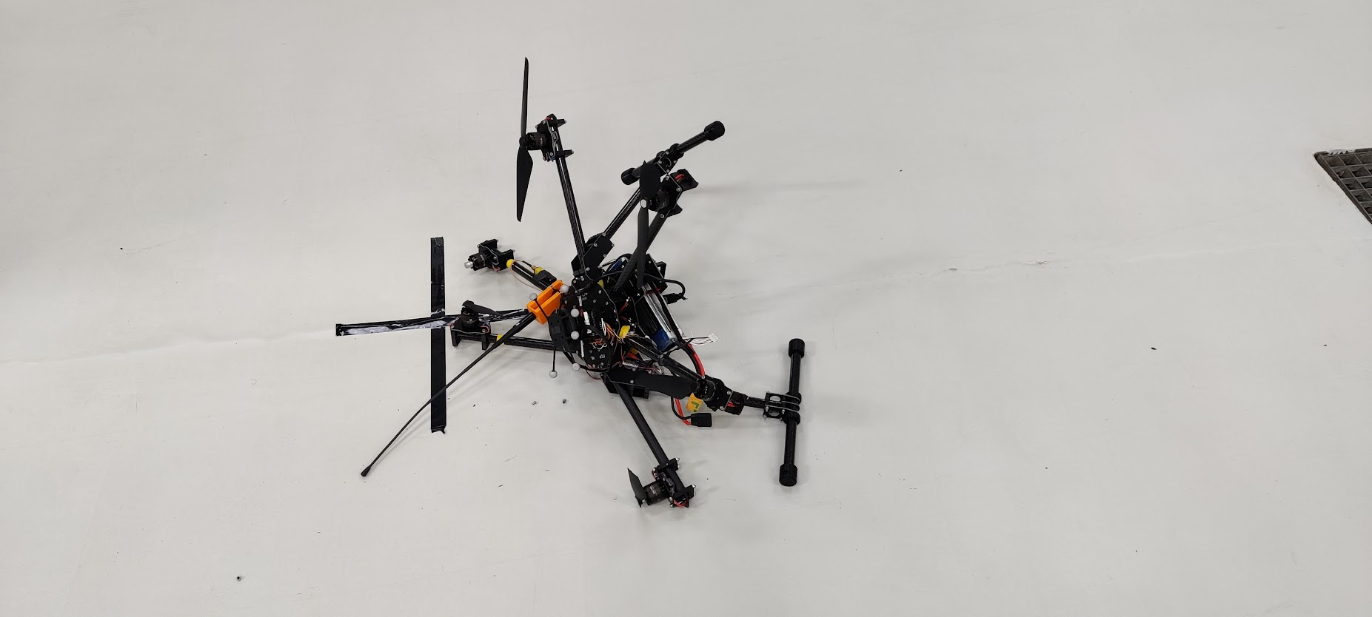Drone after the crash

Response
Since the crash happened inside, only SDU drone center was notified.
4. Analysis and recommendations
Pilot's analysis and recommendation:
Determine what causes the wrong altitude estimation. Switching to attitude instead of position mode might be better, if something goes wrong with the OptiTrack system, to avoid still using the incorrect information

