The state of ILOs - Report

Sofia Vazquez Alferez (DARS, University College Maastricht

08/07/2019

Table of Contents

# Abstract

This document presents a brief overview of the current state of the *Intended Learning Objectives* (hereafter *ILO*). Including information on:

* The number of ILOs in our courses.
* The orientation of language used in ILOs
* The most common capacities the ILOs promote broken down by Level and Concentration
* [NOT DONE YET] A description of how the current objectives map to Bloom’s Taxonomy of learning.
* [NOT DONE YET] Recommendations on how to write ILOs
* [NOT DONE YET] Suggested rephrasing of current ILO’s

# A brief overview of our data

For this analysis I used the *ILOs* for the year *2018/2019* provided by Edith. The *ILOs* of the projects (PRO) were missing from this file, and have therefore not been included in the subsequent analysis. I did have the *ILOs* for the Undergraduate Research Projects (UGR), so these are inlcuded.  
The data contained a total of **141** **courses**, which amounted to **625** **ILOs**. All quotes from *ILOs* are referenced with base to the ILOs_2018_2019.docx document.

## How many of ILOs do our courses have? (distribution per course)

In general, the courses had an average of 4.4 *ILOs* per course. Which were distributed as follows:

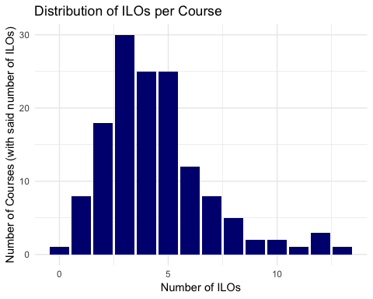

A breakdown by Level and Concentration gives:  
[to be added]

## With what orientation are they written? (Student vs. Course)

It was possible to distinguish two categories in the way *ILOs* were formulated. *ILOs* were either as student (S) oriented or course (C) oriented. **Student oriented** *ILOs* described what the student was supposed to achieve or have learned during the course, whilst **course oriented** *ILOs* described the aims of the course. For example:

1. Student Oriented *ILO*:

“To offer a broad overview of scientific models” (COR1005, p. 1)  
“To acquaint students with the problems…” (HUM2030, p.3)  
“To enhance their research skills” (SKI1009, p.11)

1. Course Oriented *ILO*:

“Apply basic bookkeeping techniques” (SSC2022, p.15)  
“To reflect on the relevance and utility of social theory in general”(SSC2028, p.15)

A few courses had some *ILOs* formulated in a student oriented fashion and others *ILOs* in a course oriented fashion. Thus, overview bellow is done at a granularity of *ILO* not courses.

In general, this is what we have in the curriculum in raw numbers:

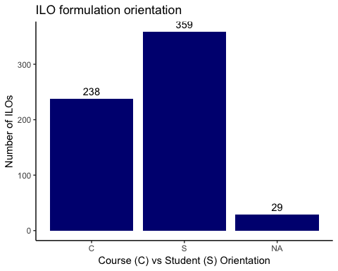

In percentages, we have the following:

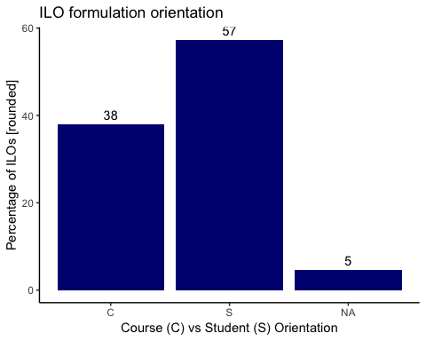 ###Inspecting NA orientation category The NA category represents courses that I did not classify in any of those categories. They were the following *ILOs*:

Table of ILOs wihout orientation category

|  |  |
| --- | --- |
| Course | ILO |
| SCI2009 | 1. Human Cells and functions |
| SCI2009 | 2. Functional organization of the body |
| SCI2009 | 3. Membrane Physiology |
| SCI2009 | 4. Cardiac function and blood pressure control |
| SCI2009 | 5. Red blood cell function and gas transport and exchange |
| SCI2009 | 6. Pulmonary ventilation and regulation |
| SCI2009 | 7. Kidney function, intra-and extracellular compartments |
| SCI2009 | 8. Neuronal control |
| SCI2009 | 9. Hormonal control |
| SCI2009 | 10. Gastrointestinal Physiology |
| SCI2010 | 1. Fairness and cooperation - in the chapters on Cooperative Games and Bankruptcy Problems |
| SCI2010 | 2. Rationality and Common Knowledge - in the chapters on Extensive Form Games, Normal Form Games, Matrix Games, Repeated Games and Repeated Games with Absorbing States |
| SCI2010 | 3. Threats and Manipulations - in the part on Repeated Games |
| SCI2010 | 4. Expectations - in the chapters on Normal Form Games, Matrix Games, Repeated Games and Repeated Games with Absorbing States |
| SCI2010 | 5. Nonmanipulability - in the chapter on Mecanism Design |
| SCI2031 | 1. Cells and humoral factors of the innate and adaptive immune system. |
| SCI2031 | 2. Cellular and molecular effector mechanisms of the innate and adaptive immunity during inflammation and infection. |
| SCI2031 | 3. The structure and function of primary and secondary lymphoid tissue. |
| SCI2031 | 4. The processes in the immune response after immunisation and vaccination. |
| SCI2031 | 5. Immune mechanisms in disease. |
| SSC1009 | All previous 5 objectives |
| SSC2052 | NA |
| SSC3030 | 1. The legal foundations of the European Union |
| SSC3030 | 2. The institutions of the EU, their historical evolution and the horizontal relationship between them |
| SSC3030 | 3. The vertical relationship between the EU and the Member States including the principles of conferral, supremacy, subsidiarity, proportionality and loyalty |
| SSC3030 | 4. The implementation and enforcement mechanisms of EU law infringement proceedings against Member States, enforcement through national courts, legal review of EU action. |
| SSC3057 | Standard economic paradigm of expected utility theory and rational choice |
| SSC3057 | What is the influence of neurology, psychology and sociology on the economic paradigm |
| SSC3057 | Development of macroeconomics and policies |

# Analysing our ILOs

## Methodology

### Phase 1- Verb extraction

In order to get a better grasp of the characterization of our *ILOs*, I manually went through all *ILOs* and extracted the verb(s) describing what the student was supposed to do in each *ILO*. This created a distiction between the course verb and the student verb, as well as between the action verb and the intended verb. For instance:

**1. Course verb/Student verb:**  
For the ILO “to provide students with […] perspectives to examine…” (COR1004, p.1) the extracted verb is “[to] examine” not “[to] provide”.

**2. Action verb/Intended verb:** For the ILO “to have the ability to interpret dynamical phenomena…”(SCI3006, p. 9) the verb “[to] interpret” was extracted not “[to] have (the ability)”.

In cases where the verb used was missleading, descriptive words were included. For instance, in the ILO “Gain basic knowledge in using economic/statistical data and present them in an informative way” (SSC2038, p. 15), the words “Gain basic knowledge” were recorded, as opposed to simply “[to] gain”. For this specific ILO, the verbs “use” and “present” were also extracted, as each ILO could have more than one verb associated to them.

During this phase I tried to keep as close as possible to the original formulation, although as I advanced through the *ILOs* I started to adapt some of the formulations to create some consistency with previously encountered data. Thus, particularily at the end formulations such as “to perform an analysis” were simply extracted as “analyse”. Moreover, because of this fidelity principle, some of the verbs for ilos were not verbs at all but conveyed the expected outcome. For instance, “overview” was extracted from the following ILO: “To give an overview over the different media platforms and media practices” (HUM2022, p.3), since the student was suppoded to ‘get an overview’.

This phase was performed in Excel and all extracted verbs were recorded in the same row as the original formulation, so it is possible to trace back the work and contest my check my interpretations.

In the following list, it is possible to see all the verbs that were extracted:

Extracted verbs after Phase 1

|  |
| --- |
| Verbs |
| to know |
| to have knowledge |
| to understand |
| to develop attitude |
| to develop understanding |
| basic understanding |
| get overview |
| work with models |
| model |
| acquaint |
| familiarize |
| introduce |
| examine |
| develop own analysis |
| [get] notion |
| understand |
| evaluate |
| [get] introduction |
| explore |
| test |
| integrate |
| analyse |
| express |
| [gain] familiarity |
| to write |
| [get] overview |
| highlight |
| pinpoint characteristics |
| explain |
| apply |
| set up |
| write |
| get acquainted |
| gain insight |
| basic introduction |
| explore the meaning |
| explore how |
| to study |
| critical reflection |
| learn |
| to trace |
| reflect |
| gain understanding |
| basic knowledge |
| select |
| communicate |
| demonstrate awareness |
| recognize |
| view films critically |
| [get] showned |
| NA |
| close reading |
| identify |
| develop sensitivity |
| distinguish |
| trace |
| to look at |
| construct design |
| address the what, who, why, how, when, where |
| study |
| present |
| grasp |
| critically analyse |
| contribute to debates |
| develop own understaning |
| describe |
| take position in debate |
| gain sufficient background |
| be presented with |
| appreciate (more) |
| acquire basic toolbox |
| reason qualitatively |
| be prepared |
| notice |
| elaborate |
| give examples |
| point out |
| design |
| use |
| improve problem solving skills |
| solve |
| develop computational skills |
| know |
| gain basic practical knowledge |
| obtain basic knowledge |
| review |
| cast |
| make use |
| interpret |
| presentation skills |
| meet |
| collect |
| demonstrate |
| translate |
| establish (link) |
| enrich discussion |
| propose (solutions) |
| work |
| formulate |
| produce |
| interview |
| execute |
| conduct |
| practice |
| enhance research skills |
| experience |
| brain storm |
| deliver |
| integrate (visual aids) |
| give feedback |
| carve out (underlying structure) |
| build argument |
| plan |
| make coherent |
| gain expertise |
| perform |
| report |
| find |
| prepare |
| position interest |
| work together |
| transcribe |
| be engaged (in scientific inquiry) |
| gain funcionalist vision |
| judge |
| comprehend |
| differentiate |
| coduct |
| make contact |
| discover |
| read |
| construct |
| engage in socio-legal thinking |
| be conversant |
| survey |
| develop |
| see |
| consider |
| retreive |
| list |
| provide (reasons) |
| form reasoned opinions |
| become aware |
| research |
| discuss |
| develop (an approach to) |
| retain |
| investigate |
| reflect (critically) |
| (conduct) research |
| cope |
| work in groups |
| keep infromed |
| frame |
| approach |
| view |
| assess |
| appreciate |
| value |
| gain perspective |
| deal with |
| discern |
| peer reviewing skills |
| to be able to see |
| use general models and modelling techiques |
| compare |
| connect |
| get an idea of |
| situate in context |
| debate |
| to explain |
| use specialized terms |
| reconstruct |
| (apply)adopt method |
| execute design |
| contextualize |
| think practically |
| talk |
| reason analyticaly |
| compose |
| debug |
| define |
| reason academically |
| inspire |
| pitch |
| organise |
| adapt |
| avoid |
| modify |
| gather |
| turn into |
| set up plan |
| observing |
| create |
| understand (critically) |
| manage |
| unlock (ongoing debates) |
| speak (“orally”) |
| illustrate |
| weigh |
| retain content |
| extract |
| give (opinion) |
| display (tolerance) |
| use frameworks |
| incorporate feedback |
| to put trends in context |
| synthesise and explain |
| to discuss |
| apply criticism |
| run programs |
| answer |
| outline |
| interact |
| speak |
| choose |
| taking fieldnotes & interviewing |
| reduce (stereotypes) |
| write/plead |
| define/analyse/answer |
| criticize |
| to further (research, analyical and writing skills) |
| reinforce (opinion) |
| use knowledge |

### Phase 2- Standardisation

As you can see, some verbs are really similar. For example, we have: “to understand”, “understand” and “basic understanding”. Therefore, in Phase 2 I standardised some of the vocabulary. All of the previous words were replaced by the same words: “understand”. Here is an overview of the replacements:

## [1] "The verbs that were taken to be the same as \"understand\" are: to understand, to develop understanding, basic understanding, understand, gain understanding, develop own understaning, understand (critically)"

## [1] "The verbs that were taken to be the same as \"know\" are: to know, to have knowledge, basic knowledge, know, obtain basic knowledge"

## [1] "The verbs that were taken to be the same as \"[gain] familiarity\" are: familiarize, [gain] familiarity"

## [1] "The verbs that were taken to be the same as \"analyse\" are: develop own analysis, analyse, critically analyse"

## [1] "The verbs that were taken to be the same as \"[be] introduced\" are: introduce, [get] introduction, basic introduction"

## [1] "The verbs that were taken to be the same as \"[get] overview\" are: get overview, [get] overview"

## [1] "The verbs that were taken to be the same as \"[get] acquainted\" are: acquaint, get acquainted"

The result is a table like this:

Table of ILOs with extravted standardized verb

|  |  |  |
| --- | --- | --- |
| Course | ILO | Verb |
| COR1002 | To have knowledge of a number of specific problems in the foundations of the social sciences, such as explanation vs understanding, structuralist vs individualist views on explaining human behavior, the limits of prediction in the social sciences, the role of social science in society | know |
| COR1002 | To have knowledge of the major problems or topics in the philosophy of science, such as the demarcation between science and non-science, the role of observation in science, the nature of scientific method notably induction and falsification, the issues of realism and instrumentalism, the problem of progress in knowledgethe difficulties regarding causality in history | know |
| COR1002 | To know the major approaches in the philosophy of science, such as the traditional or received view, Karl Poppers critical rationalism and its variants, Kuhns theory of scientific revolutions | know |
| COR1003 | To Develop a critical understanding concerning the relation between perspective bias, facts, and context, as well as the difficulties regarding causality in history. | understand |
| COR1003 | To develop a critical attitude towards the interpretation of historical data and processes | develop attitude |
| COR1003 | To understand the main trends in politics, demography, society and culture since 1945, and will be able to see and put these trends in a global context. | understand |
| COR1003 | To understand the main trends in politics, demography, society and culture since 1945, and will be able to see and put these trends in a global context. | be able to see |
| COR1003 | To understand the main trends in politics, demography, society and culture since 1945, and will be able to see and put these trends in a global context. | put trends in context |
| COR1004 | To provide the students with a basic understanding of what political philosophy is about and why it is important and useful in understanding contemporary democratic societies. | understand |
| COR1004 | To understand the central concepts like justice and equality in theory, and in application. | understand |
| COR1005 | To offer a broad overview of scientific models and modelling techniques in different disciplines | [get] overview |
| COR1005 | To teach students how to model a specific phenomenon by using general models and modelling techniques | model |
| COR1005 | To teach students how to model a specific phenomenon by using general models and modelling techniques | use general models and modelling techiques |

## Results

### Rough numeric overview:

After the previous methodology has been applied, we have 771 individual capacity learning objectives (hereafter capacities). These are the abilities we intend to promote in our students according to our learning objectives and correspond to individual “verbs” (e.g. “understand”, “analyse”). The breakdown by level is as follows:

**Level 1000:** 123 capacities

**Level 2000:** 387 capacities.

**Level 3000:** 123 capacities.

##### Graphically:

###### Across all courses:

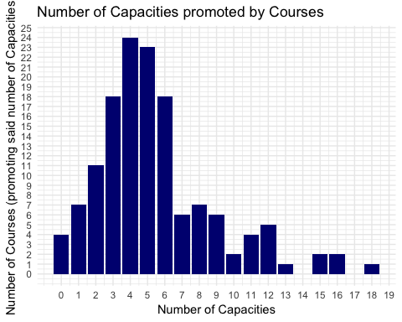

###### By Level:

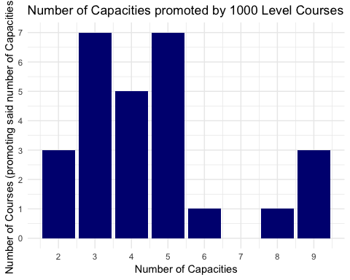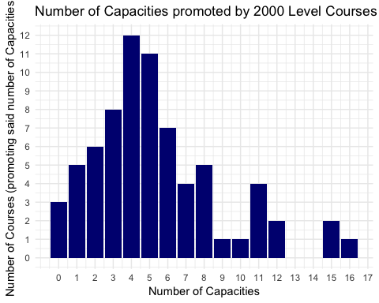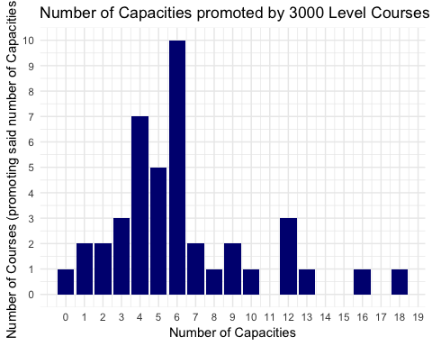

### Capacities inspection

So what are these capacities?

#### Across all courses

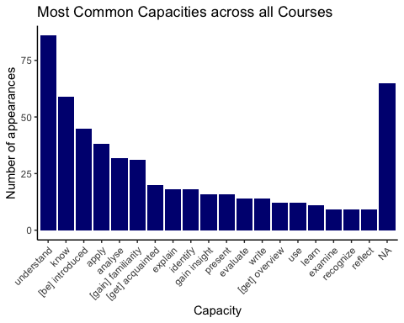

#### Breakdown by Level

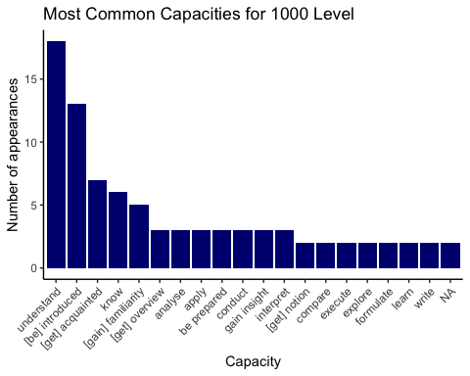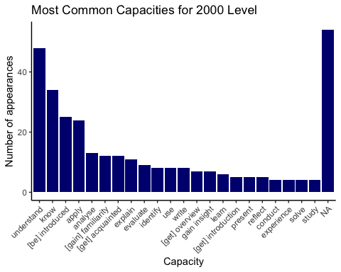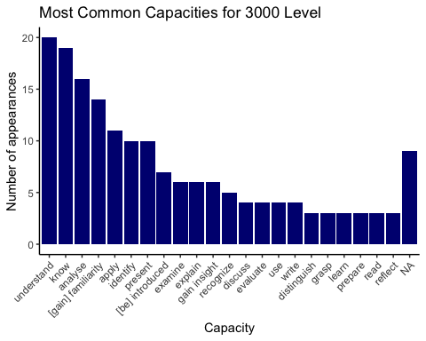

#### Breakdown by Concentration

