Identification of the Tripod finger parameters

Finger and experimental setup description :
Finger composed of two legs, as proposed during for the 2022 summerschool « Deformation in robotics ». One leg is fixed and the other is rotated using a servo-motor, the same way the Tripod robot is actuated. The finger is 3D printed with Filaflex elastomer filament, shore 75A. For identification, the finger is mounted on a manually actuated revolute joint. The rotation angle is determined using an analogical potentiometer and the torque using a load cell embedded in the rigid rotated arm. Rotation vs torque relation is measured at 2Hz by applying a slow enough rotation to the joint in both directions. An wall simulating an object can be placed at two different distances from the finger. Only one distance has been treated so far, which is 30mm. See the document of Baptiste Lievin on the identification test bench for further details.
The SOFA scene implements the finger, the fixation of the leg and the servo-motor, which angular displacement can be imposed. The torque is evaluated by applying a stiff spring on the servo motor rotation axis, and by comparing the final angular position to the desired one.
Geometric parameters of the finger
Parameter | Value (mm) | Parameter | Value (mm)
L | 100.0 | e1 | 8.0
l | 33.0 | e2 | 5.0
w | 20.0 | e3 | 4.0
d | [21.0, 21.0, …, 21.0]

Data:
Experimental data consist in several cycles of clockwise, counter-clockwise rotations of the finger, with and without objects. Due to the resolutions of the encoder, the accuracy of the ESP32 ADC and the hysteresis of the FSR sensor (other sources possible), we obtain not a single curve but a point cloud, see Figure 1. In the case without object, the point cloud seems to have a linear centerline, while in the case with object there are two distinct tangents, before and after contact.
In the case without object, we perform a linear regression is performed on the points on the interval ]0°,30°] to obtain the experimental torques that are used for the identification. We begin at an angle different from 0 in order to avoid the noise caused by the potar resolution around 0°. The offset of the resulting straight line is substracted from the torque values, as in the simulation performed in this case don’t include it. We considered 5 different values uniformly distributed on [6°,30°].
In the case with object, we find the point cloud centerline with an iterative algorithm which computes the barycentric center of a portion of the point clouds in a certain radius from the previous point, see [Sikorski 2019]. This gives a direction to find the next point at the desired rotation angle. We considered 8 values uniformly distributed on ]0°,30°].
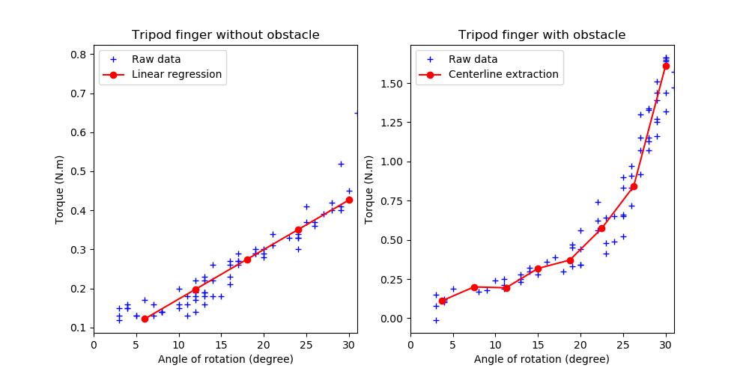Figure 1: Raw and post-processed experimental data, in the case without and with an object

Identification numerical method :
The potential mechanical parameters of the fingers to determine are: the Young’s modulus E, the Poisson ratio nu and the friction coefficient mu between the finger and the object. E is expressed in GPa for the optimization, such that its value is on the same order of magnitude as the Poisson ratio.
The cost function is the RMS error value between the simulated and measured torques.
The parameters are determined by optimization using the optimization Toolbox of Tanguy Navez, which implements bayesian and evolutionnary algorithms. They don’t ensure that the obtaines result is optimal, but allows for considering a simulation where non-smooth events, such as contacts, can appear.

Results:
Setup
Design parameters | Value | Simulation parameters | Value
E | To be optimized | Interval | 0,5 - 500MPa
Nu | 0.45 | Algorithm | Bayesian
Mu | No contact | Nb complete trials | 250
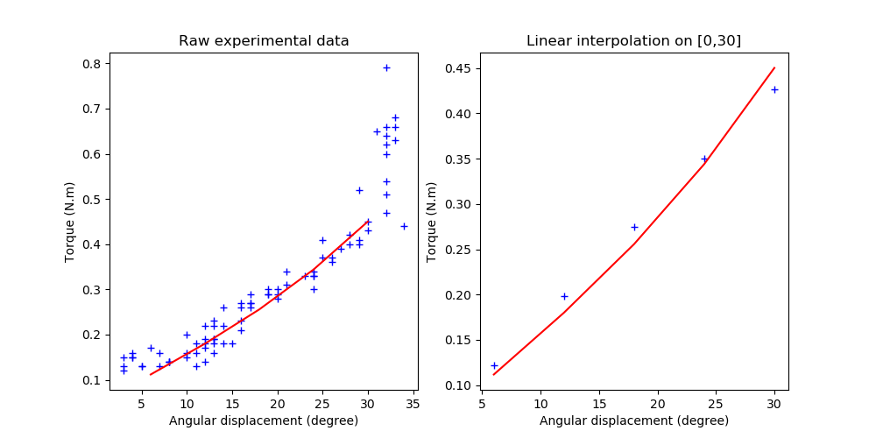Figure 2: Comparison between simulation (red) and experiments (blue) after identification
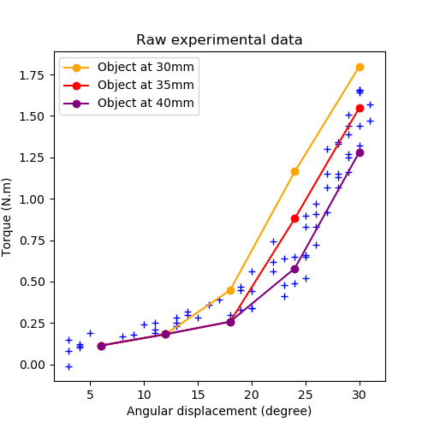Figure 3: Comparison in cases of contact, for different distances to object in simulation
Optimized Young’s modulus: 21,76 MPa
RMS error value: 0.01673 N.m
The simulated values fit quite well to the data acquired without an object. When taking the same value of E and moving to the case with an object, in experiments at 30mm from the finger, we observe some discrepancies. (1) the offset of force is a bit higher. (2) the contact seems to appear sooner in simulation than in experiments.
- Maybe the pre-stress screw on the FSR moved btw the experiments
- Need for measuring the actual distance ? Or effect of the wall deformation ?

Results:
Setup
Design parameters | Value | Simulation parameters | Value
E | To be optimized | Interval | 0,5 - 500MPa
Nu | 0.49 | Algorithm | Bayesian
Mu | No contacts | Nb complete trials | 250
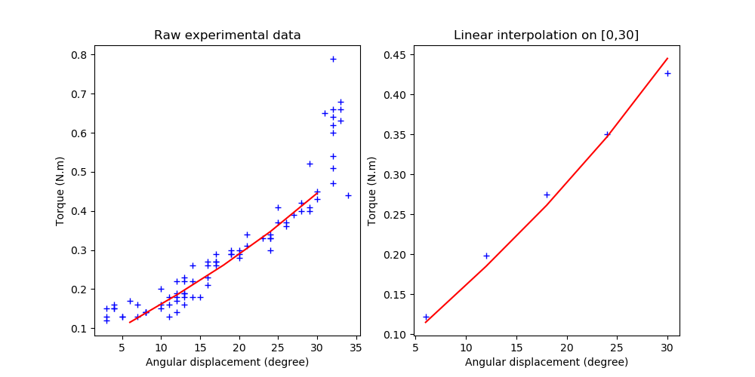Figure 4: Comparison between simulation (red) and experiments (blue) after identification
Optimized Young’s modulus: 10,60 MPa
RMS error value: 0.01238 N.m
The simulated values fit sligthly better with a Poisson ratio of 0.49. The Young’s modulus value is also closer to the theoretical value for an elastomer of shore hardness 63A. The relation between E and the hardness is given by an empirical law: E = exp((ShoreA)*0,0235-0,6403) = 2,32MPa. There is still a doubt on the filament used to fabricate the finger. The relation was taken from (https://sciencing.com/calculate-thermal-stress-2770.html). Another, maybe more reliable relation is given in the paper [Gent 1958], which is E = (0,0981*(56+7,66*ShoreA))/(0,137505*(254-2,54*ShoreA)), giving E=3,78 MPa for ShoreA = 63.

[1] Gent, A. N. (1958). On the relation between indentation hardness and Young's modulus. Rubber Chemistry and Technology, 31(4), 896-906.

Results:
Setup
Design parameters | Value | Simulation parameters | Value
E | To be optimized | Interval | 1 - 20MPa
Nu | 0.499 | Algorithm | Bayesian
Mu | No contacts | Nb complete trials | 250
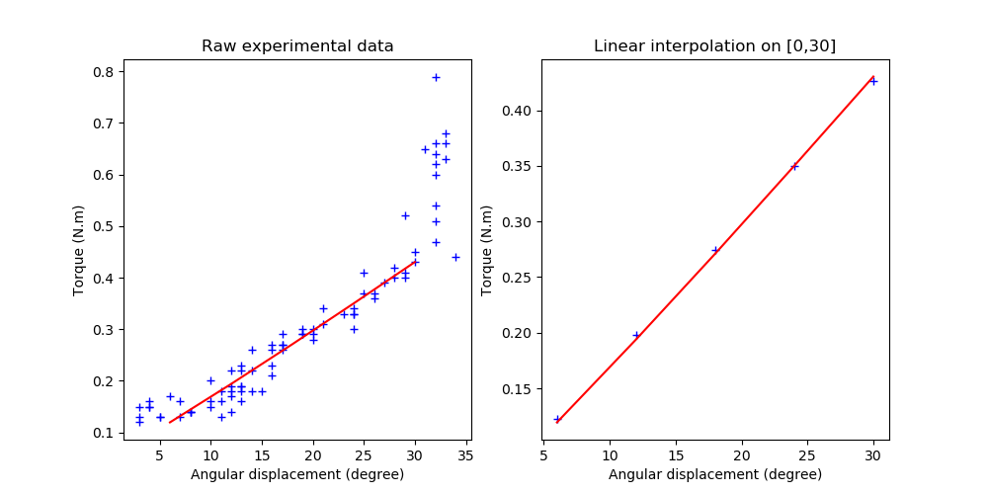Figure 5: Comparison between simulation (red) and experiments (blue) after identification
Optimized Young’s modulus: 3,307 MPa
RMS error value: 0.00328 N.m
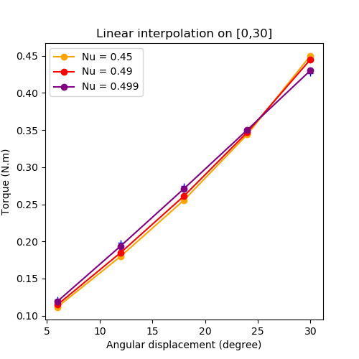Figure 6: Comparison of the simulated torques for different Poisson ratio without object
The simulated values fit far better with a Poisson ratio of 0.499. In particular, the relationship between angle and torque is more linear. As a note, do not forget we used linear regression to produce the data used in the objective function. The actual curve might not be that linear. Anyway, this results show that the Poisson ration can have a visible effect on the finger’s behavior. Also, the value of E we find is closer to the one we expected using the formula of Gent. As a note, we are unsure of the shore hardness that was used for the tested finger. Other fingers should be printed and we should keep tracks of their hardness. For the identification, another method would be to fix E at the value given by the formula and to optimize for the Poisson ratio.
If the effect of the Poisson ration is visible but not that significant on the finger behavior without any object, it becomes significative in case of contact, see the Figure 7 below. We consider the optimal value of E associated with the Poisson coefficient. The slope of the curve after contact changes quite a lot. The slope for Nu = 0.45 seems to be the closest to the actual slope. The problem of discrepancy between the simulated and actual distance from the object remains. An idea could be then to optimize, for the complete data set in the case of contact, the Young modulus, the Poisson ration and the distance to the object + maybe the offset of torque due to the pre-stress screw.
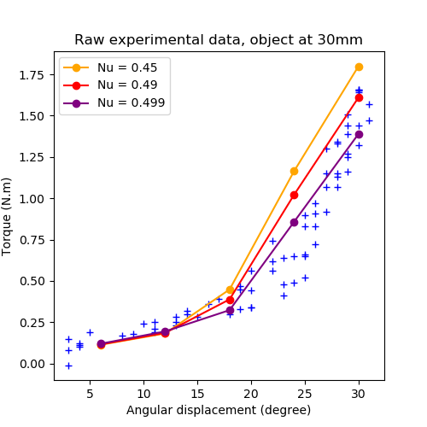Figure 7: Comparison of the simulated torques for different Poisson ratio with an object

Results:
Setup
Design parameters | Value | Simulation parameters | Value
E | To be optimized | Interval | 1 - 30MPa
Nu | To be optimized |  | 0.4-0.499
Mu | 0.05
Torque offset | To be optimized |  | 0.0 – 0.2
Distance to object | To be optimized |  | 20 – 50 mm
 |  | Algorithm | Bayesian
 |  | Nb complete trials | 500
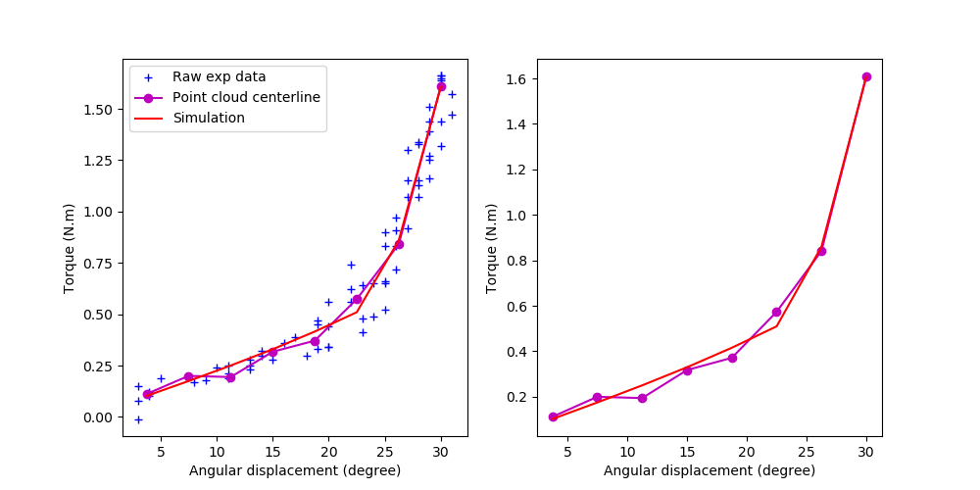Figure 8: Comparison between simulation (red) and experiments (blue) after identification
Optimized parameters: E = 29,97Mpa, Nu = 0,4713, torque offset = 0,0294, distance to object = 47,8mm (33mm in simulation should correspond to 30mm in reality)
RMS error value: 0.0360 N.m
There is a quite good correspondence between the simulation and the extracted centerline of the point cloud. The Young modulus and the distance to the object seem high compared to what we expect from the reality though. The object would be 15mm farer from the finger than expected. Even considering the deformation of the wall (which was significant for this initial version of the experimental setup) this seems high.
As a note:Taking the centerline of the pointcloud as a groundtruth implies that we consider the dispersion of the torque measurement to be symmetric with respect to the actual value, which might not be the case. Ideally, we should reduce the dispersion as much as possible.

