# Computer Vision - Final

Lior Soffer 203135058

Idan Daniel 308088624

# A: Chapter 4

## Q18 and Q20 : What is Xception pre-trained on?

pretrained version of the network trained on **more than a million images from the ImageNet database** . The pretrained network can classify images into 1000 object categories, such as keyboard, mouse, pencil, and many animals.

The researches conduct their comparison on two image classification tasks: one is the well-known 1000-class single-label classification task on the ImageNet dataset , and the other is a 17,000-class multi-label classification task on the large-scale JFT dataset.

## Q19: What are the basic building blocks of Xception?

Xception basic building block is **depthwise Separable Convolutions**.

1.     **Depthwise convolution** is the **channel-wise n×n spatial convolution**. Suppose in the figure above, we have 3 channels, then we will have 3 n×n spatial convolution.

2.    **Pointwise convolution** actually is the **1×1 convolution** to change the dimension.

Compared with conventional convolution, we do not need to perform convolution across all channels. That means **the number of connections are fewer and the model is lighter.**

The modified depthwise separable convolution is the **pointwise convolution followed by a depthwise convolution**. **In Xception**.

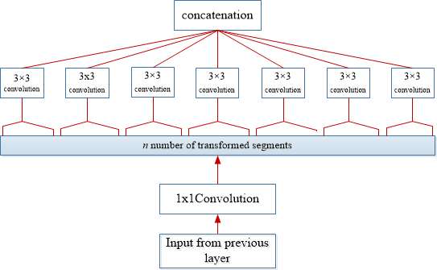

depthwise Separable Convolutions diagram

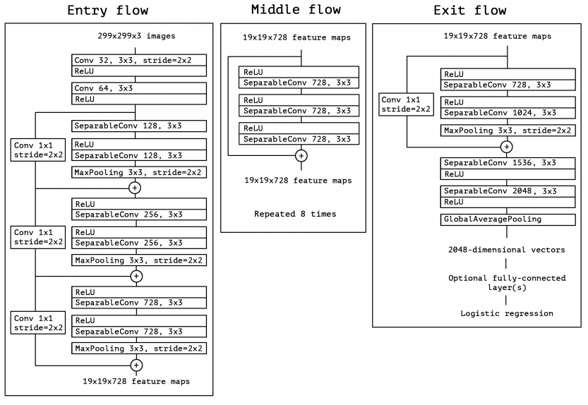

Xception model diagram

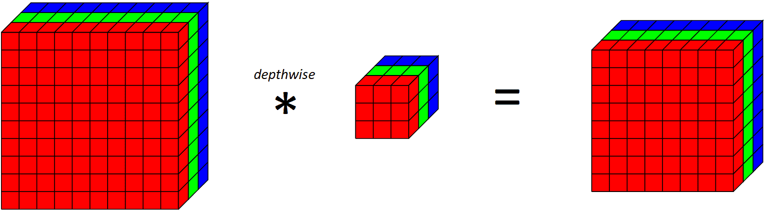

Applying a depthwise convolutional filter on 10x10x3 input volume outputs 8x8x3 volume

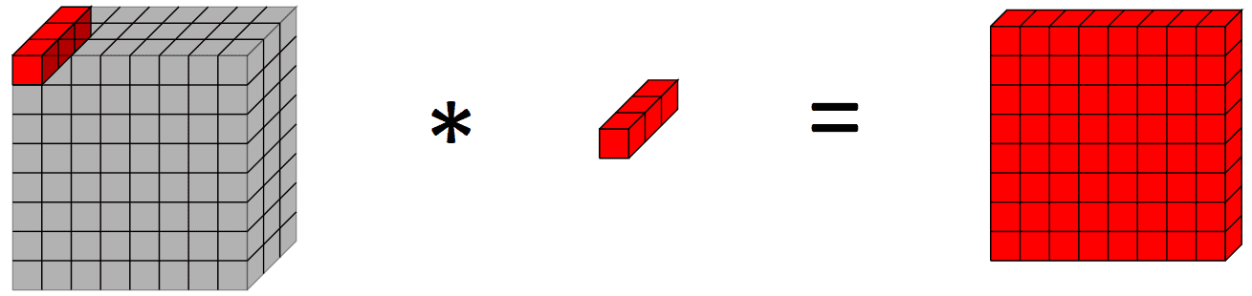

Applying a pointwise convolution on a 10x10x3 input volume outputs a 10x10x1 output volume

## Q21: What is the input feature dimension to the final classification block “fc”?

2048.

## Q22: What is the number of parameters the Xception network holds by de-fault? That is, without architectural change and default parameters.

In paper: Xception has 22.8 million parameters.

By method: 22,855,952 parameters.

## Q24: How many parameters did we add with the MLP on top of the original Xception’s parameters count?

We added 272,834 parameters.

## Q26: Run the plot accuracy and loss.py script

visualize the data held in the json. figures created:

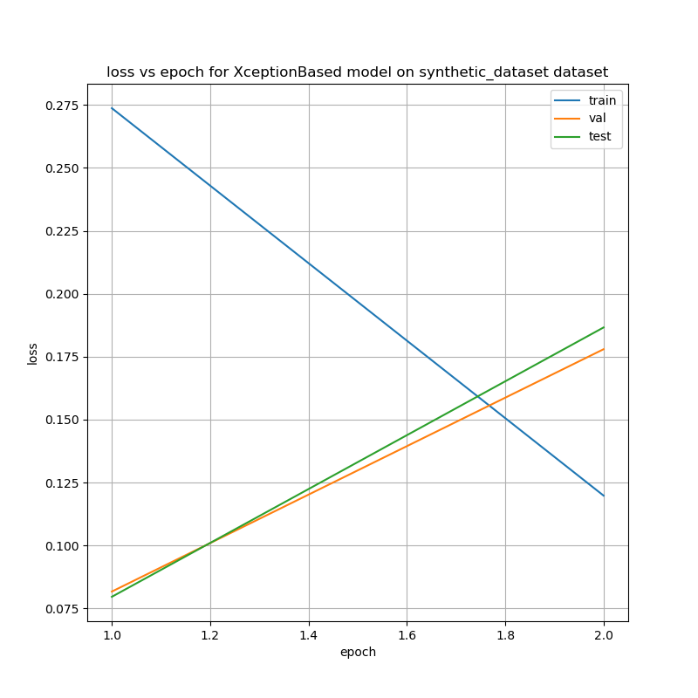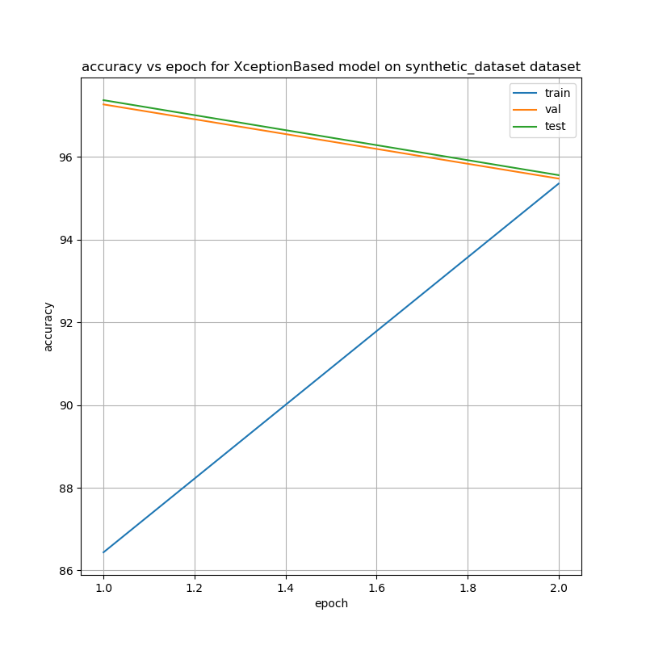

## Q27: What is the test accuracy corresponding to the highest validation accuaracy you received?

97.2

## Q28: Run the numerical analysis.py script for the Xception-Based network trained on the Synthetic Faces dataset.

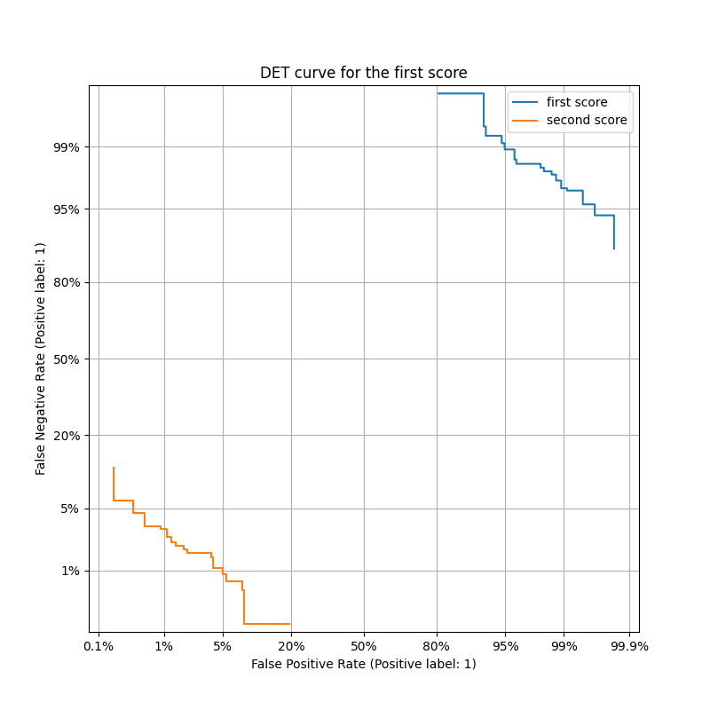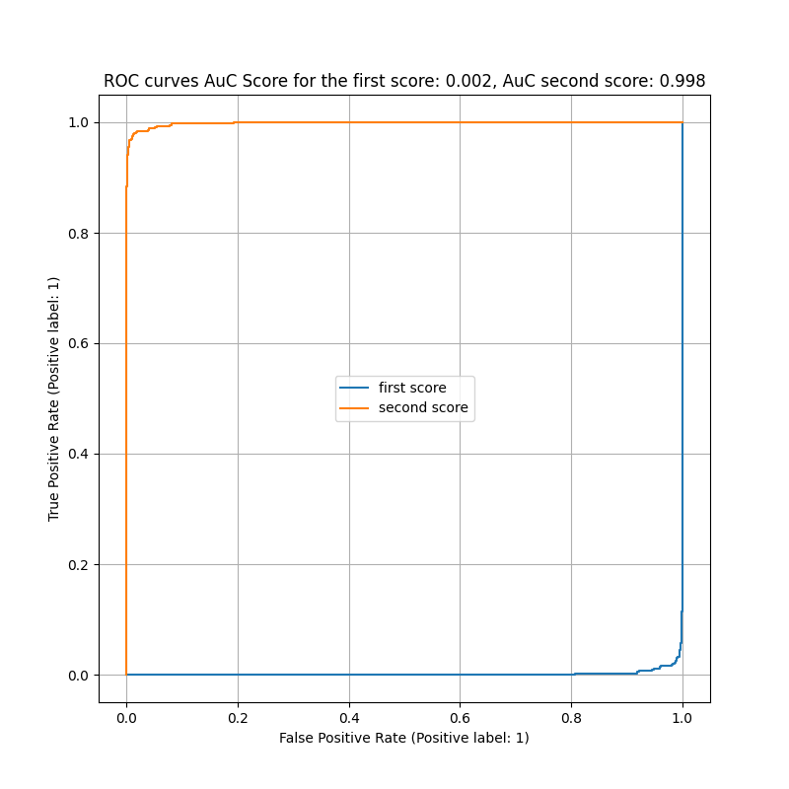

## Q29: explain shortly, in your own words, what Image-Specific Class Saliency Visualisation are.

Image-Specific Class Saliency Visualization is a way to figure out which parts of an image are most important in determining what the image is. It does this by making a map that shows which parts of the image had the biggest impact on the image's classification. The biggest impact means highest gradients. This map is specific to each individual image and the class it's been classified as. This technique can also be used to find where an object is located in an image based on what class the object is. In simpler terms, it helps you to figure out what parts of an image are most important in figuring out what it is.

## Q30: explain shortly, in your own words what Grad-CAMs are.

Grad-CAM is a way to see which parts of an image a deep learning model is focusing on when it makes a prediction. It does this by making a heatmap that shows which parts of the image had the biggest impact on the prediction. This is done by using the gradients of the last convolutional layer with respect to the final class output and then backpropagating it to the input image. This way we can understand which regions of the image the model was focusing on to make its final prediction. It's a useful tool to understand and interpret the predictions made by a deep learning model, especially in image classification tasks.