# Computer Vision - EX 1

Lior Soffer #########

Idan Daniel 308088624

A: Homography computation

*A.1*

projective transformation is a linear transformation on homogeneous 3-vector represented by a **non-singular** 3x3 matrix.

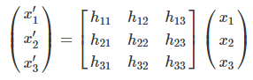

Or in short,



Both x and x′ are homogeneous coordinate so x can have a scaling factor derived from matrix H. As a result, we can divide H by $h_{33}$ and have this scalar position equal to 1 than.

Thus, we say that H is a **homogeneous matrix**. There’re **8** independent ratios among the **9** elements of H, and it follows that a projective transformation has **8 degrees of freedom (dof)**.

Get the conversion matrix is as follow:

Selecting a section of image corresponding to a planar section of the world. Let the inhomogeneous coordinate of a pair of matching points in the world and image place be (x,y) and (x′,y′) respectively.

The projective transformation can be written in inhomogeneous form as:

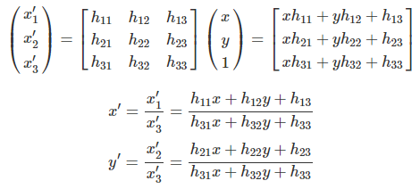

Each point correspondence (x,y) <-> (x′,y′) generates two equations for the elements of H as follow:

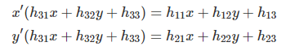

Notice that these are linear equations for elemnts in H. **4** point of correspondence lead to **8** of such linear equations in the entries of H, which are sufficient to solve H (since H has 8 dof) up to an insignificant multiplicative factor.

The only restriction is that the 4 points must be in “general position”, which means that not 3 points are collinear.

*2 (In code)*

*3*

Naive Homography 0.0000 sec

[[ 1.43457214e+00 2.10443232e-01 -1.27718679e+03]

[ 1.34265153e-02 1.34706123e+00 -1.60455872e+01]

[ 3.79279298e-04 5.56523146e-05 1.00000000e+00]]

*A.2*

*4 (In code)*

*5 (In code)*

*6*

There are several problems with forward mapping:

1. It is possible that 𝐻x is a float number. We solved it by rounding the results using the int() function.
2. There are pixels that got 2 values or more and each pixel can have only one value at the end – conflict.
3. We can see that the result has many "black areas" where the are pixels with no value after the transformation.

*7*

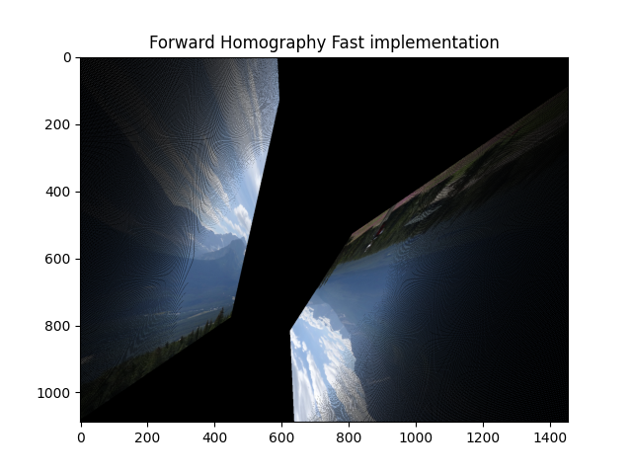

Yes, the results are different. By using all the points not the good ones we got in one image what looks like the source image separated to 2 images with different orientation.

*8 (In code)*

*9 (In code)*

*10*

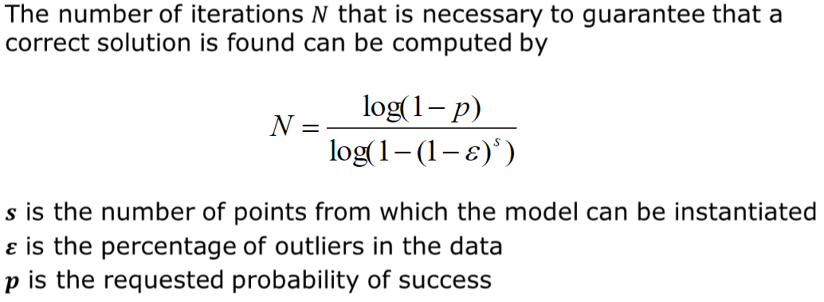

Ref : [Visual_Odometry_Tutorial](https://rpg.ifi.uzh.ch/docs/Visual_Odometry_Tutorial.pdf)

Suppose there are 30 match points and it is known that 80% of them are correct.

s = 4 (points needed for general homography)

ε = 20% = 0.2

for p = 0.9 we will need 5 iterations

for p = 0.99 we will need 5 iterations

*11 (In code)*

*12*

Naive Homography Test 9.1989 sec

[0.16, 21.329346060984314]

RANSAC Homography 2.0566 sec

[[ 1.43457214e+00 2.10443232e-01 -1.27718679e+03]

[ 1.34265156e-02 1.34706123e+00 -1.60455874e+01]

[ 3.79279298e-04 5.56523147e-05 1.00000000e+00]]

RANSAC Homography Test 2.0777 sec

[0.8, 1.9520284459063002]

Although we are using the bad matching points file, we can see that our forward mapping is much better than before and the result is similar to the perfect matching points forward mapping. RANSAC Algorithm were cleaning the inliers from the data.

