Table Of Contents
S.No. | Contents | Page No.
1 | Abstract | 2
2 | Introduction | 3
3 | Literature Review | 5
4 | Problem Statement | 7
5 | Research Objectives | 8
6 | Proposed Methodology | 9
7 | Implementation | 12
8 | Project Setup Procedure | 16
9 | Result & Discussion | 19
10 | Conclusion | 22
11 | Future Scope | 23
12 | References | 24
13 | Appendix A- Source Code(agents.py)
14 | Appendix B- Source Code(main.py)
15

ABSTRACT
The emergence of Artificial Intelligence (AI) has transformed the way complex problems are addressed by enabling intelligent systems to automate decision-making and problem-solving. Traditional AI systems typically rely on a single intelligent agent, which may encounter limitations when handling diverse and complex tasks. This paper presents a Collaborative Multi-Agent System (CMAS) developed using Python, the Ollama framework, and the Llama 3.2 large language model. The proposed system consists of a Manager Agent and multiple specialist agents, including a Researcher, Designer, Frontend Developer, Backend Developer, Tester, and Writer. The Manager Agent analyzes the user's request, decomposes it into subtasks, assigns each task to the appropriate specialist agent, and integrates the individual responses into a coherent final output. The system demonstrates collaborative problem-solving by generating software designs, website structures, code snippets, documentation, and technical recommendations. Unlike cloud-based AI systems, the proposed architecture operates locally using Ollama, providing enhanced privacy, offline functionality, and eliminating API usage costs. The developed system demonstrates the effectiveness of collaborative AI agents in improving task organization, modularity, and the quality of generated solutions. The proposed architecture can be extended to software engineering, educational assistance, intelligent automation, and decision-support applications.

INTRODUCTION
Artificial Intelligence (AI) has become one of the most influential technologies in modern computing, enabling machines to perform tasks that traditionally require human intelligence. AI techniques are widely used in healthcare, education, finance, cybersecurity, manufacturing, and software engineering to improve efficiency, automate repetitive tasks, and support intelligent decision-making. Recent advancements in Large Language Models (LLMs) have further enhanced AI capabilities by enabling systems to understand natural language, generate human-like responses, write code, and assist in solving complex problems.
Traditional AI applications generally rely on a single intelligent agent to perform all tasks. While effective for simple problems, single-agent systems often struggle with complex tasks that require multiple areas of expertise. These limitations include reduced scalability, lower modularity, increased computational complexity, and difficulty in managing diverse subtasks simultaneously. As modern applications continue to grow in complexity, there is an increasing need for AI systems capable of collaborative problem-solving.
Collaborative Multi-Agent Systems (CMAS) address these challenges by employing multiple specialized agents that work together to achieve a common objective. Each agent is assigned a specific responsibility based on its expertise, while a central Manager Agent coordinates task planning, delegation, execution, and result integration. This collaborative architecture improves task organization, promotes modular system design, and enhances the quality of generated outputs.

INTRODUCTION
In this research, a Collaborative Multi-Agent System is developed using Python and the Ollama framework with the Llama 3.2 large language model. The proposed system consists of multiple specialist agents, namely Researcher, Designer, Frontend Developer, Backend Developer, Tester, and Writer. The Manager Agent analyzes the user's request, divides it into subtasks, assigns each task to the most appropriate specialist, and combines the individual responses into a unified solution. The system operates entirely on a local machine through Ollama, eliminating dependency on cloud-based APIs while improving privacy and reducing operational costs.
The proposed system demonstrates the practical application of collaborative AI in software development and intelligent task execution. It can assist users in generating software designs, website structures, programming code, documentation, and technical recommendations. The modular architecture also allows new specialist agents to be integrated easily, making the system flexible, scalable, and suitable for future AI-driven applications.
The remainder of this paper is organized as follows. Section II presents the Literature Review. Section III defines the Problem Statement. Section IV describes the Proposed Methodology. Section V explains the System Architecture and Implementation. Section VI presents the Experimental Results and Discussion. Section VII concludes the paper and outlines future research directions.

Literature Review
The field of Artificial Intelligence has experienced rapid growth with the development of intelligent agents and Large Language Models (LLMs). Multi-Agent Systems (MAS) have emerged as an effective approach for solving complex problems by enabling multiple autonomous agents to collaborate toward a common objective. Unlike traditional single-agent systems, MAS improves scalability, flexibility, and task distribution by assigning specialized responsibilities to individual agents.
Recent advancements in Large Language Models have significantly enhanced the capabilities of AI agents. Models such as GPT, Llama, and other transformer-based architectures have demonstrated strong performance in natural language understanding, code generation, reasoning, and conversational assistance. These models allow AI agents to perform specialized tasks with greater accuracy and contextual awareness.
Collaborative AI systems have gained attention in software engineering, education, healthcare, and business automation. Existing research has shown that assigning different roles to multiple agents can improve the quality of generated solutions and reduce the complexity of task execution. However, many existing systems depend on cloud-based APIs, which may increase operational costs, introduce latency, and raise privacy concerns.
The Ollama framework enables the execution of Large Language Models locally, allowing AI applications to function without continuous internet connectivity or paid API services. Local deployment improves data privacy, reduces operational expenses, and provides greater control over AI model execution. This makes Ollama an attractive platform for developing collaborative AI applications.

Literature Review

The proposed Collaborative Multi-Agent System builds upon these concepts by integrating a Manager Agent with multiple specialist agents, including Researcher, Designer, Frontend Developer, Backend Developer, Tester, and Writer. Unlike conventional single-agent approaches, the proposed architecture distributes complex tasks among specialized agents and synthesizes their outputs into a unified response. This modular design improves maintainability, supports future expansion, and demonstrates the practical application of collaborative AI for intelligent task execution and software development.

Problem Statement
Artificial Intelligence systems have become increasingly capable of performing a wide range of tasks, including content generation, software development, data analysis, and decision support. However, most existing AI applications rely on a single intelligent agent to process all user requests. As the complexity of tasks increases, a single-agent approach may face challenges in handling multiple responsibilities efficiently, resulting in reduced modularity and limited specialization.
Many AI-based solutions also depend on cloud-hosted models that require continuous internet connectivity and paid API services. This can increase operational costs and may not be suitable for applications where privacy or offline functionality is important.
To address these challenges, there is a need for a collaborative AI architecture in which multiple specialized agents work together under the coordination of a central manager. Such an architecture can divide complex tasks into smaller subtasks, assign them to appropriate specialist agents, and combine their outputs into a comprehensive solution. This collaborative approach improves task organization, enhances maintainability, and allows the system to be extended with additional specialist agents as needed.
The proposed Collaborative Multi-Agent System is designed to overcome these limitations by integrating a Manager Agent with multiple specialist agents operating on a locally deployed Large Language Model using Ollama. The system aims to provide an efficient, privacy-preserving, and cost-effective solution for intelligent task execution, software development assistance, and technical content generation.

Research Objectives
The objectives of the proposed research are:
- To design and develop a Collaborative Multi-Agent System using Python and Ollama.
- To implement a Manager Agent capable of task planning and delegation.
- To develop specialist AI agents for research, design, frontend development, backend development, testing, and documentation.
- To improve the quality of responses through collaborative task execution.
- To provide an offline AI solution that eliminates dependency on paid cloud APIs.
- To demonstrate the effectiveness of collaborative AI for software development and intelligent problem-solving.

Proposed Methodology

A. System Overview
The proposed Collaborative Multi-Agent System (CMAS) is designed to solve complex user tasks through collaboration among multiple specialized AI agents. The system is implemented using Python and the Ollama framework with the Llama 3.2 Large Language Model. Unlike conventional single-agent AI systems, the proposed architecture employs a Manager Agent to coordinate the activities of multiple specialist agents. Each specialist agent is responsible for a specific task, and the Manager Agent integrates their outputs into a unified response.

B. System Architecture
The architecture of the proposed system consists of one Manager Agent and six specialist agents. The Manager Agent receives the user's request, analyzes the task, divides it into subtasks, assigns each subtask to the most suitable specialist agent, collects the outputs, and generates the final response.

Proposed Methodology

The specialist agents are:
- Researcher Agent: Collects and summarizes relevant information.
- Designer Agent: Designs the user interface and system layout.
- Frontend Agent: Generates HTML, CSS, and JavaScript code.
- Backend Agent: Develops Python and Flask backend logic.
- Tester Agent: Identifies bugs, validates outputs, and suggests improvements.
- Writer Agent: Produces documentation and explains the generated solution.

C.Workflow
The workflow of the proposed system consists of the following steps:
- The user enters a task or project requirement.
- The Manager Agent analyzes the input.
- The task is divided into multiple subtasks.
- Each subtask is assigned to the appropriate specialist agent.
- Specialist agents independently generate their outputs.
- The Manager Agent collects and combines all responses.
- The final integrated solution is presented to the user

Proposed Methodology
D. Algorithm
Algorithm: Collaborative Multi-Agent Task Execution
- Start
- Receive user input
- Manager Agent analyzes the task
- Divide the task into subtasks
- Assign subtasks to specialist agents
- Execute specialist agents
- Collect outputs from all agents
- Synthesize outputs into a final response
- Display the final result
- Stop

E. Advantages of the Proposed Methodology
The proposed methodology offers several advantages over conventional single-agent systems:
- Efficient task distribution among specialized AI agents.
- Improved modularity and maintainability.
- Offline execution using Ollama without API costs.
- Enhanced privacy by processing data locally.
- Flexible architecture that allows new agents to be added with minimal modifications.
- Suitable for software development, website generation, documentation, and educational assistance.

Implementation
A. Development Environment
The proposed Collaborative Multi-Agent System was developed using Python as the primary programming language. The Ollama framework was used to execute the Llama 3.2 Large Language Model locally, enabling offline AI processing without relying on cloud-based APIs. The system was implemented and tested using Visual Studio Code on a Windows operating system.
Software Requirements
Operating System: Windows 10/11
Programming Language: Python 3.13
IDE: Visual Studio Code
AI Framework: Ollama
Large Language Model: Llama 3.2
Python Libraries: ollama
Hardware Requirements
Processor: Intel Core i5 or higher
RAM: 8 GB or above
Storage: Minimum 10 GB free space
Internet: Required only for the initial download of the Llama 3.2 model

Implementation
B. System Implementation
The system is divided into two major modules: agents.py and main.py.
1. agents.py
The agents.py file contains the implementation of the Manager Agent and all specialist agents. It includes the communication mechanism between Python and the Ollama framework. The Manager Agent receives the user request, generates a task plan, assigns subtasks to specialist agents, and synthesizes their outputs into a final response.
Each specialist agent performs a specific role based on predefined prompts. This modular design allows new specialist agents to be added without changing the overall architecture.
2. main.py
The main.py file serves as the entry point of the application. It creates instances of the specialist agents, registers them with the Manager Agent, accepts the user's goal as input, executes the collaborative workflow, and displays the final output.
The specialist agents implemented in this project are:
- Researcher Agent
- Designer Agent
- Frontend Agent
- Backend Agent
- Tester Agent
- Writer Agent
The Manager Agent coordinates all these agents to generate a comprehensive solution.
Implementation
C. Workflow Implementation
The implementation follows these steps:
- The user enters a goal through the console.
- The Manager Agent analyzes the request.
- The request is divided into multiple subtasks.
- Subtasks are assigned to specialist agents.
- Each specialist processes its assigned task using the Llama 3.2 model through Ollama.
- The Manager Agent collects the responses.
- The responses are synthesized into a final output and displayed to the user.
D. Example Execution
Input:
- Create a Flask-based Student Management System.
Processing:
- Researcher Agent collects requirements.
- Designer Agent proposes the interface.
- Frontend Agent generates HTML, CSS, and JavaScript.
- Backend Agent develops Flask code.
- Tester Agent identifies improvements.
- Writer Agent prepares documentation.
- Manager Agent combines all outputs.

Implementation
D. Example Execution
Output:
- A complete response containing:
- Project overview
- Website structure
- Backend implementation
- Database design
- Testing recommendations
- Documentation
E. Advantages of the Implementation
- Local AI execution without API costs.
- Modular architecture with independent specialist agents.
- Easy to maintain and extend.
- Improved organization through task delegation.
- Supports intelligent software development assistance.
- Privacy-preserving because data remains on the local machine.

Project Setup Procedure
The following steps were followed to develop and execute the proposed Collaborative Multi-Agent System.
Step 1: Install Python
Download and install Python (version 3.10 or later) from the official Python website. Ensure that the "Add Python to PATH" option is selected during installation.
Step 2: Install Visual Studio Code
Download and install Visual Studio Code (VS Code) as the development environment for writing and executing Python programs.
Step 3: Create the Project Folder
Create a project folder with the following structure:
- Collaborative_Multi_Agent_System
        - agents.py
        - main.py
Step 4: Install Ollama
Download and install Ollama from the official website.
After installation, verify it by executing:

Step 5: Download the Llama 3.2 Model
Open the terminal and execute:
ollama pull llama3.2
This command downloads the Llama 3.2 model for local execution.

Project Setup Procedure
Step 6: Install the Ollama Python Package
Open the terminal and install the required Python package:
py -m pip install ollama
Step 7: Create the Source Files
Create the following Python files:
agents.py
main.py
Copy the implementation code into the respective files.

Step 8:Execute the Project
Run the application using the following command:
py main.py
Step 9: Provide User Input
After execution, the application prompts the user:
Enter your goal:
Example:
Create a Flask-based Student Management System.

Project Setup Procedure

Step 10: Collaborative Task Execution
The Manager Agent performs the following operations:
- Receives the user's request.
- Divides the task into subtasks.
- Assigns each subtask to a specialist agent.
- Collects the responses.
- Generates the final integrated output.
Step 12: Display the Final Output
The system displays the collaborative response generated by all specialist agents in the terminal.

Results and Discussion
A. Experimental Results
The proposed Collaborative Multi-Agent System (CMAS) was successfully implemented using Python, Ollama, and the Llama 3.2 large language model. The application was executed in Visual Studio Code on a Windows operating system. The Manager Agent successfully coordinated multiple specialist agents, including the Researcher, Designer, Frontend Developer, Backend Developer, Tester, and Writer, to solve user-defined tasks collaboratively.
The system accepted user requests through the console, divided the tasks into multiple subtasks, delegated them to the appropriate specialist agents, and generated a comprehensive final response. The generated outputs included software design suggestions, website structures, source code, technical documentation, and implementation recommendations.
B. Sample Test Cases
Test Case-01:
User Input:Explain how Artificial Intelligence is used in healthcare
Result: Successfully generated a structured explanation
Test Case-02:
User Input: Create a Flask-based Student Management System
Result: Successfully generated frontend, backend, database, and documentation
Test Case-03:
User Input: Create a responsive portfolio website
Result: Successfully generated website design recommendations and code structure
Results and Discussion
C. Discussion
The experimental results demonstrate that the proposed Collaborative Multi-Agent System effectively distributes complex tasks among specialized agents. The Manager Agent successfully coordinated task planning and response synthesis, while each specialist agent contributed domain-specific knowledge. Compared with a traditional single-agent approach, the collaborative architecture provided better organization of tasks and more structured outputs.
Running the system locally through Ollama eliminated the need for paid cloud APIs and allowed the application to function offline. This approach improved data privacy and reduced operational costs. The modular architecture also enables future enhancements by adding new specialist agents without significantly modifying the existing implementation.
D. Screenshots
Screenshot of the project folder (agents.py and main.py) 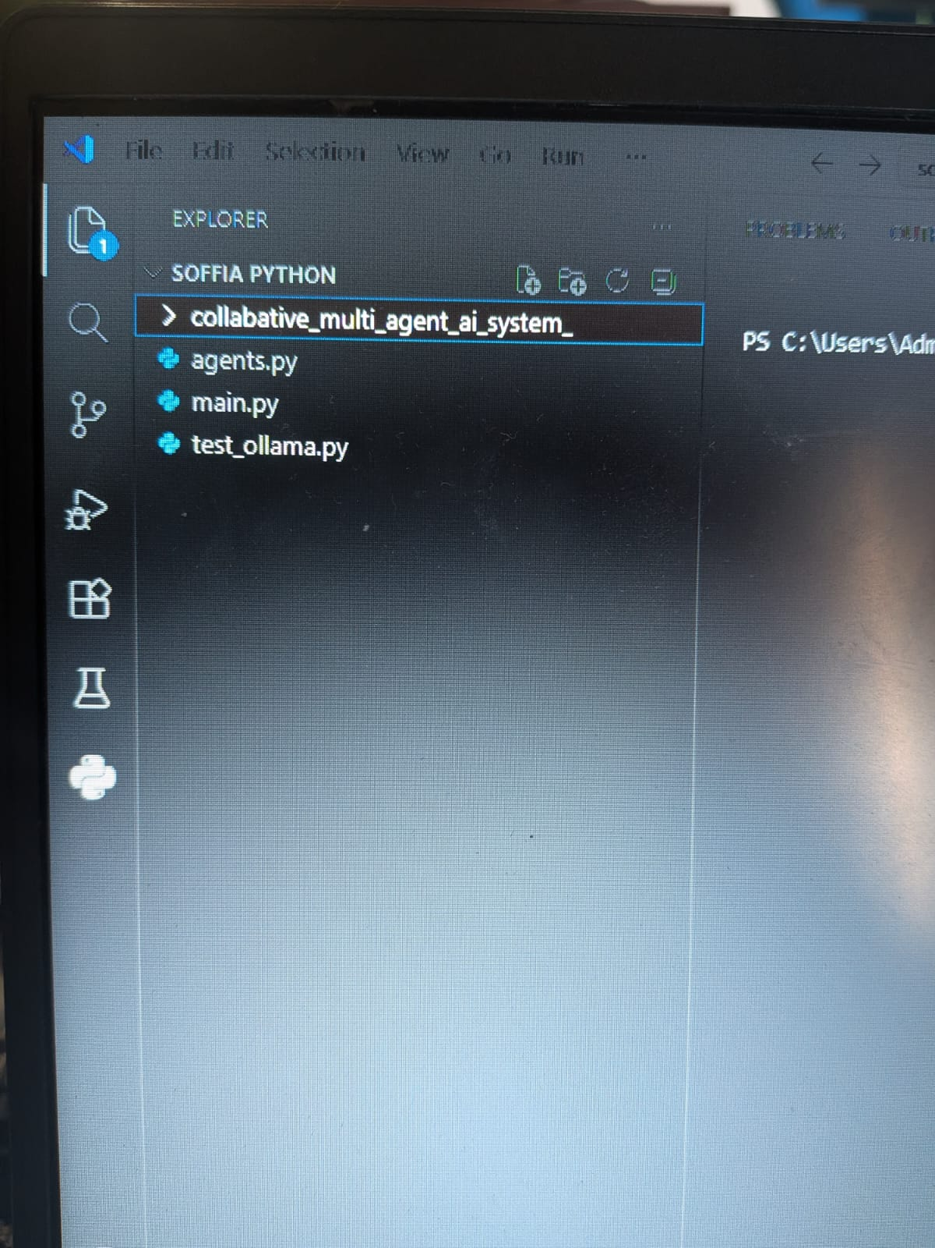
Results and Discussion

Screenshot of the ollama pull llama3.2 command
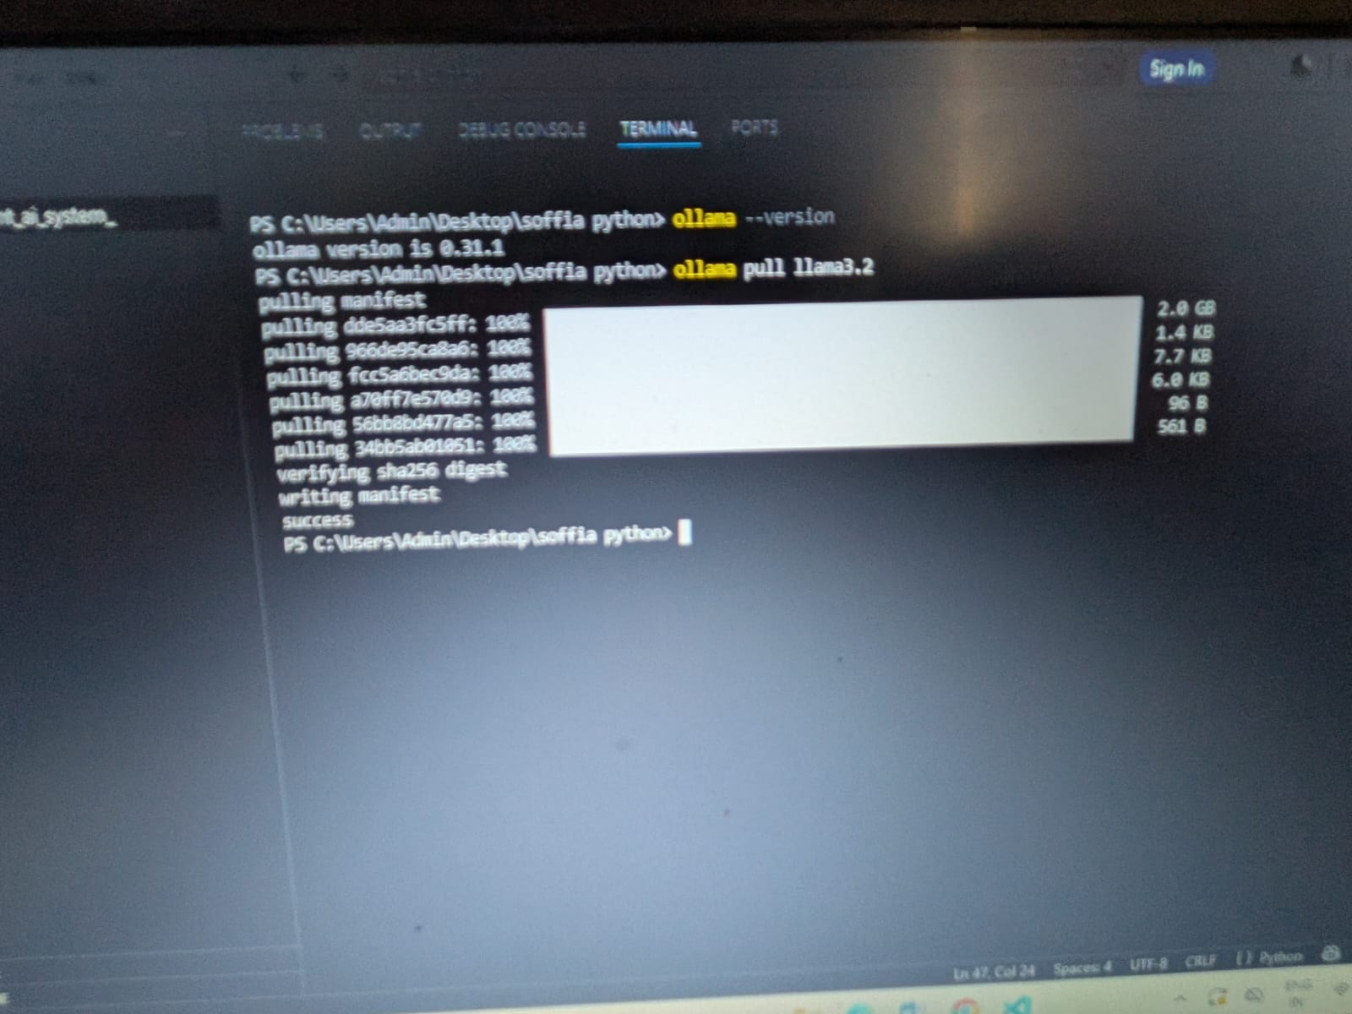
Final Output Generated by the Collaborative Multi-Agent System
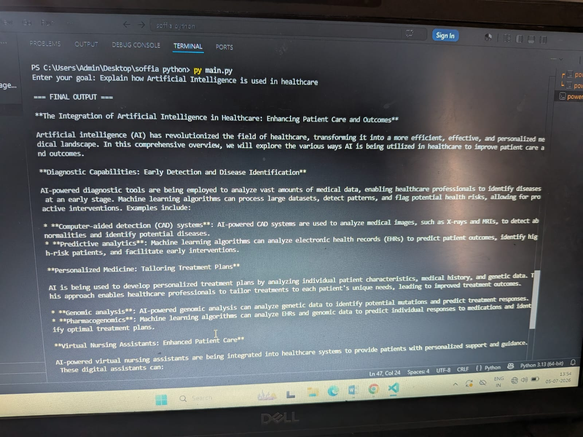

Conclusion
The proposed Collaborative Multi-Agent System (CMAS) successfully demonstrates how multiple AI agents can work together to solve complex tasks through intelligent collaboration. The system was developed using Python, the Ollama framework, and the Llama 3.2 Large Language Model, enabling offline execution without relying on cloud-based APIs. A Manager Agent coordinates the workflow by analyzing the user's request, dividing it into subtasks, assigning each subtask to the appropriate specialist agent, and integrating the individual outputs into a comprehensive final response.
The implementation confirms that collaborative task execution improves modularity, organization, and flexibility compared to a single-agent approach. The specialist agents, including the Researcher, Designer, Frontend Developer, Backend Developer, Tester, and Writer, contribute domain-specific expertise, resulting in structured and high-quality outputs. The system successfully generates software designs, website structures, programming code, technical documentation, and implementation suggestions.
The use of Ollama allows the system to operate locally, providing enhanced privacy, reduced operational costs, and offline functionality. The modular architecture also supports future expansion by allowing additional specialist agents and advanced AI capabilities to be integrated with minimal changes to the existing framework.
Overall, the proposed Collaborative Multi-Agent System demonstrates the practical application of intelligent agent collaboration in software development and task automation. It provides a scalable and extensible foundation for future AI-driven applications.

Future Scope
The proposed system can be further enhanced by incorporating additional features and advanced AI capabilities. Some possible future improvements include:
- Integration of long-term memory to retain previous interactions and improve contextual understanding.
- Development of a graphical user interface using Streamlit or Flask for enhanced user interaction.
- Integration with databases such as MySQL or PostgreSQL for persistent data storage.
- Addition of a Data Analysis Agent capable of processing datasets and generating visualizations.
- Implementation of Retrieval-Augmented Generation (RAG) to improve the accuracy of responses using external knowledge sources.
- Support for voice-based interaction using speech recognition and text-to-speech technologies.
- Integration with cloud platforms to enable hybrid local and cloud AI execution.
- Expansion of the system with additional specialist agents for cybersecurity, machine learning, DevOps, and data science applications.
- Automatic generation and storage of project files such as HTML, CSS, JavaScript, Python, and documentation.
- Performance optimization for handling complex, large-scale collaborative tasks.

References
Here are some references you can include:
- Artificial Intelligence: A Modern Approach, S. Russell and P. Norvig, Pearson, 2021.
- Language Models are Few-Shot Learners, T. Brown et al., Advances in Neural Information Processing Systems, 2020.
- Attention Is All You Need, A. Vaswani et al., NeurIPS, 2017.
- Ollama Documentation⁠
- Python Documentation⁠

Appendix A- Source Code(agents.py)
import ollama

MODEL = "llama3.2"

def call_llm(system_prompt, user_prompt):
response = ollama.chat(
model=MODEL,
messages=[
{"role": "system", "content": system_prompt},
{"role": "user", "content": user_prompt},
],
)
return response["message"]["content"]

class Agent:
def __init__(self, name, role_prompt):
self.name = name
self.role_prompt = role_prompt

def run(self, task):
print(f"\n[{self.name}] working on: {task}")
result = call_llm(self.role_prompt, task)
print(f"[{self.name}] done.")
return result

class ManagerAgent:
def __init__(self, specialists):
self.specialists = specialists

def plan(self, goal):
specialist_list = ", ".join(self.specialists.keys())

planning_prompt = f"""
Break the goal into 2-4 subtasks.
Assign each subtask to exactly one of these specialists:
{specialist_list}

Return only:
SPECIALIST | TASK

Goal:
{goal}
"""

raw_plan = call_llm("You are a precise project planner.", planning_prompt)

tasks = []
for line in raw_plan.strip().splitlines():
if "|" in line:
name, task = line.split("|", 1)
name = name.strip()
if name in self.specialists:
tasks.append({"specialist": name, "task": task.strip()})
return tasks

def execute(self, goal):
tasks = self.plan(goal)

results = []
for t in tasks:
agent = self.specialists[t["specialist"]]
output = agent.run(t["task"])
results.append(f"### {t['specialist']}\n{output}")

synthesis_prompt = (
f"Combine these specialist outputs into one final answer for '{goal}'.\n\n"
+ "\n\n".join(results)
)

return call_llm(
"You are a synthesis editor.",
synthesis_prompt,
)

Appendix A- Source Code(main.py)
from agents import Agent, ManagerAgent

researcher = Agent(
"Researcher",
"You are a meticulous researcher. Gather and summarize accurate information."
)

designer = Agent(
"Designer",
"You design beautiful and user-friendly web interfaces."
)

frontend = Agent(
"Frontend",
"You are an expert HTML, CSS and JavaScript developer. Create responsive websites."
)

backend = Agent(
"Backend",
"You are an expert Flask and Python developer."
)

tester = Agent(
"Tester",
"You are a software testing expert. Test websites and suggest improvements."
)

writer = Agent(
"Writer",
"You write professional documentation and explain code clearly."
)

manager = ManagerAgent({
"Researcher": researcher,
"Designer": designer,
"Frontend": frontend,
"Backend": backend,
"Tester": tester,
"Writer": writer,
})

if __name__ == "__main__":
goal = input("Enter your goal: ")
final_output = manager.execute(goal)

print("\n=== FINAL OUTPUT ===\n")
print(final_output)

