**COMSATS UNIVERSITY ISLAMABAD**

ABBOTABAD CAMPUS



|  |  |  |
| --- | --- | --- |
| NAME | : | Muhammad Masood Khan (FA21-BSE-028)  Sofia Aamir (FA21-BSE-036)  Mahnoor Qazi (FA21-BSE-020) |
| SECTION | : | 4A |
| COURSE | : | OOSE |
| SUBMITTED TO | : | SIR Mukhtiar Zamin |

Table of Contents

CHAPTER1: 3

INTRODUCTION: 3

VISION AND BUSINESS CASE: 3

EXECUTIVE SUMMARY 3

USE CASE MODEL: 4

1. LOGIN: 4

2. ADD BOOK TO LIBRARY: 4

3. DELETE BOOK FROM LIBRARY: 4

4. SEARCH BOOK BY NAME: 4

5. DISPLAY BOOKS DETAILS: 4

6. BORROW A BOOK: 4

7. RETURN BOOK: 4

8. REGISTER: 5

9. REGISTER COMPLAINT: 5

10. MANAAGE ACCOUNTS: 5

11. FEEDBACK: 5

12. ORDER BOOK: 5

13. UPDATE BOOKS: 5

SUPPLEMETARY SPECIFICATION: 5

Introduction: 5

Non-Functional Requirements 5

1) SECURITY: 5

2) RELAIBILITY/MAINTAINIBILITY: 5

3) PERFOMANCE: 5

4) UNDERSTANDABLE/USEABLE: 5

5) FLEXIBILITY: 5

GLOSSARY 6

Risk List & Risk Management Plan 7

1) Business Risks: 7

2) Technical Risks: 7

3) Resource Risks: 7

4) Schedule Risks: 7

CHAPTER 2 USE CASES 8

USE CASE DIAGRAM: 8

Use Cases Distribution 9

Brief Level Use Cases 9

Masood khan (FA21-BSE-028) 9

Mahnoor Qazi (FA21-BSE-020) 9

Sofia Aamir (FA21-BSE-036) 10

Fully Dressed Use Cases 11

# CHAPTER1:

## INTRODUCTION:

A library management system is a computerized system which is used to have the record of the books ,students and staff records .which has a software installed in it which helps the user in handling all the books of library and with that keeping everything up to date,

It helps the manager to know how many books are there in that particular library, how many are given to the students, how many books of same author do we have and many other features that I will explain later.

This system is easy to use and at times helps both the members of the library and the manager. There will be different sections for the student and staff to use the applications. Librarian will use complete features of application.

Futermore, the system will be flexible it will run on many machines across the world, we are using iterative development strategy we are going to processed through requirements ,object oriented analysis design and implementation.

## VISION AND BUSINESS CASE:

Out Application will be fast, reliable, robust and flexible it will be very user friendly.

**Problems:** the speed will be decrease if there are multiple users using at a time too much load will reduce speed.

Our application is in English language when people don’t know English they will not understand the use of application.

**Constraints:** Including design constraints, performance, supportability, reuseability, and Documentation.

## EXECUTIVE SUMMARY

Our traditional libraries are getting hard to manage day by day as the world is advancing with every passing day. Student life is way too busy now and it is difficult to take out time from your busy schedule to go to library. While during studies, library always acts as ours best friend. Libraries help students in studies, it not only helps students but everyone that has keen interest of reading books.

In our library management system application, there will be an admin (librarian) login. He has the access to most of the functions of the library. He registers the students, keeps a check on the students whether they are returning books on time or not.

The librarian manages all the books in library. In this library management application, it is easy for the librarian to tell which book is available, which book is currently not available in library. How many books of same author are present in our library.

Librarian issues a certificate i.e. registration of the students who desires to be a permanent member of the library. After the registration the students are able to borrow a book. In our LMS application when a student gets registered, he/she is provided with a student login account. Through this account they can borrow any book and stay up to date.

In this library management application, there is a student login that makes this software different from others, way too much interesting and attractive for users. Student login account helps student to get information about any books within few seconds. There is a search bar where they can type author’s name, book id or book name and they can know if their desired book is available or not. Students can see the date they borrowed a book and the date when they have to return the book.

Students have to pay the fine if they fail to return the book on time. They can see all the information of fine through their accounts.

The UI (user interface) will be simple to understand easily by the user, no complicated buttons will be used which that can require any special training, everyone even the beginners will learn how to use the System easily and also the system will be programmed well to avoid cyber-attacks, the System will have data of many users.

To make it safe we will add authentication processes so that unauthorized people are unable to access the data.

## USE CASE MODEL:

### 1. LOGIN:

### 2. ADD BOOK TO LIBRARY:

When new books will come the system will update the list of books by adding all information of that book and at the end letting the manager know the total number of books in the library.

### 3. DELETE BOOK FROM LIBRARY:

If a book is no longer available in the library for one reason or other the system will delete it too

### 4. SEARCH BOOK BY NAME:

If a student doesn’t knows the author name he/she will tell the librarian the book name and using thus software system, librarian will give the information about that particular book to the student.

### 5. DISPLAY BOOKS DETAILS:

### 6. BORROW A BOOK:

There will an option/feature of borrowing books. A user can borrow 2 books of their choice at a time.

7. RETURN BOOK:

When user borrows the book they have to return it after a certain mentioned time period. If they do not return the book due to one reason or other, fine will be imposed which will increase by 100RS with every passing day.  
8. REGISTER:

### 9. REGISTER COMPLAINT:

### 10. MANAAGE ACCOUNTS:

### 11. FEEDBACK:

### 12. ORDER BOOK:

### 13. UPDATE BOOKS:

## SUPPLEMETARY SPECIFICATION:

### Introduction:

This document is the repository of all Library Management system not captured in the use cases.

### Non-Functional Requirements

### SECURITY:

My software has many accounts which keeps the user data their bank info, CNIC and other information which is confidential. So, lots of data must be kept safe avoid cyberattacks and recognize the unauthorized access directly and block access to that person.

### RELAIBILITY/MAINTAINIBILITY:

The software will be reliable and work properly make sure no errors and bugs will affect the performance of the system. If any Bug or Error arises the system will only make that Function out of service not the whole system and the system will do Maintenance of that certain Function which is causing error and bugs.

### PERFOMANCE:

We will make sure our system will do a certain operation faster and the start-up time of system will be less. Whenever the customer does a certain function, the operation will be done in a fraction of a second. Our goal: authorization in less than 1minute 90% of the time.

### UNDERSTANDABLE/USEABLE:

Make the system more user friendly more understandable by the user and easily to interact with.

### FLEXIBILITY:

The system can handle Thousands of users at a time.

**Human Factors:**

* Text should be visible from 1 meter
* Avoid colors associated with common forms of color blindness.

## GLOSSARY

|  |  |
| --- | --- |
| **SDLC** | Software development life cycle |
| **LMS** | Library Management System |
| **OOP** | Object Oriented Programming |
| **ICT** | Introduction to Computer Technology |
| **SSO** | Single Sign-on |

## Risk List & Risk Management Plan

A library management system is a critical system that help to manage the books resources and along that there are also many other difficulties faces by library. Just like other systems library also face the security issues, performance issues and also maintenance issues.

### Business Risks:

Business risk that a library can face in market is that they sometimes can’t meet the needs of targeted audience. Sometimes also the budget of one project is so much that it exceed the finance.

**Mitigation/Response:**

Analyse your customer base and also we can conduct the interviews to come to know their needs. Also before planning any project we have to look to our finance and then plan the things according to that.

### Technical Risks:

There are security risks the librarian managers can face. That other cyber attacker can also reach out the accounts in the library which is not good.

**Mitigation/Response:**

Regularly perform security audits and updates the system for its security. The library should heir the well qualified employees with technical skills that they have the knowledge to use the robust security protocols such as firewall, encryption to protect the system from security threats.

### Resource Risks:

The project may require a high qualified technical skills sometimes the resources are not allocate to the right person than they leave the project in midway.

**Mitigation/Response:**

Build a team with a diverse skills and all employees must be independent and they must be one alone individual.

### Schedule Risks:

Sometimes the task assigned to one person may busy in some other project that he can’t give time to this project so there is delay in project.

**Mitigation/Response:**

Develop a project time by keeping the schedule in mind of all other staff. That they give their full time to the project.

# CHAPTER 2 USE CASES

USE CASE DIAGRAM:

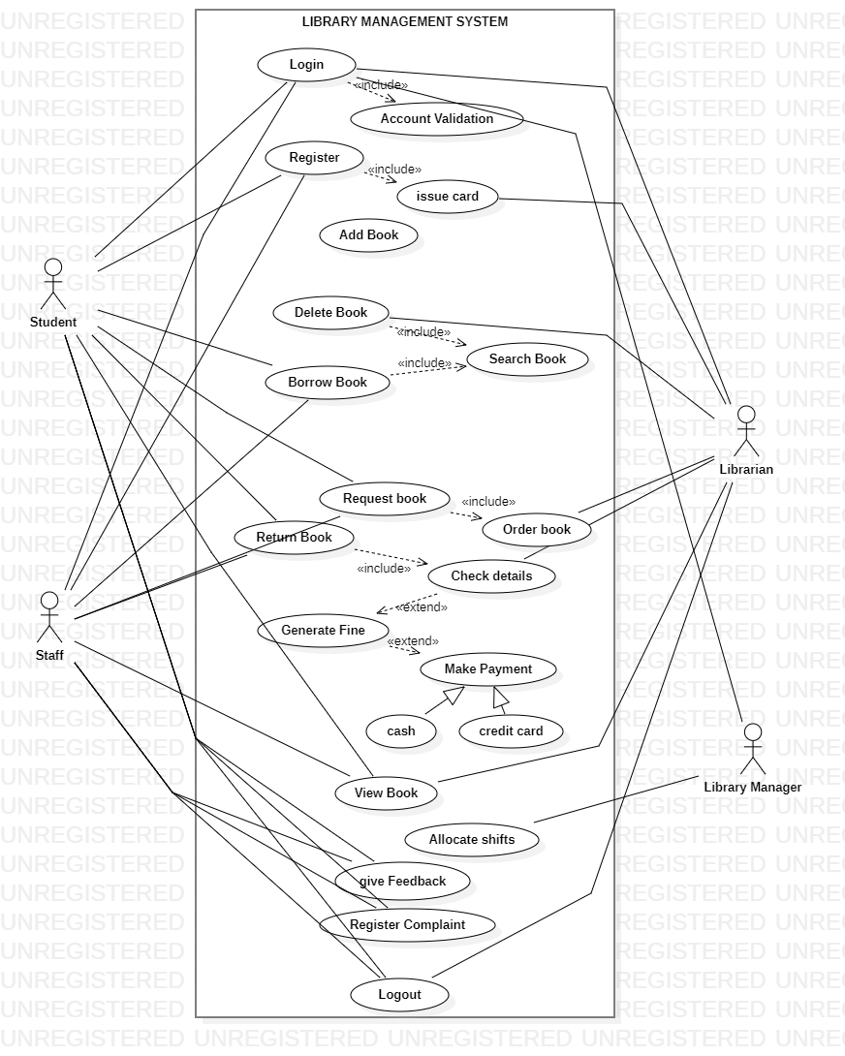

## Use Cases Distribution

|  |  |  |
| --- | --- | --- |
| S#. | Group Member | Assigned Use Cases |
| 1 | Masood Khan | Add book  Delete Account  Order books  Reserve books  Block Account |
| 2 | Mahnoor Qazi | Search book  Login  Logout  Return book  Generate fine |
| 3 | Sofia Aamir | Register accounts  Delete book  Borrow book  Give feedback  payment |

## Brief Level Use Cases

### Masood khan (FA21-BSE-028)

#### ` Add book:

As a librarian or admin, I should be able to add new books to the library system by providing book details such as title, author, ISBN, genre, publisher, and quantity.

#### Delete account:

As a librarian or admin, I should be able to manage accounts of the users of the library.so a librarian can delete an account if he want to delete .

#### Block account:

As a librarian or admin ,if any user is doing any unsuspicious activity so librarian has the authority to block his account or the user is not paying fine.

#### Order books:

As a library member, I should be able to search for the book and if I can’t find that book will place order for the desired book and the librarian will order that book.

#### Reserve books:

As a library member, I will be able to reserve the book in library so that another person can’t borrow that book.

### Mahnoor Qazi (FA21-BSE-020)

#### Search book:

As a library member, I should be able to search the book by IBSN author name, title, publisher name.

#### Login:

As a library member or guest, I should be able to login in library by username and password. If I don’t have an account I have to find make an account and then I will be able to use the functionalities of library. After login I should be able to see my account details, books borrowing history etc.

#### Logout:

As a library member, I should be able to logout from my library account to ensure the security after using all the functionalities of library for that time.

#### Return book:

As library member, I should be able to return the book after borrowing the book and the status of book will be update to available and also there will be fine generated if I have return the book after the return date.

#### Generate fine:

As a library staff, I should be able to generate the fine or late fee for the overdue books based on the library policy and the number of days the book is overdue. The system should automatically calculate the fine amount and notify the member via email or SMS. The staff should also be able to mark the fine as paid once the member clears the dues.

### Sofia Aamir (FA21-BSE-036)

#### Register accounts:

As a library member, I should be able to create a new account by providing my personal details such as name, email, phone number, and address. After registration, I should be able to login to the library system and access the available features based on my account role and permissions.

#### Delete book:

As a librarian or staff, I should be able to delete the book from library details if it is borrowed, lost or damaged. The system should update the book details.

#### Borrow book:

As a library member, I should be able to borrowed the book from library by IBSN, title name, author name. the system should update the status of book to unavailable and should also generate the date for returning the book.

#### Give feedback:

As a library member, I should be able to give feedback on the books available in library after reading the book. That feedback should be visible to all other users also.

#### Payment:

As a library member, I should be able to pay the fines or overdue charges online using various payment modes such as credit/debit card, net banking, or digital wallets. The system should process the payment securely and update the payment status for the corresponding fines or dues.

## Fully Dressed Use Cases

### MASOOD KHAN (FA21-BSE-028)

| **Use Case UC1: ADD BOOK** |  |  |
| --- | --- | --- |
| **Scope**: Library Management application  **Level**: user goal  **Primary** **Actor**: Librarian  **Users and Interests**:  - Librarian: Wants accurate, fast entry, and well managed book in the library which can be easily accessible.  - User : want to buy borrow a book from the library  - University: Wants to accurately record book details so it can be easily available for the students and Faculty members to buy or borrow a book and will facilitate them better.  - User: he/she will be at the top level and can manage all the operations in the library can override all the features of librarian.  **Preconditions**: Librarian is authorized and authenticated. |  |  |

**Success Guarantee** (or Postconditions): Book will be added the Library Management system and will be assigned the correct shelf number and will be visible to the users of Library management system.

**Main Success Scenario (or Basic Flow):**

1. Book will be Added
2. Users will now see the book in the library
3. Users can read a book within the application an electronic book facility is available for users to read.
4. Users can now borrow a book

**Extensions (or Alternative Flows):**

*a. At any time, User requests an override operation:

1. System enters Manager-authorized mode.
2. Librarian performs one Manager-mode operation.
3. System reverts to Librarian-authorized mode.

*b. At any time, System fails:

If there occur any error while adding a book to the library there must be alternate method to do the operation

1. Librarian restarts the system and check the system if it works fine or not then enter prior state
2. System reconstructs prior state.

**Special Requirements:**

- Book will be added easily and fast within 30secounds 90%of time.

- better Machines will be provided to the librarian for fast data entry

- Language internationalization on the text displayed.

**Technology and Data Variations List**:

*a. to add a book Multiple authentication process will be done. Fingerprint will be scanned .

3a. book identifier entered by bar code laser scanner (if bar code is present) or keyboard.

7a. Entry will be done through IBAN.

**Use Case UC2: BLOCK ACCOUNTS**

**Title:** Block Accounts

**Actor:** Librarian

**Preconditions:**

The librarian is logged into the LMS.

The user whose account is to be blocked has violated library policies, such as returning books late, damaging library property, or harassing other library users.

**Basic Flow:**

The librarian selects the user's account from the LMS.

The librarian navigates to the "Block Account" option.

The librarian selects the reason for blocking the user's account from a predefined list of options or enters a custom reason.

The librarian confirms the action of blocking the user's account.

The user is prevented from accessing their account and using any associated services of the library, such as borrowing books or accessing online resources.

The librarian informs the user about the blocking of their account and the reason behind it.

The librarian logs the action of blocking the user's account in the LMS with a timestamp and the reason for blocking the account.

**Alternate Flow:**

If the user disputes the blocking of their account, the librarian may review the evidence of the user's violation and decide to either unblock the account or keep it blocked.

**Post-conditions:**

The user's account is blocked and cannot be used until unblocked by the librarian.

The reason for blocking the user's account is logged in the LMS for future reference.

The user is informed of the reason for blocking their account and any steps they can take to unblock it

**Use Case UC3: DELETE ACCOUNTS**

**Title:** DELETE Accounts

**Primary Actor:** Librarian

**Goal:** To delete a user account from the Library Management System

**Preconditions:**

* The Librarian is logged in to the Library Management System.
* The user account to be deleted is not currently logged in.
* The Librarian has the necessary permissions to delete user accounts.

**Main Success Scenario:**

1. The Librarian navigates to the user management section of the LMS.
2. The Librarian selects the option to delete a user account.
3. The LMS prompts the Librarian to enter the username of the account to be deleted.
4. The Librarian enters the username and confirms the deletion request.
5. The LMS displays a confirmation message, asking the Librarian to confirm the deletion.
6. The Librarian confirms the deletion request.
7. The LMS displays a success message confirming that the user account has been deleted.

**Alternative Flow:**

* If the Librarian enters an invalid username, the LMS displays an error message and prompts the Librarian to try again.

**Postconditions:**

* The user account has been deleted from the LMS and all associated data has been removed.
* The user will no longer be able to log in to the LMS or use any of its services.
* The Librarian can no longer access the deleted user account's data.

**Use Case UC4: Order Books**

**Primary Actor:** Library Staff

**Goal in Context:** The goal of this use case is to enable library staff to order new books or replace damaged or lost books in the library system.

**Preconditions:** The library staff member has the necessary permissions to access the order books feature and has identified the need for new books or replacements.

**Trigger:** The trigger for this use case is the need to purchase new books or replace damaged or lost books in the library.

**Main Success Scenario:**

The library staff member logs into the library management system and navigates to the order books feature.

The staff member searches for the desired book(s) using the search function or by browsing the library catalog.

If the book(s) are not available in the library catalog, the staff member fills out a book request form with the required book information.

The staff member selects the vendor(s) to purchase the book(s) from and adds them to the order cart.

The staff member reviews the order details, including the book titles, quantities, and costs, and confirms the order.

The library system generates a purchase order for the selected vendor(s) and sends it to them.

The vendor(s) fulfill the order and deliver the books to the library.

The library staff member receives and checks the books for accuracy and completeness.

The staff member updates the library catalog to reflect the new additions.

Alternative Scenarios: 1a. If the desired book(s) are not available in the library catalog and a book request form is filled out, the staff member receives a notification when the book(s) are available to purchase. 5a. If the staff member reviews the order details and finds an error, they can edit the order before confirming it. 8a. If the delivered books are damaged or incomplete, the staff member can return them and request a replacement.

**Postconditions:**

The vendor(s) receive the purchase order and fulfill the order.

The library receives the ordered book(s) and adds them to the library collection.

The library catalog is updated to reflect the new additions.

**Assumptions**:

The library management system is fully functional and accessible to the library staff.

The vendor(s) can fulfill the purchase order within the expected time frame.

The library staff member has the necessary knowledge and training to navigate the order books feature and manage book orders.

**Use Case UC5: RESERVE Books**

**Title:** Reserve Books

**Primary Actor:** Librarian

**Goal in Context:** The goal of this use case is to enable librarian to reserve a copy of a book that is currently checked out.

**Preconditions:** The librarian has a valid library card and is logged into the library system. The book being reserved is currently checked out.

**Trigger:** The trigger for this use case is the library patron's desire to reserve a book that is currently checked out.

**Main Success Scenario:**

The librarian searches for the desired book using the search function or by browsing the library catalog.

The librarian selects the desired book and checks the availability status.

If the book is currently checked out, the patron selects the "reserve" option.

The librarian confirms the reservation and provides contact information (e.g., email or phone number) for notification when the book is available.

The library system places the patron on a waitlist for the reserved book.

When the reserved book is returned to the library, the library staff member checks it in and the library system sends an automatic notification to the next patron on the waitlist.

The librarian receives a notification that the reserved book is available for pick up.

The librarian picks up the reserved book from the library within the designated time frame.

**Alternative Scenarios:** 3a. If the book is not available in the library catalog, the patron can fill out a book request form with the required book information. 4a. If the patron decides not to confirm the reservation, the reservation is canceled. 5a. If the patron is not the first on the waitlist, the library system updates the waitlist to reflect the patron's position in the queue. 6a. If the reserved book is not returned within the designated time frame, the library staff may contact the borrower and request the return of the book. 7a. If the patron does not pick up the reserved book within the designated time frame, the reservation is canceled and the next patron on the waitlist is notified.

**Postconditions:**

The library patron has successfully reserved a copy of a book that is currently checked out.

The library system updates the book's availability status and waitlist.

The library patron picks up the reserved book within the designated time frame.

**Assumptions**:

The library management system is fully functional and accessible to the library patrons.

The reserved book will be returned within the designated time frame.

The library staff member has the necessary knowledge and training to manage the reservation process.

The patron has a valid library card and contact information.

### SOFIA AAMIR (FA21-BSE-036)

**Use Case UC1: REGISTER ACCOUNTS**

| **Scope**: Library Management application  **Level**: user goal  **Primary** **Actor**: User, Librarian , library manager  **Users and Interests**:  As a librarian or library staff member, I want to register a patron's account for borrowing fully dressed items, such as books that include additional components like CDs, DVDs, or other multimedia materials. This use case covers the process of registering a patron's account for borrowing fully dressed items and ensuring that the patron understands the additional responsibilities and potential fines associated with borrowing such items.  **Preconditions**:  The library has fully dressed items available for borrowing, such as books with accompanying CDs, DVDs, or other multimedia materials.  The patron is registered with the library and has a valid library card.  The patron wishes to borrow fully dressed items from the library and has expressed an interest in doing so |
| --- |

**Success Guarantee** (or Postconditions):

User will be able to do operation in the Library management system they will be able to access all the features of library.

**Main Success Scenario (or Basic Flow):**

The librarian or library staff member greets the patron and confirms their desire to borrow fully dressed items.

The librarian or library staff member explains to the patron the additional responsibilities and potential fines associated with borrowing fully dressed items, such as keeping the additional components safe and in good condition, returning all components together, and paying fines for lost or damaged components.

The librarian or library staff member confirms that the patron understands and accepts these responsibilities and potential fines.

The librarian or library staff member updates the patron's account in the library's system to indicate that they are registered for borrowing fully dressed items.

The librarian or library staff member provides the patron with any additional information or instructions related to borrowing fully dressed items, such as loan periods, renewal options, and return procedures.

The user presents their library card and selects the desired fully dressed item(s) for borrowing.

The librarian or library staff member checks out the fully dressed item(s) to the patron's account, following the library's standard check-out procedures.

.**Extensions (or Alternative Flows):**

If the librarian does not accept the responsibilities and potential fines associated with borrowing fully dressed items, the librarian or library staff member may offer alternative borrowing options or decline the patron's request to register for borrowing fully dressed items.

If the librarian fails to return all components of a fully dressed item or returns them in a damaged condition, the librarian or library staff member may follow the library's procedures for assessing fines or charges for lost or damaged items, as well as for replacement or repair of the components.

If the librarian wishes to renew a borrowed fully dressed item, the librarian or library staff member may follow the library's standard renewal procedures, including checking the condition of the additional components before renewing the item.

If the librarian encounters issues or problems with a borrowed fully dressed item, such as damaged or malfunctioning components, the librarian or library staff member may assist the patron in resolving the issue or may follow the library's procedures for handling such situations, including potential fines or charges.

| **Use Case UC2: BORROW BOOK** |
| --- |
| **Scope**: Library Management application  **Level**: user goal  **Primary** **Actor**: User  **Users and Interests**:  - Librarian: will authorize the permission of the user when user wants to borrow a book from the library.  - User : wants to buy borrow a book from the library.  - University: Wants to accurately record book details, will request more when certain book is not available. So it can be easily available for the students and Faculty members to buy or borrow a book and will facilitate them better.  - User: he/she will get request by the librarian for new books then User will approve or reject the request.  **Preconditions**: User is authorized and authenticated. |

**Success Guarantee** (or Postconditions): Book will be borrowed and a time will be generated for the returning of book.

**Main Success Scenario (or Basic Flow):**

1. Book will be Borrowed
2. User must login to their account to borrow book and a time will be generate for returning the book.

**Extensions (or Alternative Flows):**

*b. At any time, when book cannot be borrowed any error occurred,

If there occur any error while adding a book to the library there must be alternate method to do the operation

1. User will restart the system and try again with better and fast internet connection .
2. If it does not work then user will submit a complaint in the application and can email the user for the desired book he want to borrow.

**Special Requirements:**

- Book will be borrowed easily and fast within 30secounds 90%of time.

- a simple UI will be designed for the users to easily understand the Library Management system features.

- better Machines will be provided to the librarian for fast data entry

- Language internationalization on the text displayed.

**Technology and Data Variations List**:

*a. to borrow a book Multiple authentication process will be done. Fingerprint will be scanned.

3a. before borrowing a book user will get the approval from the librarian to borrow a book

7a. Entry will be done through IBAN.

**Use Case UC3: DELETE BOOK**

**Title:** Delete Books

**Primary Actor:** Library Staff

**Goal in Context:** The goal of this use case is to enable library staff to remove a book from the library's collection.

**Preconditions:** The library staff member is logged into the library system and has the necessary permissions to delete books. The book to be deleted is not checked out by any library patron.

**Trigger:** The trigger for this use case is the decision by the library staff to remove a book from the library's collection.

**Main Success Scenario:**

The library staff member searches for the book to be deleted using the search function or by browsing the library catalog.

The staff member selects the book to be deleted and confirms the deletion.

The library system removes the book from the library catalog and updates the inventory.

Alternative Scenarios: 2a. If the book is checked out by a library patron, the staff member cannot delete the book until it is returned. 2b. If the book has holds or reservations, the staff member cannot delete the book until all holds and reservations have been fulfilled or canceled. 2c. If the book has associated data such as circulation history or reviews, the staff member may choose to keep this data or delete it along with the book.

**Postconditions:**

The book has been successfully removed from the library's collection.

The library catalog and inventory have been updated to reflect the deletion.

**Assumptions:**

The library management system is fully functional and accessible to the library staff.

The staff member has the necessary knowledge and training to manage the deletion process.

The staff member has the necessary permissions to delete books from the library's collection.

The book to be deleted is not checked out by any library patron.

**Use Case UC4: GIVE FEEDBACK**

**Title:** Give Feedback

**Primary Actor:** User

**Goal in Context:** The goal of this use case is to enable library patrons to provide feedback to the library regarding their experience with the library services, facilities, or resources.

**Preconditions:** The library patron has a valid library card and is logged into the library system.

**Trigger:** The trigger for this use case is the library patron's decision to provide feedback regarding their experience with the library.

**Main Success Scenario:**

The library patron selects the "Give Feedback" option from the library system's menu.

The patron is presented with a feedback form to fill out.

The feedback form allows the patron to rate various aspects of the library experience (e.g., facilities, staff, resources) and provide comments or suggestions.

The patron fills out the feedback form and submits it.

The library system records the feedback and sends it to the appropriate library staff member for review and response.

The library staff member reviews the feedback and responds to the patron if necessary.

Alternative Scenarios: 3a. If the patron does not want to fill out the feedback form, they can select a pre-written feedback option or skip the feedback process altogether. 4a. If the feedback form does not include a specific aspect of the library experience that the patron wants to provide feedback on, they can add it in a comment box or provide feedback in a different way (e.g., email, phone call). 5a. If the feedback requires follow-up action, such as a maintenance request or a request for additional resources, the appropriate library staff member will take action and respond to the patron when necessary. 6a. If the library staff member needs more information or clarification regarding the feedback, they may contact the patron to request more information.

**Postconditions:**

The library patron has successfully provided feedback to the library regarding their experience with the library services, facilities, or resources.

The library system has recorded the feedback and sent it to the appropriate library staff member for review and response.

**Assumptions:**

The library management system is fully functional and accessible to the library patrons.

The feedback form is user-friendly and accessible to all library patrons.

The library staff member has the necessary knowledge and training to manage the feedback process.

The library staff member will respond to the patron in a timely manner when necessary.

**Use Case UC5: PAYMENT**

**Title:** Payment

**Primary Actor:** user

**Goal in Context:** The goal of this use case is to enable library patrons to make payments for library fines, fees, or other charges.

**Preconditions:** The library patron has a valid library card and is logged into the library system. The patron has a fine, fee, or other charge to be paid.

**Trigger**: The trigger for this use case is the library patron's decision to make a payment for a library fine, fee, or other charge.

**Main Success Scenario:**

The library patron selects the "Payment" option from the library system's menu.

The patron selects the fine, fee, or other charge they wish to pay.

The library system presents the patron with a payment form to fill out.

The payment form requires the patron to enter payment information, such as credit card or bank account information.

The patron fills out the payment form and submits the payment.

The library system records the payment and updates the patron's account to reflect the payment.

Alternative Scenarios: 3a. If the patron has multiple fines, fees, or other charges to be paid, they can select multiple items to pay for in a single transaction. 4a. If the patron does not have a payment method on file, they can enter payment information manually or choose to pay in person at the library. 5a. If the payment is declined, the patron can enter a different payment method or choose to pay in person at the library. 6a. If the payment is successful, the library system can automatically update the patron's account to reflect the payment and remove any holds on the patron's account.

**Postconditions:**

The library patron has successfully made a payment for a library fine, fee, or other charge.

The library system has recorded the payment and updated the patron's account to reflect the payment.

**Assumptions:**

The library management system is fully functional and accessible to the library patrons.

The payment form is user-friendly and accessible to all library patrons.

The library staff member has the necessary knowledge and training to manage the payment process.

The library system has a secure payment gateway to ensure the safety and security of patron payment information.

### MAHNOOR QAZI (FA21-BSE-020)

| Top of Form  **Use Case UC1: SEARCH BOOK** |
| --- |
| **Scope**: Library Management application  **Level**: user goal  **Primary** **Actor**: User, Librarian  **Users and Interests**:  - Librarian, User, User: he/she will search a book in the library where the book is located in the library shelf number rack number will be provided.  **Preconditions**: User, Librarian and User is authorized and authenticated. |

**Success Guarantee** (or Postconditions): Book will be searched and rack number and shelf number will be provided.

**Main Success Scenario (or Basic Flow):**

1. Find a book in the Library
2. User must login to their account to search book.

**Extensions (or Alternative Flows):**

*b. At any time, when book cannot be found any error occured:

If there occur any error while searching a book to the library there must be alternate method to do the operation

1. User and librarian will restart the system and try again with better and fast internet connection .
2. If it does not work then user will submit a complaint in the application
3. User can email to User and can access book.

**Special Requirements:**

- searching will take only 3sec because normal response time is 3sec or less

- a simple UI will be designed for the users to easily understand the Library Management system features.

- better Machines will be provided to the librarian for fast searching.

- Language internationalization on the text displayed.

**Technology and Data Variations List**:

1a. when searching book there will be provided the best match or you can search a book by author name.

2a. Every book will be available in electronic form for quick review before borrowing.

| **Use Case UC2: LOGIN** |
| --- |
| **Scope**: Library Management application  **Level**: user goal  **Primary** **Actor**: User, Librarian  **Users and Interests**:  - Librarian, User, User: he/she will search a book in the library where the book is located in the library shelf number rack number will be provided.  **Preconditions**: The library system is running and accessible.  The User has a valid user account in the library system. |

**Success Guarantee** (or Postconditions): The User is successfully authenticated and granted access to their account in the library system.

The User is able to perform actions that are authorized for their account, such as borrowing, returning, and reserving books.

**Main Success Scenario (or Basic Flow):**

The User launches the library system's login page.

The User enters their username and password in the designated fields.

The system verifies the entered credentials against the stored user account information.

If the entered credentials are invalid, the system displays an error message indicating that the login failed, and the use case ends.

If the entered credentials are valid, the system authenticates the User's account and grants access to their account.

The system logs the User's successful login event for auditing purposes.

**Extensions (or Alternative Flows):**

If the User forgets their password, they can request a password reset through the "Forgot Password" feature, which may involve additional steps such as answering security questions or receiving a password reset link via email.

If the User's account is locked due to too many failed login attempts or other security measures, they may need to contact a librarian or the system administrator for assistance in unlocking their account.

If the library system is experiencing technical issues or downtime, the User may receive an error message indicating that the login is temporarily unavailable, and they should try again later.

**Technology and Data Variations List**:

If the library system is down or inaccessible, the system may display an error message indicating that the login is not available, and the use case ends.

If the User's account is suspended, deactivated, or banned, the system may display an error message indicating that the login is denied, and the use case ends.

| **Use Case UC3: LOGOUT** |
| --- |
| **Scope**: Library Management application  **Level**: user goal  **Primary** **Actor**: User, Librarian ,library manager  **Users and Interests**:  - As a user of a social media platform, I want to be able to log out of my account while fully dressed, so that I can securely end my session and protect my personal information.  **Preconditions**: User must be logged in to their social media account.  User must be wearing appropriate clothing for the situation. |

**Success Guarantee** (or Postconditions):

User is logged out of their social media account.

User's personal information is protected from unauthorized access.

User's session is securely ended.

User can no longer access their account until they log in again

**Main Success Scenario (or Basic Flow):**

* User will first login into the account
* Then user will do some operation in the library
* Logout from the account

**Extensions (or Alternative Flows):**

If the user cancels the logout action, they remain logged in to their account.

If the user encounters an error during the logout process, they may need to try again or contact customer support for assistance.

| **Use Case UC4: Return Book** |
| --- |
| **Scope**: Library Management application  **Level**: user goal  **Primary** **Actor**: User, Librarian , library manager  **Users and Interests**:  This use case describes the steps and interactions involved in returning a book to a library in a fully dressed state, meaning the book is in its original condition, including all accessories or additional items that were originally provided with the book, such as dust jackets, bookmarks, or CDs  **Preconditions**:  The Library Patron must have previously borrowed a book from the library.  The Library Patron must have all the accessories or additional items that were originally provided with the book, such as dust jackets, bookmarks, or CDs, in their possession and in good condition.  The Library Patron must be returning the book within the library's designated return period. |

**Success Guarantee** (or Postconditions):

The book is returned to the library in its original condition, including all accessories or additional items that were originally provided with the book.

The Library Patron's library account is updated to reflect the return of the book.

The book is available for other library patrons to borrow

**Main Success Scenario (or Basic Flow):**

The Library Patron approaches the library's circulation desk where the Librarian is stationed.

The Library Patron presents the book they are returning to the Librarian.

The Librarian checks the book for any damage or missing accessories or additional items, such as dust jackets, bookmarks, or CDs, to ensure that the book is in its original condition.

If the book is in its original condition and all accessories or additional items are present, the Librarian updates the Library Patron's library account to reflect the return of the book.

The Librarian thanks the Library Patron for returning the book in a fully dressed state and provides any necessary receipts or documentation, if applicable.

The Library Patron may ask questions or seek clarification from the Librarian regarding the return process or any other library-related matters.

The Library Patron leaves the library after completing the return process

.**Extensions (or Alternative Flows):**

If the book is not in its original condition, or if any accessories or additional items are missing or damaged:

The Librarian informs the Library Patron of the issue.

The Librarian may request the Library Patron to replace or repair the missing or damaged items or charge the Library Patron for any necessary repairs or replacements, as per the library's policies.

The Librarian updates the Library Patron's library account accordingly and provides any necessary receipts or documentation, if applicable.

The Library Patron may need to resolve the issue before completing the return process.

## ENTITY REALTIONSHIP DIAGRAM(ERD):

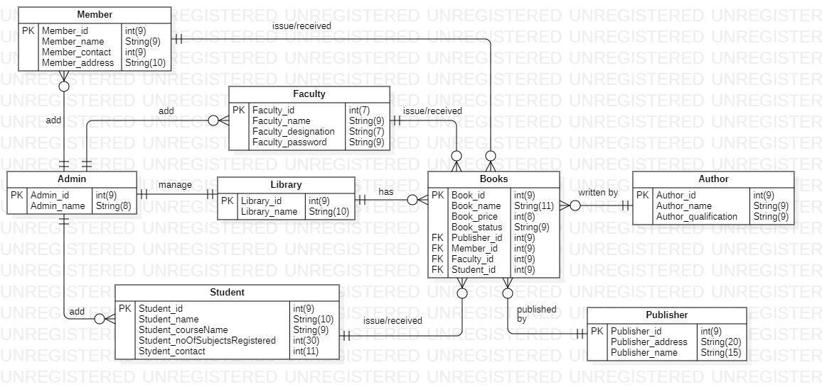

## PROTOTYPES:

### **MAIN LOGIN PAGE:**

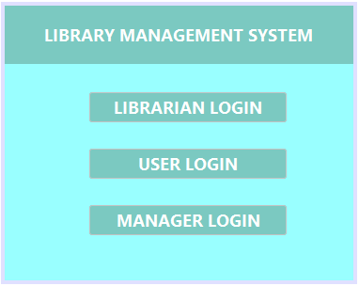

### **LOGIN:**

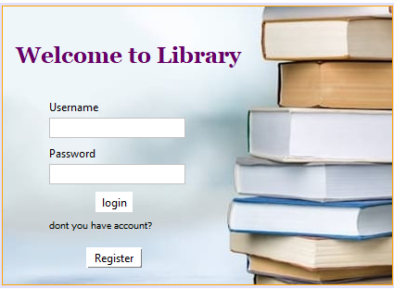

### **REGISTER ACCOUNT:**

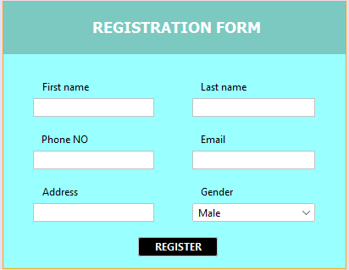

### **LIBRARIAN FUNCTIONALITY PAGE:**

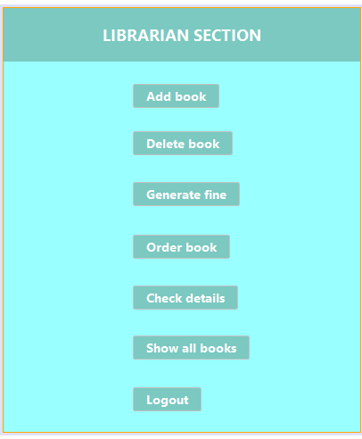

### **USER FUNCTIONALITY PAGE:**

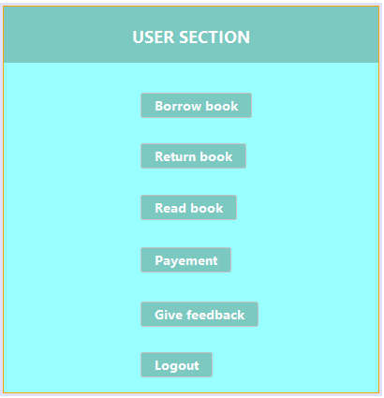

### **MANAGER FUNCTIONALITY PAGE:**

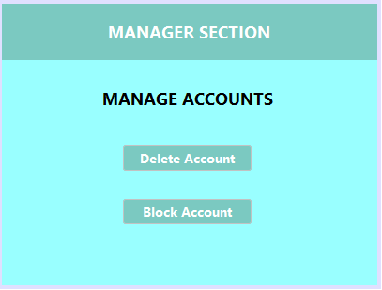

### **ADD BOOK:**

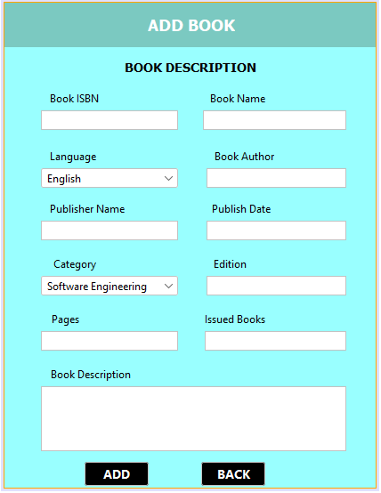

### **BORROW BOOK:**

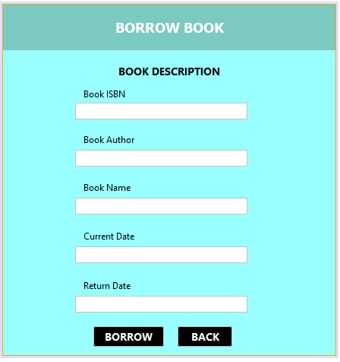

### **DELETE BOOK:**

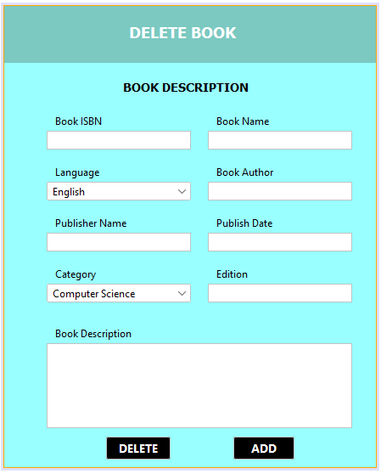

### **SEARCH BOOK:**

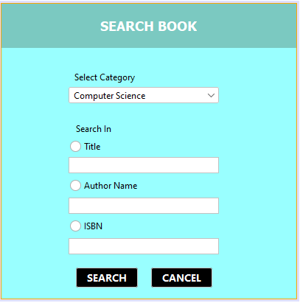

### **RETURN BOOK:**

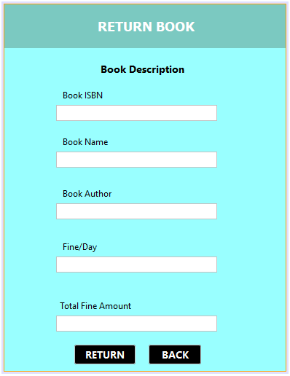

### **FEEDBACK PAGE:**

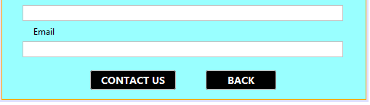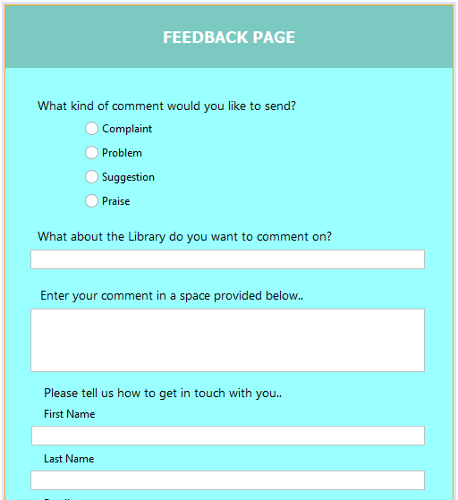

### **PAYMENT:**

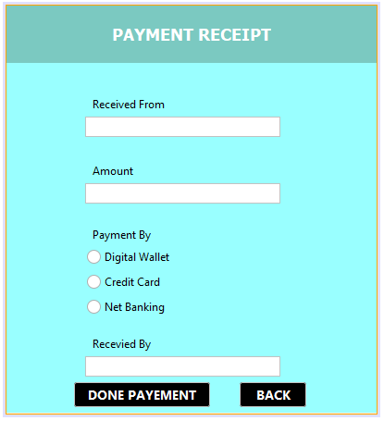

### **DELETE ACCOUNT:**

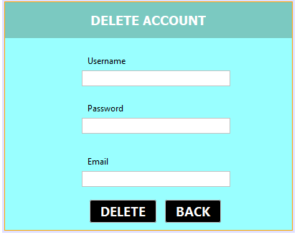

### **UPDATE ACCOUNT:**

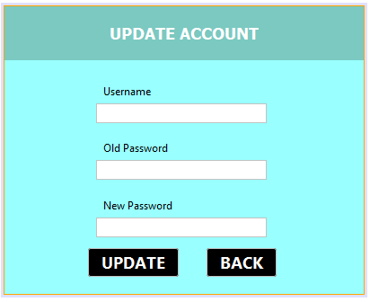

**BLOCK ACCOUNT:**

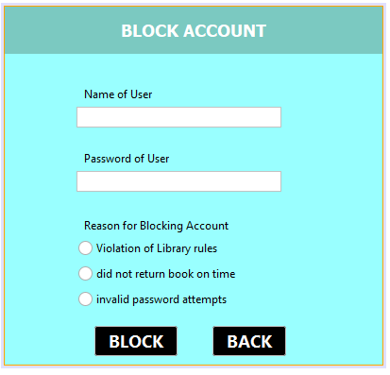

## DOMAIN MODAL:

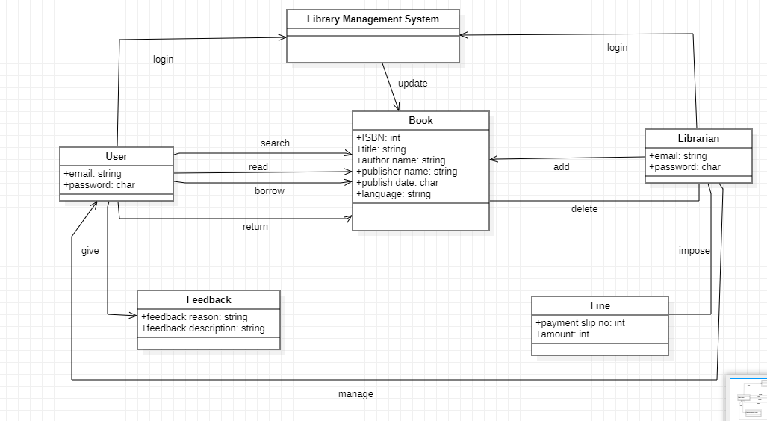

### **SOFIA AAMIR:**

BORROW BOOK:

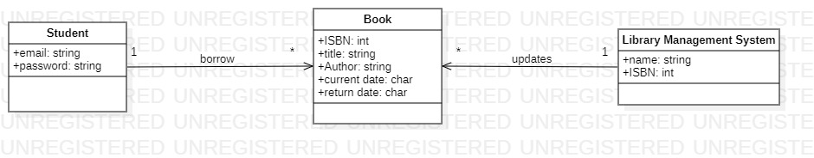

DELETE BOOK: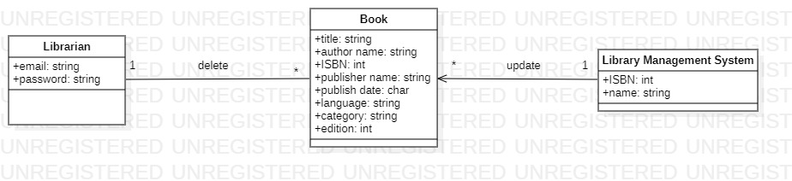

FEEDBACK:

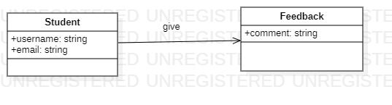

Payment:

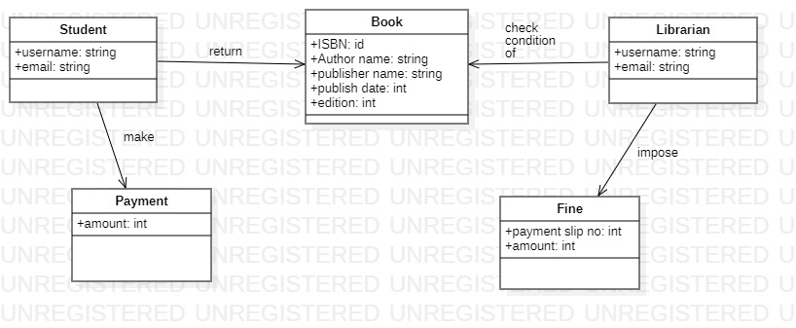

Register Account:

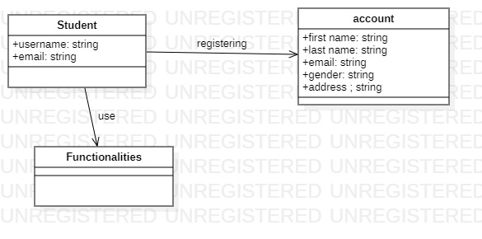

### **MAHNOOR QAZI:**

FINE:

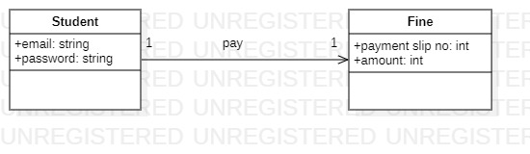

RETURN BOOK:

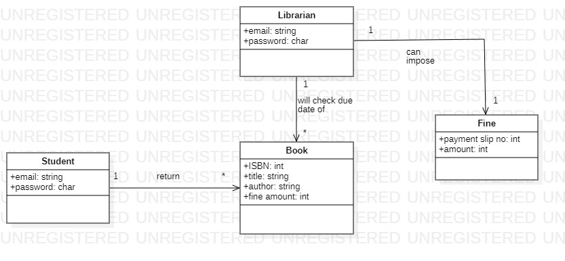

LOGIN:

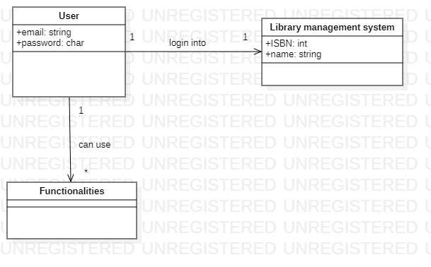

Search Book:

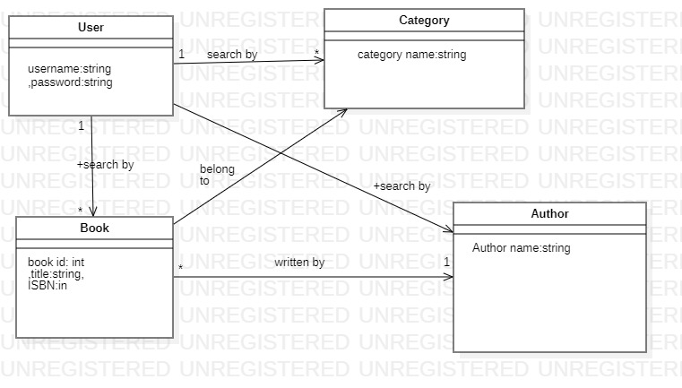

Logout:

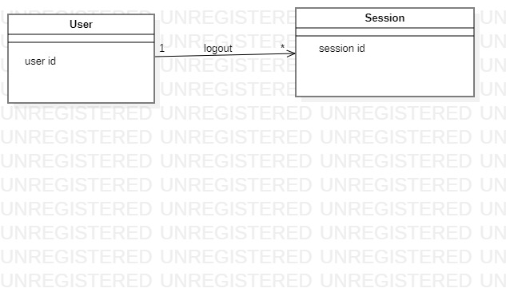

### **MASOOD KHAN:**

Delete Accounts:

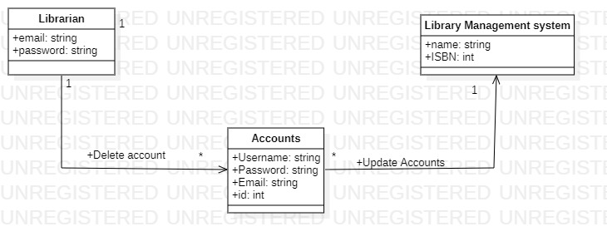

Add Book:

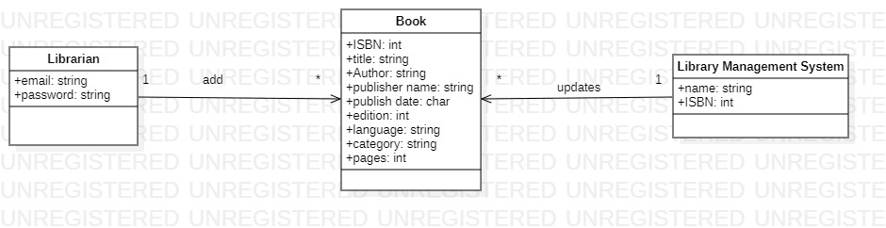

ORDER BOOK:

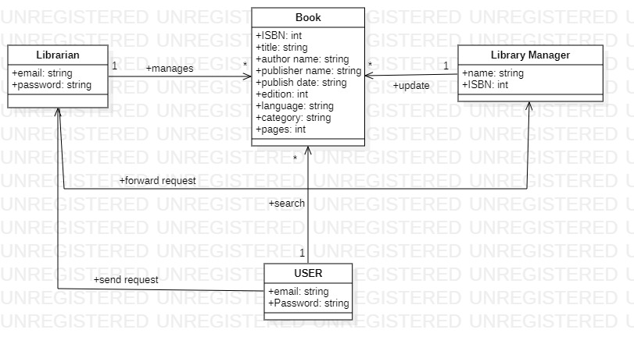

RESERVE BOOK:

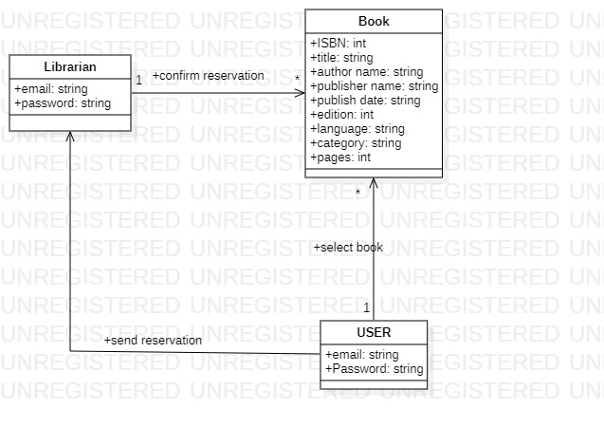

BLOCK Account

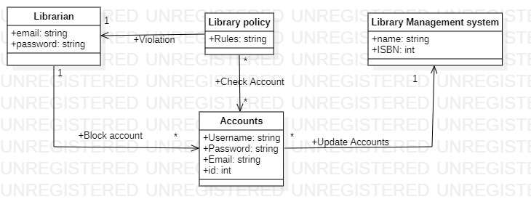

## SYSTEM SEQUENCE DIAGRAM:

### **SOFIA AAMIR:**

**BORROW BOOK:**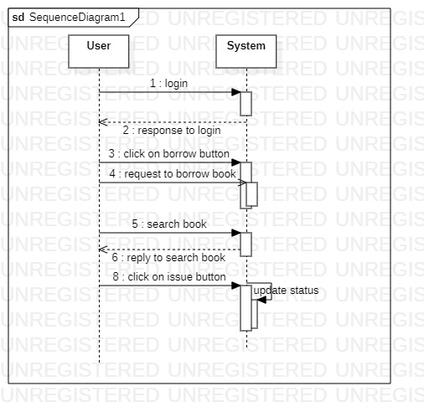

**DELETE BOOK:** 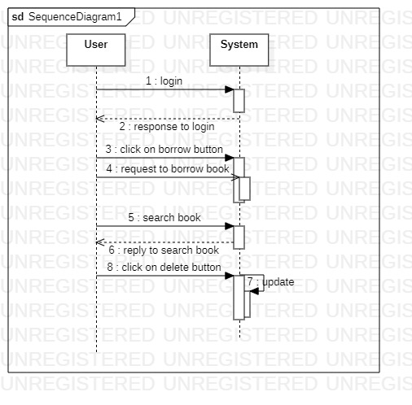

**PAYMENT:**

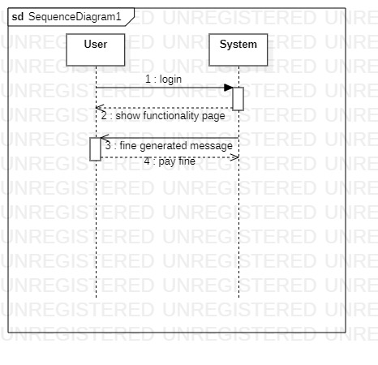

**FEEDBACK:**

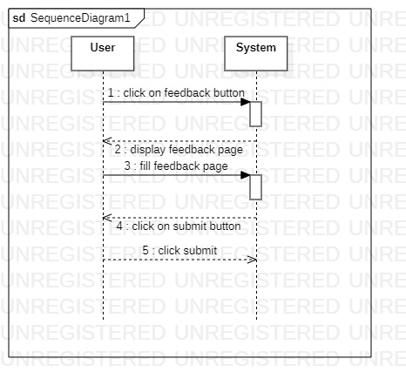

**REGISTER ACCOUNT:**

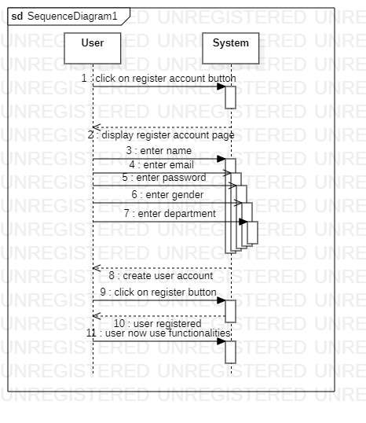

### **MAHNOOR QAZI:**

**LOGIN:**

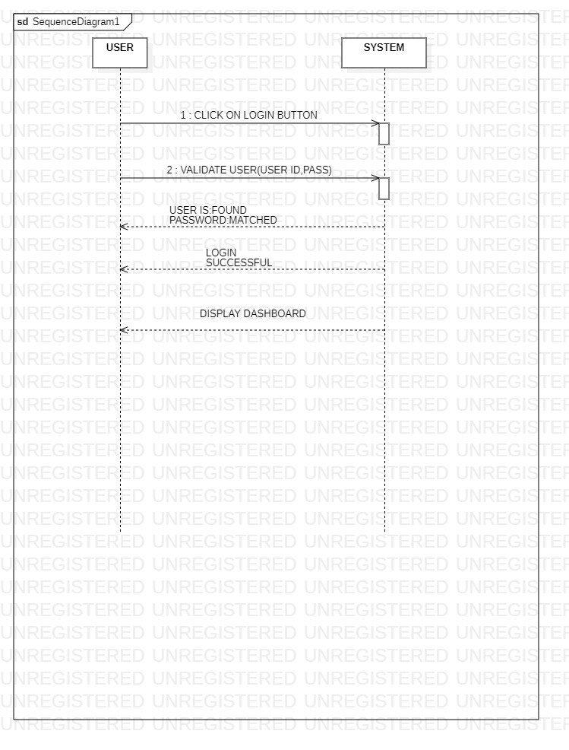

**LOGOUT:**

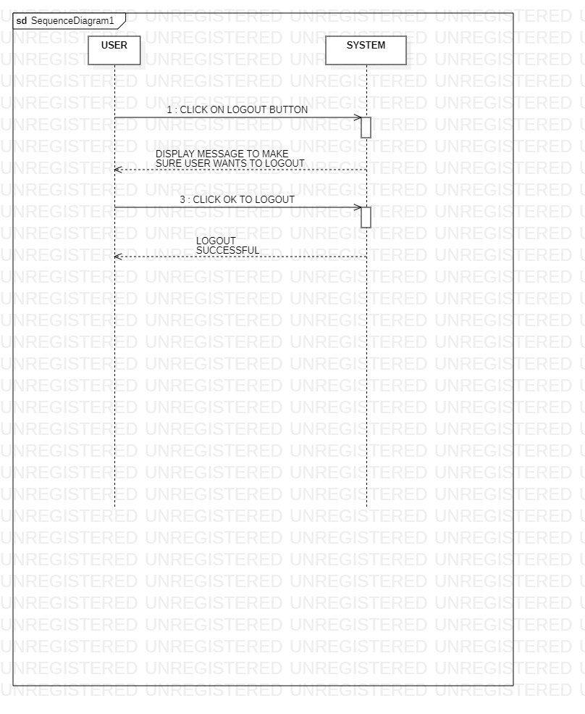

**RETURN BOOK:**

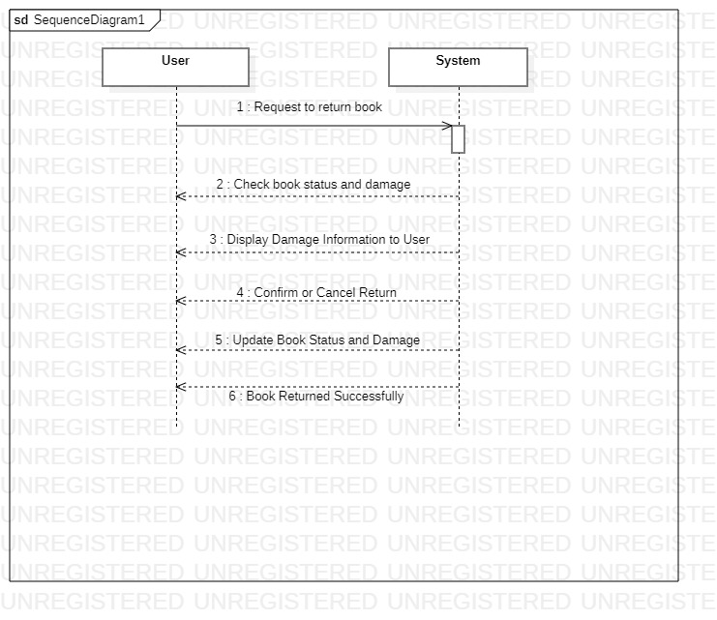

**FINE:**

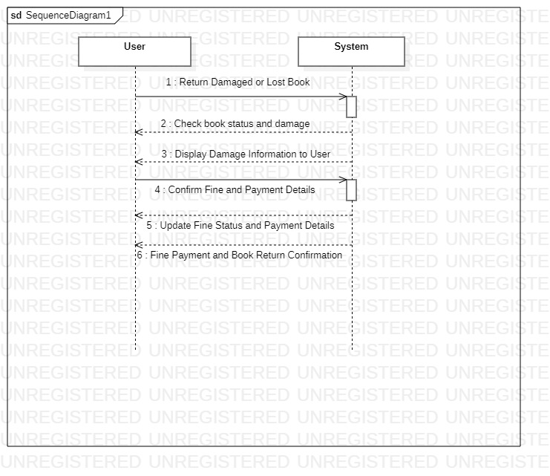

**SEARCH BOOK:**

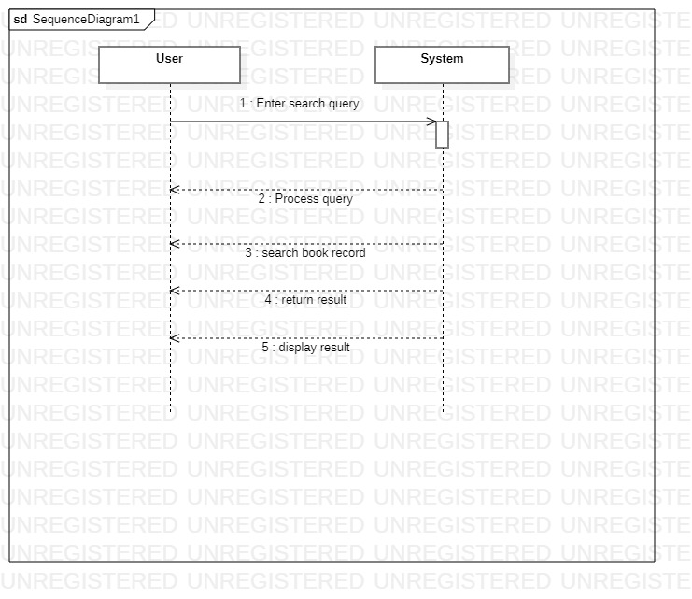

### **MASOOD KHAN:**

**ADD BOOK:**

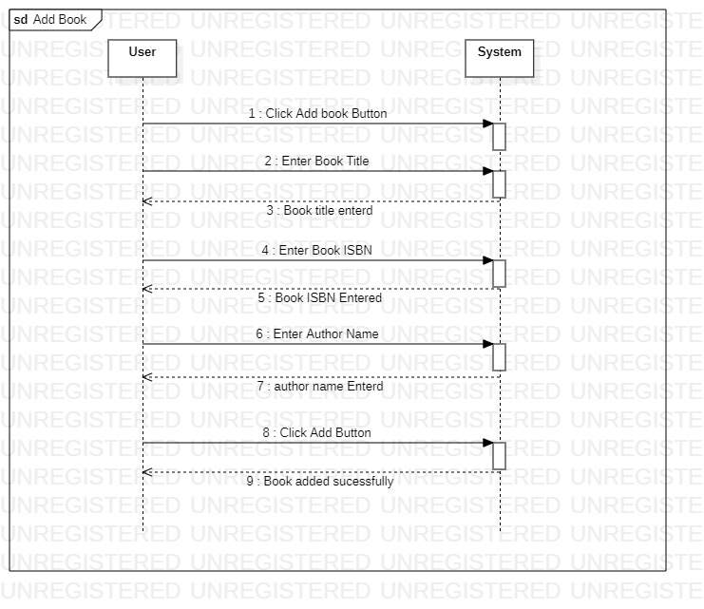

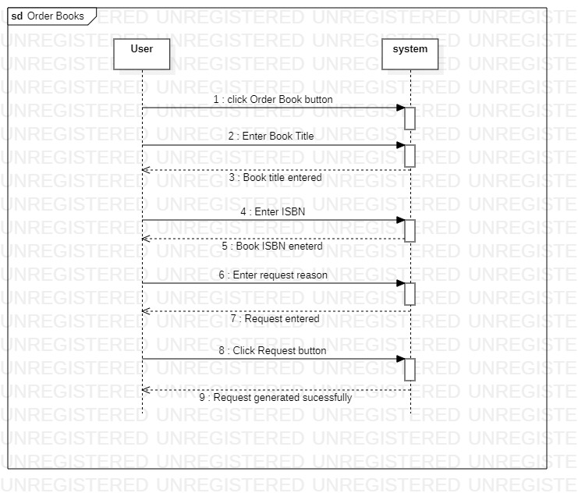**ORDER BOOKS:**

**RESERVE BOOK:**

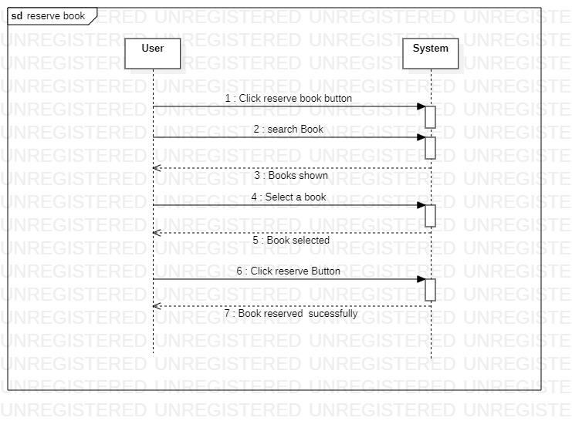

**DELETE ACCOUNT:**

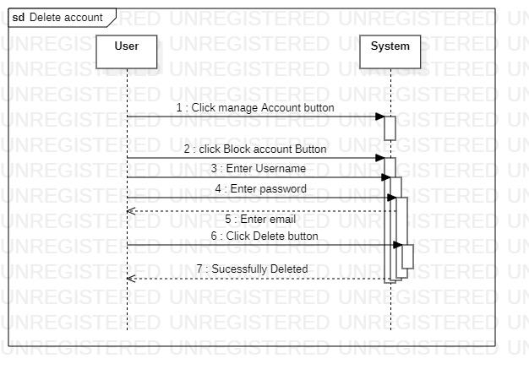

**BLOCK ACCOUNT:**

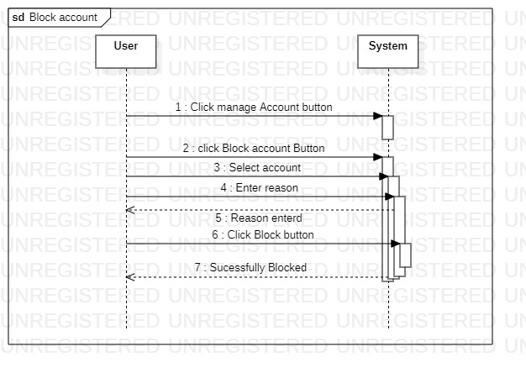

## Operation Contract:

### Sofia Aamir:

* **Register Account:**

|  |  |
| --- | --- |
| **Operation** | Register Account |
| **Cross reference** | This operation allows a user to register an account in the library management system. |
| **Preconditions** | The user must provide valid and unique personal information, including username, password, email, gender and address.  The user must choose a unique username and password for their account.  The user should agree to abide by the library's terms and conditions. |
| **Postconditions** | The user's account is successfully created and stored in the system's database.  The user can log in to the system using the chosen username and password.  The user is provided with a unique user ID or library card number. |

* **Delete book:**

|  |  |
| --- | --- |
| **Operation** | Delete book |
| **Cross reference** | This operation allows an authorized user to delete a book from the library management system. |
| **Preconditions** | The librarian must be logged in to the library management system.  The librarian must have the necessary permissions to delete books from the system.  The book to be deleted must exist in the system's database. |
| **Postconditions** | The book is successfully deleted from the system's database.  Any associated information, such as copies, borrowing history, and reservations, related to the deleted book is also removed. |

* **Borrow book:**

|  |  |
| --- | --- |
| **Operation** | Borrow book |
| **Cross reference** | This operation allows a registered user to borrow a book from the library. |
| **Preconditions** | The user must be logged in to the library management system.  The user's account must be in good standing (no overdue books or outstanding fines).  The book to be borrowed must be available in the library's inventory.  The user must have not reached the maximum limit of books allowed for borrowing. |
| **Postconditions** | The book is marked as borrowed in the system's database.  The user's borrowing record is updated with the book's details and the due date. |

* **Payment:**

|  |  |
| --- | --- |
| **Operation** | Payment |
| **Cross reference** | This operation allows a user to make a payment for fines or outstanding fees in the library management system. |
| **Preconditions** | The user must be logged in to the library management system.  The user must have an existing balance or outstanding fees to be paid.  The user must have a valid payment method associated with their account. |
| **Postconditions** | The payment is successfully processed.  The user's balance or outstanding fees are updated to reflect the payment. |

* **Feedback:**

|  |  |
| --- | --- |
| **Operation** | Feedback |
| **Cross reference** | This operation allows a user to provide feedback or suggestions about the library and its services. |
| **Preconditions** | The user must be logged in to the library management system.  The user must have used the library's services or interacted with the system. |
| **Postconditions** | The user's feedback or suggestion is submitted and recorded in the system.  The library staff can review and respond to the feedback if desired. |

### Masood Khan:

* **Contract C01:Enter BOOK**

|  |  |
| --- | --- |
| **Operation** | Enter Book details(Name ,ISBN ,etc ) |
| **Cross reference** | Use case: ADD BOOK  This operation allows librarian to add book to the library management system |
| **Preconditions** | Library must be logged in through his account  Librarian must give all the details to add book |
| **Postconditions** | The book will be successfully added  The books database will be updated new book will be added,  Proper shelf number and stack will be assigned to the book |

* **Contract C02:Enter User Details**

|  |  |
| --- | --- |
| **Operation** | Enter User Details |
| **Cross reference** | Use Case: DELETE ACCOUNT  By this a librarian can delete an account if user is no longer part of university |
| **Preconditions** | The librarian must be logged in to the library management system.  The librarian must verify if the user is not using library for so long or user is not part of university  The account which librarian want to delete must be present in the database |
| **Postconditions** | Account is successfully deleted  Account will be removed from the database  User will no longer access to the facilities of library |

* **Contract C03:Enter Request Reason:**

|  |  |
| --- | --- |
| **Operation** | Enter Request Reason |
| **Cross reference** | Use Case : Order Book  This operation allow user to order book if book is not available in the library. |
| **Preconditions** | The user must be logged in to the library management system.  The reason must be valid  The book user is trying to order for request must not be present in Library database. |
| **Postconditions** | Request will be generated  Librarian will forward request to library manager  Library manager will order book from a store |

* **Contract C04:Search Book:**

|  |  |
| --- | --- |
| **Operation** | Search Book |
| **Cross reference** | Use Case : Reserve Book  This operation allows a user to reserve a book so others cannot borrow it |
| **Preconditions** | The user must be logged in to the library management system.  The book must be present in library . |
| **Postconditions** | Book will be shown according to search  Book will be selected when after searching  Others users will not be allowed to borrow book when reserved |

* **Contract C05:SELECT ACCOUNT**

|  |  |
| --- | --- |
| **Operation** | Select Account |
| **Cross reference** | Use Case : Block Account  By this a librarian can Block an account if user is violating library rules or done any other suspicious activity |
| **Preconditions** | The librarian must be logged in to the library management system.  The account which librarian want to delete must be present in the database  There will be many account librarian will select which he wants to block |
| **Postconditions** | Account is successfully blocked when selected  Account will be blocked so user cannot login to Library Management System  User will no longer access to the facilities of library |