TASK 2 : MULTI-LINEAR REGRESSION - CAR PRICE PREDICTION

1. DOMAIN EXPLANATION
The automotive resale market is a major part of the used-vehicle economy. When a car changes hands, its resale (selling) price is influenced by a mix of mechanical and commercial factors: how new the car is, how much it originally cost, how far it has been driven, the fuel it runs on, and how it is being sold (through a dealer or directly by an individual). Understanding how these factors combine to determine price helps dealers price inventory accurately, helps individual sellers avoid under- or over-pricing their vehicle, and helps buyers judge whether an asking price is fair. Since pricing conventions and vehicle preferences (fuel type, transmission, brand mix) differ from region to region, this domain focuses specifically on the American used-car market.

2. PROBLEM STATEMENT
Predicting the Selling Price of a Used Car
The goal is to build a multi-linear regression model that identifies which variables significantly predict a car's selling price, and to quantify how well those variables explain price variation. The model should reveal, in interpretable terms, which attributes (showroom price, age, fuel type, seller type, transmission) drive resale value up or down - insight that is useful both for sellers deciding on an asking price and for buyers evaluating whether a listed price is reasonable.

3. DATASET EXPLANATION
- Source: Kaggle - "Car Price Prediction Dataset" (bhavikjikadara/car-price-prediction-dataset)
- Records: 301 vehicles, 9 columns
- Target Variable: Selling_Price (in Lakhs)
Key Features:
- Present_Price: Current ex-showroom price of the car (Lakhs)
- Kms_Driven: Total kilometers driven
- Fuel_Type: Petrol / Diesel / CNG
- Seller_Type: Dealer / Individual
- Transmission: Manual / Automatic
- Owner: Number of previous owners
- Car_Age (engineered): 2026 − Year of manufacture, used in place of raw Year for interpretability
Data quality: no missing values and no duplicate rows were found in the dataset.

4. EXPLORATORY DATA ANALYSIS (EDA)

a] Distribution of Selling Price
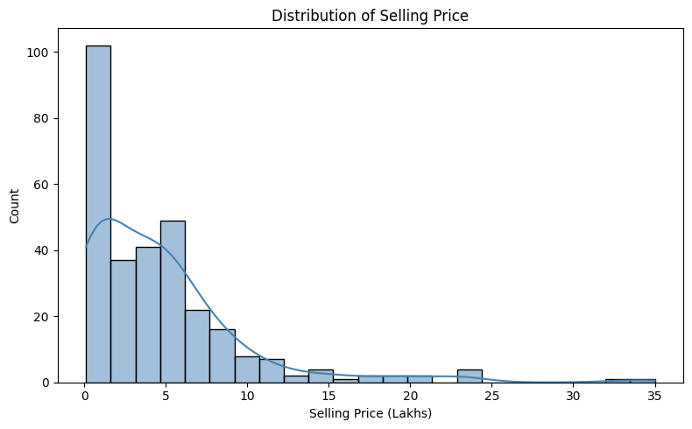

- The distribution is strongly right-skewed - most cars sell between 0 and 6 lakhs.
- A long tail extends up to ~35 lakhs, representing a small number of premium/luxury vehicles.
- This skew suggests the regression should be checked for the influence of high-value outliers.

b] Distribution of Present (Showroom) Price
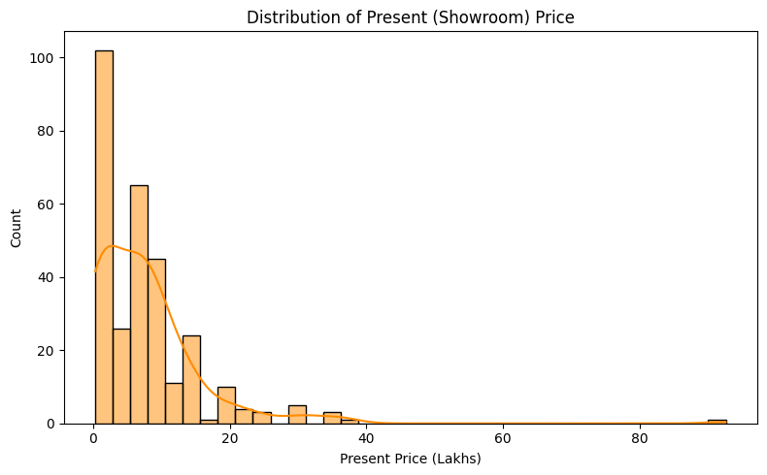

- Present Price follows a similar right-skewed pattern to Selling Price, which hints at a strong relationship between the two.
- Most cars have an original showroom price under 10 lakhs, with a few luxury outliers beyond 20 lakhs.

c] Distribution of Kilometers Driven
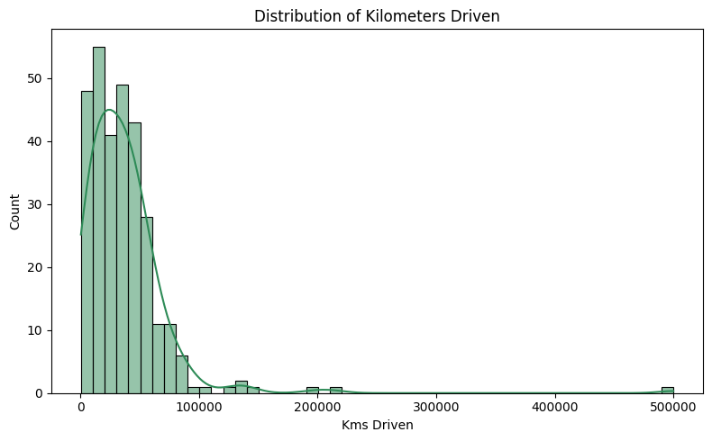

- Most vehicles have been driven between 10,000 and 60,000 km.
- A few high-mileage outliers exceed 100,000 km, typically older vehicles.

d] Correlation Heatmap
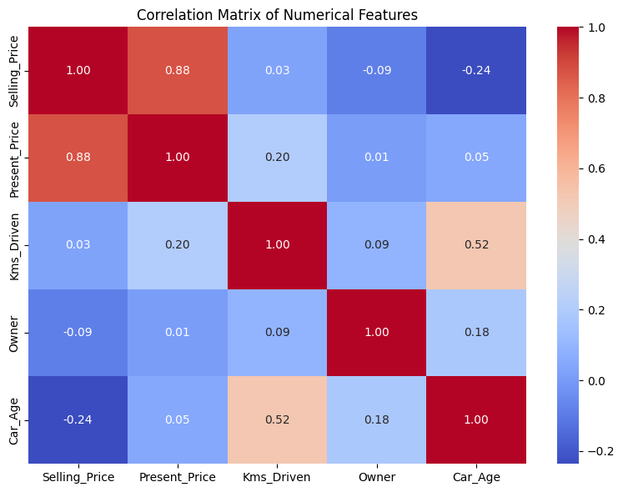
- Present_Price has the strongest correlation with Selling_Price (r = 0.879) - by far the dominant numeric predictor.
- Car_Age is moderately negatively correlated with Selling_Price (r = −0.236) - older cars are worth less.
- Kms_Driven (r = 0.029) and Owner (r = −0.088) show very weak linear correlation with price individually.

e] Selling Price by Categorical Features
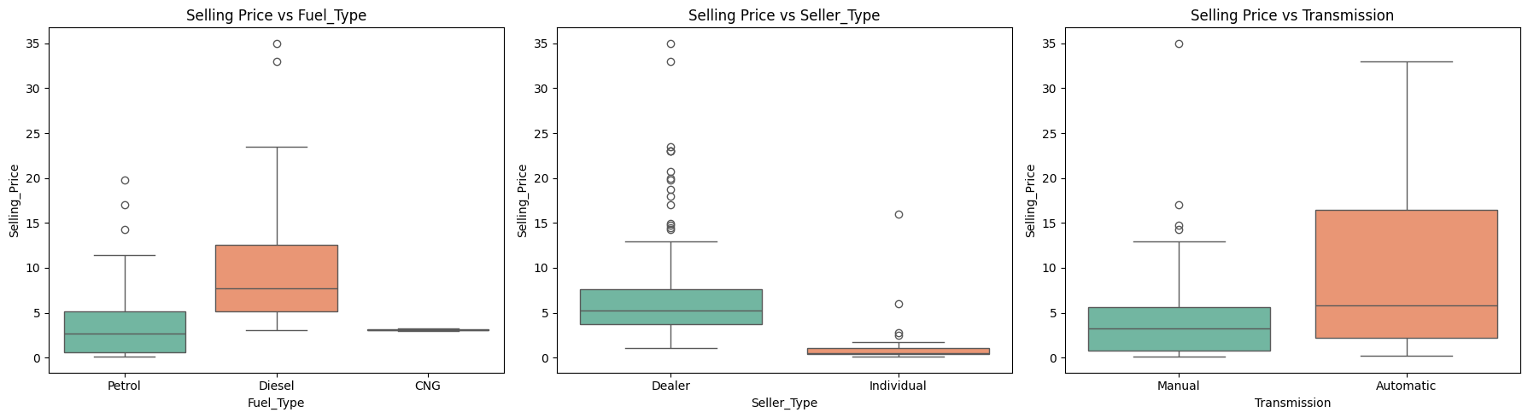
- Diesel cars tend to have a higher median selling price than Petrol or CNG cars.
- Cars sold by Dealers command a higher price than those sold by Individuals.
- Automatic-transmission cars are priced higher on average than Manual-transmission cars.

f] Selling Price vs Car Age
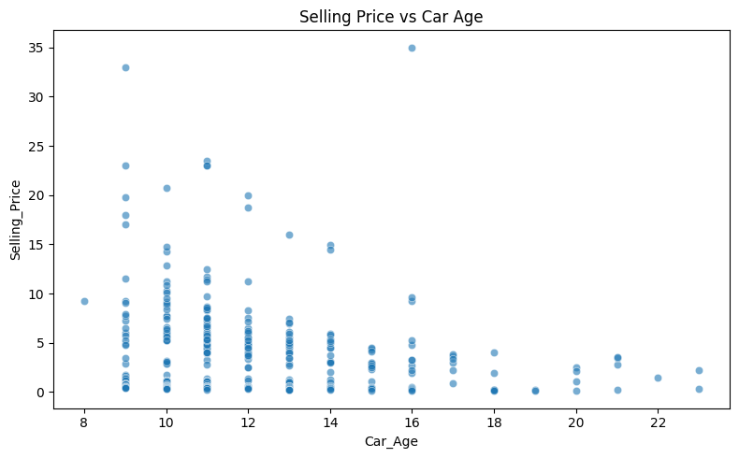

- A visible downward trend confirms that resale value depreciates as the car gets older.

g] Selling Price vs Present Price
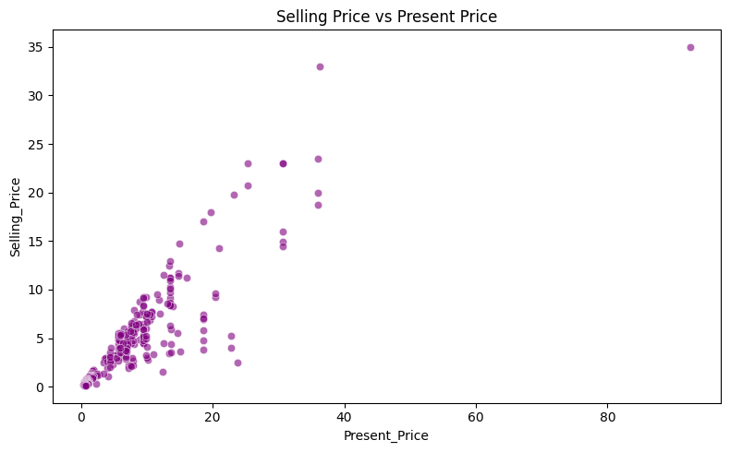

- A clear, strong positive linear relationship - this is the single best predictor for a linear model.

EDA Summary:
- Present_Price is the dominant driver of Selling_Price.
- Car_Age has a clear negative (depreciating) effect.
- Fuel type, seller type, and transmission all shift price systematically and are worth encoding as predictors.
- The linear relationship between Present_Price and Selling_Price supports the use of Multi-Linear Regression.

5. MODEL
Algorithm: Multiple Linear Regression
Why: It gives directly interpretable coefficients, showing exactly how much each feature increases or decreases the predicted selling price - important for explaining pricing decisions to a non-technical audience.
Pipeline:
- Feature engineering: Year converted to Car_Age; Car_Name (high-cardinality identifier) dropped.
- Preprocessing: Numerical features standardized using StandardScaler; categorical features (Fuel_Type, Seller_Type, Transmission) encoded using One-Hot Encoding.
- Train-Test Split: 80% training (239 rows), 20% testing (60 rows).
- Training: Fitted using Ordinary Least Squares (statsmodels, for p-values/significance) and scikit-learn LinearRegression (for prediction). 5-fold cross-validation was used to check generalizability.

6. MODEL EVALUATION

The model was evaluated using standard regression metrics on the held-out test set.
Metric | Value
R² Score (test set) | 0.7528
Mean Absolute Error (MAE) | 1.4729 Lakhs
Root Mean Squared Error (RMSE) | 2.5240 Lakhs
Cross-Validation R² (5-fold, mean) | 0.8687 (± 0.0429)
In-sample OLS R² (training set) | 0.905

i) Feature Coefficients (standardized)
Top predictors ranked by absolute coefficient size:
- Present_Price: +3.8548 (strongest positive driver)
- Car_Age: −0.9511 (older cars → lower price)
- Fuel_Type_Diesel: +0.8363 (diesel cars → higher price)
- Seller_Type_Individual: −0.6213 (individual sellers → lower price than dealers)
- Transmission_Manual: −0.5282 (manual cars → lower price than automatic)

ii) Actual vs Predicted Plot
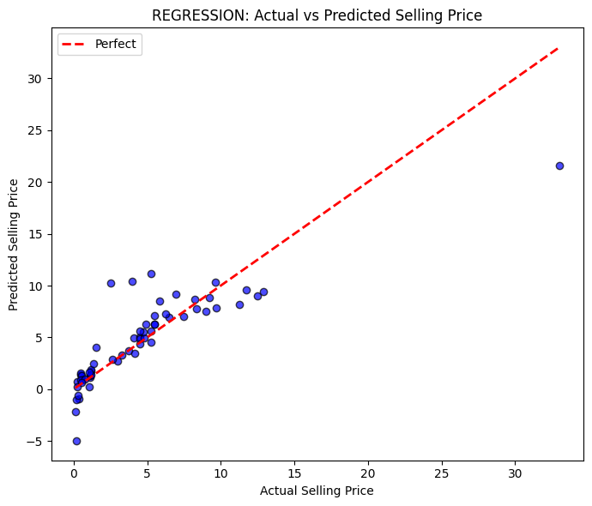

iii) Residuals Plot
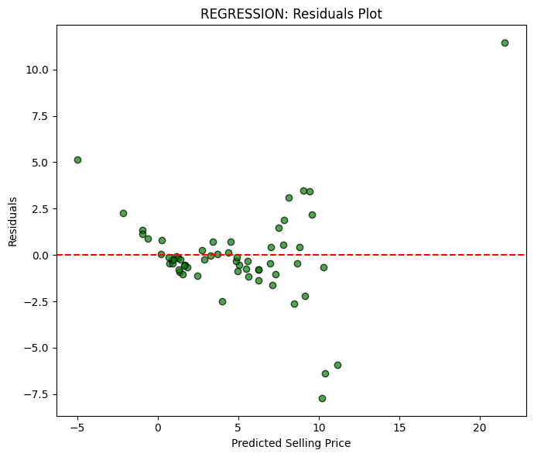

iv) Residuals Distribution
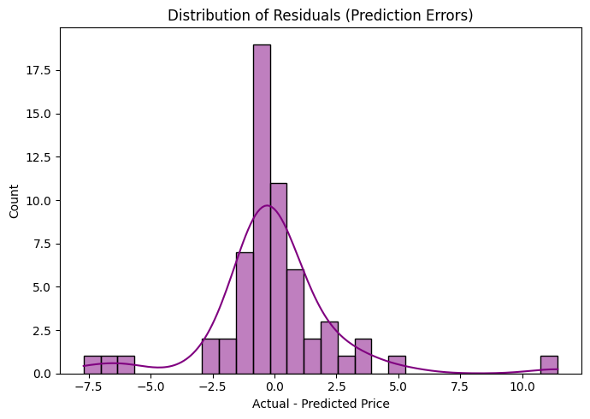

7. RESULTS & DISCUSSION
Interpretation: The model explains about 75% of the variance in selling price on unseen test data (R² = 0.7528), with an average prediction error of roughly ₹1.47 lakhs (MAE) and RMSE of ₹2.52 lakhs. The 5-fold cross-validation R² (0.8687) is noticeably higher than the single test-set R², and the in-sample OLS R² (0.905) is higher still - this gap suggests some overfitting/variance due to the small dataset size (only 301 rows, 239 for training), and indicates the test split happened to contain a few harder-to-predict points. The Actual-vs-Predicted plot shows points tracking the diagonal reasonably well for lower-priced cars, with more scatter at higher price points, where a small number of luxury-car outliers are harder to fit exactly.
Key Factors: Present_Price (the current showroom price) is overwhelmingly the strongest predictor - which makes intuitive sense, since a car's resale value is anchored to its original price. Car_Age is the next most important factor, confirming that resale value depreciates over time. Fuel type, seller type, and transmission each shift the price by a smaller but still meaningful and statistically detectable amount.
Conclusion: The Multi-Linear Regression model is a reasonably effective, highly interpretable tool for estimating used-car resale price in the American market. It could be used by sellers/dealers as a first-pass pricing guide, though for higher accuracy on high-value/luxury vehicles a larger dataset or a non-linear model (e.g., Random Forest) could be explored as a next step.

