TASK 3 : LOGISTIC REGRESSION - BANK CUSTOMER CHURN PREDICTION

1. DOMAIN EXPLANATION
Customer retention is a core concern in retail banking. Acquiring a new customer is significantly more expensive than retaining an existing one, so banks invest heavily in identifying customers who are at risk of leaving ("churning") before they actually close their accounts. This domain uses customer demographic data (age, gender, country), account behaviour (balance, tenure, number of products, active-member status), and financial standing (credit score, estimated salary) to flag customers who are statistically likely to churn, so the bank's relationship managers can intervene with retention offers or improved service.

2. PROBLEM STATEMENT
Predicting Customer Churn for ABC Bank. The goal is to build a logistic regression model that classifies whether a customer will churn (leave the bank) or stay, using their demographic and account information. Since acquiring a new customer costs more than retaining one, the bank wants to proactively identify at-risk customers and understand which factors most strongly influence their decision to leave, so it can communicate with them before they churn.

3. DATASET EXPLANATION
- Source: Kaggle - "Bank Customer Churn Dataset" (gauravtopre/bank-customer-churn-dataset)
- Records: 10,000 customers, 12 columns
- Target Variable: churn (1 = customer left, 0 = customer stayed)
Key Features:
- credit_score: Customer's credit score
- country: Customer's country (France / Germany / Spain)
- gender: Male / Female
- age: Customer's age
- tenure: Number of years as a bank customer
- balance: Account balance
- products_number: Number of bank products used
- credit_card: Whether the customer holds a credit card (1/0)
- active_member: Whether the customer is an active member (1/0)
- estimated_salary: Customer's estimated salary
Data quality: no missing values and no duplicate rows were found. The overall churn rate in the dataset is 20.37% - i.e. the classes are imbalanced (roughly 4 stayed for every 1 churned).

4. EXPLORATORY DATA ANALYSIS (EDA)

a] Churn Class Distribution
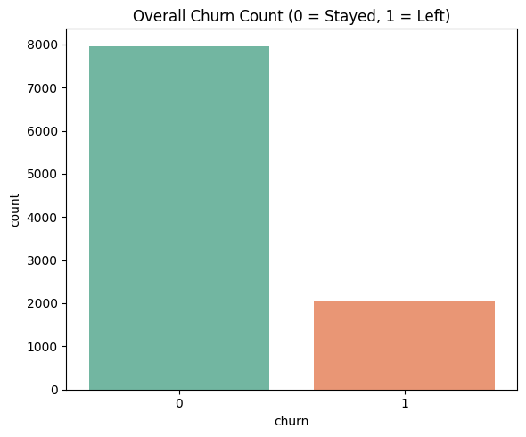

- Confirms class imbalance - about 79.6% of customers stayed and 20.4% churned.
- This imbalance is important: it means plain accuracy can be misleading, and precision/recall/ROC-AUC matter more for evaluating the model.

b] Churn by Country, Gender, Active-Member Status, Age, and Products
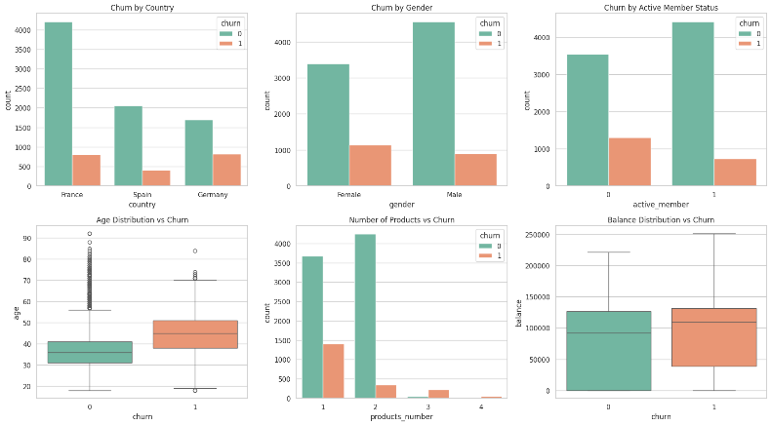
- Germany shows a visibly higher churn proportion than France or Spain.
- Customers who are not active members churn noticeably more than active members.
- Older customers show a higher tendency to churn (churn-group median age is higher).
- Customers with 3–4 products churn far more than those with 1–2 products, despite being a smaller group.

c] Correlation Heatmap (Numerical Features)
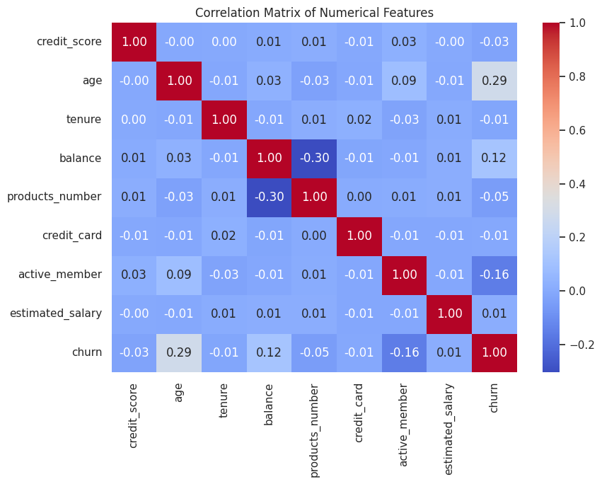
- Age has the strongest linear correlation with churn (r = 0.285) among numeric features.
- active_member is negatively correlated with churn (r = −0.156) - active members churn less.
- balance shows a mild positive correlation (r = 0.119); credit_score, tenure, estimated_salary, and credit_card show very weak correlation individually.
EDA Summary:
- Churn is imbalanced (~20% positive class), so evaluation must go beyond accuracy.
- Age and active-member status are the clearest behavioural/demographic signals of churn.
- Country (particularly Germany) and number of products also show visible patterns worth encoding as predictors.

5. MODEL
Algorithm: Logistic Regression
Why: Logistic Regression directly models the probability of churn and produces interpretable coefficients/odds ratios, showing exactly how each feature raises or lowers a customer's odds of leaving - useful for the bank to justify and prioritize retention actions.
Pipeline:
- Preprocessing: customer_id (identifier, non-predictive) dropped; country and gender one-hot encoded; all numerical features standardized using StandardScaler.
- Train-Test Split: 80% training / 20% testing, stratified on churn to preserve the class ratio in both sets.
- Training: scikit-learn LogisticRegression (max_iter = 1000). 5-fold cross-validation (scored on ROC-AUC) was used to check generalizability.

6. MODEL EVALUATION
The model was evaluated on the held-out test set (2,000 customers) using classification metrics appropriate for an imbalanced target.
Metric | Value
Accuracy | 0.8080
Precision (churn = 1) | 0.5891
Recall (churn = 1) | 0.1867
F1-Score (churn = 1) | 0.2836
ROC-AUC | 0.7748
Cross-Validation ROC-AUC (5-fold, mean) | 0.7634 (± 0.0115)

i) Feature Coefficients & Odds Ratios
Top drivers of churn, ranked by absolute coefficient size:
- age: coeff = +0.7388, odds ratio = 2.09 → each std-dev increase in age roughly doubles the odds of churning
- active_member: coeff = −0.5155, odds ratio = 0.60 → active members are notably less likely to churn
- country_Germany: coeff = +0.3567, odds ratio = 1.43 → German customers are more likely to churn than the French baseline
- gender_Male: coeff = −0.2609, odds ratio = 0.77 → male customers churn somewhat less than female customers
- balance: coeff = +0.1606, odds ratio = 1.17 → higher balance is mildly associated with higher churn odds

ii) Confusion Matrix & ROC Curve
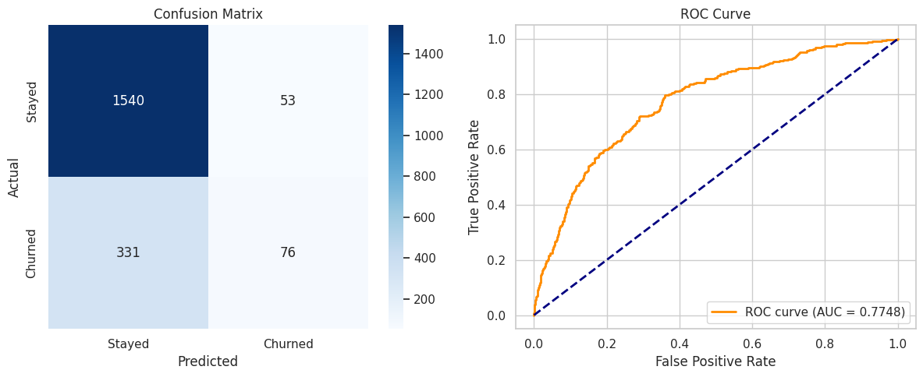

iii) Feature Importance
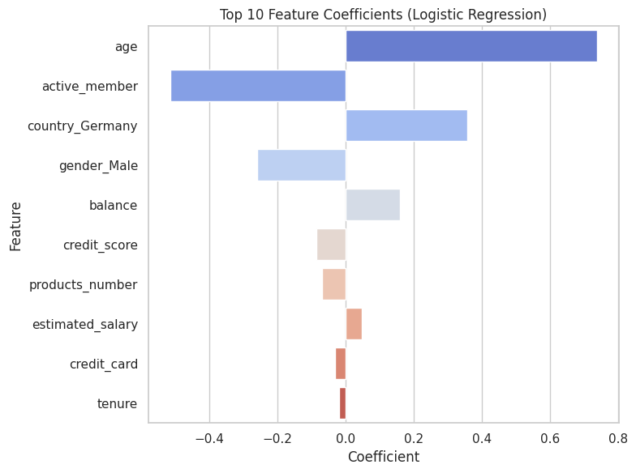

7. RESULTS & DISCUSSION
Interpretation: The model reaches 80.8% accuracy and a ROC-AUC of 0.7748, meaning it separates churners from non-churners reasonably well overall. However, accuracy is inflated by the class imbalance: the classification report shows precision of 0.59 but recall of only 0.19 for the churn class, meaning the model correctly identifies only about 1 in 5 customers who actually churn, even though when it does flag someone as a churner, it is right about 59% of the time. In practical terms, the model is currently biased toward predicting "stayed" because that is the majority class - it plays it safe rather than aggressively flagging risk, which is not ideal for a bank that wants to catch as many at-risk customers as possible.
Key Factors: Age is the strongest driver of churn - older customers are considerably more likely to leave. Being an active member substantially reduces churn odds, and customers based in Germany churn more than those in France or Spain. Gender and account balance play smaller but still measurable roles.
Limitation & Improvement: The low recall is a direct consequence of the ~80/20 class imbalance (only 20.37% of customers churned) combined with logistic regression's default 0.5 decision threshold. This could be improved by (a) training with class_weight='balanced', (b) applying oversampling techniques such as SMOTE, or (c) lowering the classification threshold to trade some precision for higher recall - all worth exploring if the bank's priority is to minimize missed at-risk customers rather than to minimize false alarms.
Conclusion: Logistic Regression provides an interpretable baseline for churn prediction, correctly ranking customers by risk (ROC-AUC 0.77) and clearly highlighting age, activity status, and country as the main churn drivers. For deployment, the bank should combine this model with a rebalancing strategy or a threshold adjustment so that more true churners are actually caught, since under the current setup most churners are being missed.

