**Q1:Brief Description of the project:**

In the context of this laboratory terminal project, we've crafted a semantic analyzer to pinpoint errors within the code block. The SemanticAnalyzer() function is designed to process a list of tokens obtained by the Scanner. It evaluates whether the sequence of tokens adheres to any of the three rules outlined in the project description using Top-Down Parsing. Subsequently, the function generates a list enumerating any errors detected. To provide a concise view, here's a summarized version of the SemanticAnalyzer() function with collapsed code.

Within the SemanticAnalyzer() function, a primary "for" loop systematically traverses the provided list of tokens. It assesses each token to determine which of the three rules is applicable to initiate acceptance. Once a rule commences acceptance, it becomes the chosen rule for evaluation. This selected rule persists until it either reports an error or signifies successful validation with an "Ok" status, indicating that the preceding sequence of tokens adhered to the rule accurately.

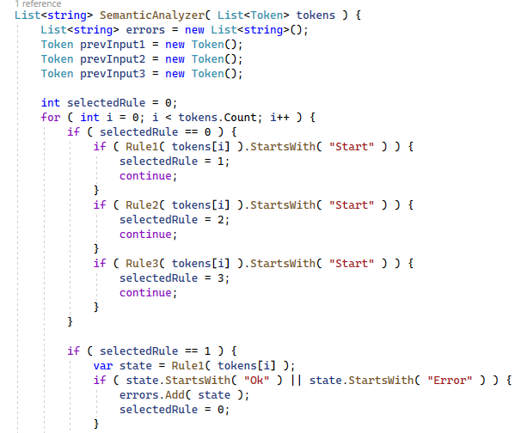

For each rule, a token is extracted during every loop iteration, and the previously observed token is stored in a variable called "previousInput." Within each rule, the upper portion delineates the conditions triggering the initiation, termination, and continuation of that rule's application. Meanwhile, the lower part of the rule handles the identification of errors and provides feedback on what the rule anticipated instead.

Roles 1, 2, and 3:

