**Q3:User Input:**

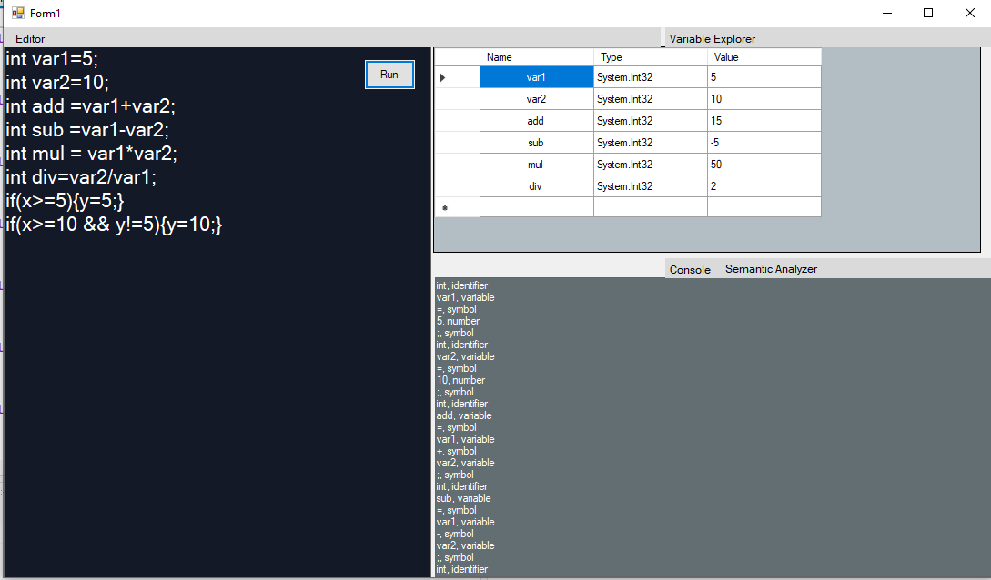

**Output:**

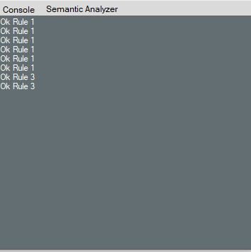

**Semantic Analyzer**

Checking the lines with roles

Ok Rule 1 Ok Rule 1 Ok Rule 1 Ok Rule 1 Ok Rule 1 Ok Rule 1 Ok Rule 1 Ok Rule 3 Ok Rule 3

If we replace by this input then,

if(x >= 10) {y = 10; }

if(x >= 20 && y != 10) { y = 20;}

with

if(x >= 10) y = 10; }

if(x >= 20 && y != 10 { y = 20;}