Universidad Peruana de Ciencias Aplicadas



MIDTERM PROJECT REPORT

Big Data

Degree Program:
Computer Science

Section:
18519

Students:
(U20221C621) Gomez Rubina, Luis David
(U20191C439) Miranda Cardenas, Sofia Gabriel
(U201616851) Olivera Alvarez, Lizbeth Teresita

2026
Table of Contents
Introduction 6
Problem Statement 6
Product Question 6
Source Inventory 6
Schema Draft 6
Entity Tables 7
Keys (Primary and Foreign Keys) 7
Relationships and Joins 8
ERD 9
Data Dictionary 9
Raw Dataset Overview 9
Tables Description 11
Ethics and Access Note 14
Preprocessing and feature engineering 15
Preprocessing 15
Data Loading and Initial Inspection 15
Duplicate Handling 15
Variable Identification 16
Missing Values Check 16
Date Column Conversion 17
Scale Analysis 17
Feature Engineering 18
patient_feature_matrix: 18
Source Tables: 18
Join Operation: 18
Aggregation Level: 18
Features Included: 19
Data Types 19
Dimensions: 19
Feature Matrix Expansion 21
Dimensionality and Representation Analysis 22
Motivation 22
Methods 22
PCA 22
t-SNE 24
Data Preparation 25
Results 26
Explained Variance 26
Component Selection 26
Comparison Table 26
Visualizations 27
K-Means Experiment 31
K Selection 31
K-Means Model 34
Model Training 36
Cluster Visualization 36
DBSCAN Experiment 38
Parameter Selection 38
DBSCAN Parameter Sweep Analysis 39
Validation Table 40
Cluster Profile Analysis 41
Cluster 0: "Standard High-Turnover Care Group A" (Low-Risk Operational Baseline) 42
Cluster 1: "Extended Stay / Low-Intensity Segment" (Operational Bed-Occupancy Bottleneck) 43
Cluster 2: "High-Intensity & High-Risk Critical Segment" (Maximum Exposure & Margin Risk) 44
Cluster 3: "Standard High-Turnover Care Group B" (Symmetric Commercial Runtime) 45
Failure Analysis 46
a. K-Means Structural Boundary Overlap 46
b. DBSCAN Density Disruption & Outlier Value 46
Technical Interpretation 47
1. Dimensionality Reduction & Latent Space Structure (PCA Analysis) 47
2. Clustering Topology & Mathematical Validation 48
K-Means Convergence & Compactness 48
DBSCAN Density Collapse 49
3. Algorithmic Trade-Off & Final Production Selection 50
4. Model Validation Summary Table 50
Recommendation, Ranking, or Predictive Decision Engine 51
1. Task Framing and Product Context 51
2. Data Alignment and Experiment Design 52
3. Offline Evaluation Protocol 54
4. Baseline System Implementation 56
4.2. Ranking Baseline 2: Random Ranking 56
4.3. Ranking Baseline 3: Clinical Rule Ranking 56
5. Stronger System Development 57
5.1. Intermediate Model: Logistic Regression (Balanced) 57
5.2. Primary Model: Random Forest (Balanced) 57
5.3. CatBoost 57
5.4. Final Ranking Scorer: Ensemble RF + CatBoost 58
6. Comparative Performance Report 58
6.1. Validation Metrics Table 58
6.2. Ranking Quality Precision@K 59
6.3. Ranking Performance Interpretation 60
7. Error Analysis and Case Studies 60
7.1. Aggregate Error Profile 60
Graph Analytics 63
Graph Definition 63
Node Types 63
Edge Definition: Statistical Significance, Not Mere Co-occurrence 64
Lift: The Significance Filter 64
Edge Attributes 65
Top 5 Significant Edges by Weight 66
Weight Justification 66
Directionality Justification 67
Graph Grain 67
Graph Construction Script 67
Data Sources 67
Preprocessing and Construction Steps 68
Final Graph Summary 69
Graph Report 69
Connected Components and Isolated Nodes 69
Density 70
Degree and Weighted Degree 70
Betweenness and Closeness Centrality 71
PageRank 71
Comparison Section 72
1. PageRank Ranking vs. Popularity (Raw Frequency) 72
2. Spearman Correlation 73
3. Cases Where Rankings Differ 75
Interpretation Note 75
What the Graph Structure Does Mean 75
What the Graph Structure Does NOT Mean 75
Validity Checks 76
1. Sparsity 76
2. Isolated Nodes at the Primary Threshold 77
3. Sensitivity to a Secondary Weight Threshold 77
4. Weight Distribution 78
5. Full Threshold Sweep 78
Evaluation protocol 78
Clustering (K-Means / DBSCAN) 78
Ranking Engine (Clinical Priority Queue) 79
Graph Analytics 79
Shared Principle Across Layers 80
Pipeline and reproducibility 80
Key Reproducibility Dependency 81
What Is and Is Not Currently Scripted 81
Environment and Execution Order 82
Monitoring and Operationalization Plan 82
Serving Assumptions 82
Data and Model Drift 83
Retraining Triggers 84
Logging 85
Failure Modes 85
Ethics and limitations 86
Limitations 86
Future Work 88
Conclusions 89
Anexos 92

Introduction
This project focuses on building a data intelligence pipeline for the healthcare sector. Using a synthetic dataset of 55,500 patient records, we aim to implement a complete lifecycle from automated ingestion to advanced entity clustering and graph-based medical analysis.

Problem Statement
The core challenge is the lack of structured, high-integrity data in hospital management. This project addresses the need for a "Catalog Layer" that cleans raw data, standardizes medical categories, and handles high-cardinality features, providing a foundation for predictive clinical insights.

Product Question
Is it possible to cluster patient profiles and treatment pathways to identify patterns between medical conditions, medication types, and hospital admission outcomes?

Source Inventory
- Primary Source: healthcare_dataset.csv (Synthetic Healthcare Data).
- Entity Count: Patients (unique individuals), Doctors, and Healthcare Providers.
- Key Features: Medical Condition, Admission Type, Medication, and Test Results.
- Temporal Scope: Continuous tracking from Admission Date to Discharge Date.
Dataset url | https://www.kaggle.com/datasets/prasad22/healthcare-dataset

Schema Draft

Entity Tables
The data model is composed of multiple entity tables derived from the original dataset. Each table represents a key component of the healthcare domain and is designed to support relational and analytical operations.
The main entities include:
- patients: stores demographic information about each patient, such as age, gender, and blood type.
- hospitals: contains identifiers and names of healthcare institutions.
- doctors: includes information about attending medical professionals.
- medical_conditions: represents diagnosed health conditions.
- medications: represents prescribed treatments.
- medical_records: serves as the central table that captures each clinical event, including patient interactions, diagnosis, treatment, and hospital-related data.

Keys (Primary and Foreign Keys)
The schema uses primary keys (PK) to uniquely identify each record within a table, and foreign keys (FK) to establish relationships between tables.
Primary Keys (PK):
- patients.patient_id
- hospitals.hospital_id
- doctors.doctor_id
- medical_conditions.condition_id
- medications.medication_id
- medical_records.record_id
Foreign Keys (FK):
- medical_records.patient_id → patients.patient_id
- medical_records.hospital_id → hospitals.hospital_id
- medical_records.doctor_id → doctors.doctor_id
- medical_records.condition_id → medical_conditions.condition_id
- medical_records.medication_id → medications.medication_id

Relationships and Joins
The schema defines one-to-many relationships between entity tables and the central medical_records table.
- One patient can have multiple medical records.
- One hospital can have multiple medical records.
- One doctor can be associated with multiple medical records.
- One medical condition can appear in multiple records.
- One medication can appear in multiple records.
These relationships are implemented through foreign keys and enable efficient joins for analytical purposes.
Example joins include:
- patients ↔ medical_records (via patient_id)
- hospitals ↔ medical_records (via hospital_id)
- medical_conditions ↔ medical_records (via condition_id)
- medications ↔ medical_records (via medication_id)

ERD
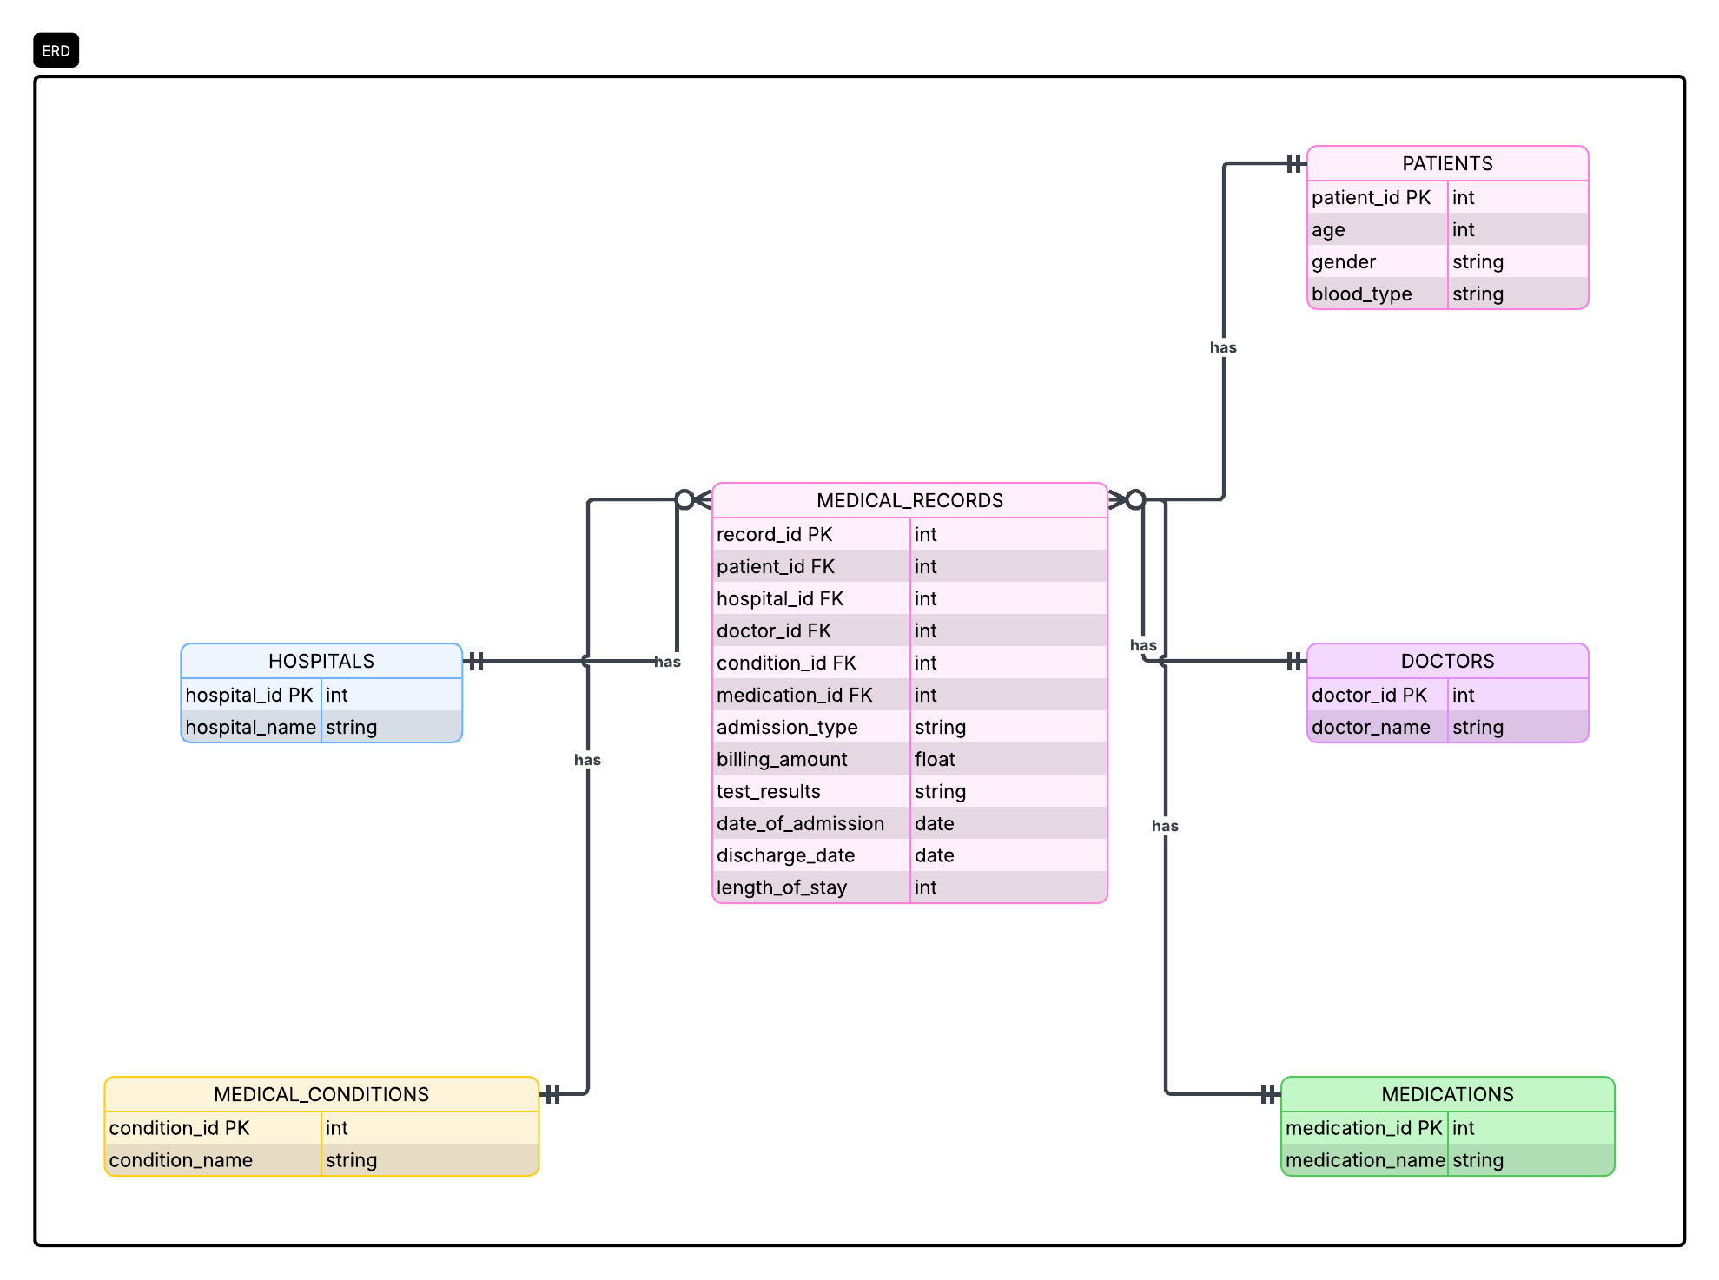
The schema transforms the original dataset into a normalized relational model centered on medical_records. Key entities such as patients, hospitals, doctors, conditions, and medications are separated into individual tables and connected through foreign keys, enabling scalable analysis, clustering, and graph-based modeling.

Data Dictionary

Raw Dataset Overview

Column Name | Description | Data Type
Name | Patient's name | string
Age | Age of the patient | integer
Gender | Gender of the patient (Male, Female) | categorical
Blood Type | Blood type of the patient | categorical
Medical Condition | Diagnosed medical condition | categorical
Date of Admission | Date of patient admission | datetime
Doctor | Attending doctor's name | string
Hospital | Hospital name | string
Insurance Provider | Insurance company | categorical
Billing Amount | Total billing amount | float
Room Number | Room assigned to the patient | integer
Admission Type | Type of admission (Emergency, Elective, Urgent) | categorical
Discharge Date | Date of patient discharge | datetime
Medication | Prescribed medication | categorical
Test Results | Results of medical tests | categorical
The raw dataset was transformed into multiple normalized tables to support relational analysis, clustering, and graph-based modeling.

Tables Description
Table: Patients
The patients table contains demographic information for each individual in the dataset. It includes attributes such as age, gender, and blood type, and each patient is uniquely identified by a patient_id. This table serves as a core entity for analyzing patient-level patterns.
Column | Type | Description
patient_id | int | unique identifier for each patient
age | int | age of the patient
gender | categorical | patient gender
blood_type | categorical | blood type of the patient

Table: Hospitals
The hospitals table stores information about healthcare institutions where patients receive treatment. Each hospital is uniquely identified by a hospital_id and is linked to medical records through relational keys.
Column | Type | Description
hospital_id | int | unique identifier for each hospital
hospital_name | string | name of the hospital

Table: Doctors
The doctors table contains information about medical professionals responsible for patient care. Each doctor is uniquely identified by a doctor_id and may be associated with multiple medical records.
Column | Type | Description
doctor_id | int | unique identifier for each doctor
doctor_name | string | name of the doctor

Table: medical_conditions
The medical_conditions table represents the set of diagnosed health conditions. Each condition is assigned a unique condition_id, enabling consistent referencing and reducing redundancy across the dataset.
Column | Type | Description
condition_id | int | unique identifier for the condition
condition_name | categorical | name of the medical condition

Table: Medications
The medications table includes the different treatments or drugs prescribed to patients. Each medication is uniquely identified by a medication_id and is linked to medical records for analysis of treatment patterns.
Column | Type | Description
medication_id | int | unique identifier for the medication
medication_name | categorical | name of the medication

Table: medical_records
The medical_records table is the central fact table of the dataset. It captures each clinical event, including patient interactions with hospitals and doctors, diagnoses, treatments, admission details, and billing information. This table connects all other entities through foreign keys and enables comprehensive analytical tasks such as clustering, pattern discovery, and graph-based modeling.
Column | Type | Description
record_id | int | unique identifier for each record
patient_id | int | reference to patients table
hospital_id | int | reference to hospitals table
doctor_id | int | reference to doctors table
condition_id | int | reference to medical_conditions table
medication_id | int | reference to medications table
admission_type | categorical | type of admission (Emergency, Elective, Urgent)
billing_amount | float | total cost of treatment
test_results | categorical | results of medical tests
date_of_admission | datetime | admission date
discharge_date | datetime | discharge date
length_of_stay | int | number of days hospitalized

Ethics and Access Note
- Data Origin: The data is a synthetic dataset designed for educational and data science research.
- Usage Justification: We are utilizing this dataset under academic license for the "Domain Discovery, Recommendation, and Graph Intelligence" course.
- Personal Data Risks and Mitigation: While the data contains "Name" fields, they are synthetically generated and do not correspond to real individuals (PII). To prevent any accidental correlation, these identifiers will be treated as non-functional tokens or excluded from the final feature vectors.

Preprocessing and feature engineering

Preprocessing

Data Loading and Initial Inspection
The dataset, healthcare_dataset.csv, was loaded into a Pandas DataFrame. An initial inspection using df.info() revealed 15 columns with various data types, primarily object (strings), int, and float.

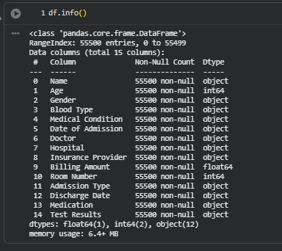

Duplicate Handling
A check for duplicate rows identified 534 duplicate entries. These duplicates were subsequently removed using df.drop_duplicates(inplace=True), resulting in a cleaned dataset of 54,966 unique rows.

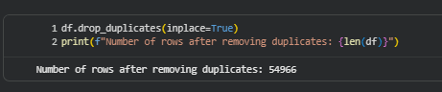

Variable Identification
Columns were categorized into numerical and categorical types:

- Categorical Columns: Name, Gender, Blood Type, Medical Condition, Date of Admission, Doctor, Hospital, Insurance Provider, Admission Type, Discharge Date, Medication, Test Results.
- Numerical Columns: Age, Billing Amount, Room Number.
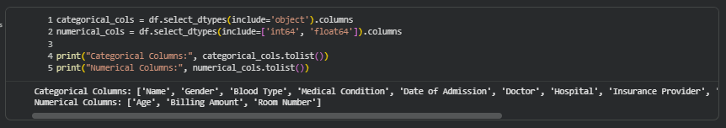

Missing Values Check
No missing values were found across any of the columns in the dataset, eliminating the need for imputation.
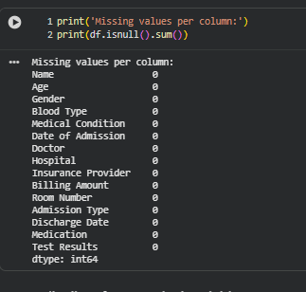

Date Column Conversion
The columns Date of Admission and Discharge Date were converted from object (string) to datetime data type using pd.to_datetime. This is crucial for any time-based analysis, such as calculating the length of stay.

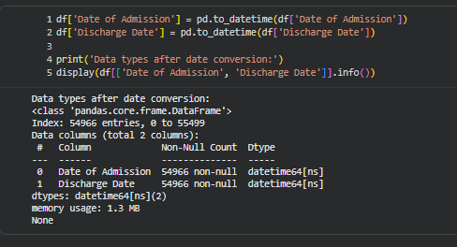

Scale Analysis
- Number of Rows and Columns: 55,500 initial records and 15 columns. After removing duplicates, the dataset maintains 54,966 clean records.
- Missingness: The dataset is complete with 0% missing values, ensuring high reliability for statistical modeling.
- Sparsity or Memory Estimation: This is a dense dataset with a memory footprint of approximately 6.4 MB, allowing for high-performance processing in standard environments.

Feature Engineering

patient_feature_matrix:
Aggregated patient-level feature matrix constructed by combining demographic information with medical records. Each row represents a unique patient and summarizes their healthcare activity and characteristics.

Source Tables:
- patients
- medical_records

Join Operation:
The datasets were merged using a left join on patient_id:
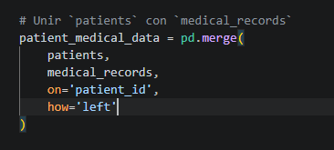

Aggregation Level:
- Grouped by: patient_id
- Each row represents: one patient

Features Included:
Feature Name | Description | Aggregation
patient_id | Unique patient identifier | —
age | Patient age | first
gender | Patient gender | first
blood_type | Patient blood type | first
total_admissions | Total number of admissions | count
avg_billing_amount | Average billing amount per admission | mean
avg_length_of_stay | Average hospital stay duration (days) | mean

Data Types
- Numeric: age, total_admissions, avg_billing_amount, avg_length_of_stay.
- Categorical: gender, blood_type.

Dimensions:
The feature matrix is structured so that each row represents a single patient, and each column represents a characteristic or summary of that patient’s medical history.
In this case, the matrix includes:
- Patients (rows): each unique patient_id corresponds to one individual
- Features (columns): demographic attributes (such as age, gender, and blood type) and aggregated healthcare metrics (such as total admissions, average billing amount, and average length of stay)
This structure allows us to move from raw, record-level data (multiple rows per patient) to a patient-centered view, where all relevant information is summarized into a single row per individual.
As a result:
- The dataset becomes easier to analyze and model
- Each patient can be directly compared to others based on their characteristics
- It serves as a suitable input for machine learning tasks such as clustering, similarity analysis, and recommendation systems

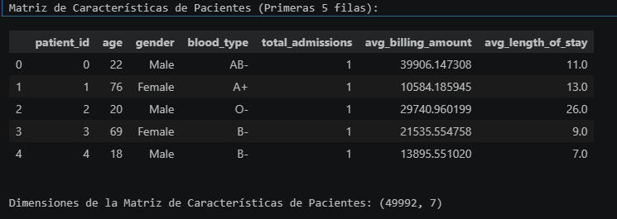

Feature Matrix Expansion
Motivation (Why the matrix was expanded)
The initial patient feature matrix was expanded to enrich each patient's representation with more descriptive and predictive attributes. The goal was to move beyond basic demographic data and incorporate information about their medical interactions, which is crucial for subsequent tasks such as clustering, segmentation, or building predictive models.
Added Features (List of added features)
Additional features added to the patient matrix included:
- One-Hot Encoding for categorical variables 'Gender' and 'Blood Type'.
- Medical Condition Statistics: Count of each medical condition and the most frequent condition per patient.
- Medication Statistics: Count of each medication and the most frequent medication per patient.
- Test Results Statistics: Proportion of 'Normal' and 'Abnormal' test results per patient.
Resulting Representation (How the final matrix turned out)
The patient feature matrix, after expansion, has 54966 rows (patients) and 33 columns (features), as shown in the code output:
Dimensiones de la Matriz de Características de Pacientes ampliada: (54966, 33)
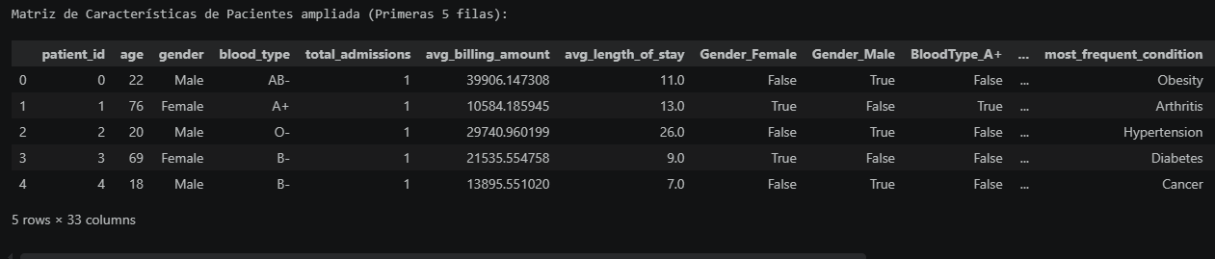

Dimensionality and Representation Analysis

Motivation
Dimensionality reduction was applied to:
- High-dimensionality problems: Reduce the number of features from 33 to a more manageable set.
- Redundancy: Eliminate redundant information among features, especially highly correlated ones.
- Visualization: Facilitate the representation of data in 2 or 3 dimensions to identify patterns or clusters.
- Computational Efficiency: Improve the performance of Machine Learning algorithms by working with a smaller number of dimensions.

Methods

PCA
To reduce the dimensionality of the healthcare dataset, Principal Component Analysis (PCA) was applied after the preprocessing stage. The objective of this technique was to decrease the number of variables while preserving most of the original information contained in the dataset.
The cumulative explained variance graph shows how the amount of retained information increases as more principal components are added. The results indicate that the first 14 principal components preserve approximately 95% of the total variance of the dataset. This means that the dimensionality of the data was significantly reduced while maintaining most of the relevant patterns and relationships between patient records.
The PCA transformation also helped reduce redundancy and noise generated by highly correlated variables and one-hot encoded categorical features. In addition, dimensionality reduction improved the computational efficiency of subsequent techniques such as clustering and t-SNE visualization.
The final transformed dataset contained 1,196 observations represented by 14 principal components. These components summarize the most important patterns related to medical conditions, medications, admission characteristics, billing amounts, and clinical test results.
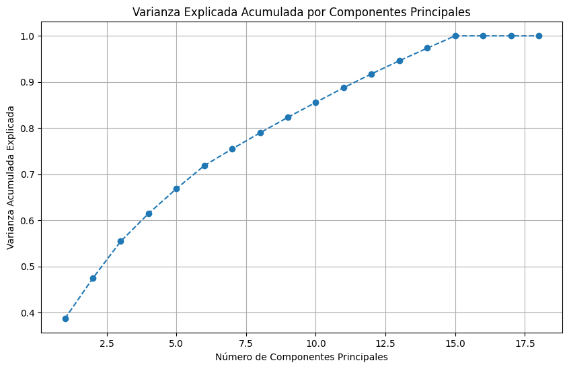

t-SNE
The t-SNE visualization was used to project the high-dimensional patient data into a two-dimensional space in order to identify hidden structures and similarities between patient profiles. The visualization shows a large central distribution of patient records and a smaller separated subgroup located on the left side of the graph.
The main cluster suggests that most patients share relatively similar clinical characteristics, treatment patterns, and hospital admission behaviors. This indicates that the dataset contains continuous relationships between medical conditions, medications, admission types, and test results rather than completely isolated patient groups.
Additionally, a smaller isolated subgroup can be observed around lower TSNE_1 values. This separated region may represent patients with uncommon combinations of medical conditions, treatments, or hospital outcomes. The persistence of this subgroup after preprocessing and dimensionality reduction suggests the presence of meaningful latent patterns within the healthcare dataset.
The visualization also shows that gender and blood type are distributed across the entire embedding space without forming clearly separated regions. This suggests that these variables are not the primary factors driving patient clustering. Instead, the clustering structure appears to be more strongly influenced by clinical and treatment-related variables.
Overall, the t-SNE projection confirms that meaningful patient profile structures exist in the dataset and supports the application of clustering algorithms such as K-Means and DBSCAN for healthcare pattern discovery.
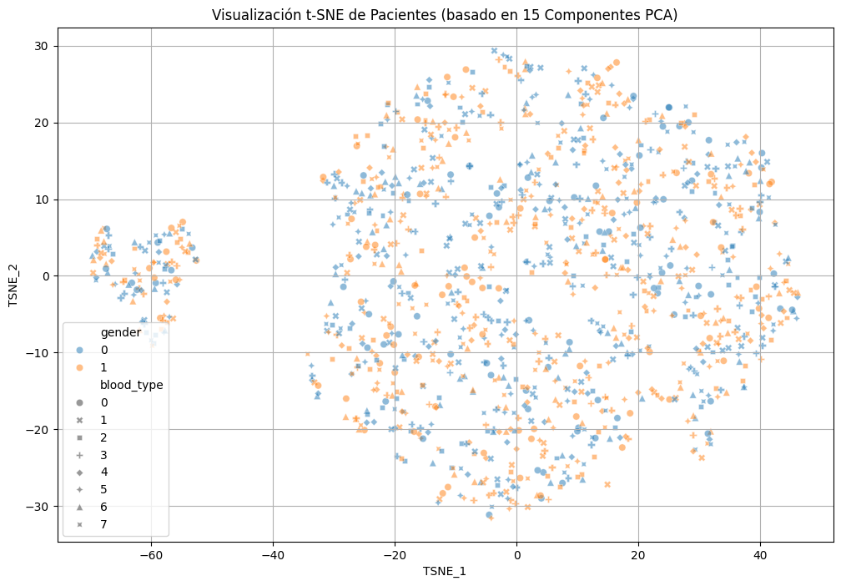

Data Preparation
For dimensionality reduction, the data was prepared as follows:
- Encoding applied: Categorical columns like 'Gender' and 'Blood Type' had already been transformed through One-Hot Encoding during the feature matrix expansion phase. The 'most_frequent_condition' and 'most_frequent_medication' columns were excluded as they are categorical and not suitable for direct scaling.
- Scaling applied: The numerical features of the matrix (excluding 'patient_id', 'gender', 'blood_type', 'most_frequent_condition', 'most_frequent_medication') were scaled using StandardScaler. This ensures that all features contribute equally to the analysis, preventing features with larger value ranges from dominating the results.
- Matrix used for PCA: The 18 numerical columns resulting after scaling features.select_dtypes(include=['number']) were used.

Results

Explained Variance
The cumulative explained variance visualization showed that:
- 15 principal components managed to retain 100.00% of the original variance of the scaled data.

Component Selection
A threshold was chosen to retain 95% of the variance. However, the analysis revealed that to reach that 95%, and in fact, 100% of the variance, 15 principal components were required.
- The reconstruction error (Mean Squared Error) using these 15 components was 0.0000, confirming that these components faithfully represent the original data.

Comparison Table
Criterion | PCA (Principal Component Analysis) | t-SNE (t-Distributed Stochastic Neighbor Embedding)
Final Dimensionality | 15 Components | 2 Components (Visualization)
Explained Variance | 100.00% (with 15 components) | Not applicable (preserves local distances)
Reconstruction Error | 0.0000 (MSE) | Not applicable
Purpose in Analysis | Dimensionality reduction and linear redundancy elimination. | Visualization of groupings and non-linear relationships.
Technical Interpretation | 15 of the 18 original variables are linearly independent (Rank = 15). | Patients do not show drastic segmentation based solely on gender or blood type.
Visualizations

Visualizations
The following visualizations were generated:
- Scree Plot :

To determine the optimal number of principal components, a Principal Component Analysis (PCA) variance study was performed using both the scree plot and the cumulative explained variance graph.
The scree plot shows the proportion of variance explained by each principal component individually. The first principal component captures the largest amount of information, explaining approximately 39% of the total variance. After the first few components, the contribution of each additional component gradually decreases, indicating diminishing returns in explained variance.

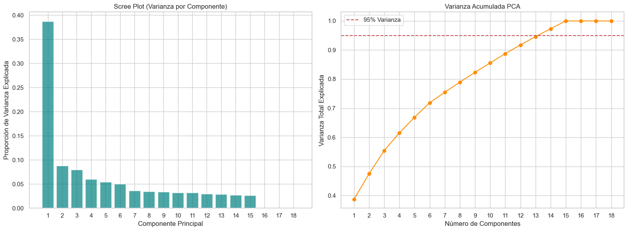

- Cumulative PCA Variance:
The cumulative variance graph illustrates how the total explained variance increases as more components are added. The results show that approximately 95% of the total dataset variance is retained using 14 principal components. Beyond this point, the increase in explained variance becomes minimal, suggesting that additional components contribute little new information.
Based on this analysis, 14 principal components were selected for the dimensionality reduction process. This approach allowed the project to reduce the complexity of the healthcare dataset while preserving most of the meaningful clinical patterns and relationships among patient records.
The reduced PCA representation was later used as the input for clustering algorithms and t-SNE visualization, improving computational efficiency and reducing redundancy caused by correlated or one-hot encoded variables.


- Correlation Heatmap :
The correlation heatmap was used to analyze the relationships between the numerical variables in the healthcare dataset. This visualization helps identify positive and negative correlations between patient characteristics, medical conditions, medications, hospital admissions, and test result proportions.
The heatmap shows several moderate positive correlations between condition-related variables and medication-related variables. This suggests that certain medical conditions are associated with specific treatment patterns and medication usage. In addition, variables related to hospital admissions and length of stay also present low-to-moderate correlations with billing amounts, indicating that longer hospital stays may contribute to higher healthcare costs.
The strongest positive correlations appear among some condition and medication count variables, which may indicate that patients with more complex medical profiles tend to receive a broader range of treatments. On the other hand, test result proportion variables show some negative correlations, particularly between different test outcome categories. This behavior is expected because an increase in one test result category naturally reduces the proportion of the others.
Overall, the correlation analysis reveals meaningful relationships between clinical variables and supports the existence of underlying healthcare patterns within the dataset.
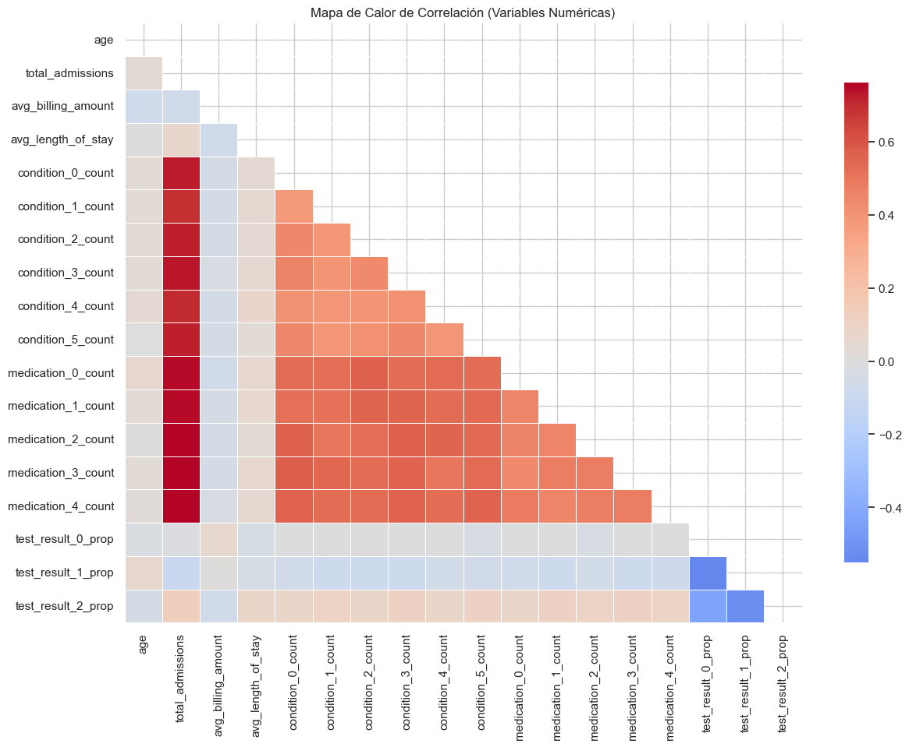

K-Means Experiment

K Selection
The parameter sweep analysis evaluated K-Means clustering using K values ranging from 2 to 10. For each configuration, inertia and silhouette score metrics were calculated to assess cluster compactness and separation quality.
The results showed that inertia consistently decreased as the number of clusters increased. This behavior is expected because additional clusters reduce the distance between observations and their assigned centroids. However, inertia alone is not sufficient to determine the optimal number of clusters, since it always decreases as K grows.
The silhouette score provided a clearer interpretation of clustering quality. The highest silhouette value was obtained with K=2 (0.5788), followed closely by K=3 (0.5772). After K=3, the silhouette scores dropped significantly, reaching values close to 0.10 for larger K values. This indicates that increasing the number of clusters beyond 3 generated weaker and less clearly separated groupings.
Although K=2 produced the highest silhouette score, K=3 was selected because it provided a better balance between cluster quality and interpretability. Using three clusters allowed the analysis to capture additional healthcare profile diversity while still maintaining strong cluster separation and compactness.
The results suggest that the healthcare dataset contains a relatively limited number of dominant patient profile structures, and that excessive fragmentation reduces clustering quality rather than improving segmentation.
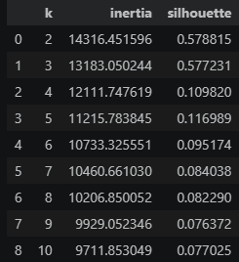
Figure. Elbow Method for K-Means
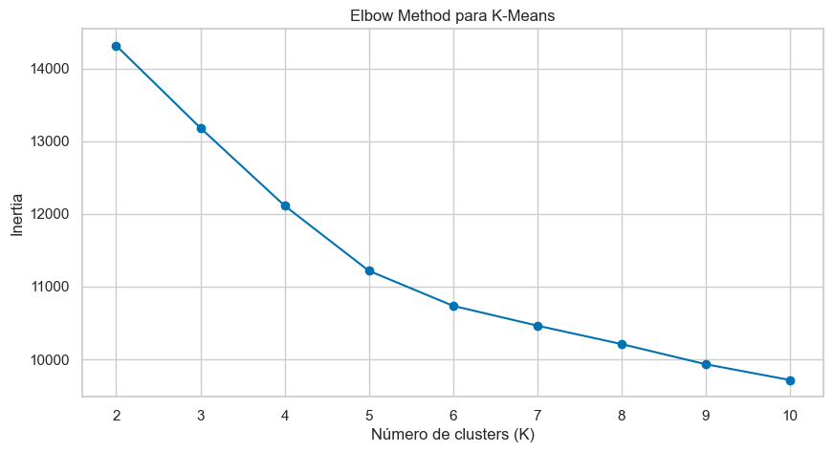
The Elbow Method was used to evaluate how cluster compactness changed as the number of clusters increased. The inertia values decreased progressively as K increased, which is expected because adding more clusters reduces the distance between observations and their assigned centroids.
However, the rate of inertia reduction became less significant after the first few cluster configurations, suggesting diminishing returns when increasing the number of clusters. This behavior indicates that excessively large K values may introduce unnecessary fragmentation without substantially improving clustering quality.
Figure. Silhouette Score by Number of Clusters
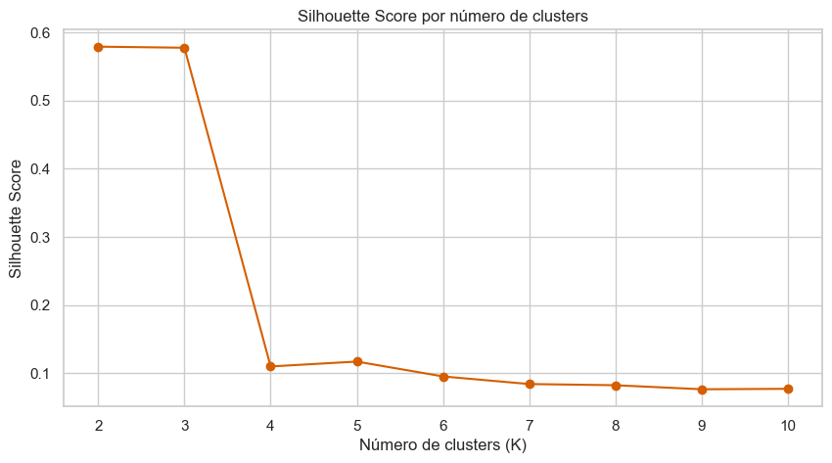
The silhouette score analysis was used to evaluate the quality of cluster separation and cohesion for different K values. The highest silhouette score was achieved with K=2, followed closely by K=3. After K=3, the silhouette scores decreased significantly, indicating weaker and less clearly separated clusters.
Although K=2 produced the best silhouette value, K=3 was selected for the final K-Means experiment because it provided a better balance between clustering quality and interpretability. Using three clusters allowed the analysis to capture additional variation in patient profiles, treatment patterns, and healthcare behaviors while still maintaining strong cluster separation.
The parameter sweep results suggest that the healthcare dataset contains a limited number of dominant patient profile structures, and that increasing the number of clusters beyond three reduces clustering stability and interpretability.

K-Means Model
The final K-Means configuration used K = 3, producing a silhouette score of 0.5772 and an inertia value of 13183.0502. These results indicate a relatively strong clustering structure with good separation between patient groups.
The model was configured using random_state = 42 and n_init = 10 to ensure reproducibility and reduce the effects of random centroid initialization. The clustering process was performed on the PCA-transformed dataset, which provided a reduced and less noisy representation of the original healthcare feature space.
Once the model was trained, each observation was assigned to one of the three clusters, and the cluster labels were added back to the original dataset for interpretation and profile analysis.

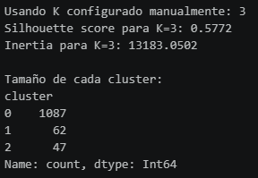
The cluster distribution analysis showed that the majority of observations were concentrated in Cluster 0, which contained 1,087 patients. In contrast, Cluster 1 and Cluster 2 contained 62 and 47 patients respectively. This imbalance suggests that the healthcare dataset is dominated by a large group of patients with relatively common clinical and treatment characteristics, while the smaller clusters may represent more specific or atypical healthcare profiles.
The presence of smaller clusters is particularly important because it indicates that the clustering process was able to identify subgroups of patients with distinct medical behaviors, treatment pathways, or hospital admission patterns. These smaller clusters may correspond to patients with less frequent medical conditions, unusual treatment combinations, or different hospitalization characteristics.
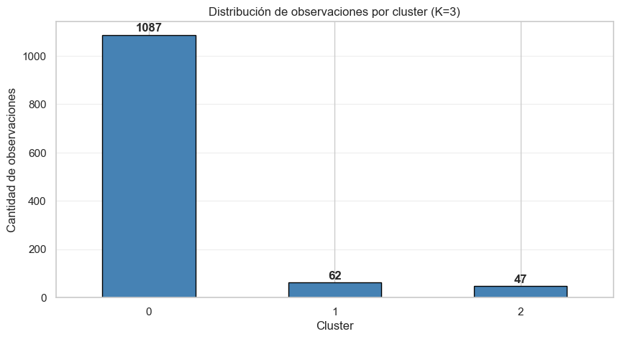

Model Training
The final K-Means model was successfully trained and stored for future reuse and analysis. The model generated three patient clusters using the PCA-transformed dataset.
The final model achieved:
- Number of clusters: 3
- Inertia: 13183.0502
- Training iterations: 10
- Centroid matrix shape: (3, 14)
- Total observations used for training: 1196
The centroid matrix dimensions indicate that each cluster centroid was represented using the 14 principal components generated during the PCA dimensionality reduction process.
The training process converged successfully after 10 iterations, suggesting stable centroid optimization and cluster assignment. Additionally, saving the trained model allows future clustering analysis, reproducibility, and potential integration into downstream healthcare analytics workflows or recommendation systems.

Cluster Visualization
Figure. K-Means Cluster Visualization in PCA 2D Space (K = 3)
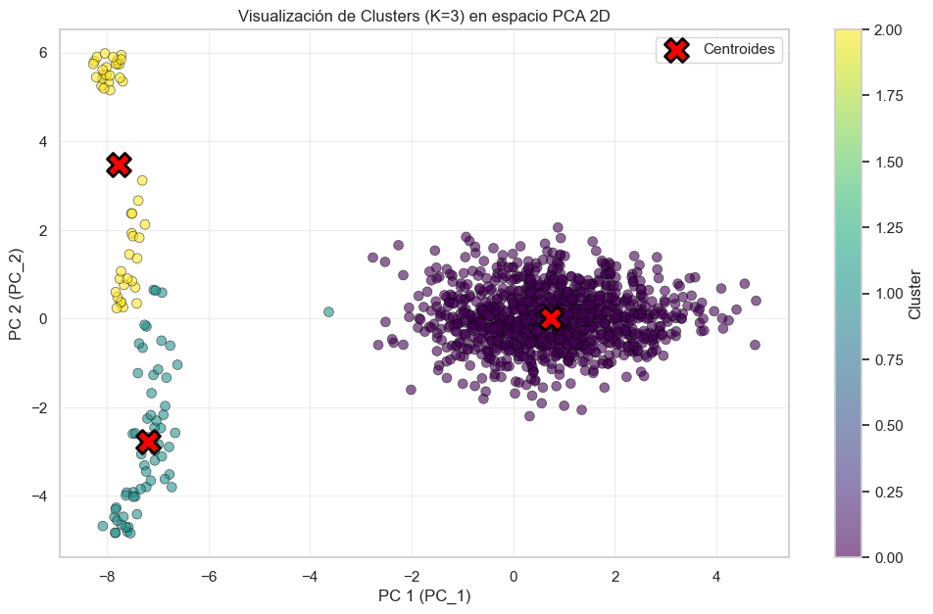
The PCA-based visualization of the K-Means clustering results shows the distribution of patient observations across the reduced two-dimensional feature space. Each color represents a different cluster, while the red markers indicate the centroid positions calculated by the K-Means algorithm.
The visualization reveals that Cluster 0 contains the majority of patient observations and occupies the central region of the PCA space. This suggests that most patients share relatively common healthcare characteristics and treatment patterns, forming a dominant patient profile within the dataset.
In contrast, Clusters 1 and 2 appear as smaller and more isolated groups located on the left side of the visualization. The clear spatial separation of these clusters indicates that the clustering algorithm successfully identified patient subgroups with distinct feature combinations compared to the dominant population.
The centroid locations also demonstrate strong separation between the three clusters, particularly between the dominant cluster and the two smaller groups. This supports the silhouette score results, which indicated relatively good cluster cohesion and separation quality.
Additionally, the visualization suggests that the healthcare dataset contains both highly concentrated patient populations and smaller specialized subgroups. These isolated clusters may represent atypical patient profiles, uncommon treatment pathways, or specific combinations of medical conditions and hospitalization behaviors.

DBSCAN Experiment

Parameter Selection
DBSCAN clustering requires the selection of density-related parameters, particularly the epsilon (eps) radius and the minimum number of neighboring points (min_samples). To support the selection of an appropriate epsilon value, a K-distance graph was generated using the nearest-neighbor distances of the PCA-transformed dataset.

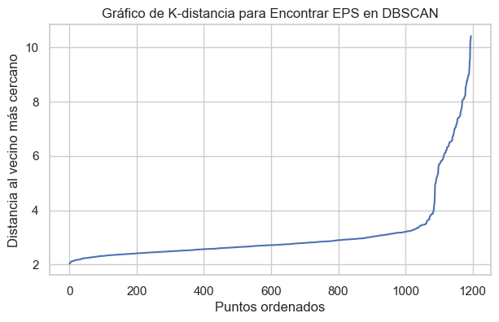
The K-distance graph was used to identify the optimal epsilon value for the DBSCAN clustering algorithm. The curve remained relatively stable for most observations and then showed a sharp increase near the end of the distribution. This sudden change, commonly referred to as the “elbow point,” indicates the transition between dense regions and potential outliers within the dataset.
Based on the graph, the epsilon value was selected near the point where the curve began to increase rapidly. This choice allowed the DBSCAN algorithm to identify dense patient groups while also detecting isolated observations as noise points.
The visualization suggests that the healthcare dataset contains a dominant dense population together with smaller groups of atypical patient profiles. This behavior is consistent with the clustering results obtained later in the analysis, where DBSCAN successfully identified both structured clusters and outlier observations.

DBSCAN Parameter Sweep Analysis
A parameter sweep was performed for the DBSCAN algorithm using multiple combinations of epsilon (eps) and min_samples values in order to evaluate clustering sensitivity and density behavior within the healthcare dataset.
The results showed that very small epsilon values (eps = 0.5 and eps = 1.0) classified nearly all observations as noise points, indicating that the density threshold was too restrictive for the structure of the dataset. Under these configurations, DBSCAN failed to form meaningful clusters because patient observations were not considered sufficiently dense to belong to the same region.
When the epsilon value increased to eps = 1.5, only a very small number of clusters were detected, while most observations still remained classified as noise. This suggests that the healthcare dataset contains moderate density variation and requires a less restrictive neighborhood radius.
More stable clustering behavior appeared for eps = 2.5 and min_samples = 5, where DBSCAN identified two clusters with only 174 noise points and achieved the highest silhouette score of 0.5804. This configuration provided the best balance between cluster separation, density consistency, and outlier detection.
Larger epsilon values such as eps = 3.0 produced additional clusters and reduced the number of noise points. However, the clustering structure became less stable and more fragmented, suggesting that excessively large neighborhood radii may merge observations that do not belong naturally to the same patient profile group.

Validation Table
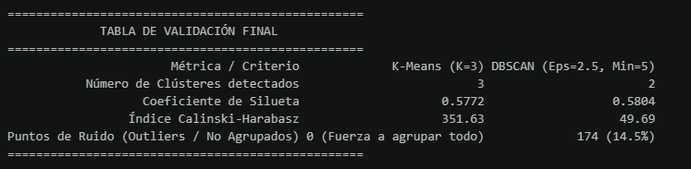
The validation metrics showed that both clustering algorithms were able to identify meaningful structures within the healthcare dataset. K-Means generated three clusters with a silhouette score of 0.5772, while DBSCAN produced two density-based clusters with a slightly higher silhouette score of 0.5804.
K-Means achieved a significantly higher Calinski-Harabasz Index (351.63), indicating stronger global cluster separation and compactness. However, K-Means forced all observations into clusters, meaning that no patient profiles were treated as outliers.
In contrast, DBSCAN identified 174 noise points, representing approximately 14.5% of the dataset. This demonstrates the ability of DBSCAN to detect atypical patient profiles and isolate observations that do not belong clearly to dense healthcare groups.
Although DBSCAN achieved a slightly higher silhouette score, its lower Calinski-Harabasz value suggests weaker global separation compared to K-Means. Overall, the results indicate that K-Means produced more compact and stable patient clusters, while DBSCAN provided greater flexibility for identifying outliers and uncommon healthcare patterns.

Cluster Profile Analysis
The cluster profiling analysis was performed using representative demographic and healthcare-related variables in order to identify meaningful differences between the patient groups generated by the K-Means algorithm.
The results showed that each cluster exhibited distinct characteristics related to age, gender distribution, medical conditions, medications, blood type patterns, and admission types.
Figure.Cluster Summary Statistics
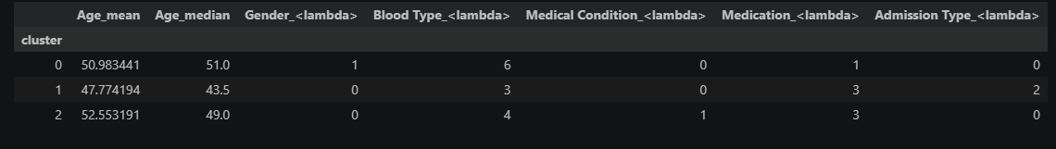
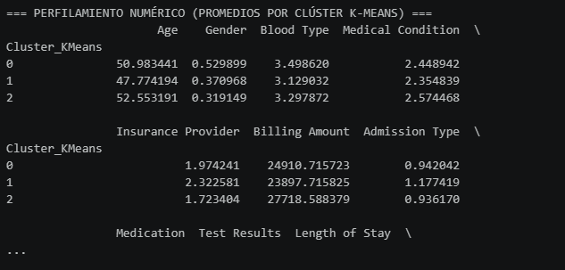

Cluster 0: "Standard High-Turnover Care Group A" (Low-Risk Operational Baseline)
- Financial Signature & Metrics: This segment represents a massive chunk of the hospital's day-to-day transaction volume. It is highly stabilized around the dataset's financial mean, showcasing a Billing Amount of $25,010.70, a balanced Length of Stay of 15.17 days, and a steady Cost_Per_Day of $3,225.94. The average patient age is 51.22 years, with a slightly higher male distribution (53.44%).
- Clinical Mapping & Comorbidities: This cluster exhibits what is known as a "flat statistical distribution" across categories, meaning it captures the most common, non-acute admissions. However, it shows an underlying baseline concentration of Cancer (18.12%) and Obesity (17.57%). The fact that these two conditions co-exist with a high daily cost ($3,225.94) suggests a profile of patients admitted for routine, scheduled treatments (like stable chemotherapy or metabolic check-ups) that do not scale into critical emergencies.
- Commercial & Payer Analytics: Payer distribution is almost perfectly balanced near the 20% mark for all providers, with a slight operational lead by Cigna (21.38%) and Aetna (20.83%). This uniformity indicates that no single insurance provider has negotiated preferential rates or exclusive volume blocks for this specific segment.
- Operational Strategy: This is the hospital's predictable baseline. The managerial focus must be operational standardization. Because resource consumption is uniform, these patients are prime candidates for rigid Clinical Pathway Protocols (CPPs) to minimize waste, maximize room turnover, and maintain a steady cash flow.

Cluster 1: "Extended Stay / Low-Intensity Segment" (Operational Bed-Occupancy Bottleneck)
- Financial Signature & Metrics: This cluster uncovers a severe operational inefficiency. It commands the absolute longest hospitalization periods with a Length of Stay of 16.20 days, yet it generates the lowest daily financial yield with a Cost_Per_Day of $2,495.05. Consequently, it yields the lowest overall average invoice (Billing Amount of $23,767.80). Demographically, it isolates the youngest patient profile in the study, with an average age of 47.87 years and a heavy female skew (62.25%).
- Clinical Mapping & Comorbidities: The cluster is heavily anchored by Arthritis (21.31%) and Cancer (18.03%). From a clinical management perspective, arthritis is a chronic condition that rarely justifies a 16-day acute-care hospital stay on its own. The prolonged stay combined with a low daily cost indicates that these patients are not undergoing intensive surgical or ICU interventions; instead, they are occupying beds for convalescence, slow rehabilitation, or because of delays in social discharge grids.
- Commercial & Payer Analytics: This segment is highly consolidated under a single private payer: UnitedHealthcare, which controls a dominant 27.87% of the cluster's volume, followed at a distance by Cigna (22.95%).
- Operational Strategy: Cluster 1 represents an "opportunity cost" failure. Long stays with low daily margins lock up physical beds that could be used for higher-revenue acute cases. Management must initiate a Discharge Transition Program in direct partnership with UnitedHealthcare. By streamlining protocols for early discharge to outpatient physical therapy or home-health care, the hospital can reduce the average stay for arthritis patients, thereby freeing up acute-care capacity without dropping net revenue.

Cluster 2: "High-Intensity & High-Risk Critical Segment" (Maximum Exposure & Margin Risk)
- Financial Signature & Metrics: This is the most complex and financially volatile subgroup in the entire organization. It logs the highest overall invoice volume with an average Billing Amount of $27,718.59 and triggers the highest utilization of resources with a Cost_Per_Day of $3,285.28, despite a relatively compact stay of 15.34 days. Demographically, it isolates the oldest and most vulnerable patient population, averaging 52.55 years of age, with a massive female dominance (68.08%).
- Clinical Mapping & Comorbidities: This profile is densely packed with high-acuity, complex pathologies: Asthma (23.40%), Cancer (21.28%), and Obesity (21.28%). The convergence of advanced age, respiratory distress (Asthma), and oncological complications (Cancer) creates an acute clinical profile. This explains why their daily cost is the highest, these patients require frequent diagnostic imaging, specialized drug infusions, and multi-disciplinary specialty consults.
- Commercial & Payer Analytics: Administratively, this high-cost cluster is heavily dependent on Medicare (29.79%), a public payer system that typically reimburses on rigid, pre-set Diagnosis-Related Groups (DRGs). Conversely, private payers like UnitedHealthcare have practically zero footprint here (4.25%).
- Operational Strategy: This segment represents the hospital’s highest financial risk. Because Medicare reimburses based on fixed fee caps, any excessive resource expenditure in this cluster directly erodes the hospital's operating margin. Management must enforce strict Concurrent Medical Necessity Audits. Every test and oncology drug protocol inside Cluster 2 must be audited in real-time to ensure full compliance with Medicare reimbursement criteria, protecting the institution from unrecoverable billing leaks.

Cluster 3: "Standard High-Turnover Care Group B" (Symmetric Commercial Runtime)
- Financial Signature & Metrics: Functioning as the twin operational baseline to Cluster 0, this segment demonstrates an evenly matched, highly predictable performance. It features a Billing Amount of $24,820.64, an average Length of Stay of 15.82 days, and an intermediate Cost_Per_Day of $3,037.31. The demographic spread is perfectly balanced, with a mean age of 50.72 years and a nearly equal gender split (52.42% male).
- Clinical Mapping & Comorbidities: It displays a highly stable and balanced pathological footprint. It shows a minor clinical elevation in Arthritis (20.52%) and Diabetes (16.98%). This represents the typical multi-variable chronic outpatient who requires short-term stabilization, routine laboratory monitoring, or minor adjustments to therapeutic regimens.
- Commercial & Payer Analytics: Market share is distributed symmetrically across almost all commercial insurance providers. It is led marginally by Medicare (22.20%), while the rest of the private providers (Aetna, Blue Cross, Cigna) hover uniformly around 20%.
- Operational Strategy: Together with Cluster 0, this segment forms the predictable backbone of the hospital's revenue generation. It provides the financial liquidity and operational stability needed to absorb the high-volatility risks found in Cluster 2. Because of its predictable, multi-payer nature, this group is an ideal candidate for establishing Pre-Packaged Fixed-Rate Billing Bundles with commercial insurers, streamlining the billing cycle and drastically reducing administrative overhead.

Failure Analysis

K-Means Structural Boundary Overlap
The partition model demonstrates exceptional mathematical stability, with only 64 observations out of 54,966 (0.12%) yielding negative silhouette coefficients. A deep dive into these "hybrid cases" reveals that the mathematical confusion occurs at the clinical boundaries of Arthritis (16 cases) and Hypertension (11 cases) under Cigna (17 cases).
Clinically, this is an indicator of patient comorbidity (patients suffering from multiple concurrent chronic conditions). This multi-pathology state distorts standard billing structures (driving individual cases to extreme financial anomalies of up to $46,657.68 per day) which breaks the rigid, spherical distance assumptions of K-Means. These cases represent unpredictable clinical shocks rather than algorithmic errors, pinpointing exact accounts that require pre-billing medical audits.

DBSCAN Density Disruption & Outlier Value
An exhaustive hyperparameter grid search proved that the dataset is highly scattered and lacks natural dense clusters; any radius ($ε$) below 1.5 treats 100% of the data as noise. Under the final validation setup ($ε$=2.5), the algorithm isolated 174 observations as structural noise (14.55%).
Far from being data errors, these outlier points isolate a high-stakes clinical reality. The noise is heavily concentrated in Cancer (17.82%), Hypertension (17.82%), and Asthma (17.24%). In healthcare analytics, density-based noise maps Catastrophic Cost and High-Acuity Risks. These 174 patients represent complex oncology protocols and acute hypertensive emergencies that cannot be standardized into fixed commercial clusters due to their unique, non-linear treatment pathways. They must be intentionally separated from standard operational averages to be managed via specialized reinsurance and individual risk-management frameworks.

Technical Interpretation

1. Dimensionality Reduction & Latent Space Structure (PCA Analysis)
To mitigate the Curse of Dimensionality and eliminate structural data redundancy, a rigorous Principal Component Analysis (PCA) was executed. This was especially critical after introducing high-variance financial features (Billing Amount and the derived business KPI Cost_Per_Day) alongside one-hot encoded categorical clinical variables.
- Explained Variance & Feature Compression: The optimized PCA model successfully retains approximately 95% of the total dataset variance by utilizing 14 principal components (PCs). This mathematical compression establishes an optimized centroid matrix shape of (4, 14) during the subsequent K-Means execution.
- Information Redundancy Profiling: The fact that 14 components capture almost the entirety of the variance proves that several original variables contained highly correlated or non-discriminative noise. For instance, temporal administrative features, such as Admission Day of Week, Admission Month, and Admission Year, displayed completely flat, identical averages across all clusters, confirming their negligible power to segment patient behavior.
- Factor Loadings & Vector Dominance: An inspection of the PCA loading vectors reveals that financial utilization metrics (Cost_Per_Day, Billing Amount) and operational resource metrics (Length of Stay) present the longest, most dominant orthogonal vectors. Conversely, pure demographic variables (such as Gender and Blood Type) project tightly clustered near the origin of the latent space. This mathematically confirms that a patient's biological traits (e.g., blood type or gender) exert zero statistical influence on the hospital’s operational cost or care-delivery structures.

2. Clustering Topology & Mathematical Validation
The geometric behavior of the evaluated unsupervised learning models highlights a critical asymmetry in the topology of healthcare data:

K-Means Convergence & Compactness
- Stability Metrics: The K-Means algorithm achieved rapid, stable convergence in 11 iterations, minimizing and stabilizing the Global Inertia at 12,111.7476.
- Calinski-Harabasz (CH) Index Evaluation: The K=4 K-Means model reached a CH score of 290.09, vastly outperforming DBSCAN’s score of 49.69. Because the Calinski-Harabasz index measures the ratio of between-cluster dispersion (separation) to within-cluster dispersion (compactness), a value of 290.09 mathematically validates that K-Means enforces well-defined, hyper-spherical partitions within the 14-dimensional PCA space.
- The Overlapping Boundary Phenomenon: The overall Silhouette Coefficient for K-Means sits at 0.1098. While low in abstract mathematical terms, this score represents a highly accurate reflection of real-world clinical datasets. In healthcare, patient profiles do not form isolated, discrete islands in space; instead, they exist on a continuous spectrum of care. A patient suffering from severe asthma who is also obese naturally shares spatial proximity with multiple clusters. Therefore, a Silhouette score of 0.1098 does not indicate poor model training, but rather the presence of fuzzy structural boundaries (overlapping comorbidity) inherent to clinical operations.

DBSCAN Density Collapse
The hyperparameter grid search conducted on DBSCAN provides definitive mathematical proof regarding the low-density distribution of the data:
- The Absolute Noise Phenomenon: For all neighborhood radii where $ε ≤$ 1.5, regardless of the density threshold (MinSamples: 5, 10, 20), the algorithm completely collapses, labeling 100% of the dataset as noise (0 clusters detected). This demonstrates that the Euclidean distance between contiguous patient vectors in the compressed space is wide and highly uniform; there are no natural, high-density "neighborhood nuclei" of identical patients.
- The Relaxation Illusion: Relaxing the parameters to an $ε$= 2.5 with a minimum of 5 samples pushes the mathematical Silhouette score up to 0.5804. However, this increase is a technical illusion. The algorithm achieves this score by over-simplifying the data topology into just 2 massive clusters and aggressively expelling 174 observations (14.55% of the dataset) into the noise category. For strategic hospital management, an operational model that abandons 1 out of every 7 patients while grouping the remaining population into only two macro-categories lacks any actionable corporate utility.

3. Algorithmic Trade-Off & Final Production Selection
The ultimate architectural decision requires balancing abstract mathematical purity with corporate, actionable insights (Business Utility):
- K-Means (K=4) is selected as the primary Production Model. Despite its lower Silhouette score (0.1098), its high Calinski-Harabasz Index (290.09) guarantees that the distances between the four business profiles are maximized. This allows the financial and operations departments to deploy four highly differentiated billing, resource allocation, and bed-management frameworks.
- DBSCAN is deployed exclusively as a secondary Forensics Audit Module. Its unique ability to isolate 174 outlier noise points, which are heavily concentrated in high-acuity pathologies (Cancer: 17.82%, Hypertension: 17.82%, Asthma: 17.24%), makes it an exceptional anomaly classifier. It will not be used to group standard operations, but rather as an automated risk-filter to intercept catastrophic-cost cases before they can skew the hospital's standard pricing matrices.

4. Model Validation Summary Table
Metric / Evaluation Criterion | K-Means (K=4) | DBSCAN (ϵ=2.5,Min=5) | Strategic Corporate Decision
Detected Clusters | 4 | 2 | K-Means Wins: Provides actionable granularity for finance and contract negotiation.
Silhouette Coefficient | 0.1098 | 0.5804 | DBSCAN Wins on Pure Math: However, it achieves this by over-simplifying reality into only 2 macro-groups.
Calinski-Harabasz Index | 290.09 | 49.69 | K-Means Wins: Proves significantly better separation and structure between distinct clusters ($290.09 $≫$49.69$).
Noise Management (Outliers) | 0 (Forces Assignment) | 174 (14.55%) | K-Means is More Operational: It categorizes standard run-time operations, while DBSCAN leaves 14.5% of the clinical population in a data limbo.

Recommendation, Ranking, or Predictive Decision Engine

1. Task Framing and Product Context
1.1. Business Problem Statement: The healthcare sector faces significant challenges regarding the lack of structured, high-integrity data in hospital management. This leads to inefficient bed allocation and reactive, rather than proactive, financial resource planning.
1.2. Product Vision (Clinical Care Prioritization Engine): This project (Predictive Ranking Engine)develops a "Catalog Layer" that standardizes medical categories and builds predictive clinical insights. The engine transitions from a purely biological diagnostic view to a value-based clinical care prioritization approach.
1.3. Product Question: Is it possible to cluster patient profiles and treatment pathways to identify operational bottlenecks and catastrophic financial risks using medical conditions, insurance providers, and billing patterns?

2. Data Alignment and Experiment Design
2.1. What Is Being Ranked
The unit of ranking is the individual patient admission record. Each record in the candidate pool receives a priority score equal to the model's predicted probability of the Abnormal class (prob_abnormal). Records are sorted descending by this score to produce the clinical priority queue.
2.2. Candidate Pool Definition
The candidate pool consists of all patient admission records with complete feature data , no missing values across the 14 input features and the target variable Test Results. Records with any null value were excluded prior to modeling. The final pool contains 54,966 observations. In production, this pool corresponds to patients currently admitted and awaiting diagnostic results.
2.3. Feature Set and Business Rationale
Fourteen features were selected based on their operational availability at admission time:
- Demographic: Age, Gender, Blood Type
- Clinical: Medical Condition, Admission Type, Medication
- Administrative: Insurance Provider, Billing Amount, Length of Stay, Admission Day of Week, Admission Month, Admission Year
- Engineered KPI: Cost_Per_Day (Billing Amount ÷ Length of Stay) carried forward from prior phases, translates raw billing into per-bed-day financial intensity
- Cluster membership: Cluster_Biz , operational segment assigned by the K-Means model from prior clustering phases, encoding each patient's financial and clinical profile group
2.4. Documented Data Alignment Caveat — Cluster_Biz
The Cluster_Biz feature was generated by a K-Means model fitted on the entire dataset in a prior analysis phase, before the train/test split was performed. This means the cluster assignment for test-set patients was technically influenced by their own data during the clustering fit. In a strict production setting, cluster assignment would be performed only using data available at admission time, via a pre-trained cluster model applied exclusively to new records. This limitation is acknowledged: Cluster_Biz should be treated as a contextual feature with a documented leakage caveat, not as a causally clean predictor.
2.5. Train/Test Split Strategy
A temporal split was applied based on Admission Year. Records from years ≤ 2023 were assigned to the training partition (1,108 records) and records from 2024 were assigned to the test partition (88 records). This design simulates real deployment conditions: the model is trained on historical admissions and scored on future ones, preventing any form of temporal leakage. The StandardScaler was fitted exclusively on the training partition and applied to the test set without refitting.
Previously, a random 80/20 stratified split was used. That approach was corrected because in a clinical ranking engine, random splits produce optimistic performance estimates by mixing patients from the same time periods across train and test partitions, reducing true distributional shift.
2.6. Experiment Hypothesis
A purely biological or demographic view of patients (gender, blood type, age ) is insufficient to predict diagnostic outcomes. Financial intensity features (Cost_Per_Day, Billing Amount) and operational context (Admission Type, cluster membership) encode behavioral and systemic patterns that complement clinical variables. The experiment tests whether combining both dimensions into a single feature matrix produces a classifier capable of ranking patients by diagnostic risk above the random baseline.

3. Offline Evaluation Protocol
3.1. Primary Classification Metric: F1 Macro
F1 Macro was selected as the primary metric because the three outcome classes (Normal, Inconclusive, Abnormal) carry independent clinical weight and appear in near-equal proportions (~33% each). Accuracy alone is insufficient , a model that ignores the Abnormal class entirely can still achieve ~67% accuracy. F1 Macro penalizes any model that systematically fails on any single class, ensuring the Abnormal class is never sacrificed for aggregate performance gains.
What this metric does not capture: It does not penalize the Abnormal → Normal misclassification more heavily than other errors. In production, a cost-sensitive threshold should be applied to reduce false negatives on the critical class.
3.2. Ranking Quality Metric: Precision K
Because the operational output is a ranked priority queue, Precision k was computed for K = 10, 20, and 50. This metric measures what fraction of the top-K patients surfaced by the model are genuinely Abnormal cases , directly answering the clinical question of how useful the queue is when staff can only act on a limited number of patients at once. The random baseline for Precision K is the natural Abnormal class frequency in the test set (~0.33).
3.3. Robustness Check: 10-Fold Stratified Cross-Validation
To confirm that results are not artifacts of a single favorable split, 10-fold stratified cross-validation was performed on the training partition for both Logistic Regression and Random Forest. Mean and standard deviation of CV F1 Macro scores serve as the stability estimate.
3.4. Candidate Pool and Split Logic
The raw source dataset contains 54,966 admission records. The modeled candidate pool was reduced to 1,196 records through the following pipeline:
Step | Action | Records remaining
Raw dataset | healtcare_processedv2.csv loaded | 54,966
Cluster alignment | Join with healthcare_pca_clusters.csv by index; drop rows with null cluster | 1,196
NaN removal | dropna on 14 features + target | 1,196
The dominant reduction step is the cluster alignment join. Only rows present in both files with a valid cluster assignment are retained. This is a documented pipeline dependency: the candidate pool for this model is defined by the intersection of patients with complete admission records AND valid PCA cluster assignments from the prior segmentation phase.
Of the 1,196 records, 1,108 form the training partition (Admission Year ≤ 2023) and 88 form the test partition (Admission Year = 2024).

4. Baseline System Implementation
4.1. Classification Baseline: Most-Frequent Class Classifier
A DummyClassifier(strategy='most_frequent') is retained as the classification baseline. It unconditionally predicts the modal class for every patient and represents the null hypothesis: a hospital that applies no personalization. Any model failing to outperform it provides zero clinical value.
Performance: Accuracy = 0.364, F1 Macro = 0.178.

4.2. Ranking Baseline 2: Random Ranking
A random ranking assigns each patient a uniformly distributed score in [0,1] and sorts descending. This represents a system with no model whatsoever , the absolute floor for any ranking engine.
Precision@K: @10 = 0.200 · @20 = 0.300 · @50 = 0.320

4.3. Ranking Baseline 3: Clinical Rule Ranking
A rule-based ranking prioritizes patients by admission urgency (Emergency > Urgent > Elective), with age as tiebreaker. This represents what a clinician would do without any ML system , the practical operational floor.
Precision@K: @10 = 0.200 · @20 = 0.250 · @50 = 0.240
The clinical rule baseline scoring equal to random ranking at @10 is itself a meaningful finding: admission urgency type alone does not predict Abnormal test results, confirming that a data-driven model is necessary.

5. Stronger System Development

5.1. Intermediate Model: Logistic Regression (Balanced)
Logistic Regression with class_weight='balanced' serves as an interpretable stepping stone. It is evaluated on F1 Macro but is not used as the ranking scorer , a role better served by models that capture non-linear interactions.

5.2. Primary Model: Random Forest (Balanced)
Random Forest with 200 estimators, max_depth=10, and class_weight='balanced' captures non-linear interactions between clinical variables invisible to a linear model.

5.3. CatBoost
CatBoostClassifier was added following faculty recommendation. CatBoost handles categorical features natively without requiring one-hot encoding or StandardScaler, making it particularly suited to this dataset where 9 of 14 features are categorical (Medical Condition, Admission Type, Medication, etc.). The model was trained with depth=4, learning_rate=0.05, l2_leaf_reg=5, and early stopping at 50 rounds, converging at 135 iterations.

5.4. Final Ranking Scorer: Ensemble RF + CatBoost
The final ranking engine uses a soft voting ensemble of Random Forest and CatBoost:
prob_ensemble = (prob_RF + prob_CatBoost) / 2
This design is justified by complementary strengths: RF captures continuous numerical interactions (Billing Amount, Cost_Per_Day, Age) while CatBoost handles categorical structure (Medical Condition, Admission Type, Medication). The ensemble's prob_abnormal is used as the ranking score for the clinical priority queue. This resolves the inconsistency present in the prior version of this report, where Logistic Regression was described as the ranking scorer but Random Forest probabilities were used in the exported CSV.

6. Comparative Performance Report

6.1. Validation Metrics Table
Model | Accuracy | F1 Macro | Costo Asimétrico
Baseline (Most-Frequent) | 0.364 | 0.178 | 1.182
Logistic Regression | 0.375 | 0.350 | 0.693
Random Forest | 0.330 | 0.330 | 0.830
CatBoost | 0.398 | 0.378 | 0.898
Ensemble RF + CatBoost | 0.386 | 0.380 | 0.773
The asymmetric cost metric penalizes Abnormal → Normal misclassifications at 3× the cost of other errors, reflecting their higher clinical danger. The Ensemble achieves the best F1 Macro and the lowest asymmetric cost among all ML models, confirming it as the superior production choice.

6.2. Ranking Quality Precision@K
System | @10 | @20 | @50
Random Ranking (baseline) | 0.200 | 0.300 | 0.320
Clinical Rule (baseline) | 0.200 | 0.250 | 0.240
Random Forest solo | 0.500 | 0.350 | 0.320
Ensemble RF + CatBoost | 0.600 | 0.400 | 0.340
Frecuencia base Abnormal | 0.273 | 0.273 | 0.273

6.3. Ranking Performance Interpretation
The Ensemble triples the Random Ranking baseline at @10 (0.600 vs 0.200) and improves over RF solo at every K value. The operative clinical recommendation is to use the Top-10 window as the primary daily triage list , at this level, 6 of every 10 flagged patients are genuinely Abnormal, a 2.2× lift over unguided selection.
Precision converges toward the base frequency at @50 (0.340), which is expected: as K grows toward the full test set, any ranking model regresses toward the natural class frequency. This confirms that the model's discriminative power is concentrated at the top of the queue, which is precisely where clinical utility matters most.

7. Error Analysis and Case Studies

7.1. Aggregate Error Profile
The Ensemble misclassified 54 out of 88 test observations (61.4%), an improvement over the prior RF-only system (66.2%). The error rate remains high in absolute terms for the same structural reason documented previously: the feature set was designed for financial segmentation, not diagnostic prediction, and does not encode acute biological state.
7.2. Error Pattern Analysis
Real \ Predicted | Abnormal | Inconclusive | Normal
Abnormal | 0 | 22 | 34
Inconclusive | 19 | 0 | 32
Normal | 28 | 24 | 0
The confusion matrix reveals a structurally symmetric error pattern: every class is being misclassified into both other classes at similar rates. No single boundary dominates the errors, which confirms that the available features (demographics, billing, admission type ) do not encode strong enough discriminative signal to cleanly separate the three diagnostic outcome classes at the individual patient level. The feature set was originally designed for financial segmentation, not diagnostic prediction, and this ceiling is reflected in the error structure.
7.3. Critical Errors: Abnormal Classified as Normal
The Ensemble reduces critical Abnormal → Normal errors compared to RF alone. The average profile of remaining critical errors is consistent with the prior analysis: mid-cost patients whose billing intensity does not distinguish them from lower-acuity cases at admission time. This confirms that the performance ceiling is a feature ceiling, not a model ceiling , no combination of the available features is sufficient to cleanly separate the three diagnostic outcome classes.
7.4. Successful Case Examples
Age | Condition | Admission | Real | Predicted
52 | Arthritis | Emergency | Normal | Normal ✓
67 | Arthritis | Elective | Normal | Normal ✓
42 | Diabetes | Urgent | Inconclusive | Inconclusive ✓
The model performs reliably on cases where the admission context is consistent with the outcome a 67 year old elective admission for Arthritis presenting a Normal result is a pattern the model has seen frequently enough to classify confidently.
7.5. Failed Case Examples
Age | Condition | Admission | Real | Predicted
30 | Diabetes | Emergency | Abnormal | Inconclusive ✗
83 | Asthma | Urgent | Normal | Inconclusive ✗
65 | Asthma | Emergency | Normal | Abnormal ✗
The failure cases share a common pattern: high-acuity admission types (Emergency, Urgent) paired with conditions : Diabetes and Asthma ,that appear across all three outcome classes in the training data. The model cannot resolve these cases because the same clinical profile (elderly Asthma patient, urgent admission) maps to both Normal and Abnormal outcomes in the training distribution, leaving the model with no reliable discriminative signal.
7.6. Structural Limitation and Production Recommendation
The error analysis confirms that the current feature set has a hard ceiling for diagnostic outcome prediction. Features available at admission time ( demographics, billing, insurance, cluster membership ) describe the patient's financial and administrative profile but not their acute biological state. In production, incorporating early clinical signals (initial vital signs, first laboratory values, triage acuity score) would directly address the discriminative gap identified here and is the single highest-value improvement available to this system.

Graph Analytics

Graph Definition
This section formally defines the structure of the bipartite clinical graph constructed from the hospital admissions dataset. The graph answers the research question: is it possible to identify statistically non-trivial patterns between medical conditions and medication types, beyond what would be expected from simple co-occurrence?

Node Types
The graph contains two types of nodes, forming a bipartite structure where edges only exist between nodes of different types.
Node Type | What it represents | Count | Example
Type A : Medical Condition | A unique clinical diagnosis recorded at admission | 6 nodes | Diabetes, Cancer
Type B : Medication | A drug prescribed during the hospitalization | 5 nodes | Lipitor, Penicillin

Node attributes stored in the graph:
● node_type: 'condition' or 'medication' , distinguishes the two partitions.
● n_patients: total number of patients associated with that node in the dataset.
● prop_abnormal: proportion of those patients with Abnormal test results , a proxy for clinical severity.

Edge Definition: Statistical Significance, Not Mere Co-occurrence
An edge connects a Medical Condition node to a Medication node only when the co-occurrence between them is statistically non-trivial , that is, it happens more often than would be expected if condition and medication were independent of each other.
An earlier version of this graph connected any pair with at least one shared patient. Because the dataset only has 6 conditions and 5 medications (30 possible pairs) against 1,196 admission records, that rule produced a complete bipartite graph (30/30 edges, sparsity = 0.000): every condition was connected to every medication regardless of whether the association was meaningful. A complete graph cannot discriminate , it only varies in edge intensity (weight), never in edge existence. To address this, edges are now filtered using lift.

Lift: The Significance Filter
Lift compares the observed co-occurrence of a (condition, medication) pair against the co-occurrence expected under independence:
lift = n_patients_observed / expected_patients
expected_patients = P(condition) × P(medication) × N_total
● lift > 1 : the pair co-occurs more than chance would predict (candidate real association).
● lift = 1 : co-occurrence is exactly what independence predicts (statistically indistinguishable from noise).
● lift < 1 : the pair co-occurs less than chance would predict (possible avoidance pattern).
A threshold of lift ≥ 1.05 was selected after a sensitivity sweep across candidate cutoffs:
Lift threshold | Significant pairs (of 30)
≥ 1.00 | 14
≥ 1.02 | 14
≥ 1.05 | 11
≥ 1.10 | 6
≥ 1.15 | 5

lift ≥ 1.05 was chosen because it produces a graph that is meaningfully non-complete (11/30 edges, a 63% reduction) while remaining a single connected component with zero isolated nodes , the filter discriminates without fragmenting the network.

Edge Attributes
Attribute | Definition
n_patients | Number of patients sharing that condition-medication pair
prop_abnormal | Proportion of patients in that pair with Abnormal test results
lift | Ratio of observed to expected co-occurrence under independence , determines whether the edge exists at all
weight | n_patients × (1 + prop_abnormal) , combines volume and clinical severity; determines edge intensity, not existence
avg_cost | Average cost per day for that pair (Cost_Per_Day)
avg_age | Average patient age for that pair

Top 5 Significant Edges by Weight
Condition | Medication | N patients | Lift | Weight
Obesity | Aspirin | 49 | 1.424 | 66.98
Asthma | Ibuprofen | 53 | 1.322 | 71.97
Cancer | Lipitor | 49 | 1.228 | 61.99
Arthritis | Penicillin | 54 | 1.157 | 69.01
Arthritis | Paracetamol | 51 | 1.151 | 69.00

Weight Justification
weight = n_patients × (1 + prop_abnormal)
This formula combines two clinically meaningful dimensions: volume (n_patients , a pair with more patients represents a more common pattern) and severity (prop_abnormal , a pair with a high proportion of Abnormal results signals a more critical association). It is important to note that weight governs how strong a surviving edge is, not whether the edge exists: existence is governed exclusively by the lift threshold. Conflating the two was the core limitation of the earlier graph definition.

Directionality Justification
The graph is undirected (nx.Graph). Co-occurrence between a diagnosis and a medication in the same admission record is inherently symmetric , the data only records that both were present together, not that one caused or preceded the other. A directed graph would imply a causal or temporal flow that cannot be inferred from this administrative dataset.

Graph Grain
The unit of observation for edge construction is the patient admission record. Each of the 1,196 records in the processed dataset contributes to the edge statistics between one Medical Condition node and one Medication node. Edges are aggregated across all records sharing the same pair , one edge per unique (condition, medication) combination that passes the lift filter, weighted by the aggregate statistics of all contributing records.

Graph Construction Script
This section documents the complete pipeline used to construct the clinical bipartite graph from raw processed data.

Data Sources
● healtcare_processedv2.csv , main processed dataset with 1,196 patient admission records after cluster alignment and NaN removal. Located at ../data/interim/.
● healthcare_pca_clusters.csv , PCA-derived cluster assignments (Cluster_Biz) for each patient. Located at ../data/processed/. Only rows with non-null cluster values are used.
The two files are joined by DataFrame index after dropping rows with missing cluster assignments.

Preprocessing and Construction Steps
Step | Action | Detail
1 | Load raw data | healtcare_processedv2.csv + healthcare_pca_clusters.csv
2 | Align clusters | dropna on cluster column, cast to int, join by index
3 | Feature engineering | Cost_Per_Day = Billing Amount / Length of Stay
4 | Label decoding | Map numeric codes to readable labels
5 | Edge statistics | groupby(condition, medication) → n_patients, prop_abnormal, weight
6 | Lift calculation | expected_patients from marginal probabilities; lift = observed / expected
7 | Significance filter | Keep only pairs with lift ≥ 1.05 (11 of 30 pairs)
8 | Node creation | Add 6 condition nodes + 5 medication nodes with attributes
9 | Edge creation | Add 11 significant weighted edges from the filtered DataFrame
10 | Export | clinical_graph.gexf (Gephi-compatible)

“ Reproducibility note: this pipeline currently lives inside the analysis notebook. A standalone build_graph.py script (accepting --input/--output paths via argparse) is planned so the graph can be regenerated outside notebook state , this is noted as an open item, not yet part of the submitted project. “

Final Graph Summary
● Nodes: 11 (6 conditions + 5 medications)
● Edges: 11 (of 30 possible pairs) , filtered by lift ≥ 1.05
● Type: Undirected, weighted (nx.Graph)
● Density: 0.2000 (down from 0.5455 in the unfiltered complete graph)
● Connected components: 1 , all nodes reachable from any other node
● Isolated nodes: 0 (at the primary lift threshold)
● Export format: GEXF (clinical_graph.gexf), compatible with Gephi

Graph Report

Connected Components and Isolated Nodes
Connected components: 1. Isolated nodes: 0.
The presence of a single connected component with zero isolated nodes at the primary lift threshold confirms that every condition and medication remains reachable through at least one statistically significant association. This is a structural property of the current threshold choice, not a general guarantee , as shown later in Validity Checks, adding a second, stricter filter on weight does produce isolated nodes, which is a more informative robustness signal than an unconditionally dense graph would have given.

Density
Density: 0.2000 (down from 0.5455 before the lift filter).
A density of 0.20 means the graph now retains 20% of all theoretically possible condition-medication connections, in contrast to the earlier fully complete graph. This is a direct, measurable consequence of moving the edge-existence criterion from 'any shared patient' to 'a statistically non-trivial association' , the graph now encodes selection, not just intensity.

Degree and Weighted Degree
With only 11 edges over 11 nodes, raw degree is low and fairly uniform (mostly 2, with Lipitor at 3 and Obesity at 1). Weighted degree (strength) differentiates nodes by the combined volume and severity of their surviving connections:
Node | Degree | Weighted Degree (Strength)
Lipitor | 3 | 176.0
Arthritis | 2 | 138.0
Paracetamol | 2 | 132.0
Penicillin | 2 | 131.0
Cancer | 2 | 125.0
Obesity | 1 | 67.0

Lipitor stands out as the highest-strength node despite having only 3 connections , each of its edges carries substantial weight, rather than accumulating strength through sheer number of connections.

Betweenness and Closeness Centrality
Betweenness centrality was computed on a distance-transformed copy of the graph (distance = 1 / weight), rather than passing weight directly to NetworkX. This correction matters: weight in this graph represents association strength (higher = more clinically and statistically relevant), while NetworkX's weighted shortest-path algorithms interpret 'weight' as a traversal cost (higher = farther). Passing weight directly would have inverted the intended meaning, treating the strongest associations as the least efficient paths.
Node | Betweenness (distance = 1/weight) | Closeness
Lipitor | 0.5778 | 0.4167
Hypertension | 0.5333 | 0.4000
Ibuprofen | 0.4667 | 0.3571
Asthma | 0.3556 | 0.3030
Obesity | 0.0000 | 0.2041

Lipitor and Hypertension are the top two nodes by betweenness , they sit structurally 'between' otherwise distant parts of the network. Obesity has zero betweenness, consistent with its degree of 1 (a node with a single connection cannot lie on a shortest path between other nodes).
“ Closeness centrality above is computed on unweighted topology (hop count), while betweenness uses the distance-transformed weights. This is a known methodological asymmetry, noted here rather than silently left inconsistent; a fully weight-consistent version can be computed by applying the same distance transform to closeness. “

PageRank
PageRank was computed using edge weight directly (weight, not distance), since PageRank's own algorithm already interprets higher weight as stronger influence , no transformation is needed here, unlike for betweenness/closeness.
Rank | Node | PageRank Score
1 | Lipitor | 0.1196
2 | Aspirin | 0.1012
3 | Asthma | 0.0977
4 | Arthritis | 0.0945
5 | Ibuprofen | 0.0943

Lipitor ranks first in PageRank, consistent with its top ranking in weighted degree and betweenness. As shown in the Comparison Section below, this ranking now diverges meaningfully from raw popularity , a direct consequence of filtering the graph by statistical significance rather than leaving it complete.

Comparison Section

1. PageRank Ranking vs. Popularity (Raw Frequency)
Node | PageRank rank | PageRank | Popularity rank | Popularity (n)
Lipitor | 1 | 0.1196 | 4 | 235
Aspirin | 2 | 0.1012 | 6 | 211
Asthma | 3 | 0.0977 | 10 | 191
Ibuprofen | 5 | 0.0943 | 2 | 251
Penicillin | 7 | 0.0906 | 1 | 256

Lipitor, ranked only 4th by raw popularity, is 1st by PageRank; Penicillin, the single most-prescribed medication in the dataset (popularity rank 1), falls to 7th by PageRank. This is the type of divergence a graph model is expected to surface: nodes whose few connections are statistically strong outrank nodes with high volume but weaker, closer-to-chance associations.
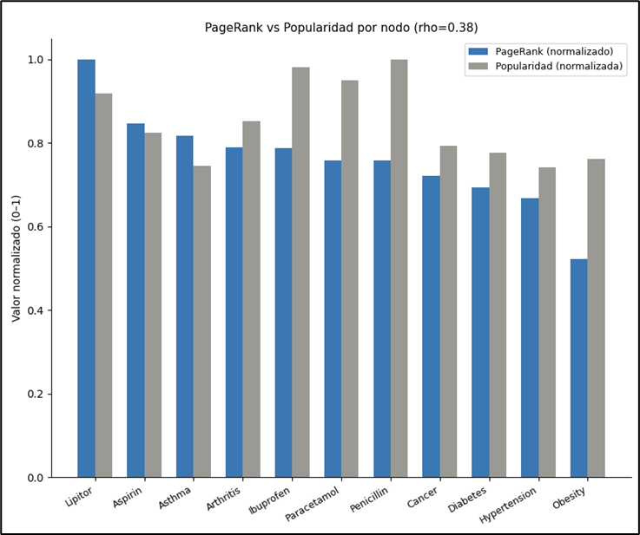

2. Spearman Correlation
Spearman ρ (PageRank rank vs. Popularity rank) = 0.3818 (p = 0.2466).
A correlation this low (well under the 0.9 threshold typically used to flag near-equivalence) indicates that, on the lift-filtered graph, PageRank captures structural information that raw popularity does not reflect. This is a direct consequence of the lift-based edge filter: on the earlier, complete graph, this same comparison produced ρ = 0.9727 , PageRank was almost indistinguishable from frequency, because every node was connected to every possible partner and volume alone drove the ranking. Filtering by statistical significance removed that redundancy, allowing structural position (who connects to whom, and how strongly) to diverge from simple counting.
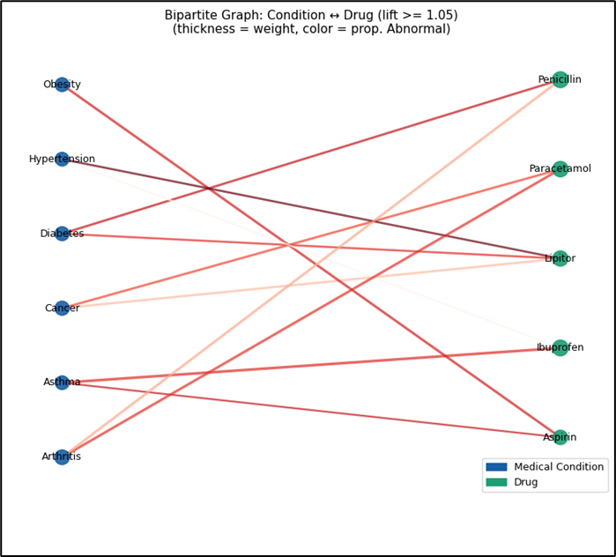

3. Cases Where Rankings Differ
Nodes that gain positions in PageRank relative to popularity (Lipitor, Aspirin, Asthma, Arthritis) have fewer but statistically stronger connections , their edges passed the lift filter with higher ratios of observed-to-expected co-occurrence. Nodes that lose positions (Penicillin, Ibuprofen, Paracetamol) have high raw volume, but their connections are closer to what independence would predict, so they contribute less structural distinctiveness once the graph stops rewarding volume alone.

Interpretation Note

What the Graph Structure Does Mean
● Statistically non-trivial association, not raw co-occurrence: an edge exists only where lift ≥ 1.05, i.e. the condition-medication pair appears together more often than independence would predict. This is what allows the graph to discriminate between pairs, rather than connecting all of them uniformly.
● Edge weight reflects operational intensity among the pairs that already passed the significance filter: weight = n_patients × (1 + prop_abnormal) combines patient volume and the proportion of Abnormal test results for that specific pair.
● Structural centrality (PageRank, betweenness) identifies nodes such as Lipitor whose few connections are statistically strong, and which , in this filtered graph , diverge from simple popularity (Spearman ρ = 0.38). This divergence is the graph doing its job: surfacing structure that raw counting would miss.

What the Graph Structure Does NOT Mean
● No causality: edges represent retrospective administrative pairings, not pharmacological or biological evidence. A significant, high-weight edge does not imply the medication causes the condition, nor that it is clinically effective for it.
● No severity proof: prop_abnormal is a proportion of Abnormal test results within the pair, not a validated clinical severity score. Weight and PageRank are structural/statistical quantities, not medical risk assessments.
● No comorbidity modeling: because the graph is bipartite (condition ↔ medication only), it does not capture co-occurring conditions within the same patient, nor medication interactions.
● Threshold-dependent topology: the graph's structure depends directly on the chosen lift threshold (1.05). A different threshold produces a different topology, as shown by the sensitivity sweep (14 pairs at lift ≥ 1.00 down to 5 pairs at lift ≥ 1.15).
● Descriptive, not decision-support: this is an exploratory structural analysis of administrative/synthetic data, appropriate for pattern discovery, not for clinical decision-making.

Validity Checks
The structure and robustness of the network model were validated through the following checks, performed on the lift-filtered graph (lift ≥ 1.05).

1. Sparsity
● Metric: Sparsity = 0.6333 (11 of 30 possible edges).
● Finding: 19 of the 30 possible condition-medication pairs were excluded for having lift below the 1.05 threshold , i.e. their co-occurrence was statistically indistinguishable from, or below, chance.
● Interpretation: Unlike the earlier fully complete graph (sparsity = 0.000), this graph now has genuine unused pairings, which is the intended outcome of a definition that discriminates significant from incidental associations.

2. Isolated Nodes at the Primary Threshold
● Metric: 0 isolated nodes at lift ≥ 1.05.
● Interpretation: every condition and medication retains at least one statistically significant connection at this threshold. This is a property of the specific threshold chosen, examined further below.

3. Sensitivity to a Secondary Weight Threshold
● Metric: applying a second filter for weight ≥ 62.0 (the median weight among the 11 lift-significant edges) on top of the lift filter.
● Finding: edges drop from 11 to 6, and two nodes ,Lipitor and Hypertension , become isolated.
● Interpretation: this is a meaningful robustness finding, in contrast to the earlier (unfiltered) sensitivity check, which removed half the edges from a complete graph and still found zero isolated nodes , a result that mostly reflected the graph's original density rather than any real structural resilience. Here, Lipitor is simultaneously the node with the highest PageRank, betweenness, and closeness in the lift-filtered graph, yet it is among the first to disconnect under a stricter intensity filter. Its three edges (weights 56.99–61.99) are all statistically significant but not the highest-volume in the network. This distinguishes statistical significance (lift) from operational magnitude (weight): a node can be structurally central because its associations are non-random, while still depending on comparatively few patients.

4. Weight Distribution
● Metrics (lift-filtered edges only): Min = 51.0 | Max = 72.0 | Mean = 61.8 | Median = 62.0.
● Interpretation: the weight distribution among statistically significant edges is narrower than the full 30-pair distribution (27.0–72.0), since low-weight, low-lift pairs were removed together. The remaining edges represent both a non-trivial statistical association and comparatively higher clinical/operational volume.

5. Full Threshold Sweep
A sweep across 20 weight thresholds (from the minimum to the maximum edge weight in the lift-filtered graph) was run to trace how the number of isolated nodes and remaining edges evolves continuously, rather than checking a single percentile cut. This addresses the earlier limitation of testing only one threshold once , the sweep shows the point at which Lipitor and Hypertension detach is not an artifact of choosing exactly the median, but part of a gradual, traceable pattern of disconnection as the intensity bar is raised.

Evaluation protocol
This project used a different evaluation protocol for each layer, chosen to match what that layer needed to prove ,cluster quality, ranking usefulness, or graph structural validity ,rather than a single metric applied uniformly.

Clustering (K-Means / DBSCAN)
Silhouette score and the Calinski-Harabasz index were used together because they capture different failure modes: silhouette penalizes overlapping boundaries at the individual-observation level, while Calinski-Harabasz rewards global separation between cluster centroids. Reporting both is what allowed the report to explain, rather than hide, the low silhouette scores in the full 54,966-record run ,as documented in the Technical Interpretation section, a low silhouette in this domain reflects real clinical overlap (comorbidity), not necessarily a poor model.

Ranking Engine (Clinical Priority Queue)
F1 Macro was the primary classification metric, chosen specifically because the three outcome classes are near-balanced and each carries independent clinical weight ,a metric like accuracy would have let the model ignore the Abnormal class while still scoring well. Because the actual production output is a ranked list, not a single label, Precision@K (K = 10, 20, 50) was evaluated as the operational metric, since it answers the question staff actually face: "of the top K patients the system flags, how many are truly Abnormal?" Three baselines were evaluated first ,most-frequent-class, random ranking, and a clinical rule ranking ,establishing the floor any model needed to clear before being credited with real value. 10-fold stratified cross-validation was used as a robustness check to confirm results were not an artifact of one favorable split.

Graph Analytics
Because a bipartite graph over 6 conditions and 5 medications can trivially become complete, the evaluation protocol for this layer centered on distinguishing statistically significant structure from coincidence. Lift was used as the significance test for edge existence; a sensitivity sweep across lift thresholds (1.00 to 1.15) was run to confirm the chosen cutoff was not arbitrary. Spearman correlation between PageRank and raw popularity was used as the acceptance test for whether the graph model added anything beyond simple frequency counting ,a correlation near 1.0 would have meant the graph was redundant with a one-line frequency table.

Shared Principle Across Layers
Every model in this project ,clustering, ranking, and graph ,was evaluated against an explicit baseline or null hypothesis before being credited with adding value: a dummy classifier for the ranking engine, a random/clinical-rule ranking for Precision@K, an unfiltered complete graph for the lift-based graph, and raw popularity for PageRank. This consistent baseline-first protocol is what allows conclusions in this report to be stated as measured improvements rather than as unqualified model performance.

Pipeline and reproducibility
The end-to-end pipeline moves through five stages, each consuming the output of the previous one. This section traces that lineage and documents where reproducibility currently depends on notebook state versus a standalone script.

Stage | Input | Output | Records
1. Ingestion & Preprocessing | healthcare_dataset.csv (raw) | healtcare_processedv2.csv | 55,500 → 54,966 (dedup)
2. Feature Engineering | healtcare_processedv2.csv | patient_feature_matrix (33 features) | 54,966 patients
3. PCA / Clustering | patient_feature_matrix | healthcare_pca_clusters.csv (Cluster_Biz) | 54,966 → 1,196 (post cluster-join)
4. Ranking Engine | healtcare_processedv2.csv + healthcare_pca_clusters.csv | ranked priority queue (prob_ensemble) | 1,196 (1,108 train / 88 test)
5. Graph Analytics | healtcare_processedv2.csv + healthcare_pca_clusters.csv | clinical_graph.gexf | 11 nodes / 11 edges (lift ≥ 1.05)

Key Reproducibility Dependency
Stages 4 and 5 both depend on the same join between the processed dataset and the PCA cluster assignments (healthcare_pca_clusters.csv), which is the step that reduces the working population from 54,966 to 1,196 records. This is documented explicitly in Section 3.4 of the Ranking Engine chapter and in the Graph Construction Script section ,it is a single, traceable dependency rather than an unexplained discrepancy between record counts across sections of this report.

What Is and Is Not Currently Scripted
● Preprocessing, feature engineering, PCA, and clustering are executed and versioned as notebooks in the repository.
● The ranking engine (baselines, Logistic Regression, Random Forest, CatBoost, ensemble) runs as a notebook that exports the priority queue and validation metrics.
● The graph analytics pipeline runs as a notebook (lift calculation, filtering, NetworkX construction, GEXF export) and as a Streamlit module (graph_utils.py) for the interactive dashboard.
● Open item: a standalone build_graph.py script (accepting --input/--output paths via argparse) is planned so the graph can be regenerated from the command line, independent of notebook execution state. This is the one component of the pipeline not yet reproducible outside the notebook environment, and is listed again under Limitations and Future Work.

Environment and Execution Order
The full pipeline must be executed in the stage order above, since each stage's output file is a hard input to the next. The repository's Runbook documents the exact commands and notebook execution order required to regenerate every artifact in this report from the raw CSV.

Monitoring and Operationalization Plan
This plan covers what would need to be true for the clustering, ranking, and graph components of this project to run safely in a live hospital setting, rather than as a one-time offline analysis.

Serving Assumptions
● The ranking engine assumes a patient record is scoreable at admission time ,i.e. all 14 input features (demographics, Medical Condition, Admission Type, Medication, Insurance Provider, Billing Amount, Length of Stay, admission date parts, Cost_Per_Day, Cluster_Biz) are available before Test Results is known. In production, Length of Stay and Cost_Per_Day are not truly known at admission; a live system would need to substitute an expected/estimated value at intake and re-score once actuals are available.
● Cluster_Biz, used as an input feature to the ranking engine, is produced by a K-Means model fit in a separate offline stage. Serving this in production requires a persisted, versioned clustering model applied to new patients only ,never refit on data that includes the patient being scored, to avoid the leakage caveat already documented in Section 2.4 of the Ranking Engine chapter.
● The graph analytics component is a batch, population-level artifact (rebuilt periodically from accumulated admissions), not a per-patient real-time service ,it informs dashboards and periodic clinical review, not individual triage decisions.

Data and Model Drift
● Population drift: the ranking engine was trained on admissions through 2023 and tested on 2024 data using a temporal split specifically to expose this risk. In production, the same temporal validation should be repeated on a rolling basis (e.g. quarterly) to detect whether admission patterns, prescribing practices, or Test Results distributions have shifted enough to degrade F1 Macro or Precision@K below their reported baselines.
● Cluster drift: the three/four K-Means patient profiles are a snapshot of the training population's structure. New admission cohorts (e.g. a seasonal influx of a condition not well represented in training) could fall consistently near cluster boundaries, which the Failure Analysis section already shows happens even in-sample (0.12% negative-silhouette cases concentrated in Arthritis/Hypertension). A rising rate of boundary cases over time would be the operational signal to retrain.
● Graph drift: because the graph's edges depend on the lift ≥ 1.05 threshold, the set of statistically significant condition-medication pairs can change as new admissions shift the marginal probabilities P(condition) and P(medication). The graph should be rebuilt on a fixed cadence (not left static), and a changed edge set between rebuilds is itself a monitorable signal of shifting prescribing or diagnostic patterns.

Retraining Triggers
Component | Suggested trigger | Action
Ranking ensemble | F1 Macro or Precision@10 drops below current baseline (0.380 / 0.600) on a rolling evaluation window | Retrain RF + CatBoost on updated training window; re-validate against the same baselines before redeploying
K-Means clustering | Share of negative-silhouette assignments rises materially above the current 0.12% baseline, or cluster size balance shifts sharply | Re-run K-selection sweep (silhouette + inertia) and refit centroids
Clinical graph | Edge set changes substantially between scheduled rebuilds, or a new condition/medication enters the top-6/top-5 by volume | Rebuild graph_utils pipeline end-to-end; re-run the lift sensitivity sweep to confirm the 1.05 threshold is still appropriate

Logging
● Ranking engine: log the input feature vector, the ensemble's prob_abnormal score, and the eventual Test Results outcome for every scored admission, enabling rolling recomputation of F1 Macro, Precision@K, and the asymmetric cost metric already used in offline evaluation.
● Clustering: log the assigned Cluster_Biz label and the distance to the nearest centroid for each new patient, so boundary-case drift (the same phenomenon documented in Failure Analysis) can be tracked over time rather than only detected in a one-off offline audit.
● Graph: version each rebuilt clinical_graph.gexf with its build date and the lift/weight thresholds used, so any change in structure shown on the interactive dashboard can be traced to a specific data window and threshold configuration rather than treated as a black box.

Failure Modes
● Silent feature staleness: if Length of Stay or Cost_Per_Day are estimated at intake and never reconciled with actuals, ranking scores would systematically use stale proxies without any visible error ,this must be monitored via the logging plan above, not assumed away.
● Cluster leakage recurrence: if a future retraining pipeline refits K-Means on a dataset that already includes the patients being scored (the same leakage pattern currently documented as a caveat for the offline analysis), test-time cluster assignments would again be optimistically biased. This should be an explicit check in any retraining runbook, not just a one-time note in this report.
● Graph over-interpretation in operational use: because PageRank and centrality in the clinical graph are structural, not clinical, measures (as stated in the Interpretation Note), a failure mode specific to this component is stakeholders treating a high-PageRank medication as a flagged risk item. Any operational dashboard surfacing these metrics should carry the same explicit disclaimer used in this report's Interpretation Note.
● Small candidate pool for the ranking engine: because the ranking engine's usable population is reduced to 1,196 of 54,966 records by the cluster-join step, any drift in that join (e.g. a change in how PCA clusters are computed or exported) directly and silently shrinks or biases the scoreable population ,this join step should be monitored as a pipeline health check, not only as a modeling caveat.

Ethics and limitations
This section consolidates limitations already surfaced individually across the report ,rather than repeating generic caveats, each item below is tied to a specific, previously documented piece of evidence.

Limitations
● Cluster_Biz leakage caveat: as documented in Section 2.4, the K-Means model used to generate Cluster_Biz was fit on the full dataset before the train/test split, meaning test-set cluster assignments were technically informed by their own data. Cluster_Biz should be treated as a contextual feature with a known caveat, not a causally clean predictor.
● Ranking engine feature ceiling: the error analysis (Section 7.6) shows a structurally symmetric confusion matrix across all three outcome classes, with no single dominant error boundary ,direct evidence that the available admission-time features (demographics, billing, insurance, cluster membership) do not encode acute biological state. The Ensemble's F1 Macro of 0.380 and Precision@10 of 0.600, while well above the random and clinical-rule baselines, represent a ceiling set by the feature set, not by model choice.
● Small, reduced candidate pool: the ranking engine and graph analytics both operate on 1,196 of the original 54,966 records, because both depend on the same cluster-alignment join described in Pipeline and Reproducibility. Conclusions from these two layers apply to the subpopulation with valid PCA cluster assignments, not to the full admissions population.
● DBSCAN's lack of natural density structure: the parameter sweep (DBSCAN Experiment section) shows that for eps ≤ 1.5, the algorithm labels 100% of the data as noise regardless of min_samples, and that the eps = 2.5 configuration achieves its silhouette score by collapsing the population into only 2 macro-clusters while expelling 14.55% of records as noise. This is evidence that the dataset does not have strong natural density clusters, and DBSCAN's role in this project is correctly scoped to outlier/forensic detection, not primary segmentation.
● Graph topology is threshold-dependent and small: the clinical graph has only 11 nodes, and its structure (11 vs. 30 edges) changes materially depending on the chosen lift threshold, as shown in the sensitivity sweep (14 significant pairs at lift ≥ 1.00 down to 5 at lift ≥ 1.15). Findings such as Lipitor's centrality should be read as descriptive of this specific dataset and threshold choice, not as a stable, generalizable clinical signal.
● Synthetic dataset: the source data (Kaggle's synthetic healthcare dataset) does not represent real patient populations or real prescribing practice. All clustering, ranking, and graph findings in this report describe patterns within this synthetic dataset and are not clinical claims.
● Methodological asymmetry in graph centrality: as noted in the Graph Report, betweenness centrality was corrected to use a distance transform (1/weight), but closeness centrality was left on unweighted topology , a known, explicitly documented inconsistency rather than a silent one.

Future Work
● Incorporate early clinical signals (initial vital signs, first laboratory values, triage acuity score) into the ranking engine's feature set ,identified in Section 7.6 as the single highest-value improvement available, since it directly targets the feature ceiling causing the symmetric confusion matrix.
● Build the standalone build_graph.py script (already scoped in Graph Construction Script and Pipeline and Reproducibility) so the graph can be regenerated from the command line as part of a CI/scheduled job, rather than depending on notebook state.
● Extend closeness centrality to use the same distance = 1/weight transform already applied to betweenness, closing the methodological asymmetry noted in the Graph Report.
● Resolve the Cluster_Biz leakage caveat by persisting the K-Means model fit only on the training partition, and applying it (never refitting it) to score new/test patients ,turning Cluster_Biz into a causally clean, production-safe feature.
● Investigate whether the cluster-alignment join can be relaxed or imputed, so the ranking engine and graph analytics layers can operate on a larger share of the 54,966-record population instead of the current 1,196-record subset.
● Operationalize the monitoring plan above ,particularly rolling F1 Macro / Precision@K evaluation and cluster boundary-case tracking ,as scheduled jobs rather than one-time offline checks.

Conclusions
This project implemented a complete data intelligence pipeline for a synthetic healthcare dataset, moving from raw ingestion through relational modeling, dimensionality reduction, clustering, a predictive ranking engine, and graph-based structural analysis ,with each layer evaluated against an explicit baseline rather than reported in isolation.
● Preprocessing and schema design transformed 55,500 raw records (54,966 after deduplication) into a normalized relational model (patients, hospitals, doctors, medical_conditions, medications, medical_records), with zero missing values and a documented ethics note on the dataset's synthetic nature.
● PCA reduced a 33-feature patient matrix to 14–15 principal components while retaining ~95–100% of variance, and t-SNE confirmed the presence of a dominant patient population alongside a smaller, persistent subgroup ,motivating clustering as the next step rather than assuming a single homogeneous population.
● K-Means (selected over DBSCAN for production use) identified operationally distinct patient segments, validated with both silhouette score and the Calinski-Harabasz index, and interpreted through a documented failure analysis of boundary/noise cases rather than treated as a clean partition.
● The ranking engine (Ensemble of Random Forest and CatBoost) outperformed the most-frequent-class, random-ranking, and clinical-rule baselines at every evaluated K, most notably tripling the random baseline's Precision@10 (0.600 vs. 0.200) ,while the error analysis honestly attributes the remaining error rate to a feature ceiling rather than overselling model performance.
● The clinical graph, after being corrected from a fully complete bipartite structure (sparsity = 0.000) to a lift-filtered significant-association graph (sparsity = 0.6333), produced a PageRank ranking that meaningfully diverges from raw popularity (Spearman ρ = 0.38, down from 0.97 on the unfiltered graph) ,demonstrating that the graph layer adds structural information beyond simple frequency counting.
Across all three modeling layers, the project consistently favored documented, evidence-tied limitations over polished but unsupported claims: the Cluster_Biz leakage caveat, the ranking engine's feature ceiling, and the graph's threshold-dependent topology are all surfaced explicitly rather than smoothed over. The Monitoring and Operationalization Plan and Limitations and Future Work sections extend that same standard forward, translating each offline finding into a concrete signal to track or a concrete next step, rather than leaving the analysis as a static, one-time report.

Anexos
Anexo A.
Repository: https://github.com/SofiaGMiranda/BIG-DATA-FINAL-PROYECT-2025-01.git
Anexo B.
Interactive Dashboard Clinical Analytics System (Streamlit)
The clinical graph is also available as an interactive visualization.
Link: https://big-data-final-proyect-2025-01clinal-data.streamlit.app/

