Developing a Formal Model of the Online Disinhibition Effect

Sofia Maria Luchiean
12733610
P 19 Practical Course in Empirical Research Methods
17.03.2026

Objective
The aim of the following work is to show the process of formalizing the Online Disinhibition Effect (Suler, 2004). This theory aims to explain the emergence of more disinhibited behavior in online environments when compared to offline environments. It proposes six factors inherent to the online environment which interact and supplement each other to create this disinhibition effect: “dissociative anonymity, invisibility, asynchronicity, solipsistic introjection, dissociative imagination, and minimization of authority” (Suler, 2004, p. 321). The resulting disinhibited online behavior can take different forms, from more benign ones such as increased levels of self-disclosure or generosity, to more toxic forms like cyberbullying and other aggressive behaviors.
In order to keep this formalization feasible, we started by limiting our scope and constructing a proto-theory based on Suler (2004), with additional assumptions to fill the gaps and make processes explicit. We limited ourselves to the first two factors: dissociative anonymity and invisibility. These two were chosen because anonymity is considered to be one of the main factors, and because invisibility overlaps with it (Suler, 2004). The theory presented in this report is our reduced and adjusted version of the original theory.
Robustness
One phenomenon the theory aims to explain is a form of toxic online disinhibition. It refers to the negative, harmful behavioral aspects that occur as a consequence of characteristics of the online environment (Suler, 2004). To my knowledge, no meta-analysis has addressed this phenomenon to date. To assess robustness, I will focus on two experimental studies. This limits the strength of evidence, as this limited data might be biased, most likely misses aspects reported in other studies and lacks statistical quantification.
Both studies were able to detect toxic online disinhibition (Lapidot-Lefler & Barak, 2012; Nitschinsk et al., 2022). Regarding different units, the studies assessed toxic online disinhibition within student populations only. However, the effect was found in two different cultures and for both male and female participants of different ages. Both studies used similar treatment conditions by varying the anonymity level (high vs. low). Lapidot-Lefler and Barak additionally varied the level of visibility and eye contact. The outcome, i.e. toxic online disinhibition, was operationalized and measured differently. Lapidot-Lefler and Barak employed three measures of flaming behavior, while Nitschinsk et al. used independent raters’ assessment of trolling. Concerning the setting, both studies were conducted in a laboratory, where participants interacted with other participants via text. Different communication channels were used between the studies. Nitschinsk et al. additionally added a condition for participation outside of the laboratory, which did not show the expected effect.
Within the scope of this assessment, the phenomenon can be said to be generalizable across different units and outcomes. For treatments and settings, generalizability is lower, as there is less variation within and between studies. Keeping the limited strength of evidence in mind, the phenomenon cannot be said to be robust. Note that assessing robustness of the phenomenon was not the main goal of this report. Our focus was rather to deduce a formal model from the very broad original theory.
Proto-theory: Constructs and Relationships
A Visualization of our reduced theory using the Visual Argument Structure Tool (VAST) (Leising et al., 2023) is presented in Figure 1. For the original sources and quotes that were used to create this display, see Table 1 in Appendix A.
Dissociative anonymity (E) describes how the possibility to be anonymous online leads to disinhibited behavior. Anonymity as a characteristic of the online environment refers to the ability to be present without one’s real identity being known to other users (B). This anonymity allows for separation of one’s online behaviors from the rest of one’s identity, creating an alternative, compartmentalized self (C).
The consequence of this separation is a decrease in the responsibility a person feels for their actions (D1). Base and Felt Responsibility both refer to assuming responsibility for one’s actions, with the former focusing on a baseline tendency to do so (D2), and the latter on a situational manifestation (D1). The original theory does not make this distinction explicit; it is based on our own interpretation that we added base responsibility as a construct. Note that we use responsibility synonymous with accountability.
Invisibility denotes how in online communication, individuals cannot see or hear each other (F), causing a decrease in interpersonal cues. Those cues refer to communicational signals exchanged during interaction in verbal, paraverbal or nonverbal ways (G1). Normally, negative cues inhibit people from behaving in a socially undesirable fashion (G2). With interpersonal cues lost in online environments, individuals become more daring to express themselves (H).

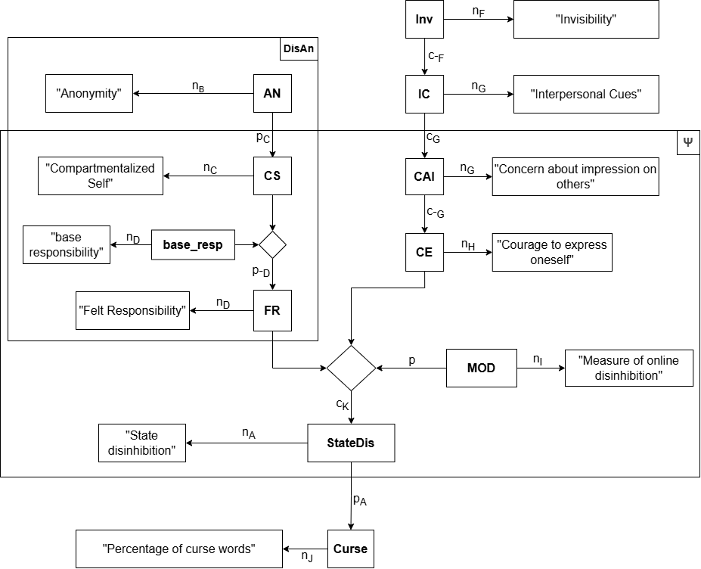
Figure 1
VAST Display

Our reduced theory includes the Measure of Online Disinhibition (Stuart & Scott, 2021) as operationalization for trait online disinhibition. This construct describes a person’s psychological disposition towards online disinhibition – measured globally, independent from characteristics of cyberspace or actual behavior (I). While not explicitly mentioned in the original theory, we included this measure to account for the difference between online and offline behavior tendencies (Suler, 2004).
What we termed state disinhibition is the psychological impulse to act more intensely in a particular online situation than one would in an offline setting (A). While the original paper does not define state disinhibition, formulations such as “feel less restrained” imply a psychological precursor that is then translated into concrete behavior. Disinhibited behavior can manifest in a multitude of ways. Generally speaking, it refers to a more extreme form of behavior compared to a person’s usual set of behaviors (A).
The original theory does not make predictions about the valence of the disinhibited behavior. The same mechanisms are theorized to lead to both benign and toxic behavioral expressions. As such, our theory too explains the phenomenon of toxic online disinhibition the same it does any form of online disinhibition: through a decrease in felt responsibility caused by higher anonymity, a higher courage to express oneself caused by higher invisibility, and the interaction between anonymity and invisibility (K). With this in mind, state disinhibition should be considered our explanatory target rather than the resulting behavior.
Since State disinhibition is a latent psychological variable, there needs to be a measurable, manifest outcome. We decided on written verbal aggression (J) as manifestation and created an operationalization based on expertise in our group. The use of curse words, more precisely the percentage of sentences containing at least one curse word, is the outcome variable of our theory.
Development of a Formal Model
In a next step, we formalized our reduced theory into a formal mathematical model. A number of assumptions had to be made, as not all relevant information was part of the theoretical model. This includes assumptions about the exact functional forms for the relationships between variables, the weighting of variables in the combined system, and the amount of random noise added to the output variable. I also chose interpersonal cues as the input variable to the model rather than invisibility, limiting complexity.
Distributions of variables within the psyche were estimated based on additional empirical literature. For approximating MOD distribution, I used the mean and standard deviation provided by Stuart and Scott (2021), assuming normal distribution. For base_resp, I used a measure instrument that best fit our definition: the Accountability Scale (Witvliet et al., 2023). As the authors did not provide sufficient information on distribution in their paper, I used the raw accompanying open data (Witvliet et al., 2022) to compute the distribution.
Table 1 shows all variables with their range and semantic anchors. As all variables are continuous, the column indicating scale level was omitted from this table.
Table 1
Variable Table
Construct | Short Name | Range | Semantic Anchors
Anonymity | AN | [0;1] | 0 = User is fully known during the interaction  1 = Full anonymity where the user remains unknowable during and after the interaction (based on Christie & Dill, 2016)
Compartmentalized Self | CS | [0;1] | 0 = Online- and offline-self are completely identical  1 = Feeling like ‘those online behaviors “aren’t me at all.”’ (Suler, 2004)
Base Responsibility | base_resp | [0;1] | Mean score for the items of the Accountability Scale (Witvliet et al., 2023), rescaled to the range [0;1] with 0 = “Disagree strongly” to 1 = “Agree strongly”
Felt Responsibility | FR | [0;1] | 0 = One feels no responsibility for one’s actions, temporary suspension of moral cognitive processes  1 = maximal feeling of responsibility for one’s actions
Interpersonal cues | IC | [0;1] | 0 = Text-only, minimal interpersonal cues  1 = Audio, video and nonverbal feedback; maximal nonverbal, paraverbal and verbal cues
Concern about impression on others | CAI | [0;1] | 0 = Not concerned about impression on others  1 = Maximally concerned about impression on others
Courage to express oneself | CE | [0;1] | 0 = Maximal inhibition and fear of expressing oneself  1 = No fear of expressing oneself
Measure of Online Disinhibition | MOD | [1;5] | Mean score on a 5-point Likert scale with 1 = “Not at all like me” to 5 = “Very like me” for the items of the MOD (Stuart & Scott, 2021)
State Disinhibition | StateDis | [-0.1;1.2] | - 0.1 = No inclination to “say and do things in cyberspace that [one] wouldn’t ordinarily say and do in the face-to-face world” (Suler, 2004, p. 321)  1.2 = Maximal inclination toward such behavior
Percentage of curse words | Curse | [0;1] | 0 = No sentence contains any curse word  0.5 = Half the sentences contain at least one curse word each  1 = every sentence contains at least one curse word
Note. The range for StateDis was not specified a priori, but is the natural result of the mathematical formula used to compute values.

Functional relationships
The theoretical model does not dictate the form of the functional relationships beyond the direction (positive vs. negative). Therefore, we defined functions loosely inspired by the theory (IDs linking to original sources in brackets), with decisions made based on common sense, plausibility and knowledge in the field. The relationships between these constructs are very specific, which is why we were unable to find empirical backing for them. It should be noted here that Suler (2004) also does not provide empirical data for the relationships he claims.
Figure 2 shows plots of the four relationships central to this model. The mathematical formulae to compute these plots are as follows:
Compartmentalized self as a function of anonymity (C):
$$CS =\frac{AN^{2}}{AN^{2}+ {\left(1-AN\right)}^{2}}$$
Felt Responsibility as a function of Compartmentalized Self and base responsibility (D):
$$FR = base_resp* {\left(1 - 0.8 * CS\right)}^{3}$$
Concern about impression on others as a function of Interpersonal Cues (G):
$$CAI = IC$$
Courage to express oneself as a function of Concern about impression on others (G):
$$CE = - CAI + 1$$
Figure 3 shows the behavior of the combined system, i.e. how the State Disinhibition behaves as a function of all exogenous variables. The following formula includes all the intermediate computational steps (K):
$$StateDis = 0.2 * MOD - 0.3 * FR + 0.2 * CE - 0.1 * FE * CE$$
The outcome variable – percentage of sentences containing curse words – is computed from State Disinhibition with added random noise (A):
$$Curse = \frac{\left(StateDis + 0.1\right)}{1.3} + rnorm(mean = 0, sd = 0.1)$$

Figure 2
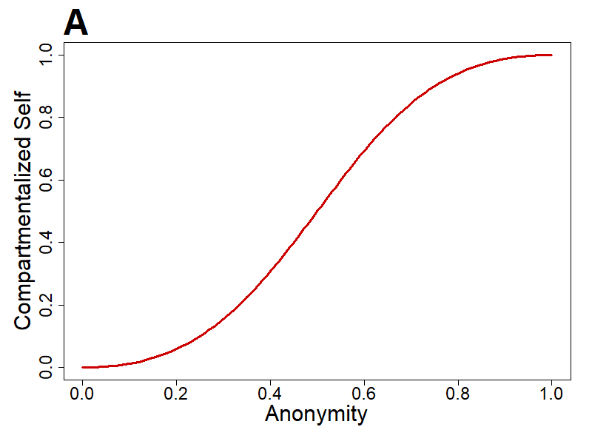
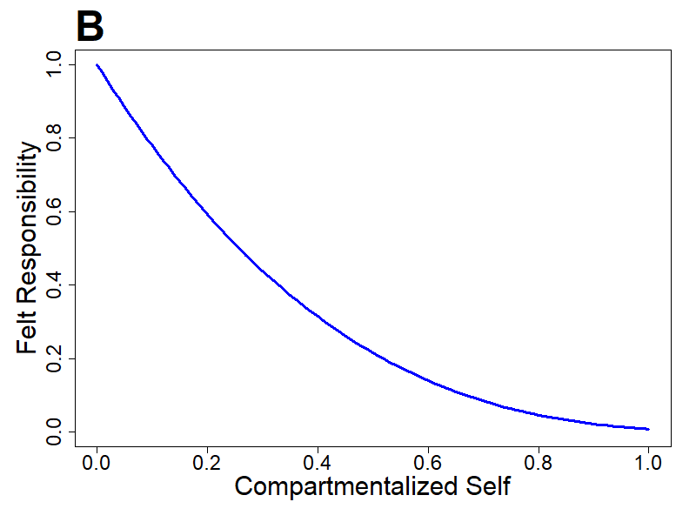
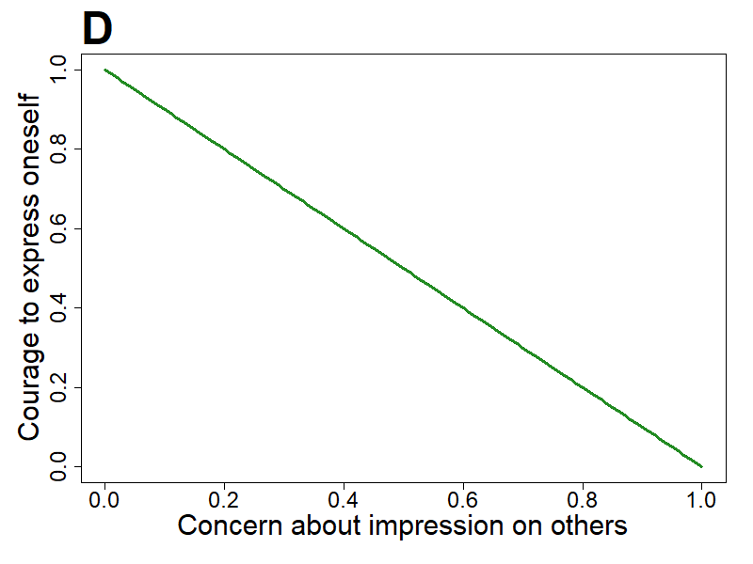
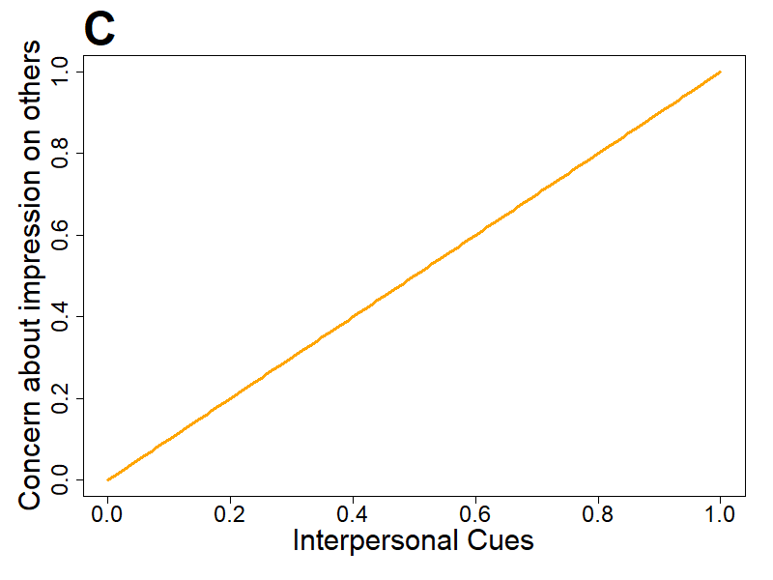
Atomic Functions
Note. A. For small or big values of AN, changes in AN do not have a big impact on the increase of CS. The effect on CS is higher for mid-range values of AN.
B. For low levels of CS, the effect it has on FR is more pronounced. The intercept corresponds to the base_resp value.
C. Increases in IC linearly predict the CAI an individual experiences.
D. With higher levels of CAI, an individual’s CE linearly decreases.

Figure 3
Behavior of the Combined System
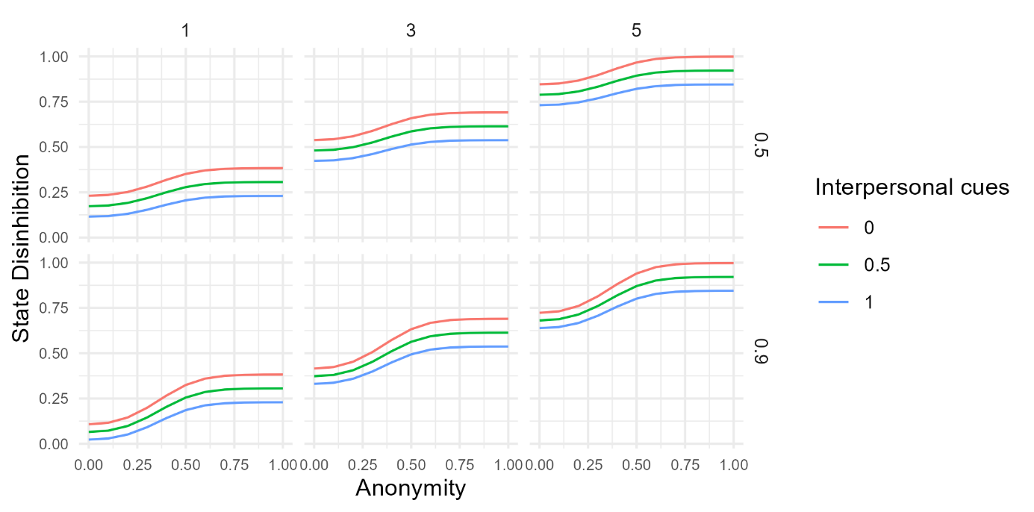
Note. State Disinhibition as a function of Anonymity, Interpersonal Cues, MOD (columns) and Base Responsibility (rows). Values for MOD and base_resp were chosen to show how the model behaves for different plausible values.
Evaluation of the Formal Model
To evaluate our model, we simulated a virtual sample with the values 0 and 1 for both experimental factors (AN and IC). A total N=140 was chosen similar to the sample size reported by Lapidot-Lefler and Barak (2012). MOD and base_resp were then drawn from their respective distribution and added as observed interindividual differences. Based on those values, the outcome variable was computed for each virtual individual.
Figure 4 shows boxplots of simulated raw data, Figure 5 visualizes the mean differences. The model seems to be producing the phenomenon. Although there is considerable variation in the outcome variable within groups, higher levels of AN and lower levels of IC (i.e. higher invisibility) lead to higher percentages of sentences containing curse words.

Figure 4
Box Plot of Simulated Raw Data by Experimental Condition
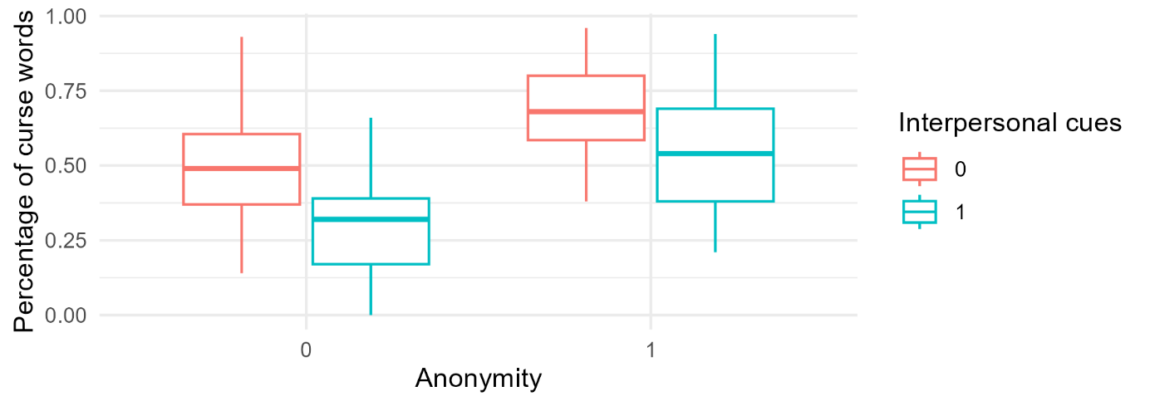
Figure 5
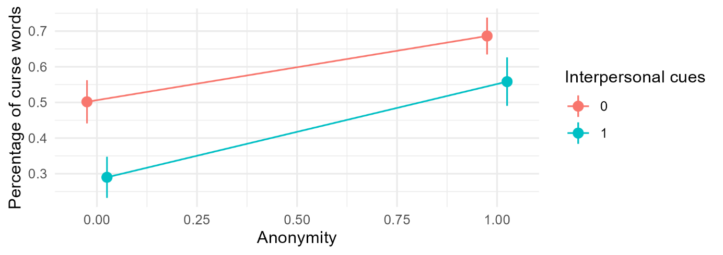
Interaction Plot Showing Means and 95% Confidence Intervals by Experimental Condition

Based on our theory, we formulated a multiple linear regression model assuming main effects of both AN and IC as well as an interaction effect. This model explained 41% of variance in the percentage of curse words (R² = .41, 95% CI [0.27, 0.52]). Table 2 shows the model’s standardized β-coefficients.
Table 2
Standardized β-Coefficients as Effect Size Measures
 | β | 95% CI
Anonymity | .51 | [.38, .64]
Interpersonal Cues | -.38 | [-.51, -.25]
Interaction | .09 | [-.04, .22]
To statistically test whether the simulated data produces the phenomenon, I used a combined hypothesis, expecting to find at least one effect (main effect or interaction). A Bonferroni-corrected alpha level of 0.017 was used to account for multiple testing. The tests revealed both main effects to be significant at p < .001. The interaction effect was not significant (p = .921). Overall, these results support the combined hypothesis; The simulated data does produce the phenomenon.
Additional Analyses
Suler claims that personality has an impact on the intensity of disinhibited behavior, which can be small in some cases, but cause “dramatic changes” (Suler, 2004, p. 324) in others. He does not, however, explicate the underlying mechanism. In our model, one instance of interpersonal variance stems from the base responsibility. With this in mind, I examined the impact base_resp has on the model output.
In the mathematical model, base_resp influences the outcome as a moderator of FR, impacting the main effect of AN and the interaction effect. Regardless of variations in base_resp, the model will – in theory – still produce the phenomenon, since a main effect of IC is built into it (see Figure 6).
Figure 6
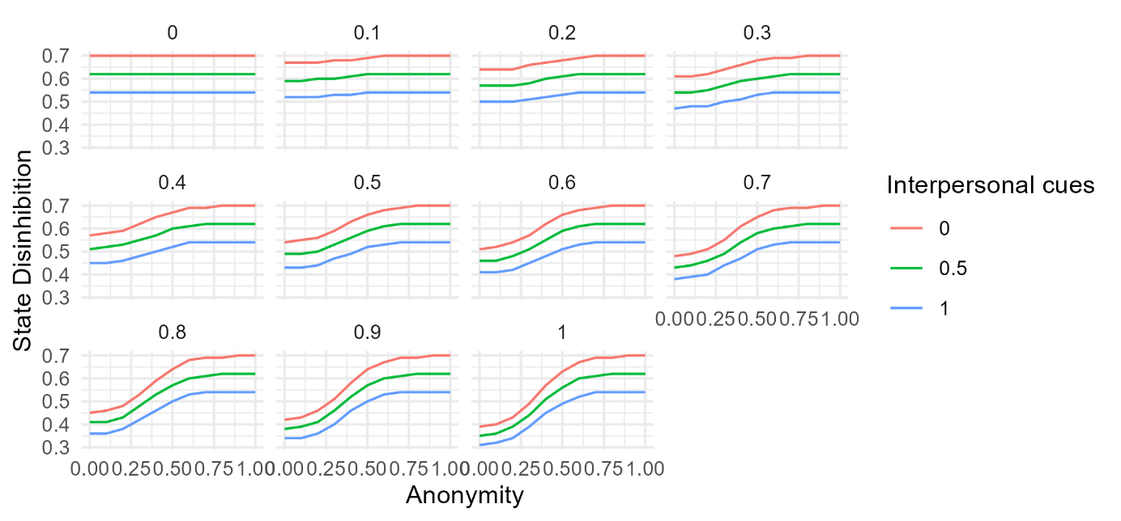
Deterministic Model Output by Base_resp Value
Note. For low levels of AN, base_resp has a big influence on the output variable. For high levels of AN, the influence of base_resp becomes negligible. A fixed MOD of 3.036 was used for this simulation, as this is the mean MOD-score in the previous simulated sample.
I recreated the experiment from before, this time manipulating base_resp levels as well. Values ranged from 0 to 1 by 0.1 increments. I sought to find for which base_resp conditions the experiment produces the phenomenon. To test that, I wrote a function that conducts the same combined hypothesis test as described previously for a given base_resp value. Then, I applied this function to all base_resp values.
On a first run, the model produced the phenomenon for all base_resp values. After simulating 100 re-runs of this procedure, a pattern emerged. For base_resp values of 0.5 and above, the phenomenon appeared in every iteration. For values below 0.5, the phenomenon appeared in the majority of cases, with occasional failures to produce the phenomenon (see Table 3 for details). Note that this procedure too is a form of multiple testing, so false positives and false negatives are likely to have happened.
Table 3
Proportion of Simulations Producing the Phenomenon by Base_resp Value
Base_resp | 0 | 0.1 | 0.2 | 0.3 | 0.4 | 0.5 | 0.6 | 0.7 | 0.8 | 0.9 | 1
Proportion | .93 | .96 | .94 | .91 | .98 | 1 | 1 | 1 | 1 | 1 | 1

To conclude, regardless of base_resp value, our model seems to always produce the phenomenon. This holds especially true since values of 0.5 and below are highly unlikely when sampling from the distribution. The influence of personality as described in the original theory is not sufficiently covered by variations of base_resp. Extensions of our model to include other personality aspects are conceivable, but would go beyond the scope of this formalization.
Discussion
Developing a formal model for this theory was not an easy feat. The original theory does not allow for precise explanations and seems to be based on speculation and anecdotal evidence rather than robust empirical findings. Consequently, we had a lot of gaps to fill. While writing this final report, I noticed how many decisions we could have made differently and still remain just as true to the original theory.
It was especially difficult to limit myself every step along the way and keep a narrow scope. If I were to start this process all over again, I would do things differently, beginning with limiting the scope even further by e.g. modelling AN and IC as binary variables. Cutting out major parts of the theory and simplifying the remaining ones felt very radical, and I ask myself to what extent this formalization attempt can actually be called a formalized version of the Online Disinhibition Effect.

References
Christie, C., & Dill, E. (2016). Evaluating peers in cyberspace: The impact of anonymity. Computers in Human Behavior, 55, 292–299. https://doi.org/10.1016/j.chb.2015.09.024
Lapidot-Lefler, N., & Barak, A. (2012). Effects of anonymity, invisibility, and lack of eye-contact on toxic online disinhibition. Computers in Human Behavior, 28(2), 434–443. https://doi.org/10.1016/j.chb.2011.10.014
Leising, D., Grenke, O., & Cramer, M. (2023). Visual Argument Structure Tool (VAST) Version 1.0. Meta-Psychology, 7. https://doi.org/10.15626/MP.2021.2911
Nitschinsk, L., Tobin, S. J., & Vanman, E. J. (2022). The Disinhibiting Effects of Anonymity Increase Online Trolling. Cyberpsychology, Behavior, and Social Networking, 25(6), 377–383. https://doi.org/10.1089/cyber.2022.0005
Stuart, J., & Scott, R. (2021). The Measure of Online Disinhibition (MOD): Assessing perceptions of reductions in restraint in the online environment. Computers in Human Behavior, 114, 106534. https://doi.org/10.1016/j.chb.2020.106534
Suler, J. (2004). The Online Disinhibition Effect. CyberPsychology & Behavior, 7(3), 321–326. https://doi.org/10.1089/1094931041291295
Witvliet, C. V. O., Jang, S. J., Johnson, B. R., Evans, C. S., Berry, J. W., Leman, J., Roberts, R. C., Peteet, J., Torrance, A. B., & Hayden, A. N. (2023). Accountability: Construct definition and measurement of a virtue vital to flourishing. The Journal of Positive Psychology, 18(5), 660–673. https://doi.org/10.1080/17439760.2022.2109203
Witvliet, C. V. O., Johnson, B. R., Roberts, R., Jang, S. J., Evans, C. S., Peteet, J., Berry, J. W., Leman, J., Torrance, A., & Bradshaw, M. (2022). Transcendent Accountability Scale Development Data and Materials. https://doi.org/10.17605/OSF.IO/GV6ZS

Appendix A
Table 1
Construct Source Table
Reference | Quote | Extracted element | Element type¹ | Rel. type² |  | Short name |  | Comment |  | ID
Suler (2004, p. 321) | “people say and do things in cyberspace that they wouldn’t ordinarily say and do in the face-to-face world. They loosen up, feel less restrained, and express themselves more openly.” | State Disinhibition | C |  | n |  | StateDis |  |  | A
Suler (2004, p. 322) | “If so desired, people can hide some or all of their identity. They also can alter their identities. As the word “anonymous” indicates, people can have no name or at least not their real name.” | Anonymity | C |  | n |  | AN |  | characteristic of cyberspaces | B
Suler (2004, p. 322) | “When people have the opportunity to separate their actions online from their in-person lifestyle and identity, they feel less vulnerable about self-disclosing and acting out. [...] The online self becomes a compartmentalized self.” | Compartmentalized Self | C |  | n |  | CS |  |  | C
Suler (2004, p. 322) | “In the case of expressed hostilities or other deviant actions, the person can avert responsibility for those behaviors, almost as if superego restrictions and moral cognitive processes have been temporarily suspended from the online psyche. In fact, people might even convince themselves that those online behaviors ‘aren’t me at all.’” | Felt Responsibility | C |  | n |  | FR |  |  | D1
Suler (2004, p. 322) |  | Base Responsibility | C |  | n |  | base_resp |  | baseline tendency of an individual to assume responsibility for their actions | D2
Suler (2004, p. 322) | “In a process of dissociation, they don’t have to own their behavior by acknowledging it within the full context of an integrated online/offline identity.” | Dissociative Anonymity | HOC |  | n |  | DisAn |  |  | E
Suler (2004, p. 322) | “In the text communication of e-mail, chat, instant messaging, and blogs, people may know a great deal about each other’s identities and lives. However, they still cannot see or hear each other.” | Invisibility | C |  | n |  | Inv |  | characteristic of cyberspaces | F
Suler (2004, p. 322) | “People don’t have to worry about how they look or sound when they type a message. They don’t have to worry about how others look or sound in response to what they say. Seeing a frown, a shaking head, a sigh, a bored expression, and many other subtle and not so subtle signs of disapproval or indifference can inhibit what people are willing to express. [...] Avoiding eye contact and face-to-face visibility disinhibits people. Text communication offers a built-in opportunity to keep one’s eyes averted.” | Interpersonal Cues | C |  | n |  | IC |  |  | G1
Suler (2004, p. 322) |  | Concern about impression on others | C |  | n |  | CAI |  |  | G2
Suler (2004, p. 322) | “This invisibility gives people the courage to go places and do things that they otherwise wouldn’t” | Courage to express oneself | C |  | n |  | CE |  |  | H
Stuart and Scott (2021, p. 9) | “the Measure of Online Disinhibition (MOD), was developed as a comprehensive and valence free instrument for assessing self-perceptions of psychological and behavioral change in the online as compared to the offline environment.” | Measure of online disinhibition | C |  | n |  | MOD |  | trait online-disinhibition | I
Suler (2004, p. 321) | “disinhibition is not always so salutary. We witness rude language, harsh criticisms, anger, hatred, even threats” | Percentage of curse words | C |  | n |  | Curse |  | % of sentences that contain at least one curse word; Operationalization of disinhibited behavior | J
Suler (2004, p. 322) | “At least six factors are involved. For some people, one or two of them produces the lion’s share of the disinhibition effect. In most cases, however, these factors intersect and interact with each other, supplement each other, resulting in a more complex, amplified effect.” | Effect of Elements of Cyberspace | R |  | c |  | EFF |  | main effect of each factor and additional interaction effect | K
¹ Concept, Relationship or HOC (Higher-order Concept).
² (n, p, i, r, c, …)

