Adaptive Functioning, Everyday Executive Functioning, and Visuospatial Abilities in Children: A Cross-Sectional Study
Sofia Pepe, Greta Fabiani, and Laura Piccardi

Methods

Participants
The source database comprised 101 typically developing Italian children aged 5–7 years. Participants were recruited from the third year of two preschools (“D. Ricci” in Acquasparta and “G. S. Bernardo” in Narni) and from the first and second years of four primary schools (“A. B. Sabin” in Acquasparta, Montecchio Primary School, “Narni S. Lucia,” and “Narni Centro”). Eligibility criteria were native Italian language, no primary sensory deficits, no neurological conditions, and no significant psychiatric or developmental disorders. The study followed the principles of the Declaration of Helsinki. Written informed consent was obtained from parents and assent from each child. General non-verbal cognitive functioning was screened with Raven’s Coloured Progressive Matrices (Raven 1995). Age-specific screening thresholds were applied to the baseline Raven accuracy score. Two children met these criteria, resulting in a primary analytic sample of 99 children (54 boys and 45 girls; mean age = 6.43 years, SD = 0.64, range = 5–7).

Procedure
Children were assessed individually in a quiet room at school. Only measures collected at the baseline assessment were used. The order of the cognitive tests was counterbalanced across participants. The present cross-sectional study used only measurements obtained during this assessment.

Measures

Corsi Block-Tapping Test
The Corsi Block-Tapping Test (Corsi 1972; Monaco et al. 2013) assessed visuospatial short-term and working memory using nine blocks arranged in an irregular spatial configuration. In the forward condition, children reproduced the examiner’s sequence in the same order; in the backward condition, they reproduced it in reverse order. The longest correctly reproduced sequence was recorded as forward span and backward span.

Tower of London
The Tower of London (Shallice 1982) assessed planning, problem solving, anticipation of consequences, and adherence to task rules. Children reproduced target configurations by moving coloured balls across pegs while respecting movement and peg-capacity rules. The present analyses used total accuracy and rule violations. Higher accuracy indicated better performance, whereas fewer violations indicated better rule-governed planning.

Moles Task
The computerised Moles Task is a child-friendly adaptation of the Digital Minefield Task (DMT), which was developed to isolate and assess spatial working memory and planning both separately and in combination. The DMT is itself a computerised adaptation of the physical Minefield Task described by Bocchi et al. (2022). The Moles Task assessed spatial memory, navigation, and visuospatial planning on an 8 × 8 grid. In the working-memory condition, children viewed and subsequently recalled mole locations; working-memory accuracy was analysed. In the planning condition, children traced a route from start to finish while avoiding visible obstacles; planning accuracy and the planning efficiency of the path were analysed. In the working-memory-planning condition, obstacles disappeared before the response, requiring their locations to be remembered while a route was planned; accuracy and planning efficiency of the path were analysed.
The efficiency variables represented the stored difference between tiles traversed and the corresponding minimum-path tiles; lower values indicated a path closer to the recorded minimum.

ABAS-II
Teachers completed the Adaptive Behavior Assessment System, Second Edition (ABAS-II) (Harrison and Oakland 2003; Ferri, Orsini, and Rea 2014) to assess adaptive functioning and everyday autonomy in the school context. The analysed standard scales were Communication, Functional Academics, School Living, Health and Safety, Leisure, Self-Care, Self-Direction, and Social functioning. A local complete total was calculated only when all eight standard scales were present.

BRIEF-2
Teachers completed the Behavior Rating Inventory of Executive Function, Second Edition (BRIEF-2) (Gioia et al. 2015). The analysed scales were Inhibit, Self-Monitor, Shift, Emotional Control, Initiate, Working Memory, Plan/Organize, Task-Monitor, and Organization of Materials. The Behavioral Regulation Index (BRI), Emotional Regulation Index (ERI), and Cognitive Regulation Index (CRI) were also analysed. A local complete total was calculated only when all nine standard scales were present. Higher BRIEF-2 scores indicated greater everyday executive-function difficulties.

Statistical Analysis
Analyses were conducted in R using readxl, sandwich, openxlsx, and ggplot2. The analysis was cross-sectional and restricted to the nine prespecified baseline outcomes. Participant characteristics, missingness, variable distributions, and Pearson correlation matrices were summarised descriptively; correlations were not treated as an additional inferential testing family.
For every questionnaire–outcome association, the outcome, questionnaire predictor, and age were standardised within the relevant complete-case sample. Age-adjusted ordinary least-squares models were then estimated:
standardized outcome ~ standardized questionnaire predictor + standardized age
HC3 heteroskedasticity-consistent standard errors and 95% confidence intervals were used (MacKinnon and White 1985). Standardised β, raw p, adjusted and unadjusted R², the increase in R² over an age-only model, and partial R² were retained. The ABAS-II and BRIEF-2 totals were first tested separately. A joint-total model additionally included both totals simultaneously. Standard ABAS-II scales, standard BRIEF-2 scales, and BRIEF-2 indices were otherwise entered one at a time with age.
Benjamini–Hochberg false-discovery-rate correction (Benjamini and Hochberg 1995) was applied separately to five prespecified coefficient families: separate totals (18 tests), joint totals (18), ABAS-II scales (72), BRIEF-2 scales (81), and BRIEF-2 indices (27). Statistical significance was defined as FDR-adjusted q < .05. Variance-inflation factors were calculated for the joint-total models. For FDR-significant models, residual shape, leverage, externally studentised residuals, Breusch–Pagan statistics, and Cook’s distance were examined. The threshold 4/n was used to flag influential observations for reporting only; no observation was automatically removed. Reporting was guided by STROBE and SAMPL recommendations (Elm et al. 2007; Lang and Altman 2015).

Results

Participants and Descriptive Statistics
Table 1: Participant flow and composition of the analytic sample.
Characteristic | Value
Source database participants | 101.00
Excluded by Raven screening | 2.00
Primary analytic sample | 99.00
Age, mean | 6.43
Age, SD | 0.64
Age, minimum | 5.00
Age, maximum | 7.00
Male | 54.00
Female | 45.00

Table 1 summarises the transition from the source database to the Raven-screened analytic sample. Table 2 describes the nine baseline outcomes. The complete ABAS-II total was available for 95 children and the complete BRIEF-2 total for 96 children; model-specific sample sizes also reflected outcome missingness.
Table 2: Descriptive statistics for the nine baseline outcomes.
Outcome | n | Missing | Mean | SD | Median | Min | Max
Corsi forward span | 99 | 0 | 3.88 | 1.36 | 4.00 | 0.00 | 6.00
Corsi backward span | 99 | 0 | 2.32 | 2.00 | 3.00 | 0.00 | 6.00
Tower of London accuracy | 98 | 1 | 24.65 | 4.03 | 25.00 | 10.00 | 33.00
Tower of London rule violations | 99 | 0 | 3.05 | 2.72 | 2.00 | 0.00 | 13.00
Moles working-memory accuracy | 94 | 5 | 1.93 | 1.64 | 2.00 | 0.00 | 8.00
Moles planning accuracy | 94 | 5 | 15.32 | 1.98 | 16.00 | 3.00 | 16.00
Moles planning tile difference (EFF) | 99 | 0 | 10.36 | 10.23 | 8.00 | -11.00 | 56.00
Moles WM-planning accuracy | 94 | 5 | 4.98 | 2.69 | 5.00 | 0.00 | 13.00
Moles WM-planning tile difference (EFF) | 99 | 0 | 2.47 | 5.92 | 2.00 | -36.00 | 19.00

The descriptive audit retained one negative PLANNING_EFF value and three negative PWM_EFF values. No case was changed or excluded on the basis of an EFF value.

Primary Age-Adjusted Models
The screened analytic sample comprised 99 children. Across the five prespecified FDR families, 216 questionnaire coefficient tests were estimated and 22 survived Benjamini–Hochberg correction. These coefficients should not be interpreted as 22 independent phenomena because correlated questionnaire scales frequently mapped onto the same cognitive outcomes.
Five FDR-significant associations involved questionnaire total scores, and 17 involved subscales or BRIEF-2 indices.
Planning accuracy was associated with 4 questionnaire predictors after FDR correction. No FDR-significant association was observed for either excess-tile outcome, PWM accuracy, or Corsi forward span.
The distribution of significant results across the prespecified FDR families is reported in Table 3.
Table 3: Results of FDR correction within each prespecified family.
FDR family | Terms | Raw p<.05 | FDR q<.05 | Median n
abas_subscales | 72 | 19 | 8 | 96
brief_indices | 27 | 8 | 3 | 96
brief_subscales | 81 | 23 | 6 | 96
totals_joint | 18 | 2 | 0 | 94
totals_separate | 18 | 5 | 5 | 95

Complete Questionnaire Totals
The FDR-significant associations involving questionnaire total scores are reported in Table 4.
Table 4: FDR-significant associations involving questionnaire total scores.
Predictor | Outcome | n | β | 95% CI | p | q | ΔR² | Partial R²
ABAS-II complete total | Tower of London rule violations | 95 | -0.427 | [-0.691, -0.164] | .001 | .019 | 0.124 | 0.134
BRIEF-2 complete total | Tower of London rule violations | 96 | 0.360 | [0.130, 0.589] | .002 | .019 | 0.126 | 0.136
BRIEF-2 complete total | Corsi backward span | 96 | -0.252 | [-0.426, -0.079] | .004 | .026 | 0.062 | 0.070
BRIEF-2 complete total | Moles planning accuracy | 91 | -0.202 | [-0.351, -0.053] | .008 | .030 | 0.039 | 0.041
ABAS-II complete total | Tower of London accuracy | 94 | 0.360 | [0.093, 0.628] | .008 | .030 | 0.089 | 0.099

Questionnaire Scales and BRIEF-2 Indices
The corresponding results for questionnaire scales and BRIEF-2 indices are reported in Table 5. All FDR-significant associations are displayed with their 95% confidence intervals in Figure 1.
Table 5: FDR-significant associations involving questionnaire scales and BRIEF-2 indices.
Predictor | Outcome | n | β | 95% CI | p | q | ΔR² | Partial R²
ABAS Functional Academics | Corsi backward span | 96 | 0.396 | [0.188, 0.605] | <.001 | .014 | 0.091 | 0.102
ABAS Self-Direction | Tower of London rule violations | 97 | -0.417 | [-0.657, -0.178] | <.001 | .023 | 0.146 | 0.159
ABAS Self-Direction | Tower of London accuracy | 96 | 0.345 | [0.127, 0.563] | .002 | .039 | 0.100 | 0.112
ABAS Communication | Corsi backward span | 96 | 0.333 | [0.120, 0.546] | .002 | .039 | 0.073 | 0.081
ABAS Self-Care | Tower of London rule violations | 97 | -0.407 | [-0.674, -0.139] | .003 | .042 | 0.131 | 0.142
ABAS Social | Moles planning accuracy | 92 | 0.229 | [0.072, 0.387] | .004 | .049 | 0.048 | 0.049
ABAS Health and Safety | Tower of London rule violations | 96 | -0.313 | [-0.531, -0.095] | .005 | .049 | 0.087 | 0.094
ABAS Communication | Moles working-memory accuracy | 91 | 0.367 | [0.108, 0.626] | .005 | .049 | 0.090 | 0.100
BRIEF Cognitive Regulation Index | Corsi backward span | 96 | -0.294 | [-0.463, -0.126] | <.001 | .016 | 0.081 | 0.091
BRIEF Cognitive Regulation Index | Tower of London rule violations | 96 | 0.360 | [0.128, 0.592] | .002 | .030 | 0.120 | 0.130
BRIEF Behavioral Regulation Index | Moles planning accuracy | 91 | -0.298 | [-0.497, -0.099] | .003 | .030 | 0.089 | 0.091
BRIEF Shift | Corsi backward span | 96 | -0.275 | [-0.439, -0.110] | .001 | .032 | 0.073 | 0.083
BRIEF Task-Monitor | Corsi backward span | 96 | -0.288 | [-0.462, -0.113] | .001 | .032 | 0.068 | 0.077
BRIEF Inhibit | Moles planning accuracy | 91 | -0.339 | [-0.548, -0.130] | .001 | .032 | 0.115 | 0.118
BRIEF Initiate | Corsi backward span | 96 | -0.268 | [-0.433, -0.102] | .002 | .032 | 0.072 | 0.081
BRIEF Working Memory | Corsi backward span | 96 | -0.281 | [-0.460, -0.103] | .002 | .033 | 0.079 | 0.089
BRIEF Working Memory | Tower of London rule violations | 96 | 0.318 | [0.109, 0.526] | .003 | .038 | 0.100 | 0.109

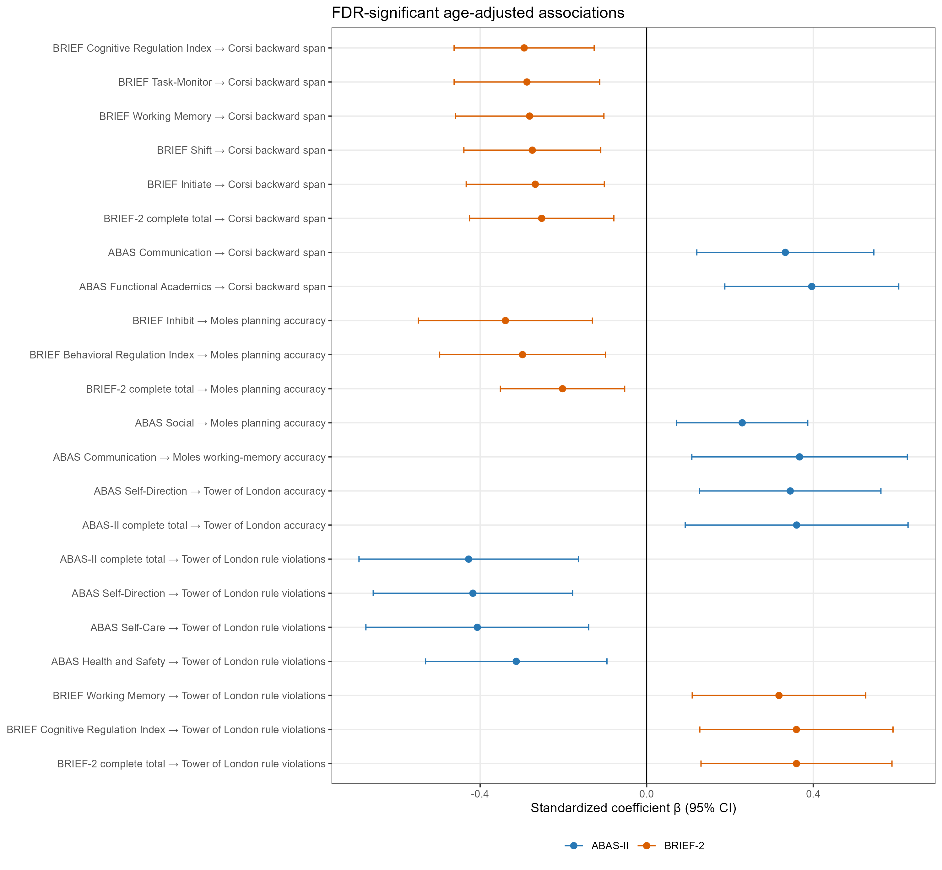
Figure 1: FDR-significant standardised coefficients from the primary age-adjusted models. Blue markers represent ABAS-II predictors and orange markers represent BRIEF-2 predictors.

Model Diagnostics
Diagnostic quantities for every FDR-significant model are reported in the analysis workbook and accompanying CSV table. They were used to characterise model fit and potentially influential observations; no participant was removed on the basis of these diagnostics.

References
Benjamini, Yoav, and Yosef Hochberg. 1995. “Controlling the False Discovery Rate: A Practical and Powerful Approach to Multiple Testing.” Journal of the Royal Statistical Society: Series B 57 (1): 289–300. https://doi.org/10.1111/j.2517-6161.1995.tb02031.x.
Bocchi, Alessia, Massimiliano Palmiero, and Laura Piccardi. 2022. “Walking on a Minefield: Planning, Remembering, and Avoiding Obstacles: Preliminary Findings.” Experimental Brain Research 240 (7–8): 1921–31. https://doi.org/10.1007/s00221-022-06391-x.
Corsi, Philip Michael. 1972. “Human Memory and the Medial Temporal Region of the Brain.” PhD thesis, McGill University.
Elm, Erik von, Douglas G. Altman, Matthias Egger, Stuart J. Pocock, Peter C. Gøtzsche, and Jan P. Vandenbroucke. 2007. “The Strengthening the Reporting of Observational Studies in Epidemiology (STROBE) Statement: Guidelines for Reporting Observational Studies.” PLoS Medicine 4 (10): e296. https://doi.org/10.1371/journal.pmed.0040296.
Ferri, R., A. Orsini, and M. Rea. 2014. Adaptive Behavior Assessment System, Second Edition. Firenze, Italy: Giunti Psychometrics.
Gioia, G. A., P. K. Isquith, S. C. Guy, and L. Kenworthy. 2015. Behavior Rating Inventory of Executive Function, Second Edition: Professional Manual. Psychological Assessment Resources.
Harrison, P. L., and T. Oakland. 2003. Adaptive Behavior Assessment System, Second Edition. Harcourt.
Lang, Thomas A., and Douglas G. Altman. 2015. “Basic Statistical Reporting for Articles Published in Biomedical Journals: The SAMPL Guidelines.” International Journal of Nursing Studies 52 (1): 5–9. https://doi.org/10.1016/j.ijnurstu.2014.09.006.
MacKinnon, James G., and Halbert White. 1985. “Some Heteroskedasticity-Consistent Covariance Matrix Estimators with Improved Finite Sample Properties.” Journal of Econometrics 29 (3): 305–25. https://doi.org/10.1016/0304-4076(85)90158-7.
Monaco, M., A. Costa, C. Caltagirone, G. A. Carlesimo, et al. 2013. “Forward and Backward Span for Verbal and Visuo-Spatial Data: Standardization and Normative Data from an Italian Adult Population.” Neurological Sciences 34: 749–54. https://doi.org/10.1007/s10072-012-1130-x.
Raven, J. C. 1995. Coloured Progressive Matrices Sets a, Ab, b: Manual Sections 1 and 2. Oxford, UK: Oxford Psychologists Press.
Shallice, Tim. 1982. “Specific Impairments of Planning.” Philosophical Transactions of the Royal Society of London. Series B, Biological Sciences 298 (1089): 199–209. https://doi.org/10.1098/rstb.1982.0082.

