Degree Project in Computer Science and Engineering

First cycle, 15 credits

Enhancing Virtual Environments: A Hydrologic Approach to Procedural Urban Terrain Generation

SOFIA ANDERSSON, LINUS LUNDSTRÖM

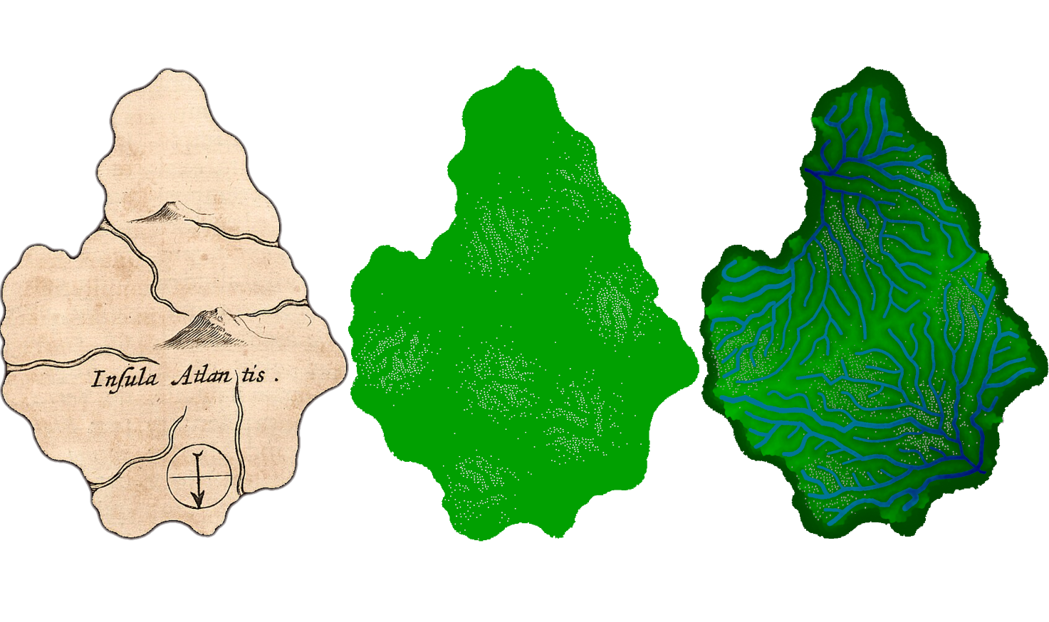

TRITA – XXX-XXX 20XX:XX

Stockholm, Sweden 2024

[www.kth.se](https://www.kth.se/)