Tutorial 03-B to do in class – Remember to upload the repo link to Teams
DIP
Antes de iniciar:
- Terminar los talleres no calificables anteriores
- Este taller muestra el ejemplo de una inversión de dependencias y de una inyección de dependencias.
- ¿Puede identificar donde está la inversión, y donde la inyección?
- Al final vemos un ejemplo de cómo sería sin inversión de dependencias.

- An interface
Interface
- Go to pages create a file interfaces.py with the next content:

Add Entire Code
from abc import ABC, abstractmethod
from django.http import HttpRequest

class ImageStorage(ABC):

@abstractmethod # any class that inherits from this one must implement this method
def store(self, request: HttpRequest):
pass

- A util library
Image local storage
- Go to pages create a file utils.py with the next content:
Add Entire Code
from django.core.files.storage import default_storage
from django.http import HttpRequest
from .interfaces import ImageStorage

class ImageLocalStorage(ImageStorage):
def store(self, request: HttpRequest):
profile_image = request.FILES.get('profile_image', None)
if profile_image:
# Store the image
file_name = default_storage.save('uploaded_images/' + profile_image.name, profile_image)
return default_storage.url(file_name)

- Go to helloworld_project/setting.py and add the following content:

Add bold Code
#top of the file
from pathlib import Path
import os
…
MEDIA_URL = '/media/'
MEDIA_ROOT = os.path.join(BASE_DIR, 'media')

- Go to helloworld_project and create a folder named media.
- Go to helloworld_project/urls.py and add the following content:

- Add bold Code
from django.contrib import admin
from django.urls import path, include
from django.conf import settings
from django.conf.urls.static import static

urlpatterns = [
path('admin/', admin.site.urls),
path('', include('pages.urls')),
path('accounts/', include('accounts.urls')),
]

if settings.DEBUG:
urlpatterns += static(settings.MEDIA_URL, document_root=settings.MEDIA_ROOT)

- A service provider
Provider
- Go to helloworld_project/settings.py/ an add the following content at the bottom of the file:

Add Entire Code
IMAGE_STORAGE_CLASS = 'pages.utils.ImageLocalStorage'}
Registering the new provider
- In pages/apps.py, make the following changes in bold.

Modify Bold Code
from django.apps import AppConfig
from django.utils.module_loading import import_string
from django.conf import settings

class PagesConfig(AppConfig):
default_auto_field = 'django.db.models.BigAutoField'
name = 'pages'

def ready(self):
ImageStorageClass = import_string(settings.IMAGE_STORAGE_CLASS)

- Rest of the code
View/Controller
- Go to pages/views.py and add the next content:

Add bold Code
…
from .models import Product
…

def ImageViewFactory(image_storage):
class ImageView(View):
template_name = 'images/index.html'

def get(self, request):
image_url = request.session.get('image_url', '')
return render(request, self.template_name, {'image_url': image_url})

def post(self, request):
image_url = image_storage.store(request)
request.session['image_url'] = image_url
return redirect('image_index')
return ImageView

Routes
- Go to pages/urls.py and add these new routes by adding the next lines at the end of the urlspatterns (check bold).

Modify Bold Code
…
path('image/', ImageViewFactory(ImageLocalStorage()).as_view(), name='image_index'),
path('image/save', ImageViewFactory(ImageLocalStorage()).as_view(), name='image_save'),

Template/view
- Go to pages/templates create a folder images.
- Go to resources/views/image/ create a file index.html with the next content:

Add Entire Code
{% extends 'pages/base.html' %}
{% block title %} Image Storage - DI {% endblock %}

{% block content %}

<div class="container">
<div class="row justify-content-center">
<div class="col-md-8">
<div class="card">
<div class="card-header">Upload image</div>
<div class="card-body">
<form action="{% url 'image_save'}" method="post" enctype="multipart/form-data">
{% csrf_token %}
<div class="form-group">
<label>Image:</label>
<input type="file" name="profile_image" />
</div>
<button type="submit" class="btn btn-primary">Submit</button>
</form>

<img src="{{ image_url }}" />
</div>
</div>
</div>
</div>
</div>
{% endblock %}

Artisan
- Run the next command in Terminal

Execute in Terminal
python manage.py runserver

Execution
- Go to http://127.0.0.1:8000/image/
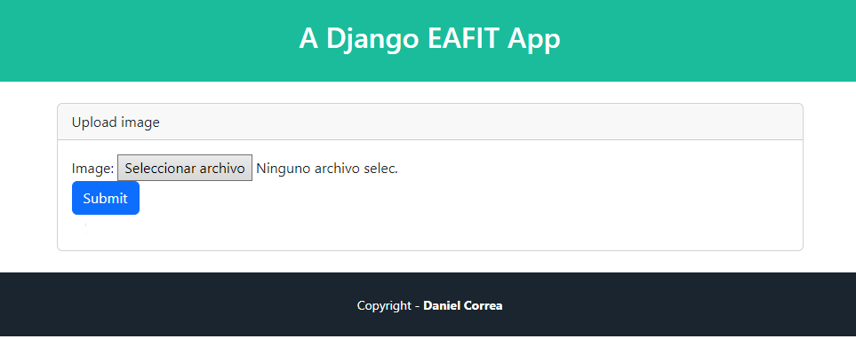
Upload image
- Upload a new image
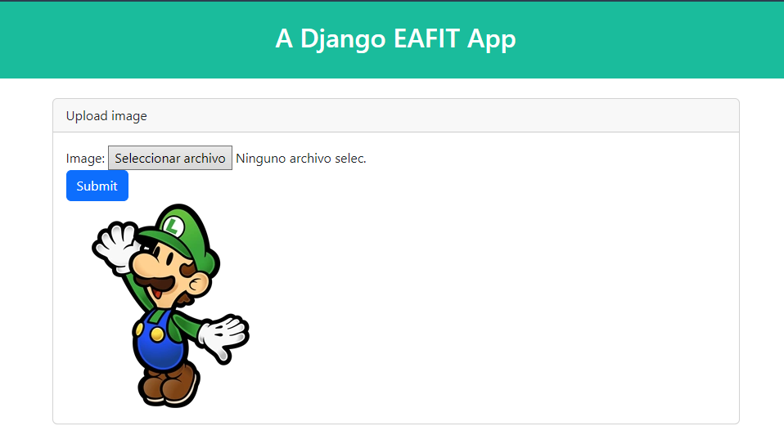

SAME APPLICATION WITHOUT DEPENDENCY INVERSION
Controller
- Go to pages/views.py create a View ImageNotDIView with the next content:

Add Entire Code

class ImageViewNoDI(View):
template_name = 'images/index.html'

def get(self, request):
image_url = request.session.get('image_url', '')

return render(request, self.template_name, {'image_url': image_url})

def post(self, request):
image_storage = ImageLocalStorage()
image_url = image_storage.store(request)
request.session['image_url'] = image_url

return redirect('image_index')}

Routes
- Go to pages/urls.pyand add these new routes by adding the next lines at the end of the file (check bold).

Modify Bold Code
…
path('imagenotdi/', ImageViewNoDI.as_view(), name='imagenodi_index'),
path('image/save', ImageViewNoDI.as_view().as_view(), name='imagenodi_save'),

View
- Go to pages/templates/ create a folder imagesnotdi.
- Go to pages/templates /imagesnotdi/ create a file index.html with the next content:

Add Entire Code
{% extends 'pages/base.html' %}
{% block title %} Image Storage - No DI {% endblock %}

{% block content %}

<div class="container">
<div class="row justify-content-center">
<div class="col-md-8">
<div class="card">
<div class="card-header">Upload image</div>
<div class="card-body">
<form action="{% url 'imagenotdi_save' %}" method="post" enctype="multipart/form-data">
{% csrf_token %}
<div class="form-group">
<label>Image:</label>
<input type="file" name="profile_image" />
</div>
<button type="submit" class="btn btn-primary">Submit</button>
</form>

<img src="{{ image_url }}" />
</div>
</div>
</div>
</div>
</div>
{% endblock %}

Execution
- Go to http://127.0.0.1:8000/image-not-di

Preguntas
- ¿Puedes entender las diferencias entre las dos propuestas?
- ¿Ventajas/desventajas de cada una?
- Qué tal si tratas de comparar estas propuestas con lo siguiente (ver siguiente página):

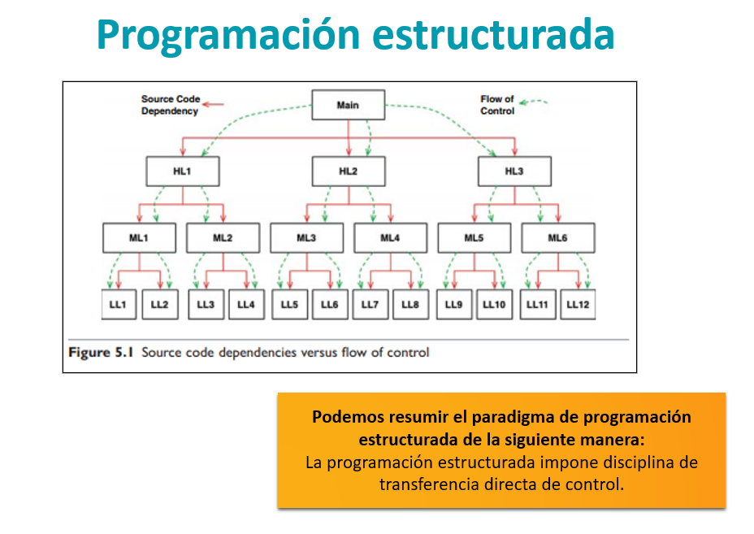
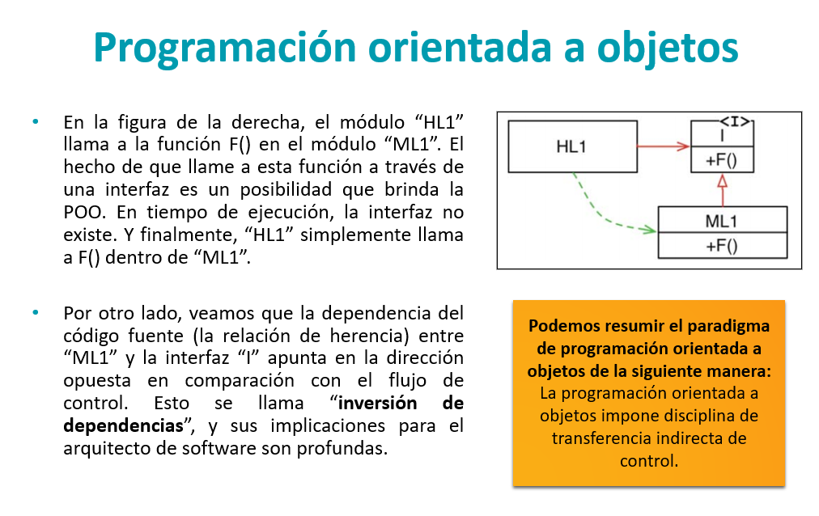
¿Será que con el ejemplo ya te queda clara esa carreta? ¿Sí? ¿No? La próxima clase conversaremos sobre esto

