Tutorial 03-A to do in class – Remember to upload the repo link to Teams
A. A cart system
View/Controller
- Go to pages/views.py and add the following content:

Add Entire Code

class CartView(View):
template_name = 'cart/index.html'

def get(self, request):
# Simulated database for products
products = {}
products[121] = {'name': 'Tv samsung', 'price': '1000'}
products[11] = {'name': 'Iphone', 'price': '2000'}

# Get cart products from session
cart_products = {}
cart_product_data = request.session.get('cart_product_data', {})

for key, product in products.items():
if str(key) in cart_product_data.keys():
cart_products[key] = product

# Prepare data for the view
view_data = {
'title': 'Cart - Online Store',
'subtitle': 'Shopping Cart',
'products': products,
'cart_products': cart_products
}

return render(request, self.template_name, view_data)

def post(self, request, product_id):
# Get cart products from session and add the new product
cart_product_data = request.session.get('cart_product_data', {})
cart_product_data[product_id] = product_id
request.session['cart_product_data'] = cart_product_data

return redirect('cart_index')

class CartRemoveAllView(View):
def post(self, request):
# Remove all products from cart in session
if 'cart_product_data' in request.session:
del request.session['cart_product_data']

return redirect('cart_index')}

Template/views
- Go to pages/templates/ and create a folder cart
- Go to pages/templates/cart and create a file index.html with the following content:

Add Entire Code
{% extends 'pages/base.html' %}
{% block title %} {{title}} {% endblock %}
{% block header_title %} {{subtitle}} {% endblock %}

{% block content %}
<div class="container">
<div class="row justify-content-center">
<div class="col-md-12">
<h1>Available products</h1>
<ul>
{% for key, product in products.items %}
<li>
Id: {{ key }} -
Name: {{ product.name }} -
Price: {{ product.price }} -
<form method="post" action="{% url 'cart_add' key %}">
{% csrf_token %}
<button type="submit">Add product to cart</button>
</form>
</li>
{% endfor %}
</ul>
</div>
</div>

<div class="row justify-content-center">
<div class="col-md-12">
<h1>Products in cart</h1>
<ul>
{% for key, product in cart_products.items %}

<li>
Id: {{ key }} -
Name: {{ product.name }} -
Price: {{ product.price }}
</li>
{% endfor %}
</ul>
<form method="post" action="{% url 'cart_removeAll' %}">
{% csrf_token %}
<button type="submit">Remove all products from cart</button>
</form>
</div>
</div>
</div>
{% endblock %}

Routes
- Go to pages/urls.py and add these new routes by adding the next lines at the end of the file (check bold).

Add Bold Code
…
urlpatterns = [
path('', HomePageView.as_view(), name='home'),
path('about/', AboutPageView.as_view(), name='about'),
path('products/', ProductIndexView.as_view(), name='index'),
path('products/create', ProductCreateView.as_view(), name='form'),
path('products/product-created', ProductCreateSuccessView.as_view(), name='product-created'),
path('cart/', CartView.as_view(), name='cart_index'),
path('cart/add/<str:product_id>', CartView.as_view(), name='cart_add'),
path('cart/removeAll', CartRemoveAllView.as_view(), name='cart_removeAll'),
]
Run the application
Go to http://127.0.0.1:8000/cart add some products to the cart and remove them.
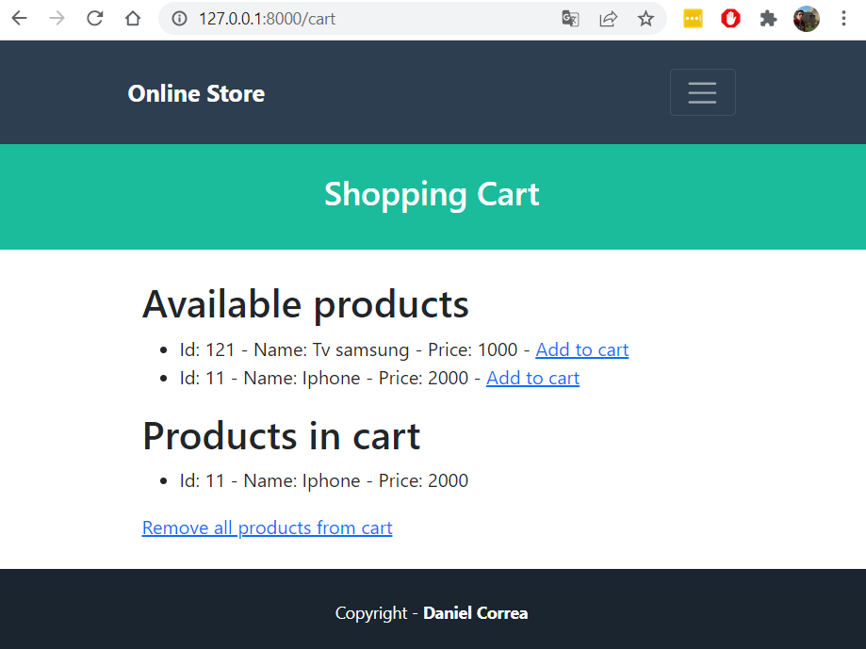
Note: complete the Django Login tutorial in Chapter 10 of the Django 4 for The Impatient book. It will be useful to understand some concepts in the next class. IF you do not have access to the book, please notify the professor.

